Developing Professional Practice

Chloe Ferraro
1802459
BMBM5005

Table of context
Activity One –
What is a professional Page 4
CIM Page 5
Activity Two-
What is group dynamics? Page 6
What factors can affect the group dynamics Page 6
Work theory Page 6
Conflict resolution method- Tuckmann, Belbin Page 7
Activity Three-
Mind map Page 9
Gantt chart Page 9
5 stages of project management Page 11
Edward de Bono Page 11
Fish Bone Page 11
Activity Four-
Continuing of personal development (CPD) Page 12
CIPD cycle Page 12
CIPD map Page 12
Professional Development Plan (PDP) Page 12
Bibliography Page 13, 14, 15
Appendix Page 16,17,18,19,20,21,23

Activity One
What does it mean to be a professional? According to Peter Johnson, a HR partner at an accountancy firm states, ‘A professional is someone who displays high levels of expertise and efficiency.’ (ACCA, 2020)
But what does it mean to be a professional and what are the professional standards in the marketing sector? – what does it mean to you/ what skills are required etc
According to the CIM, professional marketing standards the main core of what marketing means to a professional is to be completely customer focused and to have a main strategy. Using the CIM professional map as shown below, the main insights to what marketing means to a professional is split into three different groups. This is the Core, the Technical and the Behaviour.
‘The core competencies sit at the heart of marketing and are relevant to all marketers regardless of their roles, their industry sector or the stage that they have reached in their career. ‘(CIM, 2019) As stated before, this is the main focus such as strategy, customer focus, etc.
The technical competencies ‘identify the knowledge and skills required in specific areas.’ (CIM, 2019) for instance; this can be the different customer experience, the company’s brand and reputation, product management, etc.
Finally, the last is the Behaviour competencies. ‘These competencies describe the behaviours that marketing professionals need to be able to demonstrate in order to do their jobs efficiently…’ (CIM, 2019) These can be the creative aspects, responsible, financially literate, inspiring, challenging, influencing, collaborating, etc.
The CIM diagram can be shown in the appendix.

Activity Two
What is group dynamics?
In order for a group to work dynamically and efficiently, the group dynamics is considerably important to professionals when trying to get a project or other work completed. But what is the meaning of group dynamics? According to Kurt Lewin, ‘a social psychologist and change management expert, is credited with coining the term ‘group dynamics’ in the early 1940s. He noted that people often take on distinct roles and behaviours when they work in a group. ‘Group dynamics’ describes the effects of these roles and behaviours on other group members, and on the group as a whole.’ (mindtools, no date)

What factors can affect the group dynamics?
Although the significant importance of group dynamics might be to a professional, many of the group dynamics can be affected by different factors. These can be the various natures of the individuals within the team, the communication structure and how the group go about the process of communication, leadership, the structure of the group as well as how the group or team members might have power and or status issues.
A common affect that professionals might come across is the group individuals own personal political agenda. The main idea of working in a group is working together and coming to a main goal where as many individuals may be good at what they can be doing but will be only doing for personal gain and agenda. This is called organisational politics.
‘The pursuit of individual agendas and self- interest in an organisational without regard to their effect on the organisations efforts to achieve it’s goal’. (Wroblewski, 2018)
Work theory
According to Smriti Chand, ‘Group dynamics deals with the attitudes and behavioural patterns of a group.’ (Chand, no date) Which is where different team work theory can come into place. The most popular theories are from Bruce Tuckman and Belbin’s 9 team Roles. But what are they?
Firstly, Bruce Tuckman created the ‘forming, storming, norming and performing’ in 1964. According to Tuckman, the model was created due to the fact that ‘teams go through predictable phases of development that, with the right interventions, can be accelerated.’ (Harvard Business Review, 2016)
This means that in order for a professional to understand how the group dynamics work they need to be able to understand what kind of stage the group are working at. As stated above; the model contains forming, storming, norming and performing which are stages of group development.
Conversely, the Belbin 9 team roles is a personality task to identify what individuals excel at what and what individuals prefer to do which increases productivity. Many professionals use this theory in order to keep their group members happy and to also keep productivity high. Adding to this, it’s important for professionals to use this due to the risk of members underperforming ‘because they’re overwhelmed’. (Bird, 2017) The theory helps professionals to evenly distribute the work load.

Conflict resolutions
When it comes to group work, it’s important for professionals to understand that conflicts in groups or teams can happen and that conflict resolutions are a main factor in the maintaining of positivity and productivity within groups. The main conflict resolutions used by professionals can be the Thomas- Kilmann conflict instrument. This instrument is also known as the TKI which has been the leader in ‘conflict resolution assessment for more than forty years,’ and has been used by various HR departments and Organisational developments professionals in order to discuss issues and to identify how to deal with conflict. (Kilmann Diagnostics, no date)
Upon doing my own Kilmann assessment I was able to identify that I am accommodating. According to the Kilmann Diagnostics websites, accommodating means ‘when accommodating, the individual neglects his own concerns to satisfy the concerns of the other person: there is an element of self- sacrifice in this mode.’ (Kilmann Diagnostics, no date)
But why might a professional use the Kilmann method? Within marketing, its often that customer service teams have difficulty when it comes to handling their clients. This means that’s its not unusual for a marketing team to use this method in order to maintain relationships. Business leaders often use this method in order to develop their ‘interpersonal skills and leadership capabilities.’ This is usually done to achieve or maintain their goals. (Beyond theory, 2019)
Another conflict resolution method is the iPEACE framework and Model. This model looks at that there is no right or wrong approach. The main idea of this model is to;
- Identify conflict
- Pick the right strategy
- Enable voices to be heard
- Attack problems not people and Acknowledge feelings
- Create options
- Evaluate
Which is done when the actual issue is identified. (Cremins, 2017)
Referring back to my own conflict situations was back in my previous group in year one. We had trouble with others seeming they had more work than others. In order to resolve this, we all met and re- evaluated what work we wanted and didn’t want and evenly distributed it suited to our own needs. This helped us figure out the work needed to be completed, keep up with time deadlines as well as keep conflict at a minimum.

Activity Three
During my group work during year one; as stated above, I was a team member but eventually had to step up to be a team member regarding work load and absences. The overall getting the project completed wasn’t a problem but the original team member was absent for the last part of the project. The one technique I had used was to have a team meeting to discuss all of the concerned issues that had been arising with distributing the of the work load. This kept positivity within the group and kept team members motivated.
When it came to the actual project, I had used a mind map to map out what we were going to do as well as brainstorm other team members ideas so everyone felt included. ‘Mind mapping is not new, but it’s become a popular project management tool. Because of the visual aspect of these useful maps, team leaders and members can create, discuss, explore, and widen these maps for use in analysing, problem solving, and ideas or avenues to take in a project.’ (Schied, 2019)
This mind map can be seen in the appendix.
As well as this we also used Gantt charts which helped us with our timekeeping to ensure that everyone kept up with the project and that everything kept up with targets. ‘A Gantt chart is a project management tool assisting in the planning and scheduling of projects of all sizes, although they are particularly useful for simplifying complex projects.’ (APM, 2019)
This Gantt chart can be seen in the appendix.
In order to keep everyone motivated and as well keep the work flow going, I had to negotiate and persuaded with team members so that conflict issues were kept to a minimum. This was mainly due to the work load and individuals feeling almost ‘fed up’.
According to Schamotta, ‘Successful negotiation provides the team with faith in their ability to continue to co-operate with each other.’ (Schamotta, 2020)
When it comes to being apart of the project management team there are 5 different stages a professional need to identify. But what is project management? Project management is the ‘application of processes, methods, skills, knowledge and experience to achieve specific project objectives.’ (Apm.org.uk, 2019)

These are the 5 stages of project managements. (PMI, 2020)
- Initiating
- Planning
- Executing
- Monitoring and Controlling
- Closing

Although my own problem-solving techniques was to talk out the issues to keep group members happy, there are different problem-solving techniques such as the Edward de Bono six thinking hats technique as well as the fish bone diagram.
Edward de Bono
The six thinking hats is a ‘powerful tool created by Edward de Bono based on a principle of parallel thinking; everyone thinking in the same direction, from the same perspective, at the same time.’ (Six thinking Hats, no date) This tool can be useful when team members are storming ideas for the project or after ideas have been generated in order to gain a better understanding for the ideas.
Fish Bone Diagram
The Fishbone diagram is to identify the causes and effects which helps ‘you to think through the causes of a problem, including possible root causes, before you start to think of a solution…’ (Fishbone, no date) the fishbone method can be particularly useful when trying to identify why an issue is continuously occurring.

Activity Four
The continuing of Professional development (CPD) can be important to any professional. But what is CPD? According to Megginson and Whitaker, ‘Continuing Professional Development (CPD) is a process by which individuals take control of their own learning and development, by engaging in an on-going process of reflection and action.’ (Megginson and Whitaker, 2007) The purpose of this is to engage the individual to aspire them to achieve their goals.
The cycle in which an individual must go through is set out through 7 stages. This is the Identification, Plan, act, reflection, application, share and impact. (CIPD, 2020)
As well as the stages, there is the CIPD map which ‘defines the building blocks of effective people management practice across ten professional specialisms, and describes eight fundamental behaviours that underpin good practice regardless of specialism.’ (CIPD, 2013)
When completing my own professional development plan, I used the PDP template which helped me identify what I wanted to be done by the time I finished my university course. This can be seen in the appendix.

Bibliography
https://www.accaglobal.com , A. (2020). What it means to be professional | ACCA Global. [online] Accaglobal.com. Available at: [Accessed 3 Jan. 2020].
Cim.co.uk. (2019). Professional Marketing Competencies | CIM. [online] Available at: https://cim.co.uk/membership/professional-marketing-competencies/ [Accessed 3 Jan. 2020].
Mindtools.com. (n.d.). Improving Group Dynamics: Helping Your Team Work More Effectively. [online] Available at: https://www.mindtools.com/pages/article/improving-group-dynamics.htm [Accessed 3 Jan. 2020].
Wroblewski, M. (2018). The Impact of Power and Politics in Organizational Productivity. [online] Smallbusiness.chron.com. Available at: https://smallbusiness.chron.com/impact-power-politics-organizational-productivity-35942.html [Accessed 3 Jan. 2020].
Chand, S. (n.d.). Group Dynamics: it's characteristics, stages, types and other Details | Management. [online] Your Article Library. Available at: http://www.yourarticlelibrary.com/management/group-dynamics-its-characteristics-stages-types-and-other-details-management/5363 [Accessed 3 Jan. 2020].
Harvard Business Review. (2016). Leading the Team You Inherit. [online] Available at: https://hbr.org/2016/06/leading-the-team-you-inherit [Accessed 3 Jan. 2020].
Bird, V. (2017). Why Teams Matter. [Blog] Belbin. Available at: https://www.belbin.com/resources/blogs/why-teams-matter/ [Accessed 3 Jan. 2020].
Kilmann Diagnostics. (n.d.). An Overview of the Thomas-Kilmann Conflict Mode Instrument (TKI) A long-term collaboration by Dr. Kenneth W. Thomas and Dr. Ralph H. Kilmann - Kilmann Diagnostics. [online] Available at: https://kilmanndiagnostics.com/overview-thomas-kilmann-conflict-mode-instrument-tki/ [Accessed 3 Jan. 2020].
Cremins, H. (2017). Positive Peace in Schools: Tackling Conflict and Creating a Culture of Peace in the Classroom. Routledge, 2017, p.57.
Apm.org.uk. (2019). What is project management?. [online] Available at: https://www.apm.org.uk/resources/what-is-project-management/ [Accessed 3 Jan. 2020].
Pmi.org. (2020). What is Project Management?. [online] Available at: https://www.pmi.org/about/learn-about-pmi/what-is-project-management [Accessed 3 Jan. 2020].
Schied, J. (2019). The Benefits of Mind Mapping In Project Management. [online] Bright Hub PM. Available at: https://www.brighthubpm.com/resource-management/97276-examples-of-mind-mapping-in-project-management/ [Accessed 3 Jan. 2020].
Schamotta, J. (2020). Negotiation & Conflict Resolution in Teamwork. [online] Smallbusiness.chron.com. Available at: https://smallbusiness.chron.com/negotiation-conflict-resolution-teamwork-22245.html [Accessed 3 Jan. 2020].
Six Thinking Hats. (n.d.). [ebook] NHS, p.2. Available at: https://improvement.nhs.uk/documents/2167/six-thinking-hats.pdf [Accessed 3 Jan. 2020].
Cause and effect (fishbone). (n.d.). [ebook] NHS. Available at: https://improvement.nhs.uk/documents/2093/cause-effect-fishbone.pdf [Accessed 3 Jan. 2020].
beyondtheory.co.uk. (2019). Personality Profiling: Thomas Kilmann Conflict Instrument (TKI). [online] Available at: https://beyondtheory.co.uk/personality-profiling-thomas-kilmann-conflict-instrument-tki [Accessed 3 Jan. 2020].
Megginson, D. and Whitaker, V. (2007). Continuing professional development. 2nd ed. London: Chartered Institute of Personnel and Development, p.3.
CIPD. (2020). CPD Cycle Stages | CIPD. [online] Available at: https://www.cipd.co.uk/learn/cpd/cycle [Accessed 3 Jan. 2020].
CIPD. (2013). The 2013 Profession Map for HR and L&D | CIPD. [online] Available at: https://www.cipd.co.uk/learn/profession-map/2013-profession-map [Accessed 3 Jan. 2020].
Apm.org.uk. (2019). What is a Gantt chart? | APM. [online] Available at: https://www.apm.org.uk/resources/find-a-resource/gantt-chart/ [Accessed 3 Jan. 2020].

Appendix
CIM – Professional Marketing Standards diagram

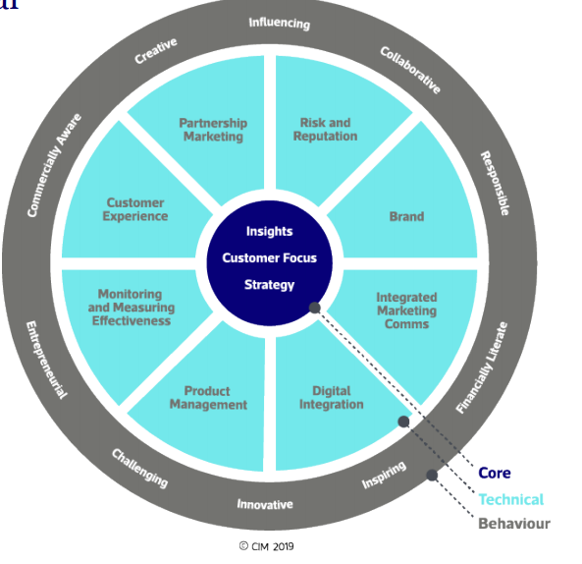

Belbin Figure
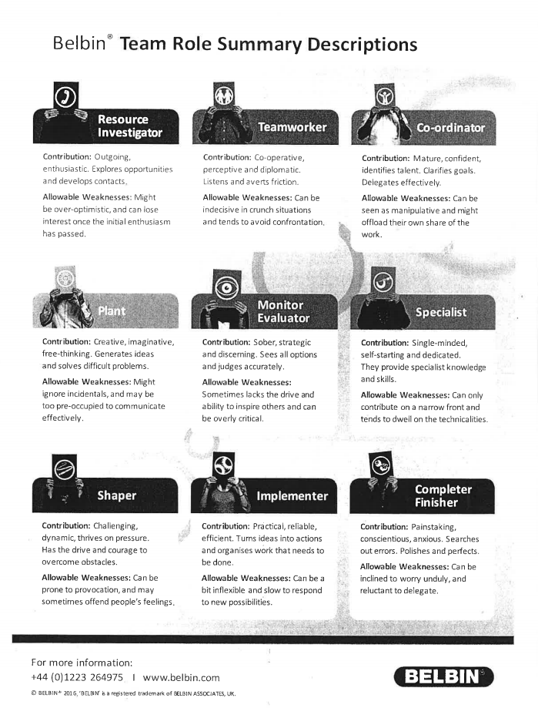

Kilmann assessment

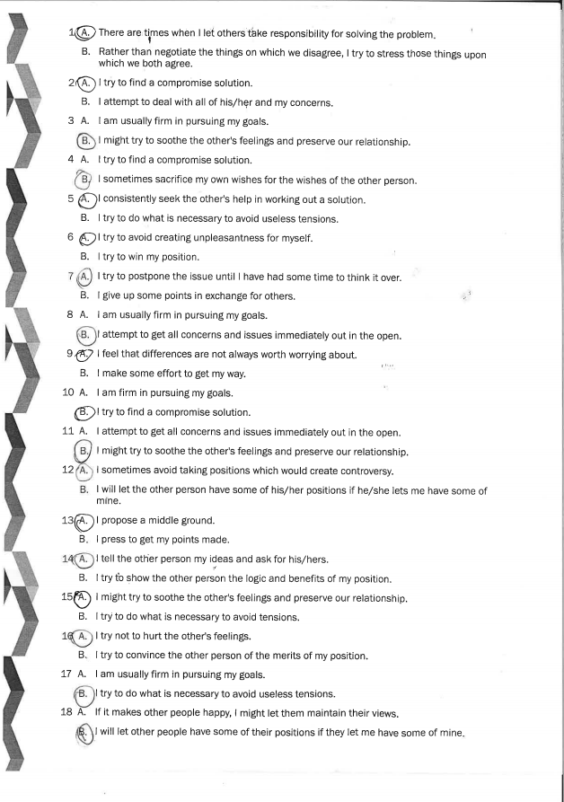

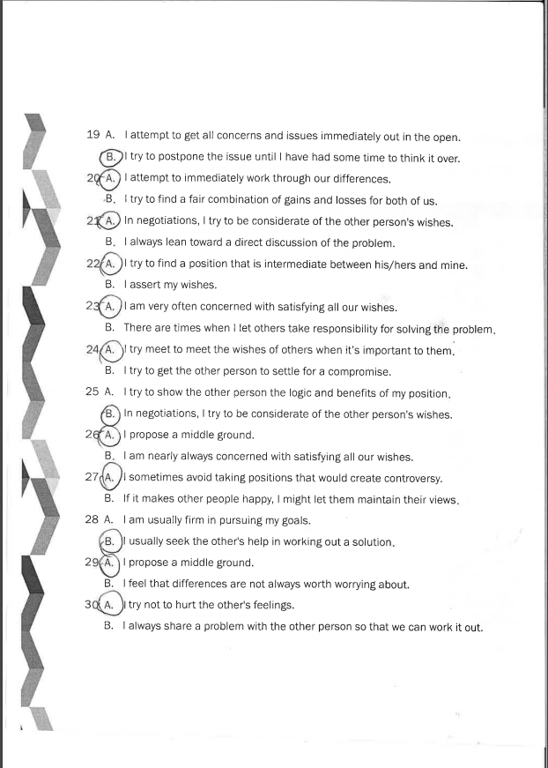

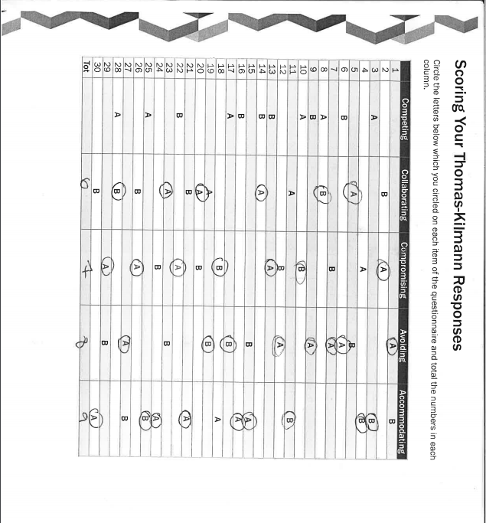

Mind map from Matthew’s House

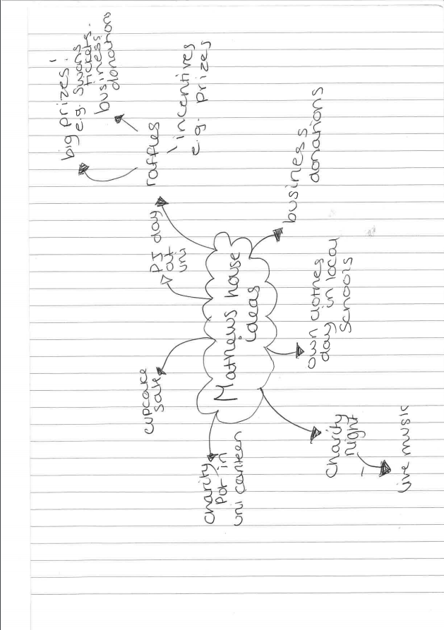

Gantt chart of Matthew’s House Timing scale
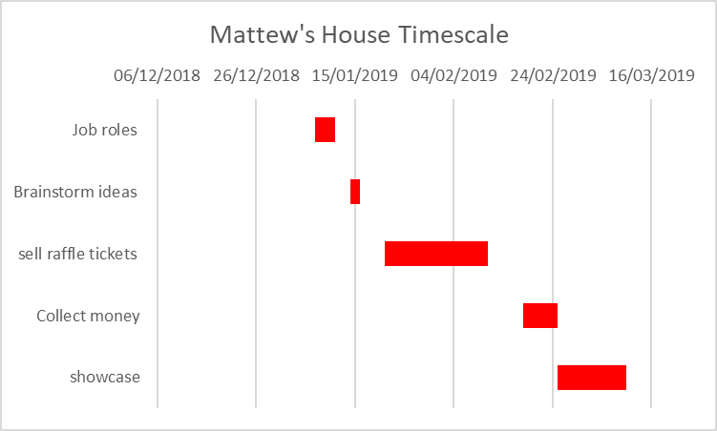

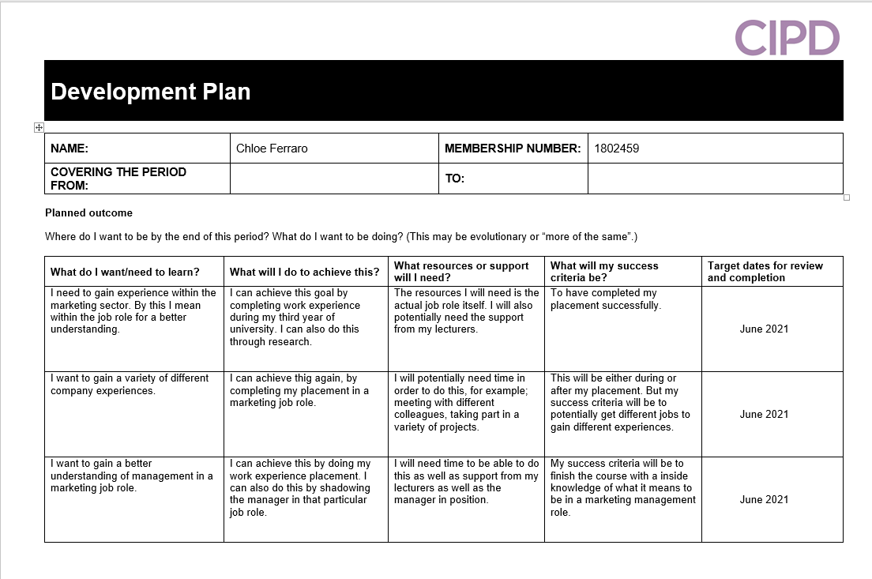
My CIPD Development plan

