

Can Wales Afford to Continue to Run and Maintain Listed Estates on the Edge in the Era of Climate Change?

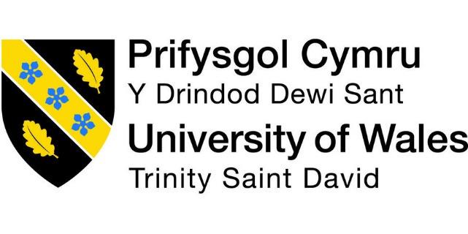

Name: Ella Curr
Student Number: 1803755
School: University of Wales Trinity Saint David
Faculty: Architecture, Built and Natural Environment
Course: BSc Architecture
Year of Completion: 2020/21
Word Count: 10,089


Copyright Statement

The copyright of this dissertation rests with the University of Wales, Trinity Saint David. No information derived from this dissertation shall be published without the prior written consent of the University.

Signature ……………………………………………………………………………………………

Date ……………………………………………………………………………………………

Author’s Declaration

I declare that the work in this dissertation was carried out in accordance with the regulations of the University of Wales, Trinity Saint David. The work is original except where indicated by special references in the text and no part of the dissertation has been submitted for any other degree.
Any views expressed in the dissertation are those of the author and in no way represent those of the University of Wales, Trinity Saint David.
The dissertation has not been presented to any other University for examination either in the United Kingdom or overseas.
I hereby give permission for my work, if accepted, to be available for photocopying and inter-library loan, and for the title and summary to be made available to outside organisations.

Signed ……………………………………………………………………………………………
Date ………………………………………………………………………………………

Abstract

Can Wales afford to continue to run and maintain Listed Estates on the edge in the era of climate change?
School of Architecture, Built and Natural Environment - University of Wales Trinity Saint David

There are approximately 30,000 listed buildings in Wales, which are divided into Grade I, Grade II* and Grade II. These listed buildings require energy, materials, and knowledge to maintain good condition and sustain them. (Welsh Government, 2017). It is necessary to bring these buildings into the 21st Century with regards to these criteria to solidify their place in society and in Welsh heritage. This piece of research explores the current listing system and its implications on the renovations and maintenance of Listed Estates, the problems put before them with regards to sustainable technologies and the zero-carbon initiative and its effects on the futures of Listed Estates. This dissertation also takes all these points and applies them to examples using case studies of Listed Estates in Wales. In doing this, the researcher also created a survey that was sent to the relevant bodies at these chosen case studies to develop a greater understanding of the reality and severity of these boundaries. There were also several interviews with professionals in the field to get an insight into the professional bodies and how they can aid the estates in running and maintaining themselves. A full bibliography and appendices are included as a part of this dissertation.

The case studies included through this work are: Bodrhyddan Hall, Llanerchaeron, Plas Newydd and Trevor Hall, each selected for their own reasons. Bodrhyddan Hall continues to be one of the very few remaining family-owned estates in Wales and so, due to its nicheness, deserved to be explored in more depth. Llanerchaeron is a Grade 2* Listed Building, comfortable with its position due to greater restrictions on Grade I Listed Buildings and so this case study was chosen to develop a greater understanding as to why this is the case. Plas Newydd is undergoing a massive period of change with a project to renew and update essential services to the house. This was of particular interest to the dissertation and so created a full-bodied case study for the advocation of sustainable technologies on Listed Buildings. Trevor Hall is an extremely rare early Georgian brick house with many original period features and is exquisite in its landscape. This case study was chosen due to the need to preserve the authenticity of the building whilst ensuring the damage to the thriving surrounding woodland environment is minimal.

Using these surveys and case studies, the results were then analysed and informed the conclusion of the dissertation. There are also several potential recommendations for how things could and should change to enable Listed Estates to continue to run and maintain themselves in the era of climate change.

Throughout this dissertation, several experts were contacted and offered their great advice and knowledge on their specialty subjects. Professor John Edwards MA, DipBldgCons, CEnv, FCIOB, FRICS, IHBC is the lead author of the British Standard for the conservation of historic buildings and has practiced in the construction and property industry for over thirty years. Keith Jones is the National Specialist on Climate Change for the National Trust and leads them on their Climate Change Approach. Finally, Andy Sutton is the co-founder and Design and Innovation Director at Sero. All three of these professionals were invaluable to the process and their insights are included through the work ahead. These experts also proved valuable in concluding this dissertation.

It is advised that this topic can be returned to with greater depth to find solutions to these problems and to test them on current heritage buildings. This could allow for a revelation that will allow for more heritage buildings in Wales to be saved and no longer at risk of being lost forever. This would mean that the history of Wales’ cultural and architectural sectors will be preserved in a modern way that can not only allow them to be self-sustaining but also give back to the beautiful planet in which we live.

Contents

Copyright Statement 1
Author’s Declaration 2
Abstract 3
List of Illustrations, Graphs and Tables 6
Acknowledgements 7
Introduction 8
Methodology 15
Chapter 1: An in-depth explanation of the case studies 18
Chapter 3: The zero-carbon initiative and its effects on Listed Estates 29
Chapter 4: The hurdles put before listed estates when considering sustainable technologies 34
Chapter 5: Aims and expectations of the field research 38
Evaluation and analysis of the results of the research 40
Conclusion 53
Bibliography: Published Works 58
Bibliography: Unpublished Works 67
Appendix A. Questions asked to case study property managers 69
Appendix B. Questions asked to experts 76

List of Illustrations, Graphs and Tables

Content | Page Number
- Pie Chart Showing Division of Listings in Wales | 12
- External Photograph of Bodrhyddan Hall | 19
- External Photograph of Plas Newydd | 20
- External Photograph of Trevor Hall | 21
- External Photograph of Llanerchaeron | 23
- Chart Showing Responses to the Question ‘to what extent do you agree or disagree with the following statements about your last experience of the consent process?’ | 25
- Extract from Chapter 2, Section 10 of the Planning Act 1990 | 26
- Graph Showing Annual Global Temperature Change Since 1880 | 27
- Diagram Showing the Circular Economy and the Built Environment | 29
- Illustration showing a Comparison of Modern and Historic Constructions and Their Thermal Efficiency | 31
- Diagram of an Example of Cost/Benefit Analysis of Replacing Glazing with Double Glazing on a Historic Building | 34
- Graph Depicting the Average Annual Visitor Numbers at Case Studies | 39
- Graph Depicting the Energy Management Systems in Place at the Case Studies | 41
- Graph Depicting the Annual Approximate Expenditure for Each Case Study | 43
- Graph Depicting the Costs that Present the Biggest Challenge in Management of the Case Studies | 44
- Graph Depicting the EPC Ratings of the Case Studies | 45
- Graph Depicting the Feasibility of the Case Studies in Reaching NetZero2050 | 47

Acknowledgements

The researcher would like to extend thanks to the staff at the University of Wales Trinity Saint David for providing continuous access to invaluable resources within the university. Especially to Ian Standen and Dr Elizabeth Walder FRSA, MCIPR for their continuous academic and emotional support enabling this piece of work to be completed.

In addition, Professor John Edwards MA, DipBldgCons, CEnv, FRICS, FCIOB, IHBC and Dr Keith Jones are thanked for their insight and professional knowledge which allowed this research to be as accurate and relevant as possible.

Finally, thanks are extended to my family; Andrew Curr, Amanda Moorcroft, and Matthew Macpherson, for their support through not only my dissertation but my entire journey up to and including this milestone.

Introduction

Focus on Wales.
After a thorough search through many publications of Architectural History produced by the Society of Architectural Historians of Great Britain (SAHGB) it was undeniable that there was a greater lack in evidencing architectural heritage sites in Wales than in the other constituents of the United Kingdom. Further to this initial research, the focus was brought to Wales and revealed that there was a significantly greater amount of information available regarding heritage buildings in the South of the country. Another strand to consider is the response of the heritage organisations and estate managers to the global crisis of climate change. Finally, as the author is studying at University of Wales Trinity St David it is appropriate to investigate key estates of North and Mid Wales through this dissertation.

Aims and objectives.
The aim of this research is to identify the key challenges facing heritage buildings with reference to the zero carbon initiatives and to develop practical solutions to these challenges.
This dissertation will address the following objectives:
- Consider existing heritage buildings that have both succeeded and failed at responding to climate change. This information will allow the author to draw experiences from and focus the scope of the research.
- Establish the challenges facing heritage organisations such as Cadw, who maintain the historic environment.
- Determine a series of case studies, from which to collect comparative.
- Discuss any challenges revealed in the data sample to develop a deeper understanding of the practical problems relating to the upkeep of the heritage buildings.
- Research the funding options available to, and the economic contributions from, the historic environment to add a further layer of analysis.
- Develop and recommend solutions for the repurposing of heritage sites in Wales, which are feasible in both the short and long term.

What is a Listed Building?
According to Historic England, a heritage building is defined as “A building, monument, site, place, area, or landscape identified as having a degree of significance meriting consideration in planning decisions, because of its heritage interest” (2021). The main indicator of an historic building is the listed status which is awarded. The listing system aims to protect and celebrate a building’s unique historical and architectural interest. Alterations to a building with listed status are extremely complex and require the amalgamation of reading the Town and Country Planning Order (2015), National Planning Policy Framework (2012), Town and Country Planning Act (1990) and R v Secretary of State for Communities and Local Government (2011). There are many clauses and paragraphs in each of these documents which may be relevant to allow changes or even demolition to occur on a listed building.

According to Historic England (2021), “the older a building is, and the fewer the surviving examples of its kind, the more likely it is to be listed.”

After a recommendation for listing status is submitted by the relevant heritage body, it is the UK Government’s Secretary of State for Digital, Culture, Media, and Sport (DCMS) who makes the final decision. According to Heritage England (2021), in England and Wales, the listing system uses the following categories:
- Grade I Listed Buildings are of exceptional interest and consist of 2.5% of all listed buildings in the UK.
- Grade II* Listed Buildings are those of more than special interest with 5.8% of listed buildings belonging in this category.
- Grade II Listed Buildings are of special interest and the remaining 91.7% of all listed buildings are categorised here.

Scotland and Northern Ireland have their own grading system for the historic environment. Once a building has been listed in England and Wales, any alterations cannot take place until the owner have been granted Listed Building Consent (LBC) as laid out in the Section 8 of the Planning (Listed Buildings and Conservation Areas) Act 1990 (UK Government).

The zero-carbon initiative and the commitments made to it.
On the 9th of February 2021, the Welsh Government formally committed to deliver a goal of net zero emissions by 2050 (Sutton, 2021). Previously, the Climate Change Committee (CCC) in 2017 and 2019, had deemed this goal impossible due to the importance of farming on the rural communities. Indeed, the Welsh Government had committed Wales to 80% lower emissions. Revisions of the goals and a roadmap has now been created for the future which is consistent with meeting the goals set in 2016 during the Paris Agreement. Under this agreement, all countries who attended should plan and report the contributions that it has made to mitigate global warming (Paris Agreement Article 3, 2015). The main aim of this agreement was to reduce the emissions of greenhouse gases to the environment to a level that prevents the temperature of the globe from increasing more than 2°C above the previously set benchmark.

The Welsh Government declared a climate emergency in 2019 and used the limitations of the CCC as a starting point. However, the Welsh Government strive to exceed these limitations, as is enshrined in the Wellbeing of Future Generations Act (2015).

The importance of Listed Buildings to Welsh heritage
Within Wales, there are 30,093 Listed Buildings, and the following pie chart shows the division between the categories, as stated above.

Figure 1: Chart Showing Division of Listings in Wales (Curr, 2021)

The history of the Welsh nation is embodied in each of its these unique environments, with each site telling its own social and cultural story. Cadw describes these buildings as “showcases for the history of Wales” (2020).

Heritage related bodies and their funding
Two key heritage organisations have been considered relevant as part of this research: Cadw and the National Trust. The researcher has interviewed representatives of both organisations, as part of this study.

Cadw, meaning ‘to keep’ in Welsh, works in partnership with the Welsh Government and acts as its historic environmental service. It is part of the Culture, Sport and Tourism Department. Cadw works to protect 127 state-owned properties and heritage sites and encourages the public to visit and appreciate these sites whilst learning about the country’s history and cultural significance (Cadw, 2019).

The National Trust is a charity which focuses on the conservation of natural and beautiful history for the public to experience and find joy from. The charity is funded by grant income, mainly from The National Lottery, the Landfill Communities Fund, Structural Funds, Interreg and LIFE. The National Trust receives money from National Trust Enterprises which is its own profit generation income at the protected properties. The charity also receives money from the Department for Environment, Food and Rural Affairs, which in 2018 amounted to approximately £2.6 million (National Trust, 2019). The Trust owns 2,480 kilometres squared of land, over 700 miles of coast, and more than 500 estates, castles, monuments, and natural sites. (National Trust, 2019).

Introduction to the case studies
Bodrhyddan Hall is a Grade I Listed stately home that has been the home of Lord Langford and his family for over 500 years and is one of the few remaining family-owned historic estates in Wales. The house is largely of 17th century design with notable Victorian additions; the 1874 remodel was designed by renowned architect, William Eden Nesfield (1835-1888). Bodrhyddan Hall continues to be one of the very few remaining family-owned estates in Wales and so, due to its nicheness, deserved to be explored in more depth. The interior of the manor house contains an extensive historical collection. Notable examples include arms and armour, a variety of fine art and portraits, and a 3,000-year-old Egyptian mummy and sarcophagus (Bodrhyddan Hall, 2021).

Trevor Hall is a mansion which has been home to some very powerful families in Llangollen since 1742. The Grade I Listed site was known to be the home of Bishop John Trevor, who built the Llangollen Bridge in 1345. The house itself was largely reconstructed to its present form in the 18th century by John Lloyd of Glanhavon, Montgomeryshire, who in 1715 married Mary Trevor, heiress of the estate. Trevor Hall is an extremely rare, early Georgian brick house with many original period features and is exquisite in its landscape. This case study was chosen due to the need to preserve the authenticity of the building whilst ensuring the damage to the thriving surrounding woodland environment is minimal.

Plas Newydd is the ancestral home of the Marquess of Anglesey. The house itself has evolved from the original Tudor house to the changes made by architect James Wyatt in 1793 and the modernisation during the 1930s. The Grade I Listed manor is currently undergoing a massive period of change and renewal to update essential services to the house. As a pioneer for the National Trust’s introduction of sustainable technologies for Listed Buildings, Plas Newydd immediately became a significant case study for this study.

Llanerchaeron in Ceredigion was designed and built by architect John Nash as a self-sufficient farm. Now under the care of the National Trust, it is of Georgian design with an entire courtyard of service amenities. As a Grade 2* Listed Building, Llanerchaeron is comfortable with attaining the lower category listing status due to the greater restrictions placed upon on Grade I Listed Buildings. This case study was selected to understand further the flexibilities between the listing categories.

Existing literature
Within the review of the previous literature relevant to this dissertation, the researcher has used government legislation documents which give the guidance and advisory notes for the protection of heritage buildings.

Online documentary sources, such as websites and archives have been researched to retrieve information on the case studies. Furthermore, interviews with experts in the field of conservation, heritage and climate change have given the author valuable data.

Key interviewees for this dissertation
Throughout this dissertation, several experts have been contacted and have offered their great advice and knowledge on their specialty subjects. Professor John Edwards MA, DipBldgCons, CEnv, FCIOB, FRICS, IHB is the lead author of the British Standard for the conservation of historic buildings and has practiced in the construction and property industry for over 30 years. Keith Jones is the National Specialist on Climate Change for the National Trust and manages the Climate Change Programme of Works. Finally, architect Andrew Sutton is the co-founder and Design and Innovation Director at Sero. Andrew Sutton is currently part of the Welsh Government’s “Decarbonisation of Existing Homes” and “Innovative Housing Programme”. All three professionals have been invaluable to this study and their insights are included through the work ahead.

Methodology

In researching material for this dissertation, I engaged in four different approaches:
- Library research and documentary sources
- Government and legislative data
- Interviews with key individuals
- Fieldwork survey with representative input from each of the selected case studies

- Library research and documentary sources
A desktop study at the beginning of the period of study into the zero-carbon initiative revealed the effectiveness of different interventions and the feasibility of their use in conjunction with the historic environment. Through the literature research, the researcher used Welsh and UK Government reports and journal articles to gain knowledge into the history of the case studies which would become a focus later in the dissertation. There were also several Welsh and UK Government-published guidelines that were analysed for a sense of what the heritage buildings were having to adhere to to be compliant. These documents were also instrumental is helping to discover what already existed around sustainable developments of heritage buildings. The researcher also attended online talks and seminars including the Royal Society of Architects in Wales (RSAW) Annual Conference 2020 to ensure the knowledge was as relevant as possible and this also allowed the researcher to ask questions and interact with professionals in the field.

The global pandemic of COVID19 has meant that all the research methods had to be accessed remotely via the internet and the world wide web. All documents within the literature review had to be downloadable and all communications were achieved through email, phone calls and video calls. However, technological developments within new platforms meant that many seminars and conferences could be attended via an online classroom.

- Government and legislative data
Cadw, the Welsh Government's historic environment service, has produced several significant reports that have been read as part of the literature review. It has also been useful to collect and digest comparative data from other notable bodies such as The Centre for Sustainable Heritage at University College London, and the British Standards Institute, amongst others.

- Interviews with key individuals
Key people were interviewed as part of the research and included Professor Edwards, Dr Jones, and Andy Sutton. Professor John Edwards was particularly helpful with his knowledge in the field of sustainable designs in heritage buildings. Dr Keith Jones was able to share insights into the experiences of the government bodies and the influences they have on decision making; and Andy Sutton enlightened the author with his experience in architecture and the practicalities of sustainable design in heritage buildings.

- Fieldwork survey with representative input from each of the selected case studies
A series of questions were written and distributed by the author to a representative of the selected case studies. The questions were designed to reveal their view about sustainability within their estate and to gain an insight into the problems they face in response to the climate crisis. The questionnaire included questions such as “In your professional opinion, how important and relevant is the idea of sustainable development for Listed Built Estates and why?” and “What costs provide the biggest challenge in managing the estate?” and the complete list of questions is included in Appendix A of this dissertation.

Chapter 1: An in-depth explanation of the case studies

Bodrhyddan Hall is a Grade I Listed stately home in Rhuddlan, Denbighshire in North Wales. The estate is made up of eight acres of formal gardens and reclaimed woodland which is home to dozens of species (Bodrhyddan Hall, 2021).

Bodrhyddan Hall has been the home of Lord Langford’s family since it was built over 500 years ago. There has been structure on the site of the estate for over 700 years and some elements of the original stone and timber still exist but most of the structure was built in the 17th Century. In the 19th century, architect William Eden Nesfield made the house larger and reorientated it west from its original south facing entrance. This new façade was completed in Queen Anne Revival style. Architect Inigo Jones is also associated with this estate through his carved pelican sculpture in the gardens (Pritchard, 2020).

When asked about the contributions of the property to the local area and community, a representative respondent to my survey (2020) stated that:
“Bodrhyddan Hall and the family itself are instrumental in the identity of the local community for hundreds of years and that the house and gardens are open to the local community for a fraction of the price on certain days of the year.”
The estate uses many different avenues to generate income including wedding and venue hire, guided tours, and rented accommodation. Bodrhyddan Hall also hosts many events on the grounds such as plant fayres, vintage car shows and war re-enactment events.
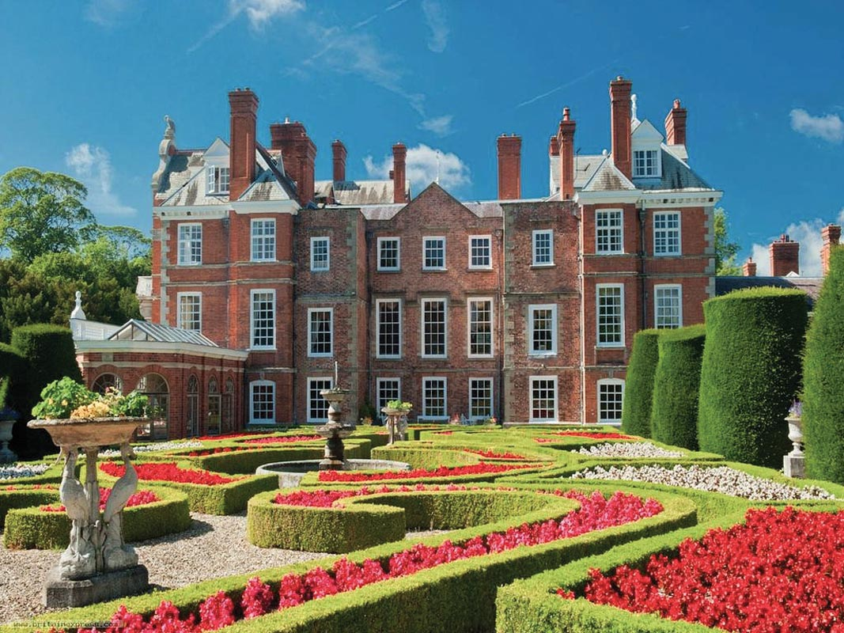
Figure 2: External photograph of Bodrhyddan Hall (Mitch, 2011)

Plas Newydd is a Grade I Listed Estate on Anglesey. The estate includes a country house, gardens, parklands, and woodlands. Plas Newydd has views over the Menai Strait and Snowdonia and has been owned by the National Trust since 1976.

Plas Newydd has been passed through the family ending with the 7th Marquess of Anglesey since 1470. In 1470, the site was bought by the Griffith family, who built the earliest elements of the current building in the early 16th Century. Later in the occupation, Lewys Bayly made the first large additions to the estate and named it Plas Newydd, meaning new manor (Lundy, 2019). Architects Joseph Potter and James Wyatt were appointed in the 18th Century and added an octagonal tower and the large Gothic stable block and refaced the building. In 1936-38, renowned artist Rex Whistler painted the largest canvas in the world which is a big draw to visitors of the site (National Trust, 2021).
When asked about the contributions of the property to the local area and community, a source from the property stated that Plas Newydd provides an attraction for tourists and the local population to enjoy the property, the history, and the outdoor space. It relies on local volunteers as room guides/visitor guides, providing a rich experience for young and old to give back to their community. It is preserving the history of a local family, building and ornaments (2020). Plas Newydd generates its income through admissions, annual memberships, fund raisers and guided tours.
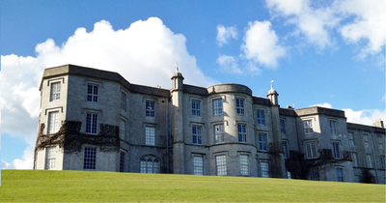
Figure 3: External photograph of Plas Newydd (Tomilsh, 2013)

Trevor Hall is a Grade I Listed Mansion in Llangollen, Denbighshire. The estate consists of 150 acres of gardens and woodlands. Owned by the Parker family, the estate doubles as rented space for private hire (Haycock, 2010).

The Trevor family owned the estate since medieval times and called for the building to be constructed for John Lloyd of Glanhavon who married heiress Mary Trevor in 1715 (britishlistedbuildings.co.uk, 1995). Over time, ownership of Trevor Hall has passed into new families. The Rice Thomas family extended the house in 1820, after which it was rented to tenants for a time including the High Sheriff of Denbighshire in 1892. Architect W.H. Spaull was employed by the sheriff to make improvements before it was sold to a local timber merchant who planned to demolish it. A Preservation Order saved the house in 1961 but just two years later the building caught fire and was reduced to a shell. In 1987, chartered surveyor Michael Tree bought the estate with the aim of restoring it. The Parker family purchased the original estate in 1998, including all 150 acres of land and still maintain it today (Haycock, 2010).

When asked about the contributions of the property to the local area and community, a source from the property stated that Trevor Hall entirely uses local staff and suppliers when the house is being rented out. This is their sole income generator; however, this generates a comparable income as other heritage sites due to the nature of the rentals (2020).
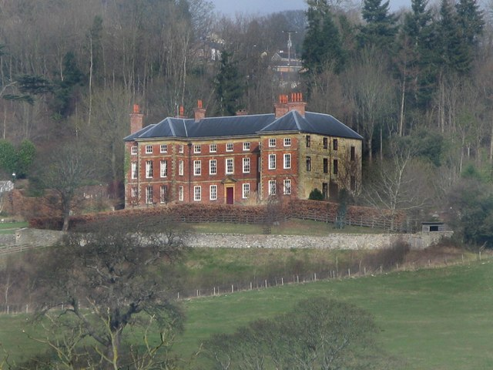
Figure 4: External photograph of Trevor Hall (Linnet, 2012)

Llanerchaeron is a Grade II* Listed mansion located on the River Aeron in Cardiganshire. Like most 17th Century estates of the period, Llanerchaeron consists of the main house, service courtyard, walled gardens, farm, and houses various collections.

In 1634, the estate was formally owned for the first time when it consisted of a farmhouse and 500 acres, including the first known formal garden in Wales (National Trust, 2021). In 1786, the owner of the estate, Colonel Lewis married the wealthy Corbetta Powell whose dowry paid for massive renovation works to the estate. London architect John Nash was employed and began his work on the transformation from farmhouse to villa. Nash went on to design the Royal Pavilion in Brighton and Buckingham Palace in London (Houghton, 2017). The Lewis family lived at Llanercharon until 1989 when it was left to the National Trust.

When asked about the contributions of the property to the local area and community, a source from the property stated that Llanerchaeron has always played a big part in the local community and this is part of their spirit of place and something they believe is important to the development and continuation of the property. They contribute to the local economy and introduce many people to the local history of the area. The National Trust’s purpose is to protect the nature, wildlife, land, and heritage, and this is done through providing access, education, and enjoyment, both to the people in the immediate local area, and those who come from further afield (2020). The income generation of the estate comes in many forms. They are a venue for school visits, weddings, local craft sellers, traditional tradesmen, seasonal fairs and sometimes, funerals. Education is also a very important part of their portfolio through children’s trails, talks and events (National Trust, 2020).
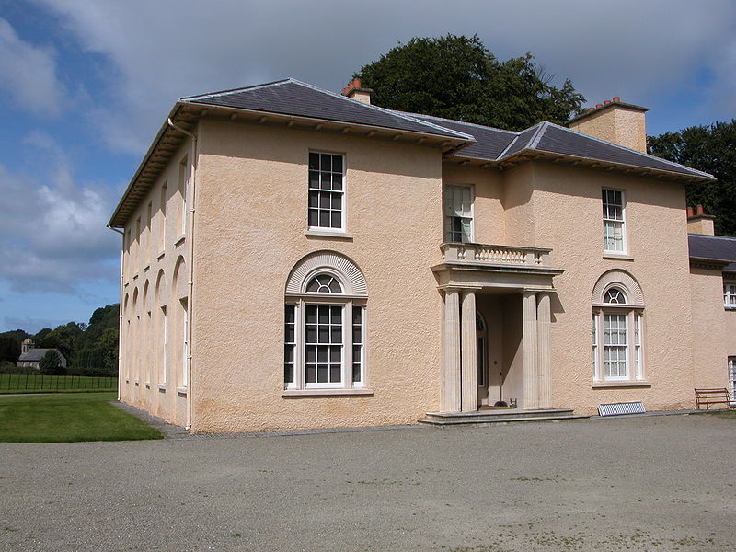
Figure 5: External photograph of Llanerchaeron, (Connelley, 2008)

Chapter 2: The implications of the listing system on renovations to Listed Buildings.

To make any sort of alterations to a Listed Building, from demolition to extension, the owner must be granted Listed Building Consent (LBC) from the local planning authority and the Department for Communities. This permission allows for agreed upon changes to be made to the building. In England and Wales, there is also a requirement to inform an amenity society if demolition is necessary, no matter how small (Secretary of State for Communities and Local Government, 2015). Once the application has been formally assessed and granted, it is then sent to Cadw for them to ensure that the planning authority has considered the preservation of the building enough for the application to be granted. If this is the case, the owners must then pay an LBC Fee which varies in amount depending on the size of the renovation proposal.

For any changes to be granted Listed Building Consent, the alterations must maintain the unique character of the original building and so, applicants are urged to retain or reinstate the original fabric and detail of the building and respect them wholly. This can be done by using like for like materials and the traditional methods of construction (Cadw, 2017). However, this can be a minefield in that using like for like fixings on, for example, a Victorian-dated window would be damaging to the historic character of that window which would not be allowed. Another example is using fresh paint throughout a room but there must be due care and attention to not remove any historic layers beneath. To find out the restrictions the building may be subject to, the Heritage List can be checked and the guide most relevant to the building chosen. These guides will include a generalised list of features that have not gained Listed Building Consent in the past and therefore gives the applicant an idea of what is allowed and what is not (Historic England, 2021).

It is important to note that if a building is Listed, the entire structure is protected, not just the façade. This complicates most proposals as it is a common misconception that the interior can be altered without permission. The same rules apply to any interior changes and so LBC would have to be granted before any interior alterations are made. However, if there are going to be alterations to the exterior, planning permission is required in addition to LBC (Khan, 2017).

It is not as simple as it seems to gain LBC, with there being multiple recorded issues with the system to Historic England through their Survey of Listed Building Commercial Occupiers (Lynch and Culliford, 2018). One of the main issues raised was that the entire process did not help the owners to make changes to the building without damaging the historic significant of it and so was perceived to be a waste of time and unnecessary. Another popular view was that the process was important, but it was excessively burdensome and that owners would reconsider applying to changes in the future due to this fact. It is important to note that it is a crime to undertake any sort of demolition or alterations to a Listed Building that will harm or change its historic significance or architectural flair without Listed Building Consent.

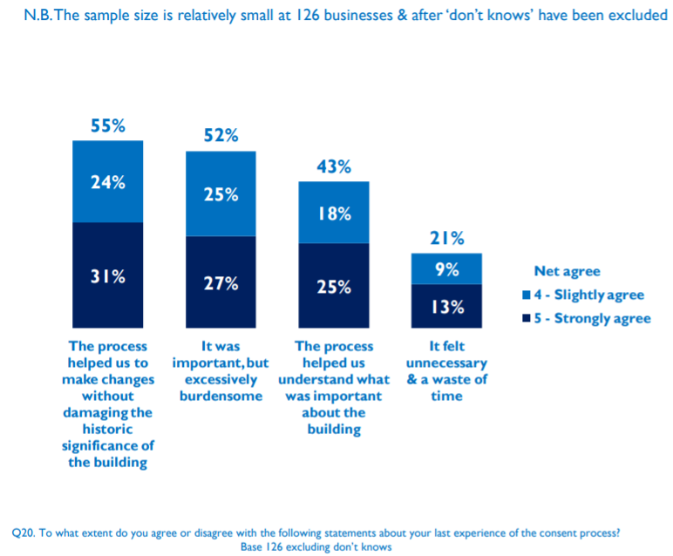
Figure 6: Chart showing responses to the question ‘To what extent do you agree or disagree with the following statements about your last experience of the consent process?’ – (Lynch and Culliford, 2018)

This survey also saw that these owners made several negative comments about the challenges of making changes to their building, with a few raising the issue of a lack of understanding and support from local authorities. In the graph above, the number above each response is the total percentage of respondents that agreed with the statements. As the graph shows, 52% of respondents agreed that the process is important but excessively burdensome which is a majority. There is also a 21% response that the process was unnecessary and a waster of time. There appears to be a perceived bias on the changes that are agreed upon through Listed Building Consent by Local Authorities in that they appear to be based on opinion as opposed to evidence based, objective research with justification to historic significance. This adds to the already confusing and complicated process and may discourage these people from reapplying for consent for changes. One representative from a Listed Office Building said:
“The issues as a listed building don't actually identify the features they are trying to protect as they are not specified anywhere. So, we get inconsistent decisions when applying for any changes and are at the whim of the listings officer who can be "Bloody minded" .eg. not allowed to change ordinary wooden skirting boards.”
The process itself can also be challenging in that since multiple people can be consulted, advice can be inconsistent which makes it difficult to understand why decisions have been made and how the owner should progress with the application for the best interest of the building and themselves. In addition to this, the forms and application notes use a great deal of technical vocabulary which many people find difficult to comprehend, as can be seen in the extract overleaf, taken from the Planning (Listed Buildings and Conservation Areas) Act 1990.

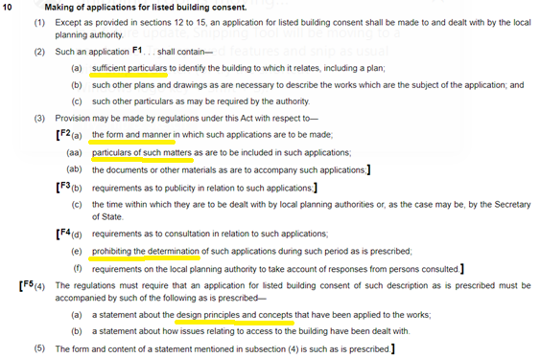
Figure 7: Extract from chapter 2, section 10 of the Planning (Listed Buildings and Conservation Areas) Act 1990.

Chapter 3: The zero-carbon initiative and its effects on Listed Estates

Earlier in 2021, Wales joined the rest of the UK in their bid to have net zero emissions by 2050. The UK agreed to this legally on the 27^{th of} June 2019 and it has become known as Net-Zero 2050 by the European Climate Foundation. There are currently 195 different countries in this agreement. Net-Zero 2050 is the initiative which guides the participant countries to accomplish the goals set out in the Paris Agreement 2015 to tackle climate change.

Climate change is the term coined for changes to the long-term conditions in any area over time. It considers temperature, rainfall, biodiversity, and plant growth. There has always been a slow change over time, but it has been found that in the past 150 years, the temperature of the planet has increased significantly quicker than expected. In the last 100 years, the global temperature as risen by two degrees Fahrenheit. This means that the amount of precipitation during storms increases as well as the intensity of heat waves and droughts.

Figure 8: Graph showing annual global temperature change since 1880 (NASA, 2021)

It is believed that the reason behind the warming of the earth is human interference as such activities as burning fossil fuels and driving vehicles are changing the earths atmospheric ‘greenhouse.’ This natural greenhouse is changing so that it traps more heat in the atmosphere and consequently, warms the planet.

The Greenhouse Effect begins with sunlight reaching the earth. Some of this is then reflected into space, whilst the rest is absorbed and re-radiated as heat. Most of this heat is absorbed by greenhouse gases and is reflected in all directions, warming the planet. The two main greenhouse gases are carbon dioxide and methane. Currently, carbon dioxide is responsible for 91% of global warming in the last 5 years and is created from human activities. Methane is responsible for 19% of global warming and is created by human activities such as rotting waste and water (May and Caron, 2021).

To slow down the rate of global warming to the levels laid out in the Paris Agreement 2015, Net-Zero 2050 must be adhered to. This initiative has been split up into different sectors to make its management more streamlined and to track the progress easier. These sectors are power, industry, transport, buildings, agriculture, forestry, land use and waste (Zenergi, 2020).

The sector that is relevant to this dissertation is Building and this is unfortunately the worst sector by far, with the recommended rate of uptake in the energy efficient measures being 20% higher than the industry is maintaining currently. The construction industry is accountable for 40% of the global greenhouse gas emissions through lighting and maintaining temperature in buildings as well as the construction of the buildings themselves.

The construction industry should be lowering the carbon footprint of the production of materials which can be done through using recyclable or combination materials. Using recyclable and combination materials will reduce the amount of landfill waste at the end of life as well as lowering the embodies carbon of the building itself. They can also consider the circular economy of their project in that most of the output can be recycled back into the usage or maintenance of the building. This would reduce the amount of landfill and therefore the amount of methane being released into the atmosphere.

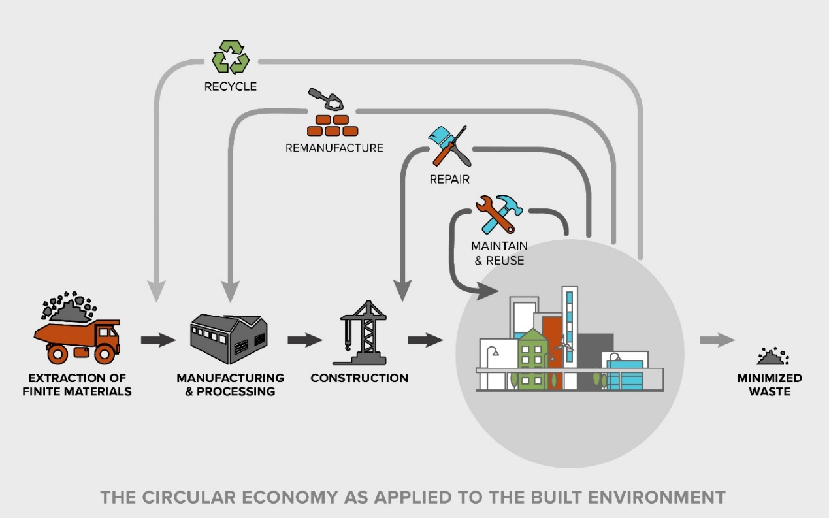
Figure 9: Circular economy and the built environment (Hickok Cole, 2018)

Finally, there can be a higher uptake of renewable, clean energy solutions in the design phases of construction to allow the building post-occupancy to be able to sustain itself through natural, renewable sources like solar power, wind, and ground source heating (Blohmke, Krick and Muller, 2021).

Despite Listed Buildings being protected, they are contributing to the statistics of this sector and so are not irrelevant when discussing it. Listed Buildings are technically exempt from adhering to the guidance set out in Part L of the Building Regulations since implementing the necessary changes would affect the historic significance and character of the buildings (Historic England, 2021). Despite this, Listed Buildings are encouraged to do as much as they reasonably and practically can without damaging this significance. This will not only have benefits to the environment, but also to the future of the sites themselves as it increases their viability (Pickles and McCaig, 2011).

There are many technologies that can be proposed and implemented that would have minimal to no negative effect on the character of the Listed Building. Edwards (2020) explained how this would have to be considered very clearly. He stated that to get the correct balance between employing sustainable technologies to historic buildings and preserving the historic value of them, you must look at them holistically and understand the building from its construction to its cultural importance and its energy strategy. If this approach is taken, the measures will be well considered, sustainable and well-co-ordinated. This would mean the cost would be lower and the time taken from start to end of the process would be shorter (McCaig, Pender and Pickles, 2018).

Listed Buildings need to be considered differently to modern buildings as there are several differences with regards to the holistic approach to energy planning. Historic buildings soak up moisture from the surrounding air and then release it depending on the conditions around them. They also heat and cool significantly slower than modern buildings, with their ability to do this being completely dependent on the external conditions. For example, if it is extremely cold outside, it will take a much longer time to warm inside than if it was warm outside. The external environment is extremely influential on the inside conditions. If the original construction materials and methods are not analysed adequately, there may become issues of damage to the external fabric, moisture gain and overheating (McCaig, Pender and Pickles, 2018). The diagram below considers the comparison of modern and traditional construction and their relationship with the surroundings.
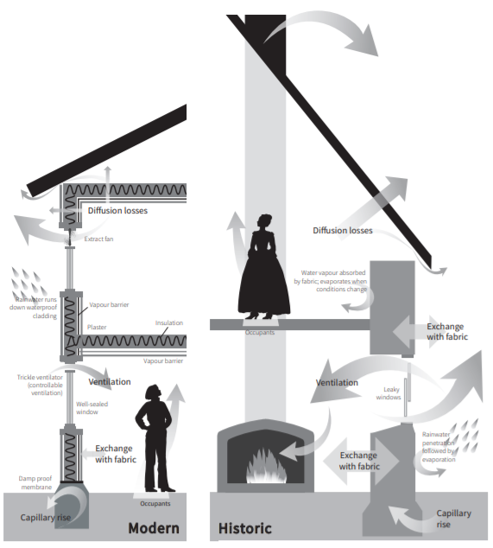
Figure 10: Diagram showing a comparison of modern and historic constructions and their thermal efficiency (Historic England, 2018)

As you can see, the analysis needed to be carried out for energy strategies differ greatly between modern and historic construction. This also means that historic and listed buildings will come up against different hurdles when trying to implement energy efficient strategies and technologies to their estates.

Chapter 4: The hurdles put before listed estates when considering sustainable technologies.

Throughout the whole process of making energy efficient changes to Listed Buildings, there needs to be special considerations that do not occur when doing the same thing for modern buildings. This paragraph will go through the process from start to finish and will focus on the processes that need to be considered exclusively when dealing with historic buildings. All the stages have been taken from the Energy Efficiency and Historic Buildings Report by McCaig, Pender and Pickles (2018).

The first stage is called Assessment. When assessing a Listed Building, the current state of the building, its constraints and potentials must be considered. This will include looking at the current energy consumption of the building and all the things that will affect the feasibility of the proposed changes. The more thorough this stage is conducted the better. This is because when the assessor has the most accurate information, the most suitable response can be considered and implemented without damaging the historical character of the building. It will also mean that the living environment inside the building will be as comfortable as possible. When assessing the character of the building, it must be considered how different interventions will affect it and a decision on strategy must be proportional to the important of the building. The Assessment stage must also include a survey of the external surroundings and the climate around the building itself. This is to analyse what measures would be best. For example, if one part of the façade is faced to frequent driving rain, it will be consistently wet. This would be helpful in indicating that insulating the affected wall will need to consider this. This would also be the case if it was very dry due to high exposure of direct sunlight.

Another aspect of the Assessment stage is the thermal performance of the external envelope of the building. This is determined by the moisture and air movement through the material and is affected by the size and construction of the walls themselves. Historic buildings are notoriously well known for being cold. However, is has been found that solid brick walls have U-Values that are one third lower than the published guidance (Pickles, 2012). This is evidence of the importance of the assessments of individual buildings’ thermal efficiency. To carry out this assessment, professionals will have to so air pressurisation tests and use infrared thermography to calculate surface temperatures and airtightness. Professionals will also have to carry out u-value measurements and co-heating tests, both of which are used to measure the heat transfer between internal and external environments.

The effectiveness of the existing building services will also be entered into the assessment. This will shed some light on how much energy is used in the building currently through analysing the heating systems, hot water supple, electricity consumption and their respective fuel sources. This leads nicely onto the final stage of assessment which is the energy usage relative to the occupation of the building. This can differ from building to building depending on the usage of the building itself. For example, residential buildings will use lots of water and electricity, however buildings for hire will only be used during rented hours and therefore will be comparably lower than the prior.

The second stage is called Objective Setting. This is where the information gathered in the assessment phase is considered in conjunction with the specific objectives of the owner of the building. This section is very important because it allows for the most feasible technologies to be considered and implemented with the least amount of conflict with the owner or planning departments. The initial consideration is the aim of the owner and their constraints. They may have a budget or an energy consumption baseline level in mind and so these will need to be discussed. There may be a certain goal for the owner, for example, reducing greenhouse emissions. These preferences are then put against the acceptable improvements that can be made to Listed Buildings to develop the most energy efficient technologies that fit the owners’ preferences. It is in this stage that the budget is set, and funding needs to be consolidated from whatever the source.

The next decisions to be made are the areas that need improving and developing a strategy on which order they will be tackled or if they will all be changed at the same time. The four areas are: building occupation, building fabric, engineering services and energy supply (McCaig, Pender and Pickles, 2018). These areas will be broken up into smaller sections, creating a checklist of things that need to be done. Each of these elements will need to be appraised to figure out their feasibility and to eliminate things that may not be beneficial to the overall objective of the project. An example of this evaluation is below.
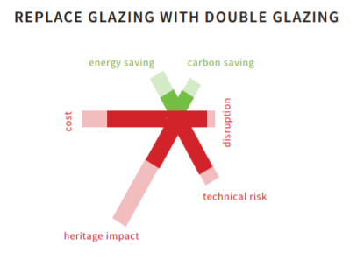
Figure 11: Example of cost/benefit analysis of replacing glazing with double glazing on a historic building (Historic England, 2018)

The third stage of the process is Detailed Design and Specification. This is where all the decisions to date are drawn up and specified. The larger and more complex projects will require these drawings as part of the applications for planning permission. These drawings will also be useful in obtaining approval under the Building Regulations.

Stage 4 is Installation and will go ahead when the permissions have all been obtained. All persons involved in this stage must be trained in carrying out the works on Listed Buildings.

The final stage, Stage 5 is the Use, Review and Maintenance of the building. Once all the changes have been made and the interventions installed, the occupiers of the building must be well informed on the performance and maintenance of them before the handover is complete. There must also be guidance issued to the owners about how the building itself should be managed with regards to ventilation, air flow etc. If the project is particularly complex, there should be guidance documents or manuals written to ensure no confusion occurs. At regular intervals after the handover, there should be regular checks on the works to ensure that they are performing as designed. Maintenance should be at the forefront of the owners’ minds as these could cost more in the long run if not maintained properly.

Chapter 5: Aims and expectations of the field research.

The surveys that were sent to the representatives of the case studies aimed to gather information on the facts and reality of running and maintaining Listed Buildings. The survey also aimed to delve into the reality of the support given to the estates through heritage bodies financially and theoretically. There are many claims made by heritage bodies about how they support the buildings in their care but how this is put into practice and how often this support is given is not so clear, and so the surveys aim to find out the reality.

The interviews that took place with Edwards, Jones and Sutton were used to gather more extensive information about their respective fields. The interview with Edwards, being the lead author of the British Standard for the conservation of historic buildings was included to provide knowledge on the practical and compliance issues when restoring historic buildings. His working knowledge expanded on the restrictions to and what this means to historic buildings.

Due to Jones’ experience within the National Trust and their climate change operations, his interview provided in-depth information on the workings of the heritage bodies and how decisions are made when discussing support for heritage sites and listed buildings. This interview contributed to a counterargument on behalf of the heritage bodies regarding the difficulties faced by buildings in their care and the support they are provided with.

Sutton’s involvement in Sero and the Welsh Government’s architectural programmes means that he understands the listing system and what these guidelines and regulations mean in practice. The guidelines and Welsh Government published documents are usually very difficult to understand and are extremely complicated and the interview with Sutton helped simplify them to be of use in this dissertation.

Evaluation and analysis of the results of the research

Analysis was conducted on all the responses received for this dissertation and the findings are divided into two:
- Views from professionals working in the field.
- Responses from the representatives of the case studies

Views from professionals working in the field.
Below comprises the areas of commonality in questioning between the three expert interviewees and their responses.

Firstly, the participants were all asked why the climate crisis is important to heritage bodies. Edwards (2021) commented on the need to mitigate risks to the country’s heritage in addition to the wellbeing of human life. Jones (2021) responded with the fact that climate poses the single biggest threat to the world. The buildings under their care’s essence, design and nature were created in a different climate and so their function and existence are under threat. Sutton (2021) said that “It should be important to these organisations on the basis that the listed buildings are on the same planet as the rest of us. Plus, Prometheus Modelling showing warmer, wetter climatic conditions to at least 2080, which will affect the material performance and maintenance requirements of buildings designed for a different climate.”

When discussing the barriers that prevent Listed Buildings from implementing sustainable strategies, Edwards (2021) responded that “the wrong expertise is deployed in making the case in the first place. A proper analysis of the degree of need, all alternatives together with the impact of significance needs to take place.” Jones (2021) answered the same question with “a lack of experience and knowledge within the teams as technologically there is no reason for prevention.” Sutton had a much broader view of the question with the response of “it comprises three main issues: technical knowledge of the sustainable technologies and how they can interact with traditional construction methods, conservative nature of sticking to the original skills approach conflicting with low or zero tech and the capital costs of measures to be put in place” (2021). It is believed by Sutton that there is not lack of will within these organisations, just complications and hurdles.

Throughout the interviews, the topic of support arose and when queried about what they believe should exist for listed buildings that is not already implemented by heritage bodies, each of the experts had differing viewpoints. Edwards (2021) responded implying that guidance does exist but advice on the process is also needed as well as good examples of successful interventions to act as positive reinforcement. Jones (2021) believes that there should be a greater network to be able to share the most up to date information on the subject, which is being developed within the Fit for The Future network. Sutton (2021) discussed this in depth, giving the impression that there is much that can be done to make this system easier for listed buildings. He believes that the teams within the buildings need the capital funding to be able to undertake the work – this might include contracting technical support if they do not already have it in-house to cover all aspects of low/zero carbon, as well as providing the funding to afford the retrofit measures themselves. It could be argued that an alternative would be to provide the financial, legal, and business forecasting to be able to quantify the capital cost requirements over a sufficiently long operational cost period.

As a final question to all interviewees, “The Welsh Government committed to the idea of 95% carbon reduction by 2050. Do you feel this should be applied or is relevant to Grade I listed buildings and why?” was asked. Edwards responded that he disagreed and that each building needs to be properly assessed to determine what can be safely achieved and that genuine expertise should be deployed when considering the technologies to be implemented (2021). Jones believes that there is no excuse as to why it should not apply to listed buildings as it can be achieved in terms of technology and sustainability. He also stated that the 95% carbon reduction should be 100% within the built environment (2021). Sutton failed to conclude on this question as his expertise is not within heritage sites and so did not feel he could answer honestly and fairly.

Responses from the representatives of the case studies
A series of questionnaires were sent out to representatives from each of the four case studies. These were aimed to find out first-hand what the realities of running and maintaining listed buildings is like and would allow this dissertation to conclude with practical considerations as well as theoretical. This section will go through each of the questions asked, the responses and analyse what this means to the dissertation thus far. The full questionnaire can be found in Appendix A for reference. The first question asked the participants how many people visited the estate on average in the last five years. The chart below shows the responses.
Figure 12: Bar graph showing the average annual visitor numbers at each case study in the last 5 years (Analysis of responses to Question 1 in Appendix A)

This graph shows that Plas Newydd had the most visitors with almost triple the amount of the next most popular, Llanerchaeron. Bodrhyddan Hall was extremely low with just over 11,000 and Trevor Hall did not have this information available as it is only for private hire and does not accommodate for individual members or visitors. This question has allowed for a proportional scope to be drawn when considering the other questions. The more visitors may mean that they would have larger budget due to entry fees or possibly a higher electrical and water output to accommodate all these members. This question means that the research following can be compared to the buildings size and demand and more accurate conclusions can be drawn.

The second question referenced the admissions charges or membership strategies were. This was asked to gain an insight into the income generated by attendance alone and will tie into further questions about the distribution of this income. The representative from Bodrhyddan Hall answered with a flat base rate of £5 per attendee, which when calculated against the previous question, gives them a generated income of £55,000 from admissions only. Llanerchaeron’s representative answered with a system of having £8 per adult and £21 for a family ticket of two adults and two children. As the researcher does not have the exact numbers on how many of each ticket was obtained, Llanerchaeron generated between £275,625 to £420,000 each year in admissions. Plas Newydd’s respondent answered with a tiered system of £8 per adult, £4 per child and £20 for a family ticket. Again, due to the lack of membership details, the admissions only income was between £20,000 and £750,000. Since Trevor Hall is for Private Hire only, they were not able to comment on their membership or attendance income. It is also important to note that the buildings under the control of the National Trust as subject to the National Trust Annual Membership which gives people access to all buildings and so this should be factored in and may influence the numbers slightly. This knowledge is very important as it will influence the budget that each estate has for sustainable technologies and may be the ultimate difference between survival and crumbling.

The third question was directed towards how each estate generates income for maintaining the building and land. Bodrhyddan Hall’s representative answered very vaguely with the answer “varied portfolio”, which after research has been found to include wedding and venue hire, guided tours, and rented accommodation. Llanerchaeron generates its maintenance income through its entry charges, commercial income through retail and rented accommodation as well as through events, grants, bequests, and donations. The team at Plas Newydd has disclosed that their income for maintenance comes from entry charges, fundraising, grants, donations and from selling the unused clean energy generated from their 50KW Solar Photovoltaic Panels on their land through the Domestic Renewable Heat Incentive. Trevor Hall generates its entire income from private hire of the whole estate for Weddings and Holidays.

The fourth question was asking each person if there was a working environmental management system in place. Bodrhyddan Hall and Trevor Hall’s respondents answered No and Llanerchaeron and Plas Newydd’s answered with Yes.
Figure 13: Graph depicting the energy management systems in place at the case studies (Analysis of responses to Question 4 in Appendix A)

This led to a follow up question for those that answered Yes, asking them to name the systems they have in place. Llanerchaeron is currently certified through the National Trust for ISO14001 (Full Environmental Management System) and Level 5 Green Dragon. This is very important information when drawing conclusions about the feasibility of sustainable technologies and historic buildings as well as allows a greater insight into the support available from heritage bodies for these structures.

Question Six was regarding the importance and relevance of sustainable development in Listed Buildings. The representative from Bodrhyddan Hall responded that if sustainable technologies can be implemented whilst not affecting the character of the buildings itself, then it should be encouraged completely. Llanerchaeron’s representative was very passionate about this question, saying that:
[Sustainable developments and listed buildings are] …” very important and relevant. Estates such as Llanerchaeron have always had to develop sustainable methods of living, working, and farming in order to survive, and this is no different today; the world may face different dangers, but we will continue to adapt, to change and to improve so that we can be here for everyone, for ever.”

This was further backed up by Plas Newydd, whose representative stated that:
“Sustainability and sustainable development is vital for our Grade 1 listed properties, to keep them viable in terms of control over running/maintenance costs and keeping the utilities and technologies within them up to date. Our environmental policy sets out how we will not only meet with all compliance obligations – both legal and voluntary – but how we will find ways to demonstrate achieving this in the context of a thriving business.”

However, the response from Trevor Hall was not so positive, as they believed that the current legal and planning requirements for a Listed House makes any development very difficult and expensive. They went on to say that this needs to change to ensure the survival of these houses. This information is very telling, as the two buildings that have no sustainable technologies or energy management systems in place are the ones with more pessimistic views on the feasibility of sustainable development in Listed Buildings. Yet those with these technologies and systems in place had very optimistic and passionate views on this.

When asked about any environmental or sustainability documents that have been produced by the estates, all the participants answered that they had not had any created. Those under National Trust control have blanket documents that are internal to the organisation that apply to them but nothing specific to the buildings.
Figure 14: Graph depicting the annual approximate expenditure for each case study (Analysis of responses to Question 8 in Appendix A)
Coming back to the topic of economic situation, the next question was directed towards the approximate annual expenditure for their estates in each year in the last five. This was to include repairs, heating, running and staff costs. The graph below documents the answers given.

Bodrhyddan Hall’s team disclosed that their expenditure was the highest at £450,000, with Llanerchaeron following with £300,000 and Trevor Hall halving this with £150,000. The representative from Plas Newydd was not able to comment on this question. This is, however, not proportional to the sizes and occupancy of the buildings, as Llanerchaeron was the most populous venue, yet does not require the highest amount of money for upkeep and maintenance costs. This could be due to the sustainable management systems that they have in place which are reducing their costs as they self-make a portion of their energy and so do not have the costs that come with this.

Following on from this question, the participants responded to the next question, asking what costs provided the biggest challenge when considering maintenance and upkeep of the estates. Bodrhyddan Hall’s representative stated that repairs and staffing were their biggest outgoings and were joined by Llanerchaeron’s which had the same answer. Plas Newydd’s teams answer differed slightly in that the largest outgoings are repairs, heating and cooling the building and Trevor Hall’s solely said repairs were the costliest. The chart below will show this information visually.

Figure15: Graph depicting the costs that present the biggest challenge in management of the case studies (Analysis of responses to Question 9 in Appendix A)

This is very telling in that historic buildings need regular maintenance and repairs to the fabric which is much more expensive than for modern buildings. This could be an area that can be improved on as these estates can implement sustainable strategies that may use like for like materials or stop the damage happening to the historic fabric through local government permissions. In the next question, the estates were asking if they currently have an Energy Performance Certification Rating and if so, what grade. However, they all responded with No and so no further information or analysis was required.

Figure 16: Graph depicting the EPC ratings of the case studies (Analysis of responses to Question 10 in Appendix A)

After discussing the current implementation of sustainable technologies, the participants were asked if there was a strategy planned for the building and estate with regards to sustainability or environmental technologies or programmes in the immediate future. Bodrhyddan Hall’s representative responded that they had plans for several solar panels across the estate, a medium sized hydro plant, ground source heating for some elements to the estate. They went on to establish that the team at Bodrhyddan Hall are always open to new projects. Llanerchaeron’s team answered that they are already working within the National Trust’s environmental sustainability strategy, and already have environmental technologies that have been introduced, such as biomass boilers, air source heating, solar panels, and energy efficient light bulbs, which are under constant review. The respondent from Plas Newydd disclosed that they have no immediate plans, except those to maintain and improve the technologies they already have in place. Trevor Hall’s representative failed to comment on this question. This was linked to another question about what had been implemented in the last five years at each of the estates. Bodrhyddan Hall have installed a hydro-plant at the former mill site on the estate, with the others stating that no work had been completed in the last five years. These answers allow a larger perspective on the last and future five years of the estates. This information shows a lack of urgency or ability to introduce sustainable technologies in a short time frame.

When asked about the annual expenditure on conservation as a percentage of the total expenditure of the property, Bodrhyddan Hall’s representative answered with 10%, Llanerchaeron’s answered with 22.7% and Trevor Hall’s answered with 0%. Plas Newydd was unable to answer this question. This statistic is shocking with reference to Trevor Hall and Bodrhyddan Hall. Despite having an allocation, this is not nearly enough consideration for something so important to the estates’ survival.

The final part of the survey was regarding the Welsh Government’s commitment to zero-carbon by 2050 and how this is perceived by Listed Buildings’ teams. Bodrhyddan Hall’s team commented that Listed Buildings contributing to this initiative would be extremely difficult, expensive, and unrealistic while retaining the character and historical aspects of the property. The participant from Llanerchaeron made the point that there are many ways of working with Listed Building Consent to future-proof Listed Buildings with regards to the climate emergency. Plas Newydd’s representative stated that due to the nature of Listed Buildings, achieving zero carbon within the property itself is unrealistic and that measures can be taken to reduce the carbon impact of these buildings. However, zero carbon is only able to be achieved through the organisation's ability to offset carbon and embedded carbon on land owned by our organisation elsewhere. Trevor Hall’s participant’s view was that they wish the zero-carbon initiative was relevant and could be aided by Listed Buildings but with the rules and restrictions of Listing, it is unlikely that this will occur.

These responses are very telling as to the perception of the ability of Listed Buildings to accommodate zero carbon initiatives and how restricted these estates feel when making these beneficial changes to their sites.

Finally, when asked how confident the representatives from each estate were that their site will meet this zero-carbon target by the given date, Bodrhyddan Hall and Trevor Hall’s respondents answered with Not at All Likely, whereas Plas Newydd and Llanerchaeron’s participants were much more positive voting it a 7 and 8 out of 10, respectively. The chart below represents this data. When discussing the reasoning behind their ratings, the representative from Bodrhyddan Hall repeated their response on the previous question about meeting the zero carbon targets. The participant from Llanerchaeron responded that their estate does not use much energy as much of their heating and electricity costs are covered by the income generated from the solar panel field. The only heating that they have comes from oil free electric heaters which are controlled by humidistats and only switch on if the humidity is high. Plas Newydd’s participant did not respond to this question and Trevor Hall’s teams answer was regarding planning permissions and restrictions placed on Listed Buildings.

Figure 17: Graph depicting the feasibility of the case studies in reaching NetZero2050 (Analysis of responses to Question 16 in Appendix A)

This concluded the questionnaire with the participants of the case studies chosen aptly in that they all have differing opinions and perceptions of the planning system and the feasibility of sustainable technologies in their futures as Listed Buildings. There is a divide, but this allows the researcher to gain knowledge from different perspectives and draw balanced conclusions without worry for biased or one-sided results.

Conclusion

The research that was undertaken as part of this dissertation has provided the author with invaluable information that has shaped the course of this piece of work. The initial research into the case studies cemented the justification for preserving Listed Buildings, with specific reference to the heritage of Wales and the architecture of the buildings themselves. Each of the case studies was different in design, history, and usage but they all have created their own identity and therefore have earned their place on the Protected Building List.

This has been taken on board and after research into the Listing system and the way it works, it is the opinion of the researcher that these buildings are adequately recognised. The Listing system itself, however, provides many obstacles for owners of Listed Buildings when they need to make renovations to their estates. The protections laid upon each property and the copious amounts of paperwork and permissions that managers and owners of these properties must submit before they can even begin making the approved changes seems to deter them from applying in the first place. It is a great shame that due to this complicated system, there are many estates out there with unapproved changes being made which could damage the heritage and authenticity of the architecture.

This could, in time, cause the buildings to lose their listed status and therefore their protection and possibly some funding. The research into Net-Zero 2050 and the background behind this initiative has highlighted the importance of the implementation of sustainable technologies wherever possible, including heritage sites. The difference in reducing the carbon footprint of the built environment sector would be invaluable to the prospects of the Net-Zero 2050 initiative and Wales’ contribution to it.

The interviews that took place with professionals allowed the researcher access to the organisations that protect heritage buildings and gain an insight into the realities of this subject from their perspectives. The findings were extremely informative as they all presented different perspectives about the topic.

Between the three professionals and the author, a well-rounded conclusion can be drawn with regards to the importance and feasibility if implementing sustainable technologies on heritage buildings. It is clear to see that finding a solution to the problem around this topic is important to all parties in the process and will ultimately benefit everybody if this is possible. It was very interesting to find that, from the inside, the biggest hurdles when considering changes to historic buildings were a lack of education on the part of the applicants and the wrong processes are usually assumed which gives the illusion of a complicated system.

After discussing with the professionals and doing some research, it is believed that there should be a greater availability of supportive documents in the language of the applicants rather than the policymakers. This would make the accessibility easier, and the uptake will be greater as the system will be streamlined to suit each applicant. Shockingly, when discussing the importance of including heritage buildings as a key contributor to the climate crisis and therefore needing to improve this, the interviews took a more controversial approach, which caused the author to consider the cost-benefit of this concept. It is believed that the benefits far outweigh the costs when applying for sustainable technologies in conjunction with heritage buildings. If there is no damage to the historically significant fabrics and systems, there is no justifiable reason to ignore the prospects of including heritage buildings in the initiative.

The case study questionnaires were extremely informative with regards to the reality and practical issues surrounding managing heritage sites. It is undeniable that Listed Buildings are not taking up the sustainable technologies as much as they could. This seems to be because of the hefty restrictions and complicated processes involved in doing so. It seems that there is certainly a want from the owners of these buildings to contribute to Net-Zero 2050, but this is not enough for them to implement them. There needs to be a change to the process that these owners must manoeuvre to make these beneficial changes to their estates.

This could be done through incentivising the installations or an allocation of advisors and support networks to these heritage buildings regularly. After analysing the surveys that took place, it is evident that the implementations of sustainable technologies can occur, as two of the case studies proved. However, this only seems possible for the larger properties that generate a significantly larger income and has support from the National Trust and other heritage organisations. There is certainly a need for some form of outreach to privately owned or smaller scale Listed Buildings from these heritage organisations to encourage and help them to participate in the process of improving the world in which we live.

It is believed that Wales can afford to continue to run and maintain Listed Estates in the era of climate change. This just needs to be considered over a much larger scale including heritage, environmental and economic. With regards to heritage, little needs doing besides a clearer and more concise breakdown of the valuable assets to each heritage building when considered for listing which will allow the owners to have a better idea of what can and cannot be done and what elements cannot be changed in any way. This will stop people from wasting their money and time applying for permissions that they will never get. The environment needs to be considered in a greater capacity in that owners of the buildings should be made aware of the contributions that their properties have on the Net-Zero 2050, be it positive or negative. This gives the owners accountability and could encourage them to make better decisions when considering this aspect of managing the building. With regards to economic aspects, there seems to be little issue with affording the installations themselves or maintaining them but incentivising this on a greater scale than already exists would significantly increase the uptake as there is no losing party.

The research process itself was not without its challenges. Not only due to the global Covid-19 pandemic, but due to the resources and data collected. It was obvious when analysing the results of the surveys and interviews that the questions could have delved deeper into personal experiences and encouraged more in depth and explanatory answers. This would have allowed the data collected to be compared alongside genuine scenarios to back up the claims made. There also could have been interviews with more professionals to gain perspectives that could have added another layer to this dissertation and filled in some gaps of knowledge.

Through the data collection and analysis, it was made clear that there is not enough commitment across the board to drive the initiative of implementing sustainable technologies to historic buildings. The National Trust has incorporated lots of strategies and systems in the buildings under their care, but this needs to be extended to owners of private estates and those under the care of other authorities.

The author would encourage others that are interested in this topic with greater resources to delve into each of these categories and to develop them further to create genuine solutions that can be implemented plausibly. There is not enough research on this topic area and this needs to change. This dissertation has been proof that this area is interesting and important to the future of the planet that we share.

Bibliography: Published Works

Almalki, S., (2016) ‘Integrating Quantitative and Qualitative Data in Mixed Methods Research--Challenges and Benefits’, Journal of Education and Learning, 5 (3).

Alshenqeeti, H., (2014) ‘Interviewing as a data collection method: critical review’. English linguistics research, 3 (1), pp.39-45.

Anon., (2021) ‘Listed Building Consent: a guide for applicants’, Gwynedd Council. Available at https://www.gwynedd.llyw.cymru/en/Residents/Documents-Residents/Planning-and-building-control/Listed-Building-Consent---a-Guide-for-Applicants.pdf (Accessed: 07 April 2021).

Blohmke, J., Krick, T. and Muller, M., (2021) ‘Putting the construction sector at the core of the climate change debate’, Deloitte Central Europe. Available at: https://www2.deloitte.com/ce/en/pages/real-estate/articles/putting-the-construction-sector-at-the-core-of-the-climate-change-debate.html (Accessed: 07 April 2021).

Bodrhyddan.co.uk, (2021) ‘Luxurious Events’, Clywd, Bodrhyddan. Available at: https://www.bodrhyddan.co.uk/ (Accessed: 22 February 2021).

Bonfield, P., (2016) ‘Each Home Counts – An Independent Review of Consumer Advice, Protection, Standard and Enforcement for Energy Efficiency and Renewable Energy’, Department for Business, Energy, and Industrial Strategy. Available at: https://assets.publishing.service.gov.uk/government/uploads/system/uploads/attachment_data/file/578749/Each_Home_Counts__December_2016_.pdf (Accessed: 28 December 2020).

British Standards Institution, (2013) ‘Guide to The Conservation of Historic Buildings’, BSI Standards Limited. Available at: https://benjiarchijourney.files.wordpress.com/2019/12/bs-7913-2013-guide-to-the-conservation-of-historic-buildings.pdf (Accessed: 28 December 2020).

British Standards Institution, (2019) ‘PAS 2035/2030:2019 Retrofitting Dwellings for Improved Energy Efficiency - Specification and Guidance’, British Standards Institution.

Britishlistedbuildings.co.uk, (1995) ‘Llanerchaeron, including rear Service Courtyard Ranges (previously listed as Llanaeron House)’, British Listed Buildings. Available at: https://britishlistedbuildings.co.uk/300010715-llanerchaeron-including-rear-service-courtyard-ranges-previously-listed-as-llanaeron-house-ciliau-aeron#.YDPQ6Oj7SMo (Accessed: 22 February 2021).

Britishlistedbuildings.co.uk, (1995) ‘Trevor Hall, Llangollen, Denbighshire’. British Listed Buildings. Available at: https://britishlistedbuildings.co.uk/300001350-trevor-hall-llangollen#.YD1ZHGj7SMo (Accessed: 01 March 2021).

Cabeza, L.F., de Gracia, A. and Pisello, A.L., (2018) ‘Integration of renewable technologies in historical and heritage buildings: A review’, Energy and Buildings, 177.

Cadw, (2011) Conservation Principles for The Sustainable Management of The Historic Environment in Wales. Cardiff: Welsh Government.

Cadw, (2017) Managing Changes to Listed Buildings in Wales. Cardiff: Cadw.

Cadw, (2017) Managing Listed Buildings at Risk in Wales. Cardiff: Cadw.

Cadw, (2019) Introducing Cadw. Cardiff: OGL.

Cadw, (2020) Our values | Cadw. Available at: https://cadw.gov.wales/about-us/what-we-do/our-values (Accessed: 22 February 2021).

Carrington, D. and Levett, C., (2019) ‘The climate crisis explained in 10 charts’, The Guardian. Available at: https://www.theguardian.com/environment/2019/sep/20/the-climate-crisis-explained-in-10-charts (Accessed: 07 April 2021).

Cassar, M., (2005) ‘Climate Change and The Historic Environment’, UCL Centre for Sustainable Heritage. London: University College London. Available at: https://discovery.ucl.ac.uk/id/eprint/2082/1/2082.pdf (Accessed: 08 January 2021).

Drewe, D., (2008) ‘Energy Conservation in Traditional Buildings’, English Heritage. Available at: https://www.rushcliffe.gov.uk/media/1rushcliffe/media/documents/pdf/planningandbuilding/planning/Energy%20efficiency%20and%20traditional%20buildings.pdf (Accessed: 07 April 2021).

Evans, M., (1996) Llanerchaeron, a tale of 10 generations 1634-1989. Ceredigion: Mair Lloyd Evans.

Foster, G., (2020) ‘Circular economy strategies for adaptive reuse of cultural heritage buildings to reduce environmental impacts. Resources, Conservation and Recycling, 152.

Fouseki, K. and Cassar, M., (2014) ‘Energy Efficiency in Heritage Buildings — Future Challenges and Research Needs’. The Historic Environment: Policy and Practice, 5 (2).

Griffiths, L., (2021) Written Statement: Wales’ pathway to achieve net zero emissions. Available at: https://gov.wales/written-statement-wales-long-term-emissions-reduction-pathway-2050-and-climate-change-committee (Accessed: 07 February 2021)

Haycock, J., (2010) ‘Trevor Hall's Georgian elegance - and 'showbiz bling', BBC North East Wales People & Places. Available at: http://news.bbc.co.uk/local/northeastwales/hi/people_and_places/newsid_8423000/8423351.stm (Accessed: 01 March 2021).

Historic England, (2020) ‘Enabling Development and Heritage Assets Historic Environment Good Practice Advice in Planning Note 4’, Historic England. Available at: https://historicengland.org.uk/images-books/publications/gpa4-enabling-development-heritage-assets/heag294-gpa4-enabling-development-and-heritage-assets/ (Accessed: 28 December 2020).

Historic England, (2021) ‘A Guide for Owners of Listed Buildings’, Historic England. Available at: https://historicengland.org.uk/images-books/publications/guide-for-owners-of-listed-buildings/guide-for-owners-listed-buildings/ (Accessed: 07 April 2021).

Historic England, (2021) ‘What are Listed Buildings? How England's historic buildings are protected’, Historic England. Available at: https://historicengland.org.uk/listing/what-is-designation/listed-buildings/ (Accessed: 22 February 2021).

Houghton, A., (2021) ‘Llanerchaeron’, Strolling Guides. Available at: https://strollingguides.co.uk/books/ceredigion/places/llanerchaeron.php (Accessed: 01 March 2021).

Institute of Historic Building Conservation, (2019) ‘Retrofitting of Traditional Buildings’, The Institute of Historic Building Conservation. Available at: https://ihbconline.co.uk/toolbox/docs/v5_Retrofitting%20in%20Traditional%20Buildings%20GN2019_5_v120919.pdf (Accessed: 28 December 2020).

Khan, S., (2017) ‘Everything you need to know about renovating a listed building’, Hiscox, 17 January. Available at: https://www.hiscox.co.uk/home-insurance/cover-stories/everything-need-know-renovating-listed-building/ (Accessed: 07 April 2021).

Knox, T., (2007) ‘Llanerchaeron, Ceredigion’, Country Life, Vol. 201, no. 28, 12 July, pp. 74-79.

Lloyd, T., Orbach, J. and Scourfield, R., (2006) The Buildings of Wales: Camarthenshire and Ceridigion. London: Yale University Press, pp. 512-515.

Lundy, D., (2019) ‘Person Page – 5342’, The Peerage. Available at: http://thepeerage.com/p5342.htm#i53412 (Accessed: 01 March 2021).

Lynch, N. and Culliford, G., (2018) ‘Listed Building Business Occupiers Survey 2018. 2’, Historic England. Available at: https://historicengland.org.uk/content/docs/research/listed-building-business-occupiers-survey-2018/ (Accessed: 07 April 2021).

May, E. and Caron, Z., (2021) ‘Global Warming for Dummies Cheat Sheet’, Dummies. Available at: https://www.dummies.com/education/science/environmental-science/global-warming-for-dummies-cheat-sheet/ (Accessed: 07 April 2021).

Ministry of Housing, Communities and Local Government, (2019) Research into Resistance to Moisture in Buildings Using Calculation Methods to Assess Surface And Interstitial Condensation. London: OGL.

Munarim, U. and Ghisi, E., (2016) ‘Environmental feasibility of heritage buildings rehabilitation’, Renewable and Sustainable Energy Reviews, 58, pp.235-249.

National Trust, (2019) ‘Annual Report 2018/19’, The National Trust. Swindon: National Trust. Available at: https://nt.global.ssl.fastly.net/documents/201819-annual-report.pdf (Accessed: 10 March 2021).

National Trust, (2021) ‘A family home for 10 generations’, The National Trust. Available at: https://www.nationaltrust.org.uk/llanerchaeron/features/a-family-home-for-10-generations (Accessed: 01 March 2021).

National Trust, (2021) ‘A talented young artist at Plas Newydd’, The National Trust. Available at: https://www.nationaltrust.org.uk/plas-newydd-country-house-and-gardens/features/a-talented-young-artist-at-plas-newydd (Accessed: 01 March 2021).

National Trust, (2021) ‘Grants and funding’, The National Trust. Available at: https://www.nationaltrust.org.uk/features/grants-and-funding (Accessed: 22 February 2021).

National Trust, (2021) ‘Llanerchaeron’, The National Trust. Available at: https://www.nationaltrust.org.uk/llanerchaeron?type=andview=map (Accessed: 22 February 2021).

National Trust, (2021) ’Plas Newydd House and Garden’, The National Trust. Available at: https://www.nationaltrust.org.uk/plas-newydd-house-and-garden (Accessed: 22 February 2021).

Pritchard, R., (2020) ‘Bodrhyddan Hall, near Rhuddlan’, History Points. Available at: https://historypoints.org/index.php?page=bodrhyddan-hall-near-rhuddlan (Accessed: 28 February 2021).

Secretary of State for Communities and Local Government, (2015) Arrangements for handling heritage applications – notification to Historic England and national amenity societies and the Secretary of State (England) Direction 2015. London.

Slattery, T., (2016) ‘Grade II Listed Building Regulations’, Hiscox. Available at: https://www.hiscox.co.uk/home-insurance/cover-stories/grade-ii-listed-building-regulations/ (Accessed: 07 April 2021).

Trevorhall.com, (2021) ‘History’, Trevor Hall. Available at: http://www.trevorhall.com/history/ (Accessed: 01 March 2021).

UK Government, (1990) Planning (Listed Buildings and Conservation Areas) Act. London: The Stationery Office Limited.

UK Government, (2016) Paris Agreement. London: OGL.

van Grieken, R., (2004) Cultural Heritage Conservation and Environmental Impact Assessment by Non-Destructive Testing and Micro-Analysis. Belgium: Taylor and Francis.

Visitwales.com, (2021) ‘Llanerchaeron’, VisitWales. Available at: https://www.visitwales.com/attraction/historic-house/llanerchaeron-829136 (Accessed: 01 March 2021).

Welsh Assembly Government, (2007) Heritage Protection for the 21st Century. Norwich: TSO (The Stationery Office). Available at: https://assets.publishing.service.gov.uk/government/uploads/system/uploads/attachment_data/file/78116/hrp_whitepaper_doc1.pdf (Accessed: 28 December 2020).

Welsh Government, (2018) Planning Policy Wales Technical Advice Note 24: The Historic Environment. London: OGL. Available at: pp. https://gov.wales/sites/default/files/publications/2018-09/tan24-historic-environment.pdf. (Accessed: 12 December 2020).

Whitear, H. and Duxbury, T., (2017) ‘Understanding Traditional Buildings’, The Tywi Centre. Available at: https://www.tywicentre.org.uk/media/1050/tywileaflet1-eng-final.pdf (Accessed: 22 February 2021).

Wise, F., Moncaster, A., Jones, D. and Dewberry, E., (2019) ‘Considering embodied energy and carbon in heritage buildings–a review’. IOP Conference Series: Earth and Environmental Science (Vol. 329, No. 1., September) IOP Publishing.

Zainal, Z., (2007) ‘Case study as a research method’, Jurnal Kemanusiaan, 5 (1).

Zenergi, (2020) ‘Ultimate Guide to Net-Zero Carbon Emissions 2050’, Zenergi. Available at: https://zenergi.co.uk/latest/the-ultimate-guide-to-net-zero-2050/#chap2 (Accessed: 07 April 2021).

Bibliography: Unpublished Works

Anonymous Source from Bodrhyddan Hall, (2020) Ella Curr Dissertation Questionnaire. Unpublished.

Anonymous Source from Llanerchaeron, (2020) Ella Curr Dissertation Questionnaire. Unpublished.

Anonymous Source from Plas Newydd, (2020) Ella Curr Dissertation Questionnaire. Unpublished.

Anonymous Source from Trevor Hall, (2020) Ella Curr Dissertation Questionnaire. Unpublished.

Edwards, J., (2021) Ella Curr Dissertation Questionnaire. 26 January 2021.

Edwards, J., (2020) Email to Ella Curr, 30 December 2020.

Edwards, J., (2020): ‘Raising Standards in Energy Efficiency Retrofit’, RSAW Annual Virtual Conference, 23 November 2020.

Evans, N., (1998) The Llanerchaeron Estate; The built environments, building descriptions and evaluations. Unpublished document, The National Trust.

Jones, K., (2020) Ella Curr Dissertation Questionnaire. 26 January 2021.
Jones, K., (2020) Email to Ella Curr, 02 November 2020.

Laidlaw, R., and Palmer C., (1998) Historic park and garden survey, Llanerchaeron. Unpublished document, National Trust.

Sutton, A., (2020) Ella Curr Dissertation Questionnaire. 22 January 2021.

Sutton, A., (2021) Email to Ella Curr, 22 January 2021.

Appendix A. Questions asked to case study property managers.

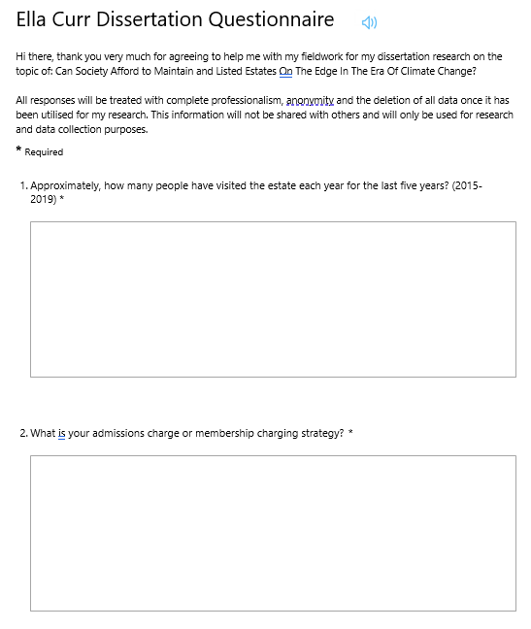

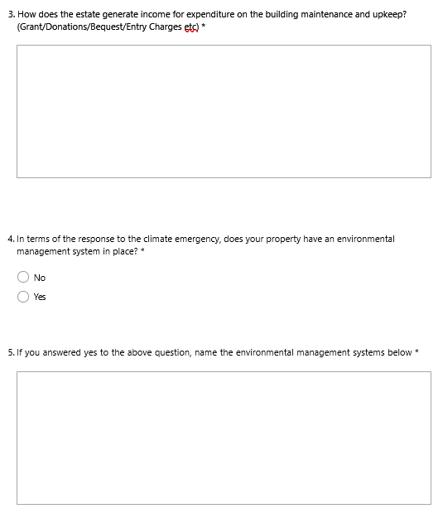

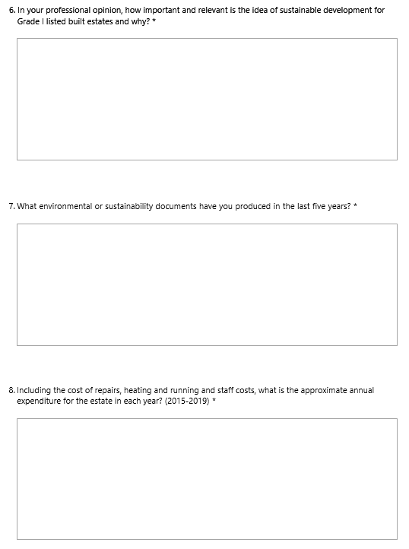
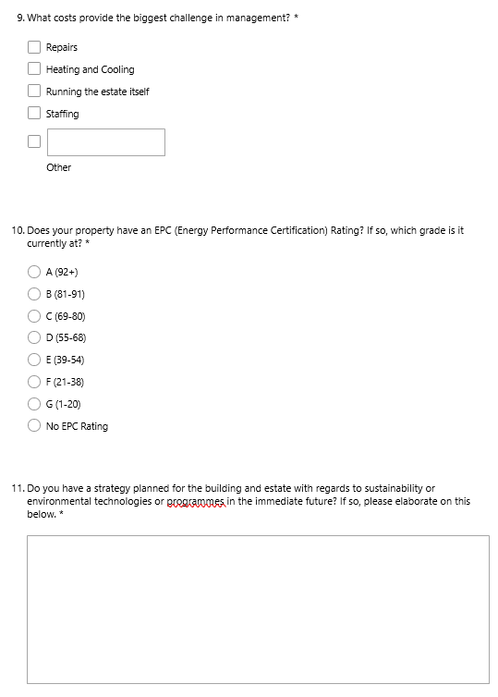
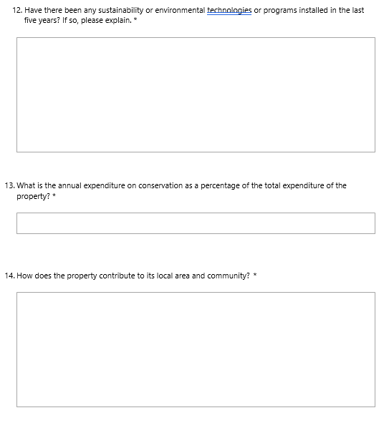
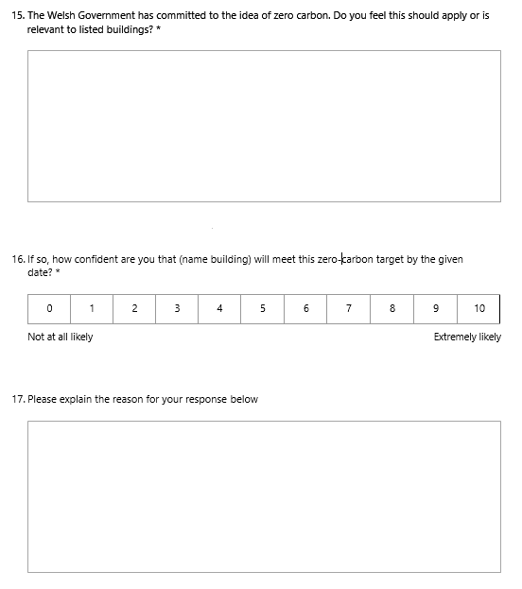

Appendix B. Questions asked to experts.
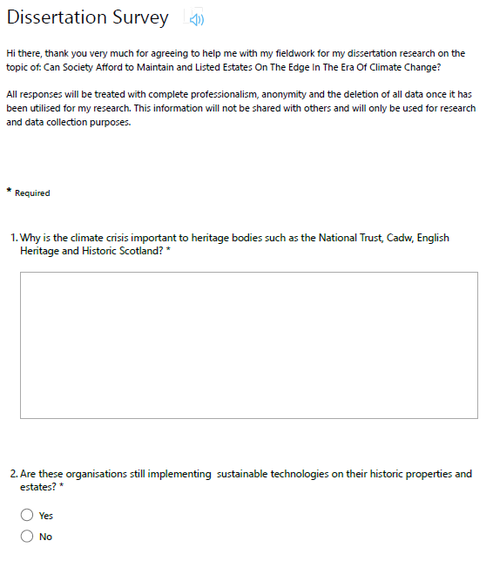



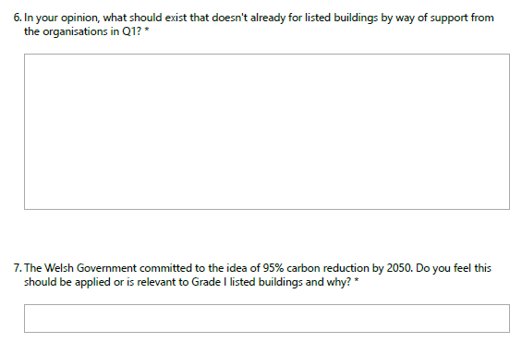

The Society of Architectural Historians of Great Britain brings together all those with an interest in the history of the built environment – academics, architects, heritage experts and the wider public. Initially conceived of as a chapter of the American Society of Architectural Historians, it was determined in 1956 that the British Society would be autonomous.
The Paris Agreement (2016) was agreed within the United Nations Framework Convention on Climate Change (UNFCCC) on climate change mitigation, adaptation and finance in Paris, France between 195 parties, including the UK.
A Preservation Order is an official order that makes it illegal for anyone to alter or destroy a building of historic interest.
ISO 14001 helps businesses of all sizes across all sectors make their day-to-day operations more sustainable. It provides guidance on how to consider multiple aspects of business procurement, storage, distribution, product development, manufacturing, etc.- so that it reduces its impact on the environment. It also helps businesses evaluate how they manage emergency response, customer expectations, stake holders and your relationships with the local community.
The Green Dragon Standard is split into 5 stages which allows organisations to gain a third-party certification that provides recognition of their environmental practices and demonstrates their commitments to sustainability, consideration of environmental impacts, compliance with legislation and environmental protection. Level 5 Green Dragon is a greater environmental commitment in respect to public reporting and carbon emissions than ISO14001.

