University of Wales Trinity Saint David (London Campus)
BA(Hons) Business Management
LCBB6000

DISSERTATION

THE IMPACT OF SOCIAL MEDIA ON THE BUYING BEHAVIOUR OF STUDENTS WITH REGARD TO IT PURCHASES

IRINA DORINA PRECUPET
STUDENT NUMBER: 1905216
SUBMISSION DATE: 05.09.2022
WORD COUNT: 6801
Acknowledgements

To begin with, I would like to acknowledge and give many thanks to my supervisor, Md Sadeque Imam Shaikh, for guiding me throughout the process of my work. I also want to send my sincere thanks to all my lecturers for their patience and guidance along the way, and to my colleagues who made the past years easier. My biggest appreciation goes to my family, for the emotional support and for understanding me for the duration of my studies and my research.

ABSTRACT

Currently, our lives are now shaped by the 21st century. This is an era made up of social media and various platforms like Twitter, WhatsApp, Instagram, YouTube, Telegram, etc. These domains are used by different people, especially students, to stay connected and in touch with one another. Apart from chatting with one another using these platforms, students usually share videos, photos, ideas, recommendations, or products they like. They share their views about the quality and price of certain products they bought from particular brands. This paper aims to investigate the impact of social media on buying behaviour of students with regards to IT Purchases. The study employed a quantitative strategy that focused on collecting data from a sample of 50 students across the university. A questionnaire that was well constructed and stated to be reliable and valid was used to collect data from the participants. The study’s outcome suggests that social media platforms like Twitter, WhatsApp, Instagram, YouTube, Telegram, and many others are highly effective in affecting the buying behaviours of students. This study result will help various businesses, marketing managers, bloggers, and marketers to adopt a strategy that uses social media to attract this growing young generation that is made up of students to buy their IT products and achieve their goals.

Keywords: Students, IT purchases, buying behaviour, social media.

Table of Contents

Chapter one: Introduction
1.1 Background to the Study………………………………………………………………………...5
1.2 Statement of the problem…………………………………………………………………..……7
1.3 Significance of the study…………………………………………………………………….…..7
1.4 Purpose of the study……………………………………………………….…………………….7
1.5 Objectives of the study……………………………………………………………………….….8
1.6 Research questions……………………………………………………………………………...8

Chapter two: Literature review
2.1 Introduction of chapter two……………………………………………………………………....9
2.2 Consumer Purchase Intention…………………………………………………………………11
2.3 Social media and consumer purchase intention……………………………………………..12
2.4 Social media as electronic word-of-mouth……………………………………………………12
2.5 Variations in student purchase decision behaviour………………………………………….13
2.6 Student buyer behaviour………………………………………………………………...……..13
2.7 The classical or traditional purchase model………………………………………………….14
2.8 Impact of social media on consumer decisions………………………………………...……16
2.9 Analysis of social media’s tools and techniques used for digital marketing………………16

Chapter three: Research methods and methodology
3.1 Research philosophy……………………………………………………………………………18
3.2 Research paradigm……………………………………………………………………………..18
3.3 Research approach……………………………………………………………………………..18
3.4 Research methodology…………………………………………………………………………19
3.5 Research strategy……………………………………………………………………………....19
3.6 Sampling methods………………………………………………………………………………19
3.7 Data collection methods/tools………………………………………………………………….19
3.8 Ways of interpreting data……………………………………………………………….………20
3.9 Time prospects of the research………………………………………………………………..20
3.10 Ethical considerations of the research………………………………………………………21

Chapter four: Conclusion…………………………………………………………………...……22

References…………………………………………………………………………………………..27

Appendix………………………………………………………………………………………...…..29

CHAPTER ONE

INTRODUCTION
Background to the Study

There is no secret that since the introduction of the internet and social media platforms, students worldwide have been allowed to use the platforms as a form of communication. These communications have led to business interactions that do not require the physical presence of anyone. To make matters even more interesting, the expansion of internet services has given these social media platforms a chance to act as a channel of central communications around the globe. Students have been able to connect to different online communities through the online world. There has been a massive growth of more than 15% in the social media community in relation to the entire world population (Baum, 2019).
This growth has presented students and various people alike with a communication channel that they can use to conduct their daily businesses. A social media tool or service refers to tools and services designed to facilitate direct communication among individuals over the Internet. They are usually web-based services that are composed of a network of connections. Social media is defined as platforms centred on various concepts regarding reading and writing web (Smith, 2009). This means that the users who use these platforms can view the content on these platforms and contribute to and share the contents they have. As an illustrative example, social media refers to anything that involves the Internet and allows for conversations, such as wikis, blogs, and social networking sites.

According to various studies, social networking sites and online communities can be used as effective web technologies that help share different information and social interactions (Gajashree, 2021). Various social media platforms such as Twitter, WhatsApp, Instagram, Youtube, and Telegram have helped students communicate amongst themselves and share different information such as videos, thoughts, comments, and images of the IT products they would like to purchase and use. The most important contribution that social media has made regarding the buying behaviour of students and their IT purchases is the way communication has been changed between the marketers or the sellers of the IT products and the students. Even though informational society has always been there to help students with their product evaluation and buying behaviours, social media has brought in more channels that provide more accessible ways of peer communication, thus sharing information.

Students nowadays usually have different sources of information traditionally given out by other student recommendations, which helps them evaluate the IT products they are buying (Gajashree, 2021). As part of marketing, the involvement of students through social media is crucial. We are living in an era where people connect through the Internet. Most students connect through the Internet instead of clicking-through face-to-face interactions worldwide.

In the last five years, according to a recent survey, there has been a 50% increase in social media usage, especially when it comes to students (Liu, 2020). Once a day, almost all university students use the Internet. Social media currently covers the whole world. A look back at the last decade reveals a dramatic increase in social media tools, particularly among students and their IT purchases as seen in chart one below (Liu, 2020).

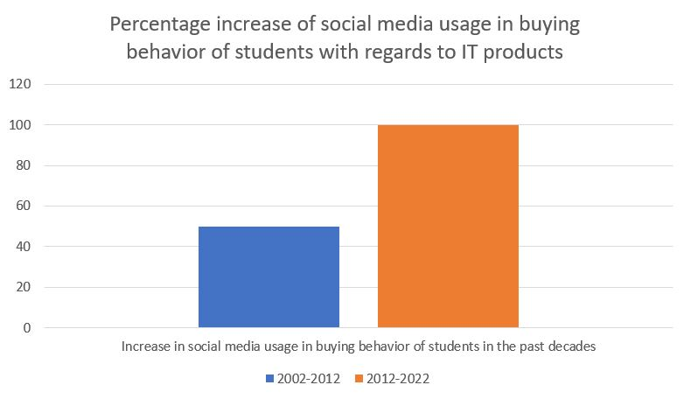

Chart 1: Percentage increase of social media usage in buying behaviour of students with regards to IT purchases

Various students use different channels such as Twitter, WhatsApp, Instagram, YouTube, and Telegram to connect and share videos and photos about new fashion trends, new changes regarding the laptops, phones, iPods, tablets, 2nd hands, latest models, etc. through social media, they get to share emotions, ideas, price, sentiments, quality, feelings, personal and professional opinions about the IT products that they have. Social media usually has a significant influence on the purchase decisions that these students make when they purchase their IT products.

In the past, when there were no social media platforms, students used to share information about IT products they would love to purchase with relatives, friends and neighbours (Liu, 2020). However, this has dramatically changed, and they are becoming more aware of the IT products they want through various social media platforms that are being invented. Many ads are shown simultaneously when watching music and videos on Youtube, Twitter, WhatsApp, Telegram, and various social media platforms. This helps make students more aware of the different types of IT products in the market. To be more precise, we can say that they make purchase decisions based on this process. As students compare the new or second-hand products on these social media platforms, they choose the one that best meets their needs. To understand what impact social media has on the buying behaviour of students with regard to IT Purchases, a quantitative study was conducted to find out the relationship between the two variables.

Statement of the Problem

Due to the introduction of the Internet and social media platforms like Twitter, WhatsApp, Instagram, YouTube, and Telegram, the buying behaviours of students with regard to IT Purchases all over the world have changed (Gajashree, 2021). These changes have led to various impacts, like changing how various students approach their decision making when buying their IT products. The promotional focus of companies that sell IT products like laptops, phones, iPods, tablets, and 2nd hand latest models has also changed dramatically and has shifted from a mass media approach that was more conventional to a digital and online approach. One of the digital platforms that many businesses use to market their IT products is social media (Gajashree, 2021). However, even though social media marketing is growing fast across the global marketplace, various studies have questioned how effective it is as a market tool in influencing student buying behaviour with regard to IT purchases (Bilal, 2014). Because of this background, this study needs to be carried out to evaluate the impact social media has on the buying behaviour of students regarding IT Purchases.

Significance of the Study

This study will be useful to business organisation management since it demonstrates the value of interacting with students on social media to persuade them of the superiority of their offerings. This is also important to industries because it gives them a better understanding of how social media platforms may be used for marketing and to gain the trust of customers to increase their likelihood of making purchases. Brand loyalty and profitability will consequently rise. The government can also gain knowledge from this research regarding the necessity of regulatory agencies that keep an eye out for unethical behaviour in online practice and take appropriate action to combat it. This study will assist the government in finding solutions to the problem of organisations selling false, subpar, and corrupted IT products online. The study will help numerous students comprehend how social media might affect their purchasing decisions when they buy IT products, which will benefit society as a whole. Thewill be able to use the study to determine the best media to use in order to make better purchasing selections. This study will also make it clear how important it is to take utility into account before buying IT products.

Purpose of the research

Future student cohorts’ ability to make wise decisions is the goal of this research. Finding the best IT products to use has become more difficult as a result of the expanding trends in IT products. The majority of students struggle with this issue and need help. The study, which assesses the influence that social media might have when looking for information on IT goods, focuses on the expanding tendency on social media platforms. Students may find this to be more convenient and so be better able to choose their IT purchases.

Objectives of the Study

This study’s primary objective, first and foremost, is to investigate the impact of social media on student buying behaviour with regard to IT Purchases. However, other specific objectives exist, and they include:
- Study the impact of social media channels on the buying patterns of students;
- Find out the relationship between social media awareness and referrals of students with regard to IT purchases;
- Find out social media communication impact on buying behaviour of students with regard to IT Purchases.

Research questions

The study will also seek to answer the following questions:
- What is the impact of social media channels on the buying patterns of students?
- What relationship exists between social media awareness and referrals of students with regards to IT purchases?
- What impact has social media communication caused on buying behaviour of students with regard to IT Purchases?

CHAPTER TWO

LITERATURE REVIEW

Over the years, there have been many investigations carried out by different scholars to determine what impact social media has on the buying behaviour of students with regard to their IT purchases. While buying a particular IT product, social media has proved that it can be a detrimental factor in the buying decisions of students. So many students depend heavily on social media to the extent that they cannot make any decision without looking at what other people have to say about what they want to do on social media. Almost every student worldwide has a smartphone or access to the internet in the 21st century. As much as social media plays are becoming a growing trend worldwide, there are various perceptions from different studies of the past about its effect on buying behaviour of students with regard to their IT purchases.

Social media is defined as applications or websites that offer social networking services to various users, thus allowing them to share or create content (Xiang, 2011). Similarly, studies reiterate and suggest that social media is the use of internet-based media which enables various people to get involved in multiple activities such as comparing, marketing, rating, selling, sharing, and buying different products and services from both online and offline market environments (Chu, 2013).

A further clarification can be made in relation to the platforms that social media relies on (Alawan, 2018). The study states that social media networking sites include the likes of Reddit, Twitter, WhatsApp, Instagram, YouTube, Telegram, and many more. However, the study also has emails, blogging sites, and chat rooms as platforms that students use to converse with one another.

In the year 2017, almost one in three students were using social media platforms to exchange ideas on which IT products to buy worldwide (Gutierrez, 2017). That is a number close to 50 million students. Four years later, other studies suggested that the number of students using social media had significantly outnumbered 50 million students ( Gashi, 2021). This shows that the number of students using social media to buy their IT products has increased dramatically over the last few years. The chart two below illustrates this significant change.
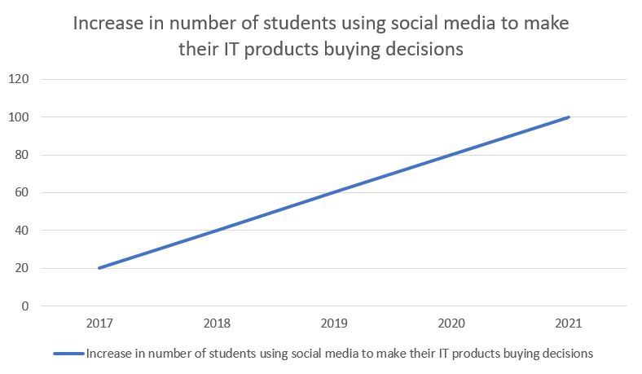
Chart 2: increase in number of students using social media to make their IT products buying decisions

Additionally, other studies indicated that social media usage by students to buy their IT products was projected to grow further by 10% every year (Voramontri, 2019). Amongst students, the majority of social media users were students from universities. However, other studies found out that younger students from high schools also used social media to evaluate what IT products they could buy (Armstrong, 2014). The study found out that even though students between the age of 18-30 years were the ones who were more subscribed to social media also, younger students between the ages of 12-17 used social media to analyse various IT products that they wanted their parents to buy for them or by themselves. The percentage difference can be seen in chart three below. The association between age and social media usage in relation to buying IT products was also analysed (Godey, 2016). It was concluded that a significant difference existed amongst age categories and that each age category varied in relation to social media usage in buying IT products.

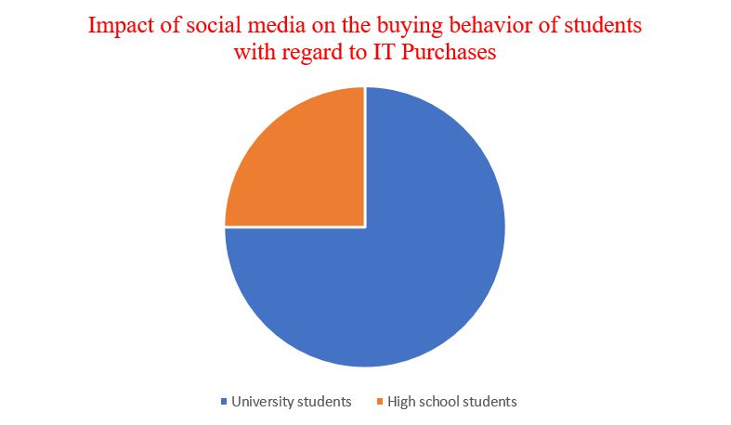
Chart 3: Impact of social media on the buying behaviour of students with regards to IT purchases

Another fascinating aspect of social media users regarding student buying behaviour comes in the part of gender relations (Godey, 2016). Literature in this area is a little bit filled with contradictory findings. Studies have found that there is no evidence supported by proven data showing that gender affects social media usage (Mangold, 2009). This notion was shared by a study which suggested that both female and male student usage was the same on social media for IT purchases (Geetha, 2018). However, a different study found out that the male students were more active on social media, conversing and sharing ideas about the IT products they would spend their money on, compared to the female students (Balakrishnan, 2014). Other studies also agreed upon this notion (Makudza, 2020).

Consumer Purchase Intention

Consumer purchase intention can be described as the willingness of a person to purchase a particular product or service. The purchasing intention can be an essential tool for knowing what they want. It shows the likelihood of a particular behaviour being performed by the student. According to the theory of planned behaviour and the theory of reasoned action, an individual’s behaviour is usually predicted by their intentions to perform the behaviour (Putter, 2017). Various studies support this notion by suggesting that behavioural intentions generally help to predict the actual usage behaviour (Kimmel, 2014). A review done by previous studies to measure an association between usage behaviour and behavioural intention revealed a straight association between the two variables. It was thus noted that organisations could use this to improve their performance in selling their IT products. They can do this by focusing on developing clear and positive student purchase intentions.

Social Media and Consumer Purchase Intention

In recent years, the growing trend of social media has proved to be the new tool for various businesses to make their IT products and influence consumer purchase intention. According to previous studies, the dynamics of student buying behaviour have been changed by social media since it has shortened their buying processes. It has made things easier for them, especially when evaluating which IT products to buy and whom to buy them from. When it comes to the consumer buying process, this process is sequential that elaborates on how consumers move from one stage of buying to the other. They include recognition of need, searching for information, and evaluating the available alternatives then the final process, which is purchasing. Thus, studies suggest that this process has been reduced through social media marketing because various consumers, including students who buy IT products, can skip other steps and develop an intention to buy, which leads to purchase behaviour (Kimmel, 2014).

Social media has enriched the information to which students are exposed. It has improved the second stage of the consumer buying process, which is searching for information. Searching for information about a particular product for students is now more accessible compared to when the times media was not available. Social media is currently acting as a highway where plenty of information about all types of products can be found.

Studies suggest that student purchase intention is also driven by influences from other students on the social networks they converse in. This is through the social media platforms that have been named above in this study that enable peer and group shopping (Powers, 2012). This means that through reference group effects and opinion leadership, this is how social media shapes the student purchase intentions. Because students usually have this natural tendency of wanting to belong somewhere, they thus tend to buy what their fellow students are buying. In actual fact, studies found a statistically significant association between student buying intentions and social media.

Social media as electronic word-of-mouth

The internet has revitalised the concept of word of mouth, which was introduced in the 1950s (Powers, 2012). According to previous studies, word of mouth can be described as a communication between a communicator and a receiver in person, in which sense the receiver perceives the communicator as non-commercial regarding service, brand, or product. In many instances, the primary source of information has always been words of mouth, which influences how students perceive the products they are buying, shapes their attitude, and affects their decision-making process. This thus involves all the phases of consumer decision-making. In today’s world, word of mouth has grown in a significant way due to the ability of people to connect through social media. Nowadays, it is called electronic word of mouth. According to previous studies, this is a form of word of mouth where people share ideas, perceptions, and reviews of products and services online (Armstrong, 2014). There are so many ways that electronic word of mouth can be conveyed. This can either be through e-commerce sites, social media platforms, or comment sections. Content usually generated by any internet user, especially students regarded as consumers, is generally perceived as independent of any commercial content. This kind of trust is the one that makes student consumers go to various social media platforms to gather the information that they need to make a purchasing decision (Powers, 2012).

Variations in student purchase decision behaviour

The buying behaviour of students when it comes to IT purchases can be classified into two samples as seen from table 1 below. That is high or low consumer involvement and significant and few brand differences.

Table 1 Types of student purchase behaviour

Purchase behaviour | Characteristics | Examples
Complex buying | High consumer involvement  Significant brand differences  Expensive  Infrequent  High risk | MacBook’s  iPhone
Dissonance-reducing | High consumer involvement  Few brands difference  Expensive  Infrequent  High risk  Price sensitive | Samsung phones
Habitual buying | Low customer involvement  Little brand difference  Frequent or repeat purchases | Local Phones
Variety-seeking buying | Low customer involvement  Significant brand differences  Brand switching for variety | Second hand  IT products

As seen from the above table, information gathering and evaluating product choices play a more significant role in complex buying because the risk involved is higher. This, however, differs from the dissonance-reducing behaviour because of the considerable differences in the IT brands involved, which would have the consumer students pass through all the stages of the decision-making process. Thus, the main focus of this research paper was on complex buying situations of IT products whereby social media plays an integral role.

Student buyer behaviour

In relation to the purpose of the research, different ways can be used to model student buyer behaviour with regard to their IT purchases. However, the best model to use is the decision process approach that studies events that come and follow purchasing, thus explaining what caused the decision. Previous studies define the student decision-making model as a behaviour pattern that students usually have which come before and follow the purchasing decision process of acquiring a product that would satisfy their needs (Powers, 2012). Over the years, there has been a different range of student consumer models, whereby one of the simplest has been the economic model. In this model, the student consumers spend the minimum amounts by following the principle of maximum utility to achieve maximum gains. The other model is the psychological model, grounded on Maslow’s hierarchy of needs theory. In this model, student buying behaviour is perceived to be motivated by their most robust needs.

The classical or traditional purchase model

According to the classical or traditional purchase model, there are five decision stages that most consumers, especially students, follow when making purchasing decisions of the products they are buying and, in the case of this study, IT products (Godey, 2016). These stages include needing recognition, information search, alternative evaluation, purchase decision, and, last but not least, post-purchase behaviour. According to various studies, this is the best model to measure consumer behaviour, and in this study’s case, student purchasing behaviour in relation to their IT products (Godey, 2016). Figure 1 below represents the classical or traditional purchase model.

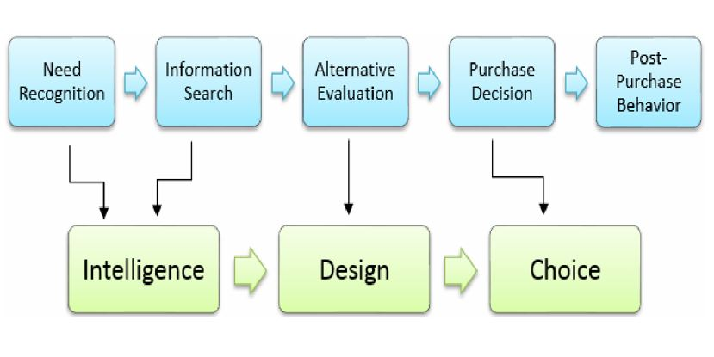

Stage 1 - need recognition

In the first stage of the buyer decision process, in this case, students need recognition is usually the first process. Certain factors typically make students recognize that there is a difference between the current state in relation to the IT products they have and the state they want to be in (Armstrong, 2014). Such factors include things like advertisements (Armstrong, 2014). These factors usually trigger students’ purchasing decisions, and it is usually the instigator of all purchasing decisions that they make. It is also the beginning of everything students will do in the future, including information search, evaluation, and purchase. There are so many individual characteristics also that may influence the choices that establish a need for investment. Due to so many complicated factors, this stage cannot be considered for this study since it is very different from the other stages.

Stage 2 -information search

After they need recognition, consumers, who are students, usually undertake a search to evaluate if there are enough options that can help them make a choice. Suppose they do not have enough internal knowledge about the IT product they want to purchase (Godey, 2016). In that case, this forces them to consider external alternatives for knowledge and information about the IT product. When it comes to the complex buying of things such as MacBooks or iPhones, this would require an intensive search. When it comes to external searches, these are usually undertaken through private sources like family members and friends, commercials from advertisements, and social media sources such as Twitter, WhatsApp, Instagram, YouTube, and Telegram. There are also user reviews that help students make better product assessments, and these usually come from websites like TripAdvisor and Amazon. Until there is sufficient information about the quality of the IT product being searched for, the search tends to continue. However, it can be constrained if there is enough information available. However, if there is low availability of information, this limits students’ decision-making process with regard to their IT purchases. Social media thus adds a new element that can be used to evaluate information about certain IT products, and its influence forms the primary basis of this research paper.

Stage 3- evaluation of alternatives

Studies suggest when information is collected, the consumers, in this case, students, start to process the alternatives they have in relation to which IT products they can choose and decide to buy (Putter, 2017). Even though presented separately, information search stages and alternative evaluation are usually entwined when decision-making. Thus, this forces consumers, who are students, to move back and forth between the two. Evaluating alternative options involves selecting the best alternative and evaluating it against the selected criteria. The performance of the other options is compared based on the salient factor, and finally, decision rules are applied to narrow down the possibilities. Purchase decisions are made based on intentions, attitudes, and beliefs in the subsequent stage.

Stage 4 - purchase decision

When it comes to this stage, this is the final choice that consumer or, in this case, a student makes with regards to which IT products they are going to buy. This stage is where the students decide on what IT product they would buy, where they want to buy it from, and the price they would pay for it. When it comes to purchasing, it is usually a factor made up of various variables like individual situations, environmental influences, and function of intentions (Putter, 2017). The things that can influence the purchase action include the availability of information, the time available for decision making, and the retail environment. The attitudes of friends and family toward a specific IT product can also influence a student’s purchasing decision that forces a re-evaluation of the product.

Stage 5 - post-purchase behaviour

After purchasing the product, consumers, or in this case, students, usually evaluate its performance based on their expectations and either feel satisfied or dissatisfied. According to the expectation confirmation theory, post-purchase satisfaction can be defined as a function that involves perceived performances, expectations, and confirmation of beliefs (Voramontri, 2019). In some moments, students who make purchase decisions usually feel doubt about whether they made the right decision to purchase the IT product or not. In this case, the consumer feels dissonance and searches for supporting information to reduce it, either by consoling themselves that their choices were wise or by concluding that they made the wrong decisions. As a result of their experiences during all stages of the purchase process, consumers’ satisfaction depends on their experiences during each step of the process. Studies on consumer satisfaction often ignore satisfaction with the decision-making process, focusing solely on satisfaction with the final choice and the outcome. However, there are different underlying dimensions from both concepts, which eventually significantly impact consumers’ overall satisfaction or, in this case, students. This is why it is essential to analyse the whole process of decision-making.

Impact of social media on consumer decisions (advantages and disadvantages)

There have been many studies that have been carried out by different authors on the impact of social media on consumer behaviour but not most of the studies have focused on the view of its effect on student decision buying process with regards to their IT purchases (Alalwan, ). Many students use various social media platforms to access information immediately, thus making it convenient for them. This helps them decide what IT product to buy, where to buy it, and at what price. Studies have shown that online student reviews have a causal impact on the student’s IT product choice and purchase behaviour (Mangold, 2009).

Studies show that social media has brought about a culture that enables various students to participate in information sharing with other like-minded students. Student purchase intentions are positively influenced by the perceived informativeness and quantity of product reviews online. Many students perceive social media to be a more trustworthy source of information regarding IT products than corporate advertisements.

However, previous studies suggest that there is a certain feeling of information overload on social media websites, making it hard for various students to decide what IT products to buy. It has become difficult for students to navigate all the information available on social media because of the sheer amount. Because of bounded rationality, students are limited in their ability to process information, and it is impossible to evaluate all alternatives in depth.

Analysis of social media’s tools and techniques used for digital marketing

According to studies from Liu et al., (2020), various social media tools and techniques are used for digital marketing. Some of these tools are used for engagement, listening and many more. Studies from Armstrong et al., (2014) support this notion by suggesting that social media engagement tools are the nucleus of brands’ efficiency, responsiveness and visibility. Every time there is a consistent and instant interaction between the brand and the customer on social media, this builds loyalty. These studies suggest that companies should seek review management systems that act as collaborative tools for tagging, task management and customer comments. Companies can create a seamless user experience on the front end of their customer messages organised in the backend. Social media engagement tools can help an organisation streamline the message flow between all platforms and profiles. Studies from Kimmel (2014) agree with this statement by suggesting that the tools can help a company be on alert whenever consumers are researching their products.

Other studies suggest that social media tools and techniques can be used for digital marketing through listening (Godey et al., 2016). The study suggests that analysing and responding to insights collected by social monitoring is possible with social media listening tools, which offer more advanced features. These tools work together to help a company improve its brand’s health and meet higher customers expectations. Studies from Bilal et al. (2014) support this notion by suggesting that social media listening tools can show a company the general sentiments of consumers about their brands. This is completely useful, especially when it comes to IT brands. Listening to what the consumers are saying about their IT brands can help them make changes and innovations that can further attract more consumers.

CHAPTER THREE

RESEARCH METHODS AND METHODOLOGY

Research philosophy

Every study often has a specific underlying philosophical premise that serves as its foundation. This relates to the factors that provide a study its credibility and the appropriate research techniques that will be employed to establish the information in the study. The purpose of this study paper was to investigate how social media has affected students’ IT purchase behaviour. The relationship between the two variables was ascertained through the use of an interpretive philosophy. Researchers attempt to analyse the study’s components when it comes to interpretive philosophy (Migiro, 2011). This implies that the investigation takes into account human interests. For instance, social media opinions or evaluations will have a greater impact on student purchasing decisions for IT purchases than firm ads for the IT product. With regard to interpretivist philosophy, there is no way to discover new knowledge. (Migiro, 2011). This implies that theories are evaluated according to how fascinating the researcher finds them. Here, it is proposed that acts of interpretation are what give meaning and knowledge. As a result, thinking is necessary for objective knowledge. This study’s broad breadth was made possible by an interpretive philosophy, which allowed it to access the pertinent problem of how social media affects students’ purchasing decisions for IT equipment. Therefore, the concept was applied to produce a more thorough understanding of social media’s effects, which will eventually allow future student cohorts to make better decisions regarding IT purchases.

Research paradigm

In many cases, the researcher must make sure that the suitable research paradigm is chosen in order to move a study in the right direction. A research paradigm’s main objective is to provide direction and a course of action for the research (Migiro, 2011). The type of research problem that has to be studied in this study is quantitative. Other words, it involves gathering numerical data to show how theory and study relate to one another. Because positivism typically supports a quantitative approach that permits questionnaires, experiments, or any other quantitative analytic tools, this study will have to adopt a positivism paradigm. This paradigm will aid this study’s analysis of the research problem and the development of remedies based on empirical evidence.

Research approach

This study will use an experimental research design. The impact of the independent variable on the dependent variable will be assessed by the researcher. Accordingly, the researcher will begin with the hypothesis and then gather information from a group of 50 students to see if there is empirical data to support the theory. A variety of questions will be posed to the study’s respondents to better understand how they feel social media has affected students’ purchasing decisions about IT. Using this method will make it simpler to gather comprehensive data related to the study issues. It will demonstrate the connection between a certain event’s cause and consequence. Additionally, it generates generalizable approximations and offers contextual information to facilitate in-depth study.

Research methodology

Due to the limited amount of time that this research paper has been allocated, the best methodology that it will employ is the use of surveys. This method will help the study collect data quickly. “Surveys are usually used to ask various questions to a chosen sample of respondents” (Migiro, 2011), which in this case will be a sample of 50 students who will be randomly selected. This will help the researcher to easily maintain the accuracy of the results that will be obtained. Questionnaires will be used as the primary tool to collect data from the students. Different types of questionnaires will be administered. There will be online questionnaires for respondents who won’t have the time to answer face-to-face questions. There will also be templates filled out with questions that will be given to the respondents to answer.

Research strategy

This research paper will employ a qualitative research strategy. This study will be driven by investigations in the form of questionnaires with the need to qualify data. Data will be collected from a random sample of 50 students who will be asked various questions on their perspectives on the impact of social media on students buying behaviour regarding IT purchases. The criteria used to select students for this study was that random students who loved purchasing IT products and were very active on social media were approached and asked if they would love to participate in giving out their responses about what they perceived on the subject matter. The study did not consider sampling students who were not active on social media or who rarely used IT products because the results would not have been accurate or they would not have answered the study’s questions. Out of 50 students that were interviewed, only three did not want to respond to the questionnaire given due to lack of time on their side. This made the sample collected out of 50 students to be 47.

Sampling methods

To be able to use a reliable statistical reference for the entire group, this study employed a probability sampling technique. Every available student had a chance to be chosen to take part in the study because the participants were chosen at random. A stratified sampling technique, which is a form of probability sampling, was employed to provide more exact data about the influence of social media on students’ IT purchase behaviour. The students were sorted into various age and gender categories.

Data collection methods/tools

Questionnaires were the main instrument used to collect data for this investigation. The Hootsuite Analytics tool was used to gauge the effect of social media. This performance tool gatherers information from all social media platforms in one location, and its findings are typically clear (Migiro, 2011). The survey asked participants about their broad impressions of how social media has affected their purchasing decisions for IT items without mentioning any specific qualities. The responses to the questionnaire from each student participant were recorded on a computer. A Likert scale questionnaire containing a series of statements in which the respondents selected how strongly they felt about the particular topic was used in relation to the questionnaires. Likert scales were preferred as research instruments since they are widely used to measure attitudes and opinions.

Ways of interpreting data/how are you going to analyse data?

For interpretation of the data, the researcher will feed data into an SPSS software tool that will help organise, analyse, and interpret. The statistical software tool is used to present data in graphs and tables (Migiro, 2011).In each of the data presentations, a percentage and numerical score describing the specific data grouping was displayed. Visual representations of quantitative data enabled the researcher to provide a descriptive statistical description. An inferential and interpretive analysis of the qualitative data was conducted.

Time prospects of the research (Gantt chart)

The following Gantt chart will help the researcher to visualise the tasks in this study therefore offering more motivation to handle the tasks assigned.

Weeks

PROJECT PLAN | 1 | 2 | 3 | 4 | 5 | 6 | 7 | 8 | 9 | 10
Introduction (background,
rationale of the study aim, research objectives, research questions)
Literature review
Research methodology
Creating the questionnaire/interview questions
Collection of data
Analysis of data
Discussion/ interpretation of data
Conclusion and recommendations

Ethical considerations of the research

Researchers are required to interact with the participants, which means reaching out to them and asking them questions that are somehow personal to them to gather the data they need for this study. Anonymity, privacy, and confidentiality were also raised, along with honesty in data presentations. However, the researcher was aware of these issues. The researcher informed the participants before the investigation began what the purpose of the study was, how the data collection would be conducted and, most importantly, how the ethical approvals from the university would be obtained. In addition, all participants were assured that they would not face any harm from participating in the study. A confidentiality and anonymity guarantee was also provided to the participants.
CHAPTER FOUR

CONCLUSION

To conclude, there are various implications that the findings of this research have on the academic research that result mainly from finding the relationship between social media impact on the buying behaviour of students with regards to IT purchases. From the results, it can be seen that there is a positive impact from social media on the buying behaviour of students based on the data collected from the Hootsuite Analytics tool. The various social media platforms such as Twitter, WhatsApp, Instagram, Youtube, and Telegram have been recorded to be the ones with the most impact on the buying behaviour of students when it comes to IT purchases (Bilal, 2014).

Overall, the results show the validity of the classical model of decision making due to its effectiveness in describing the decision process of student consumers in the current age of social media. Some of the stage characteristics that have been positively associated with the way students are satisfied are confidence, trust and enjoyment. The three stages and final purchase were more satisfying for those who enjoyed the decision-making process. There was a greater degree of satisfaction with the stages and the purchase because of high trust and confidence. A more significant percentage of students were satisfied with their information search, while a lower portion was less satisfied (Gashi, 2021).

Compared to those students who used other information sources, students that used social media found that making decisions was more accessible, and they enjoyed the process more. During the process,they also felt more confident and satisfied. More students were satisfied with social media information when it was higher quality and quantity than expected. This thus means that student satisfaction with social media was not reduced by information overload (Bilal, 2014).

Moreover, the study shows that students’ satisfaction with information search and alternative evaluation is improved when they use social media. Although this decreased satisfaction in the purchase decision stage and the post-purchase assessment, it did not improve it much in the post-purchase evaluation stage. The majority of students are just as happy to make purchases in traditional physical stores after conducting their research and evaluation on social media platforms.

As a result of social media, marketers have access to and can continuously monitor student opinions concerning IT purchases instantly (Gashi et al., 2021). They can do this by observing online discussions in forums, blogs, and online communities and listening to online conversations. Due to such information on social media platforms, it is up to most businesses to use it properly to improve their relationship with most students, improve their IT products, and thus be profitable.

Table and chart of responses for question 2:

Gender | Responses
Female | 40
Male | 7

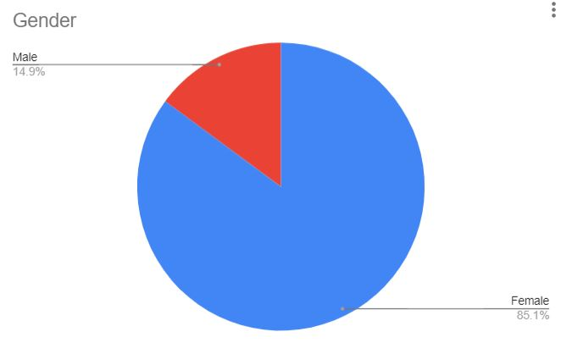
The majority of the students who completed the survey were females, meaning that these results can be generalised to female students.

Table and chart of responses for question 6:

Responses | Preffered device
Laptops | 23
Phones | 15
iPads | 4
Tablets | 5

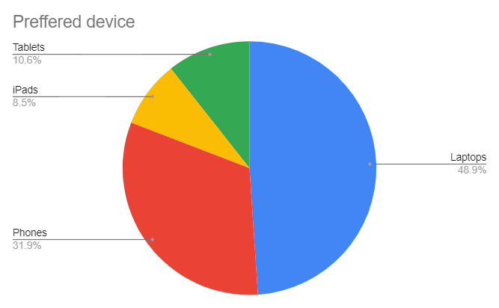

The most used device by students is laptops, closely followed by phones, meaning students are more likely to check reviews for these devices before purchasing IT products.

Table and chart of responses for question 9:

Effectiveness | Responses
very | 24
relatively | 15
somehow | 5
not | 3

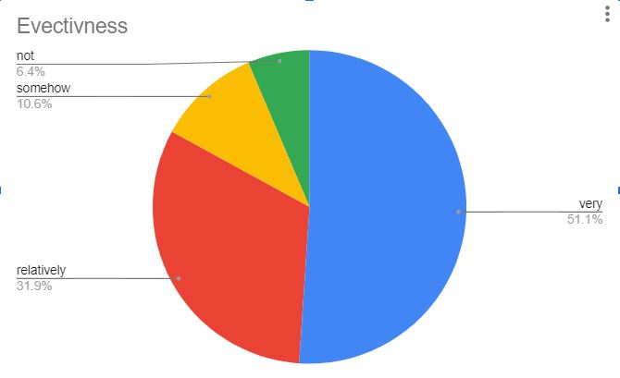
Over 50% of students who read reviews about IT products find them very effective when deciding what products to buy.

Table and chart of responses for question 11:

Impact | Responses
Big | 35
Moderate | 12
Not | 0

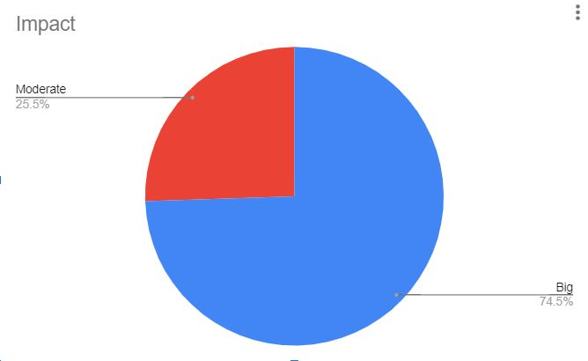

There were no students to say that social media has no impact on their decision making process when buying IT products. Majority of the students consult social media when they make a decision about IT purchases.

References

Alalwan, Ali Abdallah, 2018. “Investigating the impact of social media advertising features on customer purchase intention.” International Journal of Information Management, 42, pp.65-77.

Armstrong, G., Adam, S., Denzie, S. and Kotler, P., 2014. Principles of marketing. Pearson Australia.

Baum, D., Spann, M., J. and Thurridl, C., 2019. “The impact of social media campaigns on the success of new product introductions.” Journal of Retailing and Consumer Services, 50, pp.289-297.

Balakrishnan, B.K., M. I. and Yi, W.J., 2014. “The impact of social media marketing medium toward purchase intention and brand loyalty among generation Y”. Procedia-Social and Behavioural Sciences, 148, pp.177-185.

Bilal, G., Ahmed, M.A. and Shehzad, M.N., 2014“Role of social media and social networks in consumer decision making: A case of the garment sector.” International Journal of Multidisciplinary Sciences and Engineering, 5(3), pp.1-9.

Chu, S.C., Kamal, S. and Kim, Y., 2013. “Understanding consumers’ responses toward social media advertising and purchase intention toward luxury products.” Journal of Global Fashion Marketing, 4(3), pp.158-174.

Gajashree, S. and Anand, J., 2021. “A Study on the Impact of Social Media on Consumer Buying Behaviour of Mobile Phones in Chennai.” Shanlax International Journal of Management, 8(3), pp.54-59.

Gashi, R. and Ahmeti, H.G., 2021. “Impact of social media on the development of new products, marketing and customer relationship management in Kosovo.” Emerging Science Journal, 5(2), pp.125-138.

Geetha, V., Rajkumar, V.S. and Arunachalam, L., 2018.“Impact Of Social Media Sites On Students Purchase Intention In Online Shopping: AN EMPIRICALLY STUDY.” International Journal of Mechanical and Production Engineering Research and Development (IJMPERD), 8, pp.927-938.

Godey, B., Manthiou, A., Pederzoli, D., Rokka, J., Aiello, G., Donvito, R. and Singh, R., 2016. “Social media marketing efforts of luxury brands: Influence on brand equity and consumer behaviour.” Journal of business research, 69(12), pp.5833-5841.

Gutierrez Florez, L. E., Correa Escobar, M. I., Henao Restrepo, A., Arango Botero, D. and Valencia Arias, A., 2017. “Influence of social networks on the purchase decisions of university students.”

Kimmel, A.J. and Kitchen, P.J., 2014. “WOM and social media: Presaging future directions for research and practice.” Journal of Marketing Communications, 20(1-2), pp. 5-20.

Liu, Q., Zhang, X., Huang, S., Zhang, L. and Zhao, Y., 2020. “Exploring consumers’ buying behaviour in a large online promotion activity: The role of psychological distance and involvement.” Journal of theoretical and applied electronic commerce research,15(1), pp.66-80.

Makudza, F., Murgarisanwa, C. and Siziba, S., 2020. “The effect of social media on consumer purchase behaviour in the mobile telephony industry in Zimbabwe.” Dutch Journal of Finance and Management, 4(2), p.em0065.

Mangold, W.G. and Faulds, D.J., 2009. “Social media: The new hybrid element of the promotion mix.” Business horizons, 52(4), pp.357-365.

Migiro, S. O. and Magangi, B.A., 2011. “Mixed methods: A review of literature and the future of the new research paradigm.” African journal of business management, 5(10), pp.3757-3764.

Powers, T., Advincula, D., Austin, M.S., Graiko, S. and Snyder, J., 2012. “Digital and social media in the purchase decision process: A special report from the Advertising Research Foundation.” Journal of advertising research,52(4), pp.479-489.

Putter, M., 2017. “The impact of social media on consumer buying intention.” Marketing, 3(1), pp. 7-13.

Smith, T., 2009. “Conference notes-The social media revolution. “ International journal of market research,51(4), pp.1-5.

Voramontri, D. and Kleib, L., 2019. “Impact of social media on consumer behaviour.” International Journal of Information and Decision Sciences,11(3), pp.209-233.

Xiang, Z., 2011. “Dynamic social media on online travel information search: A preliminary analysis.” In Information and Communication Technologies in Tourism 2011 ( pp. 323-353). Springer, Vienna.

APPENDIX

QUESTIONNAIRE FOR STUDENTS

Section One: Student’s Personal Details
- Your age in complete years __________________
- Gender __________________________________
- Do you use social media?
- Yes
- No
- What social media platforms do you use the most?
- Twitter
- WhatsApp
- Instagram
- YouTube
- Telegram
- Facebook
- Any other
- Are you a fan of IT products?
- Yes
- No
- What types of IT products do you prefer?
- Laptops
- Phones
- iPad
- Tablets
- Do you prefer second hand or the latest IT products?
- Second Hand
- Latest
- Where do you get your reviews about IT products?
- Social Media
- Family and friends
- Company advertisements
- How effective are the reviews on IT products from the above answer that you chose?
- Very effective
- Relatively effective
- Somehow effective
- Not effective
- What are the advantages and disadvantages of the above method that you chose?______________________________________________________
- How does social media impact your buying decisions on IT products?
- It has a big impact
- It has a moderate impact
- It has no impact

