STUDENT: NURUL HUQE
STUDENT ID: 1815082
MODULE: Professional and Career Development
MODULE ID: BMSW 4005 (PART 1) (PART 2)
TUTOR: BUDHI PATAK
ASSIGNMENT TITLE: Reflective Portfolio



Table of Contents

PART 1
PART 1 INTRODUCTION 1
DEFINITION OF SELF AWARENESS 2
MOTIVATION TEST (Psych Test) 3
JOHARI WINDOW 4
16 PERSONALITY TESTS……………………………………………………………………………5
CONCLUSION………………………………………………………………………………………..6
PART 2
PART 2 INTRODUCTION…………………………………………………………………………...8
MOCK INTERVIEW…………………………………………………………………………………..9
IMPROVING SKILLS/CAREER……………………………………………………………………10
CONCLUSION………………………………………………………………………………………11
REFERENCE………………………………………………………………………………………..12

APPENDIX 1..CV……………………………………………………………………………………13
APPENDIX 2..COVERING LETTER……………………………………………………………..14
APPENDIX 3..JOB DISCRIPTION……………………………………………………………….15
APPENDIX 4. MOCK INTERVIEW FEEDBACK..................................................................16
APPENDIX 5.16 PERSONALITIES…………………………………………………………….17

INTRODUCTION

This assignment is a report about self-awareness skills that is required for employment and getting notice from employers, showing that using these skills to work efficiently. For this assignment there will be 2-part report, this assignment is Part 1, it covers self-awareness tools like Johari window, 123 test and Psych test which is a career motivation tests. These tools used are to understand a person’s ability, to develop skills and how certain behaviour and attitude indicate their personality at a workplace. At the end of the tests it shows results of the person characteristics and determination, these tests show results in different categories of the person’s traits. Self-awareness is used to understand how emotions, thoughts and decisions are important in achieving success and take control of the changes.

SELF AWARENESS – Definition

From ancient Greek Aphorism ‘’know thyself’’ to western society the self-awareness studied in the last century by philosopher and psychologists.

This is to recognise an individual’s abilities and separate from other individual’s conditions, it is recognition of one’s personality, strengths, weakness, beliefs, emotions and motivations. It also allows understanding how other people perceive you and observe your response.
‘’When focusing ourselves, we can evaluate and compare our behaviour to standards and values. We become conscious of oneself and evaluate the objectives’’, Duval.S & Wicklund.R, (1972).

It is best to recognise how we observe and view situations in our mind, we can judge matters using experience and knowledge to work out what is significant. It is considered that people with self-awareness act consciously and have good psychological health, they look at matters positively and compassionately

Self-awareness can be hard for people as we are always busy doing different activities and we tend to forget to observe ourselves or have the time to pay attention to our behaviour. Our mind can wander off and stick to our normal behaviour not knowing we operate unconsciously of how we feel or what we are doing.

Psych Test (MOTIVATION TEST)

In the classroom I have taken different tests called 123test and Psych test, both tests is done to see my personality traits and how I look at different categories in employment and indicate on how I view certain aspects.
Under the Psych test I had to investigate career motivation test, this part it shows how I would view certain matters, how I make decision on certain topics and if I strongly agree, neither agree nor disagree. Each subject is scored, and the scores shows how each topic is viewed and then it explains the pros and cons.

My Personality Type: The Tycoon

The result shows that I have a Tycoon personality and I am destined to reach the top, no matter what obstacle I face on the way. The tycoon is fearless person that have the motivation to conquer any challenges and making sure they beat their competitors. Along their ways we want to be financially secure, have the status and the prestige, working very hard and willing to put all the effort onto work.

- Achievement
For achievement motivation I can be driven by my sense of satisfaction on completing any task given, also need to see good results due to my effort. Sometime the desire to reaching their achievement people can get bored and constantly looking for opportunities if they feel the career is not progressing.
Pros: Can keep eyes on the prize for achieving their tasks and be very productive, keeping the mind on track and their efforts focused on the objectives even facing any difficulties.
Cons: Becoming focused on goals and not patient they can push important their mental and physical health to the side, causing them to burnout.

- Structure and Order
It is preferred to work in a company with established performing structure for duties that states the hierarchy of employees. The work in defined clearly what tasks and roles given and if it is not clear then it may cause anxiousness and worrying that what need to be done. Also need to know what exactly must be done and have the correct instructions to take actions and who to report to like their senior or managers.
Pros: Importance on structure, order and respect that they rely being told what to do, rely on their role and will not rebel when managed by others
Cons: May not have the ability to do their job specially when not matching their needs, will dislike ambiguous instructions and hesitant to speak up against the managers. This can frustrate employers when they want views and ideas from their employees.

- Balanced (Lifestyle)
Need to feel they have activities outside the workplace and not sacrifice their personal need for job success. Having the desire to seek balance between family and friends, want quality time and have energy to pursue other interests and hobbies.
Pros: Know the priorities straight but devoting to work and family, can shift from one realm to the other.
Cons: Can sacrifice their personal time, working overtime and be available when employer requests it.

- Changes and Variety
For this profile it shows that this person is motivated by the changes and varieties in the workplace, craving for new challenges, learning new experience and always wants new actions. Getting bored of same duties and do not like to limit themselves, be more comfortable in dealing with task they feel familiar with. Seeking to develop their skills and taking risks as they possess self-confidence, going out of the way to try new things.
Pros: Do not fear changes and embracing all changes, adapting to any circumstances and accepting challenges.
Cons: Can easily get bored and feel impatient when it is not busy.
- Creativity
This motivation shows the person has the desire to express their creativeness, sharing their new ideas and exploring different solutions to deal any matters that arise. People with this trait can feel frustrated or unsettled in getting stuck with a process that was already done and tested.
Pros: Effective in doing their job, thinking outside the box and viewing problems from different angles. Also have the ability in to investigate matters by brain storming and shedding light on numerous issues. They do not rely on other people but go out and seek a formula from their experiences and solutions from their past.
Cons: Constantly focusing on their ideas to solve the problem that they neglect their other duties and do not feel they need to accept other people ideas or suggestions.

- Financial Reward
Having the motivation so they are financially rewarded for their efforts and achievements and wanting a long-term financial stability in their career. Hoping to earn a lot so they can afford their ideal lifestyle and getting the salary that is equal to their work.
Pros: They are extremely hard working and not afraid to express themselves, they are satisfied with their job and making sure they will not disappoint anyone.
Cons: May choose a job with higher salary and not think about if the job is fulfilling, this can lead to job hopping and the employers might feel this person is not dedicated.

- Identity and Purpose
People with this motivation feel the need that their career should be worthy, and their identity play a role in contributing in their workplace. They have a strong connection and values to fit into their workplace, hoping to do well in their job and achieving their goals.
Pros: Having the job satisfaction, believing in that they want this and having pride of their career.
Cons: Getting lost in their job and not showing their personal side, they may not cope with career setback.

- Contribution
This motivation is for a person who wants to make a name for themselves in making new discoveries and contributing in promoting to new plans.
Pros: Always willing to learn and encouraging others, having the need to succeed and accomplish great things.
Cons: They feel let down if criticized and feel disappointed if they are not praised.

- Independence
This person will want freedom in working their own ways and making their own decisions, they like to think for themselves, feel confident and mould their work to their preferred manner.
Pros: They can work efficiently and not required to hold other people hand.
Cons: May have difficulty to compromise and allow other to take charge.

- Responsibility
This motivation is for people who like to take ownership of their decisions, their service, and take on further responsibilities.
Pros: They could lead people and willing to work effectively.
Cons: May grab responsibilities in haste and may not be able to step back to think things thru.

- Power
People with power motivation like good completion, like to lead people and enjoy in making decisions.
Pros: They are not afraid in getting what they want and take the lead.
Cons: Can cause problems with other workers.

JOHARI WINDOW

This is a tool used by people who want to better themselves and observe their behaviours with other people. This was created by a psychologist Joseph Luft (1916-2014) and Harington Ingham (1916-1995), in 1995 it was used as tests to self-help groups. The Johari Window emphasise on soft skills like co-operation and behaviours in groups and on your own. The window focus on 4 factors, first factor is what known by self; second factor is what known by others. The model also has 4 areas; one area is for what is known by yourself and what you are willing to share, which is an open area. There is a blind area where others know about you but not known by yourself, the other area is that you know about self but do not want others to know about you, this is called hidden area. Lastly, the other area is called unknown area, where it is unknown by you and unknown by others.
The Johari Window tool can be used at work, training and further developments; it can assist on understanding your own abilities and valuing other people. Participating in feedback helps people to explore the qualities that make them who they are and then with this feedback you can understand your strengths, weakness and how to improve. This also helps to understand what other people are thinking of you and how to behave so all parties can work together and have better communication. It is important to that all feedbacks are looked at positively and understand that it is not a personal attack but observing if the other parties is honest with their remarks.

(My Johari Window example)
Known to self-Unknown to self
Calm OPEN AREA  Adaptable  Confident  Dependable | Patient BLIND AREA  Logical  Witty  Responsive
Reflective  Observant HIDDEN AREA  Mature  Idealistic | Nervous  Tense UNKNOWN AREA  Accepting

Known to others

Unknown
To others

The 4 areas give the opportunity to change, it gives the options to share what information about you and may have hidden it before. The open area is for feedback from others so the hidden area can be looked at and makes changes to improve the behaviour.

Drawbacks of Johari Window:
- Not happy with the feedbacks, looking at it negatively and not communicating honestly.
- Better to not communicate at all and may cause more problems.
- Offended by the feedbacks, may take it personally and may have differences due to different cultures.

16 PERSONALITY TESTS

This is another tool created by Katherine Cook Briggs and Isabel Briggs Myers in the 20th century, it is also known as MBTI assessment to recognise people personality. They believe if people understood each other then they can work better together, Myers then developed questions, and this led to the idea of type indicator.
There are five personality aspects that define the personality type of the person; these are mind, energy, nature, identify and tactics.
Mind: is how we interact with our surrounding.
Energy: how we see the world and process the information
Nature: how we make decisions and cope with our emotions.
Identify: how confident we are in our abilities and decisions.
Tactics: how we reflect on our work, planning and decision making.

MY PERSONALITY TYPE: ‘’The Consul’’

As the consul my personality shows I am popular, taking the spotlight and leading my team to victory. I like to support my friends and loved one, like to organize social gatherings and making sure everyone is happy. I like to find out how my friends are and keep up to date on what is happening to everyone I know.
As a consul leader I am always concerned about the welfares of others take my responsibilities seriously and want to do the right things. It is important for me to uphold authority and laws, firm believer on traditions and rules. I like to participate in things and hope that other people appreciate and value me, I like everything to be stable and organized at home and at work.
My personality shows that I like to find the time to chat and laugh with everyone, like to hear about my friend’s relationship, remembering little details, aware about sensitive issues and making sure to restore stability and harmony.
Dealing with conflicts as a consul I will use my energy and determination to establish social order, like to put a lot of effort on social gatherings and arranging activities. But I feel hurt if my ideas are rejected and if people ignore me or show not interest. If anyone criticize me or disagree with me, I get upset, I am very sensitive and get very disappointed if things are not working out.

Consul Strengths:
Excellent managers, making sure everyone is well cared.
Have a strong sense of responsibilities and determine to complete the tasks given.
Loyal and trustworthy to the partners and employees, like to belong in a family and community.
Sensitive and warm, seek harmony and stability and not to hurt anyone.
Well liked in social group and have an active role in the community.

Consul Weakness:
Worried what others might think and effect on making decisions.
Think about what is socially acceptable and too cautious.
Hesitate on being creative and unwilling to step out of the comfort zones.
Challenging to accept criticism, get defensive and hurt if someone does not accept their views and ideas.
Too needy and always want to hear appreciations, be noticed and fishing for compliments.
Think about others and not for themselves, give too much attention to other people when it is not required.

Consuls Career Paths:
Choosing a career that allows to express their skills and abilities happy in doing things that need to be done. Enjoy in bringing order and structure to the workplace, respect the hierarchy that is in place and completing the task given.
Consul’s need human interactions, good feedbacks and good listeners and is an enthusiastic team player. They are comfortable with authority, supportive and friendly and satisfied with in the line of work.

Workplace Habit:
As a consul they thrive on social order and harmony, use their sensitivity, warmth and social intelligent to make sure everyone knows their responsibilities. They are clear on roles in the workplace and respect the rules and regulations.
Consuls are patient, hardworking and very efficient with their work; they define their responsibilities and have sense for purposes.
Consuls have no problem in working in teams; they seek friendship at work and always willing to lend their hand when it is required. Take pride on their work and they are sensitive to criticisms.
A consul manager they enjoy their responsibilities, managing people and like to get involved with tasks. They find a way to unite people and smoothing relations in order to get things done.

CONCLUSION
This report has explained about why self-awareness is important and what tools are available to use to measure a person’s understanding of ourselves. By understanding our areas to improve ourselves we can then identify the areas to change and to improve for the future. Being aware of ourselves helps us to deter from distractions as sometimes we are not aware of what we are doing. We think that we are doing more work; we are good listener, cleverer and have done everything compared to other people. Observing your own behaviour with other people can help to look at our own personality and observe other people as well, this will give the opportunity to communicate and work together with other people.

PART 2 INTRODUCTION

This is part 2 of the assignment, a reflective report of in-class recruitment activities done at the university and what I have done to prepare myself for a mock job interview. I was interviewed by tutors who acted as employers interviewing a job applicant; the job was taken from Indeed jobs website. I also had to prepare my CV making sure I had all my skills and abilities, my past and present job roles to show employers that I am suitable for their job. After the mock job interview, I had feedback from the tutors explaining what I could have done to get the job. The tutors commented on various suggestions which an employer would have given attention to, they noted on first impression and verbal behaviours. They also gave points earned in percentage and that showed results of how I did if I got the job or not.

MOCK INTERVIEWS

Employers set in place a process that allows them to recruit individuals who are qualified for the job position. Recruitments are done by writing a description of the job and person specification for the required role, the job is advertised and shows where the job is located. Job advertisement can be found in web sites, newspaper, social media like LinkedIn, twitter and other digital platforms.
I had to find a job that I would apply to and I found the Restaurant Manager job at Indeed Job website. The job specification had shown what role the manager is expected to perform and the responsibilities to take. I printed the job and I amended my CV, so it matched the job specification and forwarded this to the tutors for the mock job interview that was conducted in the University.

At the interviews the tutors acted as the interviewers, they had to mark me while they interviewed me. They looked at first impression and verbal behaviours, under the first impression it had about showing up in time for the interview, if I shook their hand, smiled and greeted them. Also, if I had the CV and the job details, maintained eye contact, dressed appropriately, looked at my posture and if my movements were natural. For the verbal behaviours, they marked for demonstrating knowledge of the company I was applying for, if I answered all the questions completely. Also, if I understood the format for behavioural questions, understood about the company, the qualification and the work-related skills. The interviewers also focused on me to see if I was enthusiastic, if I showed any weakness and strength, looked at my mannerism, if I asked any questions, how I responded to the questions, if I spoke clearly and if I used empty words. For each key point the interviewers marked from 1 to 5, from very poor to excellent.

INTERVIEW RESULTS

For my mock job interview the tutors who acted as the interviewers marked me with points up to 100, the points earned and then graded in percentage. The total marks were then shown on how well I done, the result suggested that if I was hired or would they have considered me, might have hired me and the last one is not to call them.
For each part the points were from 20 to 59, 60 to 79, 80 to 89 and from 90 to 100, the highest point from 90 to 100 focus on if I had clearly explained about my skills and qualities that matched the job. How I demonstrated my preparation for the job and asked relevant questions, if I maintained a professional attitude, my manners and spoke clearly and concisely. For points 80 to 89, I had to display some skills and qualities that match the job descriptions. If I had asked some thoughtful questions, showing signs of research on the company and the job, responded to the interview professionally and with maturity. Under the point from 60 to 79, focus on if I showed some communication problems, skills that do not match the job description, the communication is not clear. On the points from 20 to 59 shows that no signs of skills or abilities to do the job, have not done any research of the company or the job and manner of speaking is unclear and poorly worded.
The scores given to me by the interviewers was mostly 3 to 4, (good/average and good), they also had commented on what I could have done to at the interview to get better marks. On one comment the tutor suggested I could have dressed more appropriately, done more research on the company to show more enthusiasm and should have prepared to ask questions. The other tutor’s suggested that I could have given more information about myself, to provide deeper explanation and asked further questions.
The marks given to by one interviewer is 62% and the other is 69%, this falls into the part they might have hired me but due to lacking relevant key attributes I am not successful in getting the job.
After looking at the results I feel I could have done better with the mock interview, I feel I was nervous and panicked when they asked me questions. I will make sure from now on for future job interviews that I will do my research on the company and about the position. Making sure to show enthusiasm about the job and prepare what questions I can ask the employer, also dressing smartly and give more attention to myself.

IMPROVING SKILLS/CAREER

Employers look out for different skills from the suitable candidate, the top skills are problem solving/critical thinking, communication, teamwork, time management, digital literacy and initiative. With these skills it is important to look at the CV, this need to be continuously updated, adjusted to the job description and modifies accordingly. The employers do not always look at qualification but want to know about the job applicant and they can help the business to achieve the goals. The employers will look out for people who show creativity and ideas, show motivation and abilities, show good communicational skills and able to work under pressure. On the CV it emphasizes on the soft skills like time management and teamwork, if a person can show they have engaged with activities like volunteering, charity work, hobbies and interests. Having professional network contacts thru social media, getting notice on twitter, LinkedIn and other social platforms. Preparing for the job interview by researching on the industry the business belongs to and what services they provide. Then preparing questions to ask the employer and show enthusiasm about joining their company.

CONCLUSION

I have covered on how we can observe and measure our behaviours by using tools like 16 Personality Test, Johari Window and Psych Test, it covers my traits and my personality and how I process information that surrounds me at work and home.
I have included my mock interview results that was done in class and what I could have done to improve, I had feedback from the interviewers and had scores marked to say if I would have got the job. I have my CV, job description and covering letter to show the job that I was interested in applying, I have a better understanding of how to prepare for a job interview.

REFERENCE

Certificate in Higher Education: Skills for the Workplace Student Yearbook
Maund.A, Scriek.M, Tinkler.P. K (2017)
Resumes, Interviews and Negotiation
Quintanilla, K.M. and Wahl, S.T. (2017)
In Business and Professional Communication. Third Edition
Thousand Oaks: SAGE. Ch.4, pp.65-96
Finding Work
Neugebaur.J and Evans-Brain.J. (2016)
In Employability
London SAGE. Ch.4. pp.69-93

The Business Student’s Guide to Study and Employability
Morgan.P. (2017)
Understanding Employee Selection
pp.323 - 413

www.google.search.uk
markmanson.net
The 3 Level of Self-Awareness
By Manson.M. (2018)
(Accessed online 23/12/2019)

www.google.search.uk
https://www.skillsyouneed.com
Self-Awareness
(Accessed online 26/12/2019)

www.google.search.uk
https://www.forbes.com
How to Work with People Who Are Not Self-Aware
By Hall.J.(17/02/2019)
(Accessed Online 02/01/2020)

www.google.search.uk
https://testyourself.psychtests.com
Career Motivation Test – PsychTests
(Accessed online 13/11/2019 – 10/01/2020)

www.google.search.uk
https://www.16personalitytest.com
By Day.D
(Accessed online 13/11/2019 - 10/01/2020)

www.google.search.uk
https://www.selfawareness.org.uk
Understanding the Johari Window Model
Posted 10/11/2013
(Accessed online 15/01/2020)

www.google.search.uk
https://www.skillsyouneed.com
7 Ways to improve Your Employability Right Now – Skills You Need
(Accessed online 16/01/2020)

www.google.search.uk
https://inspiringtips.com
17 Motivating Ways to Improve Your Skills – Inspiring Tips
By Abello.J.C
(Accessed online on 17/01/2020)

www.google.search.uk
https://www.thebalancecareers.com
Top Skills and Attributes Employers Look For – The Balance Careers
By Doyle. A. (updated 22/01/2020)
(Accessed online 23/01/2020)

www.google.search.uk
https://www.indeed.com
How to Prepare for an Interview | Indded.com
(Updated 24/04/2019)
(Accessed online 24/01/2020)

www.google.search.uk
https://www.jobsite.co.uk
5 Most Important Things Employers Look for In Your CV
Updated 15/05/2014
(Accessed online 24/01/2020)

www.google.search.uk
https://www.monster.co.uk
What Should be on a CV | Monster.co.uk
(Accessed online 25/01/2020)

www.google.search.uk
https://www.thebalancecareers.com
An Overview of Mock Interviews – The Balance Careers
By Doyle.A. updated (31/10/2019)
(Accessed online 25/01/2020)

www.google.search.uk
https://www.theknowledgeacademy.com
Why Are Mock Interviews So Important? – United Kingdom – The Knowledge Academy
By Armstrong.S. (15/07/2019)
(Accessed online 26/01/2020)

Appendix 1. CV

NURUL HUQE
322 HOSPITAL STREET, NEWTOWN, BIRMINGHAM, B19 2NJ. 07903053165.huqe786@googlemail.com

PERSONAL STATEMENT
An enthusiastic manager with drive, determination and a proven ability to ensure that restaurant operates efficiently and profitability. Having a track record of maximizing guest satisfaction and profitability whilst maintaining high standards of food and service and present a positive image of the business. Extensive knowledge of the hospitality industry, it’s working practices, recruitment, and pay conditions of employment and diversity issues.
Now am looking for new and challenging managerial position, one which will make best use of my existing skills and experiences.

KEY SKILLS
- Strong motivational and people skills
- Extensive and relevant knowledge of good food and wine
- Enthusiasm for creating delicious food and providing a great service
- Ability to drive consistent standards
- Experience of managing people and driving performance
- Experience of organising private functions, including parties and weddings.

AREAS OF EXPERTISE
- Customer care
- Customer focused
- Marketing activities
- Health & safety
- Quality control
- Cost control

EDUCATIONS

GNVQ ADVANCE 1997
GNVQ INTERMIDATE 1995
GCSE 1994

WORK HISTORY
1997-2004 SHABAGH TANDOORI RESTURANT, HEREFORDSHIRE
Waiter/Manager
- Greetings customers
- Taking and packing orders
- Taking customers reservations
- Dealing with customers enquires
- Stock taking
- Maintaining records books
- Organizing staff rota
- Ensuring high level of hygiene
2004-2012 ZARA CONTEMPOARY INDIAN DINNING, HEREFORDSHIRE
DIRECTOR/SELF EMPLOYED
- Maintaining the smooth operation of the restaurant
- Bookkeeping and all accounts
- Comply with alcohol license regulations
- Staff recruitment
- Maintaining stock system
- Ensure the safety of all staff and customers
- Dealing with deliveries

2012-PRESENT STARS CARS BIRMINGHAM
TAXI DRIVER/MANAGER

- Arrived on time to customer appointments.
- Kept vehicle clean and safe to maximise passenger satisfaction.
- Minimised mechanical issues by adhering to vehicle maintenance schedule.
- Waited for passengers at designated high-volume locations such as airports and popular nightlife spots.
- Maximised passenger satisfaction by keeping vehicles in safe and clean operating condition.
- Answered, scheduled and responded to reservation calls at specific times and locations.
- Managed teams of drivers, shift schedules and reservation calendars.
- Checked in with dispatch to determine schedule and planned pickups.
- Oversaw business operations, including hiring new drivers, maintaining performance and managing customer service.

REFERENCES – Available on request

Appendix 2 COVERING LETTER

Mr Nurul Huqe
322 Hospital Street
Birmingham
B19 2NJ

Contact:07903053165
E-mail: huqe786@googlemail.com

06 December 2019
Las Iguanas
Birmingham

Dear Sir/Madam

Application for role of Restaurant Manager- Leicester

I have recently seen your job advert for a Restaurant Manager in the Indeed job site dated December 2019 and I am very interested to apply for this role.

Please see my CV enclosed with this letter.

I have the same skills, abilities and work ethics as you described on the advertisement, I have many years of experience and have a good knowledge of the food and drink industry.

I have been responsible for supervising staff and I am good at management of people, my staff always came to me with any concerns they faced.

I have been involved in organising the staff rotas, liaising with suppliers and managing the budgets. I made sure the restaurant health and hygiene were monitored, also followed the health and safety issues. I have prepared and trained new staff; I am capable in working under pressure.

For my role as a restaurant manager I have proved to be efficient, enthusiastic and a strong leader. It would be a privilege to discuss your restaurant manager role at Las Iguanas, I would be happy to come to you whenever it is convenient for you.

Thank you for taking the time to read my letter and CV.

Yours Sincerely

Appendix 3. JOB DESCRIPTION

www, indeed.co.uk
(Accessed online 06/12/2019)

Restaurant Manager - Leicester

Apply with Indeed

Birmingham

£23,000 - £25,000 a year

Time for Work? More like Showtime! Join Las Iguanas as a Restaurant Manager!
Listed as a Times Top 100 Best Company to Work for, 2019, at Las Iguanas our people and their happiness is our key ingredient to our recipe for success!
Las Iguanas is so much more than just a restaurant, it is an everyday celebration of the flavours, pleasures and joy of Latin America.
Working with Las Iguanas is the same - it is so much more than just a job, rather it is a career journey that will see you develop and progress into the Restaurant Manager you want to be.
Every single one of our restaurants rate highly on Trip Advisor and we believe this is down to the effective teams you could be joining.
Don't just take our word for it - go and check us out! A Restaurant Manager at Las Iguanas is kind, fun, passionate, consistent and is as obsessed with hospitality as we are.
As a Restaurant Manager you will need to:
- Oversee the operation, ensuring each department have everything they need to give the guests great hospitality.
- Be on the floor during service, anticipating pressure points before they arise and jumping in to help your team where needed.
- Managing the restaurant is a tough job; when managing shift, you will feel like you are pulled in multiple directions and you will need to meet various business processes, standards and controls to ensure we are consistent as a brand.
At times this industry is a tricky dish to tackle and needs that special ingredient to make it really come together - could that be you? We are proud to have over 54 sites around the country and are even looking to expand and grow even further. Therefore progression and development are a very real possibility for those that really want it.

Let's get to the best bits...

With Las Iguanas you'll get:
- you reach your potential
- A wide range of incentives and rewards for you and your team including our famous Race to Rio!
- A fantastic quarterly bonus scheme to bring in those extra pounds
- 50% discount at all Casual Dining Group restaurants
- An excellent pension schemes
- Bounty bonus scheme - Earn up to £2000 for referring a manager!

Next steps:
- You apply and we will be in touch shortly!

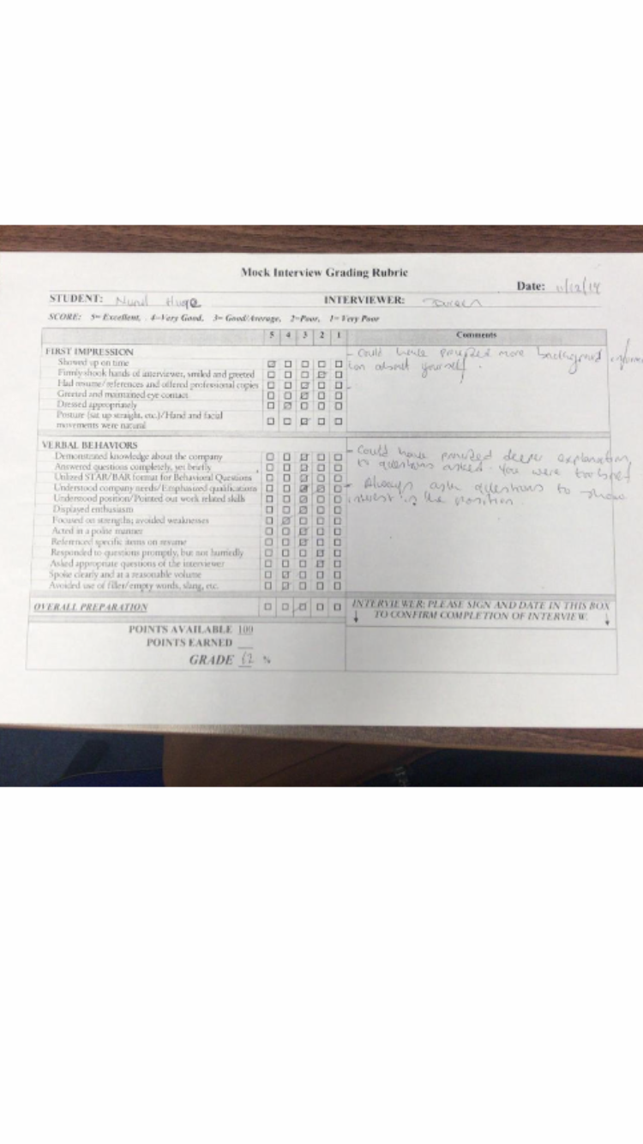
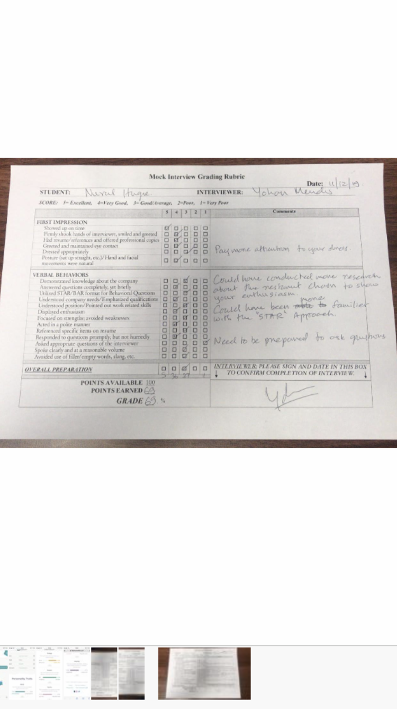
APPENDIX..5 16 PERSONALITIES



