University Trinity Saint David
Institute of science & art

Suspension Kinematics and Performance Analysis
ACHA4004/ACHA4012

Aulon Pashoja
2009355
December 2021

Contents
1. Introduction 3
2. Laboratory Sessions 3
2.1. Equipment 3
2.2. Methodology 4
2.3. Results 9
3. WinGeo Kinematic Simulation 12
3.1. Methodology 12
3.2. Kinematics Results and Discussion 12
3.3. RC Migration 13
4. Suspension Calculations 14
4.1. Calculations 14
4.2 Discussion 15
5. Validation 15
6. Conclusion 17
7. Citations 17

Introduction
The following technical report will look at how changes to a vehicles suspension system effect its handling by taking live data through workshop experiments along with simulating results. The report will show how moving the front suspension of a Van Diemen single seater car affects its ride, roll, and unsprung mass.
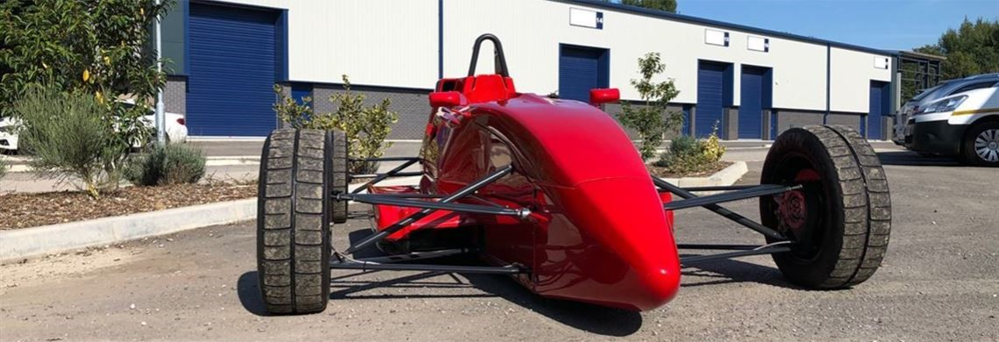
Figure 1: A Van Dieman Single seater

Laboratory Sessions

Equipment
The following Equipment was used over the tests conducted.
Wireless scale: Sends weight telemetry to a laptop wirelessly
Allen key: For disconnecting bolts.
Hydraulic press: Used to apply pressure to an object.
Vernier Caliper: A tool that precisely measures the distances between two points with a reading error of 0.05mm.
Height gauge: A vertical tool that accurately measure the height of an object from a zeroed position.
Digital camber gauge: This is a magnetic gauge that attaches to a vehicles hub or disk, it relays the amount of camber or caster angle based on the angle of the surface attached.
Toe Gauge: A long sheet that attaches to the outside of a wheel, to allow the toe to be measured.
Distance Test indicator gauges (2): The DTI gauge is used to measure minute changes in distance, two gauges can be used on a toe gauge to work out the amount of change in angle across a surface.
Spring compression tester: Used to Apply pressure to a spring to test its stiffness.
Tyre pressure gauge and pump: For checking and setting the required pressure.

Methodology
Unsprung Mass test: The first test was conducted to work out the unsprung mass of the Van Dieman wheel. First, the wheel attached to a simulated chassis using an allen key to secure the bolts.
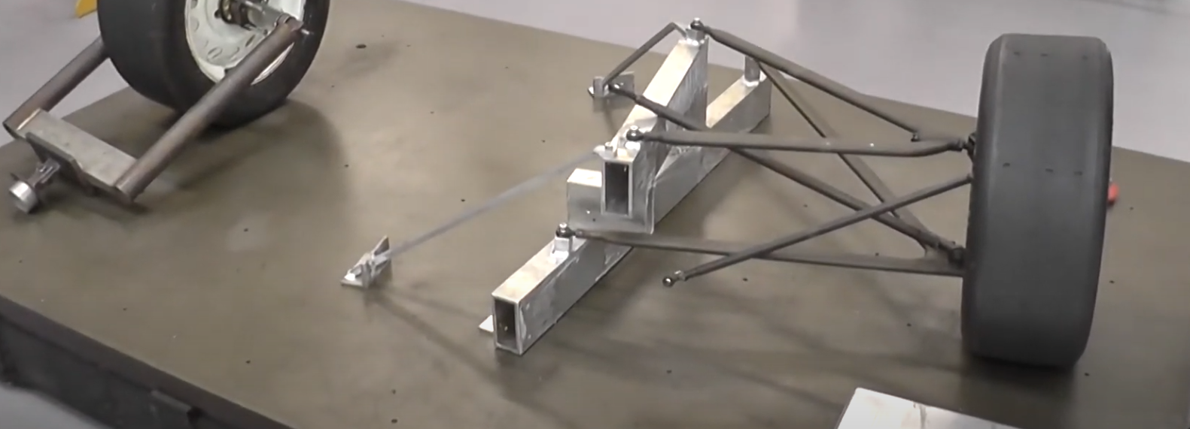
Figure 2: The wheel attached to measure sprung mass
Next, a wireless scale is zeroed and placed under the wheel.
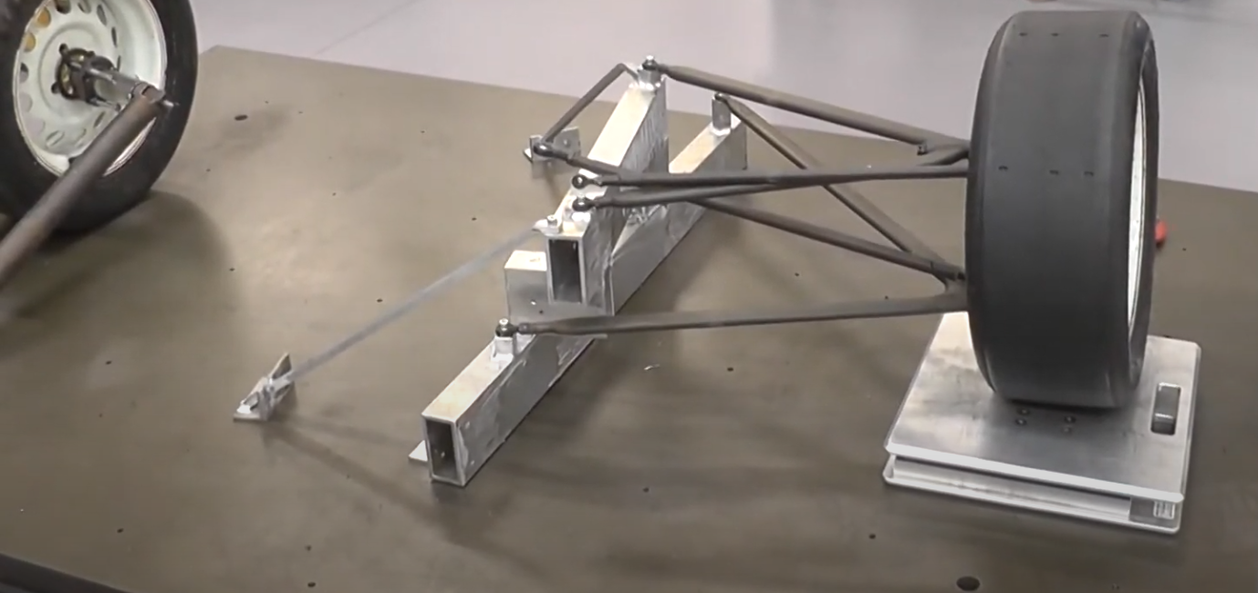
Figure 3: A Scale is zeroed and placed under the wheel
The weight is taken by the scale with the data displayed to a linked laptop, the measurement is noted, showing the mass of the wheel when ‘sprung’.
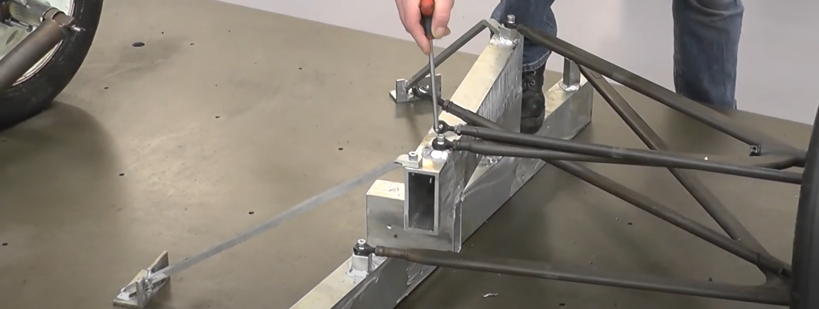
Figure 4: Use the Allen key to disconnect the wheel
Next, the wheel is disconnected from the hypothetical chassis by using an Allen key to remove the bolts holding the control arms, disconnecting the wheel. The scale is placed under the wheel again, this time the weight relayed to the laptop shows the mass when unsprung.
Tyre vertical stiffness test: Conducted to work out the vertical deflection of the tyre under multiple increasing load conditions. This data reflects on the vehicle motion as forces act on its tyres.
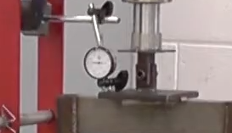
Figure 5: Place a DTI scale on the vice Figure 6: Place a scale under the tyre
Place a DTI gauge used to measure the change in deflection, and a tyre to measure applied force.
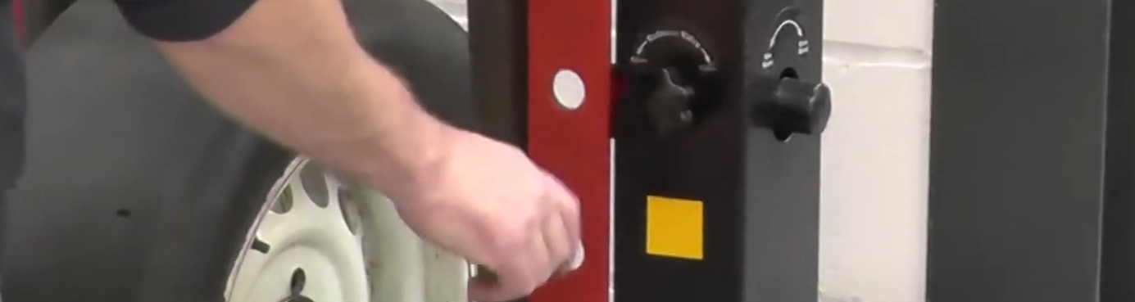
Figure 7: Valve locks the ram in place and returns it to its original position
Turn the ram valve anticlockwise to reset its position, then tighten to lock it.
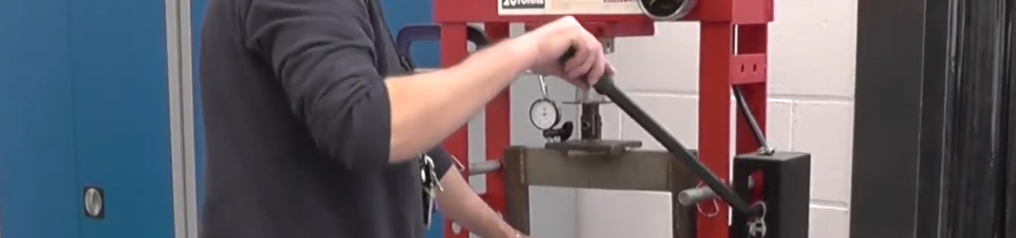
Figure 8: Pushing the ram to the wheel
Press the ram until it begins to apply force upon the tyre.
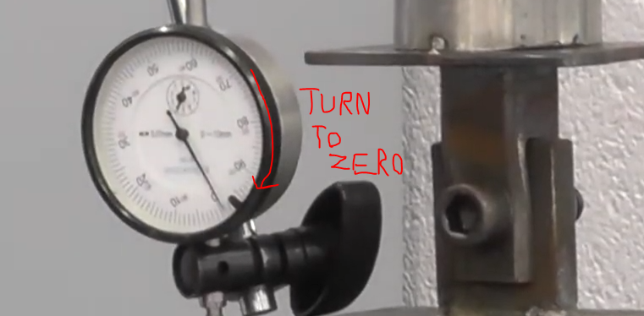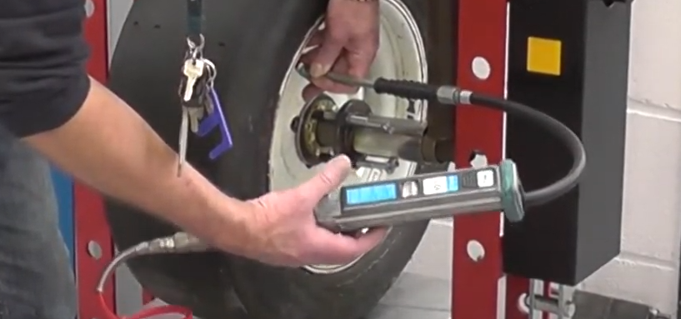
Figure 9: The DTI gauge is zeroed Figure 10: The tyre is pumped to 20PSI
Zero the DTI gauge, then ensure the pressure in the tyre is 20 PSI, set accordingly if not.
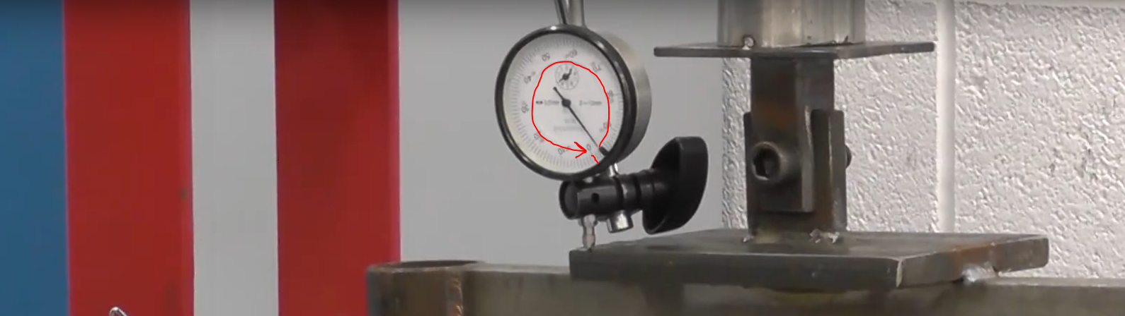
Figure 11: The DTI gauge doing a full rotation
Pull the bench handle until the DTI gauge makes two revolutions (2mm of deflection), note the scale reading for every 2 turns up to 14mm.

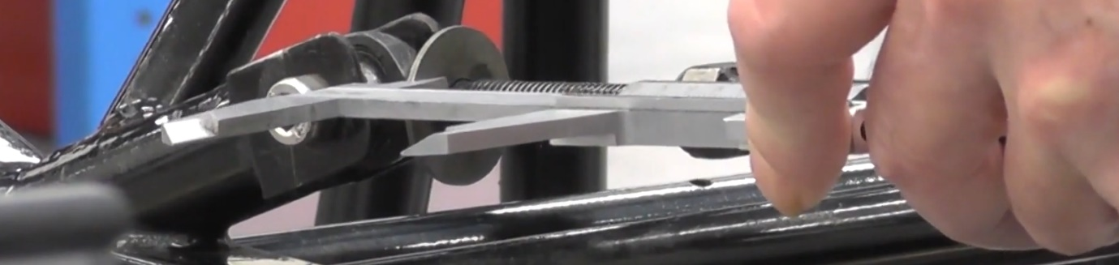
Suspension kinematics test: This test is used to show how the vertical position of the wheel, damper length, Camber and Toe is affected by changing the length of the spring on a vehicle.
Figure 12: Veneer caliper used to measure damper length
Place a veneer caliper on the turnbuckle and take the first measurement for position 0.
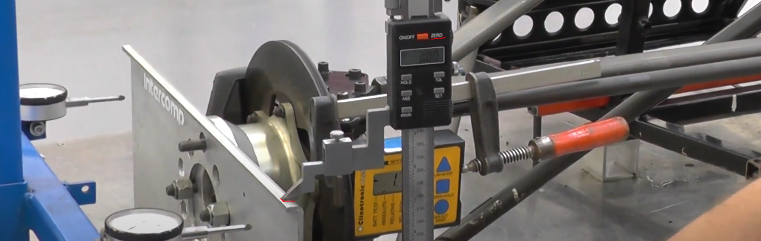
Figure 13: The Height gauge on the toe gauge
Place your height gauge on a toe gauge attached to the wheel hub and zero it for the position 0.
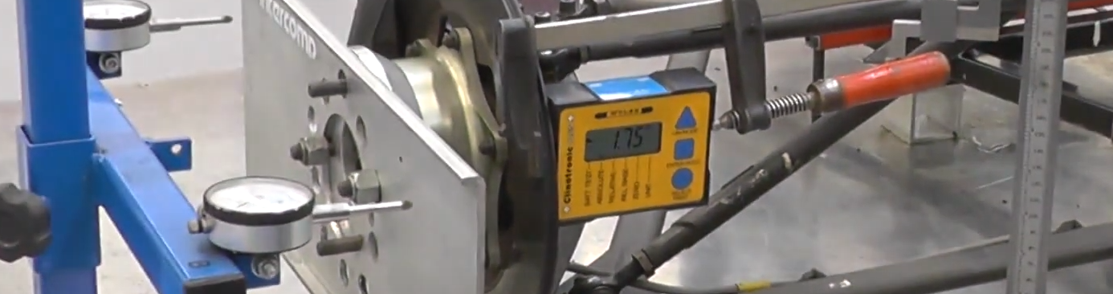
Figure 14: Place camber gauge on hub
Place a camber gauge and take the reading for position 0, convert results to negative as camber gauge is on inside of wheel.
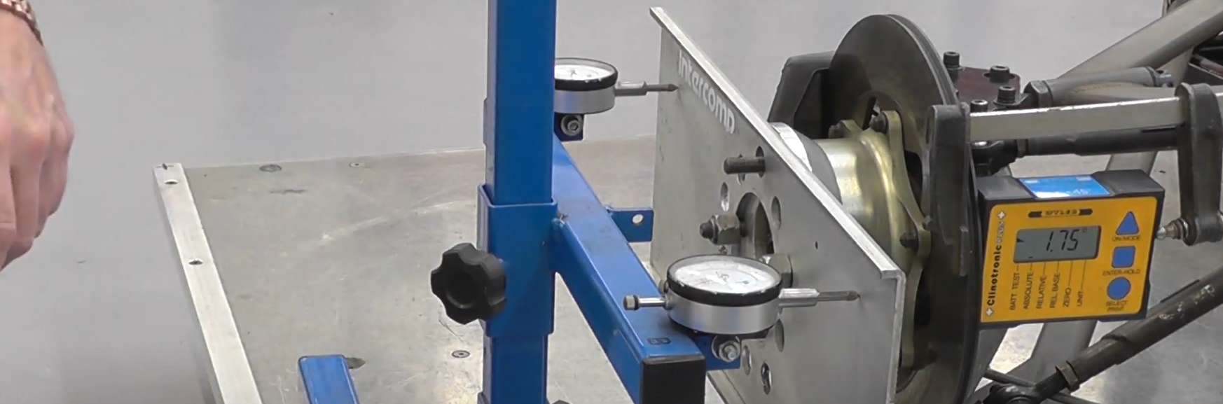
Figure 15: DTI's applied to the toe gauge
Place a DTI gauge on each side of the toe gauge, press in halfway and zero the gauges.
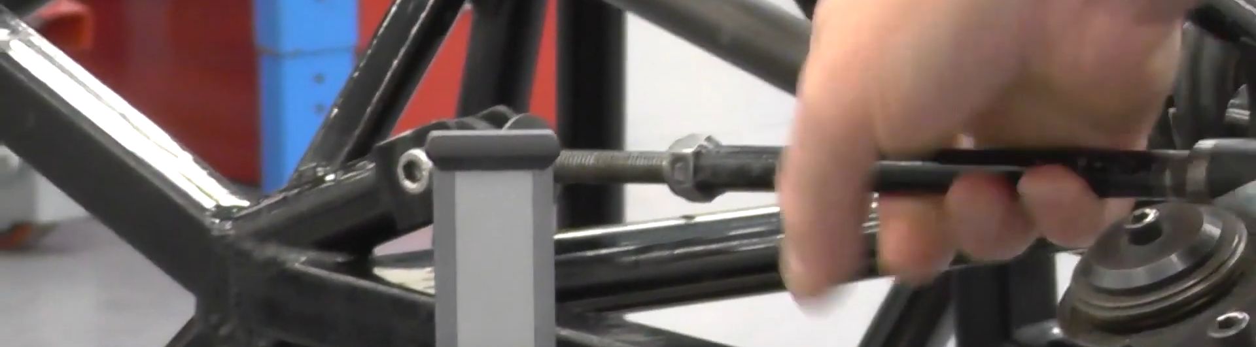
Figure 16: The turnbuckle is rotated twice
Rotate the turnbuckle two revolutions, the suspension geometry is now in the second position. Take the measurement of the dampers second distance with the veneer caliper. Take the reading from the camber gauge for the second position, for the second height position we again place the height gauge onto the toe gauge and measure. Note the measurements from the DIT gauges, A and B.
Repeat the procedure 8 more times.
Spring stiffness test: This test measures the stiffness of a spring under compression.
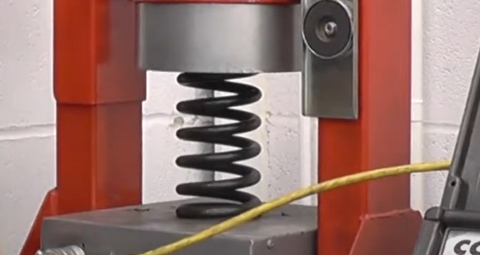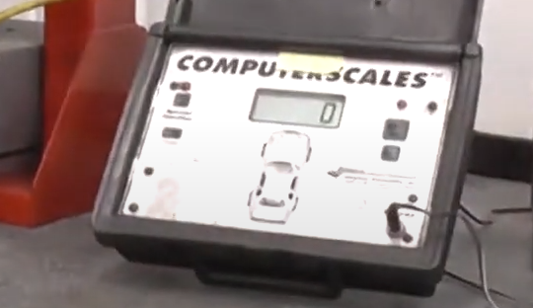
Figure 17: Spring in the vice Figure 18: Scale is zeroed
Place the vehicle spring in vice and zero scale.
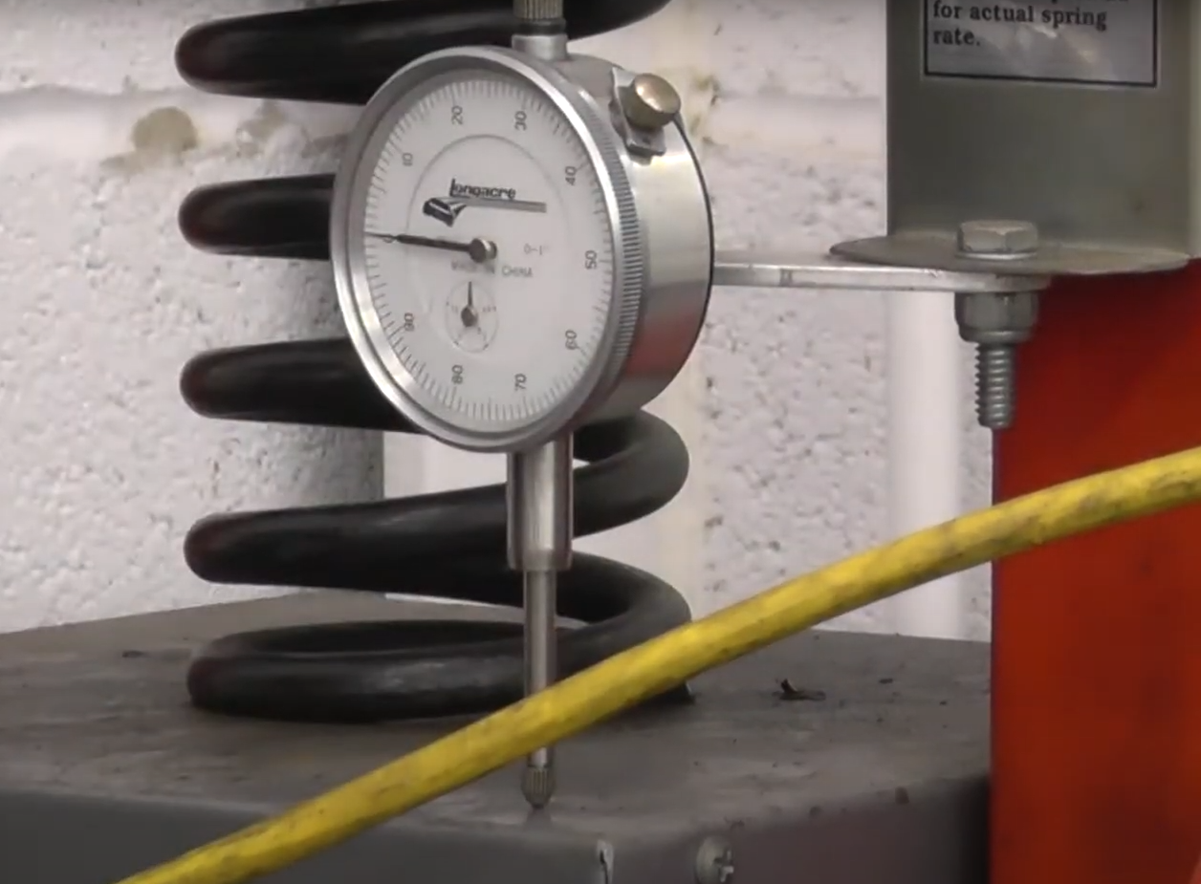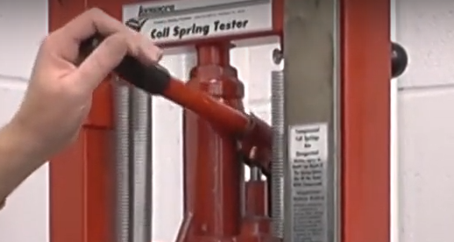
Figure 19:DTI is place on scale Figure 20: compress for one DTI revolution
Place a DTI on the scale and zero. Compress the spring for one revolution (0.1 inches) and note the measured force. Repeat this process 10 times.

Results
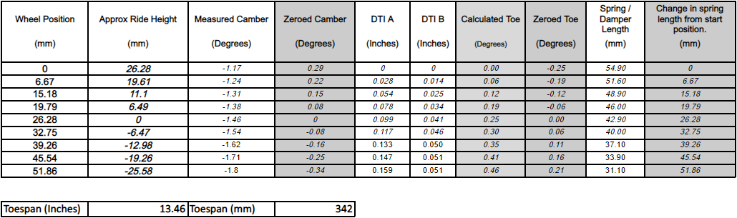
Figure 21: Suspension kinematics results
The results obtained in Figure 21 show how wheel position, camber, ride height, Toe, and damper length change as the suspension is shortened.
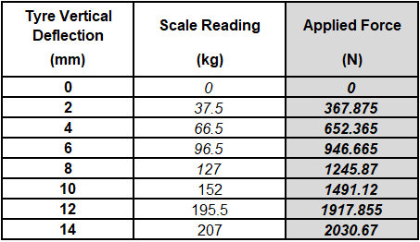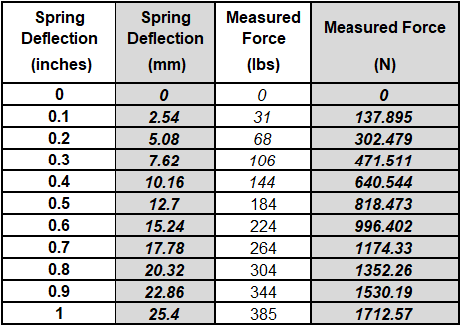
Figure 22: Tyre deflection results Figure 23: Spring deflection results
Figure 22 and 23 show tyre and spring deflection results, figure 24 below shows the mass of the wheels on and off the vehicle.
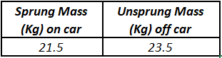
Figure 24: Weight of wheel results
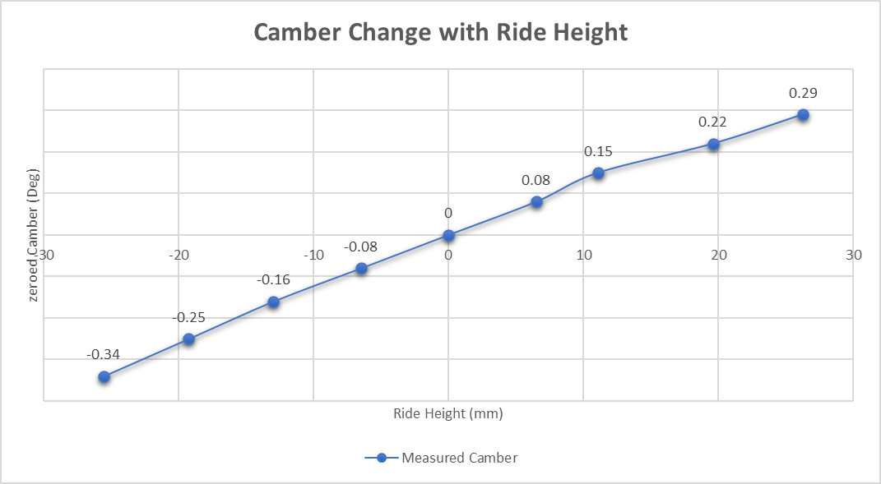
Figure 25 shows camber and ride height changed over the kinematics suspension test, there is a strong correlation between the camber and ride height. The plotted results show that camber increases along with ride height.
Figure 25: Camber change against ride height
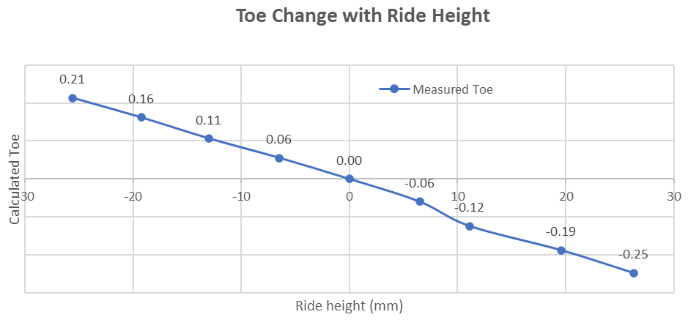
Figure 26 shows Toe and ride height changed over the kinematics suspension test, there is a strong correlation between the Toe and ride height. The plotted results show that Toe increases along with ride height.
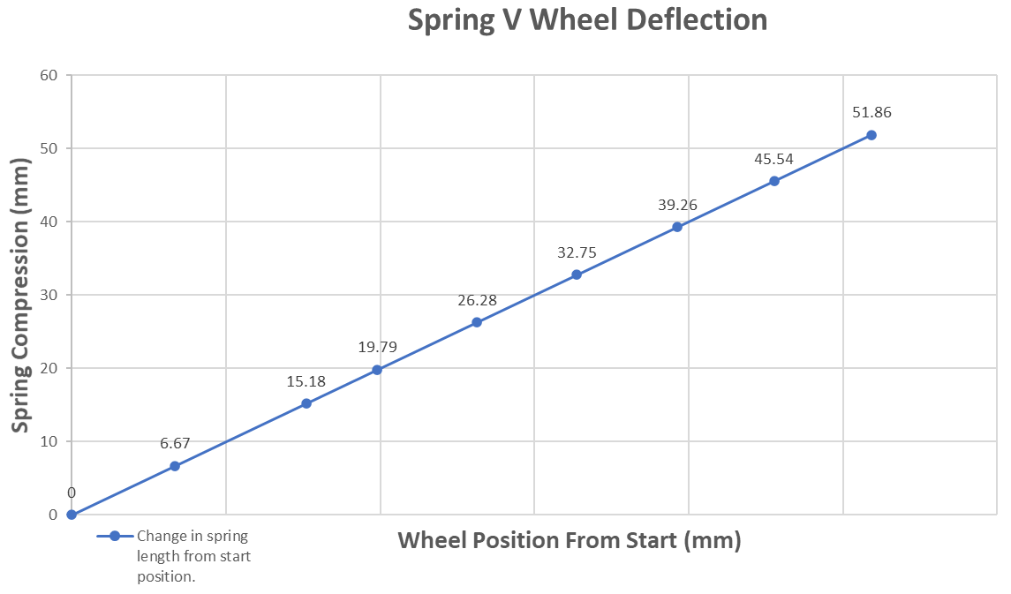
Figure 26: Toe change against ride height
Figure 27 shows the plotted data for wheel deflection and spring compression. We see a very strong correlation showing that the less compression is applied to the spring, the greater the wheel position.
Figure 27: Spring compression against wheel deflection

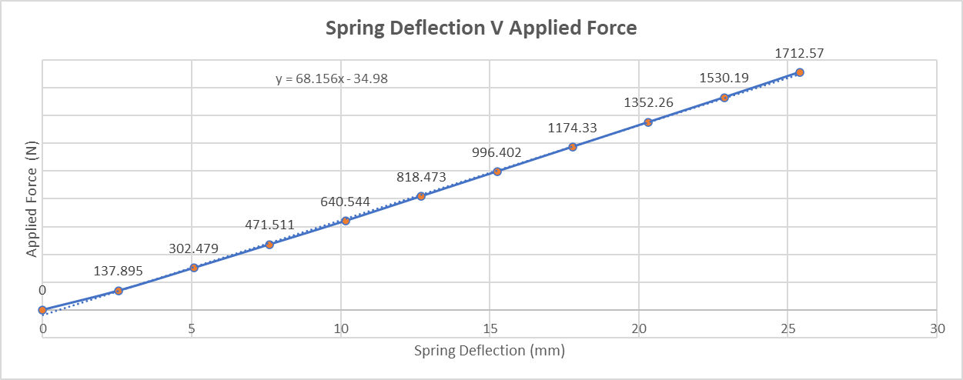
Figure 28: Spring Deflection against applied force
Figure 28 shows the plotted data for spring deflection. The graph shows how spring deflection increases parallel to increasing applied force.
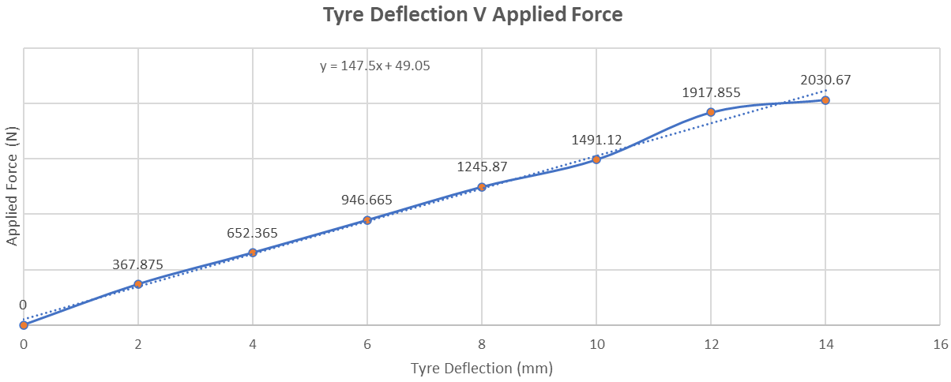
Figure 29: Tyre deflection against applied force
The graph in Figure 29 shows the tyre deflection increasing as force is applied. The graph shows that after around 1600N of force is applied, deflection begins to stop increasing.

WinGeo Kinematic Simulation

Methodology
Wingeo is a programme that simulates the suspension system of a car. A replica model of the Van Dieman setup was provided within wingeo, so that the data collected in the practical tests could be compared with theoretical data produced from simulating the same conditions.
Akin to the workshop tests, the camber, toe, ride height, and roll angle were manipulated through several simulated tests, with results that could be exported in tables. The benefits of using wingeo is that worked out results are theoretically perfect, due to a consistent and ideal environment.

Kinematics Results and Discussion
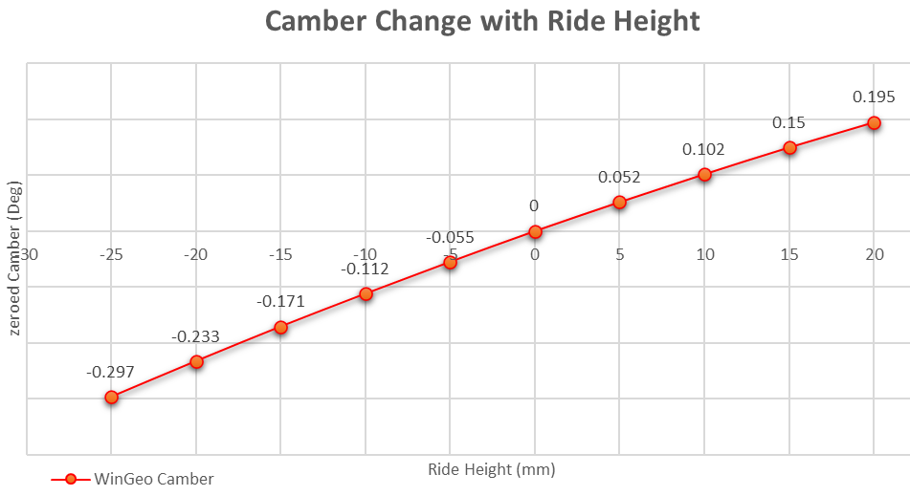
Figure 30 shows the simulated change in camber against the ride height of the vehicle, a strong correlation shows that as ride height increases, so does the camber.

Figure 30: Camber change against ride height
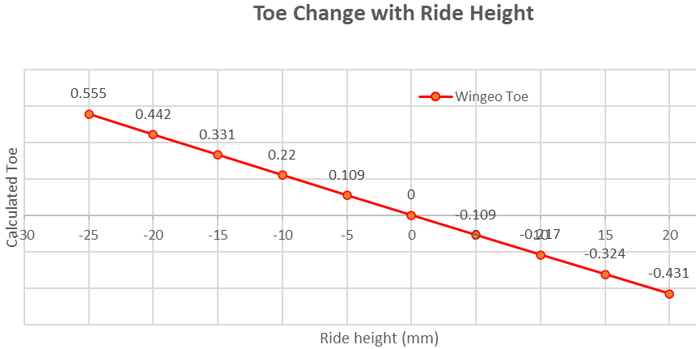
The graph in figure 31 shows the toe change against simulated vehicle ride height. The data shows that the Toe decreases in contrast to the ride hight of the car when it increases.
Figure 31: Toe change against ride height
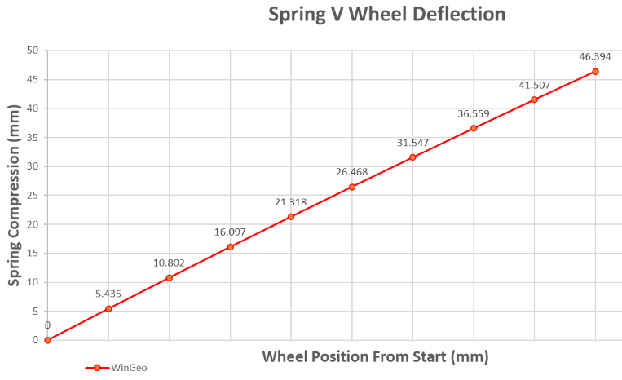
Figure 32 shows a graph populated with the wingeo data from spring compression against wheel position. The data shows that as more compression acts on the spring, the wheels position increases uniformly.
Figure 32: Spring against wheel deflection
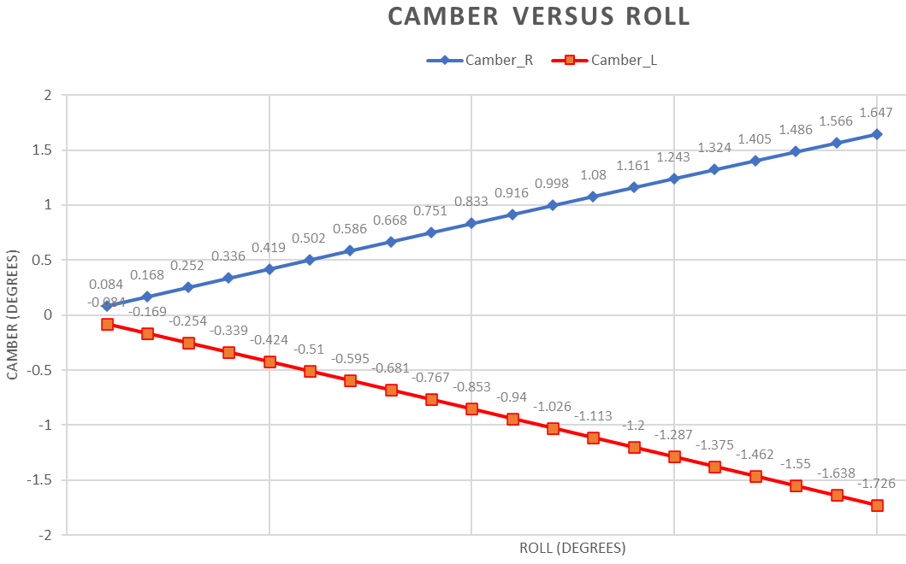
Figure 33 shows the data compiled comparing increments of camber to the roll of the vehicle. The results show that the camber changes

Figure 33: Camber against roll
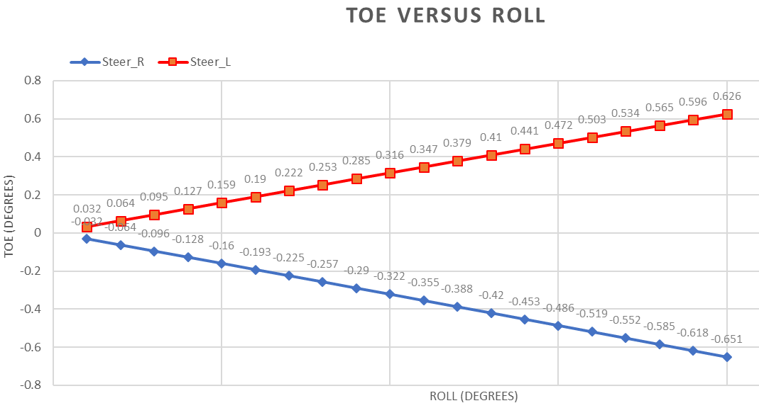
The graph in figure 34 shows how both left and right toe change are equally affected as roll increases. The data shows the left side toe increasing with the right decreasing at the same rate, visualised as both wheels pointing in.
Figure 34: Toe against roll

RC Migration
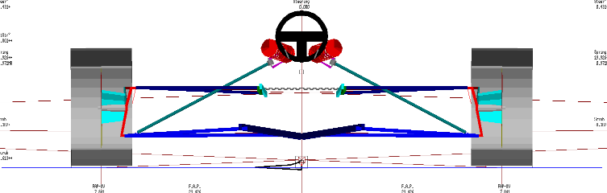
The society of engineers’ define roll centre migration as ‘The point in the transverse vertical plane through any pair of wheel centres at which lateral forces apply to the sprung mass without producing suspension roll.’ A well designed motorsport vehicle should aim to have a roll centre that moves as little as possible regardless of changes to its suspension, be it camber, toe or shock length.

Figure 35 shows the roll centre migration generated in wingeo, a locust diagram. Such a diagram is very valuable, as it enables engineers to review how much a roll centre moves and visualise it too.
Figure 35: The roll centre migration generated in wingeo

Suspension Calculations

Calculations
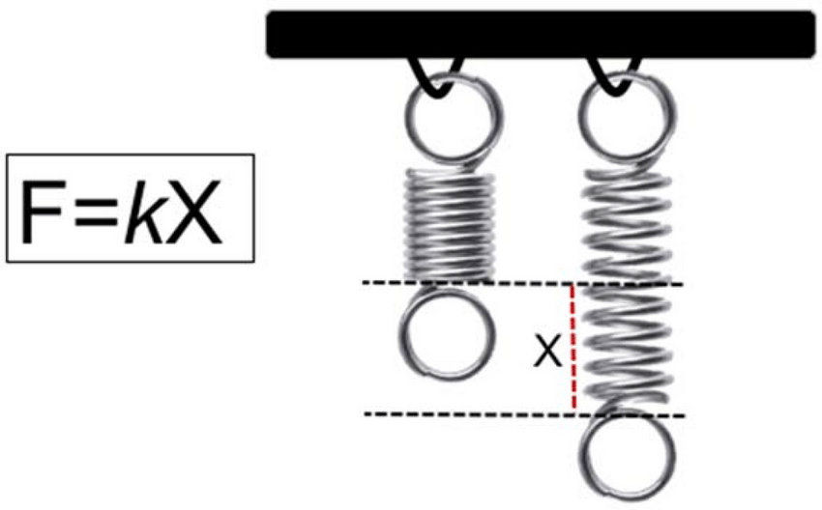
Spring rate: Hooks law states that the distance a spring is compressed is directly related to the force the spring is exerting. Figure 36 shows that force exerted (F) = Spring rate (k) * spring compression/deflection (X).
Figure 36: Hooks law
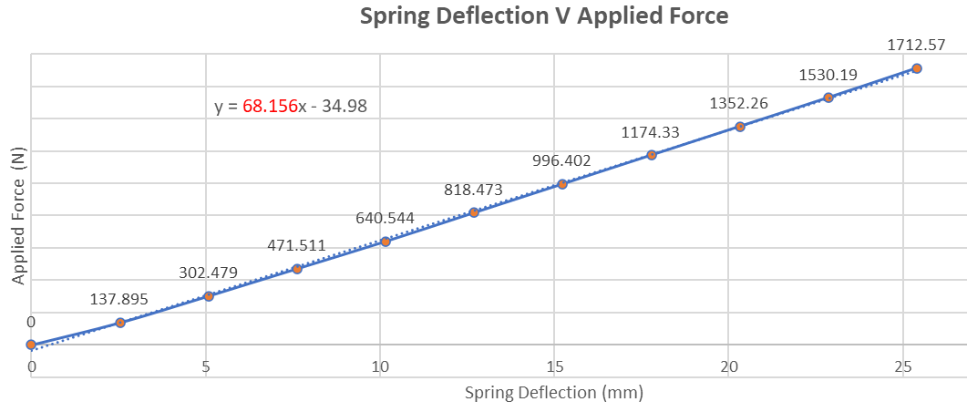
Figure 37: Hooks law in the form of y=mx+c
Figure 37 shows the spring deflection against applied force. Understanding the linear rate means the gradients of each graph can be used to work out multiple equations.
The gradient of Spring deflection against force provides the spring rate, the gradient of spring compression against wheel position provides the motion ratio, and the gradient produced in the graph showing tyre deflection against applied force gives us tyre stiffness. The collected data is then converted for use in each formula.
Wheel rate (kw): The worked out motion ratio is multiplied by the motion ratio^2 to give us 14497.15N/nm.

Front suspension ride frequency: Worked out as 1/2Pi*√wheelrate/Sprung mass. Input calculated wheelrate and gradient showing tyre stiffness to get a frequency of 1.578Hz

Front unsprung mass natural frequency: Worked out as 1/2Pi*√wheelrate+tyre stiffness/unsprung mass. Input the gradient of tyre deflection against force for tyre stiffness along with unsprung mass from the wheel test conducted in section 2 to give a frequency of 22.939

4.2 Discussion
Looking into the suspension ride frequency of most passenger cars shows that frequency varies between 1.2Hz and 1.6Hz, with sports cars having a ride frequency of 1.8 to 2Hz. Extreme race vehicles such as F1 cars can have a suspension frequency of over 3Hz. The measured frequency of the test car shows us that the ride of the vehicle is in line with most road going cars, from research it seems the frequency should be increased to be more in line with race vehicles that sport a stiffer ride. The next step would be to review the results used to work out wheelrate, tyre stiffness and unsprung mass to confirm all data is correct, once verified we should look into what part of the suspension system can be changed to improve camber, roll, bump and stiffness in order to gain a firmer ride.

Validation
As wingeo provides data that is highly accurate due to ideal theoretical settings, it can be used to benchmark the accuracy of the tests carried out in the laboratory when comparing simulated data against measured.
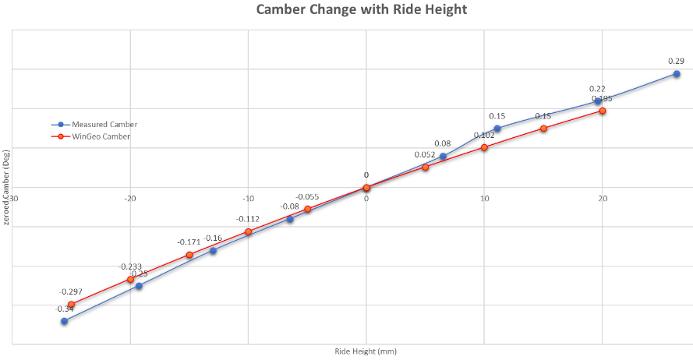
Figure 38 shows measured data against wingeo data for camber change against ride height. The camber changes in a linear fashion in both wingeo and in practice. The third test reading is brought to attention as an outlier which may indicate a bad reading due to human error, or that the suspension was not shortened by two rotations between measurement 2 and 3.
Figure 38: Camber change against ride height
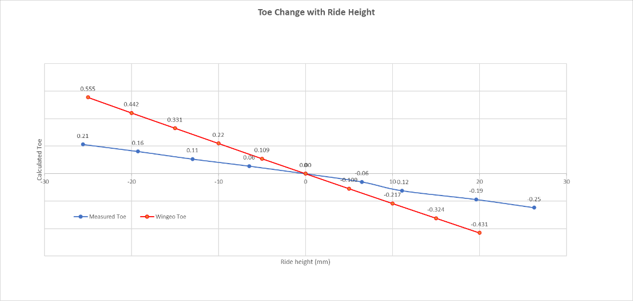
Figure 40 shows the Toe change against ride height for both data sets. The Toe in wingeo increased at double the rate measured in practice, this could be due to the increments of change in practice being done at half the rate compared to the input data in wingeo.
Figure 39: Toe change against ride height
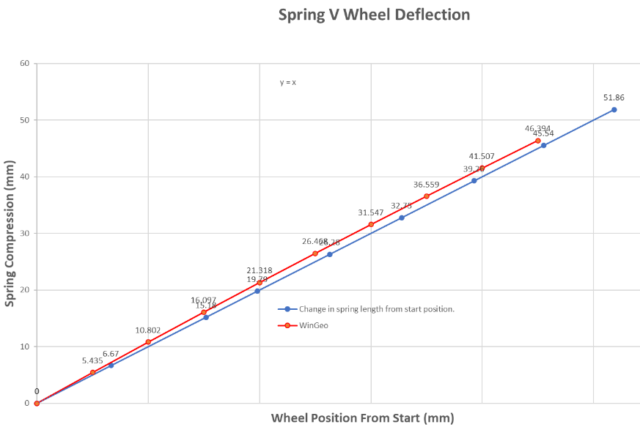
Figure 40 shows the measured data for spring compression against wheel deflection in wingeo and practice. Both results have near identical increments in data and trends. The graph shows that although wingeo moved in the same fashion, the data taken was slightly greater for the sping and wheel position.
Figure 40: Spring compression against wheel deflection.

6. Conclusion
The following technical report has shown how computer assisted programmes can have a large impact on the development and testing of a road vehicle. The results obtained in the laboratory sessions, when compared with wingeo show how accurate computer simulations are, giving proof that it is best in future to first run planned changes to a vehicle in a simulated environment in order to understand what the real procedure should achieve and point out any human error in advance.
The data collected also allowed the group to gain a finer understanding of suspension setups, how they affect a vehicles dynamic when changed and how best to modify the suspension system of a performance vehicle whilst aiming for a consistent and small range of change to the roll centre.

7. Citations
Spender, J. (2019). Car Suspension: Repair, Maintenance and Modification. (n.p.): Crowood.
Racing Aspirations. (n.d.). racing aspirations » Roll Center Movement (Kinematic). Retrieved December 9, 2021, from https://www.racingaspirations.com/roll-center-movement-kinematic/
By Jonathan Vogel. (2017, February 23). Tech Explained: Roll Centre - Racecar Engineering. https://www.racecar-engineering.com/tech-explained/tech-explained-roll-centre/
suspensiondesigner. (2021). KPI – Wheel Rate – Suspension Designer. https://www.suspensiondesigner.com/kpi-wheel-rate/
Matt Holden. (2016, September 12). Commodore’s Garage #6 - The Spring - iRacing.com | iRacing.com Motorsport Simulations. https://www.iracing.com/224202-2/

