Munyaradzi Nicholas Murira
Student No: 2211628

Course name: Structure an argument in a presentation

Aim: Structure an argument in a presentation in Google Slide

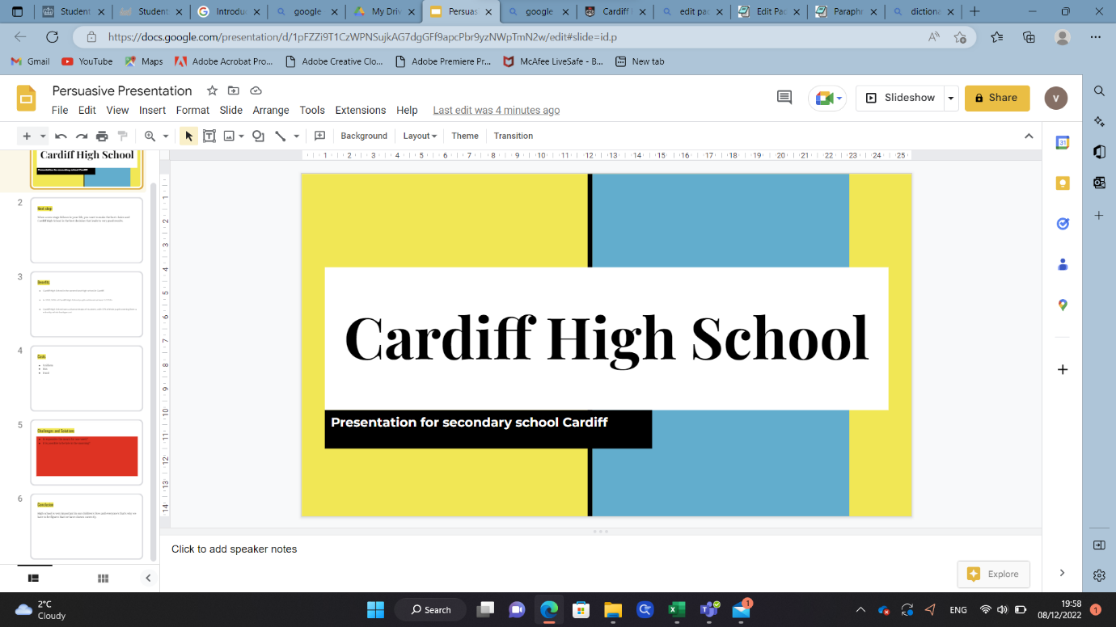
I tried to follow the steps to create a presentation in google slides

