[draft3]Research Proposal -
Impact of Machine Learning on Cybersecurity Operational Efficiency in Banking of Hong Kong – Moderating Role of Transformational Leadership

Student Name (ID): | Chiang Chun Wah, Ray (2119645)
Programme: | University of Wales Trinity Saint David – DBA
Module: | HKBM 7020 Assignment
Lecturer: | Dr. Alice Te

Table of Contents
1. Introduction 3
1.1 Trend and Significance 4
Trend 4
Significance 6
1.2 Research Background 6
Research Aim 8
Research Objectives 8
2. Literature Review 10
2.1 Machine Learning Techniques 10
2.2 Machine Learning for Cybersecurity Applications 12
2.3 Transformational Leadership Style for Innovation 15
2.4 Theoretical Framework 16
2.4.1 Background Theory 17
2.4.2 Factors in Satisfaction of Machine Learning 21
2.4.3 Summary of Theoretical Framework 23
3. Research Design 25
3.1 Research Philosophy and Approach 26
3.2 Research Methodology 26
3.3 Summary of Research Design 28
4. Expected Result 29
5. Research Work Plan 30
Reference List 31

List of Tables
Table 2.1: Summary of Studies Analysis 18
Table 2.2: Summary of Hypothesis 24
Table 5.1: Timeline of Work Plan 30

List of Figures
Figure 1.1: Loss of Cyberattack from 2018 to 2028 5
Figure 2.1 Research Framework 21
Figure 3.1: Research Flow for this Research 26

Introduction
In light of ongoing technological advancements and the ever-evolving business environment, it is imperative for organizations to dynamically reassess and realign their business strategies to adapt to external changes. This adaptive process often involves integrating technology into various aspects of business operations and everyday tasks, unlocking new opportunities to sustain a competitive edge (Ancillai et al., 2023). Over the past decade, breakthroughs in areas such as digitalization, cloud computing, and artificial intelligence (AI) have had a profound impact on enterprises, leading to significant transformations and presenting both challenges and a plethora of opportunities for growth and innovation (Chen, Wu and Zhao, 2023). For instance, cloud computing achieved widespread adoption by businesses just five years after its introduction. Similarly, AI technologies, including image and speech recognition and chatbots, began to emerge in 2016, culminating in the launch of next-generation AI solutions, like ChatGPT, by 2022 (Leme Lopes, 2023). In light of rapid technological advancements, organizations must comprehend sustainable innovation and evaluate the relevance of these technologies within their respective industries. Understanding and harnessing technological capabilities is vital for contemporary enterprises to thrive in a dynamic market. By integrating these advancements into their business strategies, organizations can better position themselves to seize opportunities and maintain their competitive edge; failure to do so may result in a loss of industry leadership. Ultimately, integrating these edge technologies is not operating with the trend but a critical strategy for enhancing operational capabilities and sustaining competitive advantage.
AI is set to be the disruptive technology with the force of the next decade, mainly due to its ability to enhance human capabilities at a low cost (Kelly, Kaye and Oviedo-Trespalacios, 2023). Bogatinovski et al. (2021) pointed out this technological advancement that is anticipated to improve everyday life by advancing information technology, and Murphy et al. (2021) further determined it positively impacts critical sectors such as healthcare, customer service, education, and transportation. Following its popularity, generative AI (GenAI) has emerged as a significant player within the AI landscape, drawing considerable attention and study. Tools like ChatGPT and Copilot exemplify this innovation, using machine learning to generate text, video, and music by leveraging existing data (Alamleh, Alqahtani and Elsaid, 2023). Most organizations (71%) that have adopted AI solutions report substantial returns on investment within just 14 months (Korolov, 2024).
Furthermore, the previous study showed that workers who use AI tools have a 14% increase in productivity; specifically, less skilled and experienced employees have up to 35% gain. Conversely, seasoned professionals have demonstrated a 59% increase in efficiency when writing business documents per hour (Noy and Zhang, 2023), while coding software projects have seen a remarkable 126% efficiency improvement (Peng et al., 2023). However, technology presents a dual challenge; while AI enhances organizational productivity, it can also be exploited for cyberattacks and criminal activities. According to Angela Romei (2024) surveys indicate that 37% of cyberattacks are attributed to AI-generated actions. Thus, while AI holds the potential to drive business growth when applied correctly, it also poses significant risks that could jeopardize organizational interests if mismanaged.

1.1 Trend and Significance

Trend
Cyberattacks can harm organizations, including data loss, financial repercussions, theft of intellectual property, system inaccessibility, leakage of personal and secret information, fraudulent transactions, interruption of business operations, and data and system recovery efforts. Additionally, such attacks can severely harm an organization's reputation. Since 2006, organizations have increasingly faced significant risks associated with cyberattacks (CSIS, 2024). Current estimates indicate that approximately 2,220 cyberattacks occur daily, culminating in over 800,000 incidents yearly (Charlton, 2024). The impact of these attacks can vary, ranging from minor disruptions in operations to substantial financial losses. Regardless of the nature of the cyberattack, each associated consequence incurs a specific cost, whether financial or otherwise. According to Statista (2024) report, they projected that the financial impact of cybercrime is expected to rise dramatically in coming four years, with losses anticipated to grow from around $9 to $14 trillion, that is shown in Figure 1.1. This trend underscores the importance of organizations developing a robust cybersecurity framework to mitigate security risks and safeguard their assets.

Figure 1.1: Loss of Cyberattack from 2018 to 2028
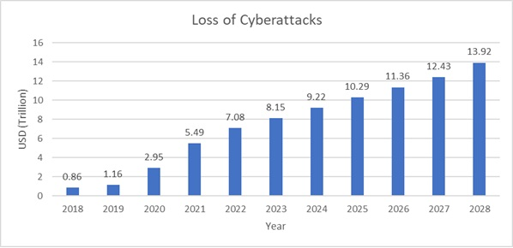

Technology has undeniably enhanced our lives and economic systems; however, it has also empowered hackers by providing them with advanced tools. Historically, cybercriminals relied on traditional phishing and social engineering techniques to deceive their targets. In recent years, artificial intelligence (AI) has allowed hackers to create convincing simulations of video and voice, thereby facilitating cyberattacks that effectively gain victims' trust. This trend poses an escalating threat as hackers increasingly adopt AI and machine learning (ML) technologies. The first instance of an AI-driven cyberattack was identified in 2017 (Yamin et al., 2021), highlighting the growing sophistication of these threats. An organization in India had a security breach where basic pattern recognition methods were used to understand the behavior of standard users in the network (Rosenbush, 2017). The malware therefore was able to emulate the behavior of the users thus making it difficult for the security systems to detect the malware as an intruder. In general terms, a cyberattack is the deliberate and coordinated attempt by one party to gain access to the computer networks of another party. Presently, companies face various cyber incidents, for instance, ransomware attacks, phishing scams, viruses, application of weak password, and social engineering. These incidents can lead to severe consequences, causing operational disruptions and substantial financial losses. Notably, a cyberattack on China's Industrial and Commercial Bank of China (ICBC), the largest bank in the world, and a ransomware incident that impacted the U.S. Treasury markets underscore the potential risks (Kharpal, 2023). In a striking case from 2024, a victim in Hong Kong transferred HKD 200 million to attackers who had successfully used deepfake technology to impersonate the CFO of the United Kingdom- based multinational company during a video conference (Hoi-ying, 2024). Such incidents highlight the urgent need for organizations to bolster their cybersecurity measures in response to evolving threats.

Significance
The increasing frequency and severity of cyberattacks each year pose significant challenges on a global scale, serving as a critical alert for cybersecurity professionals and organizations alike. This trend shows us the urgent necessity for effective measures to mitigate the threats within the cybersecurity landscape. As such, robust cybersecurity practices are essential for organizations, with effective defenses against cyberattacks vital to a business’s overall success. Integrating artificial intelligence (AI) into cyberattacks has further complicated the situation, particularly within Hong Kong’s banking sector, where security concerns have heightened (Farayola, 2024). Organizations in this industry are grappling with various cybersecurity challenges, including a shortage of skilled cybersecurity professionals in the labor market (Meineke, 2024). This makes it difficult to recruit experienced individuals to perform the routine security operations. Moreover, many organizations were still using legacy security systems and methods to analyze the threats; however, these approaches often fail to address the urgent external challenges they face effectively. Such outdated methods may prove inadequate against the sophisticated tactics employed in modern cyberattacks (Shwedeh, Malaka and Rwashdeh, 2023). As a response to this evolving threat landscape, leveraging AI technologies to combat AI-driven cyberattacks is emerging as a critical strategy for the future of cybersecurity (Sarker, Furhad and Nowrozy, 2021). Consequently, organizations must prioritize protecting their IT assets, especially internet-facing systems operating against cyberattacks. This issue must be addressed, and action must be taken immediately. This study explores how machine learning can address the challenges and impact the operation efficiency of cybersecurity.

1.2 Research Background
In the organizations, cybersecurity operations heavily depend on the effectiveness of security systems, employees experience, and tools designed to quickly and intelligently detect and prevent security incidents. Given the vast amounts of data handled by various entities, including government bodies, military organizations, corporations, financial institutions, and healthcare providers, there is a pressing need for comprehensive cybersecurity technologies and management tools. Cybersecurity encompasses governance, policy formulation, system design, procedural implementation, and ongoing monitoring to safeguard an organization's assets. Mohammadi et al. (2019) studied legacy security systems, such as antivirus, intrusion detection, firewalls, and antispam, are inadequate for addressing the evolving demands of today’s security landscape. These systems identify the threats based on the pattern and highly rely on experience to analyze the case one by one. In contrast, artificial intelligence (AI) is an innovative technology with considerable advantages that enhance capabilities in cyber-defense and monitoring. Therefore, this study focuses on AI that integrates into cybersecurity operations, aiming to automate and improve the efficiency of the operations.
Integrating AI within banking operations demonstrates a comprehensive scope, encompassing customer-facing operations and internal processes (Fares, Butt and Lee, 2023). Research conducted by HKMA reveals that 89% of financial institutions have embraced AI technologies (HKMA, 2019). The banking sector appears to be experiencing unprecedented transformation through AI adoption, where approximately 94% of institutions implementing such systems declared strategic alignment with corporate objectives. The fundamental catalysts driving this technological revolution encompass superior customer engagement metrics, enhanced cybersecurity protection, operational cost optimization, and enhanced risk mitigation protocols. This study investigation is propelled by the accelerating digitization phenomena and evolving cybersecurity landscape in banking operations. Machine learning (ML) is a type of AI for use in cybersecurity in the market. Most researchers studied ML nature, but they do not describe how to integrate it into cybersecurity measures (Mohammadi et al., 2019; Helm et al., 2020; Gorment et al., 2023). This research scrutinizes various barriers, privacy concerns, and system reliability while exploring viable solutions for precision and security measures within banking cybersecurity frameworks. Prior academic contributions have extensively documented AI's influence on service delivery optimization and cost reduction initiatives. Contemporary investigations by researchers, including Choithani et al. (2024) enhances customer service and reduce costs, AL-Dosari, Fetais and Kucukvar (2024) faced challenges when implementing it in the bank, and Mishra (2023)'s analytical framework provided a substantial theoretical foundation, Nevertheless, existing literature presents a notable gap regarding cybersecurity implications within Hong Kong's banking infrastructure.
Technology significantly boosts productivity and efficiency within organizations; however, effective leadership is crucial for maximizing the outcomes of technology implementation. Yating, Sains Malaysia, and Mengjiao (2024) identified the importance of leadership in guiding employees and enhancing their performance within organizations. Leadership entails the ability to influence, motivate, and direct followers or teams toward the achievement of organizational goals and objectives. Consequently, the leadership style adopted is viewed as a moderating factor in this study, particularly in examining the impact of cybersecurity on operational efficiency. This perspective emphasizes the interplay between leadership dynamics and technological integration in fostering a secure and efficient organizational environment.

Research Aim
This research aims to identify ML's operational efficiency within Hong Kong's banking cybersecurity infrastructure. ML deployment in cybersecurity frameworks manifests multifaceted implications due to its inherent unpredictability characteristics. The operational consequence spectrum encompasses advantageous and disadvantageous outcomes affecting cybersecurity protocol implementation. This investigation scrupulously examines diverse operational parameters, where security protocols intersect with privacy considerations while risk assessment frameworks converge with accuracy metrics. Moreover, the research scrutinizes trustworthiness indices alongside regulatory compliance mechanisms within the specified geographical context. The methodological approach incorporates a comprehensive analysis of these interconnected variables affecting cybersecurity operational efficiency.

Research Objectives
This study aims to identify the areas where ML is applied within the cybersecurity landscape of the banking sector and is guided by three main objectives. First, a comprehensive understanding of banking cybersecurity systems and AI applications offers a broad perspective when considering a robust cybersecurity framework (Herrmann and Masawi, 2022). This insight aids in prioritizing cybersecurity initiatives and effectively allocating resources to address the most pressing vulnerabilities. Second, the study highlights the significance of machine learning capabilities in enhancing operational efficiency in cyber defense for banks. ML algorithms can continuously adapt by learning from emerging patterns and threats, enabling informed decision-making. Lastly, by examining the impact of machine learning on cybersecurity operations, this research seeks to illuminate how ML can reduce human interaction, improve the detection rate, and reduce the response duration. Ultimately, it increases the overall efficiency of cybersecurity operations.
To fulfill these objectives, the study poses three research questions:
RQ1: Which operational capabilities does ML demonstrate when implemented within cybersecurity frameworks, specifically regarding threat detection and response mechanisms?
RQ2: How does ML implementation affect cybersecurity operational efficiency, considering both advantageous and disadvantageous outcomes within banking infrastructure?
RQ3: What leadership style is advantageous for innovation?

Literature Review
A comprehensive literature review provides essential insights into current research, theories, and practical applications concerning the merger of Artificial Intelligence (AI), Machine Learning (ML), and Cybersecurity within the Financial Services Industry (FSI). This review critically analyzes various influential studies and publications exploring the potential benefits, challenges, and ramifications associated with implementing these integrated strategies. Researchers have recognized the transformative potential of AI and ML in fortifying security measures within the FSI, emphasizing how these technologies can significantly enhance operational resilience against cyber threats.
The review identifies several key areas of focus, including (1) the diverse techniques employed in machine learning, (2) targeted applications of machine learning in cybersecurity, and (3) the role of transformational leadership in fostering innovation. It examines foundational research that clarifies both the advantages and difficulties inherent in adopting these integrated methodologies. Numerous studies underscore the groundbreaking impact of AI and ML in improving FSI security, illustrating their capacity to automate threat detection, accelerating response times, and strengthen efforts in fraud prevention.
Nonetheless, the literature also brings to light significant challenges that must be navigated, such as the necessity for rigorous data governance, the risk of algorithmic bias, and the continuous need for training and updating ML models to adapt to the evolving landscape of cyber threats. By synthesizing these findings, the review not only highlights opportunities for enhanced operational efficiency but also pinpoints essential factors that need consideration to effectively integrate AI and ML within cybersecurity practices in the FSI.
This in-depth understanding is crucial for informing future research initiatives and guiding practitioners as they maneuver through the complex and rapidly changing cybersecurity environment in an increasingly digital financial landscape. The insights gained from this review are instrumental for stakeholders aiming to leverage technology for improved security while addressing the multifaceted challenges presented by the digital age.

2.1 Machine Learning Techniques
Machine Learning have different learning methods that the public call “model”, including supervised, unsupervised, semi-supervised, and reinforcement learning (Taha, 2023). Each of these models offers unique methodologies and approaches for creating algorithms that enable systems to extract insights from data. The following section will clarify these paradigms and examine their specific applications.

Supervised Learning
The primary objective of supervised learning is to create a model that is guided by labeled datasets. In this methodology, the algorithm is structured to establish a connection between input features and their corresponding outputs using a dataset that includes both the input information and the related targets (Sarker, 2021). The intention is to develop a model that understands the link between the input and output data, allowing it to predict outcomes for new and previously unseen data. This approach is utilized across various domains, including image recognition and spam detection. For example, it analyzes the content of an email to classify it appropriately.

Unsupervised Learning
In contrast to supervised learning, unsupervised learning focuses on datasets that lack labels. This methodology seeks to identify significant patterns and structures within the data without the guidance of predefined output categories (Taha, 2023). The goal is to reveal meaningful groupings and generative features present in the dataset. Unsupervised learning encompasses tasks such as clustering, which organizes similar data points; feature learning; frequency analysis; dimensionality reduction; discovering correlation rules; and anomaly detection. This approach provides valuable insights into the underlying structure of the data and is often employed for exploratory data analysis.

Semi-supervised Learning
Semi-supervised learning merges elements of various learning methodologies by leveraging labeled and unlabeled data (Taha, 2023). This approach is particularly beneficial when labeled data is scarce but there is an abundance of unlabeled data (Sarker, 2021). The primary goal is to increase the forecast accuracy by extracting the information from these two types of data. Semi-supervised learning is extensively utilized in fraudulent activities, information classification, and translation. This hybrid method capitalizes on the strengths of supervised and unsupervised learning to provide a more robust model.

Reinforcement Learning
Reinforcement learning concentrates on training software agents or machines to make optimal decisions within a given environment (Gorment et al., 2023). This process involves a dynamic interaction where the agent learns from the feedback it receives, determining the effectiveness of its actions based on whether they yield positive or negative outcomes. The central aim is to either maximize cumulative rewards or minimize risks, with decisions being shaped by the feedback derived from the environment. Reinforcement learning has proven highly effective in training AI models for intricate tasks, including autonomous driving, automation in manufacturing, robotics, and managing supply chains. However, it is less effective when applied to simpler problem scenarios.

In summary, machine learning (ML) comprises several distinct methodologies:
- Supervised learning utilizes labeled datasets to discern the relationship between inputs and outputs.
- Unsupervised learning focuses on analyzing unlabeled data to identify underlying patterns and structures.
- Semi-supervised learning aims to enhance predictive accuracy by combining both labeled and unlabeled data.
- Reinforcement learning improves decision-making processes by incorporating feedback regarding the success or failure of actions taken.
Each of these methodologies possesses unique advantages and is applicable across various fields, playing a significant role in advancing artificial intelligence and automation technologies.

2.2 Machine Learning for Cybersecurity Applications
Cybersecurity operations include 3 fundamental sections: prevention, detection, and response (Li et al., 2019). In practice, totally preventing cyber threats is not possible; for instance, one cannot completely stop a hacker developing malware or send a phishing emails. Many ML applications in cyber defense focus on detection (Apruzzese et al., 2023). According to Sarker (2023), two main approaches to cybersecurity threat identification are signature-based and behavior-based. Signature-based method based on patterns corresponding to known threats. In contrast, behavior-based approaches do not depend on fixed patterns. Instead, they establish a baseline of normal behavior and identify harmful activities that deviate from this norm, interpreting such deviations as potential security incidents. These two approaches are complementary: signature-based methods excel at accurately detecting known threats, while behavior-based methods, despite a higher likelihood of false positives, are more effective at identifying novel attacks. However, those methods cannot detect zero-day attacks effectively, as these attacks do not have historical information that can be referenced. This limitation has prompted the exploration of advanced detection methods. Cybersecurity professionals increasingly leverage AI capabilities, including ML and deep learning (DL) techniques, to identify unknown malware (Martínez Torres, Iglesias Comesaña and García-Nieto, 2019). Within the field of cybersecurity, various threat detection systems are employed to enhance protection measures.

Network Intrusion Detection
Network Intrusion Detection is used to inspect and analyze network traffic to determine abnormal traffic or suspicious activities. It works by inspecting data packets traveling across the network and looking for suspicious patterns or behaviors that may indicate an intrusion or attack. In cybersecurity research, Apruzzese et al. (2017) have delved into the innovative use of clustering techniques to detect cyberattacks. Their investigation involved clustering NetFlows, data that encapsulates network traffic, by analyzing patterns of temporal behavior resembling one another. This meticulous approach led to identifying victim hosts that set off alarms within a network intrusion detection system (NIDS), which had traditionally relied on manual signature-based methods for threat identification. Incorporating machine learning (ML) techniques proved to be a transformative force, significantly enhancing the detection capabilities of the NIDS. Whereas the conventional signature-based system could only uncover a mere three malicious hosts, the integration of ML empowered the system to recognize a far more incredible array of threats, thus expanding the horizons of detection in the ongoing battle against cyber intrusions.
However, Apruzzese’s experimental environment is static that relied on the “VirusTotal” to feed a samples to system. VirusTotal is a free online website that allows visitor to upload suspicious files or URLs for analysis. It aggregates results from various antivirus engines and website scanners to comprehensively assess a file or link's safety. In real-world scenarios, skilled attackers often employ techniques to introduce perturbations to evade detection by security systems. This manipulation can significantly affect the effectiveness of detection mechanisms, leading to false negatives where malicious activities go undetected, posing substantial risks to organizations. Attackers may use data obfuscation, encryption, or altering behavior patterns to bypass security measures.

Malware Detection
Malware detection identifies and analyzes malicious software (malware) that can harm computers or networks. Malware includes viruses, worms, trojans, ransomware, and spyware. Two fundamental approaches to malware detection can be identified: static and dynamic analysis. The static analysis method involves examining a file to identify potential malware without executing it during evaluation (Gorment et al., 2023). This approach focuses on extracting specific properties from the file and scrutinizing these attributes using machine learning (ML) models. Conversely, the dynamic analysis method assesses the behavior of a file during its execution (Gorment et al., 2023). In this context, the anti-malware strategy involves executing the suspect file in a controlled environment called a "Sandbox." Here, the ML model meticulously monitors and analyzes the file's behaviors. This dual approach allows organizations to enhance their cybersecurity by employing proactive and reactive detection strategies, ultimately strengthening their defenses against potential threats.
Static analysis offers a straightforward and reliable method for identifying known malware, and its effectiveness can be further amplified by applying machine learning (ML) techniques. Li et al. (2017) discovered common properties among similar malware samples, facilitating improved Android operating system classification. Labeled data can significantly enhance detection rates, leading to greater accuracy. Kalash et al. (2018) demonstrated this potential by achieving an impressive detection rate exceeding 99% for Windows malware. However, a notable limitation of static analysis lies in its vulnerability to sophisticated attackers who can modify the malware's overlay pattern while preserving the underlying logic, thereby circumventing detection efforts. Experienced attackers often engineer malware capable of automatically altering executable parameters in response to the victim's system environment, undermining traditional detection methods' effectiveness. This highlights the need for continuous innovation and adaptation in malware detection strategies within the business landscape.

Phishing Detection
A phishing attack represents a form of cybercrime in which perpetrators seek to deceive individuals into disclosing confidential information, including login name, passcode, or credit card information. This deceit is typically executed through fraudulent emails, messages, or websites that convincingly mimic legitimate entities. Phishing continues to be a significant and enduring menace within the realm of cybersecurity, frequently employed as a tactic for breaching targeted networks. In their research, Alhogail and Alsabih (2021) present an innovative classifier for detecting phishing emails, which harnesses the power of deep learning techniques, specifically utilizing a Graph Convolutional Network (GCN) alongside Natural Language Processing (NLP) methods. The study highlights the increasing threat of phishing attacks, emphasizing that current detection methods are insufficient due to the evolving nature of these attacks. The proposed model demonstrates a high detection rate of 98.2% and a low false-positive result, showcasing its effectiveness in distinguishing phishing emails from legitimate ones based solely on email body text. The research offers significant insights for enhancing automated phishing detection mechanisms and suggests future applications in various text-based mediums, indicating the potential for broader implementation in cybersecurity.
However, Alhogail’s study focuses solely on the message text of phishing emails, neglecting to analyze attachments or URLs included in the emails. Phishing attacks often rely on these elements to deceive victims into opening attachments or clicking links, which can lead to the exposure of sensitive information. According to Positive Technologies (2024) analytics, 56% of phishing email with attachment, and 43% of phishing email with malicious links. By excluding attachments and URLs from the machine learning (ML) analysis, the research does not provide a comprehensive approach to detecting phishing attacks. This limitation means that the study may overlook critical aspects of phishing tactics, reducing its effectiveness in identifying such threats. For a more robust detection system, it's essential to consider all components of phishing emails, including attachments and URLs, to understand and combat these attacks fully.

2.3 Transformational Leadership Style for Innovation
Innovation is a key element in organizations that drive growth and sustain competitive advantage. A good leader plays a crucial role in the organization's achievement of innovation goals. The leader is like a coach who defines tactics, coordinates, and motivates the team members to achieve their goals. These behaviors refer to a leadership style, which is a classification of how leaders influence their subordinates or followers (Yating, Sains Malaysia and Mengjiao, 2024). In the early research, various leadership styles impact innovation performance, such as transformational, transactional, autocratic, and democratic leadership (Costa, Pádua and Moreira, 2023).
In this study, transformational leadership plays a moderating role in exploring the effect of the outcome of operational efficiency by using ML in cybersecurity operations. Transformational leadership leader has characters that encourage and inspire subordinates to reach their goal and exceed expectations (Korejan and Shahbazi, 2016). It involves a dynamic process in which leaders and subordinates engage in mutual influence, fostering collaboration and commitment to a shared vision. They encourage subordinates to have critical thinking and explore innovative ideas to foster an atmosphere for organizational development. This is precisely what organizations need to use innovative technology like ML.
Tayal et al. (2018) identified that transformational leadership significantly impacts information technology innovation. It shapes followers’ satisfaction by aligning their beliefs and values and motivating them to accept change. However, Tayal’s study did not include risk appetite. Risk appetite is an essential element of leadership when adopting and implementing cutting-edge technologies in the organization. It is the leader's willingness to take a risk while initiating or adopting new technologies in the organization. It is a key factor that affects the implementation scope and impacts the innovation outcome.

2.4 Theoretical Framework
Organizations must proactively assess their influence on the company and its operations before integrating new technologies or innovations. These considerations can arise from both external and internal environments. Various models analyze adopter groups' characteristics based on psychological and demographic factors, regardless of whether they pertain to individuals or organizations. Understanding these dynamics is essential for gauging the willingness to embrace technology or innovation effectively (van Oorschot, Hofman and Halman, 2018).

2.4.1 Background Theory
Numerous research models and theoretical frameworks have been developed to investigate the determinants influencing the adoption of new technologies (Hasani et al., 2023). Key among these frameworks are the Technology Acceptance Model (TAM), which focuses on user acceptance of technology (Alneyadi, Md Kassim and Yin, 2022), the Protection Motivation Theory (PMT), which examines how individuals are motivated to protect themselves from threats (Al-Kumaim and Alshamsi, 2023), the Diffusion of Innovation Theory (DOI), which explores how innovations spread within and across populations (Shaikh et al., 2023), and the Unified Theory of Acceptance and Use of Technology (UTAUT), which integrates various acceptance models to provide a comprehensive understanding of technology utilization (Alneyadi, Md Kassim and Yin, 2022). Each of these theories contributes valuable insights into the factors that drive or hinder the adoption of technological advancements in diverse contexts. Each of these frameworks serves to elucidate the processes involved in technology adoption. A significant body of research has focused on adopting new technologies in the context of cybersecurity within the financial services sector. Table 2.1 summarizes the key themes in existing studies and elaborates each framework below.

Table 2.1: Summary of Studies Analysis
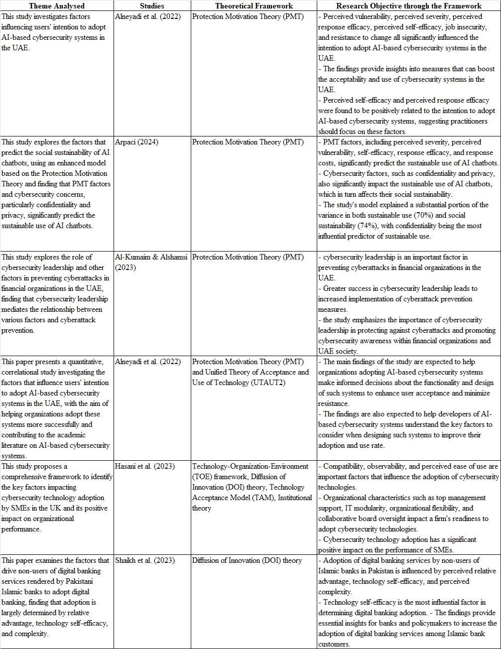

Protection Motivation Theory (PMT)
This theory is well-regarded for its insights into user behavior regarding technology acceptance (Al-Kumaim and Alshamsi, 2023). It focuses on individuals' motivations to protect themselves from perceived threats. The framework is built around two key elements: threat appraisal and coping appraisal (Alneyadi, Md Kassim and Yin, 2022). Threat appraisal involves an individual's evaluation of the likelihood and seriousness of potential harm. Specifically, perceived severity relates to the expected negative consequences of not adopting the recommended seriousness, while the vulnerability reflects the individual's awareness of the chances of encountering such harm (Farooq, Ndiege and Isoaho, 2019). On the other hand, coping appraisal includes factors like self-efficacy, response efficacy, and response costs. It signifies the belief that the recommended actions can effectively reduce harm, the individual's confidence in their capability to carry out the suggested behaviors, and the costs associated with implementing these behaviors.

Unified Theory of Acceptance and Use of Technology (UTAUT2)
The UTAUT2 model has been developed to extend the UTAUT model that was proposed by Venkatesh, Morris, Davis, and Davis in 2003 (Al-Okaily et al., 2020). This revised framework identifies two primary outcomes, behavioral intention, and usage behavior, alongside seven key predictors. These factors influence the user to accept and adopt new information technology (IT) systems. Effort expectancy, performance expectancy, and social influence variables directly affect user who are willing to accept and their behaviors. At the same time, the other factors are also strong predictors that predict the individual behavioral responses (Alneyadi, Md Kassim and Yin, 2022).

Technology Acceptance Model (TAM)
The TAM has received significant recognition while studying the adoption and utilization of new technology. It effectively reflects the users' intentions to adopt and utilize new technology across various contexts (Hasani et al., 2023). TAM provides critical insights into technology acceptance, its integration within organizational settings, and the determinants that affect user adoption (Chen, Wu and Zhao, 2023). The primary objective of TAM is to determine the relationship between accepting new technology, adopting intentions, and, ultimately, willingness to use the technology (Putri, Widagdo and Setiawan, 2023).

Diffusion of Innovation (DOI)
This theory functions as an essential framework for steering technological development by adeptly adjusting and showcasing innovations to accommodate different adoption levels. It underscores the significant role that peer interactions and communication play throughout the adoption journey (Hasani et al., 2023). The theory investigates how individuals adapt to new technologies, processes, concepts, and ideologies, categorizing them into five distinct segments: innovators, early adopters, early majority, late majority, and laggards. Each group represents a unique set of behaviors and attitudes toward the acceptance of new advancements, influenced by their social networks and communication patterns (Shaikh et al., 2023).
Innovators are characterized by their enthusiasm for technology, quick adaptability, and willingness to take risks. They typically possess extensive technical expertise and are comfortable with uncertainty regarding outcomes, displaying a strong motivation to accept new technologies. There are 2 stage for utilizing and accepting innovation that are implementation and initiation (Hasani et al., 2023). In practice, facing challenges catalyzes the adoption and diffusion of new processes or ideas. This awareness triggers the search for creative solutions to address the identified issue. Consequently, individuals navigate through five phases within the innovation-based decision-making framework (Shaikh et al., 2023): knowledge, persuasion, decision, implementation, and confirmation.

Summary of Theory
This study aims to evaluate the impact of ML on efficiency in cybersecurity operations. It is driven by different factors and adopts ML. Several theories were studied in the above section, and assessing the users’ intentions, accept new technology and adaption, the Diffusion of Innovations (DOI) theory is more appropriate framework for this study.

2.4.2 Factors in Satisfaction of Machine Learning
In section 2.4.1, a range of theories was explored. This study adopted DOI theory and integrated constructs associated with new technology, including complexity, relative advantage, and compatibility. Papernot et al. (2018) noted concerns regarding information security and data privacy risks in machine learning are significant. Training ML models can involve retaining sensitive data, which may render that data vulnerable to membership inference attacks. These considerations are critical in evaluating their impact on adopting this technology. Moreover, the transformational leadership variable is moderating to determine the interaction with the independence variables. Consequently, this research builds on the DOI theory and integrates perceived security and privacy risk with transformational leadership as vital factors for investigation, as illustrated in Figure 2.1.
Figure 2.1 Research Framework
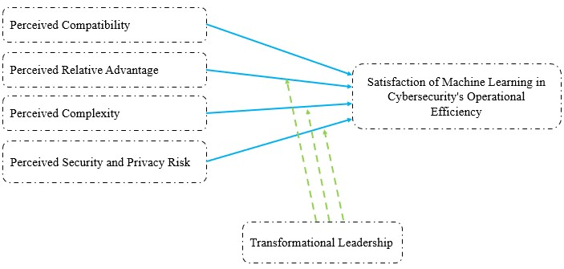

2.4.2.1 Perceived Compatibility
Perceived compatibility refers to the new technologies and how difficult it is to integrate with existing systems, reflecting the awareness of the effort that the latest technologies can be seamlessly integrated (Charlton and Cornwell, 2019). According to Shaikh et al. (2023), perceived compatibility describes a system that adheres to widely accepted standards, user experiences, and requirements. Thus, this concept is influenced by the resources available within an organization that facilitates implementing ML and the degree of integration of ML and cyber defense systems. Traditional banks often face historical and reputational challenges that differentiate them from emerging digital banks when adopting new technologies (Ya. A. Shmuratko and S. A. Sheludko, 2021). These institutions may struggle to adapt to technological advancements due to entrenched practices that obstruct the adoption of innovative solutions. Such resistance can lead to heightened security risks because their legacy cyber defense systems may not be compatible with new technological advancements. Consequently, the following hypothesis is proposed:
H1: The compatibility of machine learning is significantly associated with cybersecurity's efficiency.

2.4.2.2 Perceived Relative Advantage
Relative advantage refers to the perception that an innovation offers greater benefits than conventional methods. This concept includes advantages such as financial improvements, enhanced status, and greater efficiency (Shaikh et al., 2023). By leading transformational leadership, employees have a greater risk appetite for adopting a new feature, which can advance the capabilities of innovative solutions (Wipulanusat, Panuwatwanich and Stewart, 2017). By adopting innovative solutions, individuals can capitalize on these benefits and achieve favorable results across different activities. Therefore, the following hypothesis is proposed:
H2: The integration of machine learning, guided by transformational leadership, significantly enhances the efficiency of cybersecurity practices.

2.4.2.3 Perceived Complexity
As defined by Mohd Amir et al. (2020), complexity pertains to the difficulty and clarity associated with an innovation. Research by Izuagbe et al. (2019) indicates that increased complexity can adversely affect the adoption of new technologies. Nevertheless, transformational leaders motivate subordinates to tackle tasks and navigate challenges effectively (Wipulanusat, Panuwatwanich and Stewart, 2017). Given this context, it is crucial to examine whether machine learning (ML) positively impacts cybersecurity operations’ efficiency. Consequently, we propose the following hypothesis:
H3: The complexity of machine learning can be reduced by transformational leadership leaders, with a significantly positive impact on the efficiency of cybersecurity.

2.4.2.4 Perceived Security and Privacy Risk
ML models are designed to detect patterns from training data, which allows them to forecast the patterns on new datasets (Strobel and Shokri, 2022). Machine learning engages with various elements of sensitive organizational data during the model training process. The risk of data leakage arises when unauthorized individuals get this data in training or inference. It is a crucial consideration for cybersecurity operations. Adopting ML facilitates using cutting-edge tools and fosters innovative business solutions. Banks must implement comprehensive security strategies and controls to protect information assets (Lukonga, 2018). Transformational leaders are prepared to accept risks and inspire their followers to navigate the challenges of implementing innovation (Wipulanusat, Panuwatwanich and Stewart, 2017). Therefore, we propose the following hypothesis:
H4: Perceived security and privacy risk with transformational leadership positively impact cybersecurity operational efficiency.

2.4.3 Summary of Theoretical Framework
Machine learning can potentially raise significant concerns regarding data security and privacy within various processes. Furthermore, the preceding literature review primarily emphasizes quantitative approaches while neglecting professional opinions. IT expertise and professionals’ opinions are important inputs to studies in specific domain, like cybersecurity. Addressing these gaps is vital as organizations consider integrating machine learning into their cybersecurity frameworks. To lay the groundwork for this study, the DOI framework’s constructs and "perceived security and privacy risk" construct are determined in this studies. Four hypotheses were developed by understanding the contextual elements, summarized in Table 2.2.

Table 2.2: Summary of Hypothesis
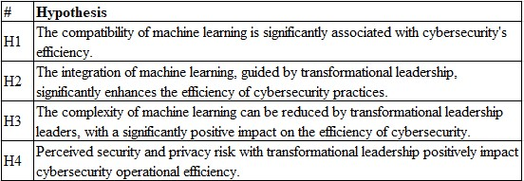

Integrating machine learning (ML) within the banking sector facilitates using sophisticated analytical tools and implementing innovative business solutions. Banks must establish robust security measures and adopt forward-thinking strategies to protect customer information and fulfill client expectations (Lukonga, 2018). Traditional banks often encounter more challenges than emerging digital banks when adopting new technologies. Adaptation to these changes can be complicated by existing practices that obstruct the implementation of innovative solutions. As a result, this situation may introduce security and privacy vulnerabilities into legacy financial and security systems, as new technologies might not be compatible with older infrastructures.

Research Design
This section delineates the methodologies employed in the study to guarantee a systematic framework for analyzing research actions and responding to research inquiries. It presents detailed information regarding the study, encompassing data collection and assessment techniques, applying various tools and methods, and the justification for the selected approaches (Bouchrika, 2024). The research design and activities were specifically crafted to address the research questions outlined in Section 1. Figure 3.1 illustrates the progression of this research.
Figure 3.1: Research Flow for this Research
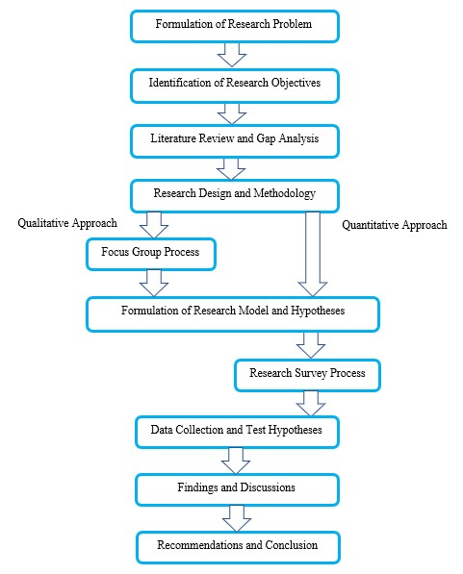

3.1 Research Philosophy and Approach
This research embraces a pragmatic philosophical approach, leveraging existing theories, concepts, and empirical findings to address the identified research problem while offering actionable solutions (Saunders, Lewis and Thornhill, 2023). It combines both theoretical and practical dimensions, employing a diverse array of methodologies and viewpoints to explore the research questions at hand. The study adopts an abductive reasoning strategy that extends the DOI theory, simultaneously introducing a novel factor that has been empirically validated through observational methods.

3.2 Research Methodology
Data collection methods are essential techniques employed to gather information for analytical objectives. Qualitative research frequently addresses inquiries by categorizing and analyzing factual or descriptive data (Hammarberg, Kirkman and De Lacey, 2016). This method involves collecting, examining, and interpreting participants' opinions or descriptive insights through interviews and focus groups (Rosenthal, 2016). In contrast, quantitative research is centered on collecting and analyzing numerical data, allowing researchers to describe, predict, or manage specific factors of interest (Goertzen, 2017). This approach typically employs tools like surveys or polls to amass data that can be explored and used for statistical predictions (Kelley-Quon, 2018).
This study adopts a mixed-methods approach, integrating both qualitative and quantitative methodologies. By leveraging the strengths of each method, this strategy enhances the validation of research findings. It allows qualitative data to be analyzed within a quantitative framework, and conversely, quantitative results can be used to corroborate qualitative insights (dos Santos et al., 2017). The research incorporates both primary data collected in real-time by the researcher, and secondary data from existing literature, ensuring a comprehensive and objective analysis (Ajayi, 2023).
Qualitative methodologies focus on capturing participants' perspectives, suggestions, and experiences related to the research topic (Hammarberg, Kirkman and De Lacey, 2016). To optimize data collection and foster meaningful interactions between researchers and participants, focus group discussions facilitated in-depth dialogue and knowledge sharing among participants. This group interview format allows for gathering insights from multiple individuals (Abraham et al., 2022), promoting an efficient and prosperous data collection process.
On the other hand, quantitative methods aim to gather and analyze numerical data objectively, which is crucial for hypothesis testing and measuring various factors (Apuke, 2017). This research used a questionnaire to collect data from IT industry employees, particularly those involved in Hong Kong's financial services sector. The mixed-methods approach not only enriches the understanding of the research topic but also enables cross-verification of data from multiple sources, yielding complementary insights and enhancing both flexibility and validity in the findings .

Comprehensive Understanding:
The mix-method integrates both methods, allowing for an extensive exploration of the research (Dawadi, Shrestha and Giri, 2021). Qualitative focus on understanding individuals' viewpoints, elaborate detailed and collecting information that leads to deeper insights. Conversely, quantitative methods provide statistical analysis and facilitate generalizability, enabling researchers to investigate patterns and relationships among different variables.

Cross-verifying:
This method also enhances the cross-check of data obtained from sources, strengthening the research's reliability and validity (Ijadi Maghsoodi et al., 2024). By corroborating findings derived from both methods, researchers can reinforce the base of their conclusions, reducing unconscious bias.

Complementary Insights:
Mixed-method yield complementary insights. Qualitative approaches concentrate on subjective experiences, constructing meaning and contextual factors that produce rich narratives and in-depth comprehension (Dawadi, Shrestha and Giri, 2021). In contrast, quantitative methods prioritize objective measurements, statistical analysis, and generalizability. Researchers can use strength of mixed-method, offering a comprehensive and balanced view of their study.

Flexibility:
Researchers can be flexible in designing the research and using the data collection techniques in mixed-method. They can combine both methods to align with particular research questions and objectives (Dawadi, Shrestha and Giri, 2021).

Validity:
Mixed-method can validate the findings using different data sources and statistical analysis results (Rahman, 2016). It can cross-check the assessment to reduce biases and provide study details.

3.3 Summary of Research Design
This research utilizes a mix-method that merges both qualitative and quantitative methods. This approach leverages the strengths of both methods, facilitating a more detailed understanding of the study, cross-checking the findings, and producing fruitful and solid conclusions. By using qualitative techniques, such as group discussion or interviews, and quantitative techniques, like statistical algorithms or modeling, researchers are able to gather sufficient information while simultaneously identifying schemes and predicting a trend within the data. This design is more holistic and investigates the problem in depth; ultimately, the research outcomes should be more reliable and credible.

Expected Result
This study's findings are expected to provide a detailed analysis of the specific cybersecurity defenses within Hong Kong's banking sector that can effectively incorporate machine learning technologies. By identifying these defenses, the research will elucidate how machine learning can be harnessed to bolster cybersecurity measures, thereby enhancing the overall security posture of banking institutions.
Furthermore, the study aims to explore the positive effects of implementing machine learning on operational efficiency, particularly in transformational leadership. This aspect is crucial, as transformational leaders can inspire and motivate teams to adopt innovative cybersecurity practices, fostering a culture of continuous improvement and adaptability. The research will investigate how integrating machine learning within cybersecurity frameworks can streamline processes, reduce response times to cyber threats, and ultimately lead to more efficient operations.
Conversely, the study will also assess the potential negative impacts of adopting machine learning in cybersecurity. These risks may include increased system complexity, potential overreliance on automated processes, and the possibility of introducing new vulnerabilities. By identifying these detrimental effects, the research will provide a comprehensive understanding of banking institutions' challenges when implementing advanced technologies.
Upon validating these results, the study will recommend strategies to reinforce the positive impacts identified and further enhance operational efficiency. This may involve optimizing existing machine learning applications, investing in training for staff to ensure they can effectively leverage these technologies, and fostering collaboration between cybersecurity teams and leadership to align strategic objectives.
The insights from this study will be invaluable for key stakeholders within banking institutions, including executives, the Chief Information Officer (CIO), the Chief Information Security Officer (CISO), and other cybersecurity stakeholders. By providing credible and actionable insights, the research will empower these leaders to make informed decisions regarding integrating machine learning into their cybersecurity strategies, ultimately leading to a more secure and efficient banking environment.

Research Work Plan
For guidance the research in these 3 years, the research work plan is developed and shows in Figure 3.1. The plan activities are listed in table 5.1 with high-level timeline.

Table 5.1: Timeline of Work Plan
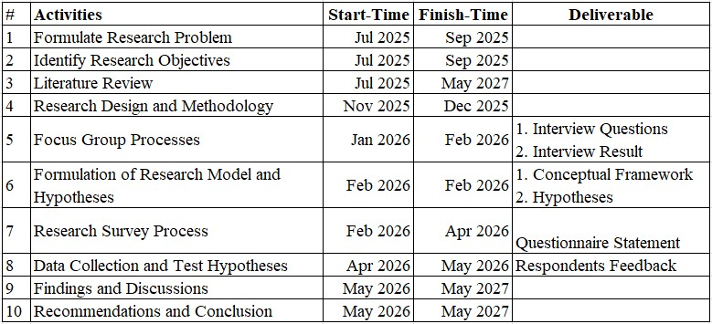

Reference List

