
Coursework

Computer Architecture

Lecturer: Dr. Anupam Mazumdar
Student: Martin Zhulyov
Student ID: 1912950

Contents
Section 1: Introduction 1
Section 2: PC Components 1
2.1 CPU 1
2.2 GPU 1
2.3 RAM 1
2.4 Motherboard 2
2.5 Hard drive 2
2.6 Power Supply Unit 2
Section 3: Case-Studies 2
3.1 Case-study Scenario 1 2
3.1.1 CPU and GPU 2
3.1.2 Motherboard 2
3.1.3 RAM 3
3.1.4 Internal data storage 3
3.1.5 Monitor 3
3.1.6 Keyboard 3
3.1.7 Case and power supply 4
3.1.8 Operating system 4
3.2 Case-study Scenario 2 4
3.2.1 CPU 4
3.2.2 GPU 5
3.2.3Motherboard 5
3.2.4 Internal data storage 6
3.2.5 Additional external data storage 6
3.2.5 RAM 8
3.2.6 Monitor 9
3.2.6 Power supply unit 9
3.2.7 Case 10
3.2.8 Operating system 10
Section 4: Shopping List Tables 11
4.1 Table for Scenario 1 (Created by the author) 11
4.2 Table for Scenario 2 (created by the author) 12
Section 5: Bibliography 13

Section 1: Introduction
The following coursework has the purpose to define the optimal selection of components for two different PC build scenarios.
Each component in Section 2 is carefully selected to be achieved an optimal price-performance ratio. With the price given as a factor, the price of the components is distributed as a proportional function with their importance in the system. Each component has been deeply analyzed and compared to other analogical and similar-priced ones.
The selection in Section 1 is emphasized on three key components (monitor, keyboard, and OS) as they are playing a major role in the usefulness of the build.

Section 2: PC Components

2.1 CPU
The CPU is the main processing unit in the PC’s hardware. The components of the CPU include:
- Registers;
- Instruction Register;
- Instruction Counter;
- Arithmetic Logic Unit (ALU);
- Control unit.
The two languages, that are working at a CPU dimension are Machine and Assembly languages. They are called also called Low-Level languages.
High-Level languages are anything that is not a machine or assembly language (Python, Java, C++, etc.). (Young, 2019)

2.2 GPU
Unlike the CPU, the GPU does parallel computations. It can do hundreds of complex computations at once.
‘' So, you can think of a GPU as that extra muscle or that extra brainpower that the CPU just can't do on its own.’’ (Hudak, 2019)

2.3 RAM
The RAM stores data temporarily, while the CPU is executing other tasks. More RAM equals faster computer speed. The two types of RAM are:
- DRAM;
- SRAM.
DRAM types are:
- SDRAM;
- RDRAM;
- DDR SDRAM – DDR1, DDR2, DDR3, DDR4. (ATP, 2018)

2.4 Motherboard
The motherboard is the main circuit board of the PC. It plays a vital role by establishing electronic connections between the PC's components. (Cockerham, 2018)

2.5 Hard drive
The hard drive stores software and files created by it. Unlike the RAM, the hard drive is permanent storage. The two types of hard drives are:
- HDD – slower than the SSD. It is vulnerable to physical damage.
- SSD – relatively new, smaller, much faster, and not vulnerable to physical damage. (Zandbergen, 2015)

2.6 Power Supply Unit
The power supply unit is a PC component that converts the power, provided from outside the system into usable power for the parts inside the PC system. (Fisher, 2020)

Section 3: Case-Studies

3.1 Case-study Scenario 1
As the PC will be used by an elderly person with vision issues, extreme care should be taken of what type of monitor is suitable and what will be the best keyboard.

3.1.1 CPU and GPU
The chosen processor is AMD Athlon 200GE. It has 2 cores and 4 threads, 3.2GHz base clock, 4MB cache. It is coming with integrated graphics card Radeon Vega 8. (Anon., n.d.)
This CPU has been chosen because it has good base clock speeds, has integrated graphics and its price is suitable for low-cost builds.

3.1.2 Motherboard
The motherboard is Gigabyte A320M-S2H mATX. Its socket is AM4 which is compatible with the processor. Its RAM technology is DDR4 SDRAM which is the most advanced one. It also supports PCIe NVMe. It has also Realtek Gigabit LAN with CfosSpeed internet accelerator software. (Anon., n.d.)
This motherboard has all the outputs needed for the elderly individual to perform basic computer actions. The DDR4 support will make the computer to execute its given actions faster when the motherboard is equipped with DDR4 RAM. The NVMe support will also deliver a higher experience in the user by reducing the time of loading the operating system. The internet accelerator will deliver smooth performance when surfing the internet.

3.1.3 RAM
The RAM will be Corsair Vengeance LPX 4GB DDR4 SDRAM. Its clock speed is 2400 MHz. (Anon., n.d.)
Lower model (DDR3, DDR2) could have also been a solution for this scenario, but for an example, similar-priced DDR3 ram is 10 pounds cheaper and its clock speed is 1400 MHz, which is much lower than the clock speed on the DDR4 module.

3.1.4 Internal data storage
Since the motherboard supports M.2 PCIe NVMe, for smoother and faster performance I have chosen WD Blue SN550 256GB NVMe SSD.
I think that 256 GB is enough, because the elderly person will not need much hard drive capacity as he has no intentions to play games, and maybe will only receive videos or pictures from his/her relatives through skype.

3.1.5 Monitor
Considering the eyesight issues of the elderly individual, I have chosen the following monitor, containing key characteristics that will not worsen his/her eye health status:
ASUS VZ279HE 27’’. It supports Low Blue Light technology and it is flicker-free. (Anon., n.d.)
This monitor is suitable for the scenario because its size is enough to satisfy the needs of the elderly individual. It has also features, which are friendly to the eyes' health.

3.1.6 Keyboard
This is the next component that should be customized with the elderly individual's eyesight issues. The following keyboard suits perfectly for that purpose:
Accurate Monster 2 – the symbols on the keys of this keyboard are extra-large which optimizes the experience when the elderly person is using it.

3.1.7 Case and power supply
CIT Classic m-ATX case, which comes with 500W power supply. It also has 4 USB ports, a microphone, and headphones sockets on the front panel for easy access. (Anon., n.d.)
This case was chosen mainly because it comes with a power supply attached to it, has a good price and the ports are on the front panel for easy access. The PSU unit can easily give the necessary power to the PC system, as its combined wattage usage is around 320.

3.1.8 Operating system
The OS should be simple, easy to use and it should not provoke doubt when the user is intending to take action.
This is why the chosen OS will be Linux Mint 19.3. Its minimum system requirements are:
- 1GB RAM;
- 15GB Disk space.
It comes with already installed Internet Browser, Email, Media players, and Libre Office. It has a description of each application on the bottom of the app menu. This helps the elderly person to make the right move quickly and accordingly. Viruses for this OS are extremely rare as Windows is widely used and the cybercriminals are targeting mainly Windows users. (Takacs, 2016)
This operating system has been chosen due to its simplicity. The description of each application on the bottom of the menu is very helpful and allows the user to do the right action.

3.2 Case-study Scenario 2
When building 4K Video editing PC, special attention should be paid to each component’s key features:
- More CPU cores for faster video processing;
- Motherboard with digital power phases (the power for the CPU is controlled digitally, which is more efficient for faster performance);
- Preferable 32 GB of RAM (the amount and the speed of the ram affects the time to process the video’s render previews);
- SSD usage as its reading and writing speed is much faster than those on the HDD. (MSI, n.d.)

3.2.1 CPU
Throughout the research of many possible CPU's, I have stopped at two similar-priced options:
- AMD Ryzen 3900x;
- Intel i9-9900k.
The I9 comes with 8 cores and 8 threads, 3.6 GHz speed per core, 16MB cache memory, and 95 watts of power consumption. It is a good processor overall, but I didn't like the number of cores, threads, and cache memory. (Anon., n.d.)
The 3900x surpasses it by many characteristics. It incorporates 12 cores, 24 threads, 3.8 GHz core speed, 70 MB cache memory, and 105 watts of power consumption. (Anon., n.d.)
The number of cores, threads, and cache memory in the AMD CPU allows it to process larger amounts of data without complications. The number of cores are suggested by MSI.com also.
My overall decision was based on the above facts.

3.2.2 GPU
Powerful GPU is a must when it comes to what video is going to be produced on the screen. The final chosen two GPU interfaces are:
- EVGA Nvidia GeForce RTX 2070 Super KO Gaming;
- Gigabyte Nvidia GeForce RTX 2060 Super WindForce OC.
The RTX 2070 Super is newer and costs £150 more than the RTX 2060. It comes with 8GB DDR6 memory, 256 memory bandwidth, 2560 CUDA cores – 14Gbps memory speed, 1605 and 1770 MHz base, and boost clock respectively. (Anon., n.d.)
The RTX 2060 is cheaper and it is more equivalent than different when it comes to comparison with the RTX 2070. It contains also 8GB DDR6 memory, 256 memory bandwidth. The Cuda cores are 2176 with 14Gbps memory speed, 1470 and 1560 base, and boost clock respectively. (Anon., n.d.)
My overall decision was choosing the first option, which is more efficient because the 2070 Super surpasses the RTX 2060 by all the features. It also delivers real-time ray tracing, which is very helpful for 4K Video projects.

3.2.3Motherboard
The Motherboard should be compatible with the brand of the CPU. MSI x570 motherboards are compatible with 3rd generation AMD processors, so I have chosen the MSI x570 Prestige Creation. Its key features, some of which are increasing the 4K video editing productivity are:
- 8 USB 3.2 Gen1, 3 USB Gen2 Type-a and 1 USB Gen2 Type-C ports;
- Lightning Gen4 M.2 solution with up to 64GB/s bandwidth for optimal transfer speed;
- Onboard 10G Super LAN high-bandwidth, high-density, and low-latency networks. It is one of the best solutions for 4K Video content creators;
- Optical S/PDIF Output;
- M.2 XPANDER-Z GEN4 for larger storage and faster operation speed;
- 7.1 channel Realtek High Definition Audio.
It is designed to prevent over-heating by enlarging the surface of heat dissipation. It optimizes the speed of communication between the PC components and allows also faster internet connection for the transfers within the network. (MSI, n.d.)
This Motherboard is one of the best solutions because it has all the features needed for 4K video editing. It supports S/PDIF, it has 64GB/s bandwidth, and it is the latest generation MSI AMD-compatible motherboard. It also supports the third generation AMD processors and maximizes the processor's productivity through its digital phases. I think that the given name of the motherboard "Creation" comes from creativity or it is designed for creative individuals, creators. 4K video editors are easily falling into this category.

3.2.4 Internal data storage
To be maximized the potential of productivity, the internal data storage will be separated into two parts:
- The NVMe SSD will be dedicated to deal with the operating system and the software for the working projects;
- The SATA Drive will be used for storing and backing up the footage.
The NVMe SSD will be Sabrent 1TB Rocket PCIe 4.0. Its data transfer rate is 5 GB per second. (Amazon company, n.d.)
This SSD has been chosen due to its ultra-fast transfer speeds, which are reachable because of the latest PCIe 4.0 technology. The motherboard supports this technology.
The SATA HDD will be Seagate Barracuda 8TB. Its write speeds are 7200 RPM, which are much bigger than the 5400 RPM on the most HDDs. (Anon., n.d.)
8TB of space is considered as enough as per the assignment requirements, the NAS drive will have to have also 8TB starting space.

3.2.5 Additional external data storage
To overcome the reliability challenge, using extra disks, containing redundant information is vital. This is called the RAID mechanism. RAID stands for Redundant Arrays of Inexpensive Disks.
How does Raid work? When a disk fails, within a short time the disk is replaced and the data is written on a new disk using the redundant information. This short time is called MTTR (Mean Time to Repair). The MTTR can be minimized if the system contains extra disks and the failed disk is replaced by a spare disk electronically. (Patterson, et al., n.d.)
As per the assignment’s requirements, a suitable NAS drive will be Synology DS1817. Its price is £850. It has 8 slots for Hard Drives and supports up to 80TB storage. It supports RAID 0, 1, 5, 6, and 1+0. The likely speeds to be achieved are 1.6GB/s and 740MB reading and writing respectively. (Ebuyer, n.d.)
The NAS will be connected with the PC via ethernet cable. Then it will be mapped on the PC, following the next steps:
- Right click on This PC Map network drive…;
- Enter data for the new drive (e.g. Drive start letter and folder);
- When the process of entering data is finished, a window will appear, confirms that the computer is connecting to the network drive;
- Once the folder Is connected, it will be visible on the side of This PC window as separate storage, next to the hard drive. (Anon., 2020)

Since the only 8TB of space is needed in the beginning, the NAS drive will be equipped with two 8TB NAS Hard drives, one of which will be used for redundancy purposes. The raid mechanism that will be used until disk space expansion is needed, will be RAID 1 (at this point RAID 5 cannot be used since it requires at least three HDDs). RAID 1 requires only two disks and half of the space will be reserved for redundancy. When the user decides to buy the third 8TB Hard drive, the raid mechanism will be changed.

The two RAID mechanisms that I have considered as reliable after the expansion are: RAID 5 and RAID 6.

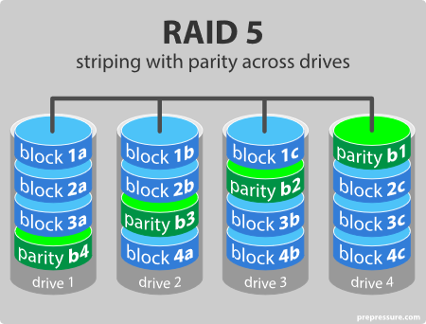
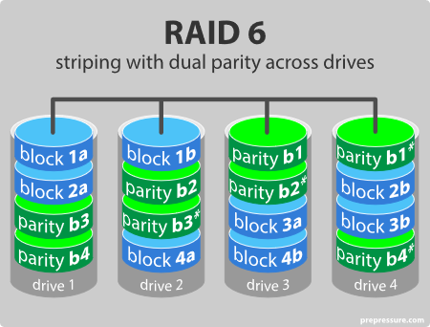
Figure 1: Raid 5. Source: (Prepressure, n.d.) Figure 2: Raid 6. Source: (Prepressure, n.d.)

- RAID 5 Requires 3 Hard Drives at minimum, one of which will be used the data to be protected in the events of a drive failure. The read speeds are similar to those on RAID 6. And it supports 1 drive failure. (Sebastian, 2013)
- RAID 6 requires at least 4 Hard Drives, two of which will be used for redundancy purposes and supports two HDD failures. It has the lower actual capacity and writes speeds than RAID 5. (Sebastian, 2013)
The chosen mechanism will be RAID 5 because it has greater write speeds, requires only 1 HDD of the overall HDD space for redundancy purposes, while RAID 6 requires two hard drives for redundancy and it less cost-effective. RAID 5 will fulfill the assignment requirements because when the NAS is equipped with 8x8TB HDDs and when using RAID 5, the exact space available will be 56TB. The RAID 6 supports two HDD failures, but it has lower capacity and lower write speeds. but it is extremely unlikely two failures to occur, so it was not considered as a factor for choosing it over RAID 5.

3.2.5 RAM
As mentioned above, the amount of RAM fastens the productivity of the PC. As there is not much difference between the price for 16GB and 32GB ram, I considered the following two 32GB (2x16) sets of RAM:
- Corsair Vengeance RGB Pro DDR4 SDRAM (AMD Optimised);
- Crucial Ballistix RGB DDR4 SDRAM.
Both of them are the latest generation (DDR4) SDRAM and are similar-priced, but the Corsair Vengeance has a memory clock speed of 3600MHz, compared to 3000 in Crucial Ballistix. (Anon., n.d.)
The faster clock speed and the AMD optimization makes the first option more relevant.
32 GB of RAM was considered because it is recommended by MSI.com for faster PC performance.

3.2.6 Monitor
The video editors need high-quality monitors so they can be able to spot the effects and the changes after the editing is done. The colors are playing also major role because if they are not visible, the video editor is facing difficulties during the editing process and the final result might not be as good as it should. Also, the resolution standard should be UHD-1, which is also called 4K for TV productions. It delivers 3840x2160 resolution level with a 16:9 aspect ratio. (Brown, 2020)
Using the above sentences as guidelines when choosing a suitable monitor, I have stopped to BenQ PD2700U 27 inch with 4K UHD 2160p resolution, display max resolution of 3840 x 2160 pixels. It also is flicker-free and has a low blue light mode. It has picture profiles like sRGB and dark-room. It has also dual-view feature, which splits the screen into two parts, each of which can be run in a custom picture profile.
The monitor has the following ports:
- HDMI 2.0;
- Display input;
- Display output;
- 2x USB 3.1 upstream;
- 4x USB 3.1 downstream. (Amazon company, n.d.)

3.2.6 Power supply unit
The PSU is also as important as the other components. There is a large amount of power supply calculators in the sites of the PSU brands. Using the one available at https://outervision.com/power-supply-calculator showed that this system will require 650 watts of power. One of the sections in COA module, available at www.moodle.uwtsd.ac.uk advises that the rule the PSU unit power should exceed by 25% the sum of the wattage of the components.
Pointing out of this and considering a future upgrade, I chose 850-watt Corsair RM850. It is compatible with the chosen motherboard and contains 80Plus technology, which makes it very energy efficient.

3.2.7 Case
The form-factor of the motherboard is e-ATX and the other components are powerful. The case should provide enough space for the motherboard and as much as more cooling fans places. The above sentences made me choose the CoolerMaster Masterbox TD500 Mesh e-ATX case (compatible with the dimensions of the motherboard).

3.2.8 Operating system
The PC has enough RAM to run a 64-bit operating system smoothly. The chosen OS will be Windows 10 Home 64-bit. The processor type of the build is also 64-bit.
The reason for choosing Windows 10 is that the previous Windows operating systems are no longer supported by the windows update. This is making them vulnerable to software viruses.

Section 4: Shopping List Tables

4.1 Table for Scenario 1 (Created by the author)

Product name | Product picture (The source  for all pictures is amazon.co.uk  and the quantity is 1) | Product price
AMD Athlon 200GE CPU & Radeon Vega GPU |  | £51.76 @ amazon.co.uk
Gigabyte A320M-S2H | 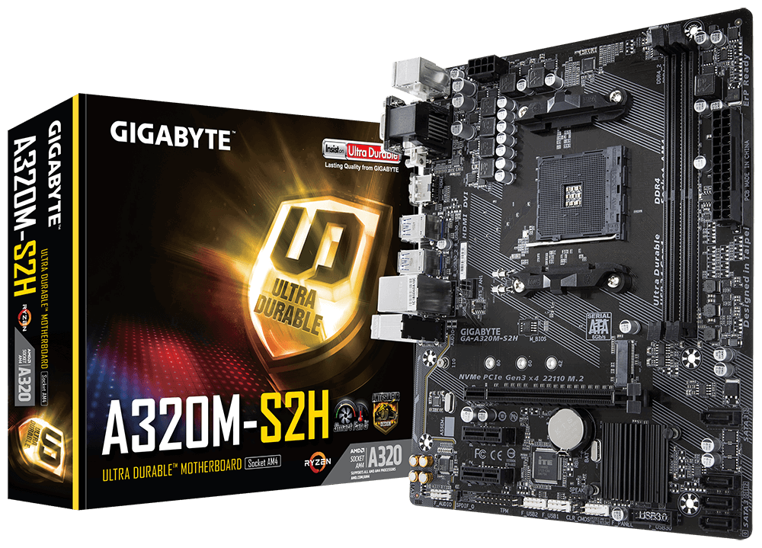 | £43.74 @ amazon.co.uk
Corsair Vengeance LPX 4GB | 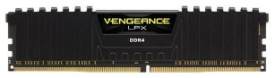 | £24.19 @ amazon.co.uk
WD Blue SN550 nVME | 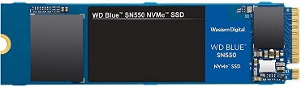 | £48.99 @ amazon.co.uk
ASUS VZ279HE 27’’ | 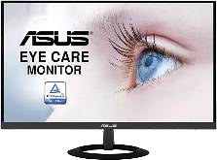 | £185.12 @ amazon.co.uk
Accurate Monster 2 |  | £35.04 @ amazon.co.uk
CIT Classic mATX + 500W PSU |  | £40.50 @ amazon.co.uk
Linux Mint 19.3 |  | Free
 |  | Total Price: £429.34

Product name | Product picture (The source  for all pictures is amazon.co.uk  and the quantity is 1) | Product price
AMD Ryzen 3900x 12C/24T, 70MB Cache CPU | 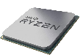 | £419.99 @ amazon.co.uk
EVGA NVidia GeForce RTX 2070 Super KO Gaming | 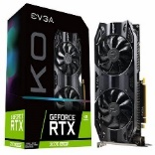 | £524.99 @ amazon.co.uk
MSI x570 Prestige Creation e-ATX Motherboard | 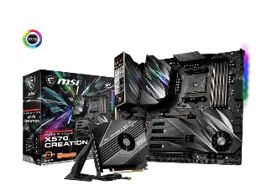 | £420.00 @ amazon.co.uk
Sabrent Rocket 1TB PCIe 4.0 nVME | 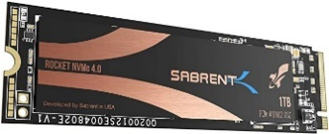 | £169.99 @ amazon.co.uk
Seagate BarraCuda 8TB 7200 RPM HDD |  | £166.00 @ amazon.co.uk
Corsair Vengeance RGB Pro DDR4 SDRAM (2x16 GB) | 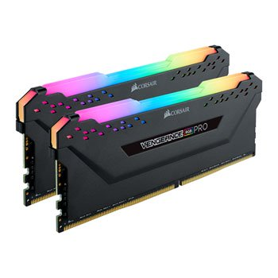 | £151.86 @ amazon.co.uk
BenQ PD2700U 27” 4K UHD 2160p | 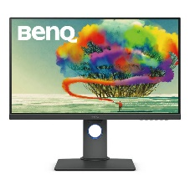 | £429.00 @ amazon.co.uk
Corsair RM850 PSU | 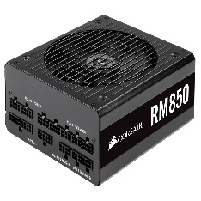 | £139.99 @ box.co.uk
CoolerMaster Masterbox TD500 Mesh e-ATX Case | 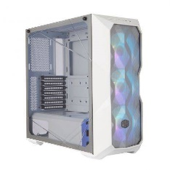 | £86.99 @ amazon.co.uk
Windows 10 Home |  | £93.44 @ Microsoft.com
 |  | Total Price: £2602.25

4.2 Table for Scenario 2 (created by the author)

Section 5: Bibliography

Anon., 2020. University of Nevada. [Online]
Available at: https://oit.unr.edu/services-and-support/data-storage/network-data-storage/nas-mapping-a-network-share-pc/
[Accessed 19 08 2020].
Anon., n.d. Amazon. [Online]
Available at: https://www.amazon.co.uk/Gigabyte-A320M-S2H-Socket-S-ATA-Micro/dp/B078KBKFZ6/ref=sr_1_1?dchild=1&keywords=gigabyte+a320m-s2h&qid=1598293879&sr=8-1
[Accessed 17 08 2020].
Anon., n.d. Amazon. [Online]
Available at: https://www.amazon.co.uk/CiT-Included-Friendly-Business-Solution/dp/B07BFH98R2/ref=sr_1_2?dchild=1&keywords=cit+classic+case&qid=1598294005&sr=8-2
[Accessed 17 08 2020].
Anon., n.d. Amazon. [Online]
Available at: https://www.amazon.co.uk/AMD-Ryzen-3900X-Processor-Cache/dp/B07SXMZLP9/ref=sr_1_3?dchild=1&keywords=ryzen+3900x&qid=1598294096&sr=8-3
[Accessed 17 08 2020].
Anon., n.d. Amazon. [Online]
Available at: https://www.amazon.co.uk/Gigabyte-GeForce-2060-Super-WINDFORCE/dp/B07V48X1ZQ/ref=sr_1_2?dchild=1&keywords=rtx+2060+windforce+oc&qid=1598294278&sr=8-2
[Accessed 17 08 2020].
Anon., n.d. Amazon. [Online]
Available at: https://www.amazon.co.uk/Corsair-Vengeance-Enthusiast-Illuminated-Memory/dp/B07GTG2T7L/ref=sr_1_1?dchild=1&keywords=corsair+vengeance+rgb+pro+32gb&qid=1598295183&sr=8-1
[Accessed 17 08 2020].
Anon., n.d. Amazon. [Online]
Available at: https://www.amazon.co.uk/Corsair-CMK4GX4M1A2400C14-Vengeance-Performance-Desktop/dp/B00UVN2BO4/ref=sr_1_2?dchild=1&keywords=corsair+vengeance+lpx+4gb&qid=1598293923&sr=8-2
[Accessed 17 08 2020].
Anon., n.d. Amazon. [Online]
Available at: https://www.amazon.co.uk/Intel-i9-9900K-Processor-Unlocked-BX806849900K/dp/B089J731BX/ref=sr_1_4?dchild=1&keywords=i9-9900k&qid=1598294056&sr=8-4
[Accessed 17 08 2020].
Anon., n.d. Amazon. [Online]
Available at: https://www.amazon.co.uk/Seagate-ST8000DM004-Barracuda-internal-Silver/dp/B075WYBQXJ/ref=sr_1_3?dchild=1&keywords=seagate+barracuda+8tb&qid=1598294465&sr=8-3
[Accessed 17 08 2020].
Anon., n.d. Amazon. [Online]
Available at: https://www.amazon.co.uk/EVGA-GeForce-SUPER-GAMING-08G-P4-2072-KR/dp/B086VSXK1R/ref=sr_1_5?dchild=1&keywords=rtx+2070+super&qid=1598294152&sr=8-5
[Accessed 17 08 2020].
Anon., n.d. Amazon. [Online]
Available at: https://www.amazon.co.uk/AMD-YD200GC6FBBOX-Athlon-Processor-Graphics/dp/B07HJWVJDN/ref=sr_1_1?dchild=1&keywords=amd+athlon+200GE&qid=1598293505&sr=8-1
[Accessed 17 08 2020].
Anon., n.d. Amazon. [Online]
Available at: https://www.amazon.co.uk/ASUS-VZ279HE-Monitor-Ultra-Slim-Certified/dp/B073Q2Q7MD/ref=sr_1_1?dchild=1&keywords=asus+vz279he&qid=1598293761&sr=8-1
[Accessed 27 July 2020].
ATP, 2018. Understanding RAM and DRAM Computer Memory Types. [Online]
Available at: https://www.atpinc.com/blog/computer-memory-types-dram-ram-module
[Accessed 07 July 2020].
Brown, L., 2020. 9 Best 4K Monitors for Video Editing in 2020. [Online]
Available at: https://filmora.wondershare.com/4k/best-4k-monitors-for-video-editing.html
[Accessed 08 July 2020].
Cockerham, R., 2018. What is the function of the Computer Motherboard?. [Online]
Available at: https://www.techwalla.com/articles/what-is-the-function-of-the-computer-motherboard
[Accessed 09 July 2020].
Ebuyer, n.d. [Online]
Available at: https://www.ebuyer.com/792510-synology-ds1817-8-bay-desktop-nas-enclosure-ds1817?wgu=267255_29553_15982221843126_e589eacd04&wgexpiry=1605998184&utm_source=webgains&utm_medium=referral&utm_content=10800&utm_campaign=idealo%20Internet%20GmbH_29553
[Accessed 23 August 2020].
Fisher, T., 2020. Computer Power Supply.
Hudak, A., 2019. Video - What is a GPU?. [Online]
Available at: https://www.ibm.com/cloud/blog/video-what-is-a-gpu
[Accessed 07 July 2020].
MSI, n.d. The productive 4K Video editing PC build.. [Online]
Available at: https://www.msi.com/Landing/motherboards-for-4k-video-editing-pc-build
[Accessed 7 July 2020].
Patterson, D., Gibson, G. & Katy, R., n.d. A Case for Redundant Arrays for Inexpensive Disks.. In: California: University of California, pp. 109-116.
Prepressure, n.d. RAID. [Online]
Available at: https://www.prepressure.com/library/technology/raid
[Accessed 4 August 2020].
Prepressure, n.d. RAID. [Online]
Available at: https://www.prepressure.com/library/technology/raid
[Accessed 4 August 2020].
Sebastian, L., 2013. RAID 5 & RAID 6 - All You Need to Know as Fast As Possible. [Online]
Available at: https://www.youtube.com/watch?v=1P8ZecG9iOI
[Accessed 08 July 2020].
Takacs, M., 2016. Top 5 Linux systems for elderly people. [Online]
Available at: https://takacsmark.com/the-top-5-linux-systems-for-elderly-people/#linuxmint
[Accessed 28 July 2020].
Young, 2019. Computer Hardware (Overview and CPUs). CS106E, p. 12.
Zandbergen, P., 2015. What is a Hard Drive? Types, function and definition.. [Online]
Available at: https://study.com/academy/lesson/what-is-a-hard-drive-types-function-definition.html
[Accessed 07 July 2020].

