L4 - Introduction to Web and Database Concepts
Assignment 2 – HTML & CSS Web Development

2401039
Jac Cromwell

Table of Contents
Introduction 2
Requirements 2
Implementation 2
Evaluation 6
REFERENCES 8
Appendices 8

Introduction
This report is a detailed run-through of the website I created which is targeted at people trying to learn about rock bands and/or rock music. It includes an analysis of how I designed the website and it’s functionality. The plan and requirements that I set before creating the website which are catered to the target audience. This document will also show the implementation of the website with screenshots and then an evaluation of the website and its features and functionality. All in all it will be a high level documentation for the website covering all angles of its quality and design. It will conclude with an Appendices with the code that I wrote to create the website itself.

Requirements

The websites main purpose is to educate people who want to learn about rock bands, this is primarily music students who are in need of study material to learn about these bands and their music or just out of personal interest wanting to learn more about rock music. On top of that this website could also be used as material by lecturers and teachers as they could create lessons or tasks surrounding the information that this website provides. The goal of the website was to be for everyone therefore the colours needed to be simple, easy to read and not too distracting therefore a good contrast but not vibrant. By creating the website I’m trying to make it easier for them to gain information by storing it all in one place and making it easy to access, navigate and read. Therefore they will not have to spend hours searching through books and online blogs with lengthy text just to search for the brief information about the bands that they need. The website needed to cover things like how the bands were made, when they were made, what albums and music they’ve produced and any significant events that have happened to the band. It also needed to have photos of the bands so that it wasn’t too text heavy and blog-like. With the photos and information the website can help provide more recognition to the more unkown bands that lie under the radar although they produce very good music.
To add the information displayed on the website will have to be reliable and correct and sourced from reliable sources via research. The website will also need room to expand in future therefore it needed no indications of it being a complete project and for any questions or support it should have contact information along with a copyright badge. This should be out of the way in a footer or corner of the page. Lastly the website should indicate how the rock genre has evolved over the decades by going from bands in each decade, explaining what type of rock they played and how it differs and display any clear patterns in each decade so that the users can see how rock music has evolved over the decades.

Implementation
The home page (index.html)
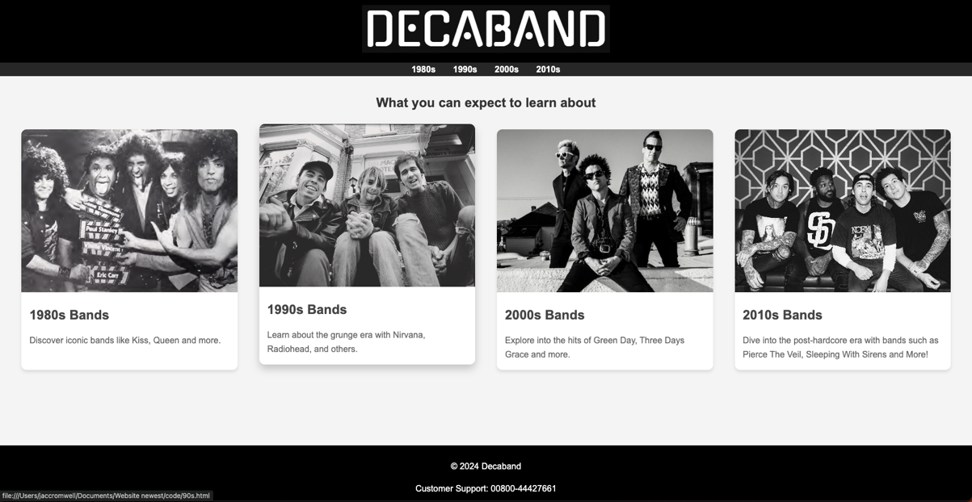
This is the websites homepage. It is simple with a black, white and grey contrast which is consistent throughout the website. It also contains the navigation bar and header at the top of the page with the website’s logo clearly displayed. Within the navigation bar are four buttons, leading to the other four pages that the website contains. The navbar has hover features so that the buttons highlight when you hover over them making it clear which button your are above. Similarly the photocards in the center of the page also raise when hovered over like you can see above I’m hovered over the 1990s card. These photocards are also functional and by clicking on them you will be directed to the said page. Within the photocards are a very brief description of what you can expect to find in them pages and an image of a band that may appear in that page. Lastly the page contains a footer on the bottom with a copyright badge for the website and information on how to contact support for the website.

The 1980s page (80s.html)
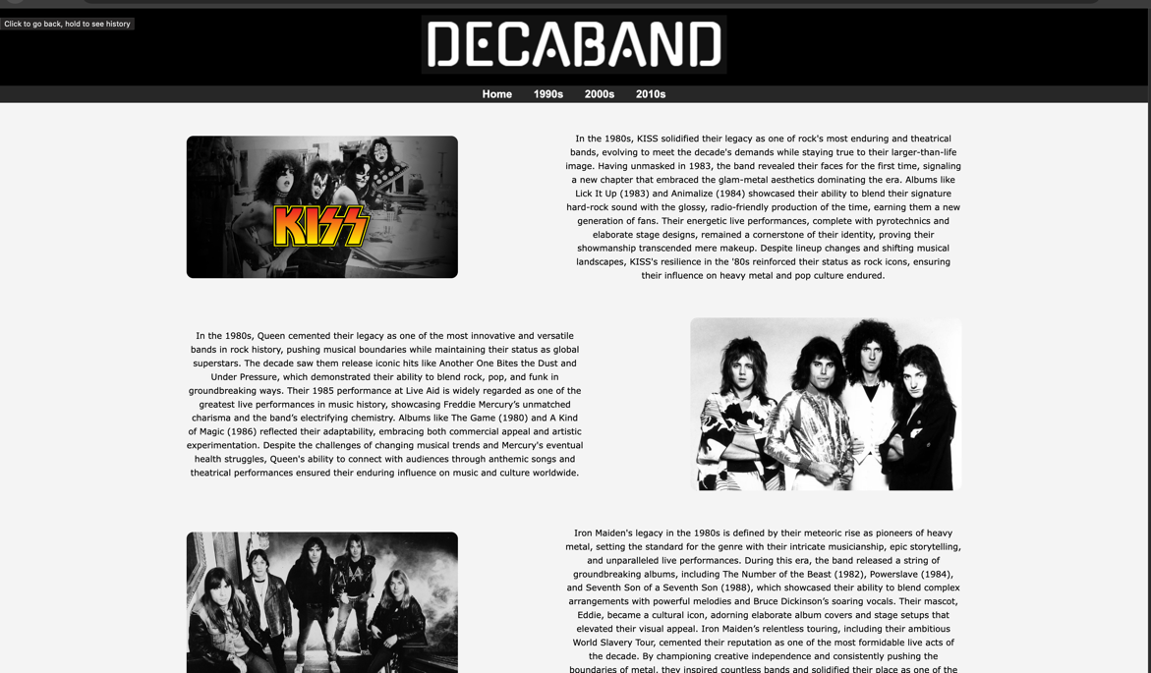
This is the 1980s page which displays information about the bands in the 80s, the three chosen are Kiss, Queen and Iron Maiden. I chose to do a Z shaped page using css placement for this page as I though it looked unique and more interesting than a photo on paragraph word document styled page. It’s also clear from left to right which paragraph is to which image. Again it contains the navbar but updated buttons to go back to home if wanted. It has a footer below again but the image cropped it out.

The 2010s Page (2010s.html)
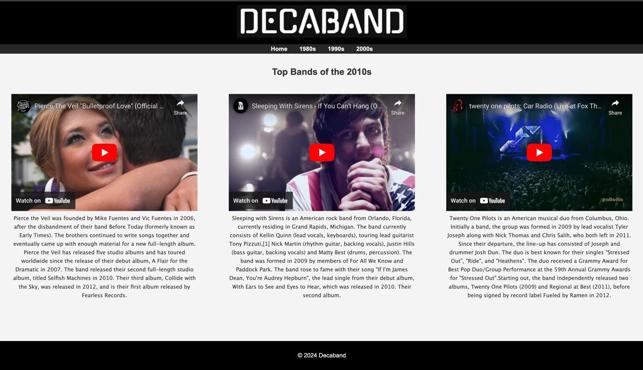
This page is one of my favourites, it contains three iframes displaying music videos from the three bands and below paragraphs introducing the bands and displaying important information about the bands. The css styling for placement was difficult but worked in the end. The page also contains a footer at the bottom with the copyright badge and a navbar and header at the top with the same contents as other pages. I didn’t choose to autoplay these as the audio may confuse the user or they may not want to listen at that time.

The 1990s page (90s.html)
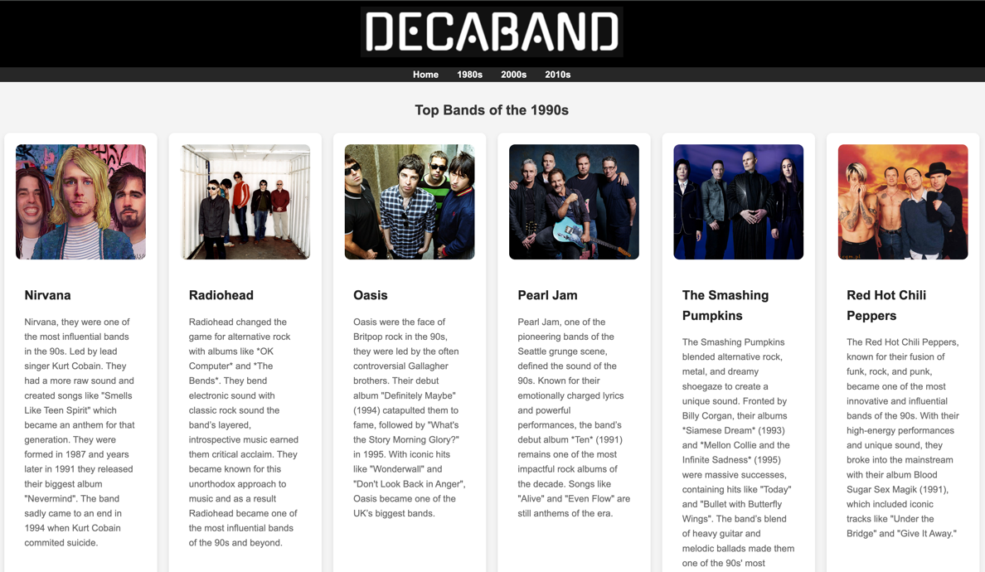
This is my favourite page. This page has multiple photocard object with similar styling to the homepage, it contains images with lossless quality at the top with the photo of the band. It then has the name of the band in bold and information below explaining about the bands, again easy to read and understand and has a modern looks. And like the other photocards they float when hovered over. The page also has a footer which was cut out in the image, you can see the header and navbar which again is the same as other pages. This page is the heaviest in terms of content but is still the most readable in my opinion as the photocards look modern and aren’t too wordy.

2000s Page (2000s.html)
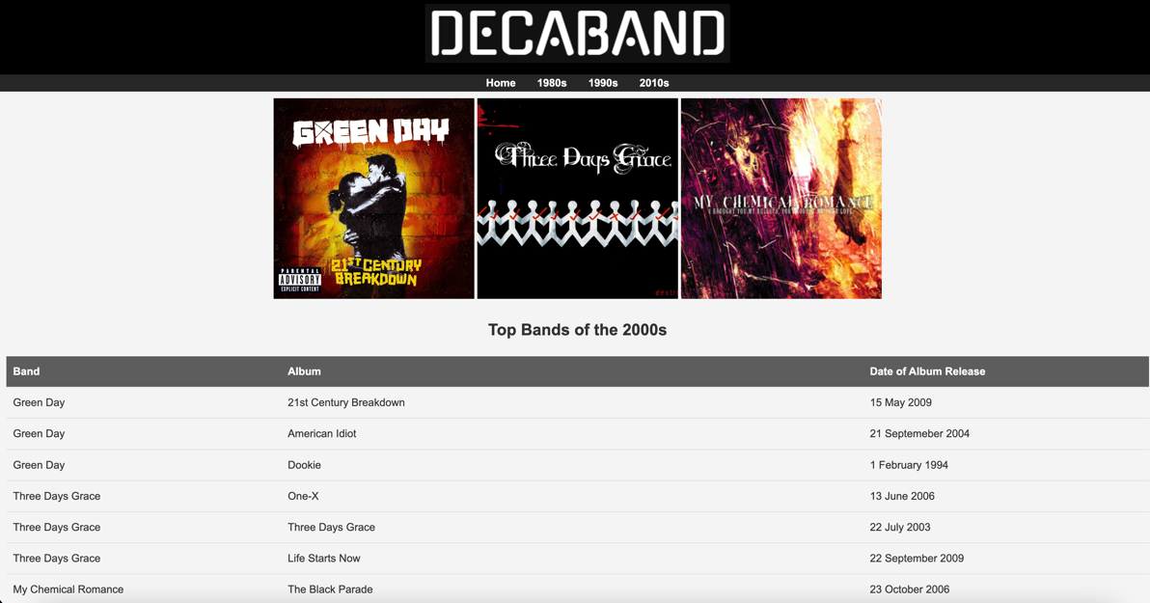
This page again contains the same header, footer and navbar as other pages to stick with the same consistency to negate any confusion to users. Unlike the other page it has side by side images centered and sized consistently, which are three of the album covers for the bands shown in the table I created below. In the table are three bands in the 2000s and each with three of their top albums with the date released. The table element makes this page different from the others and I think it fits in well with the rest of the website.

The homepage on a Phone
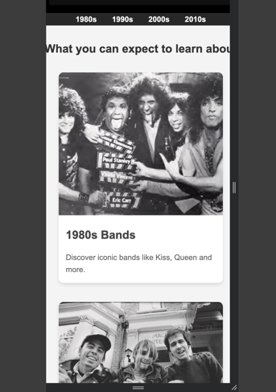
Here I tested what the website would look like if it was displayed on a phone screen and everything had resized and displayed correctly with no quality loss which was ideal.

Validation
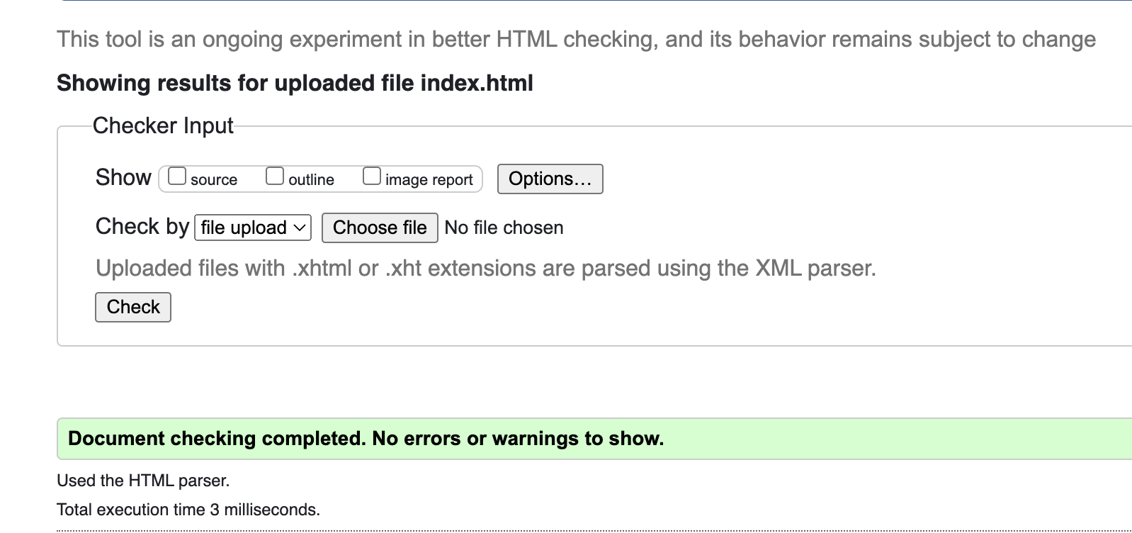

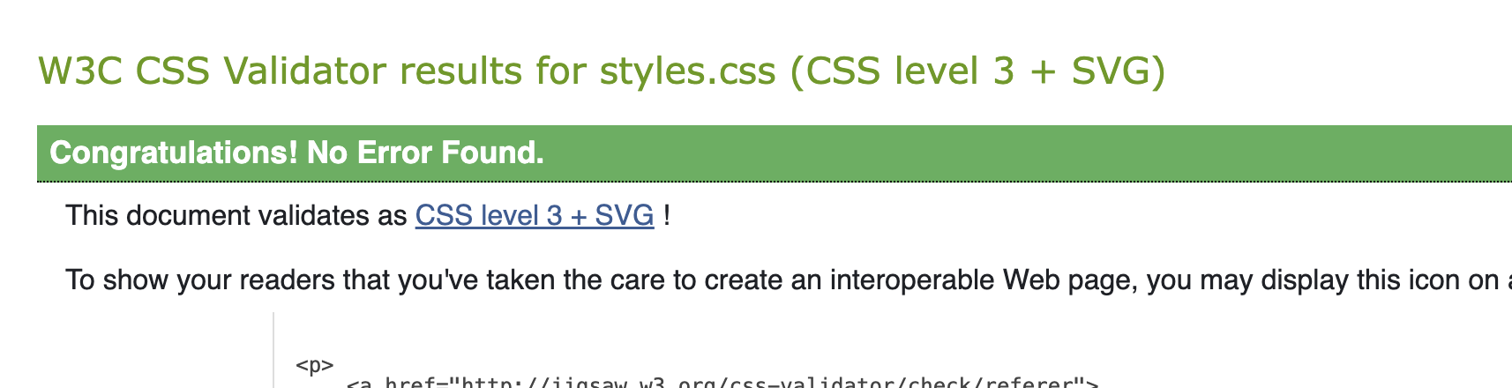

Evaluation
My website is easy and clear to navigate with buttons placed nicely and highlighting when hovered over making it clear what you are hovering over and that it is a button, This makes the website usable and useful as if a website is difficult to use people will leave.[1] Therefore I bolded all of my buttons made them clear with consistent naming convention and made it easy to return back to the homepage if they got stuck or wanted to return back there for any reason. I added the footer for contact information for if people spot errors or bugs within the website they can contact me to report them.
I stuck with a greyish black and white theme throughout the website as it has a nice contrast and makes things easy to read as it has a 21:1 contrast ratio on the contrast checker site I used.[2] Functionally the website works perfectly, the iframes, photocards on home page are clickable and direct you to their respected page, navbar buttons highlight when hovered over and everything on the page is placed correctly. The information on the pages is clearly readable and informative and the iframes and images function correctly therefore the website serves its purpose and is useful and functional. For future improvements I would expand the website or choose a different colour scheme as grey, black and white are a bit depressing although it fits the era’s of the bands displayed on the website.
For search engine optimization I’ve optimised the website and tested it through google chrome as it’s the most used website by a huge amount.[3] I’ve tested all of the iframes for YouTube through it, all of the images are consistent and that the quality is good and everything works perfectly on chrome with no issues. Using browsers like edge, as the format for this assignment we had to save images separately it doesn’t read the folders correctly like chrome does therefore the website isn’t optimised for Microsoft edge however if the website was to be hosted and images were stored differently it would be optimised.
For tooling I used visual studio code as my IDE of choice, I believe it to be great for coding as autosave settings if my computer crashes, the plugins that make it easier to use and the customisation is great. All made it quicker to complete the website, as I used the ‘Prettier’[4] code formatter I had no code errors on the validator on my first time. On top of that visual studio code has the live server ability, so if I wanted to emulate hosting my website I could through that feature although I didn’t in this case, my favourite of all is the simplicity of the IDE, if I want to create a simple website why not use a simple editor. I didn’t use any browser extensions as I wanted to emulate a user experience from a fresh browser as I believe most users wouldn’t have visually altering extensions installed. Although I did test responsiveness which I will explain later.

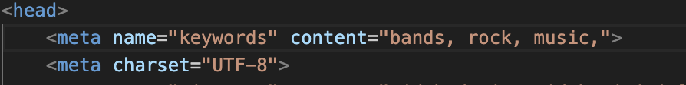
As you can see above there is some search engine optimisation to bring more traffic to the website when the keywords are searched hopefully the website will have a stronger position. The keywords I chose were related to the website so that when people are searching things similar hopefully the website will be displayed and gain more attention.

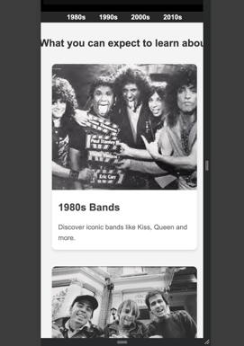
Likewise I’ve tested the responsiveness on the website and it is able to adapt to different screen sizes, in the image above I tested the website on a phone screen and it has adapted and changed to respond correctly to the screen size change. Along with that the buttons still work, the quality is the same and still looks great. I thought this was very important as it’s said ‘62%’[5] of businesses see an increase of sales with a responsive website, this may be due to a lot of users using other devices other than laptops therefore by doing this the website is more inclusive and more likely to gain traction.
Some things I would change about the website:
Firstly I would change the table on the 2000s page to be more interactive, perhaps change or be able to search for bands by name or album name. This would require some javascript behind it therefore I chose not to add it for this website but perhaps in future I could add it to the website for more functionality. On top of that I would add more pages and perhaps change the colour scheme as reflecting back on the website the colours are a bit dull and could looks more sleek with more colour added to it. To add, I’d like to perfect the navigation bar hover highlight feature. Currently it’s the outline of the button being highlight but in future I’d like to embed it into the back of the button so that it looks more modern and intuitive.

REFERENCES
1: “Usability 101: Introduction to Usability”, 3-Jan.-2012. [Online]. Available: https://www.nngroup.com/articles/usability-101-introduction-to-usability/. [Accessed: 18-Dec.-2024].

2: “WebAIM: Contrast Checker”, [Online]. Available: https://webaim.org/resources/contrastchecker/. [Accessed: 18-Dec.-2024].
3: “Most Popular Web Browsers in 2024 [Updated Dec 2024]”, [Online]. Available: https://www.oberlo.com/statistics/browser-market-share. [Accessed: 18-Dec.-2024].

4: “Prettier - Code formatter - Visual Studio Marketplace”, Visual Studio Marketplace . [Online]. Available: https://marketplace.visualstudio.com/items?itemName=esbenp.prettier-vscode. [Accessed: 18-Dec.-2024].
5. L. Astle, “Responsive web design: ensuring consistency across devices”, Alberon, Oxford. 17-Oct.-2023. [Online]. Available: https://www.alberon.co.uk/articles/responsive-web-design-ensuring-consistency-across-devices. [Accessed: 18-Dec.-2024].

Appendices
INDEX.HTML
<!DOCTYPE html>
<html lang="en">
<head>
<meta name="keywords" content="bands, rock, music,">
<meta charset="UTF-8">
<meta name="viewport" content="width=device-width, initial-scale=1.0">
<title>Decaband Home Page</title>
<link rel="stylesheet" href="styles.css">
</head>
<body>
<!-- The Decaband logo within the header -->
<header>
<img src="../Images/logo.png" alt="logo">
</header>
<!-- The navbar object with all the buttons -->
<nav>
<ul>
<li><a href="80s.html">1980s</a></li>
<li><a href="90s.html">1990s</a></li>
<li><a href="2000s.html">2000s</a></li>
<li><a href="2010s.html">2010s</a></li>
</ul>
</nav>
<!-- The photocards about each decade with the images and text -->
<main>
<h2>What you can expect to learn about</h2>

<div class="photo-cards">
<a href="80s.html" class="photo-card">
<img src="../Images/1983Kiss.png" alt="1980s Band">
<h3>1980s Bands</h3>
<p>Discover iconic bands like Kiss, Queen and more.</p>
</a>

<a href="90s.html" class="photo-card">
<img src="../Images/nirvana.jpg" alt="1990s Band">
<h3>1990s Bands</h3>
<p>Learn about the grunge era with Nirvana, Radiohead, and others.</p>
</a>

<a href="2000s.html" class="photo-card">
<img src="../Images/greenday.jpeg" alt="2000s Band">
<h3>2000s Bands</h3>
<p>Explore into the hits of Green Day, Three Days Grace and more.</p>
</a>

<a href="2010s.html" class="photo-card">
<img src="../Images/pierce-the-veil.jpg" alt="2010s Band">
<h3>2010s Bands</h3>
<p>Dive into the post-hardcore era with bands such as Pierce The Veil, Sleeping With Sirens and More!</p>
</a>

</div>
<!-- The footer object at the bottom of the page -->
</main>
<footer class="footer-fixed">
<p>&copy; 2024 Decaband</p>
Customer Support: 00800-44427661
</footer>

</body>
</html>

80s.HTML
<!DOCTYPE html>
<html lang="en">
<head>
<meta charset="UTF-8">
<meta name="viewport" content="width=device-width, initial-scale=1.0">
<title>80s Page</title>
<link rel="stylesheet" href="styles.css">
</head>
<!-- The Decaband logo in the header -->
<header>
<img src="../Images/logo.png" alt="logo">
</header>
<!-- The navbar and the buttons in it -->
<nav>
<ul>
<li><a href="index.html">Home</a></li>
<li><a href="90s.html">1990s</a></li>
<li><a href="2000s.html">2000s</a></li>
<li><a href="2010s.html">2010s</a></li>
</ul>
</nav>

<body>
<!-- All the images and band descriptions with their styling -->
<main>
<section class="z-shape">

<div class="z-item">
<img src="../Images/80skiss.jpg" height="200" width="600">
<p>In the 1980s, KISS solidified their legacy as one of rock's most enduring and theatrical bands, evolving to meet the decade's demands while staying true to their larger-than-life image. Having unmasked in 1983, the band revealed their faces for the first time, signaling a new chapter that embraced the glam-metal aesthetics dominating the era. Albums like Lick It Up (1983) and Animalize (1984) showcased their ability to blend their signature hard-rock sound with the glossy, radio-friendly production of the time, earning them a new generation of fans. Their energetic live performances, complete with pyrotechnics and elaborate stage designs, remained a cornerstone of their identity, proving their showmanship transcended mere makeup. Despite lineup changes and shifting musical landscapes, KISS's resilience in the '80s reinforced their status as rock icons, ensuring their influence on heavy metal and pop culture endured.</p>
</div>
<div class="z-item reverse">
<img src="../Images/80squeen.jpg" alt="Image 2" height="400" width="600">
<p>In the 1980s, Queen cemented their legacy as one of the most innovative and versatile bands in rock history, pushing musical boundaries while maintaining their status as global superstars. The decade saw them release iconic hits like Another One Bites the Dust and Under Pressure, which demonstrated their ability to blend rock, pop, and funk in groundbreaking ways. Their 1985 performance at Live Aid is widely regarded as one of the greatest live performances in music history, showcasing Freddie Mercury’s unmatched charisma and the band’s electrifying chemistry. Albums like The Game (1980) and A Kind of Magic (1986) reflected their adaptability, embracing both commercial appeal and artistic experimentation. Despite the challenges of changing musical trends and Mercury's eventual health struggles, Queen's ability to connect with audiences through anthemic songs and theatrical performances ensured their enduring influence on music and culture worldwide.</p>
</div>

<div class="z-item">
<img src="../Images/80sironmaiden.jpg" alt="Image 3" height="400" width="600">
<p>
Iron Maiden's legacy in the 1980s is defined by their meteoric rise as pioneers of heavy metal, setting the standard for the genre with their intricate musicianship, epic storytelling, and unparalleled live performances. During this era, the band released a string of groundbreaking albums, including The Number of the Beast (1982), Powerslave (1984), and Seventh Son of a Seventh Son (1988), which showcased their ability to blend complex arrangements with powerful melodies and Bruce Dickinson’s soaring vocals. Their mascot, Eddie, became a cultural icon, adorning elaborate album covers and stage setups that elevated their visual appeal. Iron Maiden’s relentless touring, including their ambitious World Slavery Tour, cemented their reputation as one of the most formidable live acts of the decade. By championing creative independence and consistently pushing the boundaries of metal, they inspired countless bands and solidified their place as one of the genre’s most influential and enduring forces.</p>
</div>
</section>
</main>
<!-- The footer at the bottom of the page -->
<footer class="footer-static">
<p>&copy; 2024 Decaband</p>
</footer>

</body>
</html>
90s.HTML
<!DOCTYPE html>
<html lang="en">
<head>
<meta charset="UTF-8">
<meta name="viewport" content="width=device-width, initial-scale=1.0">
<title>90s Page</title>
<link rel="stylesheet" href="styles.css">
</head>
<body>
<!-- The Decaband logo within the header -->
<header>
<img src="../Images/logo.png" alt="logo" class="logo">
</header>
<!-- The navbar with all of its buttons -->
<nav>
<ul>
<li><a href="index.html">Home</a></li>
<li><a href="80s.html">1980s</a></li>
<li><a href="2000s.html">2000s</a></li>
<li><a href="2010s.html">2010s</a></li>
</ul>
</nav>
<!-- The photocards with the images and information for the bands -->
<main>
<h2>Top Bands of the 1990s</h2>
<section class="band-gallery">
<article class="band">
<img src="../Images/nirvana-band.jpg" alt="Nirvana" class="band-image">
<div class="band-info">
<h3>Nirvana</h3>
<p class="band-description">Nirvana, they were one of the most influential bands in the 90s. Led by lead singer Kurt Cobain. They had a more raw sound and created songs like "Smells Like Teen Spirit" which became an anthem for that generation. They were formed in 1987 and years later in 1991 they released their biggest album "Nevermind". The band sadly came to an end in 1994 when Kurt Cobain commited suicide.</p>
</div>
</article>
<article class="band">
<img src="../Images/radiohead.jpg" alt="Radiohead" class="band-image">
<div class="band-info">
<h3>Radiohead</h3>
<p class="band-description">Radiohead changed the game for alternative rock with albums like *OK Computer* and *The Bends*. They bend electronic sound with classic rock sound the band’s layered, introspective music earned them critical acclaim. They became known for this unorthodox approach to music and as a result Radiohead became one of the most influential bands of the 90s and beyond.</p>
</div>
</article>
<article class="band">
<img src="../Images/oasis-band.jpg" alt="Oasis" class="band-image">
<div class="band-info">
<h3>Oasis</h3>
<p class="band-description">Oasis were the face of Britpop rock in the 90s, they were led by the often controversial Gallagher brothers. Their debut album "Definitely Maybe" (1994) catapulted them to fame, followed by "What's the Story Morning Glory?" in 1995. With iconic hits like "Wonderwall" and "Don't Look Back in Anger", Oasis became one of the UK’s biggest bands.</p>
</div>
</article>
<article class="band">
<img src="../Images/pearl-jam-band.jpg" alt="Pearl Jam" class="band-image">
<div class="band-info">
<h3>Pearl Jam</h3>
<p class="band-description">Pearl Jam, one of the pioneering bands of the Seattle grunge scene, defined the sound of the 90s. Known for their emotionally charged lyrics and powerful performances, the band’s debut album *Ten* (1991) remains one of the most impactful rock albums of the decade. Songs like "Alive" and "Even Flow" are still anthems of the era.</p>
</div>
</article>
<article class="band">
<img src="../Images/smashing-pumpkins.jpg" alt="Smashing Pumpkins" class="band-image">
<div class="band-info">
<h3>The Smashing Pumpkins</h3>
<p class="band-description">The Smashing Pumpkins blended alternative rock, metal, and dreamy shoegaze to create a unique sound. Fronted by Billy Corgan, their albums *Siamese Dream* (1993) and *Mellon Collie and the Infinite Sadness* (1995) were massive successes, containing hits like "Today" and "Bullet with Butterfly Wings". The band’s blend of heavy guitar and melodic ballads made them one of the 90s' most beloved acts.</p>
</div>
</article>
<article class="band">
<img src="../Images/red-hot-chili.jpg" alt="Red Hot Chili Peppers" class="band-image">
<div class="band-info">
<h3>Red Hot Chili Peppers</h3>
<p class="band-description">The Red Hot Chili Peppers, known for their fusion of funk, rock, and punk, became one of the most innovative and influential bands of the 90s. With their high-energy performances and unique sound, they broke into the mainstream with their album Blood Sugar Sex Magik (1991), which included iconic tracks like "Under the Bridge" and "Give It Away."</p>
</div>
</article>
</section>
</main>
<!-- The footer at the bottom of the page -->
<footer class="footer-static">
<p>&copy; 2024 Decaband</p>
</footer>

</body>
</html>

2000s.HTML
<!DOCTYPE html>
<html lang="en">
<head>
<meta charset="UTF-8">
<meta name="viewport" content="width=device-width, initial-scale=1.0">
<title>2000s Page</title>
<link rel="stylesheet" href="styles.css">
</head>
<body>
<!-- The Decaband logo in the header -->
<header>
<img src="../Images/logo.png">
</header>
<!-- The navbar with all of its buttons -->
<nav>
<ul>
<li><a href="index.html">Home</a></li>
<li><a href="80s.html">1980s</a></li>
<li><a href="90s.html">1990s</a></li>
<li><a href="2010s.html">2010s</a></li>
</ul>
</nav>
<!-- The three album images that sit above the table -->
<main>
<div>
<img src="../Images/21st century.jpg" height="300" width="300">
<img src="../Images/onex.jpg" height="300" width="300">
<img src="../Images/I Brought You My Bullets, You Brought Me Your Love.jpg" height="300" width="300">
</div>
<!-- The table object with all of its content -->
<h2>Top Bands of the 2000s</h2>
<table>
<thead>
<tr>
<th>Band</th>
<th>Album</th>
<th>Date of Album Release</th>
</tr>
</thead>
<tbody>
<tr>
<td>Green Day</td>
<td>
21st Century Breakdown</td>
<td>15 May 2009</td>
</tr>
<tr>
<td>Green Day</td>
<td>American Idiot</td>
<td>21 Septemeber 2004</td>
</tr>
<tr>
<td>Green Day</td>
<td>Dookie</td>
<td>1 February 1994</td>
</tr>
<tr>
<td>Three Days Grace</td>
<td>One-X</td>
<td>13 June 2006</td>
</tr>
<tr>
<td>Three Days Grace</td>
<td>Three Days Grace</td>
<td>22 July 2003</td>
</tr>
<tr>
<td>Three Days Grace</td>
<td>Life Starts Now</td>
<td>22 September 2009</td>
</tr>
<tr>
<td>My Chemical Romance</td>
<td>The Black Parade</td>
<td>23 October 2006</td>
</tr>
<tr>
<td>My Chemical Romance</td>
<td>Three Cheers for Sweet Revenge </td>
<td>8 June 2004</td>
</tr>
<tr>
<td>My Chemical Romance</td>
<td>I Brought You My Bullets, You Brought Me Your Love</td>
<td>23 July 2002</td>
</tr>
</tbody>
</table>

<!-- The footer at the bottom of the page -->
<footer class="footer-static">
<p>&copy; 2024 Decaband</p>
</footer>

</body>
</html>

2010s.HTML
<!DOCTYPE html>
<html lang="en">
<head>
<meta charset="UTF-8">
<meta name="viewport" content="width=device-width, initial-scale=1.0">
<title>2010s Bands</title>
<link rel="stylesheet" href="styles.css">
</head>
<body>
<!-- The Decaband logo within the header -->
<header>
<img src="../Images/logo.png">
</header>
<!-- The navbar object and all of its buttons -->
<nav>
<ul>
<li><a href="index.html">Home</a></li>
<li><a href="80s.html">1980s</a></li>
<li><a href="90s.html">1990s</a></li>
<li><a href="2000s.html">2000s</a></li>
</ul>
</nav>
<!-- The body containing the iframes and the text -->
<main>
<h2>Top Bands of the 2010s</h2>
<div class="container">

<div class="iframe-wrap">
<iframe width="560" height="315" src="https://www.youtube.com/embed/21HQAGDMDI8?si=uDkZPZDImUUK4X00" title="YouTube video player" frameborder="0" allow="accelerometer; autoplay; clipboard-write; encrypted-media; gyroscope; picture-in-picture; web-share" referrerpolicy="strict-origin-when-cross-origin" allowfullscreen></iframe>
<div class="caption"> Pierce the Veil was founded by Mike Fuentes and Vic Fuentes in 2006, after the disbandment of their band Before Today (formerly known as Early Times). The brothers continued to write songs together and eventually came up with enough material for a new full-length album.
Pierce the Veil has released five studio albums and has toured worldwide since the release of their debut album, A Flair for the Dramatic in 2007. The band released their second full-length studio album, titled Selfish Machines in 2010. Their third album, Collide with the Sky, was released in 2012, and is their first album released by Fearless Records. </div>
</div>
<div class="iframe-wrap">
<iframe width="560" height="315" src="https://www.youtube.com/embed/_UwWYtLWEZg?si=g5SwQvJjfY-yk8Du" title="YouTube video player" frameborder="0" allow="accelerometer; autoplay; clipboard-write; encrypted-media; gyroscope; picture-in-picture; web-share" referrerpolicy="strict-origin-when-cross-origin" allowfullscreen></iframe>
<div class="caption"> Sleeping with Sirens is an American rock band from Orlando, Florida, currently residing in Grand Rapids, Michigan. The band currently consists of Kellin Quinn (lead vocals, keyboards), touring lead guitarist Tony Pizzuti,[1] Nick Martin (rhythm guitar, backing vocals),
Justin Hills (bass guitar, backing vocals) and Matty Best (drums, percussion). The band was formed in 2009 by members of For All We Know and Paddock Park. The band rose to fame with their song "If I'm James Dean, You're Audrey Hepburn", the lead single from their debut album, With Ears to See and Eyes to Hear, which was released in 2010. Their second album. </div>

</div>
<div class="iframe-wrap">
<iframe width="560" height="315" src="https://www.youtube.com/embed/bQhwFeY2pAI?si=JOtAR8XQxyMLfgKE" title="YouTube video player" frameborder="0" allow="accelerometer; autoplay; clipboard-write; encrypted-media; gyroscope; picture-in-picture; web-share" referrerpolicy="strict-origin-when-cross-origin" allowfullscreen></iframe>
<div class="caption"> Twenty One Pilots is an American musical duo from Columbus, Ohio. Initially a band, the group was formed in 2009 by lead vocalist Tyler Joseph along with Nick Thomas and Chris Salih, who both left in 2011. Since their departure, the line-up has consisted of Joseph and drummer Josh Dun.
The duo is best known for their singles "Stressed Out", "Ride", and "Heathens". The duo received a Grammy Award for Best Pop Duo/Group Performance at the 59th Annual Grammy Awards for "Stressed Out".Starting out, the band independently released two albums, Twenty One Pilots (2009) and Regional at Best (2011), before being signed by record label Fueled by Ramen in 2012. </div>
</div>

</div>

</main>
<!-- The footer at the bottom of the page -->
</body>
<footer class="footer-fixed">
<p>&copy; 2024 Decaband</p>
</footer>
</html>

STYLES.CSS
body {
font-family: Arial, sans-serif;
margin: 0;
padding: 0;
line-height: 1.6;
background-color: #f4f4f4;
color: #333;
}
/*The header I made to seperate the logo from my page*/
header {
background: #000000;
color: #fff;
padding: 10px 20px;
text-align: center;
}
/* The next 5 are to create the navbar object I included and control its behaviour */
nav ul {
background: #272727;
list-style: none;
margin: 0;
padding: 0;
display: flex;
justify-content: center;
}

nav ul li {
margin: 0 15px;
}

nav ul li a {
color: #ffffff;
text-decoration: none;
font-weight: bold;
padding: 1px 1px;
transition: background-color 0.0001s ease, color 0.0001s ease;
}

nav ul li a:hover {
background-color: #b6b6b6;
border-radius: 30px;
}

main {
padding: 10px;
text-align: center;
}
/* Fixed footer for my home page */
.footer-fixed {
text-align: center;
background: #000000;
color: #fff;
position: fixed;
padding: 10px 0;
bottom: 0;
width: 100%;

/* relative footer for my other pages so footer stays at bottom*/
}
.footer-static {
text-align: center;
background: #000000;
color: #fff;
position: relative;
padding: 10px 0;
width: 100%;
margin-top: 20px;
}
/*The photo card object I used on the homepage */
.photo-cards {
display: flex;
justify-content: space-between;
flex-wrap: wrap;
gap: 20px;
margin-top: 20px;
padding: 0 20px;
}
/*The photo card object I used on the homepage */
.photo-card {
background: #fff;
border-radius: 10px;
text-decoration: none;
box-shadow: 0 4px 6px rgba(0, 0, 0, 0.1);
overflow: hidden;
transition: transform 0.3s ease, box-shadow 0.3s ease;
flex: 1;
max-width: 400px;
min-width: 300px;
margin: 10px;
text-align: left;
}
/*The photo card object I used on the homepage */
.photo-card img {
width: 100%;
height: 300px;
object-fit: cover;
}
/*The photo card object I used on the homepage */
.photo-card:hover {
transform: translateY(-10px);
box-shadow: 0 8px 15px rgba(0, 0, 0, 0.2);
}

.photo-card h3 {
margin: 15px;
font-size: 1.5em;
color: #444444;
}

.photo-card p {
margin: 15px;
font-size: 1em;
color: #666;
}

/* The Container I used on the 1980s page */
.z-shape {
display: flex;
flex-direction: column;
align-items: center;
gap: 40px;
padding: 20px;
}

/* The Object I used on the 1980s page */
.z-item {
display: flex;
max-width: 70%;
align-items: center;
justify-content: flex-end;
gap: 160px;
margin: 0 auto;
}

/* The placing for the images on the 80s page */
.z-item img {
max-width: 80%;
height: auto;
width: 35%;
border-radius: 10px;
}

/* The css for the text that I used on the 80s page */
.z-item p {
flex: 1;
font-family: Verdana, Geneva, Tahoma, sans-serif;
font-size: 0.8rem;
color: #000000;
line-height: 1.6;
}

/* reversing the object placement to put it on the opposite side of the page */
.z-item.reverse {
flex-direction: row-reverse;
}

.band-gallery {
display: grid;
grid-template-columns: repeat(auto-fill, minmax(250px, 1fr));
gap: 20px;
margin-top: 20px;
}

/* The border and background for the 90s photocard obje */
.band {
background-color: white;
border-radius: 10px;
box-shadow: 0 4px 8px rgba(0, 0, 0, 0.1);
overflow: hidden;
transition: transform 0.3s ease-in-out;
padding: 20px;
}
/* Makes the photocard objects raise when hovered over on the 90s page */
.band:hover {
transform: scale(1.05);
}

/* The setup for the images in the photocards*/
.band-image {
width: 100%;
height: 200px;
object-fit: cover;
border-radius: 10px;
}

.band-info {
padding: 15px;
text-align: left;
}

.band-info h3 {
font-size: 22px;
margin-bottom: 10px;
color: #222;
}

.band-description {
font-size: 16px;
color: #666;
line-height: 1.6;
}

/* The container object to contain the iframes on the 2010s page */
.container {
display: flex;
justify-content: space-between;
}

/* The wrap for positioning on the 2010s page */
.iframe-wrap {
float:left;
margin: 20px;
width:500px;
height:130px;
display: block;
}

iframe { width: 100%; }

/* The text settings for band descriptions under the Iframes on the 2010s page */
.caption {
text-align: center;
font-size:0.9em;
line-height:1.6;
font-family: 'Lucida Sans', 'Lucida Sans Regular', 'Lucida Grande', 'Lucida Sans Unicode', Geneva, Verdana, sans-serif;
}

/* Table settings for the table on the 2000s page*/
table {
width: 100%;
border-collapse: collapse;
}

th, td {
padding: 10px;
text-align: left;
border-bottom: 1px solid #ddd;
}

th {
background-color: #5d5d5d;
color: rgb(255, 255, 255);
}

tr:hover {
background-color: #f1f1f1;
}

