Marketing Plan SIX SENSES LAAMU MALDIVES
SAIMA JABEEN
2241265
SIX SENSES MARKETING PLAN
BMIH4005
SCOTT JAMES
WORD COUNT 1250

Marketing Plan (Six Senses – Laamu, Maldives)

Introduction
The marketing is an important technique for any business to get popular and promoted in the market (Boban Melović et al., 2020). the hotel industry requires the better marketing plan and tactics to get improved in international market. in this plan the current situations of Six Senses are explained along with the techniques required to change when entering in new market.

Situational Analysis (5Cs)
It is the process or combination of stages which explain the situations can be internal or external under which the company is operating. It includes the 5Cs which are explained for hotel Six Senses.

Company
Six senses are the globally operating hotel industry, it is wide spread in most of the tourist attracting areas. Maldives is one of the best places for the international tourists especially and the availability of Six senses at Laamu strengths the business and reveals the number of opportunities to be successful such as the continuous growth of tourism in Maldives. Further the weakness include that Six Senses hotel has not globally implemented the 100% sustainability which can increase the threat of its competitors at Laamu such as Rahaa Resort, Clouds Beach Retreat and etc. to attract the customers (Zhong et al., 2022).

Customers:
Six Senses in Laamu has segmented their customers in national and international customers that can be grouped or individual tourists who look for the quality time to be spent. According to the report of 2020 Maldives had been ranked first for attracting the international tourists in list of South Asia tourism. This is the reason Six Senses has been targeting the tourists arriving from out of the country.

Competitors:
There has been the number of competitors for Six Senses in Laamu and still it has kept itself successful because of the implementation of techniques to position their business according to the demands and recommendations of customers. Promoting its business for visitor and providing with all the facilities such as organizing the events to make visitor’s trip more enjoyable and memorable (Seyfi, Hall, and Rasoolimanesh 2020.). The Six Senses has maintained their position in the market by providing with better quality and improved services.

Collaborators:
Six Senses has been divided into 22 hotels operating worldwide and all of its branches has better collaborations with each other and other brands and companies linked with it. Six Senses has the satisfied business to business collaborations with tourism industries and event planners and managers so that the hotel industry can provide the services to their customers. this positive relationships among the businesses improve the business performance and noticeability.

Climate:
The climate factor includes the external elements affecting the company it can be either in positive or negative. The situation of COVID-19 pandemic has highly impacted the Six Senses in Laamu in terms of political, economic, social, technology, environment and legal (Sindico, 2021). The pandemic forced people to stay at home and change the governmental policies this caused the negative impact on hotel industries especially because they are highly dependent on tourists which was blocked by the government of all the countries.

Marketing Mix:
The Marketing mix techniques of Six Senses has improved the customers. As the company has kept their prices affordable with efficient products and services. Along with that as explained as Maldives is known to be best tourism place so operating hotel in such industry can be benefit for company. And also, the Six senses have been promoting their business on social media to attract the young and interested customers.

Objectives
This marketing plan is about discussing the better strategies and techniques that can be implemented by hotel Six Senses in Laamu, Maldives. The aims of this plan are to make the business more popular in the market and to develop the unique methods through which the company can face the critical situations like competitive environment, pandemic and other similar situations. Additionally, the objectives of this plan are to improve the performance in market and to make the business sustainable to keep the environment safe and secure.

Strategy
As the Six Senses is spread in multiple countries with number of different products and services. Further it can be recommended for Six Senses to develop the new market with some existing products. This strategy is known as the Market development. Here the company needs to change its marketing techniques when implementing their business in new market. When promoting the business in completely unique market it can be challenging and some of the strategies need to be changed (Pedersen et al., 2020). For example, developing the industry in Pakistan with the similar services of hotel as in Laamu or other countries would be less reliable. As Pakistan is also famous of its mountainous tourism so firstly the Six Senses should be developed in the northern areas of Pakistan. The old strategy of Six Senses is based on developing the hotel on sea side or beach side but for entering in Pakistan it needs to change this strategy. And the element of prices has always been stable and affordable so this does not need any changes of entering in Pakistan as new market. The promotion strategies should be improved and changed by applying the advertisements on billboards, and local Pakistani TV channels. The market development also requires the people’s needs to be focused. And people of different countries have different choices so the element of people choices should be changed. As Pakistan being an Islamic country people require the development of mosques near to their stay so that they can easily offer prayer, this facility would also be required provided by the Six Senses.

Tactics
The strategies that hotel Six Sense should implement is the communication mix. It includes all the required techniques for a business to improve their performance and sales by effective communicational tactics in either new or existing market. Firstly, the advertising for the hotel six sense should be improved as there are multiple advanced social media platforms that has been involved in business marketing so the hotel Six senses should also engage in social media marketing to attract the more people. Young people and tourists search for the hotels and visiting places through social media this is the reason that enhancing the social media technique can improve the sales. Additionally, the hotel industry should improve the sustainability the increase the sales and customer engagement. The customers are highly satisfied when they get to know that hotel industry follows all the hygiene products, and keep the products sustained and use the environmentally friendly products. The Six Senses should reduce or avoid the usage of plastics because plastics are one of the most harmful and pollution causing element (Allouzi et al., 2021). The business lacks in these strategies to be followed because they might be unaware of the importance of sustainability or does not spend their finances over the sustained assets. Sales can increase in company when there will be reduction in cost and this can be done by developing the renewable energy resources. Hotel industry could install the solar plants, it can be expensive but it could save the huge cost of electricity.

Action
Months | Activity | Marketing Channel | Metrics
January | Identify The market | Surveys and observations | Tourists and visitors
February | Promotions | TV and billboards | Local people
March | Social Media development | Facebook, Instagram, Twitter | Social media followers
April | Personal Advertisement | Email Marketing, or Messages | Regular or loyal customers
May | Update the website with attractive UI/UX | Company Website and Social media pages | Digital platform users
June | Implement the summer discounts | Social media (Facebook and etc.) | Social media users
July | Offer the holiday packages | Company website, social media and email marketing | Digital platform users

Control
The success of the business can be measured by analyzing an evaluating the business sales and comparing it with the previous years or the sales of other branches (Klychova et al., 2021). Along with that the customer feedback and reviews or social media or websites can explain the customer’s satisfaction. The selected metrics of social media and websites can provide the reviews on their desired platforms.

Conclusion
It can be concluded from this marketing plan that Six Senses hotel industry available in Laamu, Maldives has effectively improved the customer satisfaction and engagement. And it follows the proper marketing mix techniques. And further this study concludes the change in marketing mix and tactics for improvement when entering in new market such as Pakistan with similar products and services.

References
Allouzi, M.M.A., Tang, D.Y.Y., Chew, K.W., Rinklebe, J., Bolan, N., Allouzi, S.M.A. and Show, P.L., 2021. Micro (nano) plastic pollution: The ecological influence on soil-plant system and human health. Science of the Total Environment, 788, p.147815.
Boban Melović, Mijat Jocović, Dabić, M., Todor Vulić and Branislav Dudic (2020). The impact of digital transformation and digital marketing on the brand promotion, positioning and electronic business in Montenegro. [online] 63, pp.101425–101425. doi:https://doi.org/10.1016/j.techsoc.2020.101425.
Klychova, G., Zaugarova, E., Zakirova, A., Dyatlova, A. and Gimadiev, I., 2021. Control and analytical aspects of the management of financial results of enterprises. In E3S Web of Conferences (Vol. 273, p. 10039). EDP Sciences.
Pedersen, C.L., Ritter, T. and Di Benedetto, C.A., 2020. Managing through a crisis: Managerial implications for business-to-business firms. Industrial Marketing Management, 88, p.314.
Seyfi, S., Hall, C.M. and Rasoolimanesh, S.M., 2020. Exploring memorable cultural tourism experiences. Journal of Heritage Tourism, 15(3), pp.341-357.
Sindico, F., 2021. Building back better: Covid 19 and island economies.
Zhong, X., Deetman, S., Tukker, A. and Behrens, P., 2022. Increasing material efficiencies of buildings to address the global sand crisis. Nature Sustainability, 5(5), pp.389-392.

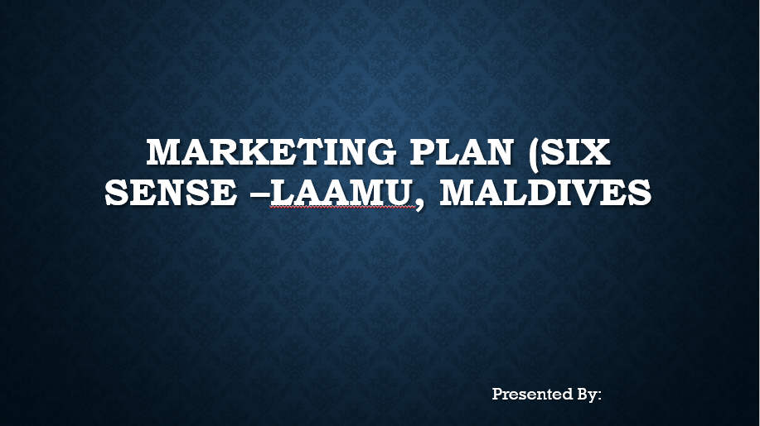
Appendix



