Student Name: SAMMY ATTOH

Student ID: 1808866

Module Title: digital skills and research methods (H&S)

Module Code: BMSK 4003

Lecturers Name: Anupon Mazumdar

This essay will discuss the effectiveness of the use of modern technology within the work place in regards to health and social care. An online presence to illustrate and evidence has also been created.
Morden technology is simply, a not so new in most cases, advancement of old technology. The impact of technology in modern life is immeasurable. Technology is used in different way and sometimes the way we implement various technologies do more damage than good. Morden technology is all about efficiency and speed. (Aging.com, 2019) We use technology on a daily basis to accomplish specific task or interest. The current daily living in an advanced world of modern technology has become obvious to accept the fact that modern technology has created so many easy ways to improve the lifestyle or the standard of living in our day to day lives, because people or staff, even those who had been nervous when introduced at work places are all in agreement. The only negative thing would be if I left a job and had to go back to a paper-based system, the old style or technology of archiving. Morden technology is so important that it has helped us to improve our life and make things better in so many ways. Furthermore, technologies have changed the world and made it a better place to live in every aspect of our lives. So could you imagine the importance of it? Our requirements are met with greater ease. There is not an industry out there that has not been affected by modern technology, transportation, communication, security, banking, education or healthcare. But there is apparently immense impact in the healthcare and medicine sector than in any field. Today cloud computing is perhaps one of the most advanced idea in health care technology. This is storage space which is loaded in the air, but does not know where t is actually physically located. To effect the health care professionals and patients are able to access certain files and data and use applications from any internet-able device. (Studymode.com, 2019)
Communication Tech
Communication tech is a technical way of transmitting of data from place to place or from a person to another. Communication is a daily important need for all because it’s used to convey ideas, exchange messages and express emotion. We are always in need of communication technology tools like phones, computers, emails, fax or messaging tools to stay in contact with friends and family. Businesses use communication technology tasks to facilitate the flow of information a workplace to help in decision making, or services to clients, staff to professionals and so much more. An example of communication technology is wireless Bluetooth headsets. (Ramsey, 2013) It is a device which allows hands-free conversation on any mobile device. It is completely compatible with android or IOS. It features dual microphones to reduce noise and wind interference for crystal clear call quality. (Ramsey, 2013) Another example is assistive technology. This is used by people with disabilities to help them or give them extra assistance to perform specific tasks that seems impossible or difficult to perform. Assistive technology is can be used in many ways. It can be used in residential homes to help clients with autism and clients with learning disabilities’ to learn better. Additionally it is also used to transport people with disable bodies from bed to bed, bed to wheelchair, wheelchair to vehicle and many more. It is much better than transporting disabled client by means of supporting them in sheets and by hand. And also much better than pushing a wheelchair in which the client would need an assistant to lift them in and push them to their next destination. But now with the aid of modern technology, service users are able to transport themselves about comfortably with off road wheelchairs. (Ramsey, 2013)
Within health and social care technology has played a long role, however it has become more widespread over time. There have been many improvements and advances in terms of technology, such as development towards health risk assessment tools, wearable devices, attendance management software and occupational health systems
Health and social care is improving with the better use of technology and data. The Better use of data and technology has the power to improve health. Better quality of technology will improve the quality, efficiency, service user’s experiences and the results produced and also the cost of health and care services. (GOV.UK, 2019) The different types of technology can also give service users and patients more control over their health and wellbeing (GOV.UK, 2019).It can aid toward empowering carers and making them feels more confident ,as they are meeting and facing challenges with efficiency and quality, but most importantly helps and supports the progress of futures medicines and treatments. Health care technology is also helping to promote less usage of care services and some new developments allow independency. However, sometimes big changes within health care technology such as digital technology in terms of shared care records and electronic patient records can be complicated with more attention need in particular aspects than before the changes. (The King's Fund, 2019) The National Information Board (NIB) is in charge of administering and putting data and technology safely for patients, service users and for health care users to use. The NIB is a new body that is established by the Department of Health to bring together national health and care organisations from the NHS, social care, public health, clinical science and local governments, together with appointed lay representatives. (Assets.publishing.service.gov.uk, 2019) The NIB constantly research on better ways to improve health through the use of technology to ensure that health and social care in the United Kingdom is improving and is sustainable. (GOV.UK, 2019) Despite the drastic improvement within the health and social care system of there is still and increasing urgency and demand for new and better technology due to unprecedented financial restrictions. (Cqc.org.uk, 2019)

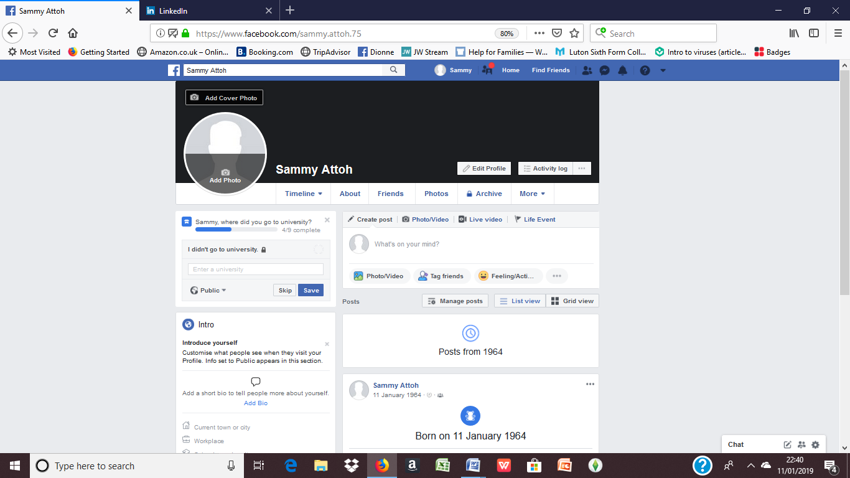

In conclusion, today we have the various technologies which were designed to solve simple problems, for example, social net works like facebook and twitter have solved communication and social interaction problems. The internet has changed lifestyles, so many skilled professionals already working in health and social care systems should be supported to continuously develop as technology is always changing and advancing. Furthermore there is the need to ensure that patients and clients and all service users have confidence that their data is held securely and used accordingly in addition, it is important how public trust is maintained and how data is held, shared and used, since there are also disadvantages to modern technology. Despite the obvious dangers, the impact of technology on health and social care is overall positive, with the benefits far outweighing the disadvantages.

Bibliography
Cqc.org.uk. (2019). [online] Available at: https://www.cqc.org.uk/sites/default/files/20171011_stateofcare1718_report.pdf [Accessed 1 Jan. 2019].
Assets.publishing.service.gov.uk. (2019). [online] Available at: https://assets.publishing.service.gov.uk/government/uploads/system/uploads/attachment_data/file/384650/NIB_Report.pdf [Accessed 1 Jan. 2019].
Aging.com. (2019). Aging.com - National Council for Aging Care. [online] Available at: https://www.aging.com/ [Accessed 1 Jan. 2019].
GOV.UK. (2019). Personalised health and care 2020. [online] Available at: https://www.gov.uk/government/publications/personalised-health-and-care-2020 [Accessed 2 Jan. 2019].
The King's Fund. (2019). Digital change in health and social care. [online] Available at: https://www.kingsfund.org.uk/publications/digital-change-health-social-care [Accessed 2 Jan. 2019].
GOV.UK. (2019). National Information Board. [online] Available at: https://www.gov.uk/government/organisations/national-information-board [Accessed 2 Jan. 2019].
Studymode.com. (2019). Free Essay Examples, Research Papers and Writing Tips. [online] Available at: https://www.studymode.com/ [Accessed 3 Jan. 2019].
Ramsey, K. (2013). Useoftechnology Home - Use of Technology. [online] Use of Technology. Available at: https://www.useoftechnology.com/ [Accessed 5 Jan. 2019].

