CONSULTANCY management (M7X00585)
The localization strategy in kfc in the uk



May 2018

Name: XIDI CHEN
Student Number: 1704389

Content
Executive Summary 1
1.0 Introduction 3
2.0 Main Findings 7
2.1 SWOT Analysis 7
2.3 Discussion & Analysis 13
2.4 Interview Findings and Analysis 16
3.0 Conclusions 19
4.0 Recommendations 21
References: 23
Appendix 26

Executive Summary
This report is the consulting project on KFC from Orient Consulting& Management. The purpose is to improve KFC’s market share in the UK. Based on the interviews and questionnaires, this report will give relevant suggestions to improve KFC’s market share in the UK.

The report provides a business case for KFC’s successful localization in China. KFC’s new food in line with the appetite of the Chinese people has been welcomed by the locals. KFC is a symbol of high quality and exquisite food in China(Li,2017). Most people prefer KFC to McDonald's, and KFC’s market share in China is twice that of McDonald's. Inspired from the Chinese case, which can give initial suggestions, KFC can also implement the same localization strategy in the UK(Li,2017).

Followed by market analysis. By giving questionnaires and interviews, will study the local people's views and suggestions on localization strategy. They also asked about KFC's deficiencies in other areas and asked for solutions. All investigations are anonymous and strictly confidential.

The next step is to study and analyze the survey data and give corresponding conclusions. Collect data from all investigators and make it a diagram. Research shows that most people support and expect KFC’s localization strategy. At the same time, they also conducted research and statistics on foods that they hope to be introduced in the future. (Bradburn, Sudman & Blair,1999). Beef and seafood are two of the most popular foods. At the same time, traditional English food like English breakfast and Fish & Chips have received a lot of respect.
However, there are still some people who think that if KFC has introduced new localized products, they will not go much more often than before. The original KFC stores are too far away and it is inconvenient for them. The food provided by KFC is not very healthy; the quality of food is not very good.

Next, based on the research results to make relevant recommendations:

1.KFC should adopt the local strategy to expand the market and improve competitiveness in the UK.
- KFC's location should be chosen in the high street, where there are more people.
- KFC can also provide some healthy food, low calorie food.
- KFC can boost exposure rate by advertising.
- We should pay special attention to the quality of food.

1.0 Introduction
This is the final report for the consultancy project in KFC in the UK. In this report，research and analysis will be undertaken during the project period. The report is based on KFC's localization strategy in the UK, analyzing local perceptions of KFC's expanded market and its feasibility. The report also highlights the strategies adopted to achieve the objectives of the project, which are described below.

Project aims and objectives
1.Analyze the success of KFC's localization strategy in China and put forward the business opportunities and benefits of localization strategy in the UK.
2.Use SWOT analysis, analyze the strengths, weaknesses, opportunities and threats of KFC in the UK market in recent years, and analyzes its competitiveness in the market.
3.Use interviews and questionnaires to conduct market research in the UK, collect and analyze data and information for the research.
4. To make recommendations on the development of KFC in the future, and offer an effective insight and outlook of how to expand market and gain competitiveness in the market.

Business Case
In China, many KFC products have been localized. KFC, in conjunction with traditional Chinese food, has introduced local specialty products with Chinese characteristics. And to cater to the taste of Chinese breakfast, KFC launched fritters and porridge, not only with Western-style fast food, but also with Chinese menus, such as rice and porridges, to meet the needs of consumers in all aspects (Sohu ,2018)
.
And in China, KFC stands for high quality and exquisite fast food, which is favored by people of all ages. KFC accounted for more than twice as much as McDonald's in China last year, according to the consulting company, with a share of 11.6% and 5.6%, respectively in 2016(Sohu ,2018).

KFC's position in western food is unshakable in China. Both its number of outlets and the number of consumers are better than those of McDonald's. But in the UK, on the other hand, the number of stores and consumers is much less than that of McDonald's, and data shows that KFC has struggled to compete with McDonald's(Hossain & Hossain, 2013).

KFC's success in the Chinese market is a reminder of localization strategy in KFC in the UK. And in the current situation, KFC could imitate the localization strategy in China and attract more customers and enhance the competitiveness in the market

Research Methodology
Questionnaire & Interview
At the initial stage of the study, the survey questionnaire was designed and distributed. The purpose is to collect local people's acceptance and suggestions of KFC’s localization strategy in the UK. And collect local tastes and their preferences, and combine qualitative and quantitative data to make further research.
In the questionnaire survey, people from all ages, different genders and careers should be considered and involve as much people as possible. In Swansea, questionnaire can be conducted at a large fitness center, such as LC2. There will be people of different ages and positions. Of course, people who are working out shouldn’t be bothered. Questionnaire can be given to people who are waiting for friends and parents who will pick up their kids from a training session, or people who rest in the café. For this group have more free time. Online questionnaire survey can also be used. Put the questionnaire on the social media, and invite friends to complete it(Bradburn, Sudman & Blair,1999).

The next phase of the study is in the form of interviews in order to get more specific information. In terms of interviews, familiar people such as colleagues, family and friends can be involved in, because the interview will occupy the interviewee more time, and the question asked will be more detailed. So it's not very realistic to invite random people in this project.

All investigations are anonymous and strictly confidential.

SWOT Analysis
SWOT analysis is an analytical tool for studying the internal and external factors of an organization. SWOT refers to strengths, weaknesses, opportunities, and threats. Strengths and weaknesses are internal factors, while opportunities and threats are external factors. The purpose of the SWOT analysis is to help the organization analyze its own business environment, consider the strengths and weaknesses of all of its businesses, and the opportunities and potential threats it faces in the market in order to develop a strong business strategy(He & Gao ,2016). In this project, KFC’s competitiveness in the UK market will be analyzed.

Localization Strategy
The localization strategy is to provide products and services that meet the needs of the local market according to different markets of different countries. The essence of localization is the process of multinational corporation integrating production, marketing, management and personnel into the host economy. Localization is the reflection of modern marketing concept, its core is that all business activities of the company should be centered on the consumer, not on the preferences and habits of the business. The company's norms must change with changes in the customer caused by regional changes(He & Gao ,2016).
In China, KFC's product localization strategy is mainly reflected in the taste of Chinese characteristics. For example, spring rolls, fried bread stick, preserved eggs and pork porridge and rice, to meet the needs of consumers in all aspects.

2.0 Main Findings

2.1 SWOT Analysis
SWOT analysis is a situation analysis, which is to analyze the main internal strengths, weaknesses and external opportunities and threats that are closely related to the research object. It draws a series of corresponding conclusions, and the conclusion usually decisive in making decisions in the market(He & Gao ,2016). The following will use SWOT analysis to analyze KFC's strengths, weaknesses, opportunities and threads in the current market.
Strengths
KFC's advantage is that it is a traditional American fast-food company, and its own characteristics and tastes in the production of chicken food compared to McDonald's and Burger King. It sells a variety of chicken foods, such as chicken burgers, chicken wraps, chicken wings and more. In KFC's chicken burgers and chicken wraps, you can also add your favorite foods, such as hash browns, which gives customers more options to save money(KFC,2018). And there's Rice box at KFC and there's no other fast food restaurant.

Weaknesses
The main weaknesses of KFC are
1. Stores are relatively remote and relatively few. Compared to McDonald's, KFC's stores are not as wide-ranging as McDonald's and they are geographically remote(Li,2017). This is a disadvantage for a fast food restaurant. Because of the nature of fast food, customers may choose other fast foods that are relatively close to them
2. The size of the store is relatively small. The size of the store in KFC in the UK is much smaller than that of McDonald's and Burger King. A lot of KFC only do TAKE AWAY business, customers do not have a place to eat. Therefore, it may turn to purchasing other fast foods, which is a big disadvantage compared to other competitive companies(Li,2017).
3. Fried food itself, KFC's food production methods are mainly fried. The food is mainly chicken, so the food structure has the characteristics of high fat, high calorie, low vitamin and low fiber. It is particularly prone to cause excess calories and obesity(Fox,2017).

Opportunities
KFC’s current opportunities are mainly
1. Food variety is relatively single. And this is a huge opportunity. In the UK, if KFC can introduce some foods that suit the tastes of the local people, it will inevitably have a huge market. After all, traditional fast food restaurants in the UK do not have such localized foods.
2. Through the previous method, KFC can quickly expand in each city, opening a branch with a certain scale in a place closer to the city center, which allows customers to dine on the spot. This will bring a huge market(Li,2017).

Threats
The threat faced by KFC is mainly from the threat of competitors in the fast food industry. McDonald's is the world's largest fast food chain. McDonald's has about 30,000 stores in the world, and KFC has less than 10,000. They also have advanced management concepts and mature food processing skills. And McDonald's is more widely distributed and relatively cheaper than KFC(Xie ,2015). In order to win the competition with McDonald's, it can serve the local people's taste, no longer only a single chicken food; promotion rapidly, and occupy the market.

Another threat comes from specialty foods from different countries. For example, in the United Kingdom, as the number of Chinese people has increased, various Chinese restaurants have begun to appear, including Chinese fast food restaurants(Xie ,2015)
. This can become a threat to the entire fast food industry. Because it will occupy a certain market share.

2.2 Questionnaire Findings
- Your Gender
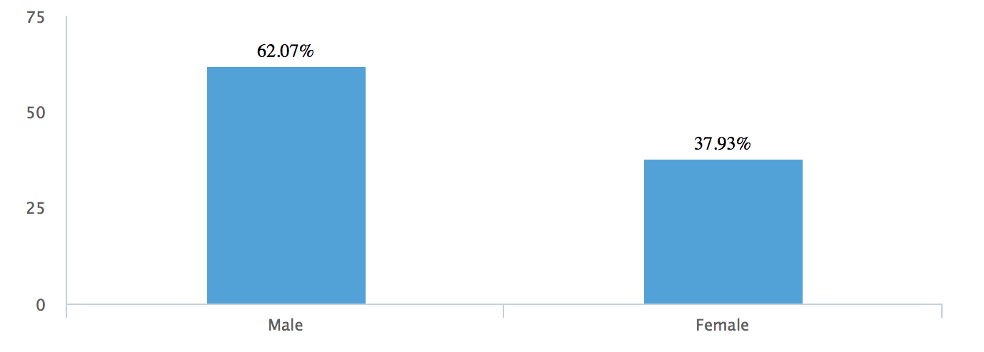
- Your Age
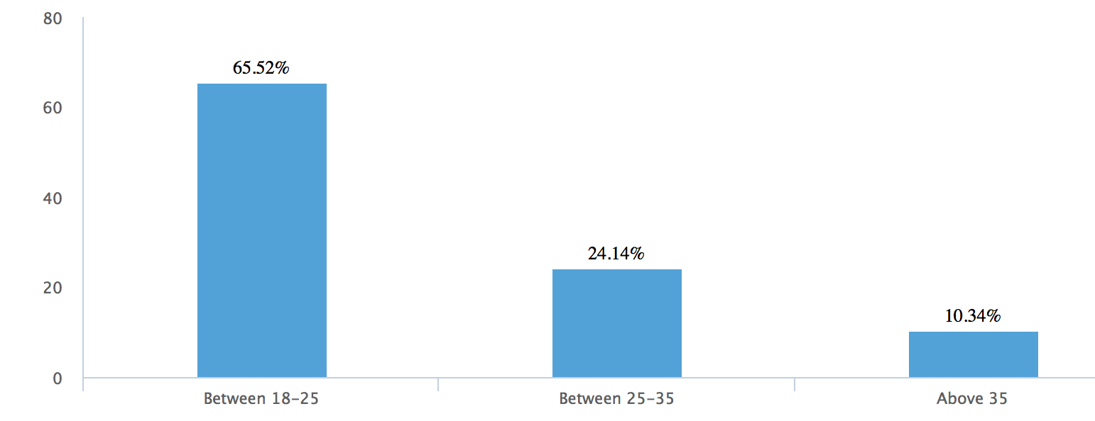
- How often do you go to KFC?
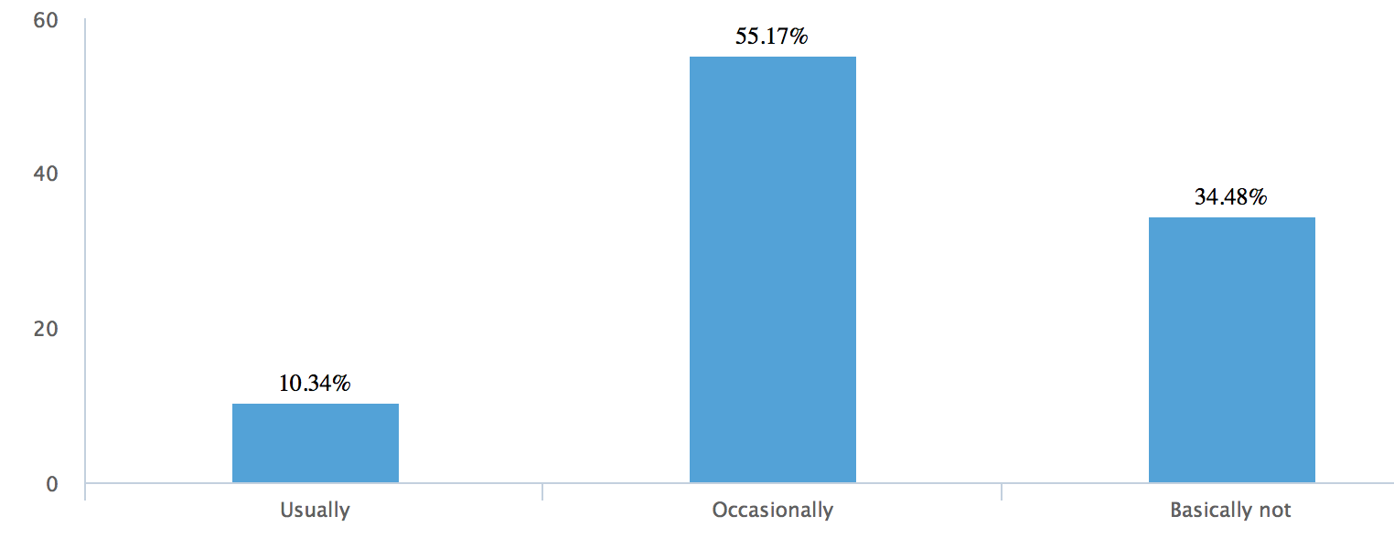
- Why you choose KFC? (Multiple choice)
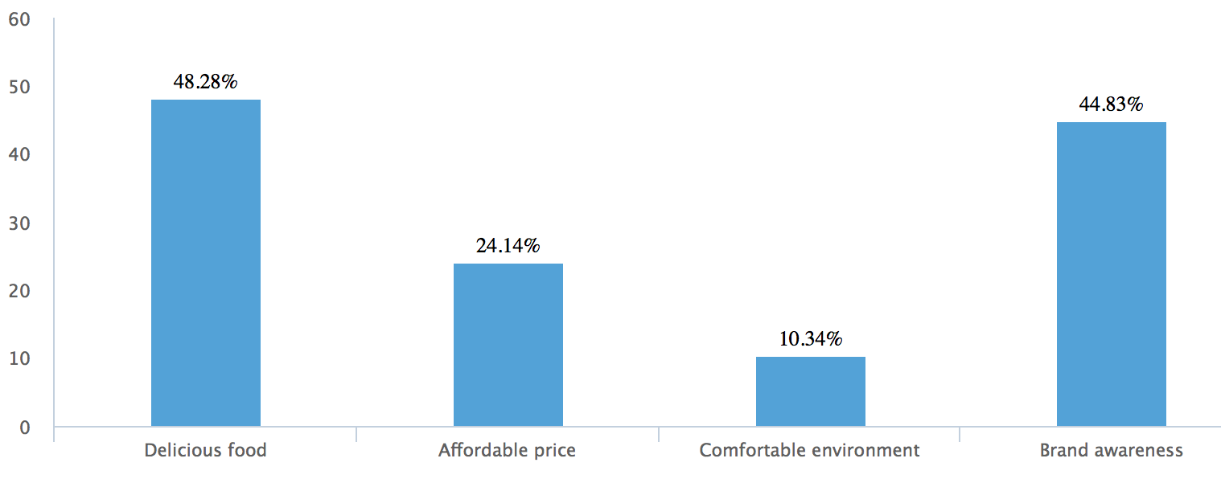
- The foods you had more often at KFC are: (Multiple choice)
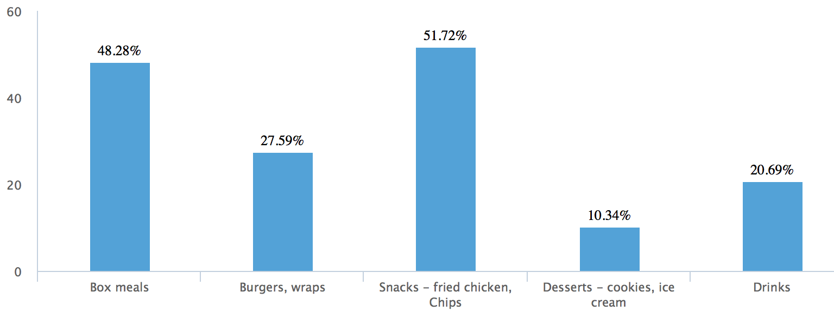
- What do you think KFC needs to improve? (Multiple choice)
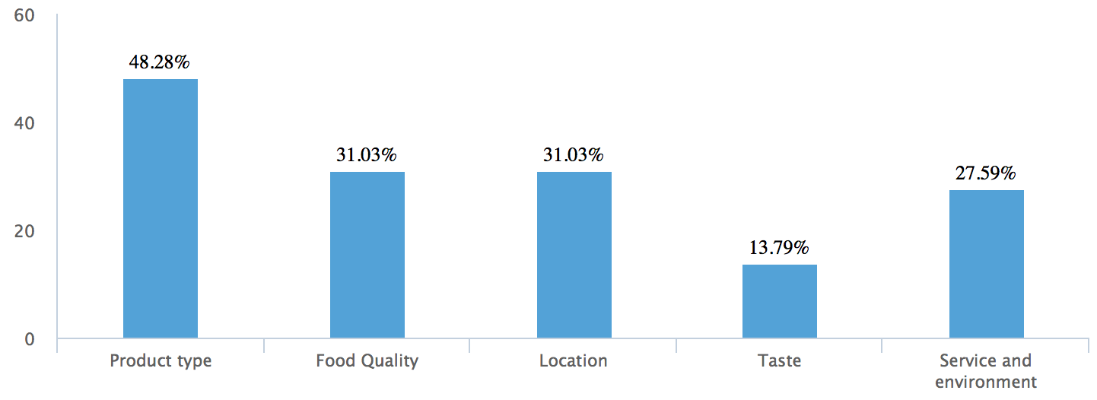

- Would you try if KFC launched local foods in the UK?
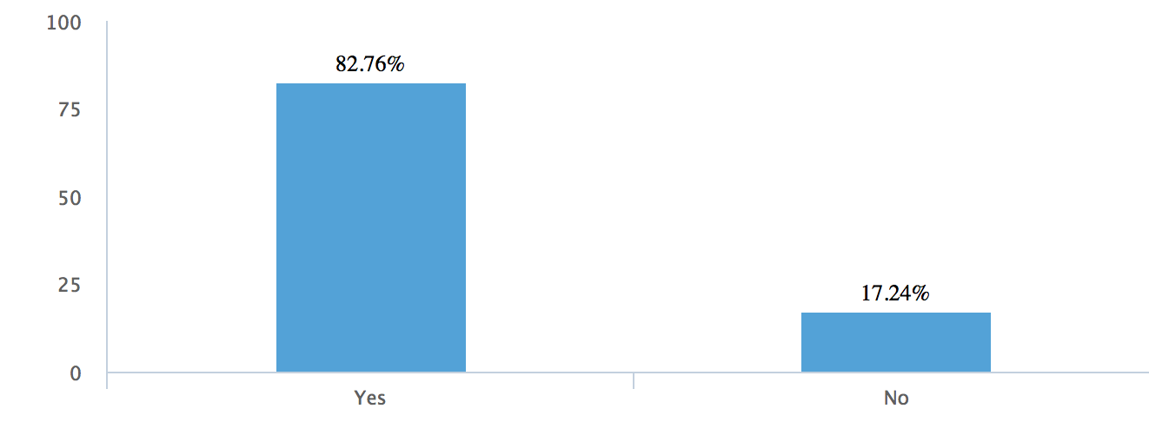

- What type of food will you try? (Multiple choice)
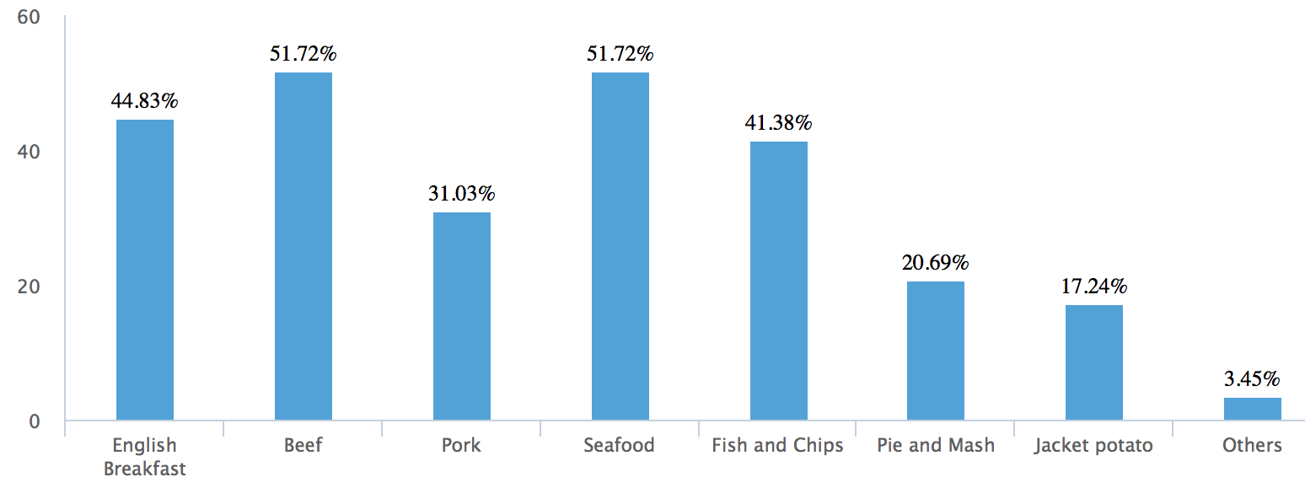

- If KFC launches your favorite new product, will you go more often than before?
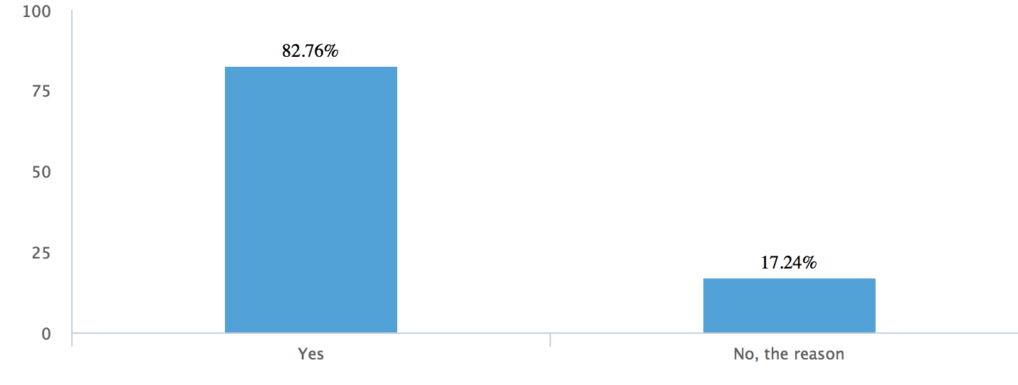

2.3 Discussion & Analysis
The questionnaire survey used a combination of distributed paper questionnaires and online questionnaires. A total of 58 people participated in the survey. Although the participants are not very large in number, they are enough to represent local people's views on KFC's localization strategy. In order to involve more people of different ages and occupations, the questionnaire was distributed to the Swansea Large Fitness Center-LC2.

There were 36 men and 22 women participating in the questionnaire. Among them, 65.52% are between the ages of 18-25, 24.14% are between 25-35, and 10.34% were over the age of 35. When asked about the frequency of their previous visits to KFC, only 10.34% would go often, but 34.5% would basically not go. The other 55.17% would occasionally go to KFC. This shows that KFC is not very good in the local people's market, only a small number of people often go to have food, more people go to occasionally or basically do not go.

When asked about their choice of KFC, 48.28% of them chose delicious food, 44.83% chose the brand's awareness, and the price and environment accounted for only a small percentage(Zhu H,2012). This shows that in many people's eyes, KFC is a representative of fast food brands, it has a long history, and also provides delicious food, people trust it. But even if there are so many people who occasionally or do not basically go, this means that KFC needs to make improvements to a large extent, to once again expand the brand's influence and attract more customers.

Of all those surveyed, 48.28% believe that KFC’s product range needs improvement, and 31.03% believe that the store's location is remote and it should be opened as far as possible in the city center. Another 31.03% believe that food quality needs to be improved, and 27.6% believe that services and the environment can be better. Only 13.79% believe that the taste of food needs improvement. This shows that most people think that KFC's food tastes good, there are too few range of food., and little choice for customers, it can not attract long-term customers. There are also a large number of people who think that KFC's location is so remote that it is inconvenient for them to have food there. In terms of food quality and services and the environment, some people think that these can also be improved.

If KFC launches local food, would you be willing to try it? The answer is that 82.76% of people are willing to go to KFC to eat their new local products. This shows that most people want KFC to launch more new and localized products.

When asked about the products you often had in KFC before, 51.72% of them chose KFC's fried chicken and chips, which is also the most KFC-specific food. As we all know, KFC is famous around the world for fried chicken, so in the future, KFC can continue to develop its fried chicken business to keep their loyal customers while launching new products. 48.28% of those chose Box meals because they generally contain different types of food and it can save money than order separately. Only a small number of people chose desserts and drinks, which also showed that KFC can launch more new products in desserts and drinks in the future to attract more customers.

If KFC has launched a new local product, what kind of food will be more popular? As shown in the chart, beef and seafood are respected by most people. The percentage is 51.72%, indicating that beef and seafood such as prawn & oyster can be added to their fast food products. The next two more popular foods are English Breakfast and Fish and chips, accounting for 44.83% and 41.38% respectively. Both of these foods are very traditional British food, and the British people are also very fond of them. So KFC is to achieve localization strategy in the future, these two kinds of foods should be taken into consideration. About 31.03% of Pork's support can also be properly considered when launching new products to cater to more people's tastes. Those who supporting the launch of Pie and Mash and the Jacket potato is not much, which is 20.69% and 17.24% respectively. At the same time, it must be taken account that when KFC launches new products, it needs to undergo a lot of market research such as product research and development, foretaste, etc. It will take up a lot of money, so for those products that are only supported by a small part, they may not be considered when implementing new products(Charles, 2008).

If KFC launches your favorite new product, 82.76% of people will choose to go more often than before. This shows that if KFC launches new products based on localization, it will be welcomed by most local people. It also shows that the implementation of KFC's localization strategy is feasible and has a great chance that it will bring success in the future.

After that, randomly interviewed several people whose answer is No. The reason why they still won't go often in the launch of new localized products is: “The nearest KFC is at a 40-minute drive from where I live, and the boy thinks it’s convenient.” said one father. The remote location of KFC is also a very important factor. Another local person said: "I don't go. I went once and there was a spine in the treated to be boneless chicken. I could literally see the vertebrae." This also shows that KFC should also improve chicken quality. The reasons for the remaining few are: fast food is not healthy; they go to KFC just to eat fried chicken, so the introduction of new products will not affect them.

2.4 Interview Findings and Analysis
Interview questions:
What areas do you think KFC need to improve?
Do you support KFC’s localization strategy and why?
If KFC develops localization strategies, what foods do you think can be added?

Ten people were interviewed this time. Their ages are all over the age of 18. When asked about KFC’s inadequacies, 10 people all said that they had too few types of food, and there were almost no options for each type of food. In burgers, for example, an interviewee said that when he once went to KFC to have food, only one kind of burger - chicken burger was offered, but only different types of sauce could be chosen. So he mentioned that he would never come to KFC if he wanted a burger. Seven other people mentioned that KFC’s position was too remote. One interviewer said that sometimes he wanted to have a dinner in KFC, but it took him 40 minutes to drive, and he finally decided not go. Five people said that KFC’s storefront is small and the dining environment is not very comfortable. Also, there are many KFC only do TAKE AWAY business, customers even do not have a place to eat.

When asked if KFC would support the localization strategy, they all expressed their support(Evetts,2011). Because KFC is a representative of fast food brands, it also has a long history. If KFC launches their localized food, they will be very interested.

And if KFC develops its localization strategy, nine of them believe that beef should also be provided because beef is a very common food for British people. In addition to the foods mentioned in the questionnaire, they also added foods such as Bigger Burgers, Chicken and Waffles, eggs, sausage, turkey, Barbecue and pasta.
After KFC implements a localization strategy, these foods can serve as an important reference.

In summary, when KFC launch new localized products, at the same time it also needs to focus on some following points to attract more people.
1. The location of KFC's shops should be located in the city center or crowded places, so that those who are willing to eat KFC will be more convenient to reach there, and will increase the possibility of ordinary customers to enter the store.
2. KFC is a representative of fast food, but it can also provide some healthy food or vegetarian food for people who have specific needs.
3. Also pay attention to the quality of food, so as to ensure that the product does not disappoint customers.

3.0 Conclusions
In the conclusion of this report, it is feasible to implement the localization strategy in the United Kingdom by analyzing the success of KFC's localization strategy in China and the local market research conducted through questionnaires and interviews(Fox,2017).

In the analysis of the results of the questionnaire, it was learned that only a very small percentage of people would go to KFC on a regular basis, and most people would go occasionally or basically never go. This shows that KFC's local market is not very good. When asked about where KFC needs improvement, most people know that its product range is too small, the location is too remote, and the quality of food needs to be improved. These suggestions can provide the basis for the future development of KFC.
About KFC's new localized products, the most recommended products are beef, seafood, English breakfast and Fish & Chips. Pork, Pie and Mash can also be considered, they also added foods such as Bigger Burgers, Chicken and Waffles, eggs, sausage, Turkey, Barbecue and pasta. After KFC implements a localization strategy, these foods can serve as an important reference.

However, there are still some people who think that if KFC has introduced new localized products, they will not go much more often than before. The original KFC stores are too far away and dining is inconvenient for them. There is the food provided by KFC is not very healthy; the quality of food is not very good. Therefore, based on KFC's localization strategy, it should also be improved in other areas (Puutio, Kykyri, & Wahlström,2008)
.

4.0 Recommendations
- In order to expand the market and enhance competitiveness, KFC should adopt a localization strategy in the United Kingdom by expanding its product range and introduce localized food like beef, seafood, English breakfast and Fish & Chips etc. which are popular with most locals and meet their appetite.

- KFC's location should be chosen in the high street, where there are more people. In the same area, KFC stores are small and remote. In contrast, McDonald's is located in the central of the city, with large and lively stores. Because of the characteristics of fast food, customers will choose the location of fast food which is near their home or city center. However, many KFC restaurants are in remote areas, so it is very inconvenient and the flow of people is very low.

- KFC can also provide some healthy foods, low-calorie foods. The phenomenon of obesity in the UK is very serious, and KFC can also improve recipes to develop a healthier, lower calorie food. In special circumstances, it is also possible to provide some vegetarian food for vegans who are dining with their friends.

- KFC can boost the exposure rate by advertising. While KFC proposes to implement localization strategies, it must also conduct sufficient advertising to attract more customers. Furthermore, KFC being an aging brand and faces the challenge of losing its appeal among young people. Since, the promotion of publicity, for example, can use the famous celebrity as the brand image endorsement, can promote the exposure and enhance the popularity(Zhu H,2012).

- Also pay more attention to the quality of food, so as to ensure that the product does not disappoint customers.

References:

Bradburn, N. M., Sudman, S., & Blair, E. (1999). Improving interview method and questionnaire design. Improving interview method and questionnaire design . Jossey-Bass.

Charles, G. (2008). Us fast-food chain to take on KFC in the UK. Marketing.

Evetts, J. (2011). Professionalism and Management in Public Sector (Not-for-Profit Organizations): Challenges and Opportunities. Professional isierung im Nonprofit Management. VS Verlag für Sozialwissenschaften.

Frcp, K. F. C. D., & Boushey, H. A. (2008). Chapter 21. Animal Models of Cough. Cough: Causes, Mechanisms and Therapy. Blackwell Publishing Ltd.

Fox.(2017) . Mcdonald's price rise points to inflation pressure | fox business. Fox Business.

He L. & Gao Y. (2016). Research on localization marketing strategy of KFC China. News research guide, 7(10), 307-307.

Hossain, M. K., & Hossain, A. (2013). Factors affecting employee’s motivation in the fast food industry: the case of KFC UK ltd. Research Journal of Economics Business & Ict, 5(9–10), 1055-1060.

KFC.(2018).KFC official Website. Available From: https://www.kfc.co.uk

Li L.R.(2017).How will the competition escalate after the ”Sinicization" of KFC and McDonald's .Available From: https://www.qdaily.com/articles/44179.html

Mortimer, R. (2003). KFC: the real meal soul food: kfc is the uk's second largest fast-food brand. with a new ad campaign which respositions the food chain as 'soul food', ruth mortimer finds out how the brand will fare in this mature, saturated sector. (fast food: KFC). Brand Strategy

Norsworthy, J. K., Smith, K. L., Scott, R. C., & Gbur, E. E. (2007). Consultant perspectives on weed management needs in arkansas cotton. Weed Technology, 21(3), 825-831.

Paik, Y., & Choi, D. Y. (2007). Control, autonomy and collaboration in the fast food industry comparative study between domestic and international franchising. International Small Business Journal, 10(5), 539-562.

Puutio, R., Kykyri, V. L., & Wahlström, J. (2008). Constructing asymmetry and symmetry in relationships within a consulting system. Systemic Practice & Action Research, 21(1), 35-54.

Sohu (2018). What's the difference between KFC in Britain and China? Available From: http://www.sohu.com/a/230211917_383510

Tsai, M. C., Shih, K. H., & Chen, J. C. H. (2007). A comparison of the service quality of fast food chain franchises. International Journal of Services & Standards, 3(2), 222-238.

Xie Y, Hu W.(2015) Comparative Study of McDonald's and Kentucky Fried Chicken (KFC) development in China[J]. Savonia-ammattikorkeakoulu, 2013.

Zhu H. (2012). KFC's localization operation analysis in China. Doctoral dissertation, Zhejiang university of technology.

Appendix
The question of Questionnaire:
- Your Gender
- Your Age
3. Do you often go to KFC?
4. Why did you choose KFC? (Multiple choice)
5. The goods you had more often at KFC are: (Multiple choice)
6. What do you think KFC needs to improve? (Multiple choice)?
7. Would you try if KFC launched local foods in the UK?
8. What type of food will you try? (Multiple choice)
9. If KFC launches your favorite new product, will you go more often than before?

The question of Interview:
What areas do you think KFC need to improve?
Do you support KFC’s localization strategy and why?
If KFC develops localization strategies, what foods do you think can be added?

