A report into the effectiveness of the current structure
of the NHS Wales.

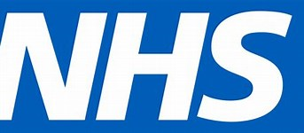

Rachel Williams
1900484
Jane Griffith-Parry
Managing organisations

Contents page
Page 1 – Title page
Page 3 – Abstract
Page 4/5 – Introduction to the report
page 7 – Information/statistics/guides
page 8 – Evaluation of current structure
Page 9 – Structure of the NHS
Page 10 – conclusions
Page 11 – recommendations
Page 12/13 – reference list

Abstract
This report is an in-depth look into the NHS Wales. This includes a look into the NHS’ history, a look into the NHS’ support from not only the Welsh government but also the other supportive trusts and Charites which have been there for the NHS to still be providing ‘free’ healthcare and support to all in Wales. Within this report, we look at how the NHS Wales is formed as in structural wise and how it has been functioning for the past 70 years. However, the weaknesses of the NHS are also discussed within this report and what can be done or changed within the NHS while thinking costly effectively to improve the NHS. This report investigates the use of the NHS and what it has to offer within Wales, from services of care, to funding and also the support network support it has which is largely growing with help from the seven Local Health Boards which are also researched within this report.

Introduction
The NHS is a National Health Service. It is a health service which provides care to everybody in the UK and when they become ill or injured, they may use the NHS service to help them get better. The NHS provides ‘free’ health care, which means people can seek medical advice or be medically treated for free when they are unwell. (Google definition). The NHS is paid through taxes, which is from the UK people who pay this fee to the government. The NHS supports and treats over three million people and the NHS also is one of the largest employers in the world and is the biggest in Europe with over 1.3 million staff. A typical day within the NHS includes over 835,000 people visiting their local GP practice or practice nurse (NHS Wales, 4th March 2020).
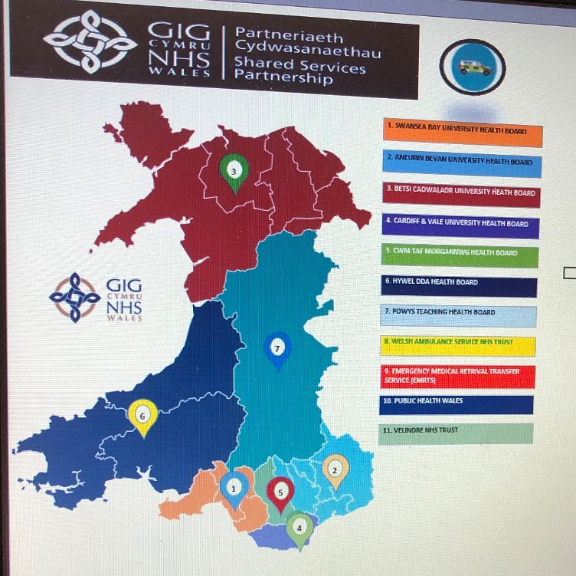
Within the NHS there are also the seven local health boards which are can be located around Wales. The Local health boards are:
● The Swansea Bay University Health Board which was known formally as Abertawe Bro Morgannwg University Health Board. This Health Board delivers healthcare to the Swansea and Neath Port Talbot areas and has its community bases services, the three main hospitals and the mental health services available, which covers around 390,000 patients and has 12,500 staff members. (NHS Wales, 7th March 2020).
● The Aneurin Bevan Local Health Board which its headquarters are in Caerleon. This health board was established on the 1st of October in 2009. It covers a wide range of areas, including Blaenau, Gwent, Caerphilly, Monmouthshire, Newport, Torfaen and South Powys. This Health Board alone, employs over 13,000 staff members, which two thirds of them are involved with direct patient care and they also provide the support of 250 consultants in a total of over 1000 hospital and general practice doctors. 6,000 nurses, midwives and community workers are also among this Health Board. (NHS Wales).
● Secondly, Betsi Cadwaladr University Health Board which is a local Health Board in North Wales, it is the largest health organisation in Wales and it provides a full range of primary, community, mental health, and hospital services for a population of around 694,000 people across North Wales (NHS Wales).
● Thirdly, the Cardiff and Vale University Health Board which came about on the 1st of October in 2009, using three NHS organisations in the Cardiff and thee Vale of Glamorgan area (NHS Wales).
● Another Health Board within Wales is the Cwm Taf Morgannwg University Health Board, formerly Cwm Taf University Health Board is one of the local health boards in Wales, which provides a wide range of services which include general medical, surgical, maternity, accident and emergency services (NHS Wales).
● The Hywel Dda University Health Board, the operational name for Hywel Dda Local Health Board which also came around on the 1st of October in 2009. It was merged with the Hywel Dda NHS trust, the Pembrokeshire Local Health Board, Ceredigion Local Health Board, and the Carmarthenshire Local Health Board. Which provides healthcare services to around 372,320 people. This Health board provides primary, community, mental health and learning disabilities services using the local hospitals, health centres or the GPs (NHS Wales).
● The last Health board is the Powys Teaching Health Board, which is responsible for healthcare in Powys, central Wales. It was established in 2003. Within Powys there are 10 community hospitals, alongside 17 GP surgeries, 25 dental practices and 23 pharmacies (NHS Wales).

There are also 4 NHS Trusts within Wales:
The Velindre NHS Trust - the Velindre NHS Trust offer a wide range of services such as cancer care and a range of support services. Such as specialists within cancer and blood services across South and Mid Wales. The aim is to deliver care, support and quality to all patients and donors. (NHS Wales).

The Welsh ambulance Services Trust - The Welsh Ambulance Services Trust for emergency services. Provide 715 vehicles across Wales to help within an emergency as already in Wales there has been 465,552 verified incidents alone in Wales and there have been 243,840 calls to NHS Direct Wales for emergency help, medical treatment and support in Wales. (NHS Wales).

The Public Health NHS Trust - Public Health Wales is an NHS organisation which sets out to improve and create awareness to protect and improve the health and wellbeing of Wales. The Public health NHS Trust provides support and advice on a wide range of medical treatments and advice for things such as the flu, smoking and pregnancy. (NHS Wales).

The Health Education and Improvement Wales (HEIW) – which was established on the 1st of October 2018. Is here to improve education, training, developing and improving the Healthcare workforce and services within Wales. This NHS Trust brings three main key organisations together, which is The Wales Deanery, The NHS Wales’s Workforce Education and Development services and finally, The Wales Centre for Pharmacy Professional Education.

The NHS was supported by the lead minster at the time, this was Aneurin Bevan, Bevan was born in South Wales into a working-class family and his father was a coal miner within South Wales. Bevan himself, left school at the age of 13 to work down the mines along side his father. However, during his teens Bevan became more interested in the local union politics and as Bevans interest grew, he became a Welsh Labour Party politician.
Bevan decided to create the NHS because during World War 2, Labour won an unexpected landslide victory in the 1945 general election and their manifesto promised a health care revolution that was strongly influenced by the Beveridge report. The new Prime Minister Clement Attlee appointed Bevan as the Minister of Health and Housing and gave him the task of creating a new ‘National Health Service’. Bevan soon created the National Health Service which is known today as the NHS. On July 5th, 1948, the NHS was finally launched, and the Labour government took responsibility for all medical services. For the first time ever nurses, doctors, pharmacists, dentists, and opticians were brought together as part of a single organisation with free diagnosis and treatment for all. (BBC Wales, 5th March 2020).

Information, statistics and guides
The NHS supports and treats over three million people and the NHS also is one of the largest employers in the world and is the biggest in Europe with over 1.3 million staff. A typical day within the NHS includes over 835,000 people visiting their local GP practice or practice nurse. (NHS Wales, 5th March 2020). The NHS receives most of its funding from the Welsh Government to cover the day-to-day costs of health services in Wales during each Year. The NHS relies on these funds to deliver the best possible health care which has been provided for the last 70 years. The local health boards within Wales receive revenue allocations to help secure local hospitals, community, and primary care services for their local population. Another way is through capital allocations to the local health boards and the NHS trusts as then the funds can be use on capital developments. Lastly, the NHS turn to targeted funding for health improvement. However, the NHS does not only rely on the Welsh government for funding. The NHS encourages people to donate or to raise money to be used as donation money which can go to their trusts for the NHS. The NHS also rely a lot on volunteers for it to work. The NHS has an estimated three million people volunteer. The volunteers help to provide care and assistance within a few roles, such as within the hospital wards, which would include keeping patients company and bringing patients hot drinks if requested. Another role is in the café or even giving patients or visitors help with directions for around the hospital. All these roles help to decrease the pressure of the NHS staff and to work faster and more efficient for the sake of the patient’s well-being. (NHS Wales Support, 6th March 2020).

The NHS’ main source of income is in fact the Welsh Government. The NHS Wales needs this money from the government to provide the best possible care and support for the residents in Wales. The NHS in Wales also covers the cost of each welsh residents’ prescriptions for medication. However, there are charges for visiting the optician and dentist. The money used to spend on health in Wales is estimated at around £7.3 billion during 2017/2018, this at the time would roughly be around £2,300 per person on health care. (NHS Wales, 7th March 2020). Wales also includes some of the money into sport as well as health. The money that is put into the sporting side is still meant to encourage people to get involved and to try to encourage a healthy and active life style, meaning that this could decrease illnesses or visits to the GPs or Hospitals if we all try to remain fit and healthy. (The Welsh Government, 8th March 2020).

Evaluation of structure
The organisational structure of the NHS can be described as a tall structure due to the separation of multiply different levels which all have different chains of command. The NHS’ structure is seen as a more traditional type of structure and most of the power is held by the government minister which is public as the NHS provides a public health service which is ‘free’ for all to use if needed. The Structure of the NHS has many strengths as there is mainly coordination and efficiency. Employees and even volunteers of the NHS know their roles and know the requirements of what they are each individually responsible for. This can then allow for the management of the NHS to run as smoothly as possible and that when everyone has their own personal task then they will have their own personal motivation to get their role completed. However, having such a large structure and number of employees to care for is also a struggle as if there are problems within one of the departments within a hospital then it can take a lot longer to be fixed or even be noticed. Communication is known as a weakness for many but mainly within a large structure it is difficult to make sure that everyone has the same message or if there is a problem then it might be tricky to get a hold of the person needed in order to help. This can be a huge setback for the NHS, due to the fact that it is a hospital and there are patients who all have different needs and some are suffering more than others and with lack of communication it could lead to life or death in the worse possible scenario for some patients.

The NHS has this tall structure because the organisation is government owned and is split into power in the government and there are different locations with certain power. Most of the power in the NHS is given to the minister of Health. The minister of Health has main control over the NHS as the role of the minister of health is to promote wellbeing and a healthy lifestyle and other social security services. (Nuffield trust, 8th March 2020).

Example of the structure of the NHS Wales

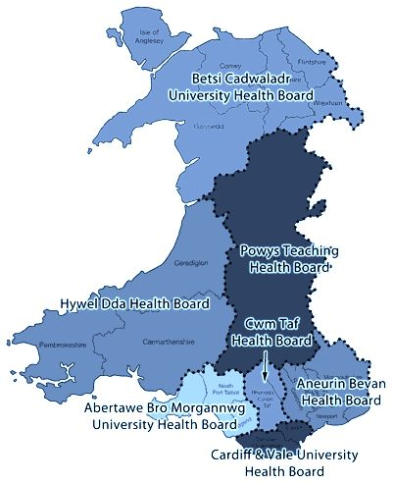

Conclusion
Overall, the NHS Wales provides healthcare to roughly 3 million people who live in the country. The NHS has a key principle which is that good healthcare should be available to all, regardless of wealth. The NHS sticks to this key principle as it does offer a wide range of care, such as pharmacies which also can provide you with free prescriptions and healthcare advice, Health, Wellbeing and support is another service which provides support and advice on a wide range of conditions such as Arthritis and diabetes. Sexual health is available within the NHS as it offers support towards abortion counselling, cervical smears, contraception support, pregnancy wellbeing and advice, vasectomy, and female sterilisation advice. There are many clinics available which are provided and run by the NHS. There is an accident and emergency service which is only used in extreme conditions for a patient who needs life-saving medical attention, support, and drugs. The Hospitals across Wales provide a range of services within themselves as they have all the equipment and staff there waiting to be at service. However, only certain hospitals have certain equipment such as cardiac surgery or the burns and plastics services which are only available at a limited range of hospitals around Wales. Lastly, the NHS has a lot of support off the seven local health boards in Wales which plan to deliver primary, community, secondary care, and specialist services within certain areas of Wales. This report indicates that the NHS is providing healthcare and support to the best of its ability and has been for the past 70 years, with its continuous service that has changed throughout time with the help of technology and also a break through within medical science has enabled the NHS to keep up within the times of care and mainly with the support of the Welsh government backing its funds through taxes.

Recommendations
The NHS face other issues within their organisation as the funding that is provided by the Welsh government can only go to provide a certain level and quality of care. If the NHS was able to charge a small fee towards patients or even gain more sponsors or trusts, then the NHS can use the extra funding money to improve their quality of care to the patients
Funding
With the use of the needed funds, the NHS staff could have extra training in order to provide and care for the patients while being up to date on the latest medical training.
Staff support
If the NHS had more funding and support then within all the hospitals around Wales, extra staff members could be employed in order to take some stress off the other staff members and this will also expand the medical team. In conclusion this means that there will be an increase in staff who can help those in need and create a happier workplace.
Training
With extra funding, more staff could be trained to a higher and advanced medical standard, meaning that patients could be receiving higher amounts of care and also with extra training it could improve staff relationships and lower the stress within the work place due to staff knowing their roles.
Increase in regional/specialist services
Finally, If the NHS had an increase in there funding then most hospitals around Wales can have specialist units such as the burns and plastics services for some patients to seek medical attention faster. This also links in to with an increased funding, an increase of new equipment could be provided. This means that patients could have less of a waiting list to be seen to and to be treated in an increased time.

Reference list

‘Aneurin Bevan biography’
BBC Wales
http://www.bbc.co.uk/history/historic_figures/bevan_aneurin.shtml
accessed – 4th March 2020

‘What is the NHS budget?’
https://fullfact.org/health/what-is-the-nhs-budget/
sited – 3rd March 2020

‘Health Education and Improvement Wales website’
https://heiw.nhs.wales/
sited – 3rd March 2020

ITV Wales
www.itv.com
sited- 7th March 2020

‘Patients’ overall experience of NHS and social care services’
Nuffield Trust Organisation
www.nuffieldtrust.org.uk/
sited – 6th March 2020

‘Aneurin Bevan and the Birth of the NHS’
Past Medical History
https://www.pastmedicalhistory.co.uk/aneurin-bevan-and-the-birth-of-the-nhs/
sited – 2nd March 2020

‘Organisational Structure of Tesco and the NHS’
Prezi
https://prezi.com/4syqsth1pqqa/organisational-structure-of-tesco-and-the-nhs/
Sited – 4th March 2020

Public Health Wales website
https://phw.nhs.wales/ sited – 4th March 2020

The Velindre NHS Trust website
www.velindre-tr.wales.nhs.uk/home
Sited – 4th March 2020
‘NHS Volunteer Responders information for health professionals’
https://volunteering.royalvoluntaryservice.org.uk/volunteering-in-hospitals
Sited – 5th March 2020

‘About Our Organisation’
Aneurin Bevan University Health Board
http://www.wales.nhs.uk/sitesplus/866/page/40762
NHS Wales website – sited 4th March 2020.

‘Our Services’
https://www.wales.nhs.uk/ourservices/
sited – 4th March 2020

The Welsh Ambulance services website
www.was-tr.wales.nhs.uk/
Sited – 4th March 2020

