


Computer Forensics (CF)

Lab 8

Wales Institute of Science and Art
Applied Computing
I.Q Building, Room 205
Swansea
SA1 8EW

Lecturer: Assoc. Professor Carlene Campbell
Email: carlene.campbell@uwtsd.ac.uk
Website: https://www.knowledgewithprofit.com

Exercise 01: Darkweb
Lab Scenario
When forensic investigators come across cases of dark web crimes, they generally do not locate any traces of criminal activity on normal browsers meant for daily use such as Google Chrome Mozilla Firefox, Microsoft Edge/Internet Explorer, etc. For perpetrating dark web crimes, criminals prefer the Tor Browser as it provides them with a high level of anonymity. In such instances, investigators need to examine the suspect machine for Tor Browser artifacts to help them solve such cases.
Tor Browser artifacts can be retrieved by examining the RAM dump of the suspect machine. In case Tor Browser has been removed/uninstalled from a system after committing the crime, investigators can discover its related artifacts by analyzing its prefetch file on a Windows machine.
Tor Browser artifacts can be retrieved by examining the RAM dump of the suspect machine. In case Tor Browser has been removed/uninstalled from a system after committing the crime, investigators can discover its related artifacts by analyzing its prefetch file on a Windows machine.
Lab Objectives
The objective of this lab is to help you understand dark web forensics techniques. The tasks include the following:
- Discovering Tor Browser activity on a Windows machine

Lab Environment
To carry out this lab, you need the following:
- Windows 11 virtual machine
- Windows Server 2022 virtual machine
- Web browsers with an Internet connection
- Administrator privileges to run the tools
Overview of the Lab
The use of dark web forensics is necessary because of an increase in illegal activities such as drugs and weapons trafficking, selling credit card details and other private information related to individuals, etc. that are facilitated through the internet. Dark web forensics helps investigators gather evidence against the perpetrators of such dark web crimes so that they can be prosecuted in a court of law.
.
Lab Tasks
Note: In this lab, we are considering that the footprint of the investigation is not a major issue. 1. Turn on the Windows 11 and Windows Server 2022 virtual machines.
2. Switch to the Windows 11 virtual machine and press Ctrl+Alt+Delete.
3. By default, the Admin user profile is selected Type Pa$$w0rd in the Password field and press Enter to login.
Note: If the Networks pane appears, click Yes to allow your PC to be discoverable by other PCs and devices on this network.
Note: Before beginning the lab, make sure you install and run Tor Browser on your Windows 11 virtual machine. Ignore any errors if Tor Browser is unable to establish a Tor network connection
4. Navigate to the shared folder on onedrive Forensics tools Dark Web Forensics\Tor Browser. Double-click on tor-browser-windows-x86_64-portable-13.0.8.exe to launch the set-up and follow the wizard-driven installation steps to complete the installation of Tor Browser.
Note: If an Open File – Security Alert window appears, click Run.
5. Navigate the shared folder on onedrive Forensics tools Dark Web Forensics\Tor Browser Detection Tools\WinPrefetchView. Double-click on WinPrefetchView.exe to launch the application. Note: If an Open File – Security Warning window appears, click Run.
Note: If a User Account Control pop-up appears, click Yes to continue.
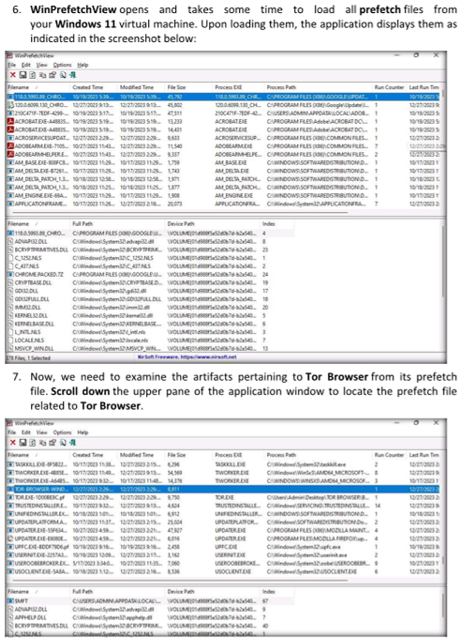
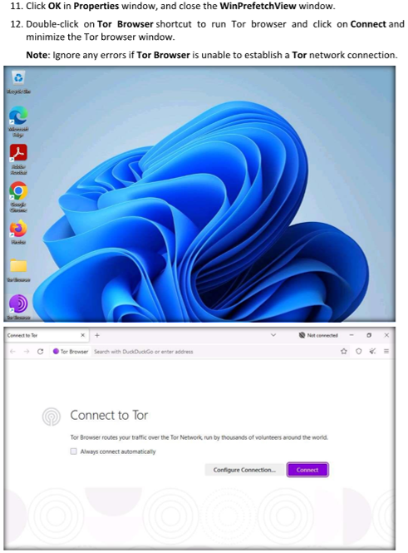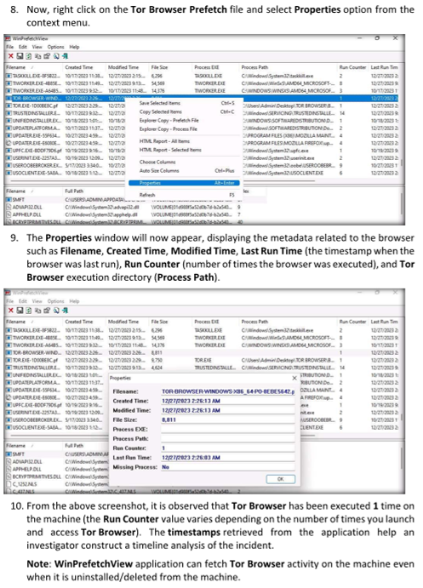
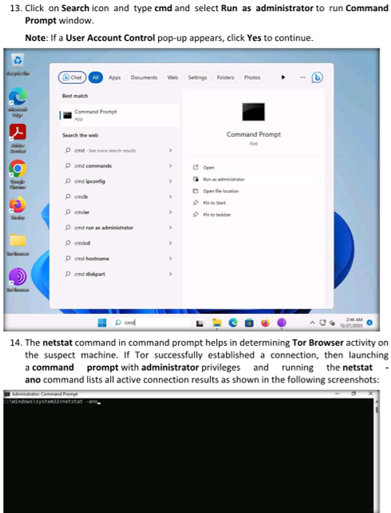
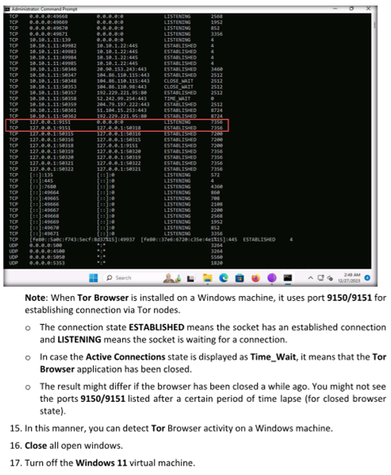

Lab Analysis
Analyse and document the results of this lab exercise.
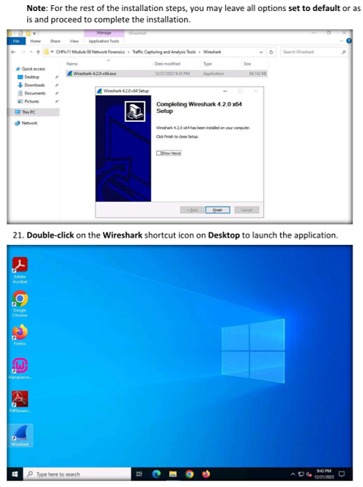
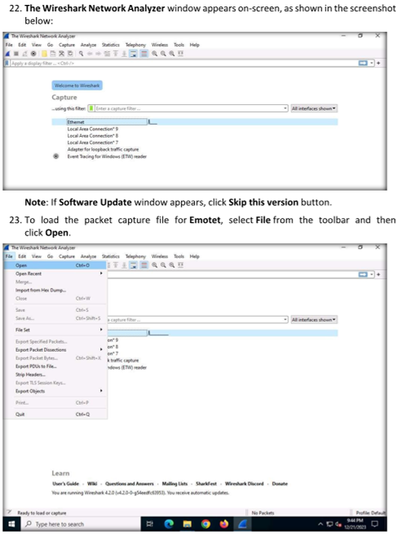
24. Wireshark. Open Capture File window will open. Navigate to the shared folder on OneDrive Forensics tools Evidence Files\Emotet Malware\Artifacts, select the Emotet Network Activities.pcap file and click Open
25. The loaded pcap file displays real time network traffic generated after an active variant of Emotet is run on the system. With the Emotet variant actively running in the background, we will now monitor the IP addresses/URLs the suspect machine is trying to connect to.
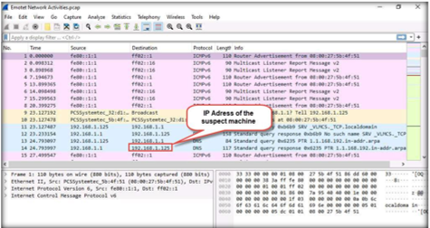
26. Upon scrolling down the captured packets, you can observe a GET request from the suspect machine to a remote IP address that assigned to the remote machine e.g. 177.185.192.135 over the HTTP protocol. Select this packet entry in the packet list pane.
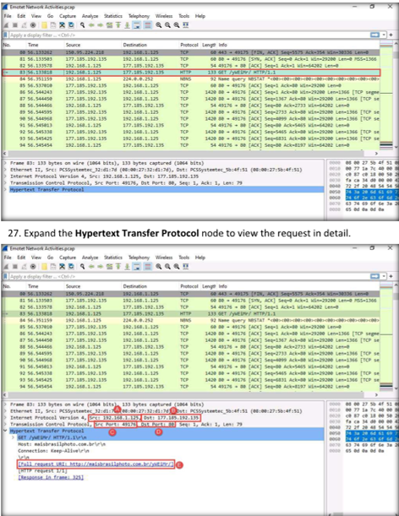
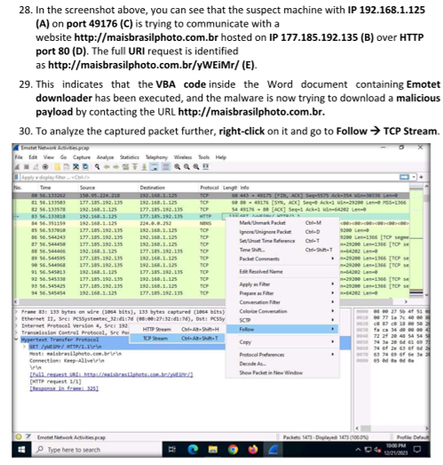
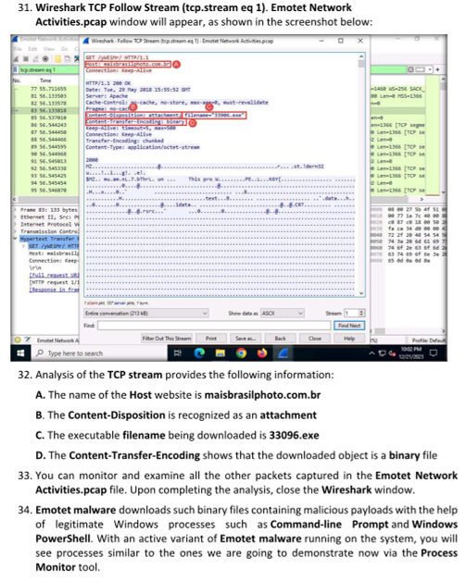
35. To launch Process Monitor, Navigate to the shared folder on OneDrive Forensics tools Malware Forensics\Dynamic Malware Analysis Tools\Process Monitor and double-click procmon64.exe.
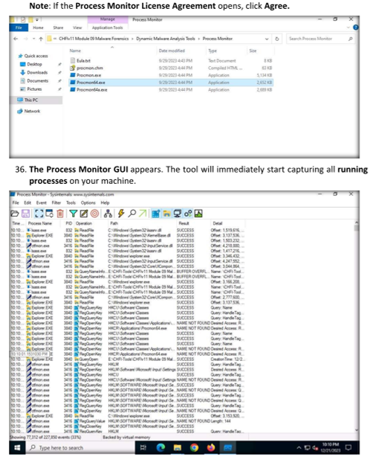
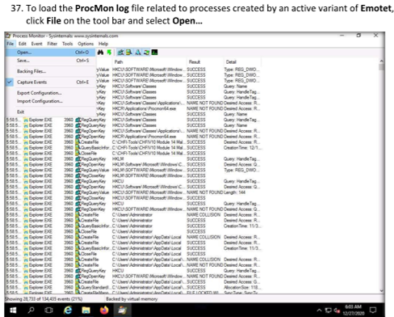
38. On the Open window that appears, Navigate to the shared folder on OneDrive Forensics tools Evidence Files\Emotet Malware\Artifacts, select Emotet ProcMon log.PML, and click Open.
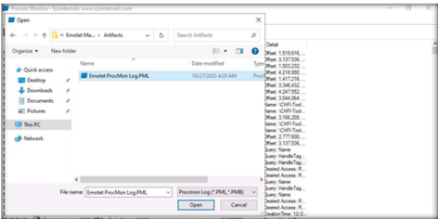
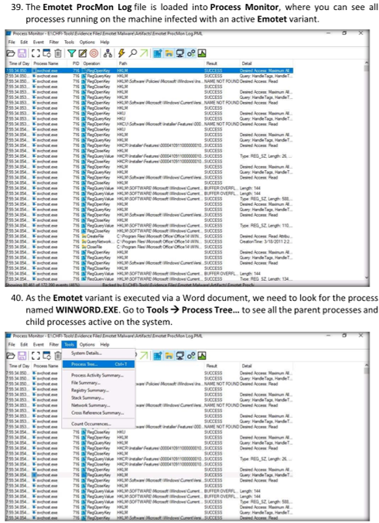
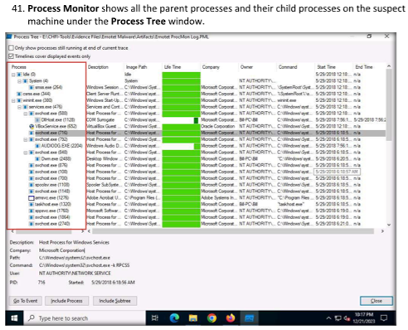
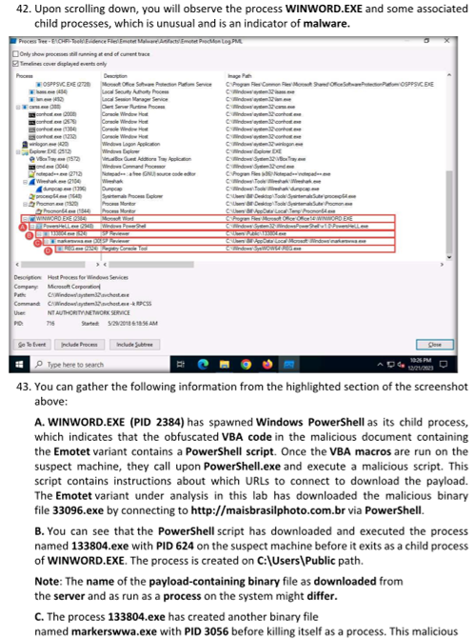
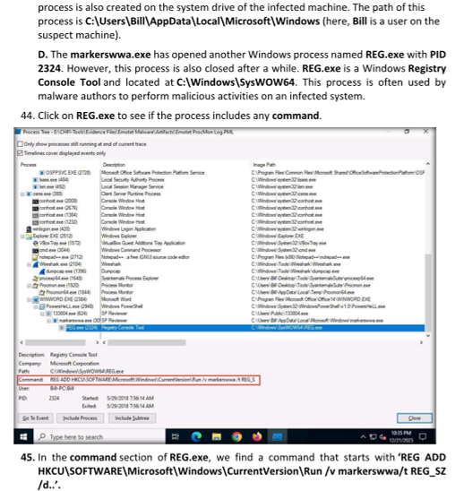
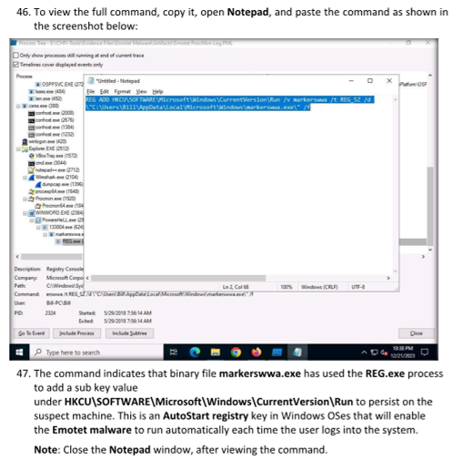
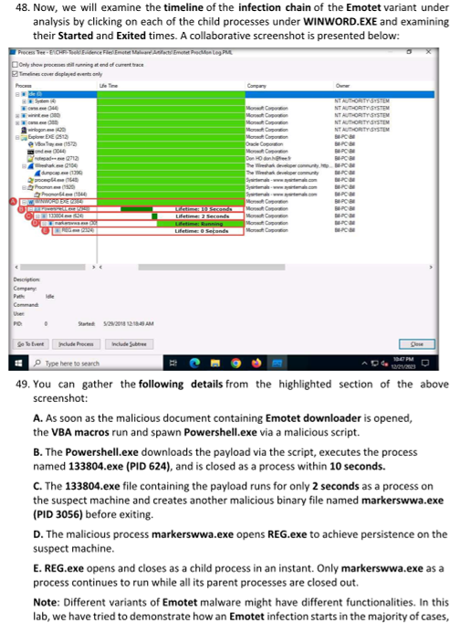
and what changes it commonly performs on the system and network properties to run and persist on the machine already infected by it.
50. Close all open windows.

Lab Analysis
Analyse and document the results of these lab exercises.
Task: tryhackme.com

Create a login account on www.tryhackme.com

The tryhackme.com website is a learning cybersecurity platform where you can develop your skills by working through hands-on guide tasks and supporting videos. You can also learn and test your skills with gamified, real-world cybersecurity challenges.

Now that you have created your account.

- Once you have sign in go to learn

- To select a free walk through task, select
  - Search
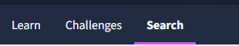
  - Type Forensics
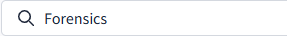
  - In the drop-down menus below the search, select the following in red circle:

  - Chose any of the free walkthrough exercises and give it a go.

If you want specific labs such as Forensics type forensics in the section “Search security terms or topics” see figure above and attempt a lab of your choice. Each week try to complete a different one.

There are many other similar site. If you are using a different one please share it to the class. We will use a number of this site free walkthrough exercise but the option is yours if you want to subscribe (pay).

