University of Wales, Trinity Saint David, London
Name: Plamen Petrov Pelov (2024898)
Lecturer: Olusoyi Ashaye
Module: Managing People

Table of Contents
Introduction 1
Diagnostic tools to measure Engagement 1
1) Employee Recognition and Rewarding Programs 1
2) Worker Reward and Recognition Programs 2
3) Employee Surveys 2
4) Have Frequent One-On-Ones 2
5) Exit and Stay Interviews 2
6) Measure Productivity Metrics and Retention Rate 3
Employee value Proposition 3
Here are some way for creating EVP 3
Understand existing perceptions 3
Communicate the message 4
Ensure alignment 4
Levels of Employee Engagement 4
Highly engaged employee 4
Moderately Engaged Employees 5
Developing an Employee Engagement Strategy 5
Strategies for Enhancing Employee Engagement 5
Conclusion 6
References 6

Introduction
In recent years, management has turned its attention to employee engagement (EE). Employee engagement's importance in the workplace has boosted its use and acceptance. The Gallup Organization is concentrating on employee engagement and how to improve it. This is due to the existence of a strong correlation between some conceptualizations of involvement and worker performance in corporate settings as well as business outcomes. Worker appointment consumes recently become a subject of concern aimed at businesses, consulting firms, and research organizations. However, in its whole, the antecedents and repercussions have yet to be uncovered. Employee engagement can be defined and quantified in a variety of ways in a variety of sectors. It appears to blend job happiness, job involvement, and organizational commitment, making it genuinely global and a desire to stay, resulting in a highly productive workplace and company. Engagement is considered as giving significant competitive advantage by the UK Company that is most advanced in employing it. Increasing levels of engagement, on the other hand, it takes time, work, commitment, and money to build and maintain them – it is not for the faint of heart (Sundaray, 2011).

Diagnostic tools to measure Engagement
Individuals' degrees of satisfaction and the amount of work they do as representatives are not indicative of their level of dedication. A thought in the workroom mentions to how submissive, attached, and agitated labors are to their tasks then their coworkers, to name a few. Representative inclusion, on the other hand, does not remain consistent over time; rather, it fluctuates. These tools will help you keep track of your representative commitment and measure it (Goswami, 2015).

Employee Recognition and Rewarding Programs
Recognizing and rewarding for representatives is an excellent way to deal with forgetting who they are. Employee loyalty is said to be influenced by recognition and rewards in a variety of ways. The opposite is also true: determining the number of award recipients. Executives benefit from acknowledgment, and human resources professionals define what constitutes representative dedication in their companies. Although engagement is a hot topic in the HR consulting world, there is a scarcity of academic research in this area. According to IES research, employee engagement is more than a transitory fad; it has tangible commercial benefits (Anitha, 2014).

Fig:01

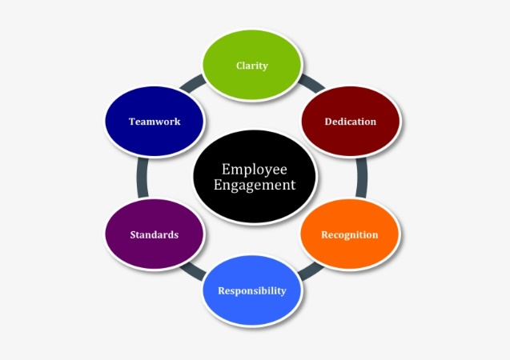

Worker Reward and Recognition Programs
Recognizing and rewarding employees is a wonderful approach to identify engaged individuals. Employee engagement is well recognized to be influenced by recognition and rewards. The opposite is also true, in terms of determining the number of employees who are rewarded. Managers and HR professionals can use recognition to identify employee engagement in their organisations.

Employee Surveys
Conducting surveys should be your first choice if you want to gauge employee engagement quickly and effectively. It not only assistances in assessing engagement, but also in inspiring operate and imploring proposals from them. This reciprocal communication is serious for a motivated staff. HR specialists and bosses should send short, brief, and actionable surveys to employees requesting about their jobs on a fixed basis. It will be backing HR professionals, executives, and the professional in determining how engaged their employees are as well as sympathetic the business's philosophy. Make certain your review questions are focused on three key metrics: satisfaction, alignment, and future orientation.

Have Frequent One-On-Ones
HR professionals and bosses must encounter with them operate individual after time to time. Since one-on-one conferences with the boss or HR are detained in being, the worker is at ease with sharing knowledge and expressing himself or herself. This must be complete on an even base, rather once or double a week.

Exit and Stay Interviews
Employee’s permission the business for a change of reasons, but as an executive or HR expert, your necessity comprehend why they are sendoff. Employees often claim a lack of appointment or enthusiasm with their work as a reason for quitting the business (Bedarkar, 2014). Exit and stay interviews notify managers and HR professionals around the areas in which they must emphasis in instruction to boost worker engagement.

Measure Productivity Metrics and Retention Rate
Employee retaining duties and productivity measures can be castoff to determine how involved workers are with the company. Operative assignation will have a direct impact on employee retention and productivity. As a result, the importance of employee engagement cannot be overstated and why it should be measured on a regular basis in order to keep your employees motivated and keep them in your company. So, if you haven't already, now been the time to implement employee engagement calculation procedures and technologies.

Employee value Proposition
An employee value proposition (EVP) is a bundle of welfares that a worker obtains in exchange for his or her services, abilities, and then knowledge. They contribute a wealth of knowledge and expertise to an organization. An EVP is all about founding your corporation's individuality what types it unusual and what it opinions aimed at. It contains the chief motives why persons are gratified besides invigorated to effort here, such as the moving dream or exclusive ethos. It's serious that your EVP is different, applicable, and convincing. A robust EVP will help memory highest players and employee the finest outside aptitude when it is combined into all rudiments of a business.
Employee one-on-one meetings on a regular basis. Human resource managers and company executives should meet with their staff on a frequent basis. Because one-on-one encounters with the administrator aren't always possible. When meetings with human resources or other departments take place in person, the representative has the opportunity to give information and are willing to put oneself out there. It must be complete on an even substance, preferably more than after a week (Arasanmi, 2019).
Fg:02

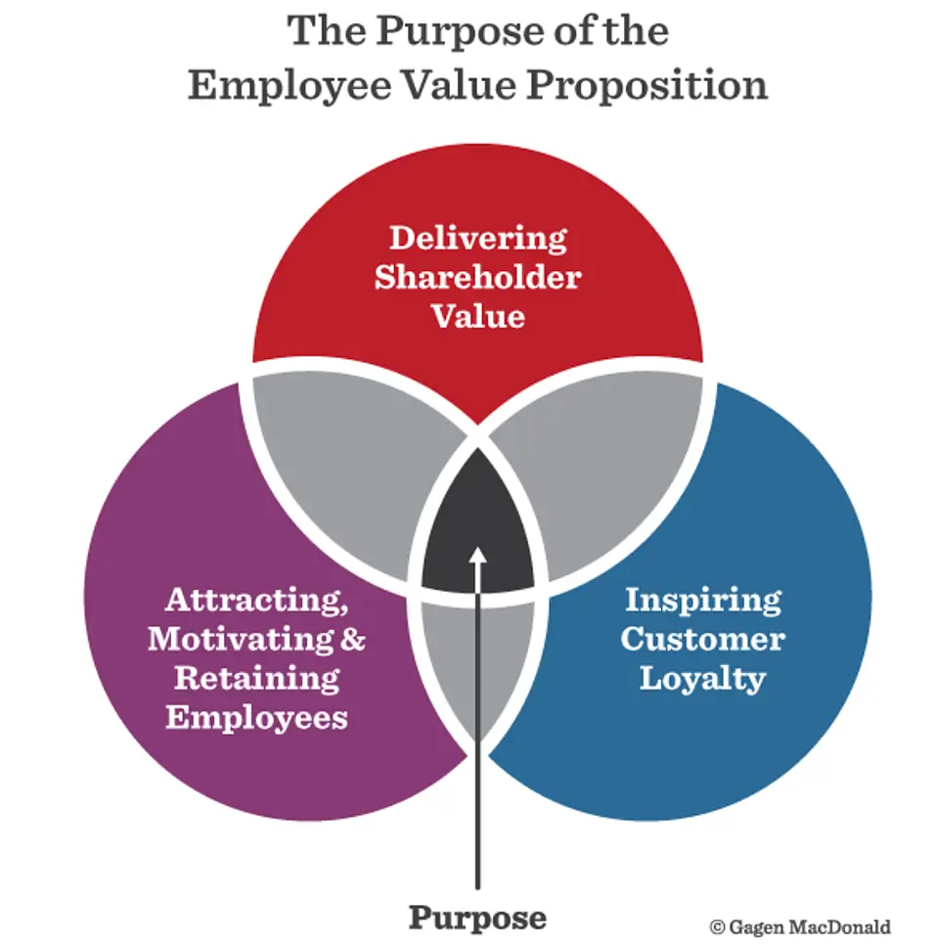

Here are some way for creating EVP

Understand existing perceptions
Building a corporation values to showcase in your EVP isn't only the accountability of commercial managers; it's also the accountability of your team memberships who live and breathe your company values (McManus, 2015). You will make your faultless business culture from your people, transporting your dream to life. To make an influential, believable EVP, you must primary study about your current employees' perceptions. And possible workers' perceptions of your business's make and ethos. Consider the next scenario:
· Why are potential employees attracted to the company?
· Why do existing workers think the company is unique?
Employee reviews, emphasis collections, and departure meetings, as fine as commentaries after preceding staffs and occupation candidates, can be used to obtain this info.

Communicate the message
Discovery creative and pertinent ways to connect your EVP to the persons you're seeking to attract once you've defined it. Start by interactive it through all engagement stations, including as business websites, publicity, and the meeting procedure, so that possible employees can measure whether or not they are a decent fit for your organisation. Using marking, public relatives, and other means to reliably connect a convincing EVP Marketing will also aid in the formation of an optimistic insight of the worth of employed for your business among the passive labor market (Imandin, 2016).

Ensure alignment
Current staffs are your most influential source of publicity and production a key part in serving to appeal aptitude. Employees must perceive constancy in the copy you sell outwardly in order to become brand advocates.as well as in the day-to-day operations of your business Join the EVP into the corporation's introduction programmes, award and credit arrangements, interior infrastructures, policies, and other initiatives and commercial tactics, so that it is mirrored in the method your firm functions on a day-to-day basis. Observe your EVP at least once a year to make sure it lasts to reflect the developing employee knowledge.

Levels of Employee Engagement
Employee meeting is a metric that gauges how content workers are with their jobs. Workers are divided into four groups based on their impressions about their workplace.

Highly engaged employee
Staffs who are extremely involved consume very optimistic feelings near their office Employees that are linked to their sides and like their jobs are more productive. They'll want to stay and put in additional exertion to assist your company embellishment if they like it and have positive thoughts about it. These "brand ambassadors" indorse their business to their domestic and networks. They inspire their colleagues to do at their finest (Mehta, 2013).

Moderately Engaged Employees
Employees that are abstemiously betrothed have a promising view of their business. They relish employed for the organization, though they trust there are parts for development. These persons are fewer motivated to request extra accountability and are additional probable to fail. Somewhat about the organization or their employ averts them after attractive completely engaged.

Developing an Employee Engagement Strategy
- Be realistic in your expectations. You won't success it available of the common on diurnal one, and you'll kind blunders on juncture. Fair recall to develop goals for your squad that are both realistic and specific.
- Make sure that everybody distinguishes what their duties are. Assign errands to the suitable persons and save path of their development. Involve important stakeholders, such as HR representatives, middle managers, and executives, in the development of your strategy. From the start, and long-term employees.
- Be adaptable. Mark certain you're assessing worker meeting on an even base and learning the information to understand what mechanism finest for your exact operate. Be open to references and regulate your plan as essential.

Strategies for Enhancing Employee Engagement
It's no secret that employee engagement is critical for cumulative factory output. A disengaged team underperforms, whereas a completely involved team can attain strange results. As a leader, you should strive to increase employee engagement at all times and you must not be content with anything less than high levels of engagement and performance. But, as with every aspect of business, motivating involvement is easier said than done. To be successful, it requires a well-defined approach (Gruman, 2011). I'll show you how to measure and improve employee engagement in your teams so that you can build an environment where they want to be engaged.
- Assess & Set Objectives
- Give your employees a voice
- Put Your Teams to the Test
- Recognize and reward innovation
- Set a good example
- Establish a Clear Vision (Ellingson, 2020).

Conclusion
Employers from a diversity of businesses are captivating an attention in worker assignation. Employers' desire to discovery habits to improve employee incentive is, in some ways, a very old aim as well as to gain more dedication to the job and the company. The importance of employee engagement is mirrored in the amount of academic study that has been done on the topic throughout a thirty-year span, and practicing awareness led to a variety of theories and hypotheses.
Employees who are hardly involved are indifferent in their work. They are normally apathetic in their occupations and will only do what is essential to become by—occasionally even less. Staffs that are barely betrothed may be observing for other effort, affectation an important risk of attrition. Employees that are detached take an immoral insight of their office. They are detached from the government's assignment, objectives, and upcoming. They are indifferent in their occupations and duties. It's dangerous to distinguish how to contract with discontented staffs so that their deprived arrogances don't touch the output of others about them.

References
Sundaray, B. K. (2011). Employee engagement: a driver of organizational effectiveness. European Journal of Business and Management, 3(8), 53-59.
Anitha, J. (2014). Determinants of employee engagement and their impact on employee performance. International journal of productivity and performance management.
Bedarkar, M., & Pandita, D. (2014). A study on the drivers of employee engagement impacting employee performance. Procedia-Social and Behavioral Sciences, 133, 106-115.
Imandin, L., Bisschoff, C., & Botha, C. (2016). Confirmatory analysis of the model to measure employee engagement. Problems and perspectives in management, (14, Iss. 2), 93-103.
Gruman, J. A., & Saks, A. M. (2011). Performance management and employee engagement. Human resource management review, 21(2), 123-136.
Mehta, D., & Mehta, N. K. (2013). Employee engagement: A literature review. Economia. Seria Management, 16(2), 208-215.
McManus, J., & Mosca, J. (2015). Strategies to build trust and improve employee engagement. International Journal of Management & Information Systems (IJMIS), 19(1), 37-42.
Ellingson, A. (2020). Using Inquiry to Raise Engagement During Third Grade Instruction.
Arasanmi, C. N., & Krishna, A. (2019). Linking the employee value proposition (EVP) to employee behavioural outcomes. Industrial and Commercial Training.
Goswami, P. (2015). Employee value proposition: a tool for employment branding. International Journal of Scientific and Research Publications, 5(12), 263-264.

