IronMan Wales
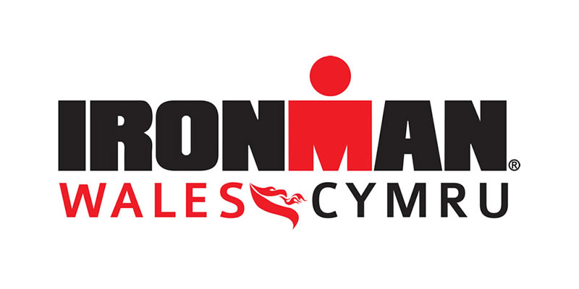
Project Initiation Document
Project Consultant: Alice Thomas (P150130)
Consultancy Project



Contents Page

- Project Justification…………………………………………….……………………..3
  - Project Aims………………………………………………………………………………3
  - Background……………………………………………………………………………….3
  - Objectives…………………………………………………………………………………4
  - Rationale…………………………………………………………………………………..4
  - Project Scope and Exclusions…………………………………………………….5
  - Constraints and Assumptions…………………………………………………….5
- Project Approaches and Business Case………………………………………7
  - Project Costs…………………………………………………………………....7
  - Potential Risks………………………………………………………………….7
  - Benefits…………………………………………………………………………..8
- Project Management and Team Structure………………………………….8
- Quality Management Strategy ………………………………………………….9
- Research Methodology……………………………………………………………10
- Communication Management Strategy……………………………………11
7.0 Gantt Chart and Project Plan………………………………………………….12

Project Initiation Document

- Project Justification

  - Project Aims
The overall aim of this project, is to provide strategical recommendations in order to increase the number of volunteers at IronMan Wales. There is a huge importance in having a sufficient number of volunteers at any event - in order to help with the smooth running and success of the event, where volunteering also goes a long way towards the building of a healthy community.

  - Background
IronMan Wales is a well-established annual Triathlon event, first launching in Tenby in 2011. It consists of a 2.4 mile swim, followed by a 112 mile cycling route, around South Pembrokeshire, finishing with a 26.2 mile run around Tenby – therefore becoming an ‘IronMan’ after completing the tough course. The event has gone from strength to strength, starting back in 2011 with only 1,500-plus competitors and 10,000 spectators in the town and surrounding area, now seeing 2,500 competitors and 25,000 spectators. The event itself has won numerous awards, including Athletes Choice Awards for 2017: Overall Swim, Run Course, Overall Satisfaction, Will Recommend to a Friend, Best Host City Experience and Best Race Venue – (Ironman.com, 2019).
However, the event has since been having trouble in regards to volunteering numbers and issues with the community, where some members have been revealing their anguish towards the event arriving to Tenby every September. This is why the volunteering aspect needs reviewing, in order to pin point any issues in order to move forward in the event.

  - Objectives
In order to achieve the project’s overall aim, a number of objectives must take place.
- Gain a clearer insight into the mindset of those wishing to volunteer, analysing exactly what they want out of volunteering.
- Understand how people hear about the volunteering opportunities at IronMan, evaluating the effectiveness of its current volunteering strategies, further highlighting strengths and weaknesses.
- Identify best practice examples of volunteering organisations and incorporating strategies to aid IronMan Wales’ practices.

  - Rationale
Volunteering is an important aspect of any event, with many people viewing volunteering as a way of gaining experience and contributing to the community by a part of a special event.
Andrea Grace Rannard, Head of Student Volunteering at Volunteering England agrees that many also emphasise the benefits of volunteering in terms of skills development: "Volunteering is a savvy use of an individual's time, valued by employers. Volunteering provides an insight into a profession and a company, allows an individual to build confidence in a role, develop or enhance relevant skills…overall, it is a great way of improving a CV." (GRB, 2019).
This proves the importance of volunteering and the many benefits an individual can gain from volunteering. However, with IronMan losing numbers and interest in the volunteering department, may oppose a risk of difficulty running the event smoothly and without trouble/hassle from locals. IronMan needs a sufficient number of volunteers in order to manage the whole race course, especially the bike course section of the race. The event is spread out across the whole of south Pembrokeshire, showing the large scale of the event, covering a mass of land. Therefore, IronMan Wales needs to adopt effective strategies in order to increase the number of volunteers marshalling the whole course and dealing with road closures. This will effectively help the spirit of the community as well as handling concerned locals, making for a more pleasant IronMan experience.

  - Project Scope & Exclusions
The project intends to help improve volunteering interests for IronMan Wales, hoping to significantly increase the number of volunteering applicants, in order to run the event efficiently each year. The project will conduct research into a number of successful volunteering organisations in the area, comparing with these organisations in order to provide the most effective recommendations to IronMan Wales. However, this project will only be focusing on the strategies and incentives used to attract a larger number of volunteers, and will not be focusing on issues regarding training or any aspect involving Human Resources and worker rights within the organisation. The consultant and the University of Wales Trinity St David will not be relying on any funding form IronMan Wales, nor will the consultant and the UWTSD be responsible for any financial costs for this project.

  - Constraints and Assumptions
It is important o consider any possible constraints that may hinder the success or potential aim of the project. Constraints include:
- As a student, time is going to be an issue and will not be in favour of the project when working towards a particular deadline, due to the project and its tasks being carried out alongside other studies. This can therefore, effect the depth and input of time taken on each task within the project. In order to combat this constraint, there will be weekly check ins on the extent of time and input placed on each part of the project, therefore having a focus on what needs to be done and when within the time scale. The consultant will study extensively during the time period, maintaining contact with the organsation.
- There may be a constraint in terms of the lack of people wanting to take part in surveys and questionnaires, therefore prohibiting the depth of knowledge and information needed in order to understand the mindset of volunteers and not creating optimal solutions. In order to encounter full engagement, the use of social media will be an effective format when conducting research. This is mainly due to its easy and relaxed nature, potentially reaching many participants who are more likely to contribute to surveys/questionnaires.
- Although the consultant has been accepted to partake in the project by IronMan managers, the consultant may not be respected by other members of staff, who may see the individual as a threat to their jobs.
- The organisation may not be willing to accept strategies from the consultant or may even be insulted by the consultant implying their current strategies aren’t enough, therefore shutting off the project and any recommendations made after gathering the information.
- There is the assumption that the management at IronMan will be readily available to get in contact when and whenever necessary throughout the project, however they will be busy with their own projects and tasks so they will require contact and queries in advance.

2.0 Project Approaches and Business Case
In order to finalise an overall breakdown structure on the project, this report will go into detail on the steps that will be taken in order to achieve the desired overall aim.

2.1 Project Costs
In terms of funding and costs for the project, this will require very minimal input/output do to the nature of the project. The consultant will be applying their extensive research to provide optimal recommendations for the organisation at no cost, and will do so to implement their perspectives in order to add value to the orgainsation – whether managers were to take action on it or not, after the project has been concluded. However, that’s not to say that the project will involve no costs entirely, and if there were to be a small financial cost – this will come from IronMan Wales’ budget. Other costs will include time costs, where this project will require a sufficient amount of time from both the consultant and event managers, putting in both their efforts and attention to specific tasks.

2.2 Potential Project Risks
It is inevitable that some potential risks may occur when conducting the project. This means that actions must be adopted in order to minimise and manage the risks. These risks include:
- The project aims to find out the organisation’s current volunteering strategies, how there may be a possible lack in communication/contribute from event managers do to their own hefty schedules to run and prepare for their events – therefore potentially slowing down tasks and findings, hindering the project time frame. This can be accomplished by regularly reviewing the indicated time scale and committing to that accordingly.
- Lack of involvement from individuals completing primary research, giving errors that may hinder the clarity of the research findings – this will be managed by effectively communicating with individuals, highlighting exactly what needs to be done, advising all participants to proof read their work. Also primary research would’ve been done by other organisations, therefore comparing current strategies to those will allow for more accurate results.
- There is the possibility some stakeholders may take offence to the project, therefore will lack in efforts to contribute to the finding of the project. This can be eradicated simply by advising that the project is mainly to the organisation gain a perspective from a fresh set of eyes at no cost.

2.3 Benefits
There are many potential benefits that may come out of this project, both short-term and long-term benefits. These include:
- Increased awareness of volunteering opportunities at IronMan, as well as increase of awareness in Swansea and not only Pembrokeshire.
- Potential increase in volunteering numbers.
- By undertaking Primary research in the form of surveys/questionnaires, this will show that the company has an interest to keep in contact with the public and with past/potential volunteers. The public will recognise the effort made and understand that the organisation truly cares about what people want, and will therefore look more into the event itself – either to pursue the option of volunteering or even to sign up as a participant in the race – due to respecting the company and its incentives of public satisfaction.

3.0 Project Management and Team Structure
In order for the smooth running on the consultancy project, there must be a logical and a clear approach to the assignment of roles and responsibilities between the consultant and event directors/stakeholders. However, due to the project involving research undertaken by the consultant, there is no need for managers to be involved in every section and task in the project. They will only be needed when called open to obtain necessary information in regards to requiring business resources/strategies in order to compare to other successful organisations.
The IronMan Wales Race Course Director, Rachel Jackson, will be the main director involved when obtaining the necessary information from IronMan and will play a major role in the project regarding the communication with the consultant. Rachel has had an array of volunteering management experience specifically at IronMan Wales, and will be an asset to the project – delivering rich knowledge on volunteering aspects that she has dealt with first hand.
The consultant themselves will in charge with the orgainsation and planning of the project, coordinating the designated tasks and implementing the surveys/questionnaires themselves, as well as identifying possible issues that may hinder the success of the project – providing solutions when moving forward.

4.0 Quality Management Strategy
It is important to understand the quality management strategies that need to take place in order to form an effective structure to the project. The 4D Project Management Model will be used in order to attain a high standard in such management practices. Being a manager of any project will enable one to deliver something real in the organisation, where “you can make an impact both on your organisations performance and on you own reputation”, therefore making it vital to set off on the right foot, where “clarity in the aims, objectives and outcomes for the project are essential to start well and must be then supported by a well- crafted plan” (The Happy Manager, 2019).
The following table reveals the 4D Project Management Model - a step by step process for an effective quality management strategy, revealing the quality techniques and standards to be applied – a process on how the overall aim of the project will be achieved.
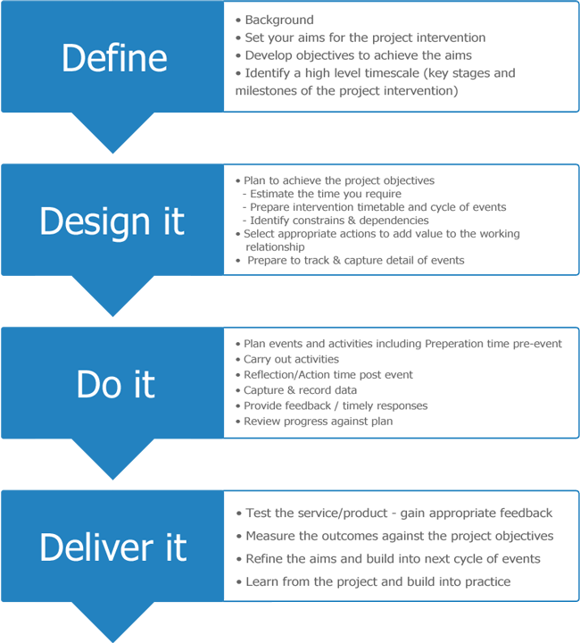
(The Happy Manager, 2019)

5.0 Research Methodology
The main purpose of the project is to gain a clearer insight into the mindset of potential volunteers across all groups of all ages.
  - Primary Research
The research will involve the use of qualitative research carried out first hand, where it will involve a large number of surveys being conducted on Survey Monkey as well as face-to-face questioning in a relaxed environment, and will be structured in a way that will enable the use of facts and statistics to help guide the responses in an orderly structure. A large number of up to 100 surveys will be recorded in order for a higher validity and accuracy in results.
This is also known as the interpretivism method. This will involve the consultant interpreting elements of the study, thus interpretivism integrates human interest into a study (Research-Methodology, 2019), this being to interpret the range of answers given – due to there not only being one straight forward answer to cover all aspects of volunteering. This will also involve the exploration of elements that motivates people, as well as covering many groups with different backgrounds, ages, male/female.
The research will adopt Epistemology, where this concerns the possibilities, nature, sources and limitations of knowledge in the field of study and can be branded as the “study of the criteria by which the researcher classifies what does and does not constitute the knowledge” (Research-Methodology, 2019). In regards to the project, epistemology will be used to focus on what is known to be true/the facts in regards to what people want out of volunteering. This will then be followed by the inductive approach in order to develop and construct a theory/recommendations on the appropriate actions to take upon analysing the findings. A Matrix chart will also come into use when comparing the data across many groups – therefore allowing the smooth interpretation of the results.
  - Secondary Research
Secondary research will be carried out by reviewing already implemented strategies from other volunteering organisations, such as Discovery – a volunteering scheme adopted by Swansea University. However, it is important to note that this form of research may not get to the underlying factor in regards to the issues faced by IronMan Wales, due to other organisation’s practices being carried out with other issues in mind that may not relate to those of IronMan’s.

6.0 Communication Management Strategy
It is important for both the consultant and the organisation involved to understand the forms of communication involved throughout the project, in order to both be on the same path and plan ahead to arrange a time to communicate effectively – making both sides content, engaged and know exactly where they are in the project.
Due to IronMan Wales being a huge scale event, it will be difficult to arrange face-to-face meetings with directors due to the nature of their jobs. They will most likely be busy travelling all over the country, giving talks, planning and organizing events all in the aid of IronMan Wales. There it is most likely that communication will be limited to emails and telephone calls between the consultant and directors, however it must be noted that emails and phone calls will be rich with data/information, therefore meaning the project will not be lacking in terms of effective communication and all tasks will be carried out with very little concerns.
Emails will be carried out a least once a week, where the consultant will be emailing the Race Director for necessary information, as well as keeping them updated on the research findings. Telephone calls will be needed in the case of requiring information off the director urgently.
All communication between the consultant and the director will be logged accordingly, where minutes will be recorded after the telephone calls, as well as all emails being logged and saved onto the laptop/Usb, for the final project report – therefore minimising the risk of losing all communication evidence.

7.0 Gantt Chart and Project Plan
The Gantt chart demonstrates a summary of the tasks taken place throughout the project, as well as scheduled dates, activities and milestones that needs to be achieved to research the potential aim of the project. It also includes a time management plan that must be followed accordingly to keep on track of schedule.
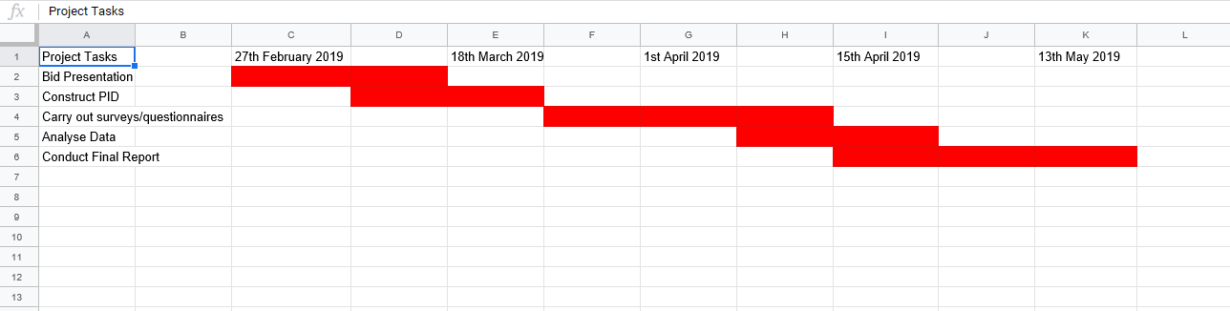
The first section of the Gantt chart, reveals how both the client and the director have discussed and agreed on the goals they would like to achieve – revealing the project’s aims and objectives in the Bid presentation.
The second stage entails constructing the Project Initiation Document, where the consultant is carrying out a document revealing the stages and practices of collecting data for the project. At this point the consultant will also be thinking about what information to gather in order to form and construct the surveys.
The third stage will involve carrying out the surveys and collect rich data from an array of focus groups, where the consultant wishes to obtain a number of responses, therefore making answers more valid across all groups.
Alongside the collection of data, the consultant will being reviewing other strategies from successful volunteering organisations, carrying out a SWOT analysis in order to compare other organisation’s Strengths, Weaknesses, Opportunities and Threats to those at IronMan Wales.
Upon the collection of data, the consultant will be analysing and interpreting the data, gaining a clearer understanding to the mindset of potential volunteers.
Finally, by mid-May, the data will then be translated into a final project report containing strategical recommendations on the best actions for IronMan Wales to implement into their current volunteering recruitment strategies, as well as solutions to help combat the lack of interest/depletion in volunteering numbers. The report will then reviewed by the University as well as a copy being sent to Ironman Wales for them to follow up on if they wish to do so.

References
GRB. (2019). Graduate Employability Skills, Employability Advice. https://www.grb.uk.com/careers-advice/graduate-employability-skills Graduate Recruitment Bureau
IRONMAN.com. (2019). IRONMAN Wales http://eu.ironman.com/triathlon/events/emea/ironman/wales.aspx#axzz5UgJ03kS0
Research-Methodology. (2019). Interpretivism (interpretivist) Research Philosophy - Research-Methodology. https://research-methodology.net/research-philosophy/interpretivism/
Research-Methodology. (2019). Epistemology - Research-Methodology. https://research-methodology.net/research-philosophy/epistomology/
The Happy Manager. (2019). Project Management Model | clarify your project aims & outcomes. https://the-happy-manager.com/articles/project-management-model/

