

Programme
Master of Business Administration

Module Name & Code
Marketing Management - LCMB7024

Lecturer’s Name: Dr Laila Maazouz (London)

Student Name: MD MOINUL HASAN BAPPY
Student ID: 2503567

Word Count: 2537

Table of Contents
Introduction 3
Element 1: Segmentation, Targeting, Differentiation, and Positioning (STDP) Analysis for Hydra HomeCell 4
Hydra HomeCell Overview 4
STDP 4
Segmentation 5
Targeting 6
Positioning 6
Differentiation 7
Element 2: Marketing Mix - 4Ps 9
Product: Hydra HomeCell 9
Price: Pricing Strategy for Hydra HomeCell 10
Place: Distribution Strategy for Hydra HomeCell 10
Promotion: Promotional Strategies for Hydra HomeCell 11
Element 3: Marketing Strategy Pitch 12
Element 4: Reflection 13
Conclusion 15
Reflection 16

Introduction
The Hydra HomeCell is a new brand of Toyota, and it is aimed at satisfying the increasing need of clean, reliable and sustainable energy storage. Through the hydrogen fuel cell technology, it provides homeowners with another option to conventional energy systems which guarantees energy security at a time when there is an increase in the cost of energy and when there is instability in the grid. As a high-end, environmentally friendly product, Hydra HomeCell is in line with the global trends of using renewable energy (Precedence Research, 2024).

Element 1: Segmentation, Targeting, Differentiation, and Positioning (STDP) Analysis for Hydra HomeCell

Hydra HomeCell Overview
Toyota is entering renewable energy through Hydra HomeCell which is a household-based energy storage powered by hydrogen. Hydra HomeCell is a long-term solution to energy independence with the increase of instability and energy prices in the grid.
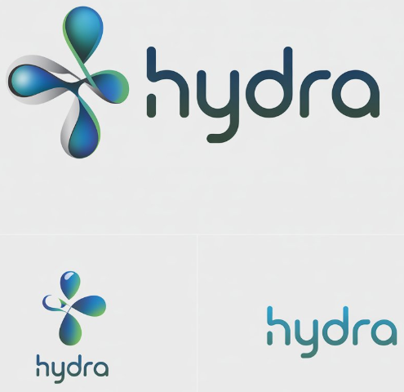
Figure 1: The New Brand
Source: Author
Hydra HomeCell is a long-term and environmentally sustainable energy storage technology due to Toyota reputation of safety and innovation. Another aspect that the product exploits is the demand of clean energy and sustainability on a global scale (Rolo, Costa & Brito, 2023).

STDP
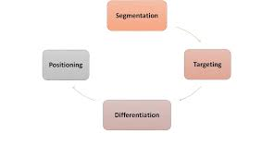
Figure 2: STDP Analysis
Source: (Fripp, 2022)
Segmentation, Targeting, Differentiation, and Positioning (STDP) is a marketing model that is applied to analyse and design marketing strategies. Segmentation breaks a wide market into small groups sharing common characteristics. Targeting concentrates on groups to be targeted, whereas Differentiation makes the product special. Lastly, Positioning describes the perception of the product as compared to the competitors (Fripp, 2022).

Segmentation
Demographic Segmentation: Hydra HomeCell segmentation method takes into account such attributes as demographic factors. Homeowners with middle-to-high income and aged between 30 and 70 years tend to invest in premium and long-term energy solutions (Patel et al., 2024). These consumers consider energy independence and sustainability as key decision-making factors.
Geographic (Regional) Segmentation: Hydra HomeCell shall focus on grid-unreliable or solar-powered sites that have high energy storage demands. Figure 3 shows that the hydrogen energy storage market is expanding, with a forecast of USD 459.5 billion by 2032, particularly in regions prone to grid instability or those highly concentrated on renewable energy adoption (P&S Intelligence, 2025).
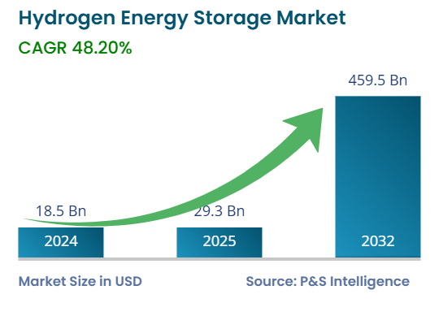
Figure 3: Hydrogen Energy Market
Source: (P&S Intelligence, 2025)
Psychographic Segmentation: Psychographically, the product is addressed to customers who are tech-savvy and eco-conscious and who prefer innovative and sustainable technologies. Consumers in this segment are more concerned about their carbon footprint and actively seek green energy solutions.
Behavioural Segmentation: Hydra HomeCell will fit well with early adopters who are concerned with energy security and long-term cost-effectiveness. According to Figure 4, the market segment of home hydrogen energy storage currently accounts for only 9.81, indicating significant untapped potential for environmentally friendly energy sources that allow consumers to save money and reduce long-term dependence on the grid (P&S Intelligence, 2025).

Targeting
The optimum market of Hydra HomeCell consists of homeowners in areas where the grid systems are not reliable or where there is a high level of adoption of solar systems. As Figure 4 shows, the residential hydrogen storage market is underdeveloped and will occupy only 9.81% of the entire market in 2024 (Precedence Research, 2024). This is a huge expansion prospect to Hydra HomeCell to respond to the new demands of residential customers.
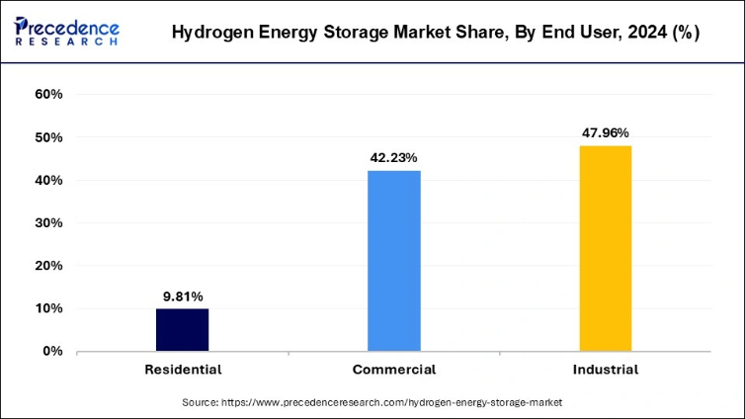
Figure 4: Hydrogen Energy Storage Market Share
Source: (Precedence Research, 2024)
The early adopters constitute the target market and are driven by environmental sustainability and energy security. These are consumers who are in search of long term and reliable energy solutions. Hydra HomeCell will attract families that want to lessen the use of conventional energy sources and invest in the energy self-sufficiency in the long term (Lubello et al., 2022). With the growing hydrogen infrastructure, especially in sun-heavy areas, Hydra HomeCell will be the perfect answer to the needs of households that require a stable and scalable energy storage system (Precedence Research, 2024).

Positioning
Hydra HomeCell will be placed as a high end, environmentally friendly, and innovative energy storage system. It will highlight its hydrogen fuel cell technology that has a better energy density and longer lives than the conventional battery-based systems (Bajra, 2021). As Figure 5 indicates, the increase in sector-specific hydrogen demand implies a rise in heat and power energy demand by 2035, which means that the potential of Hydra HomeCell to become a source of residential energy in the long-term may increase (Department for Energy Security & Net Zero, 2023). The product will be positioned as a high-quality option among home owners who want to find high-quality and environmentally-friendly energy sources that will ensure they save money and not be dependent on the grid in the long run.
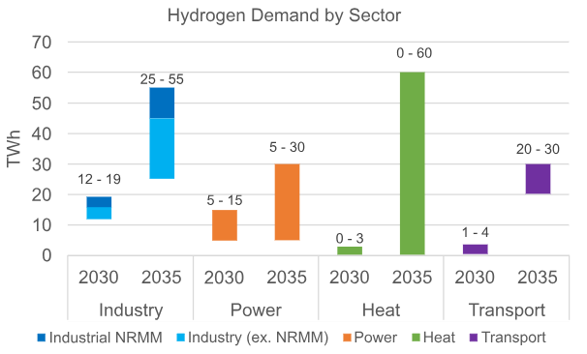
Figure 5: Hydrogen Demand by Sector
Source: (Department for Energy Security & Net Zero, 2023)
By marketing Hydra HomeCell as a high-tech solution, it will stand out of the conventional, less-efficient energy storage solutions. The safety and innovation brand equity of Toyota is another strong factor in this respect, as it makes consumers identify Hydra HomeCell with the high reliability and the technology of the future (Yap and McLellan, 2023).
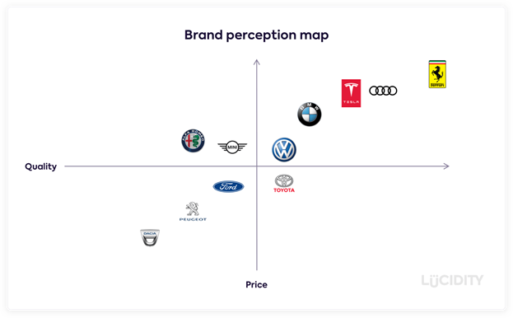
Figure 6: Positioning
Source: (Bajra, 2021)

Differentiation
Various characteristics will be used to differentiate the Hydra HomeCell. The Hydrogen fuel cell technology offers more energy and life compared to lithium-ion batteries. Long term energy storage is a better reserve to instability of domestic grid. Hydra HomeCell will become the most identifiable amongst the market where reliability and durability are the most important features (Toyota Motor Corporation, 2025). The product has a competitive edge since Toyota has an image of quality and innovation. Modular architecture enables the Hydra HomeCell to adapt to its homeowner to tailor and scale to its energy requirements (Patel et al., 2024). Figure 3 shows that the market of hydrogen energy storage is expanding at a very high rate, and Hydra HomeCell will have the opportunity to exploit this market and offer a sustainable and efficient household energy storage solution (P&S Intelligence, 2025).

Element 2: Marketing Mix - 4Ps
The 4Ps Marketing Mix (Product, Price, Place, Promotion) offers a systematic approach for Toyota supports its new brand development which has been presented below:
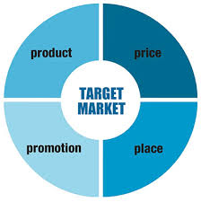
Figure 7: Marketing Mix
Source: (Universal Marketing Dictionary, 2023)

Product: Hydra HomeCell
Product: Hydra HomeCell
Hydra HomeCell is a residential hydrogen fuel cell energy storage that Toyota created to solve grid instability, escalating household energy prices, and increased demand of sustainable power solutions (Rolo, Costa & Brito, 2023).
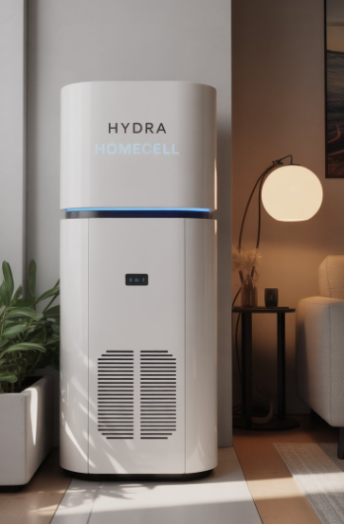
Figure 8: Hyda Homecell
Source: Author

Core Product Value:
Simply, Hydra HomeCell provides its customers with energy security, reliability and long-term independence. The most important value proposition is the 24/7 access to clean and reliable electricity especially where the grid is not reliable and volatile. With the help of hydrogen as a clean energy carrier, the system will decrease the reliance on the traditional energy grids and help to ensure the absence of emissions to the household energy consumption, which will correspond to the growing consumer demand regarding sustainable solutions (Lubello et al., 2022; Rolo, Costa & Brito, 2023).
Actual Product:
The real product is a hydrogen fuel cell-powered energy storage system which transforms hydrogen stored into electricity to be used in homes. Hydra HomeCell has greater power density and a longer storage time than traditional lithium-ion batteries. Toyota is an engineering firm, which has provided high safety levels with leakage and pressure technology. Its design can be expanded to increase storage capacity according to the energy demand of the household due to the possibility of scalability and modularity (Yap and McLellan, 2023; Patel et al., 2024).
Augmented Product:
The augmented product will contain professional in-store installation, maintenance services, system monitoring, and long-term warranties that will have the assistance of Toyota worldwide services. An instruction on how to incorporate Hydra HomeCell with renewable energy sources like the use of solar power also adds value to it. The operation with zero emissions, and water is the sole by-product, strengthens the brand positioning of Toyota as a high-quality and environmentally friendly company (Lubello et al., 2022).

Price: Pricing Strategy for Hydra HomeCell
The Hydra HomeCell pricing strategy will be based on the premium pricing model according to the high-technology and energy independence in the long run that the product will provide. The first one will involve installation, Hydrogen refueling, and fuel cell technology. Since the hydrogen technology is in its early stages, the price will be comparable to those of other similar high-end residential energy options (Ogbonnaya et al., 2021).
To bring Hydra HomeCell closer to the people, the price model will have the installation packages according to the location and the complexity of the installation. There will also be funding possibilities to divide the initial price into several payments to suit a wider audience of consumers (Jakob & Steckel, 2022). Also, it will include maintenance and service packages where the customers can get the knowledge of Toyota in terms of maintaining the performance and life of the product. The price of Hydra HomeCell will be lowered in the regions where the adoption of hydrogen energy is promoted by subsidies to increase its competitiveness in the market (Ogbonnaya et al., 2021).

Place: Distribution Strategy for Hydra HomeCell
Hydra HomeCell distribution strategy will utilize the vast global network and network with clean energy providers that Toyota has to deliver the product to the target markets. Direct sales will be the main distribution option by Toyota dealership and online. This strategy guarantees customers the advantage of the Toyota brand image and customized customer service and also allows them to build their own energy plan online (Jakob and Steckel, 2022).
Also important in marketing Hydra HomeCell will be partnerships with solar providers. Such alliances will enable Toyota to sell the product to existing homeowners who are already using solar power to develop a complete energy system (Patel et al., 2024).
Also, the product will be channelled via certified energy retailers and home improvement stores dealing in renewable energy technologies. These retailers will inform consumers on the benefits of hydrogen energy storage and provide Hydra HomeCell as a sub-offering to an energy-efficient back-off home upgrade (Jakob & Steckel, 2022).

Promotion: Promotional Strategies for Hydra HomeCell
The Hydra HomeCell advertising strategy will focus on technology, environmental friendliness and sustainable energy activities of Toyota. The social media campaigns will be part of digital marketing that will inform people about hydrogen energy and why it is better than traditional energy storage. The content marketing will focus on the long-term savings, energy self-sufficiency, and impact on the environment (Lubello et al., 2022).
Hydra HomeCell requires environmental activists, green NGOs, and sustainability influencers to gain trust. Collaborations with these organisations will increase the level of awareness and promote the environmental friendliness of the product, and the brand will be consistent with the consumer values of sustainability and clean energy (Jakob and Steckel, 2022). The TV commercials, print advertisements, and billboards will also be focused on the areas that have a high energy instability or interest in clean energy in an effort to market Toyota as a safe and reliable car (Yap and McLellan, 2023).

Element 3: Marketing Strategy Pitch
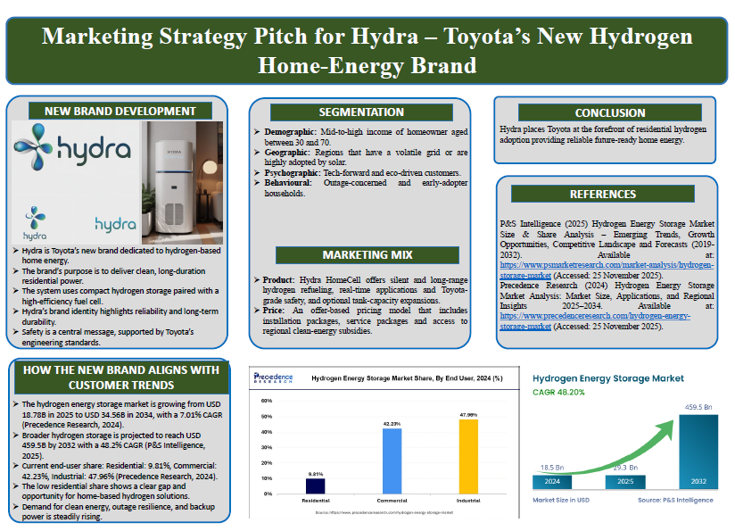

Element 4: Reflection
The Reflective Cycle by Gibbs offers a systematic method of reflection particularly within the business and education environment (Gibbs, 1988). My marketing pitch strategy reflection has been presented below trough Gibbs reflective cycle:
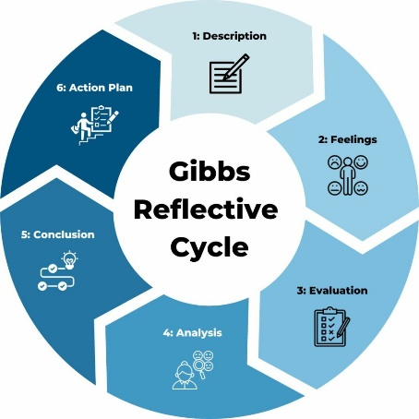
Figure 9: Gibbs Reflective Cycle
Source: (Gibbs, 1988)
Description: In the third element of the marketing portfolio, I presented a marketing strategy pitch in which Hydra HomeCell has been presented as a high-end reliable and sustainable residential power system. The pitch was effective in conveying the value proposition of the product, market segmentation, pricing justification and sustainable energy story, with a long-term clean energy product being hydrogen fuel cell technology. I organized the pitch logically connecting segmentation, positioning and marketing mix into a logical story of market-entry.

Feelings: I was comfortable in introducing the sustainability and technology issues, as I had good research-based support. I was however a bit confused in explaining the premium pricing model especially when I predicted questions to be raised on affordability and adoption barriers to residential consumers.

Evaluation: Clarity and professional delivery were one of the strengths of my presentation. I have employed the right marketing words, matched the strategy with the trends of clean energy and actually tapped the brand equity that Toyota enjoys to warrant trust and reliability. The sustainability narrative and market logic were found to be persuasive according to the class feedback. One weakness however, was the lack of depth in the explanation of consumer price sensitivity and alternative pricing models, which decreased how convincing the argument on the commercial feasibility was. In addition, I was somewhat nervous while presenting the pitch in the class but later I performed well.

Analysis: On reflection on Gibbs Cycle, I can admit that my strategic thinking was solid, but I paid more attention to the benefits of products and sustainability, rather than the behavioural pricing perceptions. Perceived value, reduction of risk, and financial flexibility are vital in the technology market, especially in the emergent markets, and I might have presented a better case in these areas in the pitch.

Conclusion: The experience enhanced my skills of presentation, strategy storytelling and critical thinking. It emphasized the need to balance the positioning choice based on innovation with the pricing logic that is customer-oriented.

Action Plan: For brand development capabilities as proposed by (Munir et al., 2024), I would concentrate on getting more consumer insights by surveying or conducting focus groups to streamline the pricing structure and make sure that this is more accepted in the market. I will also consider other pricing strategies such as subscription to reduce the entry barrier to customers. Moreover, I will concentrate on improving following skills to improve my marketing pitch strategy:
Development Area | Identified Weakness / Challenge | Planned Action | Expected Improvement
Pitch delivery skills | Reduced confidence when explaining pricing and handling questions during the class presentation | Practise structured pitch rehearsals and simulate Q&A sessions before presentations | More confident, fluent and persuasive pitch delivery
Research skills | Limited depth in consumer price sensitivity and early-stage market adoption data | Conduct primary research such as short surveys and secondary analysis of similar clean-energy launches | Stronger evidence-based marketing decisions
New brand development skills | Over-reliance on sustainability messaging without full commercial framing | Develop multiple brand value propositions combining innovation, cost savings and trust | More balanced and market-ready brand positioning
Time management skills | Time pressure during pitch preparation affected refinement of pricing strategy | Create a structured preparation timeline with clear milestones for research, design and rehearsal | Improved organisation and higher quality outputs
Communication skills | Complex technical and pricing concepts were not always communicated simply | Use clearer visuals, simplified language and comparative value charts | Improved audience understanding and engagement

Conclusion
Finally, the creation of the Hydra HomeCell brand was a good experience on how to work with the dynamism in the clean energy market and the implementation of the marketing strategies. Through market research, segmentation, and 4Ps, I was capable of developing a holistic brand plan that will make Hydra a dependable, environmentally-friendly energy source. The project has developed critical thinking, strategy planning, and research capabilities, which will make me prepared to meet future obstacles in the field of marketing and brand development.

References
Bajra, A. (2021, August 12). Using perceptual mapping for competitive analysis. Medium. https://anupambajra.medium.com/using-perceptual-mapping-for-competitive-analysis-9aae239ec736 (Accessed: 08 December 2025).
Czinkota, M. R., Kotabe, M., Vrontis, D., & Shams, S. R. (2021). Marketing management: Past, present and future. Springer Nature.
Department for Energy Security & Net Zero. (2023, December 14). Hydrogen production delivery roadmap. GOV.UK. https://www.gov.uk/government/publications/hydrogen-production-delivery-roadmap/hydrogen-production-delivery-roadmap (Accessed: 06 December 2025).
Dwivedi, A., & McDonald, B. (2025). A model of brand price premiumness and its marketing outcomes. Journal of Marketing Theory and Practice, 1-22. Available at: https://www.tandfonline.com/doi/pdf/10.1080/10696679.2025.2544671 (Accessed: 07 December 2025).
Fripp, G. (2022). Understanding the STDP process in marketing. Segmentation Study Guide. https://www.segmentationstudyguide.com/understanding-the-stdp-process-in-marketing/ (Accessed: 09 December 2025).
Gibbs, G. (1988). Learning by doing: A guide to teaching and learning methods. Oxford Polytechnic.
Jakob, M., & Steckel, J. C. (2022). The political economy of coal: obstacles to clean energy transitions (p. 364). Taylor & Francis. Available at: https://library.oapen.org/bitstream/handle/20.500.12657/52615/1/9781000551556.pdf (Accessed: 08 December 2025).
Liu, G., Guo, T., Wang, P., Jiang, H., Wang, H., Zhao, X., ... & Xu, Y. (2024). Economic analysis of hydrogen energy systems: A global perspective. Heliyon, 10(18). Available at: https://www.cell.com/heliyon/pdf/S2405-8440(24)12250-5.pdf (Accessed: 08 December 2025).
Lubello, P., Pasqui, M., Mati, A., & Carcasci, C. (2022). Assessment of hydrogen-based long term electrical energy storage in residential energy systems. Smart Energy, 8, 100088. Available at: https://www.sciencedirect.com/science/article/pii/S2666955222000260 (Accessed: 08 December 2025).
Munir, A., Kadir, N., Umar, F., Pasryb, A & Sulaiman, S. (2024). Brand capabilities in digital marketing: The key to enhancing marketing performance.International Journal of Data and Network Science, 8(2), 947-956.
Ogbonnaya, C., Abeykoon, C., Nasser, A., Turan, A., & Ume, C. S. (2021). Prospects of integrated photovoltaic-fuel cell systems in a hydrogen economy: A comprehensive review. Energies, 14(20), 6827. Available at: https://www.mdpi.com/1996-1073/14/20/6827 (Accessed: 08 December 2025).
P&S Intelligence (2025) Hydrogen Energy Storage Market Size & Share Analysis: Emerging Trends, Growth Opportunities, Competitive Landscape and Forecasts (2019–2032). Available at: https://www.psmarketresearch.com/market-analysis/hydrogen-storage-market (Accessed: 05 December 2025).
Patel, S. K. S., Gupta, R. K., Rohit, M. V., & Lee, J. K. (2024). Recent developments in hydrogen production, storage, and transportation: Challenges, opportunities, and perspectives. Fire, 7(7), 233. Available at: https://www.mdpi.com/2571-6255/7/7/233 (Accessed: 04 December 2025).
Precedence Research (2024) Hydrogen Energy Storage Market Analysis: Market Size, Applications, and Regional Insights 2025–2034. Available at: https://www.precedenceresearch.com/hydrogen-energy-storage-market (Accessed: 08 December 2025).
Rolo, I., Costa, V. A., & Brito, F. P. (2023). Hydrogen-based energy systems: current technology development status, opportunities and challenges. Energies, 17(1), 180. Available at: https://www.mdpi.com/1996-1073/17/1/180 (Accessed: 08 December 2025).
Toyota Motor Corporation (2025) Toyota Motor Corporation: Corporate Overview. Available at: https://global.toyota/en/company/profile/overview/index.html (Accessed: 07 December 2025).
Universal Marketing Dictionary. (2023). Marketing mix. Retrieved December 9, 2025, from https://marketing-dictionary.org/m/marketing-mix/ (Accessed: 09 December 2025).
Yap, J., & McLellan, B. (2023). A historical analysis of hydrogen economy research, development, and expectations, 1972 to 2020. Environments, 10(1), 11. Available at: https://www.mdpi.com/2076-3298/10/1/11 (Accessed: 08 December 2025).

