Lecturer: Rexon Nting

LCBB4005 - The Global Business Environment

Student name: Rodica Georgiana Dinu
Student Number: 1921784

BMW Group Porter’s Value Chain Analysis

Table of Contents
Introduction 2
Porter’s Value Chain 3
The Primary Activities 4
Inbound logistics 4
Operations 4
Outbound Logistics 5
Marketing and sales 5
Service 5
The Secondary Activities 6
Infrastructure 6
Human Resources 6
Technology Development 6
Procurement 6
Conclusion 7
References list 8

Introduction

How has the car industry changed over the years?

The car industry is one of the most changing and evolving industries. The evolution in this industry is impressive with each year realising changes and every ten years jumping forward and bringing entire developments of cars. The car manufacturing industry is changing and evolving so fast since the turn of the last century that is impossible to determine what types of vehicles we will be driving even just another years from now.

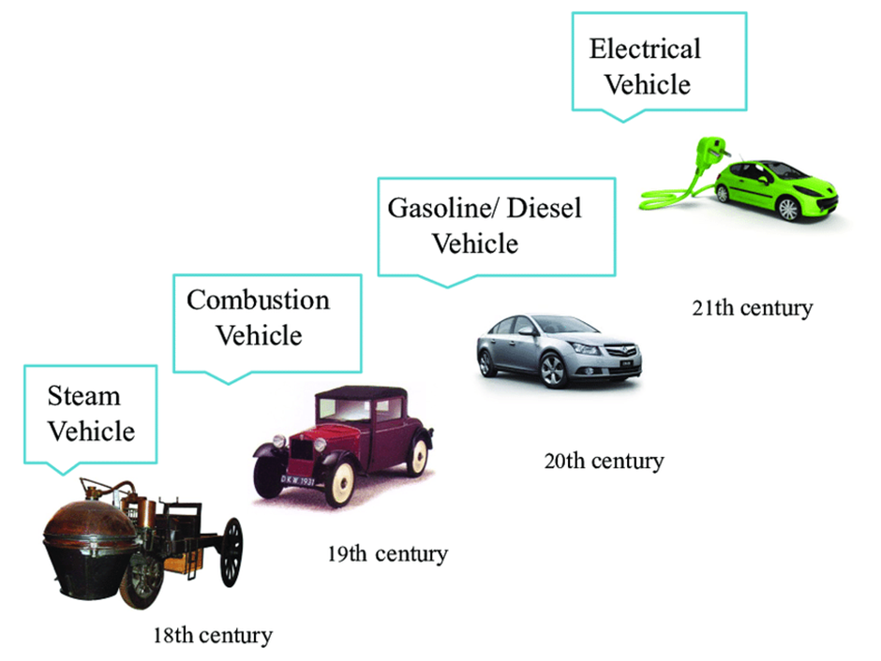
(Soheib, 2014)

The figure above shows the development of the car industry from steam-powered cars four centuries ago to electric-powered cars in the present.
Why are we moving to electric cars?
In the coming years, the growth of electric vehicles is expected to pass the use of conventional cars. One popular aim in recent years is to help to save the environment. The world realised that we need clean energy and people are appreciating that electric cars are helping to improve air quality and preserve the environment.

Porter’s Value Chain

In this report, we will apply Porter's Value Chain to BMW Group.
Bayerische Motoren Werke AG, better known as BMW Group is a German automobile, motorcycle and engine manufacturing company founded in 1916.The company car brands are BMW, MINI and Rolls-Royce, and motorcycles are merchandised under the brand BMW Motorrad. Harald Krüger, since 1992 has been working in the company and from May 2015 has become the CEO and Chairman of the Board of Management.
A value chain is a business model that describes all of the activities that a business employs to create a product or service ( Tardi,2020).

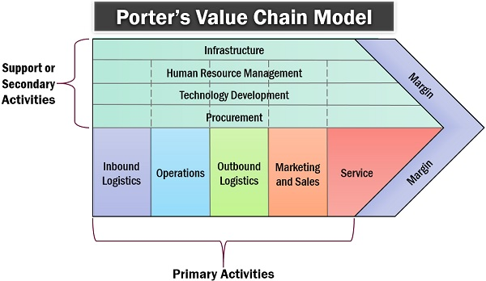
(Prachi, 2019)

The Primary Activities

Inbound logistics

With 12,000 suppliers located in 70 countries, the global supplier network has a significant contribution in creating value, quality and innovation and conduct to the success of the BMW Group. (BMW, Responsibility)
Suppliers also have a significant impact on sustainability performance and the sustainable development of society.
BMW Group increases the value of its inbound logistics primary activity by reducing transportation costs and collecting raw materials of the best quality.
The suppliers are selected systematically based on competitiveness according to the criteria of operating excellence, quality, innovation, flexibility, cost and sustainability.
The company procures a significant part of its raw materials from Germany (33.4%) and Eastern Europe (22%) since the majority of manufacturing and assembly units are based here, in order to obtain lower logistics costs and guarantee an accurate supply.
The company give significant importance to observe the social and environmental standards and have a productive use of the resources along the whole value chain. That is why the BMW Group Sustainability Standard it is firmly established in its purchasing processes.
The company is also involved in initiatives aimed to standardise the sustainability requirements and establish verification mechanisms for supply chains in connection with critical raw materials.
An example of critical raw material is the cobalt since it is an essential component for producing electrified cars, and BMW Group aims to achieve the most excellent possible level of transparency in the supply chain. From 2020 forward, the company is planning to acquire cobalt directly from the mines in Australia and Morocco and make it available to its suppliers in order to reorganise the supply chains used to acquire cobalt. (BMW Annual Report, 2019, p. 38)

Operations

By the end of 2019, the BMW Group reached a significant achievement with the delivery of its 500,000th electrified automobile. Reaching this milestone has been very important to the BMW Group as it cements their position as an e-mobility industry leader, with 12 electrified models in its range. It confirms that its variety of electric and hybrid vehicles is precisely what customers nowadays desire.
Based on many years of knowledge and experience in this field the company develops the drivetrain technology such as the motor, the power electronics and also the battery, including the battery cell itself, guaranteeing the typical driving characteristics for its electrified cars that customers identify with BMW brand.
According to the company's Annual Report on 2020, the BMW X3 will be the first company model available in four different drivetrain versions: with an efficient diesel or petrol engine, as a plug-in hybrid, and with an all-electric powertrain system in the form of the BMW iX3*.
The BMW Group manufacturing network involves a total of 31 locations in 15 countries. Across its production network, the company implements innovative technologies from digitalisation and Industry 4.0, standardised processes and intelligent composite construction.
BMW Group brought value to its operations primary activity thanks to innovative automation with the use of robotics technologies by using smart solutions to support employees to complete the human flexibility and sensitivity with the firmness of robots.

Outbound Logistics

The company’s supply chain involves a worldwide distributed supplier network, with close cooperation with different logistics service providers.
Daily more than 30 million parts have to be delivered on time, so that more or less 9,000 new cars can be manufactured at the company’s 31 manufacturing locations around the world.
The Outbound Logistics can aid the company to achieve its sustainability objectives. As more than 60% of all new cars leave production plants by rail, the focus here is on efficient modes of transport to reduce CO2 emissions. The BMW Group aims to reduce truck emissions by 40 per cent by 2030 and absolutely emission-free by 2050 (BMW Press Kit, 2018).

Marketing and sales

According to Wagner in his article “Global revenue of BMW Group 2007-2019” published on www.statista.com BMW announced an enthusiastic sales plan to increase electric car sales within two years. Complete electrification expects to one of the BMW Group brands, and the company may even have ambitious ideas for completely electric, high-performance sports cars and motorbikes. The global electric fleet-size is expected to grow ten-fold to 127 million cars by 2030( Wagner, 2020)
BMW Group uses elements of marketing communication such as print and media advertising, social media advertising and viral marketing, and also benefits from product placement marketing strategy in popular movies and shows.

Service

Excellent quality of service in general and especially the post-sale customer service is one of the essences of the company’s competitive advantage. The BMW Group anticipates customer needs and business challenges, always looking for the best overall solution for the customer. The company aims to be on top of the leading providers of premium mobility services going
forward. To accomplish with this objective the company needs to have a clear understanding of the needs of customers around the world. This knowledge is the basis for offering customers a stunning, comprehensive selection of services in this field. These include easy to-use, digitally supported mobility services that also feature bring-and-collect services or help customers find open parking spaces in urban environments. In order to reinforce this strategic field, the BMW Group founded the joint venture YOUR NOW together with Daimler AG (BMW Annual Report ,2019, p. 29 ).

The Secondary Activities

Infrastructure

The BMW Group leadership structure and organizational structure is very complex due to the immense size of the business and the global scale of its operations.
In the global market BMW Group has 31 production and assembly facilities in 15 countries and has a global sales network in more than 140 countries.
The economic success of BMW Group is focus on long-term thinking and responsible action, as well as ecological and social sustainability throughout the value chain - at local, national and international level.

Human Resources

Inside the BMW Group the HR strategy is playing an essential role. With operations in over 140 countries and 130.000 employees, the company has a leading position in the car manufacturing industry as a global employer.

Technology Development

Along with excellent customer service, regular technological innovations are the core of the BMW Group competitive advantage.
According to Taylor in his article “BMW raises R&D spending for electric, autonomous cars” published on www.reuters.com in 2018
the BMW Group was expected to increase research and development expenses to more than 7 billion euros in its attempts to bring on the market 25 electrified models by 2025.

The company is using digitalisation to optimise production processes. BMW eDrive technology, automatic car-park parking, BMW Connected are just a few of the company innovations.

Procurement
The international orientation of the Purchasing and Supplier Network provides the BMW Group with good access to global procurement markets. It is responsible for the worldwide procurement and quality assurance of production materials, raw materials, capital goods and services as well as the manufacturing of vehicle components produced in-house.
BMW has started implementing Procurement 4.0 in order to integrate better procurement and production, as more agile and lean processes are essential to deliver customized cars.

Conclusion

Electric vehicles are increasing in popularity due to the latest technological progress, and now they are more economical and more comfortable to charge.
As with any other purchase people make, there are both advantages and disadvantages by choosing an electric car. First of all, is how better these cars are for the environment compared to a gasoline-powered vehicle. An electric car is a solution for better air quality and a healthier planet, electricity is less expensive than gas, and many persons can charge the cars inside the garage, and also electric car maintenance is lower than a gas-powered car.
In any case the electric cars have their disadvantages such as short ranges for driving, charging them can take a lot of time, charging stations are not available everywhere and are more expensive than a traditional car.

References list

1 Soheib F (2014) Robust multivariable control for vehicle dynamics available at: https://www.researchgate.net/figure/Historical-development-of-automobile_fig5_301578455 [Accessed on 6 September 2020]
2 Prachi M. (2019) Porter’s Value chain model available at :https://theinvestorsbook.com/porters-value-chain.html [ Accessed on 7 September 2020]
3 Tardi C. (2020) Value chain available at : https://www.investopedia.com/terms/v/valuechain.asp [Accessed on 7 September 2020]
4 BMW Group, Responsibility Supply Chain Management available at: https://www.bmwgroup.com/en/responsibility/supply-chain-management.html [Accessed on 7 September 2020]
5 BMW Group Annual Report 2019 available at : https://annualreport.bmwgroup.com/2019/ [ Accessed on 7 September 2020]
6 BMW Press Kit (2018) Connected, flexible, autonomous: BMW Group expands use of innovative technologies in production logistics available at: https://www.press.bmwgroup.com/global/article/detail/T0287775EN/connected-flexible-autonomous:-bmw-group-expands-use-of-innovative-technologies-in-production-logistics?language=en [Accessed on 7 September 2020]
7 Wagner I. (2020) Global revenue of BMW Group 2007-2019 available at: https://www.statista.com/statistics/264340/global-revenue-of-bmw-group/ [ Accessed on 7 september 2020]

