

Student Name: Ranjit Masaribhai Modhwadiya
Student ID Number: 2529489
Programme: Master of Business Administration
Module: Strategic Management
Module Code: LCMB7003
Contribution to Overall Module Assessment: 100%
Lecturers: Amare Desta (London) and Ejike Udeogu (Birmingham)
Internal Verifiers: Vasilios Tavlaridis and Hoang Nguyen
Assignment Title: Assessment Component – Individual Report
Word Count: 5,000 words (±10%)
Submission Deadline: Friday, 17 July 2026
Return Date of Provisional Marks and Written Feedback: 14 August 2026

Executive Summary

The aim of this report is to assess the competitive situation of the Tesla Model 3 in the German market for electric vehicles and to determine the direction of the strategy. Tesla is analysed by strategic management tools such as PESTEL, Porter's 5 Forces, VRIO, SWOT, Corporate Social Responsibility (CSR), Balanced Scorecard and Ansoff Matrix which are used for analysing the external environment of the business and the internal capability of Tesla. The results show that the company has a solid technological innovation, brand reputation, software integration and Supercharging network, while the competition, supply chain risk, and regulatory changes are the major challenges to the company. The analysis suggests that the product development is the most suitable business strategy and that the technology developments regarding battery, AI and autonomous driving systems of the products, as well as the software functions to enhance competitive position in Germany are suitable. Recommendations for implementation, with particular emphasis on the supply chain and innovation and customer experience, are also included in the report. A reflective piece of writing based on Gibbs' Reflective Cycle is then submitted, that reflects on the learning that took place during the research process and identifies the skills of strategic analysis, critical thinking and consultancy skills.

Table of Contents
Section 1: Organisational Context and Overview 2
1.1 Organisation Overview 2
1.2 Justification for Selecting Tesla's Model 3 in Germany 3
1.3 Industry and Competitive Position 3
2. External and Internal Analysis 4
2.1 External Environment Analysis 4
2.1.1 PESTEL Analysis 4
2.1.2 Porter's Five Forces Analysis 6
2.2 Internal Environment Analysis 8
2.2.1 VRIO Analysis 8
2.2.2 SWOT Analysis 10
3. Comprehensive and Holistic View 13
3.1 Corporate Social Responsibility (CSR) 13
3.2 Balanced Scorecard 14
4. Strategic Choices and Implementation 16
4.1 Current Business-Level Strategy 16
4.2 Strategic Evaluation: Ansoff Matrix 16
4.3 Recommended Strategy 18
4.4 Implementation Challenges and Recommendations 18
Section 2: Reflective Account 20
References 23

Section 1: Organisational Context and Overview

1.1 Organisation Overview
Tesla, Inc., founded in 2003, has become one of the world's leading electric vehicles (EV) manufacturers by combining technological innovation with a strong commitment to sustainable energy. Tesla sold some 1.79M vehicles in 2024, of which more than 95% were the Model 3 and the Model Y (Tesla, 2026).
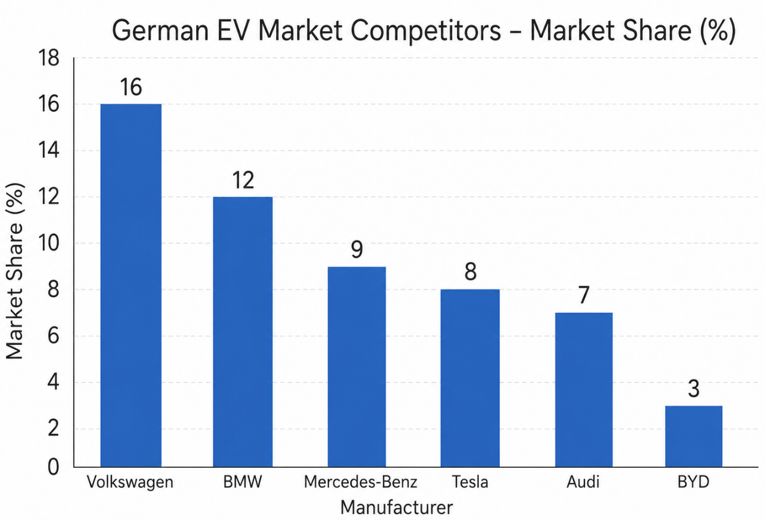
Figure 1: Competitive Position of Major EV Manufacturers in the German Market
Source: (Author's Own illustration, 2026)
According to Ilhan (2025), The key to Tesla's impressive growth has been its ability to continuously innovate, vertically integrate, and upset the entire car industry. Tesla's vision is “to accelerate the world's transition to sustainable energy” and its business model includes vehicle production, battery technology, software, and a network of Superchargers that are built and owned by Tesla (Tesla, 2023). Despite vertical integration promoting innovation and creating a better experience for customers, it also adds complexity to operations and to the supply chain risks (Susanto and Ellitan, 2024). Moreover, Tesla's first year of decrease in global vehicle deliveries in 2024 underlines the necessity for strategic adaptation as well as technological leadership to stay competitive (Tesla, 2024).

1.2 Justification for Selecting Tesla's Model 3 in Germany
The report will be based on the product – Model 3 – in Germany, as the assignment asks for analysis of one product in a single geographical market. Germany boasts the largest automotive market in Europe and ranks among the fastest-growing markets for EVs, with ambitious environmental goals, technological advancements, and a growing demand for sustainable transportation (International Energy Agency, 2025). Meanwhile Germany offers a very competitive market, with established local manufacturers. The Model 3 has been chosen as the Tesla flagship mass-market vehicle, and sits in the premium mid-size EV market, which will be used to assess the Tesla strategy.

1.3 Industry and Competitive Position
The German automotive market for EVs is competitive, with established brands like Volkswagen, BMW, Mercedes-Benz and Audi competing with each other, while Chinese brands, particularly BYD, are continuing to increase their footprint in Europe (European Automobile Manufacturers' Association, 2025). According to Han (2021) Organisations' sustainable competitive advantage is achieved by providing more value than just competing on price. The key factors for Tesla's value proposition stem from the advanced battery technology, the integration of a software platform, the over-the-air updates and the Supercharger network, which allows Tesla to differentiate itself from its competitors. However, sustaining the advantage will continue to require a continuous innovation and strategic adjustment of the product and services as the competition and customer expectations keep changing in the German EV market.

2. External and Internal Analysis

2.1 External Environment Analysis

2.1.1 PESTEL Analysis
PESTEL analysis is used to assess the macro environmental factors that affect Tesla's Model 3 in Germany. External environmental conditions have become more important to organisational performance as Nwokolo (2024) suggest that companies need to continually adjust their strategies as a result of changes in political, economic, technological, and regulatory environments. Germany offers a lot of potential for Tesla, but the country also poses many challenges and competition.
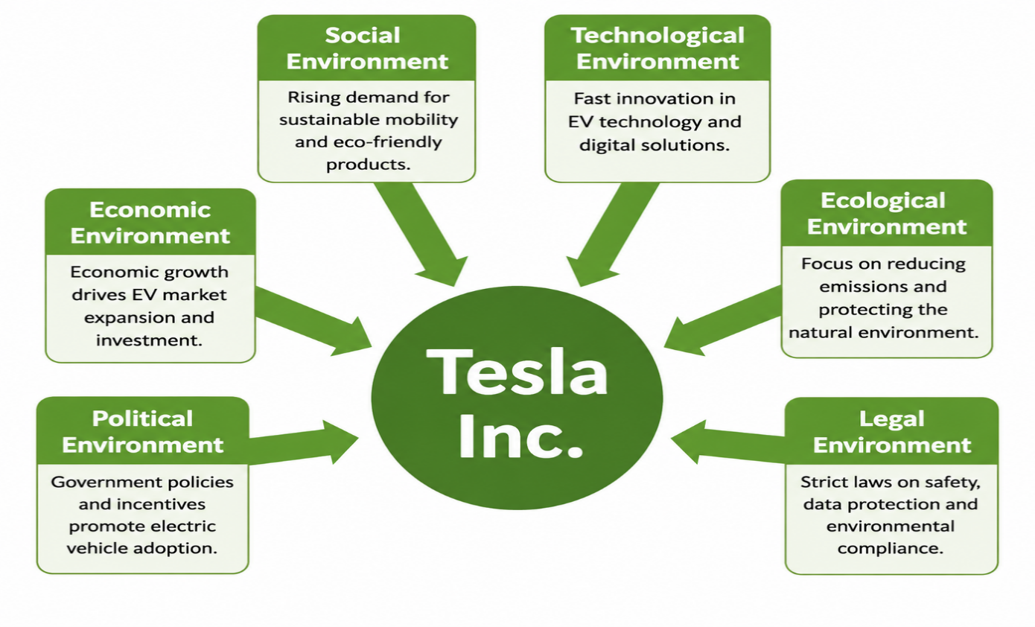
Figure 2: PESTEL Framework for Tesla's Strategic Environment
Source: (Author's Own illustration, 2026)

Table 1: PESTEL Analysis of Tesla's Model 3 in the German Market
Factor | Key Issues | Strategic Implications for Tesla Model 3
Political | Carbon neutrality programme in Germany, EU climate laws, business EV incentives, elimination of direct EV incentives, trade conflicts. | Long-term climate policies remain supportive of EV demand, despite the policy uncertainty. Tesla needs to be flexible and adapt to changes in regulation (International Energy Agency, 2025).
Economic | Germany's huge EV market, inflation and high interest rates, battery material fluctuation prices. | Along with market growth, costs are rising which is putting pressure on prices, making it more critical to be more efficient in operation.
Social | Increasing environmental awareness, demand for sustainable mobility, digital technologies and after-sales service. | Tesla will need to innovate and bring customer service and value to the table in order to keep the customers.
Technological | Advance in battery tech, AI, software updates and Supercharging network; more investments by competitors. | While innovation continues to be Tesla's most competitive edge, ongoing investments are crucial to close the technology gap of the competitors (Nweke and Nweke, 2024).
Environmental | More stringent emission regulations, Renewable Energy, battery recycling and ethical sourcing. | Environmental trends are good for EV adoption, but are calling for Tesla to improve sustainable supply chain.
Legal | EU safety regulation for vehicles, cybersecurity, battery sustainability and data protection. | The compliance adds expenses, but also creates entry barriers for competitors, furthering Tesla's competitive edge in the long run.
Source: (Author's Own illustration, 2026 adapted from International Energy Agency (2025))

2.1.2 Porter's Five Forces Analysis
Porter's Five Forces analysis is a tool that is used to analyse the competitive forces that affect industry profitability and positioning (Porter, 1985). The framework serves to show a picture of the challenges the Tesla Model 3 is likely to encounter in Germany, as well as the competition present in the EV market and the expectations of consumers.
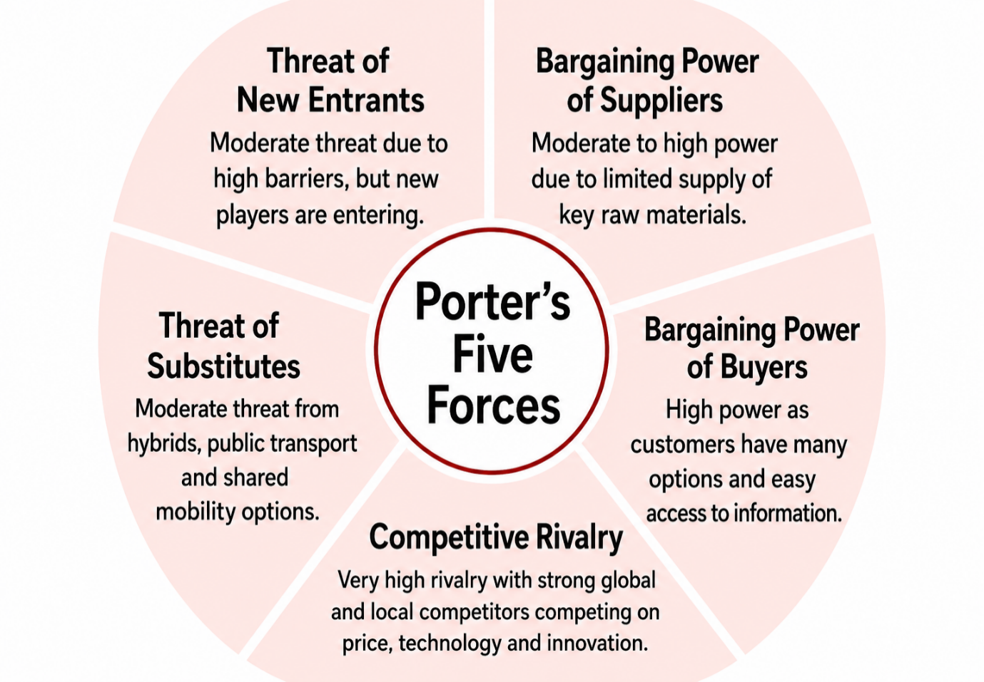
Figure 3: Porter's Five Forces Analysis of Tesla's Model 3 in the German Market
Source: (Author's Own illustration, 2026)
Threat of New Entrants
The threat from new entrants is moderate, due to the amount of capital needed to become a player in the EV industry, the need for advanced technology, and compliance with strict European regulations. The Gigafactory Berlin, the knowledge about the batteries and the Supercharging network make for a high barrier of entry for Tesla. But the tide has turned against Tesla, with Chinese manufacturers like BYD and government policies that have improved the state of electric mobility eroding these obstacles, and forcing the company to keep innovating.
Bargaining Power of Suppliers
The supplier power is high, because the manufacture of batteries relies on critical raw materials like lithium, nickel and cobalt, which are provided by only few global producers. Volatility and geopolitical uncertainties raise production costs (Ibrahim Abugarayesh, 2025). Even though Tesla has improved its supply chain integration through long-term agreements, supply chain resilience is still a priority since the company is still dependent on fluctuations in raw material prices.
Bargaining Power of Buyers
The buyer power is also high, consumers can more easily compare pricing, technology and performance among many brands, such as Volkswagen, BMW, Mercedes-Benz, Audi and BYD. The lower are the switching costs the higher is the bargaining power of customers (Liu, 2025). Therefore, Tesla will need to innovate continually and provide the highest quality products and service in order to be the winner.
Threat of Substitutes
The threat of substitutes is moderate. EVs are gaining traction, but charging availability, affordability and economic factors may drive consumers to opt for hybrid vehicles or traditional vehicles and public transit. New developments in hybrid technology from established manufacturers could also further postpone the shift to EVs for certain customers. This has forced Tesla to find ways to boost its EV sales beyond the market's natural expansion and to continue to improve battery performance, charging convenience and the overall customer experience. Improving these aspects will be crucial to boost EV adoption and keep Tesla competitive in Germany.
Competitive Rivalry
The competition is very high and is an external threat to Tesla. The established manufacturers are still working on battery technology, software and competitive pricing and they are being met by rapidly growing Chinese competitors. More competitors decrease the ability of a company to set prices, and the more competition a company faces, the more pressure it is under to innovate (Fedotov, 2022). Accordingly, Tesla needs to continuously enhance battery efficiency, software features and enhanced customer experience to maintain its competitive edge in Germany (European Automobile Manufacturers' Association, 2026).

2.2 Internal Environment Analysis

2.2.1 VRIO Analysis
The VRIO framework is used to determine that the competitive advantage attained by a firm's internal resources-and-capabilities is sustainable if they are valuable, rare in the industry, inimitability and supported by the firm's organisation (Kafoe, 2024). While some of Tesla's resources are now becoming commonplace as competitors ramp up investment in technology, the company has a portfolio of strategic advantages that bolster the position of the Model 3 in Germany.
Table 2: VRIO Analysis of Tesla's Model 3 in the German Market
Resource / Capability | Valuable | Rare | Difficult to Imitate | Organised to Exploit | Competitive Implication
Tesla Brand | ✓ | ✓ | ✓ | ✓ | Sustainable competitive advantage
Battery Technology | ✓ | ✓ | ✓ | ✓ | Sustainable competitive advantage
Software Capability | ✓ | ✓ | ✓ | ✓ | Sustainable competitive advantage
Supercharger Network | ✓ | ✓ | ✓ | ✓ | Sustainable competitive advantage
Manufacturing Capability (Gigafactory Berlin) | ✓ | ✗ | ✗ | ✓ | Temporary competitive advantage
Innovation Capability | ✓ | ✓ | ✓ | ✓ | Sustainable competitive advantage
Human Capital | ✓ | ✗ | ✗ | ✓ | Competitive parity / temporary advantage
Artificial Intelligence Capability | ✓ | ✓ | ✓ | ✓ | Sustainable competitive advantage
Source: (Author's Own illustration, 2026 adapted from Tesla (2024).
The Tesla brand is one of the company's most important intangible assets, which stands out for innovation, sustainability and electric mobility in high quality. High brand awareness will build trust with customers and make the Model 3 stand out in the German EV market (Ryu et al 2025). The brand is valuable, rare, hard to imitate and well-supplied by the organisation, meaning that it offers a sustainable competitive advantage to the organisation. Its rarity is however diminishing with the competition from the German and Chinese manufacturers slowly, but steadily.
Another strategic resource for Tesla is its battery technology. By continually investing in battery innovation and powertrain efficiency, superior driving range and vehicle performance can be achieved (Tesla, 2024). These capabilities meet the VRIO criteria and, thus, currently offer a sustainable competitive advantage, but are closing the technological advantage gap through greater research and development effort.
Tesla's software ability, such as over-the-air software updates, vehicle connectivity, and an integrated digital experience, additionally set the Model 3 aside. These resources, combined with the unique Supercharger network, enhance customer satisfaction, build switching costs and boost customer engagement and loyalty (Liang and Yubin, 2025). As both resources are valuable, rare, difficult to imitate and supported by the organisation, they provide a sustainable competitive advantage.
Gigafactory Berlin-Brandenburg also serves Tesla as a boost in terms of production efficiency and advancing the supply chain in the region. This resource, however, is a competitive advantage for an increasingly large number of competitors, as manufacturing is more readily available. Moreover, with investments in artificial intelligence and autonomous driving, the innovation culture in Tesla will position it for greater future competitiveness (Kim, 2020). Human capital is very valuable but it is not uncommon: skilled employees may transfer from firm to firm, leading to competitive parity or a short-term competitive advantage.

2.2.2 SWOT Analysis
The SWOT analysis is a combination of the external and internal environments findings that helps assess Tesla's strategic position in the German electric vehicle market. It helps to identify core strengths, weaknesses, opportunities and threats that can affect the company's ability to maintain a competitive advantage, and aid its future strategic decisions (Levchenko and Yanchuk, 2024).
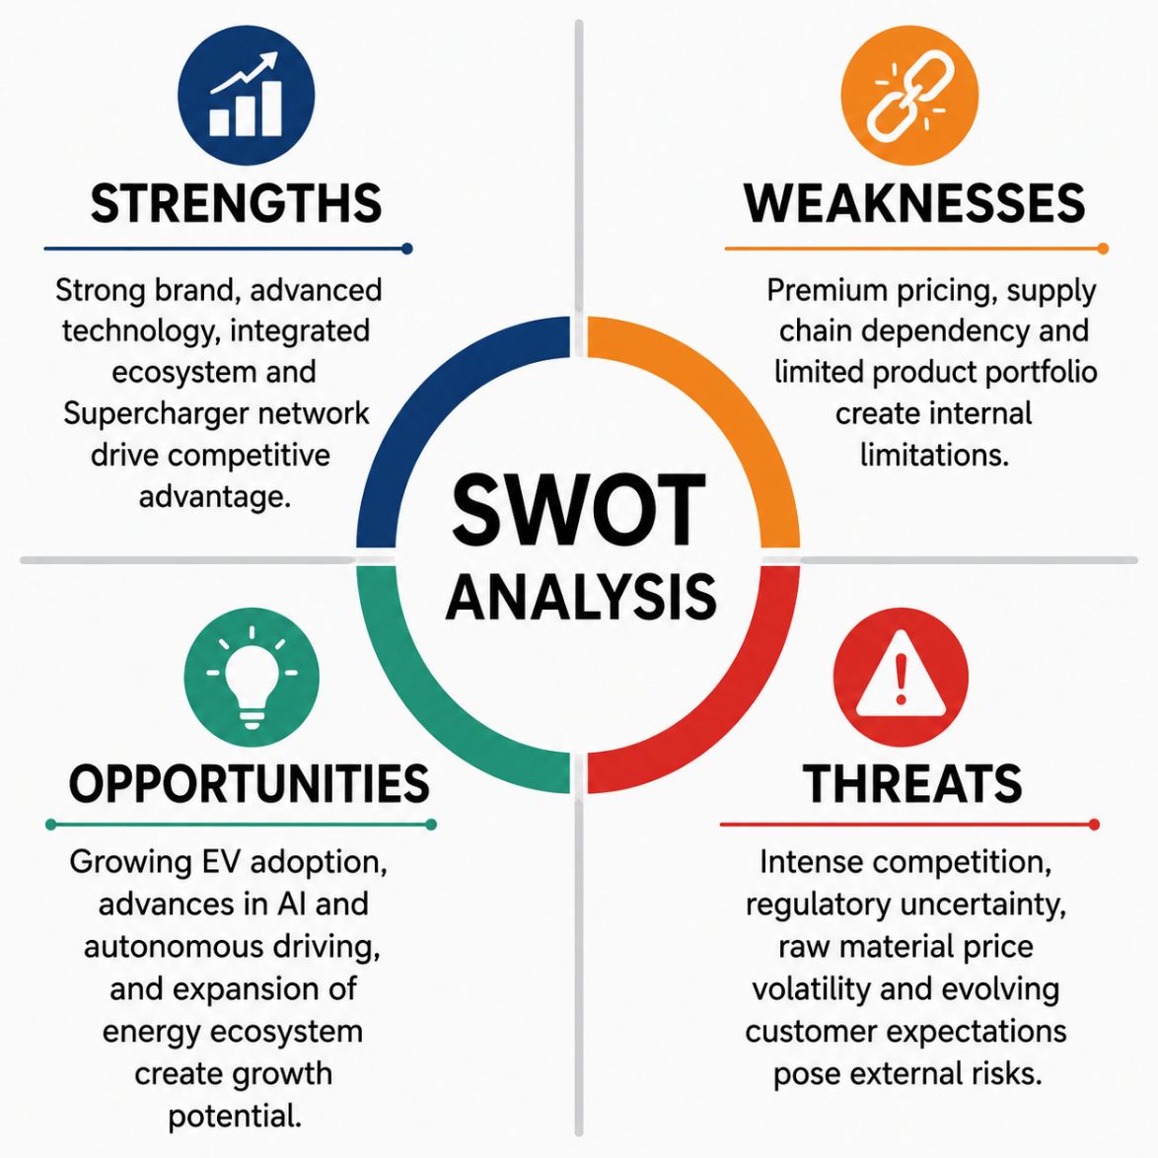
Figure 4: Strategic SWOT Analysis of Tesla in Germany
Source: (Author's Own illustration, 2026)
Strengths
The Model 3's sophisticated battery system, software platform, over-the-air software updates and proprietary Supercharging network make it stand out from other electric vehicles by enhancing vehicle performance, convenience and the overall customer experience (Tesla, 2023). Tesla takes a different approach than traditional automakers by continually upgrading functionality, via software, after vehicles are sold, thereby increasing their value over time. The features enhance customer retention and introduce barriers for other companies to replicate Tesla's full customer experience. But for them to maintain the lead, they must invest in the technology themselves in order to keep up to date with other manufacturers who are also working on similar digital features.
Weaknesses
Although it is strong, there are a number of weaknesses within Tesla that could limit growth in Germany. Premium prices reduce the availability to price-sensitive customers, which is becoming more common with the introduction of more affordable EVs. In addition, Tesla's reliance on foreign supply chains has made it susceptible to the availability and prices of key battery inputs, supply chain uncertainties, and business risks (International Energy Agency, 2025). Additionally, by focusing on the Model 3 and Y, the company is limiting product diversity, which can make Tesla more susceptible to fluctuations in consumer demand and increased competition in the mid-size EV market.
Opportunities
The long-term decarbonisation plans of Germany, the expansion of charging infrastructure and increased demand for electric mobility are conducive to the future development of Tesla (International Energy Agency, 2025). There is potential to further differentiate products and create new revenue streams by continued investment in artificial intelligence, autonomous driving technologies and connected vehicle services. The move into renewable energy solutions and corporate fleet markets would also broaden Tesla's operations and minimize reliance on the sales of passenger cars.
Threats
Germany is a very competitive EV market, and while Tesla is a relatively young company with a long way to go, other players such as Volkswagen, BMW, Mercedes-Benz, and Audi, and recently fast-rising Chinese brands like BYD, continue to invest in battery tech, software advances, and pricing. Further, uncertainties in raw material prices and regulatory shifts add to the complexity and risk of operations and supply chains. All of this puts pressure on Tesla to compete on anything else besides innovation, and so they must keep innovating, cutting their costs and making sure their services are of high standard if they want to maintain their competitive position.

3. Comprehensive and Holistic View

3.1 Corporate Social Responsibility (CSR)
Corporate Social Responsibility (CSR) has evolved beyond the status of ethics to become a powerful competitive advantage. Carroll (1991) suggests that sustainable value is added to the organisation when it incorporates economic, legal, ethical and environmental responsibilities into its business strategy. The way that Tesla does this is by integrating sustainability into its core business instead of CSR as a standalone corporate project.
The CSR approach of Tesla is focused on speeding up the transition to sustainable energy by offering electric vehicles, battery storage systems and renewable energy solutions (Tesla, 2024). As opposed to the traditional automotive companies, which mostly look for ways to cut emissions from their current production, the Tesla business model directly facilitates carbon reduction by eliminating emissions from the use of internal combustion engine cars in favor of zero-emission ones. The company also invests in battery recycling, renewable energy technologies and energy-efficient manufacturing processes, thereby contributing to the circular economy (Adewale, 2025). Organisations create shared value when their sustainability efforts simultaneously create value for business and for society, as Oladele et al (2025) argue. Tesla's environmental strategy is therefore closely related to its long-term commercial goals.
However, Tesla's CSR performance still faces criticism. But without governance and supply chain issues addressed, it is not enough to be a leader in the environment. According to Quttainah et al (2026), this is because transparency in all the activities of the organisation is essential for good CSR. As demand for lithium and other critical minerals rises (International Energy Agency, 2024), Tesla has come under intense scrutiny for its ethical sourcing of battery minerals, labour practices and corporate governance. Such problems can pose reputational hazards, potentially compromising the trust of stakeholders if not addressed properly.In summary, Tesla's CSR approach shows good coherence with its mission and is beneficial for its competitive position in the German EV market.

3.2 Balanced Scorecard
Balanced Scorecard is a performance management system that allows to communicate an organisation's strategy in terms of measurable financial and non-financial goals in four interrelated perspectives (Vuong, 2025). This framework supports Tesla's Model 3 in Germany by measuring the strategic priorities, key performance indicators and initiatives.
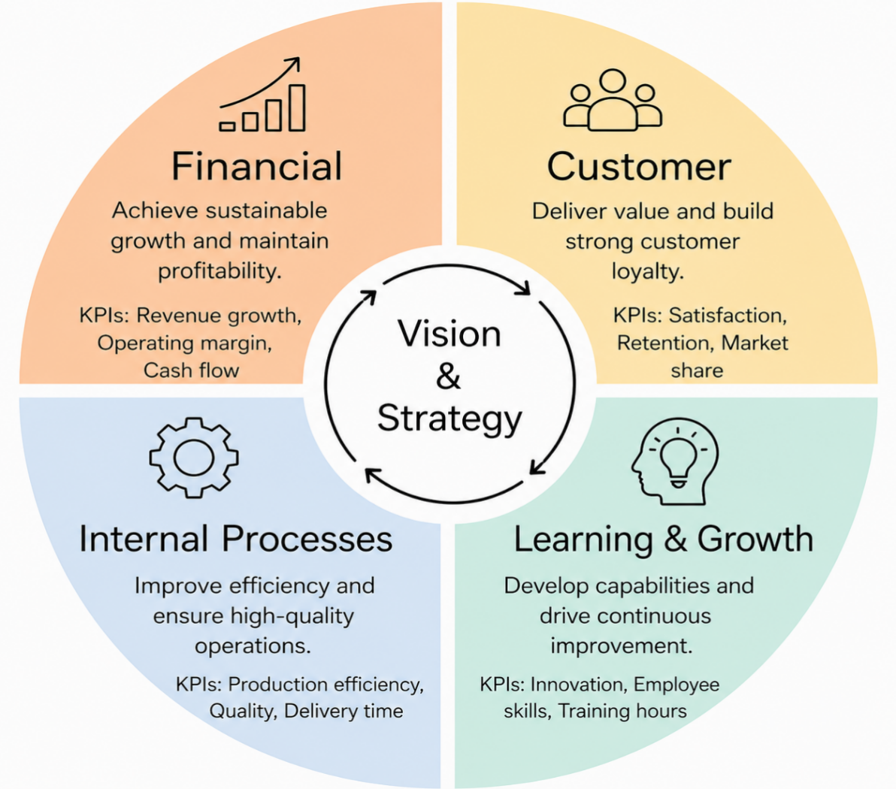

Figure 5: Balanced Scorecard Applied to Tesla's Strategic Objectives
Source: (Author's Own illustration, 2026)

Financial Perspective
Tesla's main financial goal is to sustainably grow its revenues while staying profitable in the fiercely competitive EV market in Germany. Kurznack, Schoenmaker and Schramade (2021) state that financial measures are still required as they will show whether strategic initiatives create long-term value for shareholders. Tesla's key performance indicators (KPIs) include revenue growth, operating margin, vehicle deliveries, return on invested capital and free cash flow (Kang, Lin and Ho, 2022).
Target: Increase annual Model 3 sales in Germany by 10% within the next three years, improve operating margin by 5%, and maintain positive free cash flow through improved production efficiency.
Tesla needs to focus on making the production processes more efficient in the Gigafactory Berlin, and also find a way to optimize the supply chain process, instead of just cutting prices. This technique helps in cost control without losing the product differentiation and long-term profitability.
Customer Perspective
Tesla is working to improve customer satisfaction and loyalty with the introduction of new products and the connected digital driving experience. Measures of customer performance should be measures which are proper to value creation and customer's competitive positioning as stated by Ilhan (2025). Key Performance Indicators are typical customer satisfaction scores, vehicle delivery performance, customer retention, market share as well as Supercharger utilisation rates. All strategies should focus on increasing charging station availability, after-sales support and software features, which should be regularly updated over-the-air. Although Tesla have high brand value, they must be competitive in their levels of services and consumer experience as well as innovations (Adewale, 2025) given the competition from the German manufacturers.
Internal Business Process Perspective
The efficiency and quality of product and technological innovations are the main concerns of the internal processes of Tesla. Some of the key performance indicators are production efficiency, manufacturing costs per vehicle, battery performance, defect rate and delivery lead time (Tesla, 2024). The Berlin Gigafactory is a key enabler to better leverage production flexibility and logistics costs in the European market. Ongoing investments in automation, AI and battery production help Tesla to optimize its business processes and quickly adapt to market needs. As production volumes rise, though, it is important to keep these efficiencies going, which means there is a need to have effective supply chain management and quality assurance to do so.
Learning and Growth Perspective
Tesla has to grow, get better and continue to evolve their technology and people if they are to stay competitive over time. The emphasis of Nwokolo (2025) is on the need for innovation and organisational learning as the basis for sustainable strategic success. Examples of KPIs are research and development spending, employee retention, training hours, outputs of research and development, performance of software development. The investments should be targeted towards the strategic points of artificial intelligence, autonomous driving, collaboration between diverse functions and employee development. Tesla's innovative culture is a key strategic asset that goes on.

4. Strategic Choices and Implementation

4.1 Current Business-Level Strategy
The business level strategy of Tesla is mostly differentiation with cost leadership and focus strategy elements. Porter (1985) states that differentiation allows a firm to be competitive by providing something that is unique to them that customers will pay for. Tesla does the same with the advanced battery technology, over-the-air software updates, AI, the autonomous feature set, and its own Supercharger network (Susanto and Ellitan, 2024). These capabilities are features that condition the value of the customers and make it harder for the competitors to easily replicate (Barney, 1991).
While at its core, Tesla's strategy is differentiation, it is also seeking to become more cost efficient by manufacturing improvements at Berlin's Gigafactory, supply chain optimisation and economies of scale. Through these programs, Tesla can continue to keep costs down, quality high, and prices competitive while continuing to innovate and develop new technologies. Tesla in turn would be competing with more affordable brands like BYD, however, if they take this approach they'd be in direct competition with the lower-cost manufacturer.
Tesla's focus strategy is further illustrated by its focus on the environmentally conscious and technology-minded consumer, who values sustainability and digital connectivity and appreciates premium driving experiences. However, as demand for the Model 3 grows and reaches a wider variety of customers, the car is now in a more competitive position to compete with the mainstream EV market instead of just a niche market.

4.2 Strategic Evaluation: Ansoff Matrix
Ansoff Matrix is a structured approach which can be used to analyse strategic growth opportunities in terms of existing and new products and markets (Ansoff, 1957). Each strategic alternative has varying degrees of opportunities and risks associated with Tesla's Model 3 in Germany. But, depending on what's happening in the market, and Tesla's competitiveness, the suitability varies.
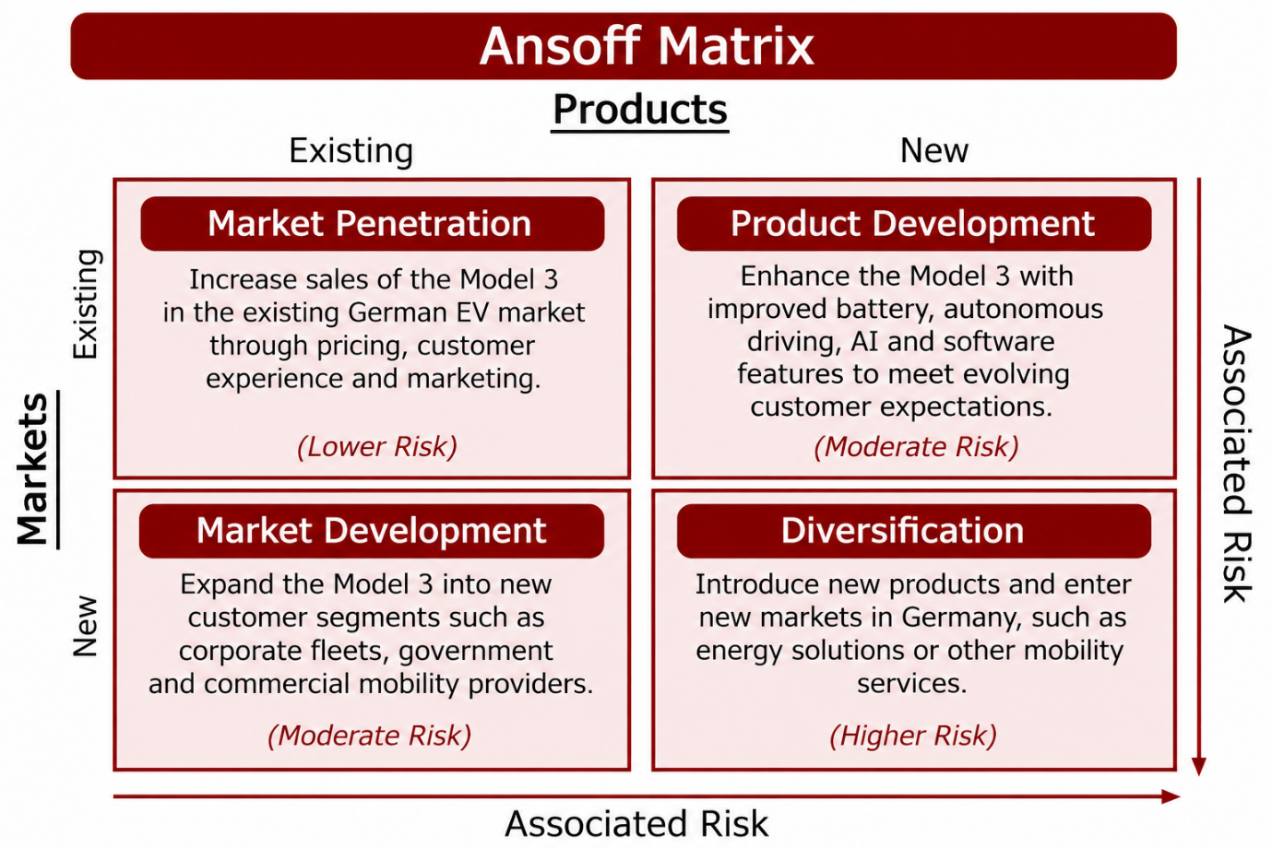
Figure 6: Ansoff Matrix Applied to Tesla's Model 3 in the German Market
Source: (Author's Own illustration, 2026)
Market Penetration is the strategy that focuses on growing the revenue of the Model 3 in the German electric vehicle (EV) market, primarily by lowering the price and improving customer experience and marketing efforts. The advantage of this option is that there will be less risk since there is an already established market, but the effectiveness of this option will be limited as there are high competition from Volkswagen, BMW, Mercedes-Benz and BYD. Thus, market penetration can improve sales, but might lead to a lower profit margin because of a higher level of competition.
Market Development is about growing into new markets like corporate fleets, government bodies and commercial mobility service companies. The approach will help to diversify customer base for Tesla and utilize its current product line. It is simpler to implement, though, when a combination of favourable regulatory conditions, competitive pricing and tailored fleet solutions exists.
Product Development is the most appropriate strategic alternative as it is closely related to the innovative approach of Tesla's business model. Tesla will continue to enhance its battery efficiency, self-driving feature and artificial intelligence and software capabilities to further differentiate its products and meet shifting customer expectations. Adewale (2025) suggests that product development can be especially suitable for an organisation that is already involved in an existing market, and where innovation provides a sustainable competitive advantage. This view aligns with Levchenko and Yanchuk (2024) argument that differentiation based on superior value can lead to competitive advantage, even in the face of rising competition in the market.
Diversification is a strategy that enters into completely new products and markets. While Tesla has diversified into energy storage and solar technologies, additional diversification in the German market would demand significant financial investment and management efforts and would further increase the company's strategic risk. As such, diversification is not as suitable as augmenting the current model 3 product line.

4.3 Recommended Strategy
Tesla's differentiation strategy suggests product development as the strategic option for the Model 3 in Germany. According to Kim (2020), differentiation provides sustainable competitive advantage because it offers greater value than a price-based approach. The competition in Germany's electric vehicle market is increasing and constantly new market innovations are more likely to foster sustainable growth than price-cutting.
The strategy should be toward improving the battery's performance, software functionality, artificial intelligence and autonomous driving features. Tesla's ability to provide regular over-the-air software updates and new, sophisticated digital features enhances customer value and solidifies its competitive position (Liang and Yubin, 2025). Barney (1991) states that resources that have value and are hard to be imitated are needed for a long-term competitive advantage and this makes innovation a strategic investment.This move is believed to boost customer satisfaction, enhance Tesla's luxury brand image, and benefit the company's ongoing financial performance (Tesla, 2023).

4.4 Implementation Challenges and Recommendations
Adopting the recommended product development strategy has several challenges. The German market is very competitive with manufacturers like Volkswagen, BMW and Mercedes-Benz and other companies still investing in electric vehicle technology, Tesla. Furthermore, the uncertainty surrounding operations can be exacerbated by regulatory uncertainty, supply chain disruptions and price swings in battery material development (Dugoua and Noailly, 2025). But this is just the beginning; there are also other factors that are driving up the demand for affordability, after-sales service, and charging infrastructure, which will force Tesla to continually enhance its value proposition.
Table 3: Strategic Implementation Roadmap for Tesla's Model 3 in Germany
Challenge | Strategic Response | Timeframe | Expected Outcome
Supply risk | - Secure multiple sourcing channels | - Short-term | - Stable operations
Market rivalry | - Accelerate product innovation | - Medium-term | - Enhanced competitiveness
Infrastructure gaps | - Increase charging coverage | - Medium-term | - Better user experience
Regulatory changes | - Strengthen compliance systems | - Ongoing | - Lower business risk
Customer expectations | - Enhance service quality | - Short-term | - Greater customer retention
Source: (Author's Own illustration, 2026)
Tesla will need to make its battery supply chain even more resilient to meet these challenges, which include more suppliers and spreading out local production via Gigafactory Berlin. This should continue to differentiate the product and further encourage investment in battery technology, AI/software development, increase in the Supercharger network, and increased after-sales support to improve customer satisfaction (Quttainah et al., 2026). Tesla's short-term strategy should be to focus on software improvements and efficiencies. Medium term, the firm needs to invest in new battery technologies and increase charging infrastructure. In the medium to long term, ongoing investments in artificial intelligence, self-driving technologies, and supply chain resilience will further enhance Tesla's market position and contribute to a sustainable growth in the German EV market. These efforts will help to enhance Tesla's competitive position and contribute to ongoing growth in the German electric vehicle industry.

Section 2: Reflective Account
The following section is a critical reflection of the process of research, analysis and completion of this strategic management report in relation to (Gibbs, 1988). It assesses the knowledge, skills and professional insights and indicates where development of strategic analysis and consultancy practice may be improved in the future.
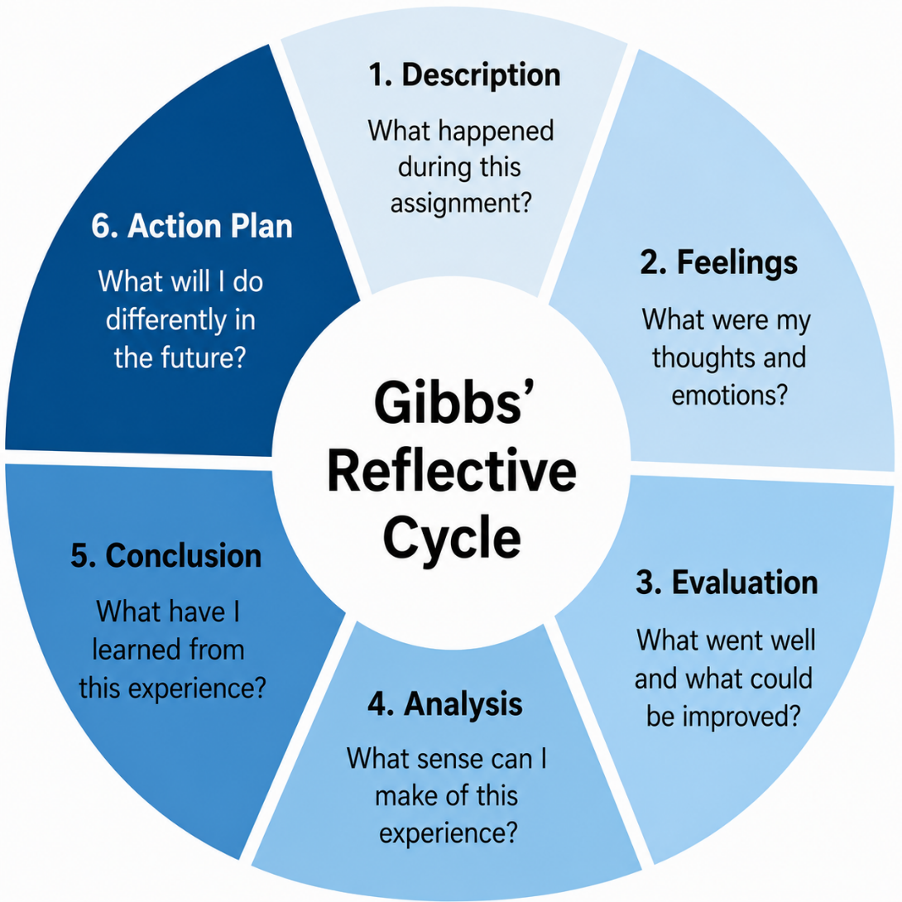
Figure 7: Framework of Gibbs' Reflective Cycle
Source: (Author's Own illustration, 2026)
Description
The aim of this report is to analyze the situation of Tesla's Model 3 in the German market by applying strategic management theories and frameworks, and to choose a suitable strategy for this company. In order to form conclusions through research and analysis, the academic journals, company reports and industry publications were utilized and Gibbs' Reflective Cycle was used, in which I reflected on the research and analysis process (Gan and Yao, 2025). I used all the tools in the PESTEL, Porter's Five Forces, VRIO, SWOT and the Balanced Scorecard and Ansoff Matrix throughout the assignment. While it was difficult to get a handle on these frameworks in the beginning, I became more adept at critically examining strategic issues and supporting recommendations with credible evidence (Grantham, 2022).
Feelings
Initially I felt confident about understanding Tesla's business model, but not as confident when choosing strategic frameworks and interpreting the existing industry evidence. As I continued my research, I soon learned that balanced judgement, citing academic literature, is required for effective consultancy reports, not opinion. While the process wasn't easy to assess conflicting evidence, it helped me to grow in confidence to think critically and deepen my understanding of strategic management. Gibbs (1988) states that it is important to reflect on both the challenges and the achievements in order to keep learning, and this assignment has helped me to grow in my strategic thinking skills and apply them to real-life business scenarios.
Evaluation
In my opinion, the report was quite successful in terms of combining practical business analysis and the theories of strategic management in relation to this assignment. PESTEL, VRIO, SWOT and the Balanced Scorecard and Ansoff Matrix have been applied to provide a comprehensive assessment of the strategic aspects of Tesla. Reflection is to recognise the positive and negative aspects. One major benefit was the inclusion of relevant academics-based and industry based data for recommendations of strategies. But I struggled to assess the information that was conflicting from different sources, and needed to make careful judgments, and critical analysis.
Analysis
The assignment strengthened my grasp of the way in which strategic management frameworks can work together to aid business decision making. The teaching of learning is more effective if theory is used in the context of practice (Ryu, Miller and Godfrey, 2025). Multiple strategic models showed that none were sufficient for an organisational assessment. Rather, a mix of external and internal analyses led to a more holistic set of conclusions and recommendations. I have developed my critical thinking, research skills and confidence using strategic management theory to apply in practice in the real world within a consultancy role (Kafoe, 2024).
Conclusion
Working on this assignment has enhanced my knowledge and understanding of strategic management and its significance to real business contexts. Gibbs' Reflective Cycle helped me to reflect on the research process and the strategies employed during the report. I gained more experience in combining theories and evidence to propose balanced and sound recommendations. Overall very positive experience as my analytical thinking, research ability and confidence in assessing complex strategic issues have been enhanced.
Action Plan
In the future, I want to continue to build my consultancy capabilities; particularly gaining the ability to analyse industry information and consider strategic options critically. I will also be furthering my education in digital transformation, sustainability and emerging technologies in strategic management. According to Li, Zou and Zhu (2024), reflective practice is important for lifelong learning and for the development of professionals. I will have the ability to apply these lessons to my future academic studies and consultancy practice to ensure that I can help create evidence-based strategic recommendations and support in organisational decision making in dynamic business environments.

References

Adewale, L.D. (2025) 'Lifecycle assessment and circular economy strategies for sustainable automotive materials: Optimizing recycling, waste reduction, and cost efficiency', International Journal of Research Publication and Reviews, 6(2), pp. 3206–3222. Available at: https://doi.org/10.55248/gengpi.6.0225.0953 (Accessed: 30 June 2026).
Ansoff, H.I. (1957) 'Strategies for diversification', Harvard Business Review, 35(5), pp. 113–124.
Barney, J.B. (1991) 'Firm resources and sustained competitive advantage', Journal of Management, 17(1), pp. 99–120. Available at: https://doi.org/10.1177/014920639101700108 (Accessed: 30 June 2026).
Carroll, A.B. (1991) 'The pyramid of corporate social responsibility: Toward the moral management of organizational stakeholders', Business Horizons, 34(4), pp. 39–48. Available at: https://doi.org/10.1016/0007-6813(91)90005-G (Accessed: 30 June 2026).
Dugoua, E. and Noailly, J. (2025) Critical minerals and the clean energy transition: The role of innovation across the supply chain. OECD Environment Working Papers. Paris: OECD Publishing. Available at: https://repository.graduateinstitute.ch/record/321928?v=pdf (Accessed: 30 June 2026).
European Automobile Manufacturers' Association (2025) Economic and market report: Global and EU auto industry. First half 2025. Brussels: European Automobile Manufacturers' Association. Available at: https://www.acea.auto/files/Economic_and_Market_Report-First_half_2025.pdf (Accessed: 30 June 2026).
European Automobile Manufacturers' Association (2026) Economic and market report: Global and EU auto industry. Full year 2025. Brussels: European Automobile Manufacturers' Association. Available at: https://www.acea.auto/files/Economic_and_Market_Report-Full_year_2025.pdf (Accessed: 30 June 2026).
Fedotov, P. (2022) 'Critical analysis of the electric vehicle industry: Five forces and strategic action fields', Exchanges: The Interdisciplinary Research Journal, 10(1), pp. 43–56. Available at: https://exchanges.warwick.ac.uk/index.php/exchanges/article/view/362/954 (Accessed: 30 June 2026).
Gan, L. and Yao, Y. (2025) 'A corpus-based critical discourse analysis of identity construction in CSR reports of China and USA new energy vehicle companies: A case of BYD and Tesla', Research Square (Preprint). Available at: https://assets-eu.researchsquare.com/files/rs-7347669/v1/215fd943-16b3-4914-8efb-44d780290bcb.pdf (Accessed: 16 July 2026).
Gibbs, G. (1988) Learning by doing: A guide to teaching and learning methods. Oxford: Oxford Polytechnic.
Grantham, A. (2022) Sustainable business strategy: Analysis, choice and implementation. Berlin: Walter de Gruyter.
Han, J. (2021) 'How does Tesla Motors achieve competitive advantage in the global automobile industry?', Journal of Next-generation Convergence Information Services Technology, 10(5), pp. 573–582. Available at: https://doi.org/10.29056/jncist.2021.10.09 (Accessed: 30 June 2026).
Ibrahim Abugarayesh, O. (2025) Tesla EV vehicles scenario planning. SSRN Working Paper. Available at: https://doi.org/10.2139/ssrn.5876762 (Accessed: 30 June 2026).
Ilhan, E. (2025) How Tesla and Elon Musk revolutionized the automotive industry through disruptive innovation. ResearchGate. Available at: https://www.researchgate.net/ (Accessed: 30 June 2026).
International Energy Agency (2024) World Energy Outlook 2024. Paris: International Energy Agency. Available at: https://iea.blob.core.windows.net/assets/140a0470-5b90-4922-a0e9-838b3ac6918c/WorldEnergyOutlook2024.pdf (Accessed: 30 June 2026).
International Energy Agency (2025) World Energy Outlook 2025. Paris: International Energy Agency. Available at: https://iea.blob.core.windows.net/assets/9753df19-0a71-422a-b725-012c555763b3/WorldEnergyOutlook2025.pdf (Accessed: 30 June 2026).
Kafoe, A.S. (2024) 'Holistic competitive strategy: Embracing a holistic approach to establishing a competitive edge', Land Forces Academy Review, 29(4), pp. 550–562. Available at: https://doi.org/10.2478/raft-2024-0057 (Accessed: 30 June 2026).
Kang, C.K.T., Lin, C.Y. and Ho, Y.H. (2022) 'Key factors to increasing free cash flow for manufacturers utilizing lean production: An AHP-DEMATEL approach', Information Management and Business Review, 14(2), pp. 28–45. Available at: https://pdfs.semanticscholar.org/0a20/03a5c8f33cd7d6303cf728eaa14ee645cebc.pdf (Accessed: 16 July 2026).
Kim, H. (2020) 'Analysis of how Tesla creating core innovation capability', International Journal of Business and Management, 15(6), pp. 42–61. Available at: https://doi.org/10.5539/ijbm.v15n6p42 (Accessed: 30 June 2026).
Kurznack, L., Schoenmaker, D. and Schramade, W. (2021) 'A model of long-term value creation', Journal of Sustainable Finance & Investment. Available at: https://doi.org/10.1080/20430795.2021.1920231.
Levchenko, N. and Yanchuk, T. (2024) 'Strategy for increasing the competitiveness of the Tesla electric vehicle', Three Seas Economic Journal, 5(2), pp. 7–13. Available at: http://www.baltijapublishing.lv/index.php/threeseas/article/view/2471/2464 (Accessed: 30 June 2026).
Li, W., Zou, Y. and Zhu, C. (2024) 'The electric vehicle revolution: A new track for industrial competition among major countries', Journal of WTO and China, 14(3).
Liang, L.Y. and Yubin, Z. (2025) 'The impacts of digital transformation on firm performance: A case study of Tesla business model', International Journal of Research and Scientific Innovation, 12(5), pp. 287–302. Available at: https://doi.org/10.51244/IJRSI.2025.1205022 (Accessed: 30 June 2026).
Liu, Y. (2025) 'BYD's pricing strategy in the EV market: Comparative analysis with Tesla and strategic recommendations for sustainable development', Finance & Economics, 1(6). Available at: https://lseee.net/index.php/fe/article/view/1522/FE007832.pdf (Accessed: 16 July 2026).
Nweke, G.I. and Nweke, O.C. (2024) 'Harmonising strategy, innovation, and law: Navigating the path to ethical and sustainable progress', Beijing Law Review, 15(1), pp. 200–218.
Nwokolo, S.C. (2024) 'From policy to practice: Evaluating the role of private-sector champions like Elon Musk in shaping Trump's 2.0 climate agenda', Trends in Renewable Energy, 11(1), pp. 122–154.
Oladele, O.K. (2025) The influence of strategic management on sustainable business development. ResearchGate. Available at: https://www.researchgate.net/publication/389270916_The_Influence_of_Strategic_Management_on_Sustainable_Business_Development (Accessed: 30 June 2026).
Porter, M.E. (1985) Competitive advantage: Creating and sustaining superior performance. New York: Free Press.
Quttainah, M.A., Xue, B., Saci, F. and Liu, M. (2026) Corporate social responsibility: Theories, strategies, and innovations for a sustainable future. GBP Publications. Available at: https://shs.hal.science/halshs-05621937v1/document (Accessed: 30 June 2026).
Ryu, K., Miller, E.G. and Godfrey, D.M. (2025) 'Brand faith: How spiritual relationships develop between consumers and brands', Journal of Consumer Research. Available at: https://doi.org/10.1093/jcr/ucaf055 (Accessed: 30 June 2026).
Susanto, M. and Ellitan, L. (2024) 'Unveiling the Tesla touch in supply chain effectiveness', International Journal of Research, 11, pp. 71–90.
Tesla (2022) Model 3. Available at: https://www.tesla.com/model3 (Accessed: 30 June 2026).
Tesla (2023) Annual report 2022 (Form 10-K) for the year ended 31 December 2022. Austin, TX: Tesla, Inc. Available at: https://www.annualreports.com/HostedData/AnnualReportArchive/t/NASDAQ_TSLA_2022.pdf (Accessed: 30 June 2026).
Tesla (2024) Annual report 2023 (Form 10-K) for the year ended 31 December 2023. Austin, TX: Tesla, Inc. Available at: https://www.annualreports.com/HostedData/AnnualReportArchive/t/NASDAQ_TSLA_2023.pdf (Accessed: 30 June 2026).
Tesla (2026) Annual report 2025 (Form 10-K) for the year ended 31 December 2025. Austin, TX: Tesla, Inc. Available at: https://ir.tesla.com/_flysystem/s3/sec/000162828026003952/tsla-20251231-gen.pdf (Accessed: 30 June 2026).
Vuong, T.K. (2025) 'Enhancing financial and non-financial performance through the balanced scorecard approach for firms' sustainable development', Intangible Capital, 21(2), pp. 248–264. Available at: https://doi.org/10.3926/ic.3186 (Accessed: 30 June 2026).

