Name: Alex Estuardo Rivas Cusihuaman
Student No: 0552096
Module Code: M4X02063
Title: Corrosion
Corrosion

Abstract
I have chosen ‘Corrosion’ as my subject because it has a very big impact in engineering and the world, where it is very important and critical to follow the regulations of health and safety to secure the safety of the company and work colleagues as well as my own. This research is about corrosion awareness, the different types of corrosion and how it can impact on solid material such as iron, gold, aluminium, platinum, etc.
Through this research, I have established the process that corrosion undertakes to damage and decay different types of metal, how harmful and dangerous it can be if neglected. There are some samples how metals react and how its environment plays a role to give way to corrosion.
Furthermore, there is an example how corrosion has affected greatly in history such as the HMS Alarm incident in 1763, and then again in 1769 because the health and safety regulations were overlooked and not followed.

Contents
Contents
Abstract 2
Contents 3
Introduction 4
Literature Review 5
Uniform corrosion 5
Pitting corrosion 5
Filiform corrosion 5
Crevice corrosion 6
Selective leaching 6
Stress corrosion cracking 6
Galvanic corrosion 7
Erosion corrosion 7
Results and Discussion 8
Conclusion 9
Works Cited 10

Introduction
Corrosion is a threatening and expensive problem for industries, buildings, bridges, steel works and homes where corroded electrical contacts or equipment are at risk of breaking, collapsing, flooding and even causing fire. At hospitals, equipment such as injections can cause blood poisoning if corroded. Furthermore paintings, sculptures, among other work of art has been affected by pollution. It weakens containers meant to store radioactive waste for at least ten thousand years. [1]
General corrosion takes place when the exterior of a metal compound is oxidized decaying the material from the outer side. In majority of cases when metals are oxidized, these are likely to decrease in electrons and increase its numbers of atoms, process called oxidation. And it is called reduction when the number of atoms decreases and electrons increases. [1]
When different types of metal come in touch with one another where reduction and oxidation happened is denominated galvanic corrosion. Another similar process happens in electrical appliances, where humidity trapped in between two live contacts where electrical voltage flow gives way to electrolytic corrosion. [1]
Corrosion can affect most metals; the process of decaying can be faster in some than others. For example, iron in its pure form is likely to decay faster while stainless steel on the other hand decays slowly due to its composite with other alloys. [2]
For example, take a look at the structure of the Statue of Liberty. It looks solid and secure. But it is being affected due to its environment (pollution) giving way as a result to oxidize. This could be beneficial because of the lime green glaze that has formed covers the statue’s copper skin, protecting it from the climate. Although the outer side is protected, the inner side has suffered damage throughout the years. The copper skin of the statue and its iron framework has reacted as a result of a galvanic corrosion, that has been corroding half of the statue’s framework by 1986, the Statue of Liberty’s 100th anniversary. [1]
There is a small class of metals that can resist corrosion which makes them valuable specially if they are in their pure form. Such as gold, rhodium, palladium, and silver. [2]

Literature Review

Uniform corrosion
Also known as uniform attack, that happens when a whole area being exposed, reacts either to chemical or electrochemical agents; where the area of the compound becomes weaker, thinner and then fail eventually. For instance, if a part of metal steel (or zinc) is submerge in diluted sulfuric acid, it will eventually dissolve. Another example is a thin sheet of iron will corrode eventually rusting over its whole outer area. [3]
Uniform corrosion, or any other corrosion is the most destructive corrosion on metal in a tonnage basis. However, it’s not a big concern nowadays, because thanks to comparation simple tests that can deduce the life span of an appliance. More over just by immersing specimens in fluids to test their durability is sufficient. Corrosion can be minimized by using certain protective elements such as inhibitors, coating and cathodic protection. [3]

Pitting corrosion
Type of corrosion that produces holes or cavities on the surface of the area of a metal compound. Pitting corrosion it’s difficult to detect that’s why it is more damaging than uniform corrosion because is hard to find and prevent. Small pits with decay can fail an entire system in engineering. Pitting corrosion is characterized by pits with opened holes or framed by a sheet of corrosive elements. Can be represented as a cup-shaped and hemispherical. [3]
Pitting Corrosion
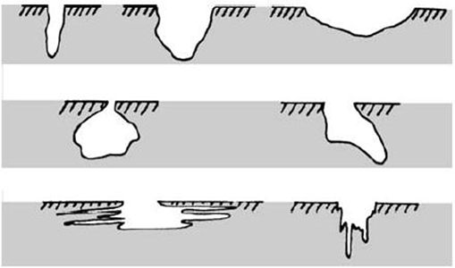
[4]

Filiform corrosion
Another different type of rusting that happens on metals under protective coating film and its characterized by small tracks with definite structure and directional growth. It happens more often than it is recognized. And it has become a tread of concern specially to industrial finishers. Distinguished for its distinctive head with shapes of V and blue in colour suggesting that the decaying metal is on its ferrous state. [5]

Crevice corrosion
This type of corrosion attacks alloys like stainless steel and metals such as copper, titanium and aluminium. It is a confined form of attack on a surface where the passive layer breaks down or at shielded areas underneath deposits. To be effective in corroding a particular surface area, the crevice needs to be wider to let in the corroding electrolytes and stablish the ‘stagnant’ conditions. Specially of concern in places where gaps are few micrometres wide. Similar to pitting corrosion crevice corrosion has a distinctive initiation and a way of propagation, there are number of speculations. [6]

Selective leaching
This type of corrosion reacts by removing the surface layer of a metal compound. A typical example is when it selectively removes the brass in zinc; called dezincification. Most of the alloys are defenseless to this type of corrosion if it falls under certain circumstances meanwhile the unyielded components remains, as long as it has sufficient structure that prevents them from tearing apart in little particles. [7]

Stress corrosion cracking
Stress corrosion cracking is characterised by a crack, where the impact on a material falls between dry cracking and the worn-out verge of it; result of a harmful surrounding and tensile stress; where the stress could be applied straight or in a residual manner. An example of this could be cold deformation, heat treatment, and grinding. [8]
The impact and relevance of these form of stresses is often underrated. For example, the residual stress created by welding applications lean to reach the yield strength. The accumulation of corrosion agents in restricted places shall not be overlooked because it could develop significant stress. [8]
Generally, most part of the surface prevails without much damage, but with fine fissures permeating deep inside the component; these fissures may be of an intergranular design. Stress corrosion cracking is categorized as a devastating work of corrosion, as these fine fissures could be very hard to detect and to unforeseen the damage it could cause. [8]

Stress Corrosion Cracking
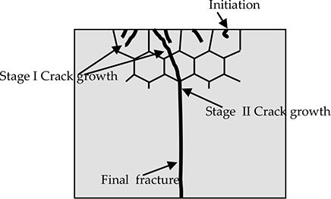
[4]

Galvanic corrosion
Termed bimetallic corrosion is an electrochemical process as a result of the flowing of a tiny electric current between two diverse metals causing more anodic giving way to corrosion, leaving the noble or cathodic metal undamaged. [9]
The flow of the current is the potential difference that continue either between two different parts of the same metal or two pieces or metal, where an electrolyte like moisture is present at the contact point, without it there would not be corrosion. [9]

Erosion corrosion
Erosion corrosion is a fast pace ratio of corrosion attack in metals; for example, when corrosive fluid flows over the area of a metal. On the inner side of a tube pitting aggravates the turbulence by incrementing it, giving way to a rapid increase of erosion ending into a leakage. Also flawed workmanship could form part of erosion corrosion. Extreme high pitting rates in offshores well systems could be the product of a combined erosion and corrosion, sand-bearing liquids come in touch with the units in this industry process, which becomes a critical problem, [10] and this type of corrosion can be presented in pumps, nozzles, valves, turbine parts, and equipment exposed to liquid sputter or jets. [4]

Erosion Corrosion
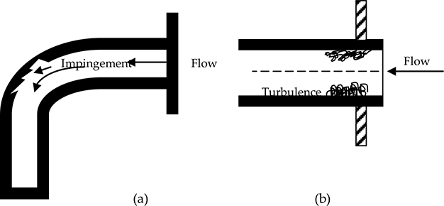
[4]

Results and Discussion
From the research of this paper evidence has been found how corrosion has affected greatly in history, such as the incident of the HMS Alarm in 1763, which was the first time ever recorded study of bimetallic corrosion. [11]
A couple years before the arrival of the documented information of the 32-gun frigate, HMS Alarm’s hull was entirely framed by a thin layer of copper. The reason was for a dual function. First was to minimized the great damage that could produce the teredo woodworm, and second to take advantage of the toxic properties of copper to prevent the increase of barnacles on the hull which use to slow down ships in those times. Two years has passed since it was sent to the West Indies, HMS Alarm was taken ashore to evaluate the results of its probe. It was then noted that the layer of copper has been disconnected from the hull and several locations; the nails used to frame the copper to the hardwood that were made of iron, had been compromise to a rotten point. A deep investigation showed that brown paper caught below the head of some nails served as an insulator, reason that these nails were not totally corroded. In conclusion to the documented information of 1763, was that iron must not come into contact with copper at sea, to prevent serious iron corrosion. [11]
It appears that the first incident where this advice was heard but ignored in 1769, when Commodore John Byron undertook a course in his coppered ship, Dolphin. In direction of an unknown Coral Sea reef, ‘Foul-Weather Jack’ lost his sleep by loud thud sounds underneath the stern windows of his cabin. He documented in his log book that he was worried the Dolphin’s loose rudder could fall off at any moment because of its iron pintles were corroded away to a shape of a needle, was in contact with the copper layer. With no expectation of fixing in such a critical circumstance, this was a needless worry including the rest of the crew that he had to confront. [11]
From then on, the anomaly of bimetallic corrosion (galvanic corrosion), in addition with other types of corrosion mentioned in this research, has continue to happen but not as often if not rare, as long as health and safety regulations are followed to the letter, to prevent these tragedies from happening again, also as technology keeps moving forwards letting us reach (scan and monitor) places the human eye cannot see to find and detect this phenomenon in time.
HMS Alarm and the Royal Navy Frigate in 1763
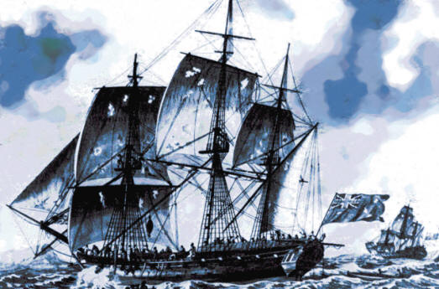
[11]

Conclusion
With the conclusion of this research we have looked the importance of ‘health and safety’ and to be aware of the types of corrosion to be able to identify them as well as how dangerous and fatal these can be if neglected; because accidents cost greatly to companies and organizations as well human lives.

Works Cited

[1] | Electrochem.org, “The Electrochemical Society,” [Online]. Available: https://www.electrochem.org/corrosion-science. [Accessed 14 11 2019].
[2] | T. Bell, “The Balance,” 2019. [Online]. Available: https://www.thebalance.com/what-is-corrosion-2339700. [Accessed 16 May 2019].
[3] | NACE International, “Corrosion Basics,” 2019. [Online]. Available: https://www.nace.org/resources/general-resources/corrosion-basics/group-1/eight-forms-of-corrosion. [Accessed 08 11 2019].
[4] | M. H. A. Rana Afif Majed Anee, “Intechopen,” 2016. [Online]. Available: https://www.intechopen.com/books/advances-in-tribology/tribocorrosion. [Accessed 14 11 2019].
[5] | M. Van Loo and D. D. &. B. R. R. Laiderman, “Corrosion,” Filiform Corrosion, vol. 9, no. 8, pp. 277-283, 1953.
[6] | British Stainless Steel Association, “Corrosion & Oxidation,” Crevice Corrosion, p. 116, 2018.
[7] | TEC Eurolab Srl, “TEC Eurolab,” 2019. [Online]. Available: https://www.tec-eurolab.com/eu-en/selective-leaching-V1.aspx. [Accessed 14 11 2019].
[8] | Corrosion Doctors, “Corrosion Doctors,” 2019. [Online]. Available: https://www.corrosion-doctors.org/Forms-SCC/scc.htm. [Accessed 14 11 2019].
[9] | Galvanizers Association, “Galvanizers Association,” 2019. [Online]. Available: https://www.galvanizing.org.uk/galvanic-corrosion/. [Accessed 14 11 2019].
[10] | N. International, “NACE International,” 2019. [Online]. Available: https://www.nace.org/resources/general-resources/corrosion-basics/group-2/erosion. [Accessed 14 11 2019].
[11] | T. &. Chamberlain, “Historic Corrosion Lessons,” 1988. [Online]. Available: Learning from mistakes hms alarm https://corrosion-doctors.org/Corrosion-History/Lessons.htm. [Accessed 14 11 2019].

