Name: Malaikah Ul Haq
Student Number: 2331954
Module code: LCHS4003
Lecture’s Name: Wafa Nasir
Assignment Title: Introduction to Health and Social Care

Community Mental Health Services (CMHS) are provided by The National Health Service (NHS). These services offer individuals with mental health support within the community, outside of hospital settings. They support adults and elderly people with severe mental health conditions and complex needs when a person's primary care General Practitioner (GP) can’t offer them the support they require, when general talking therapies are not sufficient. (NHS England N.D)

COMMUNITY MENTAL HEALTH SERVICES

1950’s-1960’s | People moved out of mental hospitals, and care started in the community.
1970’s-1980s | Local teams help people live independently and gain support outside hospitals
1990’s | Social workers, doctors and nurses start providing more
2000’s | Early psychosis and rehabilitation programs were put into place to support people,
2010’s | NHS Long term aim to provied adults with better joing up.
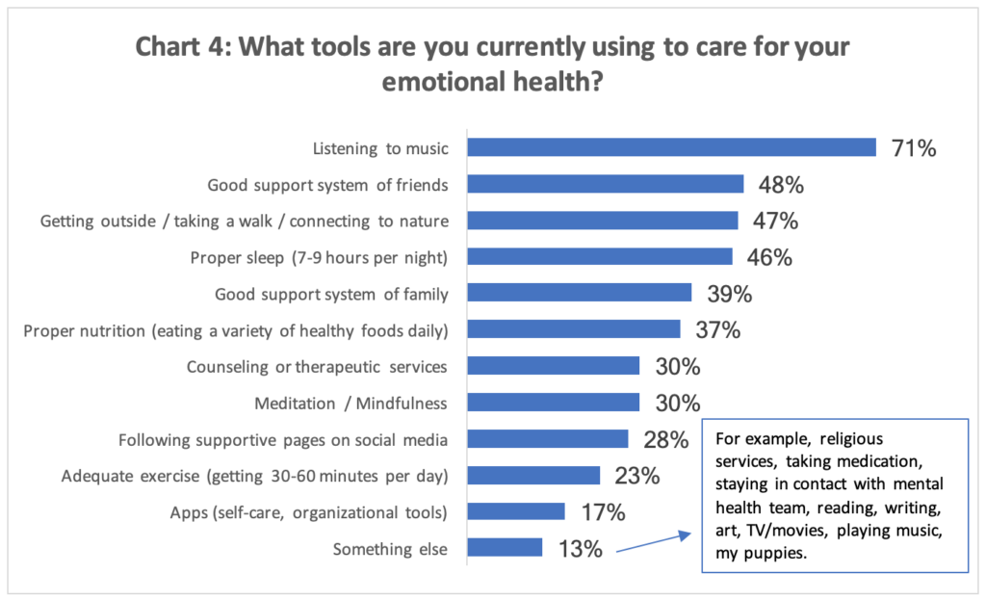
Challenges faced:
- High demand- Is a significant problem in the UK because it is placing pressure on services that already have limited capacity. The COVID-19 pandemic caused mental health to rise even faster than they were before COVID-19. This leads to people seeing there GP a lot more increasing workload for the NHS workers which could lead to burnout.
- Long waits- people are not able to access the care that is needed, leading them to be neglected. 4 in 10 people have stated they did not receive any support when waiting. Furthermore, studies show 43% of those people waiting for mental health services mental health deteriorated
Current function:
- Being redesigned under the NHS Long Term Plan, for separate community-based care (NHS England Supporting services for mental health illness in community mental health services
- Community rehabs and cross-functional teams deliver core support. (NHS England commissioner guidance for adult community mental health rehabilitation services).
- Offers psychological therapies for individuals with severe mental health. (NHS England implementation, guidance 2024)
- Mental health framework promotes coordinated, place-based care. ( Royal College of Psychiatrists Community Mental Health Framework for Adults and Older Adults).
- Clinic guidelines embrace a comprehensive individual assessment and support. (NICE Psychosis and schizophrenia in adults and prevention and management).
Dentistry services
Dentistry services Origins, Development and modern role:
dentistry services play a big role in the essential part of health care, they focus on preventing, diagnosing and treating conditions of the mouth, teeth and gums. In the modern United Kingdom, public dental care is closely related to the development of the National Health Service (NHS). They not only relieve pain and treat diseases, but they also contribute to overall health and wellbeing. This essay explores the origins of dentistry services. The historical context that shaped their development, how the service functions today, and its significance in improving the quality-of-service users.
Origins and historical context:
The United Kingdom evolved gradually during the twentieth century. One important step was the introduction of school dental services by local authorities in the early 1900’s, aimed to improve children's oral health and a widespread dental disease (Tidman, 2023). These early initiatives reflected growing recognition that oral health was an important public health issue rather than a private matter.
A major turn occurred in 1948 when the NHS was formed, which introduced Universal access to healthcare services, including dentistry. At the start of the NHS Dental services wear free and demand at the time was extremely high because many people had untreated dental problems after the Second World War (Bedi,2025). Many teeth were extracted, and people received dentures. The high cost of providing completely free dental care led to the government introducing patient charges in the early 1950’s. Beginning with dentures in 1951, later expanding to other treatments (National Health Service, England, 2024). This shift reflected financial Pressure on the healthcare system and marked the beginning of the next funding model that still exists today
Services started to evolve with changes in their training services organisation and policies. In the late 20th century and the early 21st century, new Contact find clinic standards and professional Development requirements For dentist aiming to introduce better quality efficiency in dental care (Tidman,2023). These developments were shaped by advances in science, growing awareness of preventive healthcare and the need to control healthcare spending.
How they function today;
Dental services today operate on several branches within the NHS system. These include general dental practitioners working in community practices, Hospital dental services, or specialist or community dental services. For vulnerable children or individuals with additional needs (Department of Health and Social Care, 2019). Most NHS dental services function as Independent contractors who provide care under a contract agreed with NHS, Which determine Services are offered and how dentists are paid (NHS, England,2024)
Preventive care includes routine checkups, and advice on oral hygiene. Fluoride treatment and early detection of dental disease. These strategies are designed to reduce long term burden of oral health problems and improve population health. Technology and Clinical knowledge have improved Dental treatment.
Access to NHS dental services became hard in some areas due to work shortages bonding pressure, and changes in the Dental contract system. Recent reports show that people are struggling to find NHS dental clinics, and satisfaction with dental services has declined significantly in the last few years. (British Social Attitude Survey 2025) Furthermore, the COVID-19 pandemic disrupted dental services, creating backlogs and reducing access to people's routine care. This issue has ongoing debates on how dental practises are funded and organised.
Significance of Dentistry services in enhancing the quality of life:
Oral health is connected to your overall physical health, as untreated dental problems can lead to physical pain Infection and discomfort when eating It can also affect your social interaction And you're speaking. Fall over health can lead to heart disease Diabetes an inflammatory disorder.
Dental care has Psychological and social benefits. Good oral hygiene can boost your self-esteem, leaving you with a confident smile, communication and social participation. Preventive dentistry helps people avoid treatment in the long run.
For children and the vulnerable population, oral health is important. Being seen early prevents long-term oral health problems and reduces health inequalities. By providing education, treatment and preventive care, dentistry services support healthier lifestyles and contribute to broader public goals.
Conclusion:
Dental services have evolved from small local initiatives into key parts of the United Kingdom’s health care system throughout the NHS. After the Second World War widespread of dental disease and the introduction of Universal Healthcare shaped how these services were organised and funded. Today dentist focus on both prevention and treatment, but still face ongoing challenges. Nevertheless, dental services are important for reducing dental disease Oral health and well-being and reducing health inquiries.

References:
- Back to the future: moving beyond a 1948 mindset to design NHS dentistry for 2025 | British Dental Journal (Bedi,R,2025)
- NHS dentistry - Wikipedia (NHS Dentistry)
- [1712.04784] Quantifying a qualitative framework of patients' perceptions, attitudes and behaviour relevant to oral health-related quality of life
- Patient satisfaction with NHS has hit record low of 21%, survey finds | NHS | The Guardian
- UK dentistry: a timeline of events 1920-2020 - Part 3: 1993-2020 | British Dental Journal
- Dentists barred English NHS patients over skipped checkups in pandemic | Dentists | The Guardian
- DLS0100 - Evidence on Dentistry services
- NHS England » Community mental health services
- High demand, long waits, and insufficient support, mean people with mental health issues still not getting the support they need - Care Quality Commission
- NHS England » Commissioner guidance for adult community mental health rehabilitation services
- community-mental-health-framework-for-adults-and-older-adults.pdf
- NHS England framework community mental health

