Cieran McGillian
2505763

ACBA5017 – Building Services 2 Integration
Assignment 2 - PHPP Modelling

Table of Contents
Introduction 2
Approved Document Part L (Wales) 2
Existing Building to Part L (Wales) 3
Existing Design 4
PHPP Results - Appendix 1 4
Passivhaus 6
Passivhaus Build Performance Criteria 6
Passivhaus Key principles 6
Proposed Building to Passivhaus 7
PHPP Results – Appendix 2 8
Evaluation 9
Cost Comparison 9
Energy costs 10
Whole-life Payback 10
Embodied Carbon 11
Conclusion 12
References 13

Introduction
The purpose of this report is to demonstrate why a typical new-build dwelling in Wales, designed to meet current Building Regulations, cannot be considered Net Zero carbon, and how adopting a higher performance standard can significantly improve operational energy performance and Net Zero credentials. Achieving Net Zero in domestic buildings requires a clear understanding of how the concept differs from minimum set standards such as Approved Document L. Net Zero operational carbon requires a building to minimise energy demand first and then offset any remaining emissions through renewable generation or equivalent measures, rather than relying on technology additions to compensate for fabric inefficiencies.
The proposed dwelling will be modelled using the Passive House Planning Package (PHPP). Initially, the building will be assessed as designed to meet the requirements of Approved Document L (Wales), which sets the minimum standard for the conservation of fuel and power in new homes. Part L compliance is primarily demonstrated through SAP-based energy performance indicators that allows trade-offs between fabric performance and building services efficiency. While this approach can achieve regulatory compliance, it does not ensure low energy demand, nor does it align with Net Zero operational carbon principles.
The same dwelling will then be modelled against more rigorous standard, which could include the Passivhaus Standard, AECB Carbon Lite Standard, B&NES or LETI. These standards define measurable limits for space heating demand, airtightness, and operational energy use, and promote a fabric-first design approach supported by appropriately designed building services.
Through comparative PHPP modelling and critical evaluation this report will demonstrate how targeted M&E design changes can close the performance gap between minimum compliance and genuine Net Zero-aligned domestic design.

Approved Document Part L (Wales)
Approved Document L (Part L) in Wales, sets the statutory minimum requirements for the conservation of fuel and power in new dwellings. Compliance is demonstrated using the Standard Assessment Procedure (SAP), which compares the Dwelling Emission Rate (DER) against the Target Emission Rate (TER). In addition to this calculation, designers must meet elemental backstop U-values for the building fabric and achieve an airtightness level typically no worse than 3 m³/m²·hr at 50 Pa, alongside minimum heating system efficiencies and basic lighting performance. On-site renewables, such as PV, are often incorporated to assist in meeting the carbon target.
Part L is compliance-based rather than performance-led. It permits trade-offs between fabric performance, building services efficiency, and renewable technologies, provided the DER remains below the TER. The assessment considers only regulated energy uses and demonstrates carbon compliance through calculation rather than imposing absolute limits on energy demand. As a result, Part L represents a framework of minimum legal standards rather than a best-practice benchmark for low-energy or Net Zero domestic design.
Because Part L permits performance balancing, services are often used to compensate for higher heat losses. This can result in:
- Larger heat emitters (e.g., radiators)
- Higher design flow temperatures
- Greater reliance on PV to achieve SAP targets
- Conservative plant sizing due to higher heat loads
Services are selected to achieve SAP compliance, rather than designing a building to require reduced service.
Part L reduces carbon emissions compared to older regulations, but it does not set limits on space heating demand, total energy use, or embodied carbon. A dwelling can be fully compliant while still having relatively high energy demand in operation. As a result, Part L homes are typically low carbon by calculation, but not necessarily low energy, and therefore fall short of Net Zero operation without further design intervention.

Existing Building to Part L
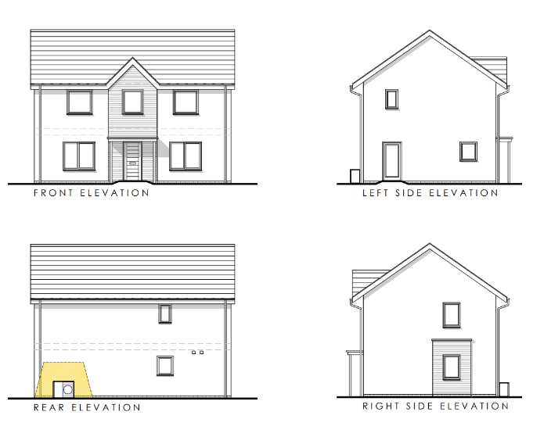

Existing Design
The dwelling to be modelled is a 6 person 4 bedroom house, the fabric of building is designed to be highly efficient with 550mm external wall build up achieving a U-value of 0.13W/m2K and well insulated floors and roof space both achieving U-value of 0.11W/m2K. It has been designed to utilise an Air Source Heat Pump (ASHP) to provide space heating, Mechanical Extract Ventilation (MEV) to control air changes within the property and no provisions for renewable energy systems and designed to meet minimum Part L standards which are outlined in Table 1 which is modelled using the Passive House Planning Package (PHPP).
Building Fabric
Air Permebility | 5.00 m3/m2/hr
Thermal Bridges | 0.200 W/mK
Doors and Windows
Frames U | 1.400 W/m2K uPVC
Installation thermal bridging | 0.040 W/mK
Glazing U | 1.120 W/m2K double low-e glazing 16mm Ar
Glazing g-value | 0.64
Glazing edge | 0.040 W/mK
Ventilation Stratergey
Ventilation rate | 30m3 per person/ hour via MEV
Ventilation Unit | MEV
Heat recovery efficiency | N/A
Ducting | N/A
Duct Insulation | N/A
Heating
ASHP | Generic
SCOP | 3.20
Controls | On/Off

Table 1 – Existing Building to Part L

PHPP Results – Appendix A
From modelling the dwelling compliant to Part L (Wales) although it would have a good EPC rating it still has a high demand for energy use. The calculation below highlights the annual cost for space heating using the ASHP.

7978KWh (Figure2) x 24.67p/KWh(Ofgem cap Q2)

= 196,817.26p

=£1,968.17
This is the Annual cost just to heat the dwelling with the ASHP with the current air tightness and envelop values, add to this the amount for Hot water (DHW) as shown in the calculation below.

3442KWh (Figure 3) x 24.67p/KWh(Ofgem cap Q2)

= 84,914.14p

= £849.14
Totalling £2817.31 for electricity bills, not including energy consumption for lighting and outlets and another £208.81 in daily standing charges. This is a high cost that can be unaffordable or certainly burdensome. The way this would be offset under compliant to Part L would be to add Renewable generation such Solar PV’s with Battery Storage, which would add a substantial cost to the build. The aim of remodelling to a high standard such as Passivhaus is to reduce the energy consumption rather than to offset it.
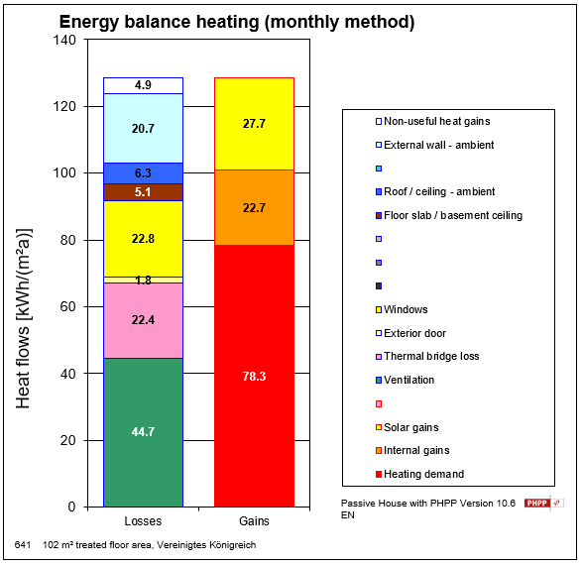

Figure 1 – Energy Consumption
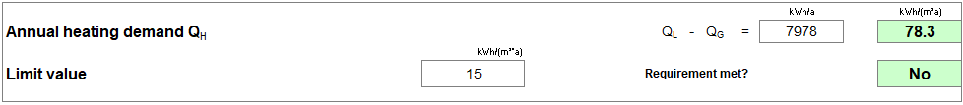

Figure 2 – Annual Heating Demand
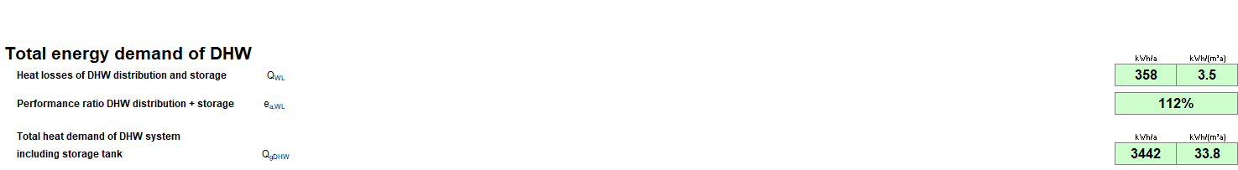

Figure 3 – DHW energy Consumption

Passivhaus
Passivhaus is an international, performance-based building standard developed in Germany that delivers ultra-low energy buildings through a rigorous fabric first approach. Rather than relying on renewable technologies to offset high demand, Passivhaus reduces the need for heating and cooling to a level where low-capacity systems can maintain comfort year-round.
The standard is set and verified by the Passivhaus Institute and assessed using the Passive House Planning Package (PHPP), a detailed energy balance tool that models heat losses, gains, ventilation, and occupancy to predict real performance with high accuracy.

Passivhaus Build Performance Criteria
- Space heating demand: ≤ 15 kWh/m²·yr
- Airtightness: ≤ 0.6 air changes per hour @ 50 Pa
- Primary energy (all uses): ≤ 120 kWh/m²·yr
- Thermal comfort: Overheating limited to ≤10% of hours >25 °C

Passivhaus Key principles
- Very high insulation to minimise heat loss through the envelope.
- Exceptional airtightness to prevent uncontrolled infiltration.
- Thermal bridge-free detailing at junctions.
- High-performance windows (typically triple glazed) installed within the insulation layer.
- Mechanical Ventilation with Heat Recovery (MVHR) to provide fresh air while reclaiming heat from exhaust air.
Because the heating demand is so low, Passivhaus buildings can be heated with very small heat sources, often integrated into the ventilation system or delivered through low-temperature emitters. This enables high heat-pump efficiencies, small plant sizes, and reduced distribution losses. Services are designed to support a low-energy envelope, not compensate for poor fabric performance. Passivhaus makes Net Zero operational carbon achievable with modest renewable generation, improves occupant comfort, and narrows the performance gap between design and operation. It is widely used as a benchmark for low-energy, low-carbon homes.

Proposed Building to Passivhaus
To improve the current building as identified it will be modelled to comply with Passivhaus Standard. The purpose of this report is to look at the M&E improvements that could be made and not building fabric, but that is counter intuitive to achieving Passivhaus standard. The fabric of the proposed building performs well but with some improvements it can have a big impact on the M&E strategy.
Its proposed to improve the airtightness of the building so that it conforms to Passivhaus’ air permeability standards. Another area which can vastly improve the performance of the building is to replace the double glazed uPVC windows with energy efficient triple glazed units. These changes make the building more air tight so as a result improved ventilation needs to be considered to ensure adequate air changes occur for a comfortable living environment this will be achieve by installing a Mechanical Ventilation Heat Recovery (MVHR) system.
The benefit of making these fabric changes means that a smaller Air Source Heat Pump (ASHP) can be specified, this can also be paired with Under Floor Heating (UFH) to provide efficient space heating. The demand for space heat will be reduced compared to the original design due to the improved airtightness level that is required by Passivhaus. Table 3 shows the data modelled using the Passive House Planning Package (PHPP).
Building Fabric
Air Permebility | Max 0.6 ACH @50Pa
Thermal Bridges | 0.01 W/mK
Doors and Windows
Frames U | 0.81 W/m2K
Installation thermal bridging | 0.023 W/mK
Glazing U | 0.55 W/m2K triple low-e glazing
Glazing g-value | 0.63
Glazing edge | 0.025 W/mK
Ventilation Stratergey
Ventilation rate | 30m3 per person/ hour
Ventilation Unit | MVHR
Heat recovery efficiency | 92%
Ducting | 150mm
Duct Insulation | 50mm, non reflective, k=0.04W/mk
Heating
ASHP | Valliant aro Therm plus 5KW
SCOP | 4.10
Controls | Smart Controls

Table 2 – Proposed Building to Passivhaus

PHPP Results – Appendix 2
As can be seen from Figure 4 by upgrading the windows, improving the air tightness, and reducing thermal bridging the energy consumption has reduced by over 50%. The calculation below show how this looks in terms of monetary value.

3292KWh (Figure4) x 24.67p/KWh(Ofgem cap Q2)

=81,213.64p

=£812.14
That’s an annual saving of £1156.03, on space heating costs alone. This cost saving would contribute to the return on investment of spending more initially to complete the dwelling to higher standard.
 | Part L | Passivhaus | Improvement
Space heating demand (kWh/m²·yr) | 7978KWh | 3292KWh | -4686KWh
Heat load (W/m²) | 78.3 W/m² | 32.3 W/m² | -46 W/m²
Annual heating cost | £1968 | £812 | -59%

Table 3 – Space Heating Comparisons

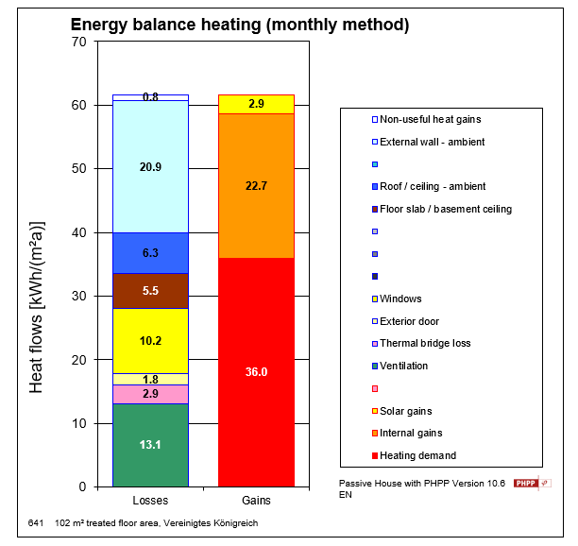

Figure 4 - Energy Consumption

Figure 5 – Annual Heating Demand
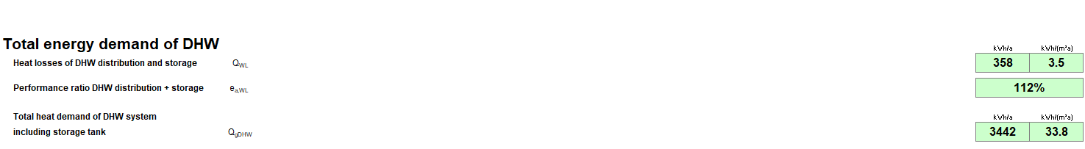

Figure 6 – DHW energy Consumption

Evaluation
Passivhaus works because it first addresses airtightness which has been done in this model by upgrading the windows to Passivhaus compliant triple glazed units, along with improving airtightness and thermal bridging values in line with the more rigorous standard. This creates the need to provide adequate ventilation, so the introduction of a mechanical ventilation with heat recovery systems(MVHR) ensures controlled air changes within the dwelling and operates far more efficiently and significantly reduces the building’s heating demand. The lower heat load enables the use of low-temperature systems such as underfloor heating, improving heat pump efficiency and reducing overall energy consumption, without the reliance on photovoltaic generation to achieve low-carbon performance.

Cost Comparison
For a new-build dwelling in the UK in 2026, industry cost benchmarks indicate that construction costs alone (excluding land, professional fees, planning, VAT, and contingencies) typically fall within a broad range depending on specification level and region. Standard residential new build costs are generally estimated at approximately £2,000–£2,500 per m² for a typical mid-range specification.
Evidence shows that the additional cost of delivering homes to Passivhaus has fallen as industry knowledge, supply chains, and contractor experience have improved. The Passivhaus Trust notes that current cost uplifts, 3–8% higher, are modest relative to total build cost, and are often offset by whole-life benefits from smaller services, reduced plant, and lower energy demand (Passivhaus Trust, 2020). Crucially, studies demonstrate that Passivhaus dwellings reliably achieve their predicted performance, narrowing the “performance gap” common in Part L homes where actual energy use exceeds SAP estimates. This means the modelled energy savings are far more likely to be realised in operation, supporting a life-cycle value case rather than a focus on upfront capital cost alone (Passivhaus Trust, 2024; Johnston and Miles-Shenton, 2018).
Energy costs
Comparative modelling from the Passivhaus Trust finds that Passivhaus buildings cost significantly less to run than homes built to UK regulatory standards: in some cases, tens to hundreds of pounds per year lower in regulated energy costs. For example, Passivhaus Classic performs similarly or more efficiently than Future Homes Standard (close to Part L) designs, with lower energy bills especially where PV is limited or unavailable.
Whole-life Payback
Whole-life cost analysis indicates that the initial Passivhaus premium can be recouped within the life of the dwelling through reduced energy bills, typically within 8–15 years depending on heating system choice (air source heat pump payback ~15 years, electric direct heating shorter). This payback does not even include benefits from improved comfort, reduced maintenance, or long-term durability.
Cost Implications | Part L (Wales) | Passivhaus
Build Cost | £2,000–£2,500 per m² | £2100 - £2625 per m2
M&E | Higher due to oversizing | Cost saving for passivhaus
Operational | Higher due to inefficient envelop of building | Substantially lower bills for Passivhaus typically 50% less
Wholelife Cost | No cost saving unless renewables are added which still has a longer payback time. | Passivhaus costs often recouped in 8–15 years

Table 4 – Passivhaus Cost Implications

Embodied Carbon
Adopting Passivhaus in place of Part L reduces embodied carbon and overall cost by lowering the building’s heat demand to a level where smaller services are sufficient, such as the reduction of an ASHP sizing from 7Kw to 3.5Kw. This is due to the fact that Passivhaus limits space heating demand to ≤15 kWh/m²·yr and requires very high airtightness, which substantially reduces peak heat loads. The building is designed to sit at an ambient temperature consistently with very little fluctuations. UK guidance from CIBSE notes that lower flow temperatures and reduced heat loads enable smaller heat pumps, emitters, cylinders, and distribution networks, cutting both material quantities and distribution losses (CIBSE, 2022). With verified low heat demand from results modelling to Passivhaus standard using PHPP, designers can avoid the conservative oversizing commonly seen in Part L dwellings, where uncertainty and higher losses drive larger plant selection. Oversizing hot water storage tanks is a prime example where M&E can lead to unnecessarily wasted energy, resulting in higher carbon outputs.
From an embodied carbon perspective, UK whole-life carbon guidance by Royal Institution of Chartered Surveyors (RICS) shows that building services can contribute a significant portion of upfront embodied impacts, particularly where plant capacity is oversized (RICS, 2017). By contrast, Passivhaus envelopes allow downsizing of mechanical plant and emitters, reducing the amount of high embodied carbon materials. Material carbon data from the University of Bath further indicates that reducing steel components (e.g., large radiators, oversized cylinders, extensive pipework) lowers embodied carbon impact when compared with right-sized, low-temperature systems (ICE, 2019).
Although Passivhaus may increase upfront fabric costs, these can be offset by smaller services, simpler distribution, and long-term energy savings. Cost benefits are seen over the life of the building . The Carbon Trust highlights that heat pumps operating at lower temperatures achieve higher seasonal efficiencies, reducing electricity consumption and operational costs (Carbon Trust, 2021). In whole-life terms, this aligns with UK Net Zero design guidance that prioritises demand reduction first, then efficient systems and renewables.

Conclusion
This report has demonstrated that a dwelling designed to comply with Approved Document Part L (Wales) cannot be considered Net Zero in operation, despite achieving regulatory compliance and a good EPC rating. Through PHPP modelling, it has been shown that the baseline dwelling has a relatively high heating demand, requiring larger plant and greater reliance on renewable technologies such as PV to offset calculated carbon emissions rather than reducing energy demand.
By remodelling the same dwelling to Passivhaus principles, significant reductions in space heating demand were achieved through improved airtightness, enhanced window performance, reduced thermal bridging, and the introduction of MVHR. These fabric-led improvements allowed the mechanical and electrical strategy to be fundamentally redesigned, enabling the use of a smaller ASHP, low-temperature underfloor heating, reduced distribution losses, and lower operational energy consumption. The PHPP results clearly show a reduction of over 50% in heating energy demand, equating to substantial annual cost savings.
While not fully Passivhaus compliant, this would require further fabric improvements, adopting a Passivhaus approach reduces embodied carbon associated with oversized plant and emitters, aligns with whole-life carbon assessment principles, and provides a more reliable route to achieving predicted energy performance in use, addressing the performance gap commonly seen in Part L dwellings.
The evidence presented confirms that Net Zero domestic design is not achieved through compliance or renewable offsetting alone, but through a fabric-first approach that enables building services to be smaller, simpler, and more efficient. Passivhaus therefore provides a practical and measurable framework for transforming a compliant dwelling into a genuinely low-energy, Net Zero-aligned home.

References
GOV.WALES (2026) Approved Document L: Conservation of fuel and power. Available at: Approved Document L: conservation of fuel and power | GOV.WALES (Accessed: April/May 2026).
GOV.UK (2024) Sustainability and Net Zero Annex. Available at: Sustainability and Net Zero Annex - GOV.UK (Accessed: April/May 2026).
LETI (2019) Net Zero: Carbon definitions for the built environment. Available at: Net Zero | LETI (Accessed: April/May 2026).
Passivhaus Trust (2025) What is Passivhaus?. Available at: What is Passivhaus? (Accessed: April/May 2026).
AECB (2025) The AECB CarbonLite™ Standards. Available at: The AECB CarbonLite™ Standards - AECB (Accessed: April/May 2026).
Carbon Trust (2021) Heat pumps and efficiency in buildings. London: Carbon Trust. Heat pumps guide | The Carbon Trust (Accessed: April/May 2026).
Royal Institution of Chartered Surveyors (2017) Whole life carbon assessment for the built environment. London: RICS. Whole life carbon assessment for the built environment | isurv (Accessed: April/May 2026).
Passivhaus Trust (2020) Passivhaus costs summary. Available at: https://passivhaus.uk/passivhaus-costs-summary/ (Accessed: April/May 2026).
Passivhaus Trust (2025) Passivhaus compared to FHS 2025. Available at: Passivhaus Compared to the Proposed FHS • Passivhaus Trust (Accessed: April/May 2026).
Passivhaus Trust (2024) Passivhaus benefits summary. Available at: PHT_PH-Benefits-Summary_Full-report_5.0_Double-Page.pdf (Accessed: April/May 2026).
Passivhaus Trust (2024) Passivhaus & Building Regulations. Available at: https://passivhaustrust.org.uk/competitions_and_campaigns/passivhaus-building-regulations/ (Accessed: April/May 2026).
Homebuilding & Renovating (2025) Are passive homes cost effective? Available at: Passivhaus: a self-builder's guide to this eco accreditation | Homebuilding (Accessed: April/May 2026).
Average Electricity Cost 2026 Average Cost of Electricity per kWh in the UK (2026) | NimbleFins (Accessed: April/May 2026).

