

Managing Enterprise in the 21st Century

Business Plan of

Local Family Café
“Moné”

Submission Date: 30.03.2026
Lecturer: Dr. Tola Odugbesan
Student: Zoriana Shpyt
Student ID: 2437386
Table of Contents
Table of Contents 2
Executive Summary 3
Business Concept 5
Business Description 5
Product Description 5
Business Objectives (SMART Objectives) 5
Short-Term Objectives (less than a year) 5
Long-Term Objectives (less than a year) 5
Market Analysis and Marketing Plan 6
Market Analysis (Competitors, Customers, Target Groups) 6
PESTEL Analysis 6
SWOT Analysis 6
Marketing Mix (4Ps) 6
Management Team 6
Management Team and Their Background 7
Organisational Chart 7
Key Milestones 7
Financial Plan (One Year) 7
Sources of Finance 7
Cash Flow Forecast 7
Sales Forecast 7
Cost of Production Forecast 7
Break Even Analysis 7
Operations and Management Plan 7
Production of Good and Service 7
Technology Plan 7
Human Resource Plan 7
Expansion Plan 8
Reference List 8
Appendices: 9

Executive Summary

The proposed business is a family and pet-friendly café located in a quiet residential area of London, such as Richmond upon Thames. Positioned between a residential complex and a public park, the café will attract local residents, families, and pet owners.
The café will offer high-quality coffee, fresh meals, and healthy breakfast options, including protein-based dishes and smoothies, appealing to both families and health-conscious customers. This reflects increasing demand for healthier food choices (Statista, 2024).
With its combination of family-friendly, pet-friendly, and health-focused services, the café will create a strong community space and competitive advantage.
The business aims to achieve profitability within the first 12 months by building a loyal customer base and maintaining high standards of quality and service.

Business Concept and Description

The café will operate as an independent business offering dine-in and take-away services. It will provide a relaxed, welcoming environment for families and pet owners.
The café will provide indoor and outdoor seating, a small play corner for children, and a designated pet area with water bowls and treats for dogs. The business will prioritize fresh ingredients, friendly service, and cozy atmosphere.
Independent cafés are increasingly preferred due to their personalised service and atmosphere (Mintel, 2024).

Business Product


Food & Drinks:
• Coffee, tea, hot chocolate
• Healthy breakfasts (avocado toast, protein-based meals,vegan and low-sugar options, smoothies). This responds to growing demand for healthier café options (Statista, 2024)
• Lunch meals (sandwiches, soups)
• Cakes, pastries and desserts
Kids Menu:
• Healthy snacks
• Babyccinos
• Allergy-friendly options
Pet-Friendly Features:
• Dog water bowls
• Dog treats
• Outdoor seating for pet owners
Menu will be kept simple to ensure efficiency and reduce waste (Food Standards Agency, 2023).

Business Objectives (SMART)

Short-Term Objectives (Within 1 Year)
- Achieve break-even within 6–12 months
- Build a base of at least 100 regular customers
- Establish strong local brand awareness
- Launch loyalty cards (example each 10th coffee is free)

Long-Term Objectives (1–3 Years)
- Increase revenue by 15–20% annually
- Expand services (events, delivery)
- Open a second café location

Market Analysis and Marketing Plan

Segmentation, Targeting, and Positioning Strategy

The segmentation, targeting, and positioning strategy helps the café clearly define its ideal customers and differentiate itself from competitors.

1. Market Segmentation
For the family and pet-friendly café, segmentation will help identify the most relevant customer groups in the local community.
The café can segment its market using demographic, geographic, psychographic, and behavioural factors.

Geographic Segmentation include:
- Local residents – 65% of customers
- People working in nearby offices
- Visitors spending time in the area
- Dog walkers and park visitors

Demographic Segmentation
The café’s key demographic segments include:
- Families with children. Parents often look for comfortable places where children are welcome and where they can relax while spending time together.
- Young professionals and students
People aged 22–40 who enjoy visiting cafés to work remotely, meet friends, or relax.

Psychographic Segmentation
The café will target customers who:
- Value community and social interaction
- Enjoy relaxed and cozy environments
- Love animals and outdoor activities
- Prefer local, independent businesses instead of large chains
- Appreciate quality coffee and homemade food

Behavioural Segmentation focuses on families and groups who prefer to visit cafés on weekends for brunch or leisure time.

2. Targeting Strategy

After identifying different segments, the next step is selecting the most attractive and profitable target markets.
The café will primarily focus on three main target groups.

Primary Target Market: Families with Children
The café can attract families by offering:
- A small children’s play corner
- Kid-friendly menu items
- Comfortable seating areas
- Weekend family brunch specials

Secondary Target Market: Pet Owners
The café will attract pet owners by providing:
- Pet-friendly seating areas
- Water bowls for dogs
- Dog treats or small pet snacks
- Outdoor seating where pets are welcome

Third Target Market: Young Professionals and Students
The café can attract this group by offering:
- Free Wi-Fi
- Comfortable seating
- Good-quality coffee
- A calm and cozy environment
- Affordable lunch or coffee deals

3. Positioning Strategy

The café will position itself as:
“A cozy community café where families, friends, and pets are always welcome.”
Unlike large coffee chains, the café will focus on creating a warm, local, and personal experience and will be focused mostly on regular clients.

Key Positioning Elements

1. Community-focused atmosphere
The café will promote itself as a neighbourhood gathering place where people can relax and socialize.
2. Pet-friendly concept
Allowing pets and providing small services for them will make the café stand out from traditional coffee shops.
3. Family-friendly environment
The café will offer a safe and welcoming space for parents and children.
4. Quality products
Fresh coffee, homemade pastries, and light meals will reinforce the café’s reputation for quality.

Brand Personality
The brand personality would reflect:
- Friendly
- Welcoming
- Relaxed
- Community-oriented
- Inclusive
The design of the café, staff behaviour, and marketing messages would support the business image.

4. Positioning Statement

A positioning statement clearly summarizes how the business wants to be perceived by customers.
Example positioning statement:
“Our café provides a welcoming and cozy space for families, pet owners, and local residents who want to enjoy quality coffee and homemade healthy food in a relaxed, community-focused environment where everyone — including pets — feels at home.”

By focusing on families, pet owners, and young professionals, the café can build a strong and loyal customer base.

PESTEL Analysis

To anticipate external challenges and opportunities, below I made a PESTLE Analysis, it helps to make informed decisions and reduce business risks.

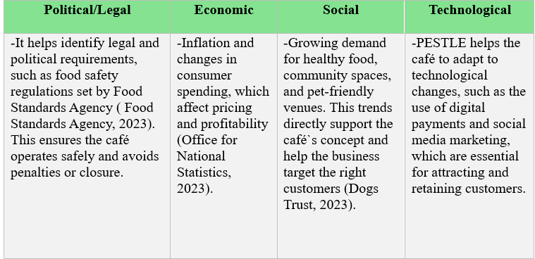

SWOT Analysis

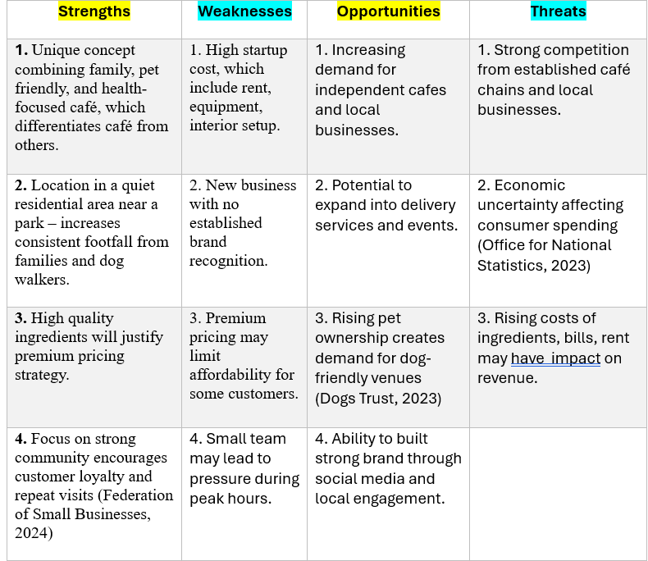

Marketing Mix (4Ps)

Product: High-quality food, drinks, healthy and pet-friendly options
There is a growing trend towards speciality coffee and high-quality food, with consumers prioritising quality over price in café choices (Statista, 2024).
Price: Premium pricing, justified with quality and atmosphere (£5 coffee, £7 avocado toast, £6 smoothies) reflecting quality (Statista, 2024)
Place: Quiet residential area near park, located in one of the best area in London.
Promotion: Social media via Instagram, Facebook, reviews on Google Maps, local partnerships.

Management Team

Management Team and Their Background

Strong management improves business performance (British Business Bank, 2023). Management team of my café will consist from:
- Owner (Me): Dealing with staff onboarding, finance, accounting
- Partner (Vasile): Dealing with suppliers and analytics

Organisational Chart of the Cafe

Key Milestones

- Find a location: January - February 2027
- Setup café: March 2027
- Hire staff: April 2027
- Launch marketing: April 2027
- Open café: 1st May 2027
- Reach break-even: from November 2027

Financial Plan (One Year)

Sources of Finance
The business will be financed through a combination of:
1) Personal savings – providing initial capital and reducing reliance on loans
2) Bank loan – used to cover major startup costs such as equipment, etc.
3) Government support schemes – potential grants or small business support.

Cash Flow Forecast
Key Assumptions:

Total Revenue | 294,840 £
Expenses:
Rent | 36,000 £
Staff wages | 96,000 £
Ingredients | 36,000 £
Utilities | 6,000 £
Marketing | 2,400 £
Miscellaneous | 3,600 £
Total Costs | 180,000 £
Net Profit | +114,840 £

What business will earn?
Total yearly profit – 114, 840£
Average monthly profit – 9,570£
Average daily profit – 368£

Sales Forecast
Opening days: 26 days/month
Customers per day: 90
Average spend: 10.50
Yearly Revenue:
- Daily - £945
- Monthly - £24,570
- Per year - £24,840

Cost of Production Forecast
Variable Costs:
- Ingredients: £3,000 x 12 = 36,000
- Packaging and supplies included
Fixed Costs:
Rent: £3,000 x 12 = £36,000
Staff wages: £8,000 x 12 = £96,000
Utilities: £500 x 12 = £6,000
Marketing: £200 x 12 = £2,400
Miscellaneous: £300 x 12 = £3,600
Total yearly cost = £180,000

Break Even Analysis

Rent | Staff wages | Utilities | Marketing | Miscellaneous | Total Fixed Costs
3,000 – monthly,  36,000 - yearly | 8,000 – monthly  96,000 – yearly | 500 - monthly,  6,000 - yearly | 200 – monthly, 2,400 - yearly | 300 – monthly,  3,600 - yearly | 12,000 – monthly,  144,000 - yearly

Contribution per customer:
Average selling price | £10.50
Variable cost per customer | £3.80
Contribution per sale | £6.70

To find Break-Even you need Fixed Costs divide on Contribution per customer.
Measure: | Result:
Break-Even (monthly customers) | 1,791
Break-Even (yearly customers) | 21,493
Break-Even (per day) | 69

Comparison with Expected Sales
Metric: | Value:
Expected customers per day | 90
Break-Even customers per day | 69
Difference | +21 customer/day

The café needs 69 customers per day to cover all costs.
Expected customers are 90 per day. This means the business operates above Break-Even and makes profit.

Operations and Management Plan

Production of Good and Service

Fresh food and drinks will be prepared daily following hygiene standards (Food Standards Agency, 2023)

Technology Plan
The café will use modern technology to improve efficiency, customer experience, and marketing effectiveness.
1. A POS system will be used to:
- Process payments (cash and contactless)
- Track daily sales and revenue
- Monitor popular products
2. Payment Technology
The café will offer:
- Contactless payments
- Card payments
- Mobile payments (Apple Pay, Google Pay)
3. Online presence is essential, as customer choices are strongly influenced by digital visibility and reviews (Statista, 2024).
We will use platforms such as:
- Instagram
- Facebook
It will significantly help to:
- Promote products and events
- Engage with local customers
- Build brand awareness
4. Positive reviews will help attract new customers and build trust.
The café will be listed on:
- Google Maps
- Review platforms
5. Inventory & Supplier Management
Simple digital tools or software will be used to:
- Track stock levels
- Manage orders from suppliers
- Reduce waste
6. Future Technology Development
In the future, the café may introduce:
- Online ordering or delivery platforms
- Loyalty apps or digital rewards systems

Human Resource Plan
The café will operate with:
- 2 baristas (cashier role included)
- 2 kitchen staff (food+cashier)
- 1 cleaner ( also dishwashing)

Expansion Plan

- Delivery services
- More seatings
- Open second location

Reference List

1. British Coffee Association (2023) UK coffee market report. Available at:
https://www.britishcoffeeassociation.org
(Accessed: 15 March 2026).
2. Mintel (2024) Coffee shops – UK market report. Available at: https://store.mintel.com/report/uk-coffee-market-report-2024 (Accessed: 15 March 2026).
3. Federation of Small Businesses (2023) UK small business statistics. Available at: https://www.fsb.org.uk (Accessed: 29 March 2026).
4. Food Standards Agency (2023) Food hygiene and safety for businesses. Available at: https://www.food.gov.uk (Accessed: 29 March 2026).
5. Office for National Statistics (2023) Family spending in the UK. Available at: https://www.ons.gov.uk (Accessed: 29 March 2026).
6. Statista (2024) Consumer behaviour in coffee shops in the UK. Available at: https://www.statista.com (Accessed: 22 March 2026).
7. Dogs Trust (2023) Dog-friendly businesses and public attitudes. Available at: https://www.dogstrust.org.uk (Accessed: 29 March 2026).

Appendices:

The Break-Even analysis demonstrates that the café has a strong financial position, as expected customer numbers exceed the Break-Even point. This reduces financial risk and confirms that the premium pricing strategy supports long-term profitability.

