ASSIGNMENT 2: ‘CONTEMPORARY THEME - TECHNOLOGY’

Table of Contents
Slide 1: Introduction 3
Slide 2: Assignment theme: Exploring the 'Technology' Contemporary in Hospitality 3
Slide 3: Importance and relevance for the hotel and hospitality sector 4
Slide 4: Background of the case study 5
Slide 5 Overview of some key theory and concepts 5
Slide 6 Overview of some key theory and concepts: Cont. 7
Slide 7: Analyzing the Impact of Technology on Hospitality: A Theoretical Perspective 8
Slide 8: Analyzing the Impact of Technology on Hospitality: A Theoretical Perspective: Cont. 9
Slide 9: Focused Area: Front Office in Hotel Industry 10
Slide 10: Focused Area: Front Office in Hotel Industry: Cont 11
Slide 11: Specific area of the hotel industry 11
Slide 12: Examples of management responses to the technology theme 12
Slide 13: Strengths and limitations of technology in hotels 13
Slide 14: Recommendations for the hospitality industry 14
Slide 15: Conclusion 14
Reference 15

Slide 1: Introduction
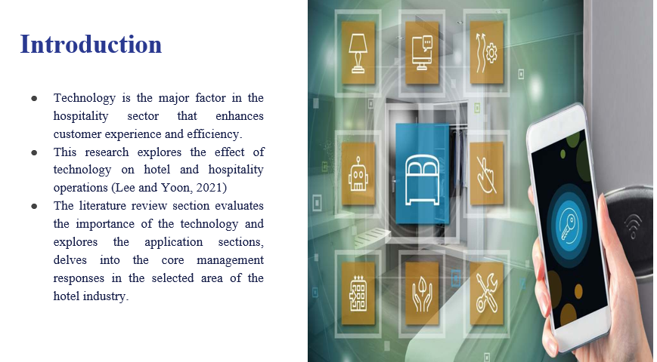
The core context of this presentation highlights the vital role of technology in shaping the hospitality industry. The major approach of key theories and concepts that draw insights from the different articles and journals and provide a cultural understanding of how technology influences different hotel operations.

Slide 2: Assignment theme: Exploring the 'Technology' Contemporary in Hospitality

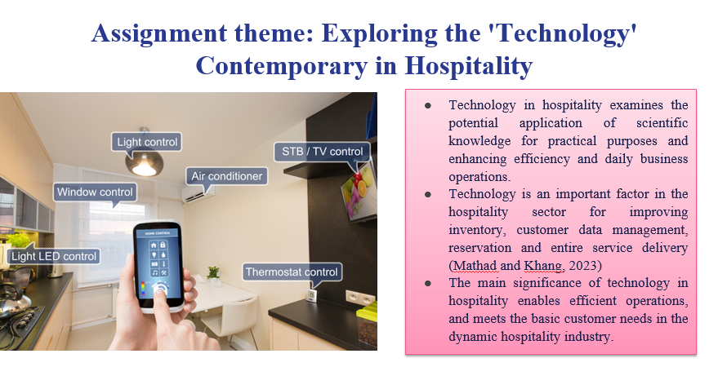
In the present context, examine technology in hospitality, and outline its definition and importance. Technology is the basic instrument in enhancing the daily business operations from managing the inventory to meeting the customer needs. This theme sets the potential exploration of “technology” that impacts the hospitality and hotel sector.

Slide 3: Importance and relevance for the hotel and hospitality sector

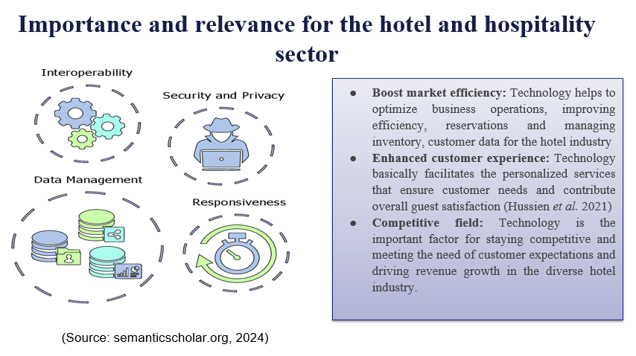
In the field of the hospitality sector, technology plays a vital role and it enhances the operational efficiency, manages vital aspects like reservations, inventory and it reveals the customer value through the personalized services. The embracing technology is necessary for meeting the customer expectations and fostering the sustained growth in the dynamic industry.

Slide 4: Background of the case study

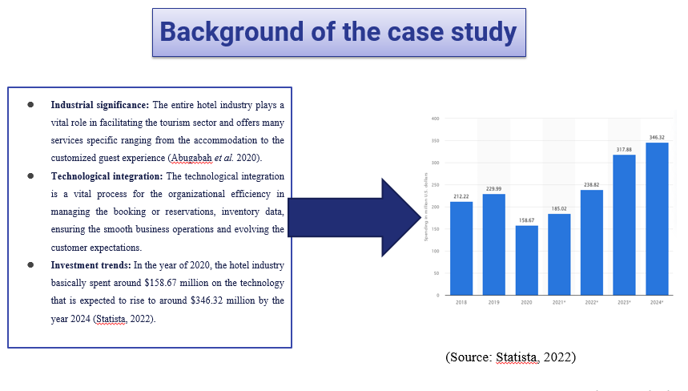
In the field of the dynamic hospitality sector, technology is the effective tool for industrial growth. The industry’s significance basically facilitates the tourism data and integration of technology that signify its relevance. The increasing trend of the effective investment expects $346.32 million by the year 2024 and reflects the proactive approach to stay competitive with exceptional guest experiences.

Slide 5 Overview of some key theory and concepts

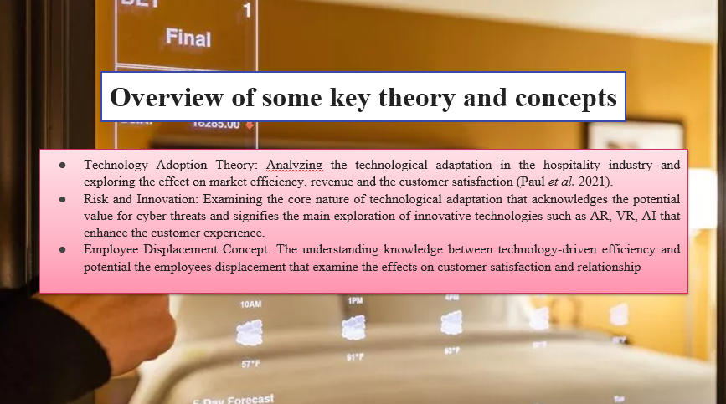
The core technological concept develops with the theories and it shapes the understanding of technological value in the hospitality sector. The adaptation of AI, AR technology considering the delicate connection between customer satisfaction and employee dynamics, navigates the associated risks associated with the technological value emphasizing the basic need for the state innovation that enhances the customer experiences while mitigating the potential value in cybersecurity threats.

Slide 6 Overview of some key theory and concepts: Cont.
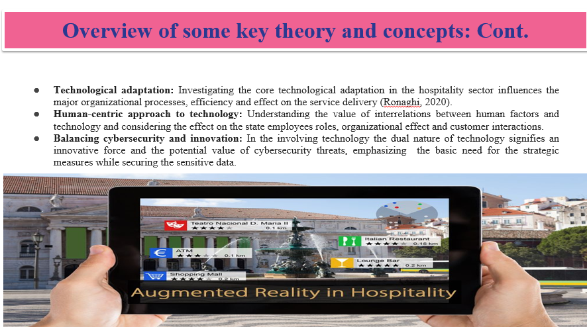
This analysis evaluates around the key concepts and theories that are vital for understanding the technological role in hospitality. This assignment develops into the connection between cybersecurity and innovation. These concepts form the strong foundation for the state exploration of the technological influence on the hospitality industry.

Slide 7: Analyzing the Impact of Technology on Hospitality: A Theoretical Perspective
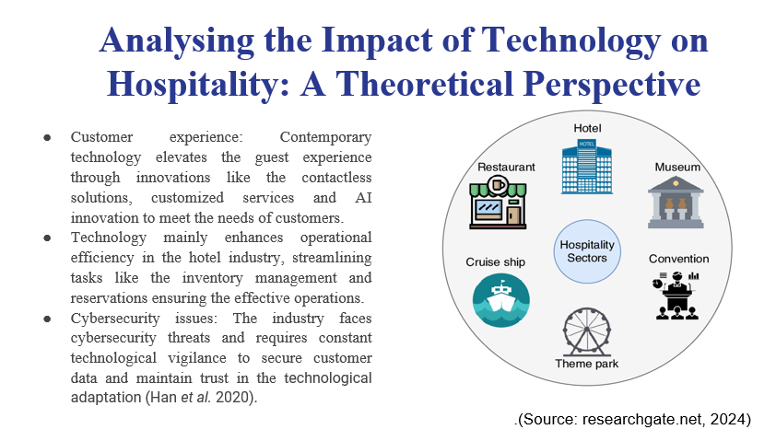
In the field of technological effects on the specific theme of the hospitality industry, that explores the operational efficiency and improved customer experiences. Hence, the main analysis also signifies the industrial vulnerability to the cybersecurity issues, emphasizing the basic need for the robust measures to protect the customer data and ensure the potential trust in the adaptation of technological advancement.

Slide 8: Analyzing the Impact of Technology on Hospitality: A Theoretical Perspective: Cont.
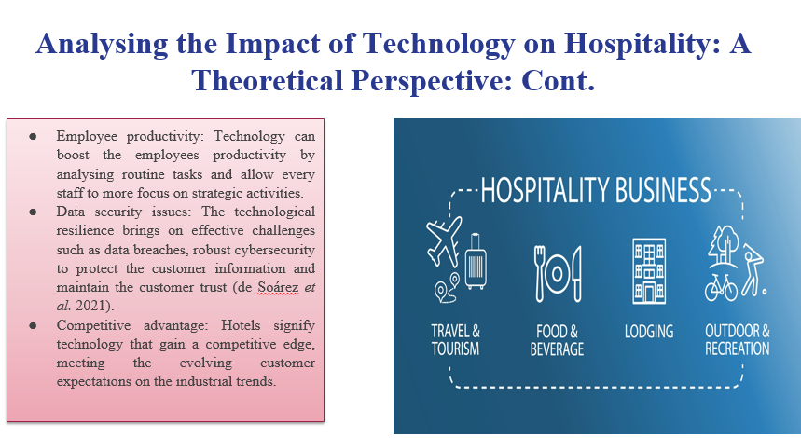
The entire overview of how technology transforms the hospitality that enhances the operational efficiency and elevates the customer experiences, driving the future revenue growth and boosting the employee’s productivity and evaluates data security issues for sustained industrial development.

Slide 9: Focused Area: Front Office in Hotel Industry
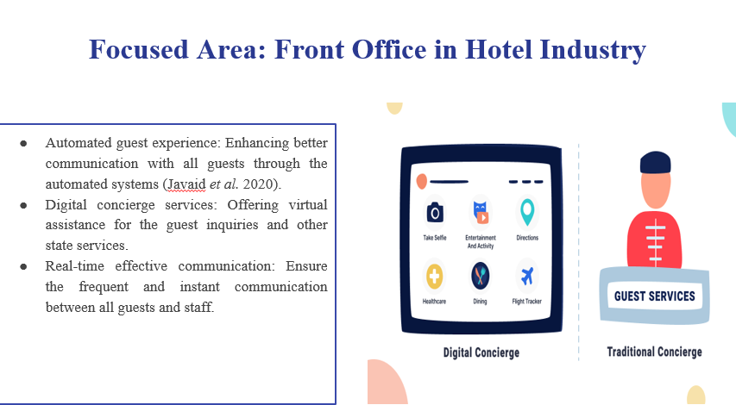
This study introduces a specific arena in the front office of the hotel industry, and investigates the potential effects of technology. Understanding automated AI-assisted and check-in services helps to find out the guest recognition and examine the technology and their role in operational efficiency.

Slide 10: Focused Area: Front Office in Hotel Industry: Cont
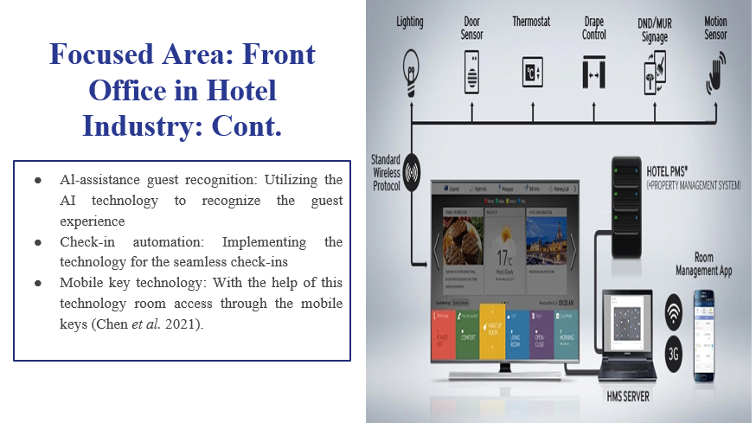
This present study examines the Front Office that justify the impacts of technology. From AI-assisted guest recognition and it ensures the personalization to streamlined check-ins and the the basic application of mobile key technology, and explore how these advancements redefine guest experiences and operational processes in the hotel industry.

Slide 11: Specific area of the hotel industry
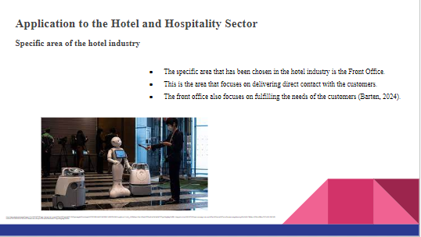

The technologies that are implemented in the front office of the hotel industry are culd-based and even automated. The implementation of technology in the front office has led to the improvement of efficiency in the operational aspect of the front office of the hotel sector (Barten, 2024). It has benefited the practice of personalising the experiences of the guests along with providing them with real-time data and insights that allow them to make efficient decisions.

Slide 12: Examples of management responses to the technology theme
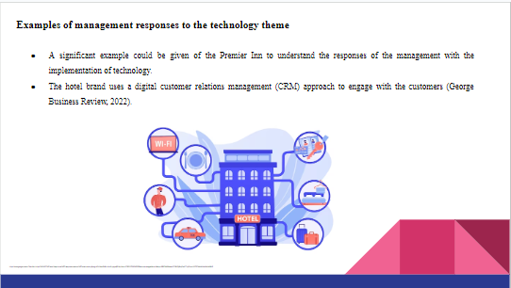

The use of digital CRM allows the brand to conduct efficient primary communication along with the management of the website. The use of Chatbots helps resolve the queries of the customers along with replying to their questions. The communication process is highly data-driven which favours the aspect of customisation and payment practices (George Business Review, 2022). It also allows the customers to have the convenience of digital payment and rapid confirmation.

Slide 13: Strengths and limitations of technology in hotels
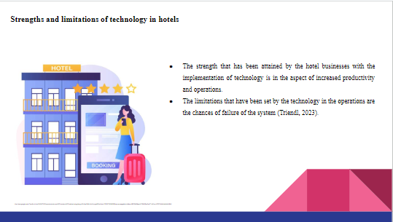

The rise in the productivity level leads to the streamlining of operations along with the process of administration and automation of tasks. This has also allowed the brands to have efficient management of the resources in the workplace. However, the risks of systems failure lead to the occurrence of the chances of disruption which eventually causes dissatisfaction among the customers (Triendl, 2023).

Slide 14: Recommendations for the hospitality industry
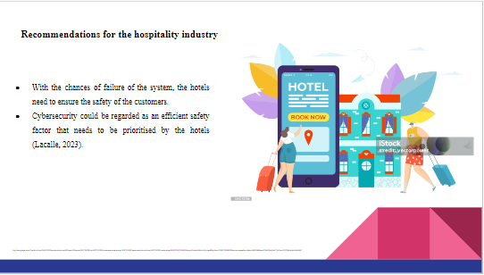

The rise of technology and its usage in the hotel sector has led to the risks of data breaches in the businesses imposing threats on the reputation of the hotels and the safety of the guests. Thus hotel brands need to focus on the monitoring and evaluation of the efficiency of their password encryption to ensure the technologies are being used efficiently (Lacalle, 2023).

Slide 15: Conclusion
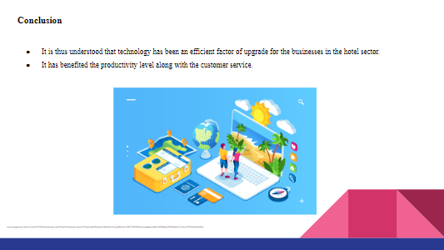

The reference to the technological usage of hotel brands like Premier Inn has provided an understanding that all hotel brands need to use the technologies that are needed to maintain the rate of productivity in the workplace along with benefiting the management and services that are provided to the customers.

Reference
Abugabah, A., Nizamuddin, N. and Abuqabbeh, A., 2020. A review of challenges and barriers implementing RFID technology in the Healthcare sector. Procedia Computer Science, 170, pp.1003-1010. https://www.sciencedirect.com/science/article/pii/S1877050920305329/pdf?md5=94b98e5cc0269acd6ec38b1548882cf3&pid=1-s2.0-S1877050920305329-main.pdf
Barten, M. 2024. Front Office Technology: The Latest Tech for the Reception in 2024. Available at: https://www.revfine.com/front-office-technology/#:~:text=It’s%20important%20to%20improve%20operational,a%20smooth%20and%20efficient%20operation.
Chen, L.K., Yuan, R.P., Ji, X.J., Lu, X.Y., Xiao, J., Tao, J.B., Kang, X., Li, X., He, Z.H., Quan, S. and Jiang, L.Z., 2021. Modular composite building in urgent emergency engineering projects: A case study of accelerated design and construction of Wuhan Thunder God Mountain/Leishenshan hospital to COVID-19 pandemic. Automation in Construction, 124, p.103555. https://www.ncbi.nlm.nih.gov/pmc/articles/PMC8589358/
de Soárez, P.C., Pepe, V.L.E. and Novaes, H.M.D., 2021. Hospital-based health technology assessment in Brazil: current experiences and challenges. International Journal of Technology Assessment in Health Care, 37(1), p.e86. https://www.cambridge.org/core/journals/international-journal-of-technology-assessment-in-health-care/article/hospitalbased-health-technology-assessment-in-brazil-current-experiences-and-challenges/66CF600A5CC2A3249278D2A7D9242D66
George Business Review., 2022. Customer Service Management of Premier Inn. 2022. Available at: https://www.george-business-review.com/customer-service-management-of-premier-inn/#Impact_of_digital_technologies_on_Customer_Relation_Management_CRM.
Han, Y., Lie, R.K. and Guo, R., 2020. The internet hospital as a telehealth model in China: systematic search and content analysis. Journal of Medical Internet Research, 22(7), p.e17995. https://www.jmir.org/2020/7/e17995/
Hussien, H.M., Yasin, S.M., Udzir, N.I., Ninggal, M.I.H. and Salman, S., 2021. Blockchain technology in the healthcare industry: Trends and opportunities. Journal of Industrial Information Integration, 22, p.100217. https://www.sciencedirect.com/science/article/pii/S2452414X21000170
Javaid, M., Haleem, A., Vaishya, R., Bahl, S., Suman, R. and Vaish, A., 2020. Industry 4.0 technologies and their applications in fighting COVID-19 pandemic. Diabetes & Metabolic Syndrome: Clinical Research & Reviews, 14(4), pp.419-422. https://www.ncbi.nlm.nih.gov/pmc/articles/PMC7180383/
Lacalle, E. 2023. 11 technologies that are changing hotel security | Mews. Available at: https://www.mews.com/en/blog/hotel-security-technology.
Lee, D. and Yoon, S.N., 2021. Application of artificial intelligence-based technologies in the healthcare industry: Opportunities and challenges. International Journal of Environmental Research and Public Health, 18(1), p.271. https://www.mdpi.com/1660-4601/18/1/271/pdf
Mathad, K. and Khang, A., 2023. Hospital 4.0: Capitalization of health and healthcare in Industry 4.0 economy. In Data-Centric AI Solutions and Emerging Technologies in the Healthcare Ecosystem (pp. 319-330). CRC Press. https://www.taylorfrancis.com/chapters/edit/10.1201/9781003356189-19/hospital-4-0-kavita-mathad-alex-khang
Paul, S., Riffat, M., Yasir, A., Mahim, M.N., Sharnali, B.Y., Naheen, I.T., Rahman, A. and Kulkarni, A., 2021. Industry 4.0 applications for medical/healthcare services. Journal of Sensor and Actuator Networks, 10(3), p.43. https://www.mdpi.com/2224-2708/10/3/43/pdf
researchgate.net (2024) Available at: https://www.researchgate.net/figure/IoT-is-utilized-in-various-hospitality-sectors_fig4_344242560
Ronaghi, M., 2020. A Conceptual Framework for Smart Hospital towards Industry 4.0. Journal of Hospital, 19(2), pp.60-68. https://jhosp.tums.ac.ir/browse.php?a_id=6273&sid=1&slc_lang=en
semanticscholar.org (2024) Available at: https://www.semanticscholar.org/paper/Technology-in-the-Hospitality-Industry%3A-Prospects-Kansakar-Munir/14643863e5326a9df6ab73f6d55574b4384bdf38
Statista, (2022). Total software spending in accommodations, restaurants and nightlife industry in the United Kingdom from 2018 to 2024 [Online] Available Through <http://surl.li/pxbkc>
Triendl, C. 2023. The Pros And Cons Of Using AI In Hospitality. Available at: https://stampede.ai/blog/the-pros-and-cons-of-using-ai-in-hospitality.

