Data Handling and Business Intelligence assignment 2 2018-2019- An evaluation of the importance of Excel and Weka within an organisation

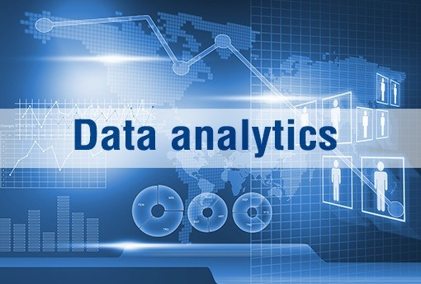
May 2019

MODULE NAME: Data Handling and Business Intelligence
MODULE NUMBER: M5X00842
STUDENT NAME: PHILS MUOBIKE
STUDENT NUMBER: 1706873
LECTURER NAME: CHRISTOPHER THOMAS

Table of Contents
1. Introduction 4
2. Importance of using spreadsheets and their functions 4
2.1 VLOOKUP 4
2.2 IF Statement 5
2.3 PIVOT TABLES 6
2.4 Graphs and charts 7
3. Evaluation of Microsoft Excel 8
4. Weka and its functions 9
4.1 Pre-process 9
4.2 Classify 10
4.3 Cluster 11
4.4 Associate 12
5. Conclusion 13
6. References 14

Table of Figures
Figure 1 VLOOKUP applied to original data 5
Figure 2 IF Statement applied to original data 6
Figure 3 PIVOT TABLES applied to original data 7
Figure 4 Graphs and charts (Column) applied to original data 8
Figure 5 Graphs and charts (Pie) applied to original data 8
Figure 6 Pre-processing 10
Figure 7 Classification (Decision Tree J48) 11
Figure 8 Classification (Linear Regression) 11
Figure 9 Clustering 12
Figure 10 Association 13

Executive Summary
This report aims to inform companies such as Sarn Helen Office Supplies about Excel, which is a traditional spreadsheet used for daily analysis, and Weka, which is used for mining data for specific purposes. The author of the report, a data analytics assistant, will analyse the data provided by Sarn Helen Office Supplies and demonstrate how the company can utilise data analytics in the future for decision-making. Weka and Excel will be utilised to increase efficiency and show how it could identify the problem of reduced profit faced by Sarn Helen Office Supplies. The software Excel has been considered an important tool utilised to analyse data, even though there are some weaknesses. The most relevant weakness could be the potential inaccuracy of spreadsheets when analysing large datasets, and it can be confusing to interpret and detect errors. Generally, Weka applies various types of algorithms to data and provides the most appropriate and correct result. Weka is used for data mining and analysis for specific purposes, in this case, discovering the reason why the Sarn Helen Office Supplies had a reduction of profit in the year 2017. Sarn Helen Office Supplies could adopt Excel and use it regularly to monitor the data of the company. For further analysis, the company could train their staff to be knowledgeable about Weka but it could be costly and time-consuming. The organisation could also ask a data analytics assistant to analyse and interpret the data. The author of the report believes that the company should utilise Excel daily in order to monitor and prevent any irregularity in the company. He also believes that Weka is complex software to use if the user has no familiarity with this data mining system. Weka and Excel are used to discover lucrative customers and unprofitable customers. Sarn Helen Office Supplies can identify the perfect strategy to increase their profit and develop new products.

Introduction
The purpose of this report is to investigate the reason behind Sarn Helen Office Supplies’ reduction of profit in the year 2017. In this report, there will be a discussion on how the data analytics assistant could help the company to identify the issue that reduced the organisation’s profit. There will be a description of the functions of Excel, and how it could be useful to determine and analyse the issue affecting the Sarn Helen Office Supplies; in the following section, the weaknesses and benefits will be evaluated. A brief description of Weka functions will be also explained along with how Weka could be used effectively to investigate on companies’ performance.

Importance of using spreadsheets and their functions
Companies can fail due to bankruptcy, low profit and other factors. Sarn Helen Office Supplies is dealing with low profit and a lack of innovation and growth are the reasons why the company is having reductions in profits (Marr, 2016). Excel and Weka are important tools for companies to monitor their business and control the anomalies (Turban, Sharda and Delen, 2014).
Microsoft Excel™ or simply Excel is a spreadsheet designed by Microsoft. It presents pivot tables, calculations, Macro programming languages and Excel has been the most used spreadsheet for these forms of platforms (Smith, 2018). Traditionally, in the computer age, spreadsheets were the main tool utilised to manage assets. Although businesses are living in a technological environment, basic tasks are still often completed in a ponderous way due to a lack of knowledge of the software available (Witten, Frank, Hall, and Pal, 2016). Excel is still used for inventory and managing data. There are various functions in Excel such as VLOOKUP, IF STATEMENT, PIVOT TABLES, graph and charts (Moriarty, Held and Richardson, 2018).

2.1 VLOOKUP
VLOOKUP could help Sarn Helen Office Supplies to search a value in a table or a range and in return it gives an equivalent number. VLOOKUP could help Sarn Helen Office Supplies to understand how to calculate profit and sales (Moriarty, Held and Richardson, 2018). With VLOOKUP, Sarn Helen Office Supplies could use the ID number to find out the name of the customers, or total profit or sales. In the spreadsheet below, it was possible to utilise the ID number to know if a customer made the company have a profit or loss (Jelen, 2018). It is necessary to use the formula =VLOOKUP( E3,A3:C7122,3,FALSE). In words, this means select the ID number that the company is looking for and include the parts of the column Excel should search and add the FALSE because it is used for the correct match (Smith, 2018).
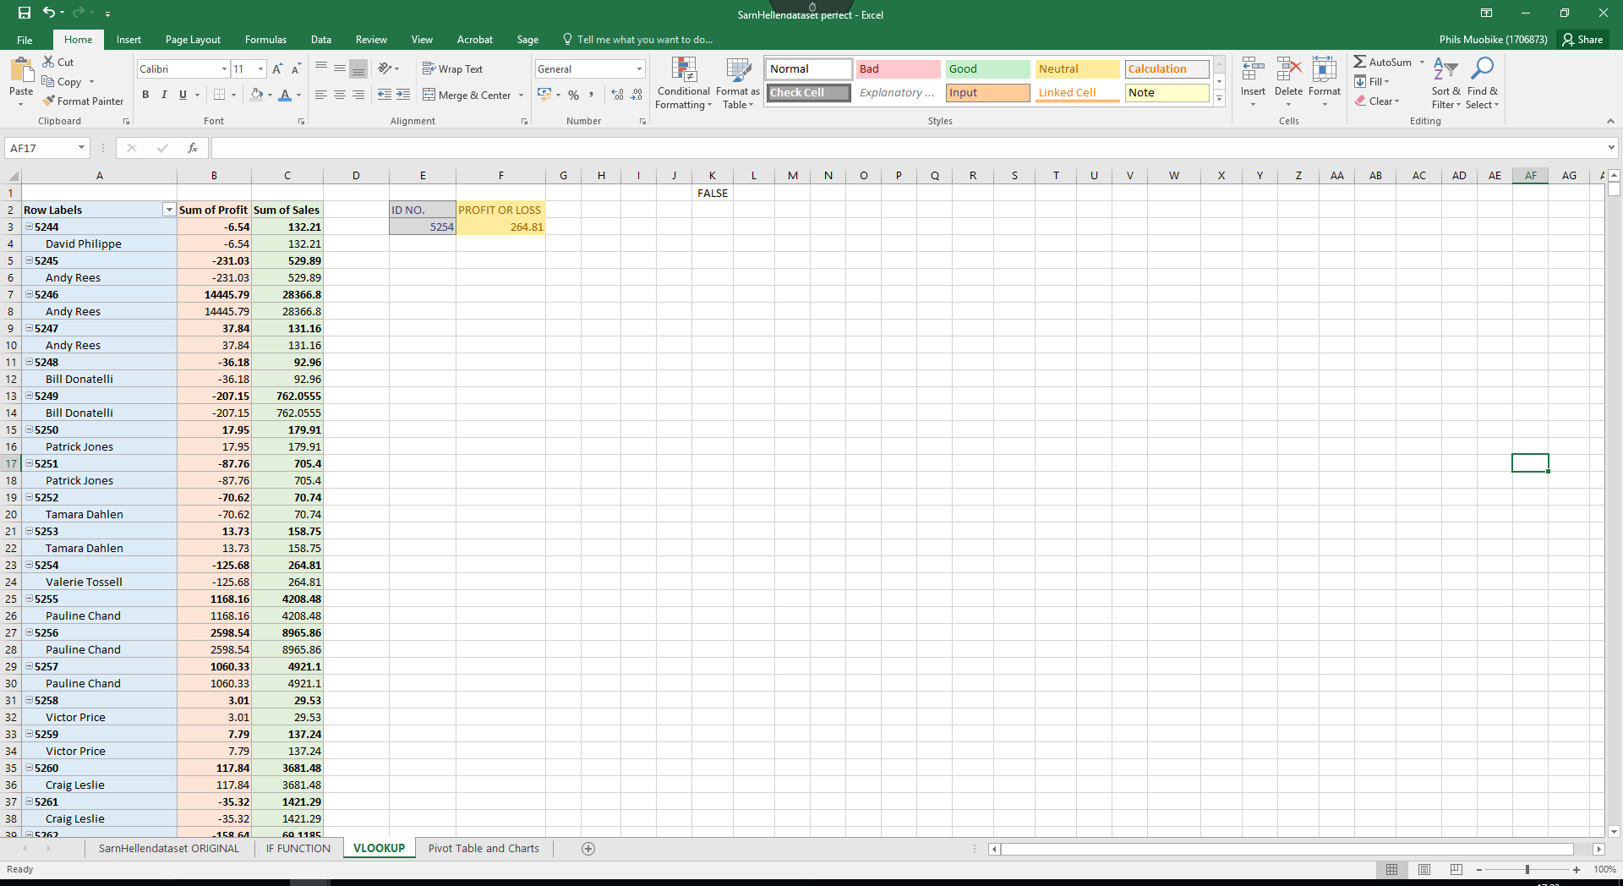
Figure 1 VLOOKUP applied to original data

2.2 IF Statement
According to Moriarty, Held and Richardson (2018), the IF statement is a useful function in Excel. It allows utilising formulas that calculate in a certain way when something is true and in another way when something is false (Smith, 2018). For example, it is possible to mark when Sarn Helen Office Supplies has profit or loss by marking “Profit” and “Loss”. If the figure is greater than 0 there is a profit, if it is less than 0 it is a loss. The IF statement examines a logical test and it gives a result if it is true or false, but in this case, it says if it is a profit or a loss. Although, in the IF statement it is possible to combine more than one condition when using the logical function such as “AND” and “OR”. The example used in the Sarn Helen Office Supplies was ‘=IF(I2>0,” Profit”,” Loss”)’, when the final result is Loss it means that there was a loss with that customer. The IF statement is the most straightforward and quick function in Excel because the formula could be reversed and have the same final result (Korol, 2016).
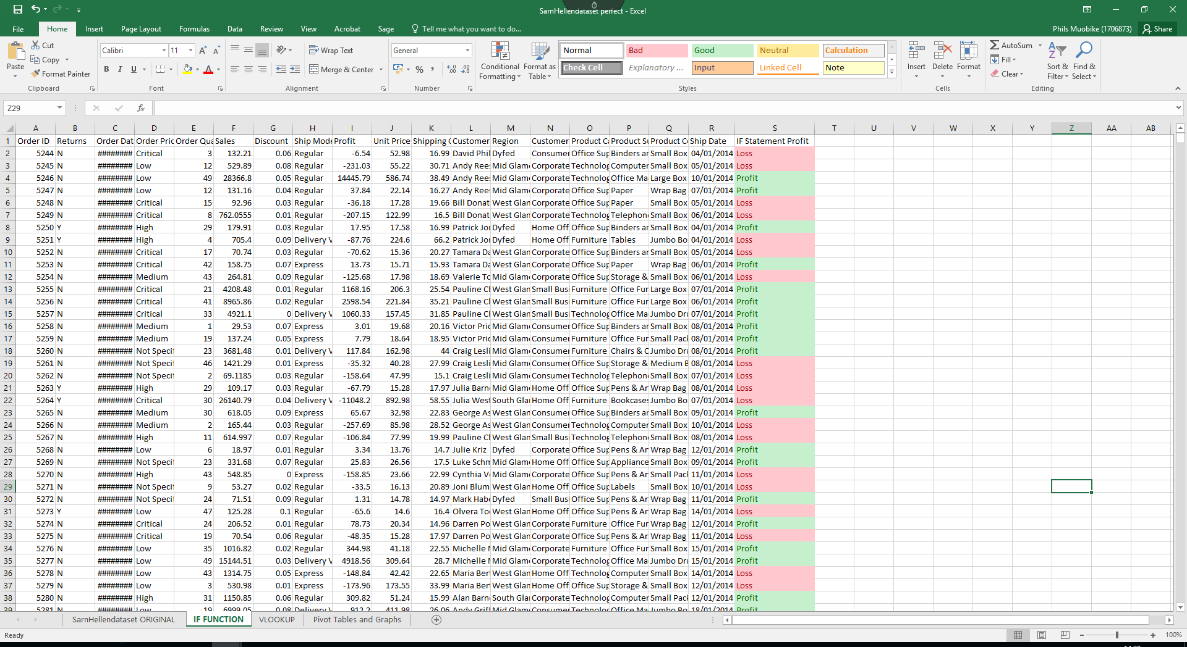
Figure 2 IF Statement applied to original data

2.3 PIVOT TABLES
Pivot Tables could help to convert a data table to an assumption table which could help the company to make a decision easily. With this function, it is possible to know how much profit was made by selling to some customers in particular regions, or to know the average number of customers that bought a particular product (Moriarty, Held and Richardson, 2018). A pivot table is convenient with larger data, because it summarises the selected rows and columns of the data in the spreadsheet (Smith, 2018). In the Excel spreadsheet below, it shows the sum of sales, discount and unit price of each item of furniture, office supplies and technology in a clear and easy way to view and understand (Korol, 2016). Pivot tables enable companies to maximise their time management and restructure the data to create a brief summary for an element or item, which is essential in order to understand the reason behind the reduction of profit in Sarn Helen Office Supplies (Jelen, 2018).
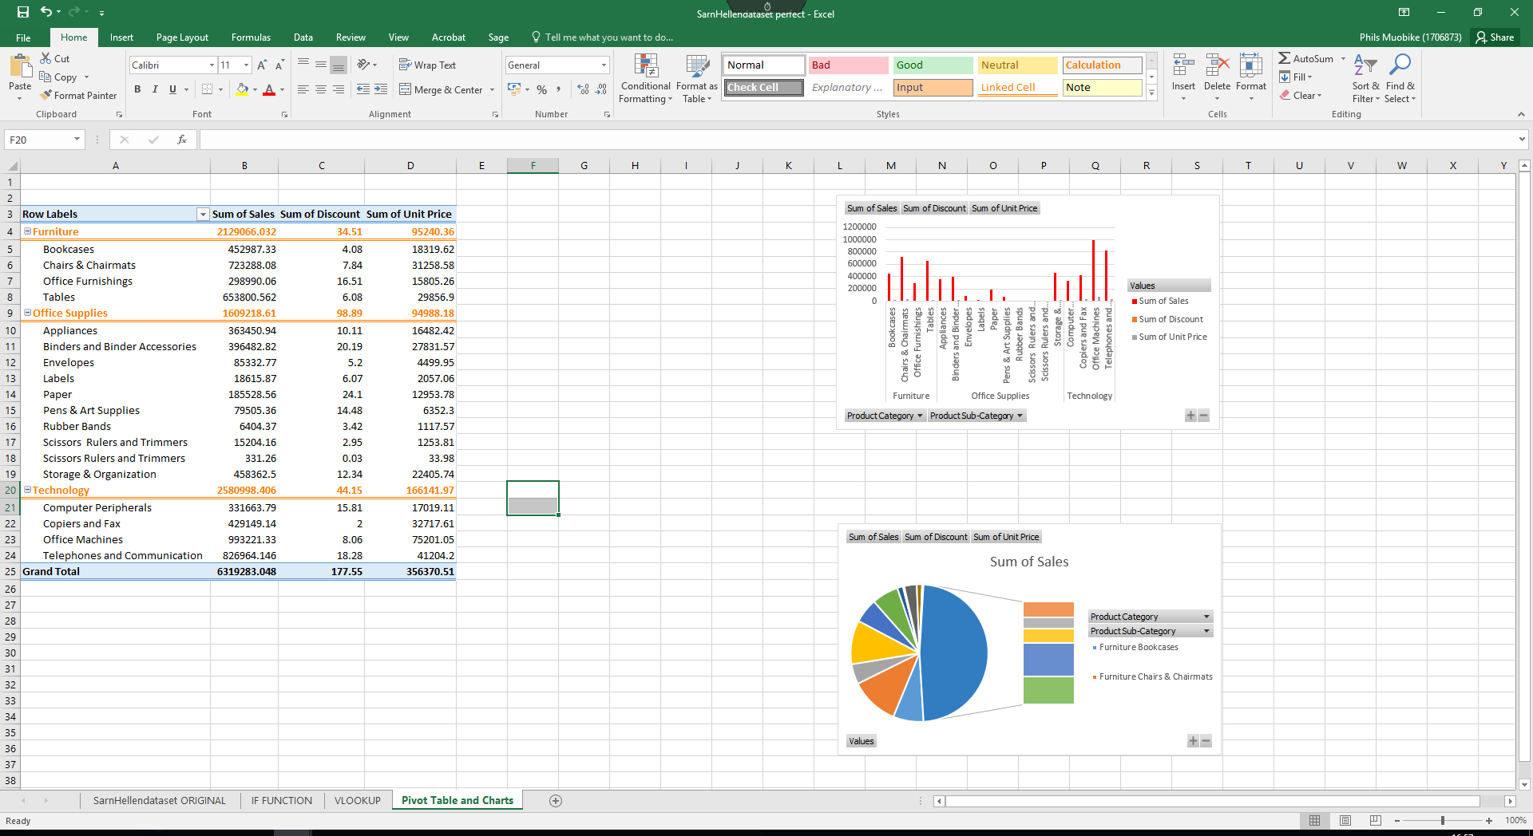
Figure 3 PIVOT TABLES applied to original data

2.4 Graphs and charts
Graphs and charts are the easiest functions in Excel because they require the selection of data that is needed to create a chart or a graph (Korol, 2016). Once the chart or graph is created, it is possible the see the data clearly and also customise them. Graphs and charts are commonly utilized for data visualisation and presentation (Smith, 2018). On the other hand, it is hard to find the right graph and chart because when an incorrect graph is used for data analysis, it could display the data in a confusing way and negatively affect the business decisions (Linoff, 2015). In the two figures below, it is essential to notice that there are two different charts where the sum of sales, the sum of the discount and the sum of the unit price are shown in a clear way (Moriarty, Held and Richardson, 2018).

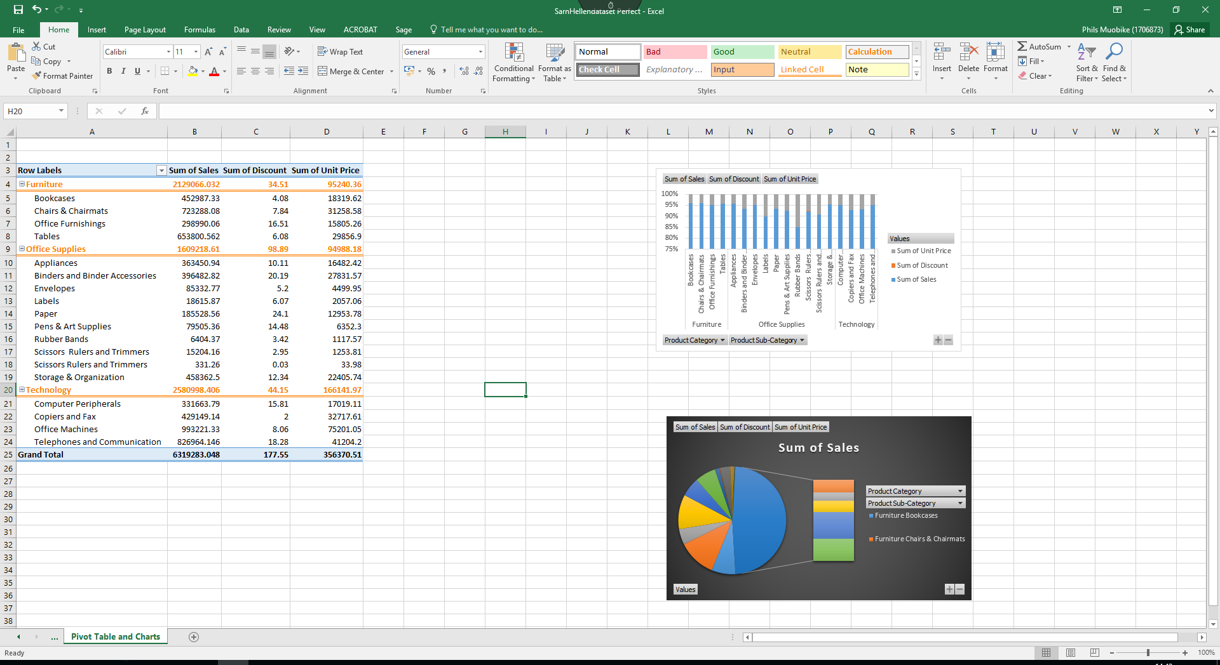
Figure 4 Graphs and charts (Column) applied to original data
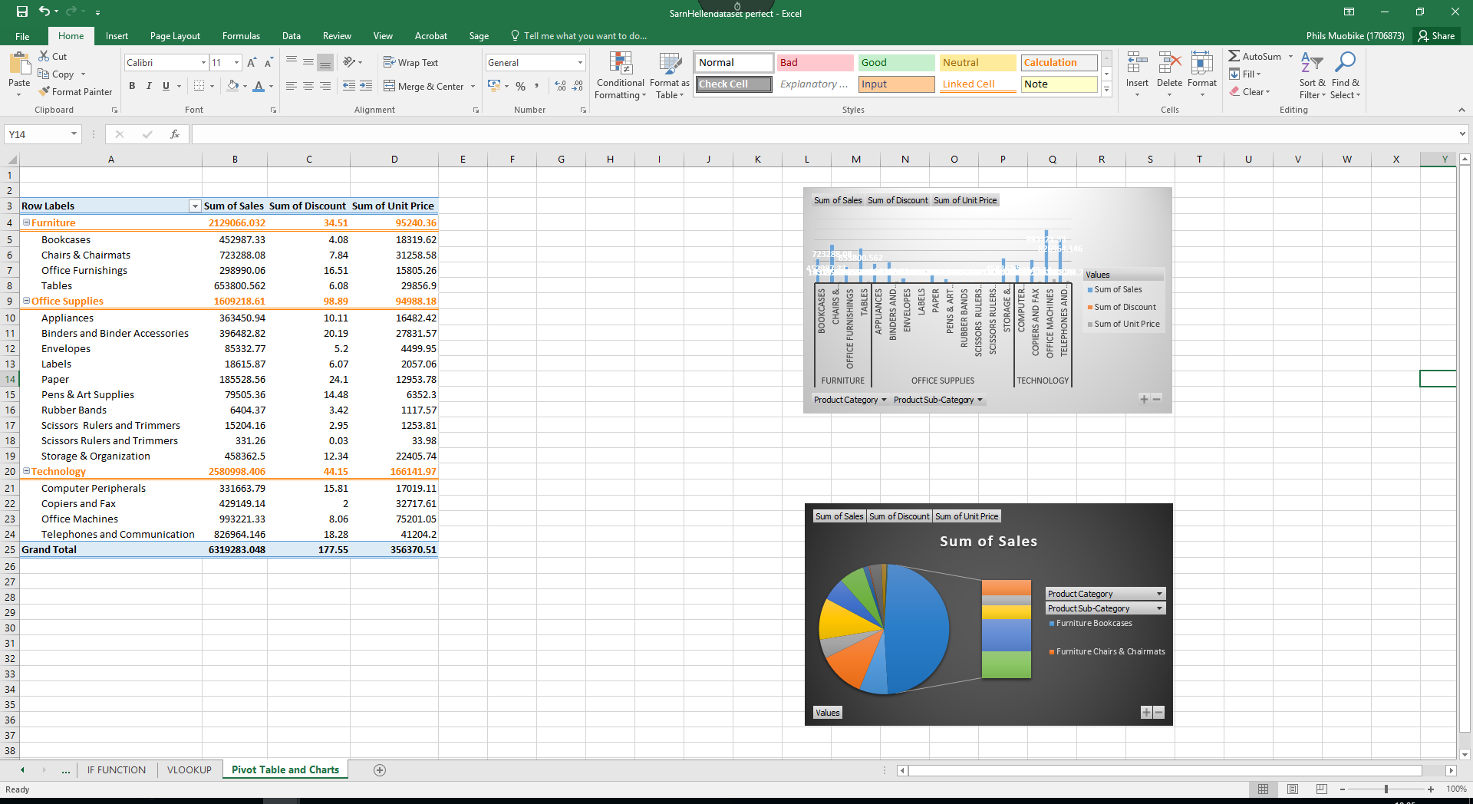
Figure 5 Graphs and charts (Pie) applied to original data

Evaluation of Microsoft Excel
Excel is a tool utilised by the company because it is cheap and easy to utilise. Although there are benefits when companies use Excel, it should be mentioned that there are various disadvantages. According to Winston (2016), Excel could be an inaccurate spreadsheet due to factors such as time-consumption when validating and monitoring data. There could be an increased chance of data errors with larger datasets, or when changing the position of the information in the spreadsheet (Mark, 2018). It could be challenging to detect the errors and correct them (particularly data with large volumes). There could be a virus or computer crash which could damage all the data saved (Linoff, 2015).
Excel could also be very complex and prevent fast data analysis making it difficult to have a general overview (Jelen, 2018). When there is a large amount of data, it can be complex to identify any relevant information. As reported by Korol (2016), over 80% of spreadsheets contain a minimum of one error. Eight out of ten spreadsheets in a company could contain some formatting or calculation errors and spelling mistakes (Forbes, 2019).
Although there are some weaknesses in Excel, it should be mentioned that there are more benefits. Excel has efficient analytical tools which enable organisations to analyse large amounts of data and summarise the data using Excel’s graphic, search, filtering and sorting system (Winston, 2016). As discussed in the previous section, Pivot tables, IF statements and other tools are helpful to analyse and find information quickly (Jackson, 2016).
With the development of smartphones and tablets, it is possible to take spreadsheets into a meeting or to a customer without using a computer (Winston, 2016). With the Excel app, people could work and share the spreadsheets synchronously with other users. According to Jackson (2016), additional benefits are that Excel is web-based so it is possible to work anywhere with an internet connection.

Weka and its functions
Waikato Environment for Knowledge Analysis (Weka) “is a collection of machine learning algorithms for data mining tasks” (The University at Waikato University, 2019). Weka is a system that can apply various algorithms to data and choose the one that gives the correct and best results. Weka is mainly utilised for data mining and includes functions for data pre-processing, clustering, association and other functions (Frank, Hall and Witten, 2016). Weka was created to allow users to have access through JAVA programs and it provides new learning methods. One limitation of Weka is the requirement, before uploading a file, to remove all apostrophes, replace all the symbols like “&” with “and” and remove random numbers or letters; another weakness could be that it has only limited error measurement and it could be difficult for the user to identify errors in the file (Rangra and Bansa, 2014).

4.1 Pre-process
Pre-processing involves the uploading data from a database (.csv and .arff), and it uses the filtering algorithm to pre-process the data. Filters are essential and are utilised to change the data and make it easier to delete unwanted attributes following specific criteria (Frank, Hall and Witten, 2016). Weka will identify the attributes and when the data are examined, there will be some fundamental statistics on the attributes. As figure 6 shows, the customer's name and profit attributes were selected to show the data clearly.
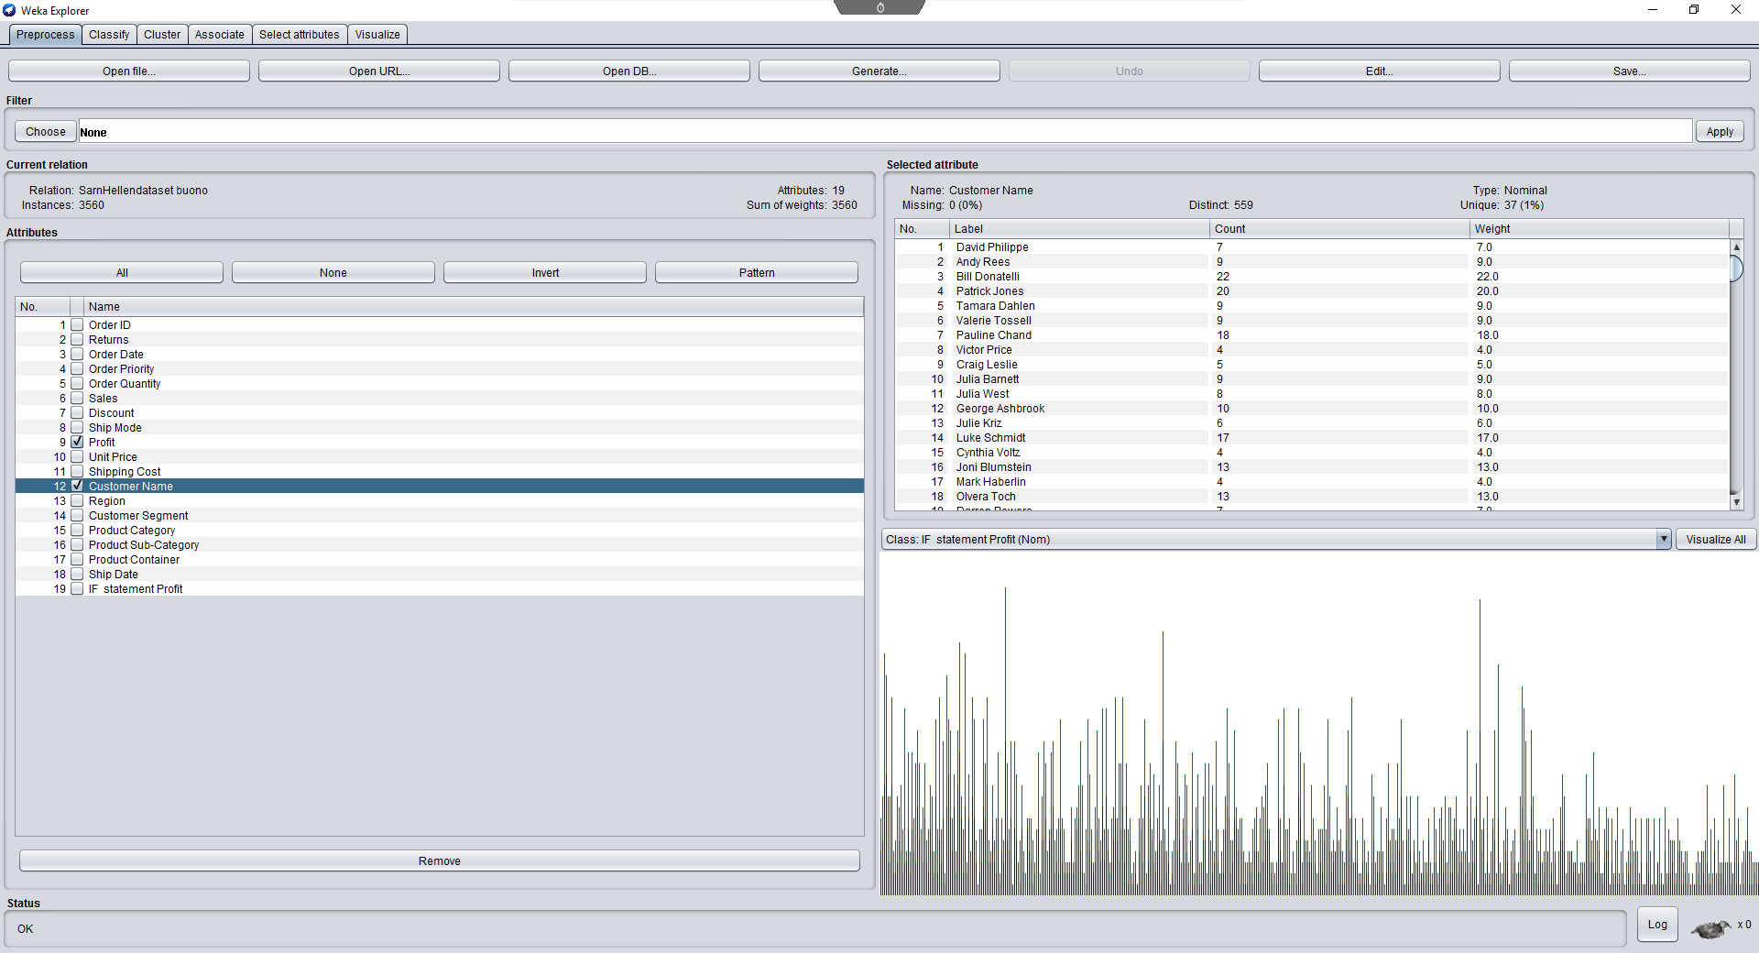
Figure 6 Pre-processing

4.2 Classify
As described by Frank, Hall and Witten (2016), Decision Tree and Linear Regression are the main learning algorithms. The Decision Tree is easy to understand, while Linear Regression is useful only when the data are linear. As an example of classification could be used in a situation when a company wants to know how likely a customer is to purchase the latest product in the company. It is necessary to create a decision tree, and the data could be mined to find out the customers who might want to buy a new product from the company (Frank, Hall and Witten, 2016). There are various elements in Sarn Helen Office Supplies such as Sales, Profit and Region. The elements on the spreadsheet could be utilised with the decision tree (J48) to find the customers that will be likely to buy a particular product. When in the spreadsheet there are only numbers, it is preferable to use the Linear Regression function because the decision tree (J48) will not be available. Figures 7 and 8, show seven attributes displayed in two different ways (Witten, Frank, Hall and Pal, 2016).
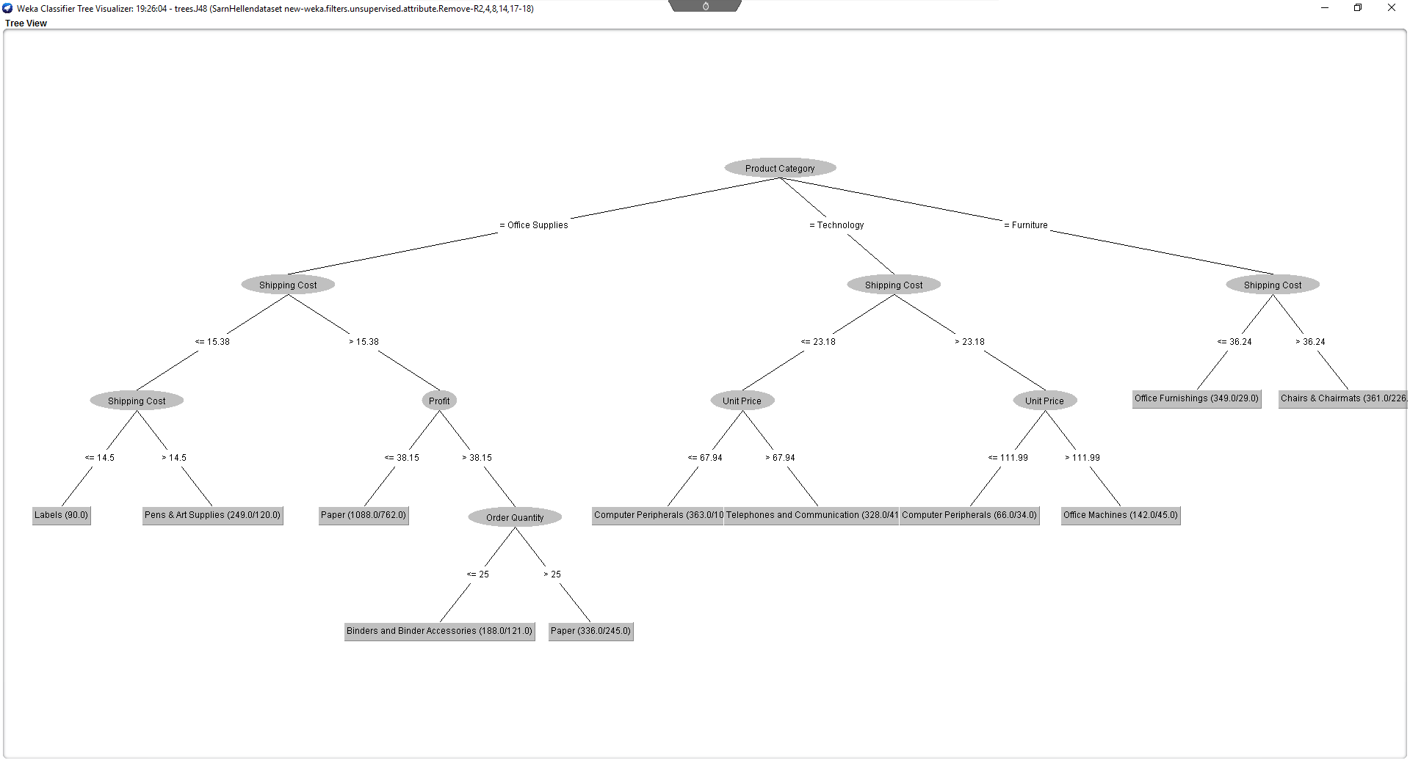
Figure 7 Classification (Decision Tree J48)

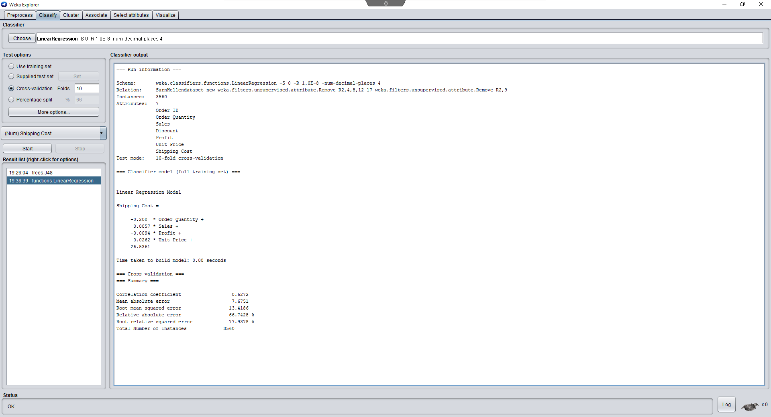
Figure 8 Classification (Linear Regression)

4.3 Cluster
If, for example, a company wants to know the age group or the gender that would like to buy a product from the company, then the data could be mined to compare and contrast the age groups and genders of the customers that bought similar products in the past, and with specific features (Smith and Frank, 2016). When the data is mined, the users could choose to cluster over the selected attributes that are needed to compare, and allows the company to easily determine the information (Han, Pei and Kamber, 2011). In the figure below, it is possible to visualise, compare and contrast the data. Applying the SimpleKMeans enables users to see the centroids of each cluster and the numbers assigned to the clusters (Mehta and Dhiman, 2017).
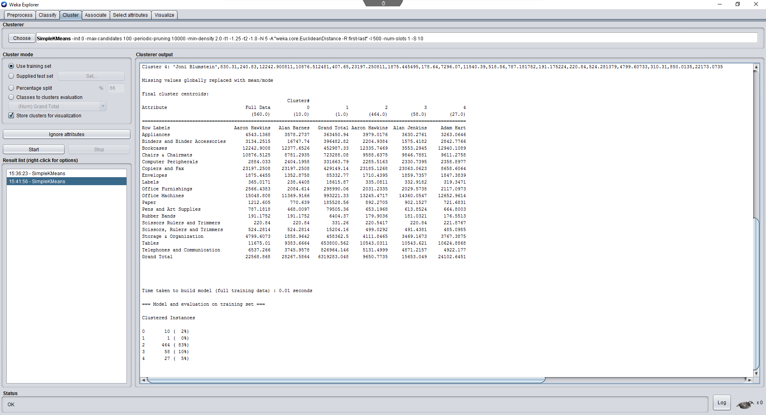
Figure 9 Clustering

4.4 Associate
Associate is a function mainly used to discover the right connection between different attributes in the database (El Tayeb, Pareek, and Araar, 2015). It is necessary to use a different algorithm to find these associations; the best-known association rule learner is Apriori. This helps to analyse the essential interrelationships between all the attributes in the data (Smith and Frank, 2016). Utilising the Apriori algorithm, various results were obtained, focused on the itemsets 12, 22 and 11. The highest item was 306 papers and the lowest was 138 computer peripherals (Rathi and Garg, 2017).
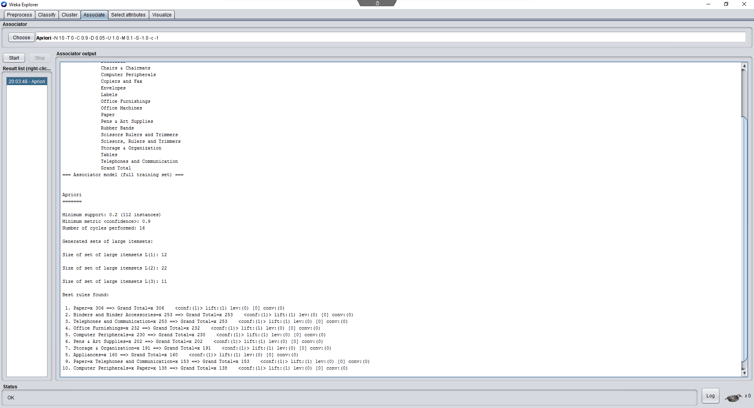
Figure 10 Association

Conclusion
It is evident that Sarn Helen Office Supplies is not fully secured financially due to the reduction of profits and the company needs to improve its decision-making strategy in order to grow their business efficiently. The main area the company should reform is the lack of frequently utilising spreadsheets which are normally utilised to analyse the data of a company and, specialised software for data mining like Weka could identify the problem of the company promptly.
It should be mentioned that these two software have some limitations that should be considered. Excel is not always 100 per cent accurate, but it still helps companies to analyse data easily. Weka is more complicated to use and Sarn Helen Office Supplies will need a data analytics assistant to interpret the data, which could be cost-intensive and time-consuming. The company could also employ or train some of their staff, so that they could mine the company’s data for the future.
At this point, the organisation does not know the reason behind its low profits and this could lead to bankruptcy. The company should, therefore, use Excel regularly to monitor the organisation’s data and identify anomalies. Thanks to Excell and Weka it is possible to identify the profitable customers and those making a loss. The company will then be able to identify the strategies needed to improve sales, such as targeting new customers or developing better products for the demands of the market.

References

El Tayeb, A.A., Pareek, V. and Araar, A., (2015). Applying association rules mining algorithms for traffic accidents in Dubai. International Journal of Soft Computing and Engineering.
Forbes (2019) What Are The Shortcomings Of Spreadsheets. Available from: https://www.forbes.com/sites/quora/2019/04/04/what-are-the-shortcomings-of-spreadsheets/#265d7fb14ee4. [Accessed: 20 April 2019]
Frank, E., Hall, M.A. and Witten, I.H., (2016). The WEKA workbench. Morgan Kaufmann.
Han, J., Pei, J. and Kamber, M., (2011). Data mining: concepts and techniques. Elsevier.
Jackson, J., (2016). Microsoft EXCEL 2016: Learn Excel Basics with Quick Examples (excel 2016, excel 2013, excel vba, Excel 2016, Excel Charts, Excel project, MS Excel, MS Excel... book, spreadsheet excel)(Volume 1).
Jelen, B., (2018). USE HELPER CELLS TO IMPROVE FORMULA SPEED. Strategic Finance, 99(7), pp.58-60.
Korol, J., (2016). Microsoft Excel 2016 Programming by Example. Stylus Publishing, LLC.
Linoff, G.S., (2015). Data analysis using SQL and Excel. John Wiley & Sons.
Mark, K., (2018). Introduction to Data Analysis Using Excel and Lab Report Writing Using LaGCC Institution Data.
Marr, B., (2016). Big data in practice: how 45 successful companies used big data analytics to deliver extraordinary results. John Wiley & Sons.
Mehta, K. and Dhiman, S., (2017). GAIT Analysis Using Weka: Guard Mobile Device. Coordinates, 4(4).
Moriarty, B., Held, B. and Richardson, T., (2018). Microsoft Excel Functions and Formulas. Stylus Publishing, LLC.
Rangra, K. and Bansal, K.L., (2014). Comparative study of data mining tools. International journal of advanced research in computer science and software engineering, 4(6).
Rathi, K. and Garg, K., (2017). EXECUTION OF ASSOCIATION RULE MINING WITH DATA GRIDS IN WEKA 3.8. International Educational Applied Scientific Research Journal, 2(5).
Smith, G.A., (2018). An Old Tool with Enduring Value: Using Excel to Prepare Data for Analysis.
Smith, T.C. and Frank, E., (2016). Introducing machine learning concepts with WEKA. In Statistical genomics (pp. 353-378). Humana Press, New York, NY.
The University at Waikato University (2019) Weka 3: Machine Learning Software in Java. Available from: https://www.cs.waikato.ac.nz/~ml/weka/index.html. [Accessed: 30 April 2019]
Turban, E., Sharda, R. and Delen, D., 2014. Business intelligence and analytics: systems for decision support. Pearson Higher Ed.
Winston, W., (2016). Microsoft Excel data analysis and business modeling. Microsoft press.
Witten, I.H., Frank, E., Hall, M.A. and Pal, C.J., (2016). Data Mining: Practical machine learning tools and techniques. Morgan Kaufmann.

