Individual Presentation & Supporting Marketing Plan

Marriott

ANA-MARIA STOICA

STUDENT ID: 2210328

The module title: MARKETING ESSENTIALS: BMIH4005

Lecture Name: LUCIANA SUARDI

Introduction
The following report will be discussing the internal external factors which impact the Multinational Hotel chain Marriott. The report will also be discussing the different marketing strategies and marketing plans of the company along with provided recommendations for digital marketing strategies.

Company SWOT analysis

Strengths | Weakness
- The company is currently present in more than 130 countries around the world which makes it one of the most dominant hotels in the world.  - It has been also found that the company receives and serves more than 44 million customers within the hotel which is really huge in number (GIRGEN, 2021). This makes the company have so many loyal customers because of the different loyalty campaigns of the company. | - Despite having so many advantages one of the weakest points of Marriott is the less security towards the protection of data and information about the customer which makes the customer a bit concerned about the company.  - Also the company is very much well known for its negative publicity.
Opportunities | Threats
- The company has a great scope in the future in terms of developing new ventures and products and services and entering the untouched industries for better growth and development.  - The company can also enter the new emerging markets for getting more exposure and popularity. | - There are many multinational hotel brands and chains which are the biggest competition of the company like Hilton, Hyaat, Intercontinental Hotel Groups PLc and so many more which can overcome the company very much easily (GIRGEN, 2021).  - The company being present in many different countries had to face the different legal problems and legal allegations which hindered the business operations of the company.
Table.1 SWOT analysis of Marriott
(Source: Created by the learner

Customers
The following analysis will be explaining the segmentation, targeting of the customers strategy of Marriott:
Segmentation: The company uses the geographic segmentation of the market as the company comes from the hospitality industry this makes the company focus on the location more than the people.
Targeting: The organisation basically targets those customers which are the luxury travellers, corporate meeting seekers, over the road travellers and many more (Shastri, 2021).

Competitors
In order to analyse the competitor of the organisation the following evaluation will be the analysis of the porter's five forces on Marriott:

Forces | Evaluation
Bargaining power of the suppliers (high) | The company uses different products and services for the suppliers in which it has been seen that the suppliers have a very strong power of suppliers as the prices of the products and services have been increasing due to various reasons (Kasi, 2022).
Bargaining power of the customers (high) | The bargaining power of the customers are also very high as the customers of the company are very much luxurious in nature and in order to make it a bit affordable people often bargain a lot.
Threats of new entrants(low) | The threat of new entrants is very low as the company is one of the leading brands and to invest the same amount of money and to have fame in the market is quite impossible (Kasi, 2022).
Threats of substitutes (moderate) | The risk of getting overlapped by the substitutes is very much less than the company and its product is different from the substitutes. This decreases the risk for the company.
Competitive rivalry in the market (High) | The company has many competitions in the market like Hilton, Hyatt, intercontinental hotels groups’ plc and many more. This shows that the company has some of the toughest competitors in the market (Kasi, 2022). .
Table.2 Porter's Five forces
(Source: Created by the learner)

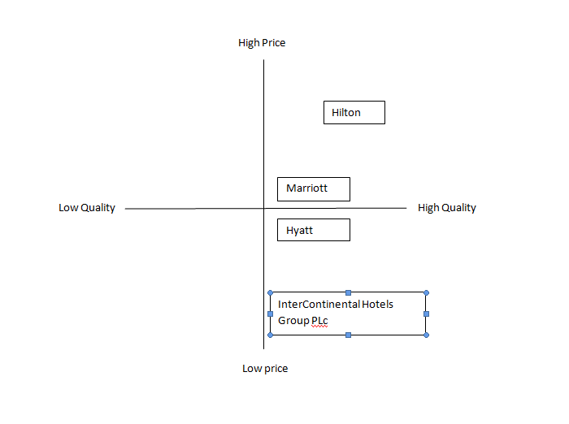
figure .1 Perceptual mapping of marriott
(Source: Created by the learner)

Collaborations
The company is very much conscious and dedicated towards the awareness programmes of the company in order to make sure that the company tries to connect to as many customers as possible. For which the company has come up with a new concept named as M live which is a social media command centre for the customers to keep tracking the activities and interests of the customers (PR Daily, 2022). The company makes sure that it follows each and every internet trends to make sure that there are communications and connections between the customers.

Climate The Marketing Environment (Macro)
The following PESTLE Analysis will helps in evaluating the external factor impacting on the growth and development of Marriott:

Factors | Impact
Political | Recently the Russia Ukraine war has impacted on the works of the organisation as after serving the country for 25 years the company has left all the operations in russia (Parker, 2020).
Economical | Since inflation has been increasing in the UK the company has been facing financial instability as the inflation rate has been increased to 9,7% from 8.7% within a span of 1 month . This makes the company very much concerned regarding the increasing tax rates and inflation in the UK(Parker, 2020).
Social | In order to be a good example marriott also provides innumerable services to the people via fundraisers, volunteerism and also via cash. For making the society a better place to live in and to make a meaningful impact.
Technological | The increasing internet penetration rate which has reached up to more than 7 billion as of 2021 will adjust in the UK by 62.86 Million (EdrawMax Online, 2022). This shows the company has many growth and development opportunities along with having the chances of meeting and attracting more new people.
Legal | There are many different legal rules and regulations which need to be followed and obeyed by the organisation while working within the different countries. In which one of the main laws Marriott has to follow are Employment Rights act of 1996 and Consumer Rights act of 2015. Along with other laws impact on the easy workings of the organisation (Parker, 2020).
Environmental | The company has to act sustainability as the company makes a lot of wastes every year. Along with that the company has to follow the environment act of 2021 as well. This make the workings of the organisation more difficult yet sustainable (EdrawMax Online, 2022).
Table.3 PESTLE analysis of Marriott
(Source: Created by the learner)

Objectives
The objective of this marketing plan is to identify the specific areas of development of marketing strategies of Marriott in order to make sure that the company can achieve it in a particular time frame and can lead to more success and development.

Strategy
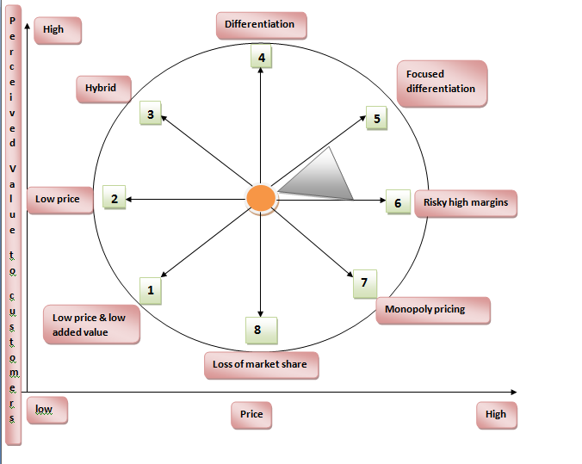
Figure.2 BOWMAN'S strategy clock
(Source: Created by the learner)

As per the above report it can be clearly seen that the company is focused on focused differentiation which is listed to provide high value product and services at high price. The company has the best luxurious services with the high prices. This helps the organisation in being different from other rivalries. On the other hand it can be seen that the company takes a lot of risk in terms of margins. This strategy is used by the company by setting the prices of the products high but without adding any kind of added value. This shows the company is mainly focused on providing the best services with a good amount of rates as well.

Conclusion
In the above report is the marketing plan of the multinational hotel company Marriott in which marketing mix of the company has been done along with the external and internal factors impacting the organisation. Which is then followed by the evaluation of the different marketing strategies which the company uses and can use in the future. The report has then suggested the company to use the digital marketing team for more effective digital marketing strategies and more customer engagement.

References
EdrawMax Online (2022). Available at: https://www.edrawmax.com/article/marriott-swot-analysis.html (Accessed: 10 November 2022).Jobber, D. and Ellis-Chadwick, F (2020), Principles and practice of marketing. 9th ed. London:
GIRGEN, M.Ü., 2021. IMPORTANCE OF MARKETING STRATEGIES FOR TOURISM COMPANIES. Research and Reviews in Social, Human and Administrative Sciences-I.
Kasi, A (2022). Available at: https://www.porteranalysis.com/porters-five-forces-of-marriott-international/ (Accessed: 19 November 2022).
Parker, B. (2020) Marriott SWOT Analysis, Business Strategy Hub. Available at: https://bstrategyhub.com/marriot-swot-analysis/ (Accessed: 10 November 2022).

PR Daily (2022). Available at: https://www.prdaily.com/awards/content-marketing-awards/2017/winners/brand-awareness/ (Accessed: 19 November 2022).
Pratap, A. (2020). Available at: https://www.notesmatic.com/marriott-international-marketing-mix/ (Accessed: 10 November 2022).
Shastri, A. (2021). Available at: https://iide.co/case-studies/marketing-strategy-marriott-international/ (Accessed: 10 November 2022).

Component B

Presentation

Introduction
The following report is a summary of the above marketing plan. The report will consist of the summary of the marketing plan which has been done for Marriott International.

Summary

The Marketing Mix
The company is very well known for its marketing strategies. The following analysis will be the marketing mix on Marriott:
Product: The company’s product is well known for quality which is served by the company and the company also serves unique products and services. The company also has a good strong portfolio under which hotels like Renaissance, Ritz-Carlton, Sheraton like companies are under the company which is well known for providing quality and luxurious services (Shastri, 2021).
Place: Marriott is present in around 139 different countries and territories around the world which clearly shows that the company is one of the biggest multinational luxurious hotel chains (Pratap, 2020). The company is present in those popular cities which have the most number of people attracted and is situated in main towns and locations.
Price: Marriott is a well known luxurious hotel brand which makes the prices of the hotel's rooms adequately expensive. Despite having so much competition in the international market the company is able to provide high quality services to the customers at a competitive high price. Like the normal room costs starts from £76 in the UK and increases as per the quality and the services of the rooms (Shastri, 2021).
Promotion: The company is very well known all over the world yet the company really focuses on the promotional activities under which the company uses social media marketing strategies, brand awareness programmes and publicity activities as well (Pratap, 2020).

Action
Activities | Start date | End date | Duration
Preparation | 1-10-2022 | 6-10-2022 | 5 days
Market research | 7-10-2022 | 24-10-2022 | 17 days
Marketing channels schedule | 25-10-2022 | 5-11-2022 | 21 days
Gathering feedbacks | 6-11-2022 | 10-11-2022 | 4 days
Table.4 Gantt Chart table
(Source: Created by the learner)
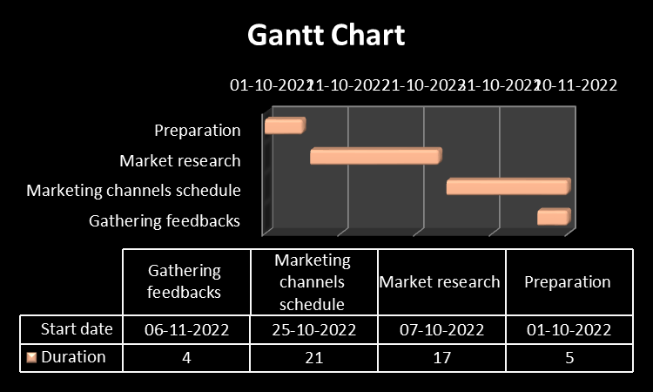
Figure.3 Gantt chart
(Source: Created by the learner)
The marketing channel schedule was the collection of the different information about the company from the different marketing channels the companies use like the websites, social media and advertisement and many more.

Control
The company can use the different channels of digital marketing in which the company can use the different digital content creators team which can do this job more effectively. The company can apply many different techniques of promoting the company via digital marketing. The company focuses on the superiority of providing luxurious offerings and services to the customers, The company focuses on delivering the services and products in different styles and ways so that the company can sustain its competitive advantage, company profile effectively within the market.

Conclusion
The above report is a summary of the marketing plan which has been made for the Marriott hotel. The summary consists of the key points which have been discussed in the marketing plan.

POWERPOINT PRESENTATION





