

Student name: Maritza Estefania Ramirez Rivera
Student ID:2022095
Module name: Introduction Physiology
Module code: BMHP5003
Lecturer name: Laila Surani
Assessment: Assessment 2 Written Report
Topic: Lymphatic system
Table of Contents

1. Introduction 3
2. Anatomy and Physiology 3
3. Health and Lifestyle routine measures 5
4. Health and Social Care practice 6
5. Recommendations 7
6. Conclusion 8
References 9

1. Introduction

In this study, a particular health condition has been taken into consideration for making a coherent analysis of its anatomy, physiology, and related aspects in a number of ways. The lymphatic system has been selected for this particular study and based upon this system an examination of its structure and functioning in the human body has been illustrated. The study has provided the opportunity to understand the relationship between the body functions and the relevant anatomy and physiology along with the manner in which the routine data collected regards it can help in making informed planning of care for individuals suffering from conditions related to this particular body system.

What is the lymphatic system?
Lymph is a colourless, watery fluid that is returned to the circulatory system through a network of tissues, veins, and organs known collectively as the lymphatic system (bloodstream).
Daily, the body's arteries, arterioles, and smaller capillaries transport around 20 litres of plasma. About 17 litres are returned to the circulation through veins after transporting nutrients to cells and tissues and collecting waste products from them. The remaining three litres make their way into the body's tissues through the capillaries. This surplus fluid, now known as lymph, is drained from the body's tissues, and transported through the lymphatic system back into the circulatory system.
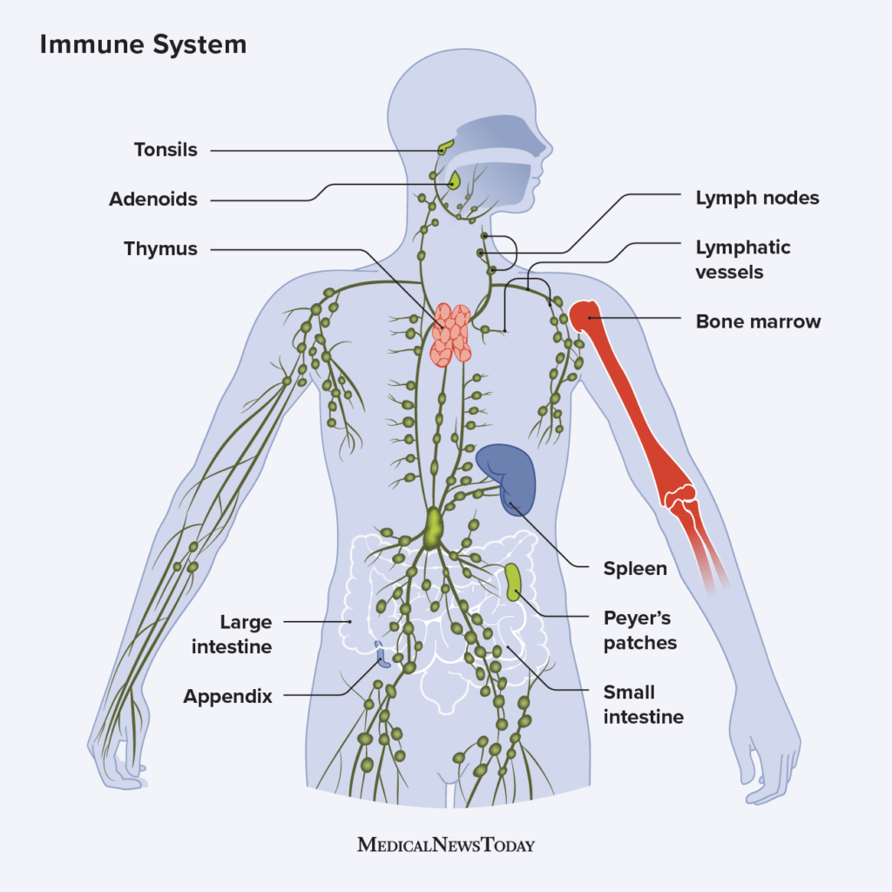
Figure 1: Immune System
Lymphatic system has many functions. Its key functions include:
- Helps keep your body hydrated
- Protects against disease and infection by using lipids absorbed from the digestive system
- helps transport lymph fluid and eliminate abnormal cells.

2. Anatomy and Physiology
The lymphatic system is correlated to the circulatory system of the human body. It is identified to be a complicated network of tissues, organs, and tubes that facilitate the circulatory system in the vertebrate body. In order to explain the anatomy of the particular lymphatic system, it is at first essential to understand the different components that developed this particular human system of the body (Da et al. 2018). Lymph node open-ended vessels, tonsils, spleen, and thymus are the major components of this particular body system. The lymphatic fluid is identified to be the extra weight that comes out from the different cells and the tissues which are together gathered in the limbic system along with the lymphocytes that eventually help in preventing any kind of infection in the body. The lymph nodes are observed to be bean-shaped and are mostly involved in cleansing the overall system in order to remove any kind of cancer or damaged cells (Cifarelli and Eichmann, 2019). The thymus as stated earlier is an essential component of the concerned system which is located behind the sternum and is also named the lymphatic and endocrine gland which secretes hormones for the effective development of the T cells. Tonsils are the fleshy part that is located on each side of the back of the neck and is usually involved in generating Lymphocytes and other antibodies for creating a defence mechanism which is named the immune system of the body. Although the spleen and bone marrow do not formulate the direct component of the lymphatic system they are found to play a vital role in the overall structure and development of the concerned system (Kataru et al. 2019).
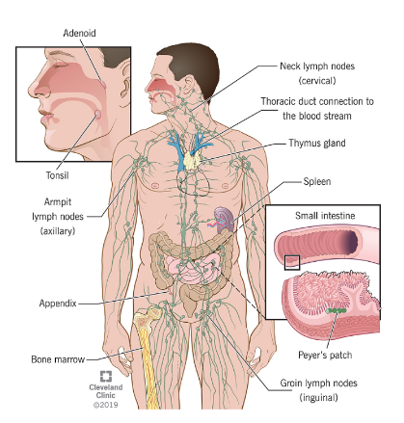
Figure 2: Anatomy of Lymphatic system
The physiology of a body system illustrates the major functions that are usually performed by an organ system in the vertebrae body (Suami and Scaglione, 2018). One of the primary functions of this particular system is that it helps the immune system and maintains the homeostasis of the body. Immunity becomes an important part of overall bodily function because it prevents the human body from a number of external and internal factors. The lymphatic system in this context has turned out to play a major role as it has the ability to protect from infectious diseases (Jiang et al. 2019). By this it has also been observed that the lymphatic system also maintains a fluid balance and is contributing to the fat absorption process as well. With the physiological functions of this particular system, the extensive network of lymph vessels is known to allow a movement of the fluid called limb which circulates through the body in a similar way as the blood and acts as the drainage system. One of the key characteristic functions of the lymphatic system is that it acts as the one-way drainage system for transporting fluid from one tissue to the blood circulation system. Following this, getting rid of the waste material of the body is also an important physiological aspect of the lymphatic system (Shin et al. 2019).

3. Health and Lifestyle routine measures
There are some health and lifestyle measures that are usually adopted by the health and social care professionals of the UK in order to gather information about the bodily function of the lymphatic system of individuals. These factors have been identified to be involved in the daily life activities of the concerned individual and are correlated to the concerned body system of the individual in a significant manner (Moore et al. 2018). By the inclusion of such measuring techniques by the HSC practitioner, precise knowledge in regard to the current conditions of the system could be acquired especially in terms of its physiology.
Physical activity
Just like every other body system of the human being, physical activity has always been identified to play a key role in their effective functioning. The lymphatic system was no less dependent on the physical activity of the concerned individuals. The kind and level of physical activity involved in the individuals is a health and lifestyle measure that is gathered by the HSC practitioners to get detailed information about the lymphatic system. If an individual is found to be having no physical activity involved in their daily health and Lifestyle factors it is usually observed that there is an accumulation of toxins reducing the functions of the cells and potentially leading to the development of an environment in which infectious complications are at risk. This is because the lack of physical activity creates blockages and swelling of the lymph nodes and constriction in the flow of lymphatic fluids (Antoniak et al. 2021).
Diet
Another health and Lifestyle measure that is usually considered by health care professionals in the UK in order to assess the lymphatic system of an individual is the diet factor. Diet is something that is significantly correlated with the healthy functioning of any body system and is there for healthcare professionals. It has been observed that the concerned professionals look into the matter of what kind of diet is being undertaken by the content individual because there are some foods that are rich in toxins Which eventually affect the lymphatic system. In addition to this if an individual undertakes too much-processed food and food with high oil and sugar content then also it has been observed that a slower rate of function is found to be in concern to the lymphatic system (Patil et al. 2021).
Stress level
In today's competitive and fast-moving Lifestyle Stress is identified to play a contributing role in providing significant information to health care professionals in order to understand the functioning of the lymphatic system and other body systems as well. HSC professionals in the UK undertake stress and health and lifestyle masters for gaining knowledge about the lymphatic system because it disrupts the body environment and homeostasis on a large scale. large scale. For the effective functioning of the lymphatic system, it is important that an alkaline environment is developed however when there is increased breast undertaken by the concerned individual which is a stress hormone is released resulting in the development of an acidic environment which breaks down the lymphoid tissue and reduces the overall protectiveness towards antibodies and promotes fat gain (Norden and Kume, 2020).
Intake of water
As the lymphatic system is made of 96% water therefore the health care professionals of the UK undertake the intake of water as an important health and Lifestyle daily routine measure which could provide information regarding the functioning of the lymphatic system. Individuals that have a low intake of water and are suffering from dehydration are usually found to be suffering from lymphatic system-related health conditions because this slows down the waste removal process from the body contributing to sedentary behaviour (Woods, 2019).

4. Health and Social Care practice
The health and social care professionals in the nation of the UK have undertaken significant practices and campaigns in order to help individuals improve their lymphatic systems and also utilise the information gathered from these practices to improve the care planning of the concerned people suffering from a particular condition of the lymphatic system. A discussion of some of those practices is as follows
British Lymphology Society Everybody Can campaign
The particular UK Association is identified to be a dynamic and innovative body of Data providing a strong professional voice and support for those who need care in regard to the conditions related to the lymphatic system. This particular Association of UK undertook the initiative of helping Health Care practitioners around the concerned nation to give people that are at risk of developing lymphatic system-related disorders the encouragement towards the need of staying active (Reddy and van der, 2020). Their intuition was named the EveryBodyCan campaign which utilises the routine health lifestyle factors of physical activity in order to have basic well informed care for the lymphatic system. In the particular campaign, a number of activities were involved which were targeted at both the general public of the UK as well as the health-care professionals. The association has developed resources for the health care practitioner so that they have immense knowledge about the lymphatic disorder from which the patient is suffering. These resources usually included factsheet recent updates as well as newsletters in relation to the lymphatic system and its related conditions which could turn out to be an effective way of gathering the health and lifestyle data for developing and informing their planning for the patient suffering from this particular issue. Followed by this keeping physical activity as one of the major lifestyles and health factors for the improvement of the lymphatic system the everybody can campaign provided the general public of the UK as well as a patient suffering from lymphatic disorders opportunity to understand the different ways in which they can get their life involved into small physical activities which could positive Movement in their daily life and improve their conditions of the lymphatic system by using both large and small muscles of the body
NHS guidelines to boost the functioning of the lymphatic system
The NHS UK has also included significant intervention strategies that included a prominent development of guidelines for boosting the functioning of the lymphatic system. Under this particular guideline, the NHS was found to be providing Healthcare professionals with a significant approach that they could undertake by providing patient information for improving the conditions of the lymphatic system and making it healthy (Ren et al. 2021). For having a well-informed care planning service developed in accordance with the daily routine health and Lifestyle factors the NHS UK guidelines were developed in such a manner that provided a distinct knowledge to the patients regarding the manner in which they could undertake significant steps for having separate the diverse factors that could make them a patient of lymphatic system disorders thesis guidelines involved into information rejected to above stated health and lifestyle factors that were taken as measured by the HSC professionals to gather data about the lymphatic system.

5. Recommendations
For the people who are living with the conditions of related disorders in relation to the lymphatic system in the UK, there are some recommendations that would be followed by them in order to improve their health conditions. The recommendations are as follows:
- Improvement in the diet is an important factor that should be considered by people living with lymphatic system disorders. It is recommended to the people that they incorporate into their daily habits foods and diet that would improve their lymphatic conditions. such as they need to eat beans, pulses, and fish every week in two portions (Vercruyce, 2020).
- It is also necessary to avoid oily foods as well as utilising of saturated oils and spread their eating habits
- People living with this condition could choose to keep themselves hydrated by drinking 6 to 8 cups of fluid a day whether it is Milk or water the best drink they can have
- In addition to this, it is also necessary for them to involve in some physical activities that could help them to move their large and small muscles and keep them moving which could eventually reduce their blockages in the lymphatic system and improve their conditions effectively (Trincot et al. 2019)

6. Conclusion
In drawing conclusions from the above-stated study it could be determined that the lymphatic system is one of the primary body systems which is usually not considered to be vital among the general public as a whole due to the lack of health education towards it. In addition to this, the kind of exposure and awareness of other systems of the body such as the circulatory system has obtained the lymphatic system is found to be avoided which has eventually made people in the UK to be suffering from lymphatic system disorders to some scale. With the execution of this knowledge about the Anatomy and Physiology of the lymphatic system could be acquired and the manner in which HSC professionals in the UK could undertake different lifestyle and health measures to improve care planning towards it can be known.

References
Da Mesquita, S., Fu, Z. and Kipnis, J., 2018. The meningeal lymphatic system: a new player in neurophysiology. Neuron, 100(2), pp.375-388.
Cifarelli, V. and Eichmann, A., 2019. The intestinal lymphatic system: functions and metabolic implications. Cellular and molecular gastroenterology and hepatology, 7(3), pp.503-513.
Kataru, R.P., Baik, J.E., Park, H.J., Wiser, I., Rehal, S., Shin, J.Y. and Mehrara, B.J., 2019. Regulation of immune function by the lymphatic system in lymphedema. Frontiers in immunology, 10, p.470.
Suami, H. and Scaglioni, M.F., 2018, February. Anatomy of the lymphatic system and the lymphosome concept with reference to lymphedema. In Seminars in plastic surgery (Vol. 32, No. 01, pp. 005-011). Thieme Medical Publishers.
Jiang, X., Tian, W., Nicolls, M.R. and Rockson, S.G., 2019. The lymphatic system in obesity, insulin resistance, and cardiovascular diseases. Frontiers in Physiology, 10, p.1402.
Shin, M., Nozaki, T., Idrizi, F., Isogai, S., Ogasawara, K., Ishida, K., Yuge, S., Roscoe, B., Wolfe, S.A., Fukuhara, S. and Mochizuki, N., 2019. Valves are a conserved feature of the zebrafish lymphatic system. Developmental cell, 51(3), pp.374-386.
Moore Jr, J.E. and Bertram, C.D., 2018. Lymphatic system flows. Annual review of fluid mechanics, 50, p.459.
Antoniak, K., Hansdorfer-Korzon, R., Mrugacz, M. and Zorena, K., 2021. Adipose Tissue and Biological Factors. Possible Link between Lymphatic System Dysfunction and Obesity. Metabolites, 11(9), p.617.
Patil, A.P., Patil, T.M., Shinde, A.R., Vakhariya, R.R., Mohite, S.K. and Magdum, C.S., 2021. Nutrition, Lifestyle & Immunity: Maintaining Optimal Immune Function & Boost Our Immunity. Asian Journal of Pharmaceutical Research and Development, 9(3), pp.129-136.
Norden, P.R. and Kume, T., 2020. The role of lymphatic vascular function in metabolic disorders. Frontiers in Physiology, 11, p.404.
Woods, M., 2019. Risk factors for the development of oedema and lymphoedema. British Journal of Nursing, 28(4), pp.219-222.
Reddy, O.C. and van der Werf, Y.D., 2020. The sleeping brain: harnessing the power of the glymphatic system through lifestyle choices. Brain Sciences, 10(11), p.868.
Ren, M.H., Qi, X.S., Chu, Y.N., Yu, Y.N., Chen, Y.Q., Zhang, P., Mao, T. and Tian, Z.B., 2021. Risk of lymph node metastasis and feasibility of endoscopic treatment in ulcerative early gastric cancer. Annals of Surgical Oncology, 28(4), pp.2407-2417.
Vercruyce, M., 2020. THE BIOMECHANICAL PROPERTIES OF THE LYMPHATIC SYSTEM AND THE CHANGES IN LYMPHEDEMA (Doctoral dissertation, Ghent University).
Trincot, C.E. and Caron, K.M., 2019. Lymphatic function and dysfunction in the context of sex differences. ACS Pharmacology & Translational Science, 2(5), pp.311-324.

