

M6X02255
Mental health and the ageing population

Design an intervention to help an elderly person or their family deal with Dementia (1500 words).
The proposal form will be marked in line with the Level Six Grading Rubric. The boxes below will expand as you type.

Suggested intervention title: (between 10-15 words and must reflect the essence of your proposed intervention, study design and study population and should be more specific than a broad topic area).
Carers looking after people with mild to moderate dementia, how do pets help?

Please state the aim and rationale of your intervention: (why is your intervention important?, how will it improve the lives of those who take part in the intervention?)

My intervention will be looking at how pets help a carer look after a person with the early stages of dementia. The aim of the intervention is important as it will help to relieve stress for the carer and for the person with dementia, it will help conquer loneliness which is one of the triggers for dementia. Plus, giving the elderly person something to do, such as a structured daily routine in looking after the pet, will help to slow down the onset of dementia by keeping their brains active.
The rationale of the intervention is the fact that a pet needs a person to look after it, it gives the person with depression, loneliness, or dementia a reason to get up in the morning and is also much-needed company for the person and the carer. The pet is someone to talk to and gives unconditional love which is felt and appreciated and returned by the person with dementia. The pet gives the person relying on it the companionship they so desire. The pet will help the carer by giving the person with dementia responsibility and an interest which will alleviate some of the demands on the carers.

What theory and empirical research evidence supports your intervention? (Please provide a brief review of relevant psychological literature and theory and a minimum of six references – refs not part of the word count).
Approx. 500 words
The Alzheimer’s Society state that a person with dementia can find that caring for a pet is a great stress reliever and that the animal is a great source of support. The person living with dementia will also benefit from the companionship and friendship that occurs when living with an animal plus caring for the animal on a daily basis. The animal helps the person with dementia, have that sense of responsibility, that reason for getting up, and sticking to the animal’s routine helps enormously. There are suggestions that animals can communicate better with people with dementia because they rely on body language rather than speech to communicate. Having an animal to care for can improve self-esteem and build up confidence in people with dementia. Animals can give the person with dementia a quality of life and encourage independence. Animals can also be a source of love and laughter for the person suffering from dementia. As long as the person with dementia can meet the animal’s needs and has the mental capacity to decide if they want a pet, there is no reason that they cannot have a companion in the form of an animal.
The World health organisation (WHO) in 2017 stated that 5 to 8 per 100 people worldwide were suffering from dementia, that’s around 50 million people globally. It is estimated that that number will rise by 10 million per year. The expectation of the total global population with dementia will be 82 million by the year 2030 and 152 million by the year 2050 (WHO, 2017). Most of the population with dementia is expected to be from low to middle-income countries (WHO, 2015). Dementia is going to be a major cause of disability and dependency among the older population. The calculated cost is around 820 billion united states dollars (Prince et al., 2015). The idea of pet therapy intervention is to improve the physical as well as the social, emotional, and cognitive functions. The most common animals used are cats and dogs, these provide a way of reducing boredom and the sense of loneliness, they provide pleasure, and relaxation and can promote motivation which benefits the person with dementia (Edwards & Beck, 2002). It was discovered that the person with dementia had increased muscle strength, a better range of movements, improved pain toleration, reduced blood pressure and heart rate, an increase in self-esteem and reduce depression from looking after a pet. They also had an increase in appetite once they had an animal to look after (Travers, 2013).

The NHS Wales Site called Health in Wales (2006) states the current amount of population in Wales with dementia stands at approximately 42,000. Dementia usually affects 1 in 20 over the age of 65 and 1 in 5 over the age of 80.
The Older People Commissioner for Wales states that approximately 45,000 people in Wales are living with dementia and that number was expected to increase to 55,000 by 2021. Most of these people are older, with early onset dementia, under the age of 65, being rare. By 2055 they are estimating this number will reach 100,000.
The Strategy for Older People in Wales (2013-2023) as set out by the Welsh Government states that older people in Wales have the right to be able to participate as fully in society as they desire, whether that means contributing to the community and family life, having a say in all decisions and having their needs met.
The National Service Framework says old age is often associated with negative views of decline, being vulnerable, dependency and frailty. This, however, is not always the case many older people go on to have a rich full life, taking up new activities, and keeping fit and healthy. Older people should be encouraged to have healthy, active, and meaningful lives as they should have a quality of life, be independent and have individual choices. Older people in Wales have contributed to the development of the NSF. The aim is to guide the elderly through the next stage of their lives and make services available and responsive to their needs.

Methodological Details
The method will be a qualitative study, which will involve participants aged 65 and over who have mild to moderate dementia, and half must own or have daily access to an animal. A questionnaire will need to be filled in about their feelings about certain tasks they will be asked to complete, such as making and receiving phone calls, going for a short walk, going to the shops, socialising, spending time grooming the animal, feeding the animal.

Please describe the anticipated design of your intervention (e.g., exercise programme, cognitive tasks, pet-therapy)

The design for this study is pet therapy. Pets are great company for an elderly person or any person, they give unconditional love and do not expect anything in return. The idea is that pets help give a structured day to people with mild to moderate dementia. The dog will need feeding twice a day plus a small walk, if possible, if not most small dogs are happy with a spin around the garden. The elderly person would have to be capable of remembering the dog's daily schedule, which would help slow the decline of cognitive progress. If the dog was fed 3 small meals a day, this in turn would remind the person with dementia that they need to eat after they have fed the dog.

Participant group – including anticipated numbers, target population, and any specific inclusion/exclusion criteria:

The study will need people over the age of 65, with mild to moderate dementia, who are still capable of looking after a pet. The study would require around 40 people who meet the above criteria. 20 of whom have pets and 20 who do not own a pet. They would be asked to fill in a questionnaire on how they feel in their daily lives whilst undertaking specific tasks. E.g., going for a short walk, going to the shops,

Materials/measures (dog, cognitive tasks):
Questionnaire
Pens
A quiet room in the university
Table and chairs
Consent form
Debrief if required

Please describe the study procedure (what will your participant have to do from start to finish? It should be clear from this how you are actually planning to carry out your intervention, and what will happen to participants – how long is the intervention?):
An advert would be placed in the local paper requesting the older generation to partake in the study. They must have low to moderate dementia and a pet. Half need a pet, half do not.
The participants would have to sign a consent form to take part in the study. The study would be explained to the participants and the fact that they can withdraw from the study at any time will be explained. No reason is required. If they decide to remove themselves from the study.
The participant would fill in a questionnaire asking them questions about how they feel throughout the day,
at certain times of the day, after achieving certain tasks. E.g., going for a short walk, going to the shops.

Ethics: Describe the main ethical issues of your intervention and explain how you will address them here (Refer to the BPS ethical guidelines and address all issues not just informed consent)

Carers would be welcome to accompany the person with dementia.
All people attending the study will be treated with respect, competence, responsibility and integrity.
All data will be kept securely in the university.
The age of the person taking part would be the only data needed.
No names or personal information is required.

Please describe how you will measure the effectiveness of your intervention. the data you will obtain and how it will be analysed (e.g., tests, questionnaires, interviews; stats tests, qualitative analysis)

The data collected will show that having a pet to look after is a great way of slowing down cognitive decline in people with mild to moderate dementia. The data will be collected via a questionnaire.

Appendix (not included as part of the 1,500 words but must still be completed)
- Attach any questionnaires/materials to the end of this proposal as an appendix.

References

Edwards, N.E., Beck, A.M. (2002). Animal-assisted therapy and nutrition in Alzheimer’s disease. Western Journal of Nursing Research. 2002;24(6):697-712. Doi: 10.1177/019394502320555430
Prince, M., Wimo, A., Guerchet, M., Ali, G.C., Wu, Y., Prina, M. (2015) World Alzheimer Report 2015. The global impact of dementia: an analysis of prevalence, incidence, cost and trends. www.alz.co.uk/research/world-report-2015. London: Alzheimer’s Disease International
Travers, C., perkins, J., Rand, J., Barlett, H., Morton, J. (2013). An evaluation of dog-assisted therapy for residents of aged care facilities with dementia. Anthrozoos 2013;26(2):213-25. Doi:10.2752/175303713X13636846944169
World Health Organisation. (WHO). (2017)

Questionnaire

- How old are you?

- How do you feel when you get up in the morning?

- Do you like to go for a walk?

- If you had a dog, would you enjoy your walk more?

- Would you be happy to pick up poo after a dog?

- Could you go to the shops on your own?

- Could you go to the shops with a dog?

- Are you comfortable on your own?

- Would you feel more comfortable on your own if you had a dog?

- Do you feel safe living alone?

- Would you feel safer living alone if you had a dog?

Mental Health and the Ageing Population
As a Carer, you do have rights according to the Social Services and Well-being (Wales) Act 2014. Carer Aware is a joint organisation, between Carers Trust Wales and Carers Wales, who work together with social care, and health professionals to help unpaid carers. The objective is to raise awareness of the rights of unpaid carers as stated in the Social Services and Well-Being Act in Wales (2014). This Act gives unpaid carers rights of their own, this includes using the pre-existing good practice already in existence in Wales and supporting unpaid carers to be involved in any changes. The unpaid carer will be kept informed of any new training information available and will be given support for their understanding of the systems and will be encouraged to work with the professionals to improve the outcome for the patient and themselves.

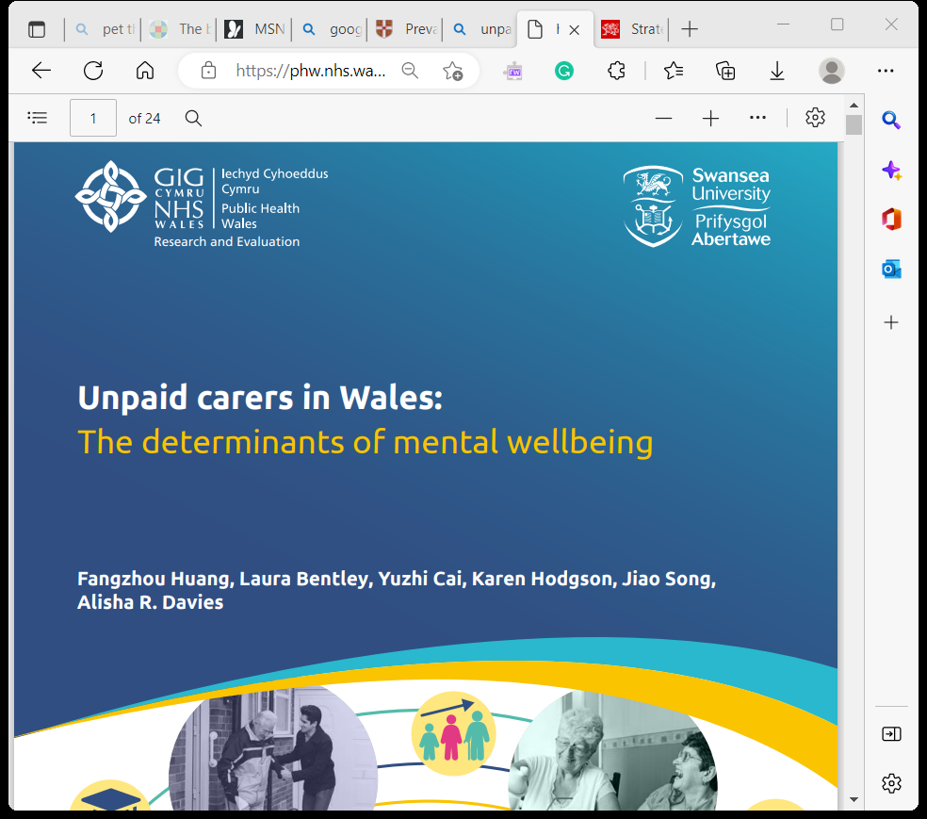

Caring for a person usually comes down to a family member, who looks after someone who is ill, older, or has a disability, mental health issue or an addiction problem, it is usually unpaid work. It usually involves all types of care from physical to emotional and financial help, keeping the house clean, doing the washing, cooking, and taking care of all the person’s personal needs and taking care of any medication that they need to take for their condition. Being a carer for somebody is a full-time job on its own.
Anyone under the age of eighteen is classed as a young carer. From the age of eighteen to twenty-five, they are classed as young adult carers. Young adult carers may be in further education or starting work, they may well have had to put their plans on hold to care for their relatives. Young adult carers have the same rights as adult carers but may need extra support due to their age.
Although, The Older People Commissioner for Wales states that approximately 45,000 people in Wales are living with dementia and that number was expected to increase to 55,000 by 2021. Most of these people are older, with early onset dementia, under the age of 65, being rare. By 2055 they are estimating that the number of people with dementia will reach 100,000.
The Strategy for Older People in Wales (2013-2023) as set out by the Welsh Government states that older people in Wales have the right to be able to participate as fully in society as they desire, whether that means contributing to the community and family life, having a say in all decisions and having their needs met.
The National Service Framework says old age is often associated with negative views of decline, being vulnerable, dependency and frailty. This, however, is not always the case, many older people go on to have rich full lives, taking up new activities, and keeping fit and healthy. Older people should be encouraged to have healthy, active, and meaningful lives as they should have a quality of life, be independent and have individual choices. Older people in Wales have contributed to the development of the NSF. The aim is to guide the elderly through the next stage of their lives and make services available and responsive to their needs.
A study in 2007, revealed that depression is also prevalent in old age. Depression in women (10.4%) was higher than in men (6.5%), this was found to be due to functional disability, co-morbid medical disorders and social deprivation. The prevalence of depression in the elderly is high, this could be caused mostly by functional disability.

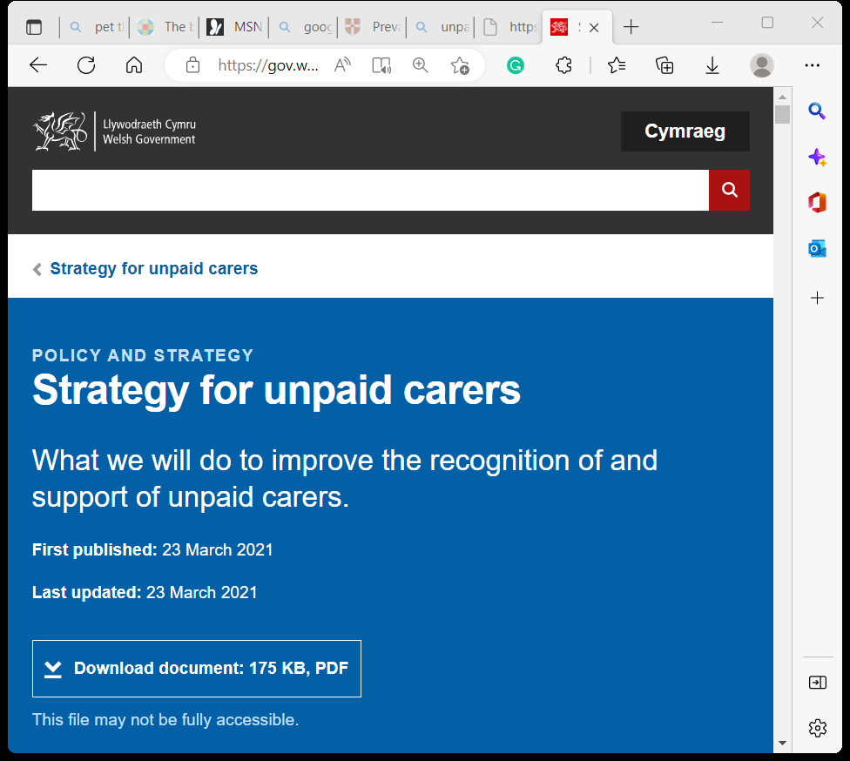

Behavioural and psychological problems affect almost all people with dementia at some stage during cognitive decline. (Guzman-Castillo et al., 2017). Behavioural and psychological symptoms of dementia (BPSD) can result in hospitalisation, an increase in medication and a decrease in quality of life for caregivers and patients (Carers Wales, 2019).
The number of unpaid carers in Wales stands at 400,00, in the year 2019. This was stated in NHS in Wales, and unpaid carers in Wales (Huang et al., 2021). This number is expected to rise to over half a million by 2037 (Carers Wales, 2019) studies have shown that most carers for relatives are unpaid. Understanding the health and well-being of the carers themselves is very important to ensure support is in place so they can maintain their own health and mental well-being. Providing unpaid care can cause a strain on the carer causing ill health, and a poor quality of life, and affects education outcomes and employment potential (Verbakel et al., 2014., Brenna & Di Novi, 2016., Abraham-Cottagiri & Sykes, 2019). The duration of care plus the intensity of care provided can worsen these outcomes (Kelly & Kenny, 2018., Diminic et al., 2019., Euro Carers, 2017). Whereas if a carer has a high level of mental well-being, they are more able to cope with any problems. (Pressman & Cohen, 2005., Chida & Steptoe, 2008., Campion et al., 2012). Although the need for supporting the unpaid carer’s health and mental well-being is known, less is known and understood of the relationship between caring intensity, socioeconomic status and mental well-being. understanding these factors and how it differs across socio-economic groups would help to better target support to the correct areas.

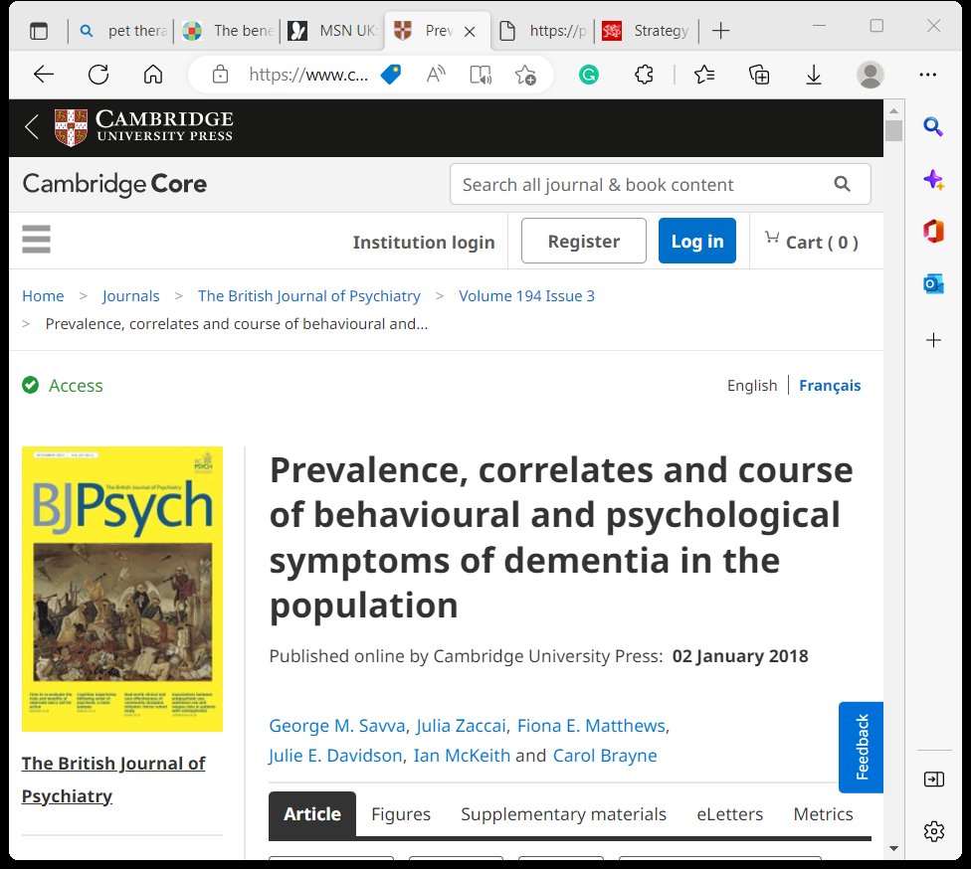

Although caring can be rewarding it is also very tiring, the carer can find it stressful and a cause of anxiety with levels of fear, loneliness isolation and uncertainty which results in poor mental well-being (Carers UK, 2015., Carers UK, 2019) female carers are more likely to provide a high-intensity care and are more likely to experience negative impacts of caring on mental and physical health. Older carers seem to suffer less mental distress and less life dissatisfaction than compared to younger carers (Anderson et al. 2013., Cook et al., 2018., Kjm & Kim, 2017., Stickney et al., 2012). Becoming an unpaid carer may result in dropping working hours or having to give up work altogether, therefore, reducing the income for the new carer which in itself could cause stress to the unpaid carer (Neubert et al., 2021., Carers UK. 2019., Kang et al., 2011). Providing Care at home could mean an increase in outgoings, and less money coming into the household could cause stress and anxiety to the carer. Equipment and medication would be an added requirement and another drain on the household’s budget. Some carers have struggled to pay household bills and have had to reduce essentials such as food and heating (Future Care Capital, 2019., Alzheimer’s Research UK, 2019., Carers UK, 2019).
Young carers are more likely to miss school and generally get lower grades in their exams. They are less likely to go to college or university (Hounsell, 2013., Huang et al. 2013). Not being able to get the education they need these carers are more likely to be unemployed or in a poorly paid job resulting in poor health and depression in later life (Hounsell, 2013).

References

Abraham Cottagiri, S. and Sykes, P. (2019). Key health impacts and support systems for informal carers in the UK: A thematic review. Journal of Health and Social Sciences. Doi:4:p. 173-198
Alzheimer’s Research UK. (2015). Dementia in the Family: The impact on carers
Anderson, L.A., Edwards, V.J., Pearson, R.C., McGuire, L.C., Andersen, E.M. (2013). Adult caregivers in the United States: characteristics and differences in well-being, by caregiver age and caregiving status. Preventing chronic disease. Doi:10:p. E135-E135
Brenna, E. and Di Novi, C. (2016). Is caring for older parents detrimental to women’s mental health? The role of the European North-South gradient. Review of Economics of the Household. Doi:14(4):p. 745-778
Campion, J., Bhui, K., Bhugra, D. (2012). European Psychiatric Association (EPA) guidance on the prevention of mental disorders. European Psychiatry. Doi:27(2):p. 68-80
Carers UK. (2015). Alone and Caring
Carers UK. (2019). Facts about Carers
Carers UK. (2019). Juggling work and unpaid care: A growing issue.
Carers UK. (2019). State of Caring: A snapshot of unpaid care in the UK.
Carers Wales.(2019). Unpaid carers in Wales feel demoralised and disillusioned
Chida, Y., Steptoe, A. (2008). Positive psychological well-being and mortality: a quantitative review of prospective observational studies. Psychosom Medicine. Doi:70(7):p. 741-56
Cook, S.K., Snellings, L., Cohen, S.A. (2018). Socioeconomic and demographic factors modify observed relationship between caregiving intensity and three dimensions of quality of life in informal adult children caregivers. Health Quality Life Outcomes. Doi:16(1):p. 169
Diminic, S., Hielscher, E., Harris, M.G. (2019). Caring hours and possible need for employment support among primary carers for adults with mental illness: Results from an Australian household survey. Health Social Care Community. Doi:27(5):p. e837-e849
Euro Carers. (2017). The impact of caregiving on informal carers’ mental and physical health
Future Care Capital. (2019). A Forgotten Army: Coping as a Carer
Guzman-Castillo, M., Ahmadi-Abhari, S., Bandosz, P., Capewell, S., Steptoe, A., Singh-Manoux, A., Kivimaki, M., Shipley, M.J., Brunner, E.J., O’Flaherty, M. (2017). Forecasted trends in disability and life expectancy in England and Wales up to 2025: a modelling study. Lancet Public Health. Doi:2(7):p. e3017-e313
Hounsell, D. (2013). Hidden from View: The experiences of young carers in England. The Children’s Society
Huang, F., Cai, Y., Florentin, D., Song, J., Davies, A. (2021). Closing the educational engagement gap for young carers. Public Health Wales NHS Trust: Cardiff
Huang, F., Bentley, L., Cai, Y., Hodgson, K., Song, J., Davies, A.R. (2021). Unpaid carers in Wales: The determination of mental wellbeing. Cardiff: Public Health Wales NHS Trust
Kang, X., Li, Z., Nolan, M.T. (2011). Informal caregivers’ experiences of caring for patients with chronic heart failure: systematic review and meta-synthesis of qualitative studies. Journal Cardiovasc Nurse. Doi:26(5):p.386-94
Kelly, A. and Kenny, C. (2018). Unpaid Care. Doi: Parliamentary Office of Science and Technology
Kjm, J. and Kim, H. (2017). Demographic and Environmental Factors Associated with Mental Health: A Cross-Sectional Study. International journal of environmental research and public health. Doi:14(4):p. 431
Neubert, L., Konig, H.H., Mietzner, C., Brettschneider, C. (2021). Dementia caregiving and employment: a mixed-studies review on a presumed conflict. Ageing and Society. Doi:14(5):p. 1094-1125
Pressman, S.D., Cohen, S. (2005). Does positive affect influence health? Psychology Bulletin. Doi:131(6):p.925-971
Social services and well-being (Wales) Act 2014
Stickney, S., Yanosky, D., Black, D.R., Stickney, N.L. (2012). Sociodemographic variables and perceptual moderators related to mental health stigma. Journal Mental Health. Doi:21(3):p. 244-56
Together for mental health delivery plan 2019-22
Welsh Government strategy for unpaid carers; a healthier Wales: long term plan for health and social care
Verbakel, E., Tamlagsronning, S., Winstone, L., Fjaer, E.L., Eikemo, T.A. (2017). Informal care in Europe: findings from the European Social Survey (2014) special module on the social determinants of health. European Journal Pub

