Marketing Plan for Six Senses Hotel

Student Name: Zomir Hussain Khan
Student ID: 2209207
Module: BMIH4005
Lecturer: Gayathri Mudiyanselage
Wordcount: 1250

Table of Contents
Introduction 3
Situation Analysis 4
5C’s 4
Company SWOT Analysis 4
Customers: STP 4
Competitors: Perceptual Positioning Map 5
Climate: PESTLE analysis 5
Objectives 6
Tactics: Marketing Mix 7
Action 7
Control 8
Conclusion 9
References 10

Introduction
Marketing is one of the most important things in any business. For marketing plan, one need to focus on how to make best use of the business. The main prospect of business is to look for the opportunities that will aid the overall prospect of business. The main target here is to check for how big operation chain works. For this report, the marketing plan of Six Senses is going to be prepared. The framework that we are going to use is 5 C’s Company analysis would be done in SWOT analysis (Strauss and Sinha, 2014). The STP analysis will be used customer analysis. The bowmans strategy clock will be used for the competitor analysis. The SMART target will be discussed in details for making the best use of the time. The strategy of the organization will also be described along with marketing mix. The product and other actions will be described here in details with Gannt chart too for approach to the marketing plan of Six Senses.

Situation Analysis

5C’s

Company SWOT Analysis
Strength
A strong point of the company is the number of countries it operates in. The market the corporation can cater to and the ease of getting their products is affected (Lamb et al, 2012). Having so many options available to customers increases the likelihood that they will find something they like and helps to mitigate any losses incurred in any one area.
Weakness
The firm has been criticised by environmental groups for the way it deals with rubbish and for not being sustainable. Ineffectiveness might result from sloppy inventory management. There is the possibility of a shortage or excess in inventory.
Opportunities
Because of the exponential growth of the population, businesses may see an increase in customers. Keeping abreast of market trends may help businesses adapt to customers' ever-changing desires (McDonald, 2009).
Threats
Changing regulations pose a danger to Six Senses Resorts and Hotels. That makes it harder for companies to comply with the law. If one doesn’t follow the rules, you might be sued for a lot of money. As a result of the market's need for skilled labour, it may be difficult for the organisation to find qualified workers (Goi, 2009). The expanding number of both direct and indirect competitors has an impact on the company's clientele.

Customers: STP
Segmentation
Six Senses is one of the most important hotel chains in the world. The main prospect here is to check in which segment it will work (Cravens and Piercy, 2006). Mostly it has wide range of hotel chain.
Target
Their customer target is mostly mid to high level customer base which is necessary.
Positioning
Mostly they are positioned them as the luxury hotel chain in the world.

Competitors: Perceptual Positioning Map
They provide them in the market for the high quality and high price segment. Mostly they are in this market segment.
Collaborators
They have collaboration with lots of new companies. Bill gates and other companies from middle east has invested here.

Climate: PESTLE analysis
Political
According to PESTEL analysis, politics have an effect on the long-term profitability and sustainability of Six Senses Hotels & Resorts. The company's global reach has made it more susceptible to political changes (Chaffey and Smith, 2013). Political diversification strategy is essential in today's dynamic global business climate.
Economic
Because of their impact on the economy, factors such as the foreign exchange/interest rate, the state of the labour market, inflation, and savings rates are all important for Six Senses Hotels & Resorts to understand.
Social
Organizational culture is influenced by the norms, values, and fashions of society at large. Demographic shifts, shifts in power, changes in customer preferences, and the prevalence of common beliefs might all be advantageous to Six Senses Hotels & Resorts. PESTEL analysis aids in the development of effective marketing communications and the attainment of organisational objectives.
Technological
The fourth element of the PESTEL framework is technological development. Because of the rapid pace of technological development and worldwide reach, technological factors are assuming an ever-greater role in strategic planning.
Environmental
The "environmental analysis" component of PESTEL analysis was recently included in light of growing concerns about global warming and other climatic changes. Environment-related rules and regulations might differ widely across markets. In order to avoid significant legal complications, careful legal study is required. The company's competitive edge may be harmed if employee’s broke consumer, worker, or environmental protection laws due to their lack of knowledge.

Objectives of Six Senses
The smart objectives of this hotel are to check for making the world sustainable. The main target here is to bring more customers who are highly connected with the green infrastructure. The marketing of a product or service is among the most crucial aspects of any company. While developing a strategy for marketing, one should concentrate on how to make the most of the company's resources. One of the most important parts of running a business is keeping an eye out for new chances that might improve the company as a whole. The primary objective of this test is to investigate the functioning of the huge operation chain.
Strategy
The fundamental goal of the Six Senses project is to ensure that it is as environmentally friendly as is practicable. The marketing effort will focus on the possibilities of persuading the natural target of customer base to buy new things that are more in line with being environmentally responsible as a purchasing decision. This campaign's principal rallying cry would be "Let's Go Green with Six Senses," which is the slogan that would be used for this campaign.

Tactics: Marketing Mix of Six Senses
Product
The main product is to change the hotel environment for making it more sustainable. The main product in this market is to check for the product that has impact on making Six Senses more sustainable and implement it in our market. The main product of the market should be eco-friendly and cutting edge that will revolutionize the market.
Place
The place that will be working on is mostly easy to accessible from all channels and will be focused on the aspects of the market that will be looking for making it the absolute best which is essential for making the market more flourish.
Promotion
The promotion of the market will be on every channel. But digital marketing will be used for getting advantages from the customer base.
Price
The price we are looking for will be mostly goodwill basis. But the new product line up we will bring something luxury for the market.

Action
The Gannt chart is given below
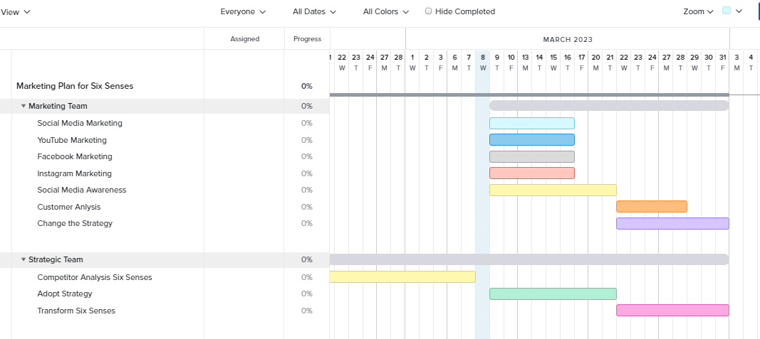
Figure 1: Gannt Chart for Marketing Plan

Control
The level of success that may be attained will be determined by a number of different factors. To begin, a campaign can only be considered a success if it results in increased profits from the services it provides to customers. The primary objective of this marketing plan is to do an examination of the market and then to propose a strategy for operating within that market. The primary objective of this study is to determine how well these processes function in the modern era and what aspects of them can be improved. The core marketing team will evaluate the performance of the marketing team, and the strategic team will concentrate on transforming the company from the inside out.

Conclusion
In preparation for this report, a marketing strategy covering the next Six Senses has been drafted. The 5 Cs was the structure that we operated off of for our company study, which is going to be a SWOT analysis. A customer analysis has been performed using the STP analysis. In order to complete the competition analysis, we have employed the bowman's strategy clock. In order to make the most efficient use of the available time, we have gone through the SMART goal in great detail. In addition to describing the marketing mix, we had also discussed the organization's overall strategy. In this section, the product and several additional acts has been discussed in detailes in depth, and a Gannt chart had also been included as an approach to Six Sense’s marketing strategy.

References
Chaffey, D. and Smith, P.R., 2013. eMarketing eXcellence: Planning and optimizing your digital marketing. Routledge.
Cravens, D.W. and Piercy, N., 2006. Strategic marketing (Vol. 6). New York: McGraw-Hill.
Doole, I. and Lowe, R., 2012. International marketing strategy (Vol. 7). Cengage Learning.
Goi, C.L., 2009. A review of marketing mix: 4Ps or more. International journal of marketing studies, 1(1), pp.2-15.
Kottler, P. and Keller, K.L., 2009. Marketing management. Jakarta: Erlangga.
Lamb, C.W., Hair, J.F. and McDaniel, C., 2012. Marketing. Cengage Learning.
McDonald, M., 2009. Marketing plans: how to prepare them, how to use them. Elsevier.
Strauss, J., Frost, R. and Sinha, N., 2014. E-marketing (p. 496). Upper Saddle River, NJ: Pearson.



