Module Leader: Dr. Zainab Atta
Component 1: Coursework Essay
Word Count:2116
pROJECT mANAGEMENT
LCBB60006
Tefik Leshkov
Student ID: 2316010

Table of Contents

1. Introduction 2
2. Aim, Objectives, and Scope 2
2.1) Aim 2
2.2) Objectives 2
2.3) In Scope: 3
2.4) Out of Scope: 3
3. Project Outputs (Deliverables and Direct Results) 3
3.1) Primary Deliverables 4
3.2) Direct Results 4
4. Activities Required to Deliver Outputs 4
5. Work Breakdown Structure (WBS) 5
6. Deliverables, Milestones, and Timeline 9
7. Resource Requirements (Personnel & Materials) 10
7.1 Personnel Resources 12
7.2 Materials & Technical Resources 13
7.3 Other Materials 13
8.Conclusion 13
9.References 14

1. Introduction
Aurora Apparel is a newly established clothing business specialising in minimalist streetwear for young adults. While the brand has been operating through pop-up stalls and social media pages, it lacks a dedicated digital platform to support long-term growth. In an increasingly digital retail environment, establishing an e-commerce website is essential for brand credibility, customer engagement, and revenue expansion.
This project plan outlines the development of a full e-commerce website for Aurora Apparel, including product listings, secure payment systems, branding elements, photoshoots, and a marketing launch. As project manager, this plan provides a structured roadmap covering deliverables, tasks, milestones, resources, and timelines necessary to deliver the project successfully.

2. Aim, Objectives, and Scope
In project management, defining the aim, objectives, and scope is essential for clarifying what the project intends to achieve and what boundaries surround it (Snijders et al., 2013).
- Project Aim provides the overall, high-level intention of the project — the broad end goal.
- Project Objectives break the aim into specific, measurable outcomes that the project must deliver. These often follow SMART principles (Specific, Measurable, Achievable, Relevant, Time-bound).
- Project Scope defines the boundaries of the project — what will be included (in scope) and what will not (out of scope). This prevents scope creep and ensures resources and expectations are clearly managed.

2.1) Aim
To design, develop, and launch a fully functional e-commerce website for Aurora Apparel within 12 weeks, enabling online transactions, product browsing, and brand engagement.

2.2) Objectives
- Develop a user-friendly website with secure payment integration.
- Create high-quality product content including photography and descriptions.
- Establish a consistent brand identity (logo, colours, typography).
- Implement a marketing launch strategy to attract initial customers.
- Ensure website compatibility across desktop and mobile devices.

2.3) In Scope:
- Website design and development
- Content creation (product photography, descriptions)
- Payment gateway setup
- Basic customer account system
- Search engine optimisation (SEO)
- Social media integration
- Launch marketing campaign
- Testing, debugging, and revisions

2.4) Out of Scope:
- Physical store setup
- International shipping systems
- Advanced mobile app development
- Wholesale partnerships
- Long-term website maintenance beyond initial launch

3. Project Outputs (Deliverables and Direct Results)
In project management, outputs are the tangible products, services, or results the project will deliver. These are usually expressed as deliverables, which are the concrete items produced during or at the end of the project (Portny, 2020) (e.g., a website, a report, a piece of equipment).
Clearly identifying outputs ensures everyone understands what the project will physically or digitally produce and provides a baseline for evaluation, scheduling, and resource allocation.
In the case of Aurora Apparel, the project will deliver the following:

3.1) Primary Deliverables
- Fully functional e-commerce website
- Website branding package (including logo, colour palette, typography)
- Product photography package (up to 30 high-quality images)
- Product descriptions and content library
- Secure payment system (e.g., Stripe or PayPal)
- SEO-optimised web pages
- Quality assurance (QA) test report
- Marketing launch plan

3.2) Direct Results
- Improved digital presence
- Ability to process online sales
- Enhanced customer experience
- Increased brand visibility
- A scalable foundation for future digital growth

4. Activities Required to Deliver Outputs
Before developing a WBS, core activity of Project Management is the diligent identification of all major activities required to create the deliverables (Turner and Ledwith, 2016). This forms the basis for planning time, cost, quality, and resources. Identifying activities ensures no critical work is overlooked and enables better sequencing and estimation. It is also foundational for risk assessment and scheduling (Jutte, 2012).
Below is the list of high-level activities required to produce the above deliverables:
A. Website Planning and Design
- Conduct competitor analysis
- Define website requirements
- Create wireframes and mock-ups
- Approve visual design
B. Content Creation
- Schedule product photoshoot
- Prepare clothing items
- Capture and edit photographs
- Write product descriptions
C. Website Development
- Build homepage, product pages, and checkout flow
- Integrate payment gateway
- Enable inventory tracking
- Create user accounts/login system
- Implement mobile responsiveness
D. Testing and Review
- Functional testing
- Bug fixes
- Security checks
- Load and speed testing
E. Marketing and Launch
- Develop social media teasers
- Create launch ads
- Final review and go-live
- First-week performance monitoring

5. Work Breakdown Structure (WBS)
A Work Breakdown Structure is a core project management tool that decomposes the project’s deliverables and activities into smaller, manageable components (Webster, 1994).
The WBS follows a hierarchical structure:
The WBS ensures clarity, supports accurate scheduling, and forms the basis for estimating cost, time, and resources. It also improves accountability, as tasks can be assigned more precisely.

The Entire Project

Major Phases

Activities

Sub-Activities & Tasks
The Work Breakdown Structure (WBS) for the Aurora Apparel e-commerce project decomposes the initiative into four key phases: project initiation, design and content creation, website development, and deployment. Each phase is further divided into three structured work packages with clearly defined tasks, ensuring that all essential activities—from branding and UI design to front-end coding, testing, and launch—are planned systematically. This hierarchical structure enables the project team to visualise the full scope of work, assign responsibilities efficiently, and maintain control over deliverables. By organising the project into manageable components, the WBS supports more accurate scheduling, resource allocation, and risk identification across all stages of development (Project Management Institute, 2021).
Below diagram illustrates a high-level visual representation of the WBS.
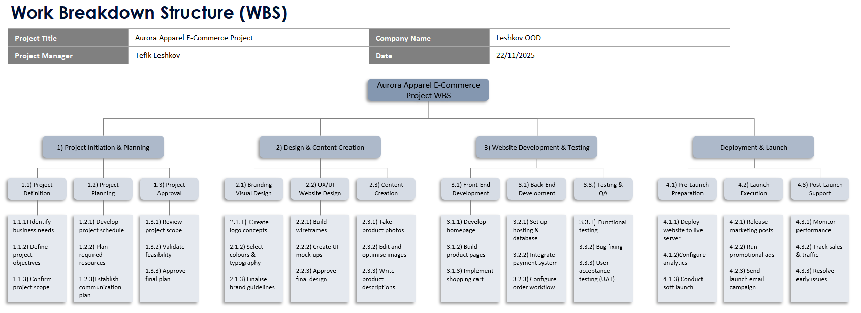
For further detail, the visual diagram is verbalized in more granularity in the below elements:
1) Project Initiation & Planning
1.1 Project Definition
- Identify business needs – clarify the market or operational problem.
- Define project objectives – set clear goals for the website.
- Confirm project scope – outline what is included/excluded.
1.2 Project Planning
- Develop project schedule – create a timeline of all activities.
- Plan required resources – define people, tools, and skills needed.
- Establish communication plan – set how updates will be shared.
1.3 Project Approval
- Review project scope – check alignment with brand strategy.
- Validate feasibility – assess technical and financial viability.
- Approve final plan – secure client/stakeholder sign-off.
2) Design & Content Creation
2.1 Branding & Visual Design
- Create logo concepts – generate multiple visual identity ideas.
- Select colours & typography – choose consistent brand styling.
- Finalise brand guidelines – document final visual standards.
2.2 UI/UX Website Design
- Build wireframes – map the layout of key website pages.
- Create UI mock-ups – design detailed visuals for the interface.
- Approve final design – obtain approval to start development.
2.3 Content Creation
- Take product photos – photograph clothing items professionally.
- Edit and optimise images – adjust lighting, size, resolution.
- Write product descriptions – produce clear, persuasive text.
3) Website Development & Testing
3.1 Front-End Development
- Develop homepage – build visual and interactive home page.
- Build product pages – create catalogue and item layouts.
- Implement shopping cart – enable add-to-cart functionality.
3.2 Back-End Development
- Set up hosting & database – configure servers and databases.
- Integrate payment system – connect Stripe/PayPal checkout.
- Configure order workflow – set up order and confirmation flow.
3.3 Testing & QA
- Functional testing – verify buttons, links, and navigation.
- Bug fixing – correct errors and retest functionality.
- User acceptance testing – validate site with real users.
4) Deployment & Launch
4.1 Pre-Launch Preparation
- Deploy live website – move final build to live server.
- Configure analytics – connect tracking tools (e.g., Google Analytics).
- Conduct soft launch – test site with limited audience.
4.2 Launch Execution
- Release marketing posts – publish launch content on socials.
- Run promotional ads – initiate paid campaigns.
- Send launch email campaign – notify subscribers.
4.3 Post-Launch Support
- Monitor performance – check speed, uptime, and metrics.
- Track sales & traffic – analyse early customer activity.
- Resolve early issues – fix bugs reported after launch.

6. Deliverables, Milestones, and Timeline
Milestones are a significant event in a project, typically marking the completion of a key deliverable or phase. Milestones are used to track progress and ensure the project is moving according to schedule (Tristancho, 2023). A timeline (often in the form of Gantt chart) visually represents the sequence and duration of activities, helping to identify dependencies and critical paths.
Assuming a 12-week project schedule, major milestones are:
Phase | Milestone | Timeline
Planning | Requirements approved | Week 2
Design | Wireframes and mock-ups completed | Week 4
Content Creation | Photoshoot & content library finalised | Week 6
Development | Website prototype completed | Week 8
Testing | All QA testing completed | Week 10
Launch | Website goes live | Week 12

The Gantt chart below illustrates the sequential scheduling of the Aurora Apparel e-commerce project across a 12-week timeline, with each major phase allocated a two-week duration. It visually demonstrates how the project progresses from Planning in Week 0 to Launch in Week 12, showing a clear linear flow where each phase begins immediately after the previous one is completed. Milestones are displayed at the end of each bar, marking key achievements such as requirements approval, wireframe completion, content finalisation, prototype delivery, testing completion, and the final website launch. This structure provides a simple yet effective overview of the project’s critical path, ensuring transparency in timelines and supporting effective monitoring and control throughout the lifecycle.
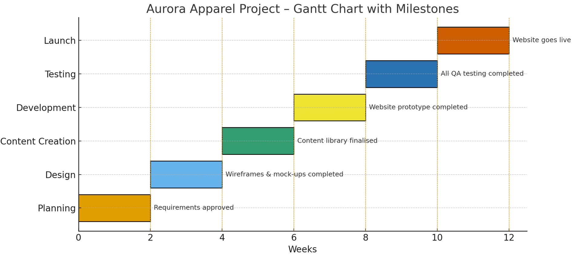
Key Milestones Explained
Milestone 1: Requirements Approved (Week 2)
All technical and business requirements signed off.
Milestone 2: Design Completed (Week 4)
Client approves UI design and wireframes.
Milestone 3: Content Completed (Week 6)
Product photos and descriptions are ready for upload.
Milestone 4: Prototype Ready (Week 8)
Website pages and payment system functional.
Milestone 5: Testing Completed (Week 10)
All bugs resolved; website is stable.
Milestone 6: Launch (Week 12)
Marketing campaign activated and website deployed.

7. Resource Requirements (Personnel & Materials)
Project management requires identifying all human, material, and technical resources required to complete each task (Bird, 2018).
Resource planning answers questions such as:
- Who is responsible for each activity?
- What skills are required?
- What equipment, software, or materials must be procured?
Effective resource planning prevents delays, ensures capacity is available at the right time, and supports accurate budgeting. It also enhances stakeholder coordination and risk mitigation.
The successful completion of the Aurora Apparel e-commerce project relies on a strategic combination of personnel and material resources. Each member of the project team contributes specialist skills that ensure the project is delivered to the required quality standard, within the planned timeline. Technical roles such as the web developer, graphic designer, photographer, and content writer are essential for producing the website’s functional, visual, and written assets, while the QA tester and marketing specialist ensure that the site performs effectively and reaches its intended audience upon launch. Alongside human expertise, the project also requires material and technical resources—such as camera equipment, editing software, hosting services, and e-commerce tools—which provide the infrastructure needed to develop, test, and deploy the final product. Together, these resources create a coherent support system that underpins every phase of the project lifecycle.

7.1 Personnel Resources
Project Manager | • Oversees timeline, budget, and quality  • Coordinates team communication  • Manages project risks, approvals, and stakeholder alignment
Web Developer | • Builds front-end and back-end systems  • Integrates payment gateway  • Ensures mobile responsiveness and site performance
Graphic Designer | • Creates branding package  • Designs UI/UX mock-ups  • Selects colour palette and typography
Photographer | • Conducts product photoshoot  • Edits, resizes, and optimises images  • Prepares visual assets for web
QA Tester | • Conducts functional and user testing  • Identifies bugs and usability issues  • Validates performance across devices
Marketing Specialist | • Designs social media advertisements  • Develops launch campaign strategy  • Coordinates promotional activities

7.2 Materials & Technical Resources
Resource | Purpose / Use
Camera equipment | Used for product photography to ensure high-quality visuals
Lighting setup | Enhances photo quality and consistency during shoots
Development computers | Used for coding, testing, and content creation
Web hosting service | Provides server space for website deployment
Domain name (auroraapparel.com) | Unique online identity for the brand
CMS / E-commerce platform (Shopify) | Enables website building, catalog management, and secure checkout
Editing software (Photoshop/Lightroom) | Used for image enhancement and optimisation
SEO tools (e.g., Yoast SEO) | Helps improve search engine visibility and metadata

7.3 Other Materials
Material | Purpose / Use
Clothing samples | Required for product photography
Studio space | Provides controlled environment for photoshoot
Branding templates | Support consistent visual identity across pages
Marketing budget | Funds advertisements and promotional activities

8.Conclusion
In conclusion, the Aurora Apparel e-commerce project demonstrates a structured and methodical approach to delivering a functional online retail platform. By defining clear aims, objectives, and scope, the project establishes a strong foundation for planning and execution. The WBS, Gantt chart, and resource plan collectively ensure that activities, responsibilities, and timelines are fully aligned with project goals. Through coordinated efforts across design, content creation, development, testing, and launch, the project is positioned to achieve a high-quality outcome. Ultimately, this plan provides a realistic and comprehensive framework that supports successful project delivery and long-term operational effectiveness.

9.References
Bird, K. (2018). What is resource management | APM. [online] Apm.org.uk. Available at: https://www.apm.org.uk/blog/what-is-resource-management/.
Jutte, B. (2012). Project Risk Management Handbook. Xlibris Corporation.
Portny, S. (2020). Project Management . 5th ed. Hoboken, Nj: John Wiley & Sons, Inc.
Project Management Institute (2021). A guide to the project management body of knowledge (PMBOK® guide) – seventh edition and the standard for project management . 7th ed. Project Management Institute.
Snijders, P., Wuttke, T., Zandhuis, A. and Newton, S. (2013). PMBOK Guide : a pocket companion to PMI’s : a quick introduction to ‘A Guide to the Project Management Body of Knowledge’ (PMBOK Guide). Zaltbommel: Van Haren Publishing, Cop.
Tristancho, C. (2023). What Are Milestones in Project Management. [online] ProjectManager.com. Available at: https://www.projectmanager.com/blog/milestones-project-management.
Turner, R. and Ledwith, A. (2016). Project Management in Small to Medium-Sized Enterprises: Fitting the Practices to the Needs of the Firm to Deliver Benefit. Journal of Small Business Management, 56(3), pp.475–493. doi:https://doi.org/10.1111/jsbm.12265.
Webster, F.M. (1994). Work Breakdown Structure (WBS) - Basic Principles. [online] www.pmi.org. Available at: https://www.pmi.org/learning/library/work-breakdown-structure-basic-principles-4883.

