A Report on communication within the workplace.
By Parul Begum 1811324
University of wales – Trinity Saint David



Executive Summary.
Terrance Thomas’s business has communication problem and sharing information issues with his employees. Currently there is no formal teams within the workplace and a sale assistant who has taken a long term sickness. Researcher will be looking at how to improve the performance of the business and the importance of two-way communication, by using the model to illustrate the point across. In workplace if the communication isn’t clear then there is misunderstanding which can cause conflicts between employees and manager. The researcher will advise Terrance Thomas on the issues that he has concerns on also give him an action plan that he can use.

Contents Pages
- Introduction ……………………………………………………………………………………….page 1

- Findings ………………………………………………………………………………………………page 2-6

- Conclusions …………………………………………………………………………………………page -7

- Recommendations ………………………………………………………………………………. page -8

- Action plan ……………………………………………………………………………………………page-9

- Reference …………………………………………………………………………………………….page-10

Introduction

Terrance Thomas’s business has grown rapidly, a year ago it was a small grocery store and he had only 4 people working for him in Neath. Now, he has 27 people working for him in various ages and experience, most of the employee’s work part-time and various hours 7:00am-10:00pm. There are some stockroom staff who do night shifts work without the manager on duty also a sale assistant who is off on long term sickness and there are no formal teams within the workplace, Ad hoc who works on a particular shift in the shop. This can lead to a breakdown in communication and also information not being shared effectively in the workplace all this can have an effect on the smooth running of the business. For businesses to function well, managers and employees need to interact clearly and effectively with each other, through verbal and non-verbal communication to achieve their goal.





1.0 Findings

As the researcher has mentioned that Terrance Thomas’s business has a communication breakdown and there are issues about information not being shared properly with his staff. In any business or organization effective communication is important because this allows manager and employees to share vital information, which can help company to its success.
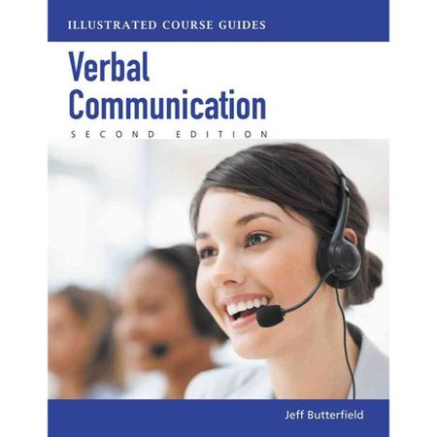
Effective communication is also called open communication; this prevents barriers from forming among the employees within the company. For business to function well managers and employees need to interact clearly and effectively with each other through verbal, non-verbal and visual. Verbal communication can bring great reward to business, when carried out successfully.
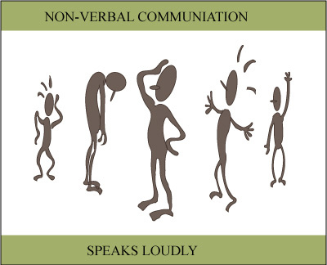

Verbal communication is language, both written and spoken. Communication is the transactional of symbols, influenced, guided and understood the context of relationship.
Non-verbal communication refers to body language, eye contact, tone of voice and gestures such as smile, nodding and crossing arms. These all are non-verbal communication that we use without releasing it in our daily life. None-verbal communication is important because your body language and your words both need to support each other. This will show that you are confident in what you are saying or doing.

Bruce Tuckman’s theory looks at group development the process of Forming, Storming, Norming, Performing and the last one is adjourning. Terrance Thomas can use Tuckman`s theory in his workplace to encourage his employees to engage with each other, by doing group activities such as playing quiz game in a team which will encourage maturity and ability to build good relationship with each other within the workplace. By doing this kind of things it will encourage good communication as well. Terrance Thomas can keep an eye on his employee’s progress on communication as well as team buildings.
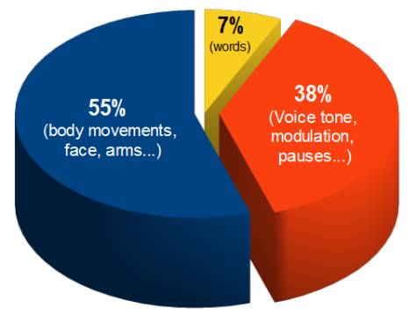
Language %
(By Lucy Debenham BA (hon) 15 may 2018)

This suggests that only 7% effect is produced by speaking words,38% by tone of voice, inflexion and other elements, and 55% by body language for e.g. movement, smile and eye contact.
Words- which is literally being said. Spoken language is the words of verbal communication in this and the intonation and body language are both part of non-verbal communication.
Intonation - How someone says something (use of voice) Intonation is the vocal factor and body language the vocal factors.
Body language (Visual)- This is the part where postures, facial expressions and gestures that someone uses during conversation.
Looking at the pie chart it shows that the verbal and non-verbal elements both support each other on congruent. What a person says will then be more powerful and convincing because of their gestures and intonation.

What is 2- way communication.
Two-way communication is what happens when two people, the sender and receiver, exchange messages. The sender first relays a message to the receiver, who once received the message responds back accordingly to the sender, acknowledging that they have understood and received the message.
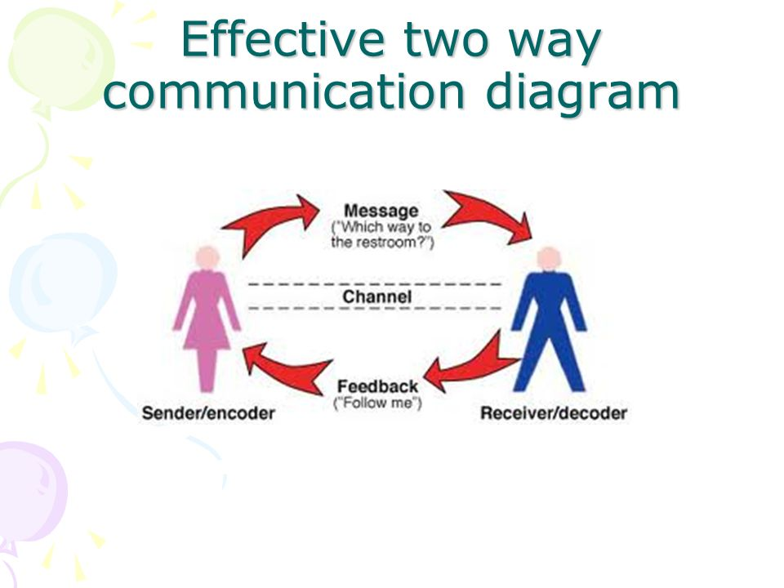

(Study.com>academy 2003/2019)

As Terrance Thomas has communication and sharing information issues within his business, he needs to find out and understand his employee’s needs. Terrance Thomas needs to know what kind of work environment is suitable for his employees and which is the best method to encourage them to perform better. All this is possible when Terrance Thomas know his employees and their skill, this is where two-way communication comes in. As you can see the diagram, the figure on left hand side is the sender and the right hand side is the receiver. The sender sends message and receiver decodes it by looking at the body language of the sender(encodes) and gives the feedback to the sender and sender decodes that. Communication can be misunderstood by employer and employee which can cause barriers in the work environment. Two-way communication also can be speaking on the phone/mobile, Terrance Thomas can phone his employee who is ill and ask her how she is and this will show the employee that he does care for his employees. Here are few of the barriers that can happens in the business environment, Researcher will be discussing some of the barriers and how to overcome them in the workplace.

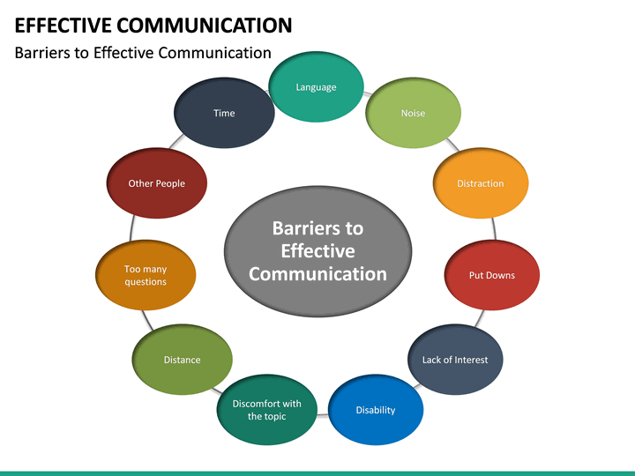
(Sketchbubble.com 2019)

Language barrier- people speaking the same language can have difficulty understanding each other for e.g. different generation and different regions.
Overcoming the Language barrier- Terrance Thomas can use plain language that everyone can understand. Use visual methods of communication where possible, and respect everyone.
Noise barrier- This could be traffic noise or noise around us which can interfere with our ability to focus.
Overcoming the Noise barrier- Terrance Thomas can try and remove the cause of distraction such as telephone or the mobile which they can switch it off. Also he can close the windows so noise don’t disturb them, being more active listener would be good.
Time barrier- when there are no boundaries in workplace this can cause barriers. If there are no schedule for the employees as well this can cause issues in the workplace.
Overcoming the Time barrier- Terrance Thomas can set some boundaries for the workplace also make a schedule for the employees to have meetings for e.g. every other week if possible.

Terrance Thomas needs to motivate is employees to get their best performance in the business, so to do that. First need to decide upon the employees and the aspects of what they are looking for, then the next step is to choose through which channel of messages can reach the concerned persons. Keep in mind that the feedback is always taken in a formal manner. If this happens then the employees will get more confidence in the business. After intergrading two-way communication into the business Terrance Thomas needs to allow time to time the feedback from his employees, this will show him how the process is working in his business. So if there any issues that come up, Terrance Thomas can respond fast to the complaints of the employee. This will show the employees the positive wave among the employees since they believe that they are valued in the business. As a manager Terrance Thomas needs to solve the problem of the employees faster and in the right manner, by doing that Terrance Thomas will get better support from his staff. This gives the employees that their feelings, idea and thoughts can make a change to the business. Give feedbacks to the employees of their ideas and suggestion.
When getting the feedback, it’s not all about understanding the feedback and keeping them at one place, it’s more important to use that feedback in a right manner for the business. This show how important 2-way communication is between a business and the employees, which shouldn’t be overstated. Among other benefits, 2-way communication builds rapport and trust between colleagues, maintains transparency in the workplace. This enables better employee management, boots moral and facilitates innovation.
Jesses James Garrett Quoted that “Effective communication is a key factors in the success of your product.” Which is very true.
Terrance Thomas can use Belbin’s theory of team work in his workplace, Belbin looks at effective ways to assess the relative strength and the weakness of a team.
Think-oriented role
Plant These people are good at solving problems.
Monitor-Evaluator
Specialist
People-oriented role
Co-ordinator These are the people who gather information together.
Team worker
Resource Investigate
Action –oriented role
Shaper
Implementer These people are the drivers.
Completer-finisher
3.0 Conclusion
As the researcher has mentioned that Terrance Thomas has communication problems and sharing information within his business. It looks like there are no schedules or any kind of boundaries in the business itself. As researcher has mentioned that Terrance Thomas need to motived his employees to perform in their best of their ability. Researcher also discuss some of the barriers in the workplace and how Terrance Thomas can use these as an example to overcome his issues in the business.
So far what the researcher has pointed out is that communication is a vital part of any business or organization, also pointed out that our body language and our spoken words both needs to interact with each other and we need to be aware of our body language while we speak to someone. It’s also important in workplace to have visual communication for e.g. putting some information on the note board so everyone can read it. Terrance Thomas can use either Tuckman’s or Belbin’s theory’s in his workplace to get the best out of his employees. By using Tuckman theory Terrance Thomas can see how well his staff are getting along with each other, Also by using Belbin’s theory he can see which of his employees fit in to which categories for e.g. Thinking-oriental people are good at solving problems, so someone who is good at monitoring things can fit into the role of a supervisor in Terrance Thomas business.

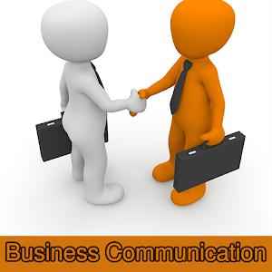

5.0 Recommendation.

By following the rota Terrance Thomas can see how well his employees and his business are doing and by listening to his employee’s feedback and talking to customers also will help his business too.

Due to Terrance Thomas having a sale assistant who is off work due to long term sickness, Terrance should find a responsible replacement for the time being. As the ill employees still remains as one of Terrance`s staff, Terrance should ring weekly checkups to the employer as to reassurance of employee recovery. Terrance should also insure that there is a non- permanent replacement so the employee shouldn’t worry about letting Terrance or the company having down. Always encourage your employees to share their concerns with you or other staff. If Terrance Thomas can go and see his employee who is ill, it would be nice for the person who is ill. They will feel that as a manager you do care for the staff.

Action plan
Task | Weekly monitoring | Time / weekly
New Rota | Ask employees to see if they are happy with the new rota and if they need a day off or not | 2 week
Staff meetings | Suggestions/questions/problems | 4 weeks
One to one meetings with employees | Private matters/personal problems. | 2 week
Give and receive feedback | Improvements / Areas of training | 3 week
Monitor employee’s | Watch how employee work | 4 week
Training | Trainng stragies /courses | weekly

Reference
Books:
- Donald.B. Egolf, D.B.E, (2001), Forming, Norming, Storming, Performing, - 236 pages, (NO LOCATION), iUniverse.
- R. Meredith Belbin, (2000), Management Teams and Changing the way we work, (NO LOCATION), British Library Cataloguing.

Websites:
- Duck, s@McMahon D.T, (2015 p.5)

- Lucy Debenham BA, (2000/2019), communication. What percentage is body language. [Online] Available at: www.bodylanguageexpert.co.uk, [Accessed on: 27.06.19]

- (2003/2019), What is two-way communication. [Online] Available at: https://study.com>acadamey, [Accessed on: 28.06.19]

- Mild Bill Hiccup, (2 months ago), Two-way communication. [Online] Available at: https://on.m.wikipedia.org., [Accessed on: 28.06.19]

- Posted by the Business Communication 4-comments. [Online] Available at: https://thebusinesscommunication.com, [Accessed on: 28.06:19]

- Statitical-pie-chart. [Online] Available at: https://Mcburyess11.wordpress.com, [Accessed on: 27.06.19]

- [Online]Available at: https://slidesplayer.com/slider/61557990, [Accessed on: 02.07.19]

- [Online] Available at: https://sketchbubble.com/en/presentation-effective-communication.html, [Accessed on: 02.07.19]

- [Online] Available at: https://quotefancy.com, [Accessed on: 03.07.19]

- [Online] Available at: https://www.youtube.com/watch?v=efolvgEvm, [Accessed on: 03.07.19]

