Operating Systems
Module Name: Computer Architecture & OS
Module Code: ACCA4022
Student Name: Fatima Bandali
Student ID: 2520390
Lecturer Name: Dr. Md Shantanu Islam

Submission date: 09/07/26

Contents
Introduction 4
Key functions of general Operating Systems 4
Task Management: 4
Application/Program Management: 4
File/Directory Management: 5
Device Management: 5
Security Management: 6
Use of Windows OS CLI commands 7
Example 1: 7
Example 2: 7
Example 3: 8
Example 4: 8
Example 5: 8
Example 6: 9
Example 7: 9
Example 8: 10
Example 9: 10
Example 10: 11
Use of Linux OS CLI commands 11
Example 1: 11
Example 2: 12
Example 3: 12
Example 4: 13
Example 5: 13
Example 6: 14
Example 7: 14
Example 8: 15
Example 9: 15
Example 10: 16
Use of Windows OS scripts 16
Example 1: 16
Example 2: 17
Use of Linux OS scripts 18
Example 1: 18
Example 2: 19
Conclusion 20
References 20
Appendices 21

Introduction
This coursework will show several examples and explanations of the functions of general operating systems in our computers and will also look at windows CLI and Linux CLI. It will highlight the similarities as well as differences between the two systems, key functions and processes. This will include examples of command prompts as well as scripts on both systems.

Key functions of general Operating Systems
Windows operating system is widely used, which was launched in 1985. The system makes it easy to use computers due to the graphical interface offered to the user. It controls both hardware and software of the computer and offers an environment for application execution and file management (1).

Task Management:
Task management in windows is the method of viewing and managing running applications, background processes (1), and system performance through the Task manager Tool shown in image below. This tool allows users in viewing CPU, memory, disk, and network utilization in real time. Task manager enables users to close unresponsive applications, manage startup applications, see which user is active and monitor system performance. Using Task manager, users are able to increase system performance, solve software problems and ensure the stability of the Windows operating system (1).
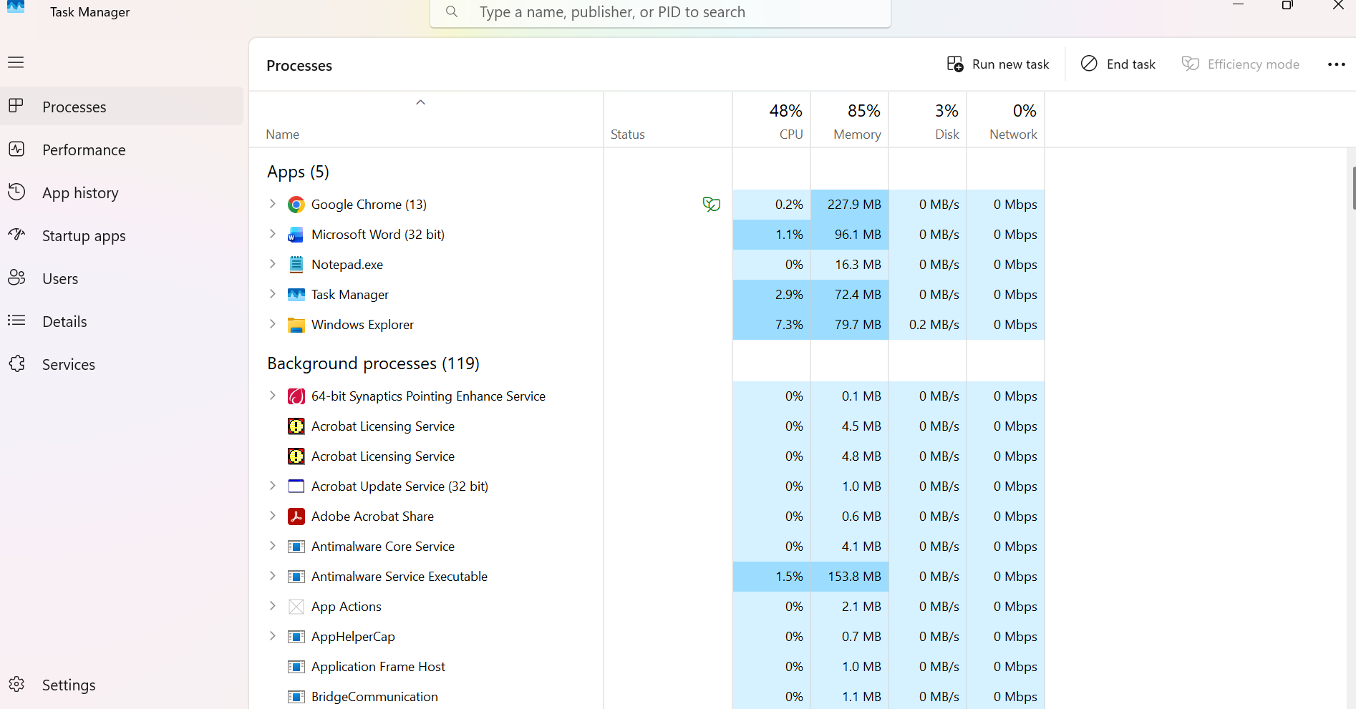
Figure 1: Shows a screenshot showing the task manager

Application/Program Management:
Application management refers to the process of installation, update, execution, and deletion of applications. Users in Windows can install their applications from Microsoft Store and other trusted locations (1) The applications can be executed from the Start menu, desktop shortcuts, and taskbar. The applications can be updated by the users to have access to the latest features and security updates (1). The unwanted applications can be deleted through Settings and Control panel to have more space in the hard drive. This is important for improving the performance of the computer.
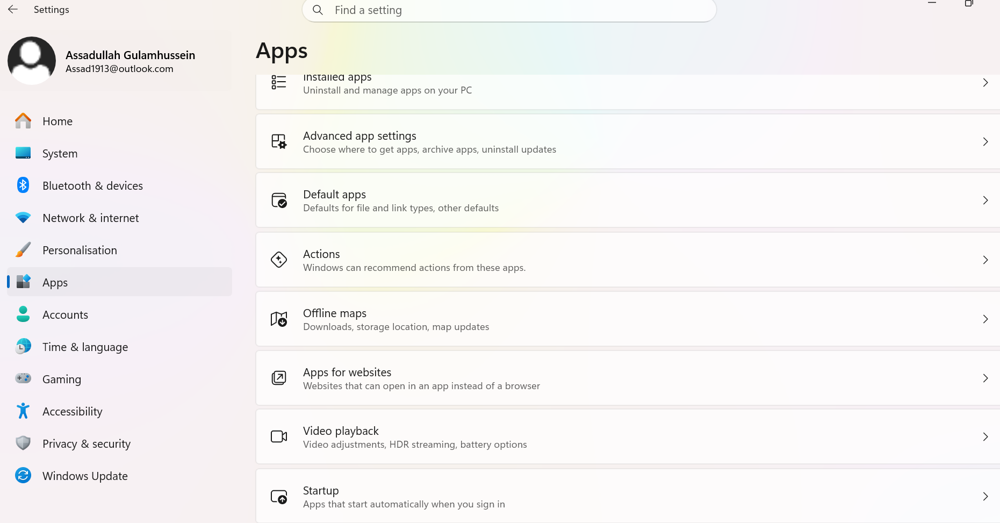
Figure 2: Shows a screenshot of Application in settings

File/Directory Management:
Windows file and directory management entails the efficient organisation and access of files and directories. Windows offers File Explorer software that helps in creation, copying, moving, renaming, deleting, and searching of files and directories (2). Filing of files is done within folders and makes it easier to organise documents, images, videos and applications. Sorting of files through different options such as name, date, type and size can be easily done to facilitate quick access to files (2). Other features like recycle bin make it easy to recover accidentally deleted files, while shortcuts give quick access to important folders.

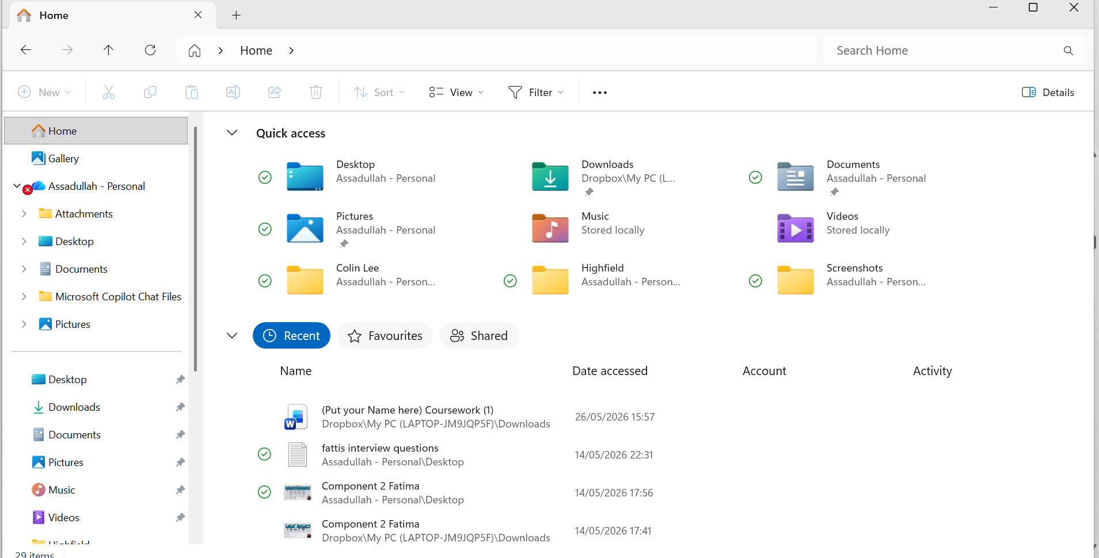

Figure 3: Shows a screenshot showing File manager

Device Management:
Device management in Windows refers to the management and maintenance of devices installed on a computer system. Windows comes with an application called Device Manager that enables users to view, install, update, disable, enable, and remove device drivers (2). The application makes it easy to identify problems with hardware by showing a warning icon for problematic devices. Some of the devices that one can manage include printers, keyboards, monitors, network cards, and USB devices. The maintenance of up-to-date device drivers ensures proper performance, and security of the computer system (2).
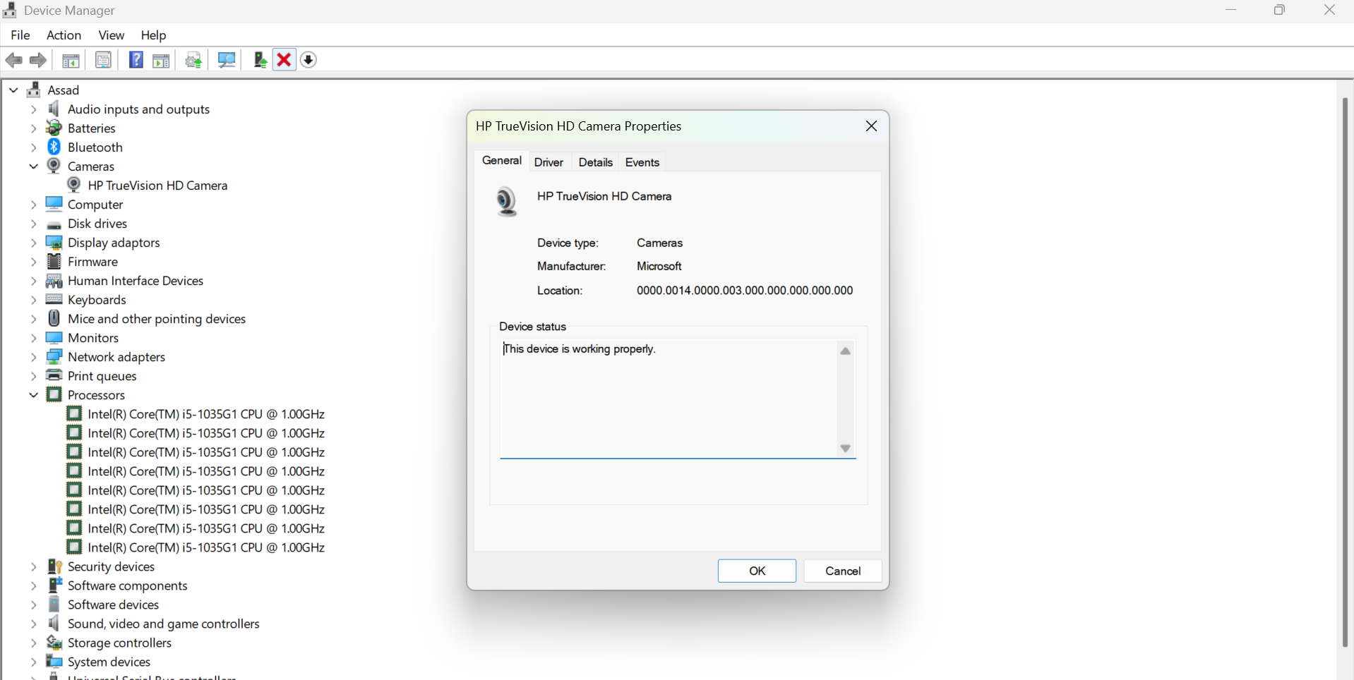
Figure 4: Shows a screenshot of Device Manager

Security Management:
Windows security management is about security computer systems using features built within the operating system and other management mechanisms which limit access, keep track of any threats, and ensure the safety of data. Some features include user account management, password policy, permissions, firewall settings, anti-virus protection, and updating (2). Windows security management is performed using such tools as Windows Defender, BitLocker, and Group Policy, among others. The process of effective Windows security management calls for continuous monitoring of risks and proper setting of configurations. Using good security management tools allows limiting any threats to important data (2).

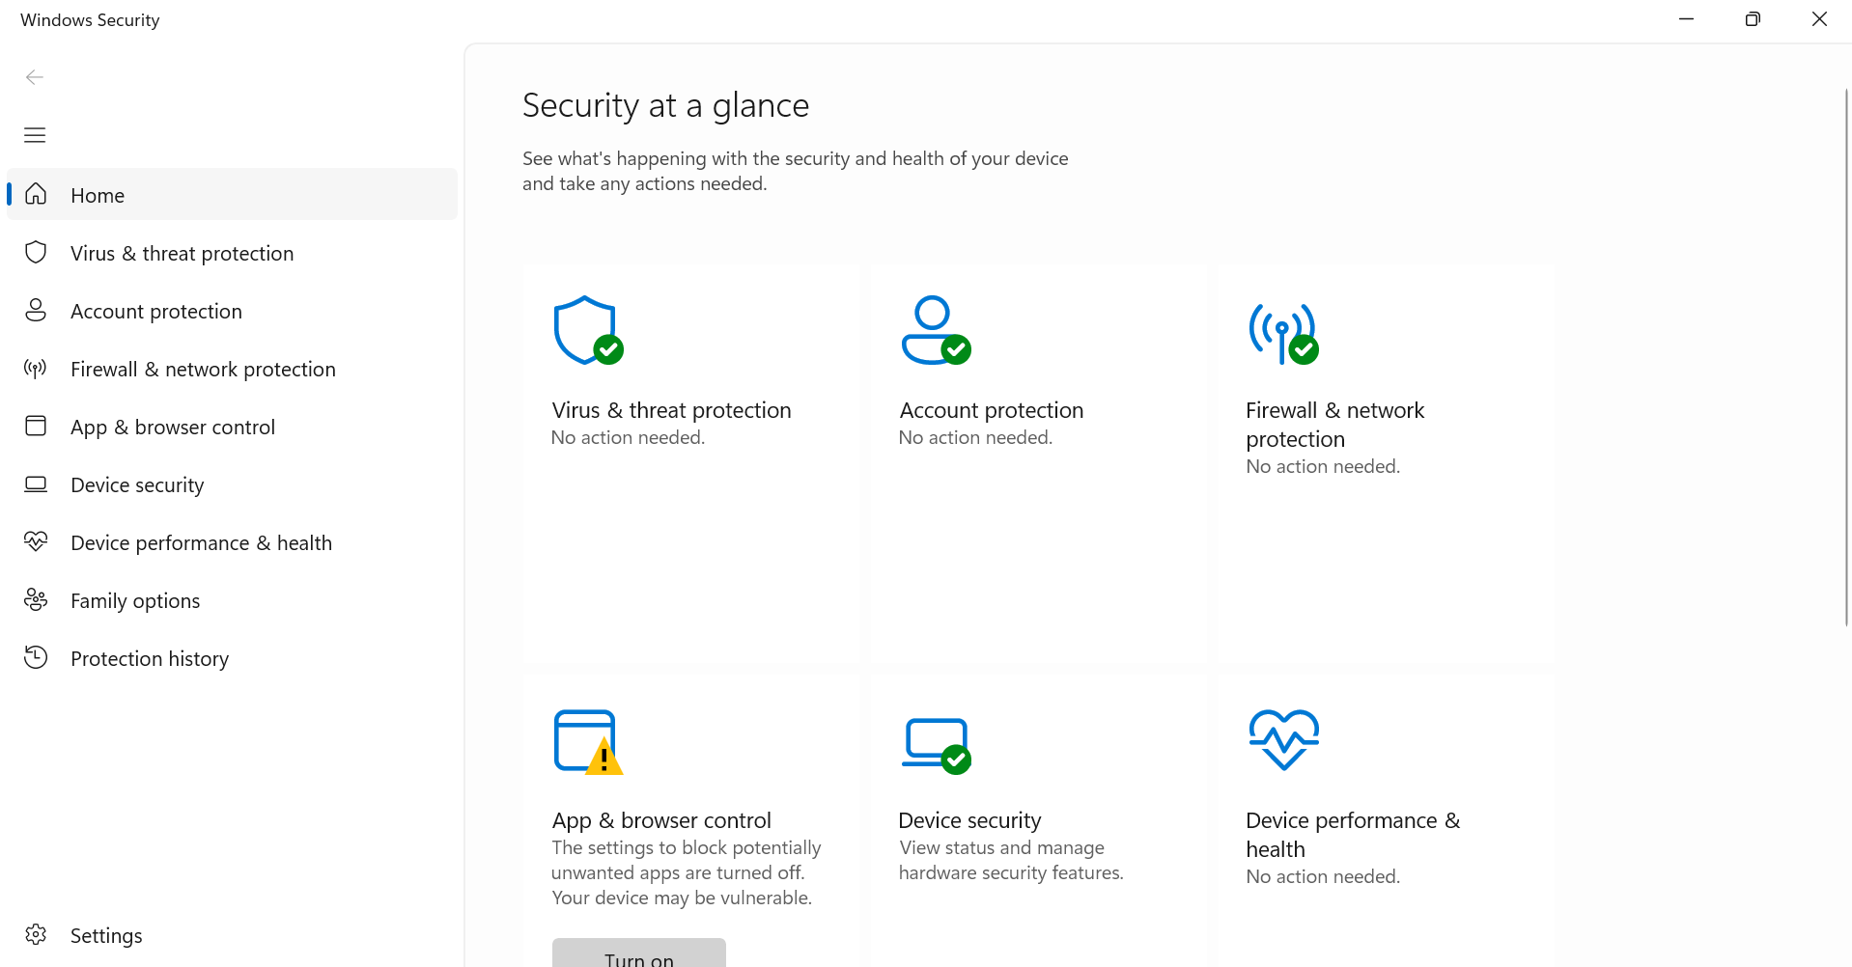
Figure 5: Shows a Screen shot of Windows Security App

Use of Windows OS CLI commands
Command Line Interface (CLI) is a text base application that allows the user to interact with the operating system by writing commands (3). Through the command line the user can navigate through files and folders. Some functions of CLI command are; File and folder management (faster to create new files through command especially if needed in larger numbers e.g. student files), manage user accounts, system settings, and check network configurations (3).

Example 1:
The command prompt Dir is shown below, and the output shows what folders the user has on the folder.
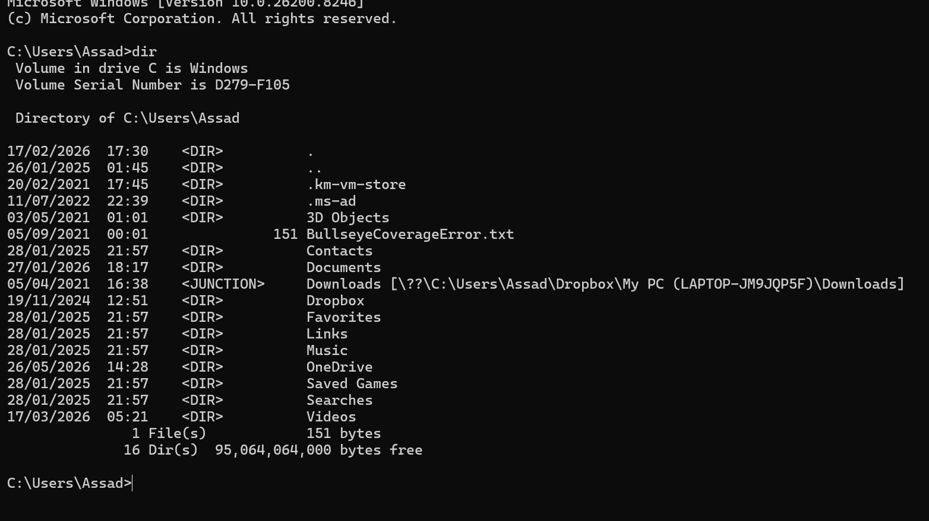
Figure 6: A snapshot showing the Directory

Example 2:
The command prompt cd is shown below, and the output displays the current directories
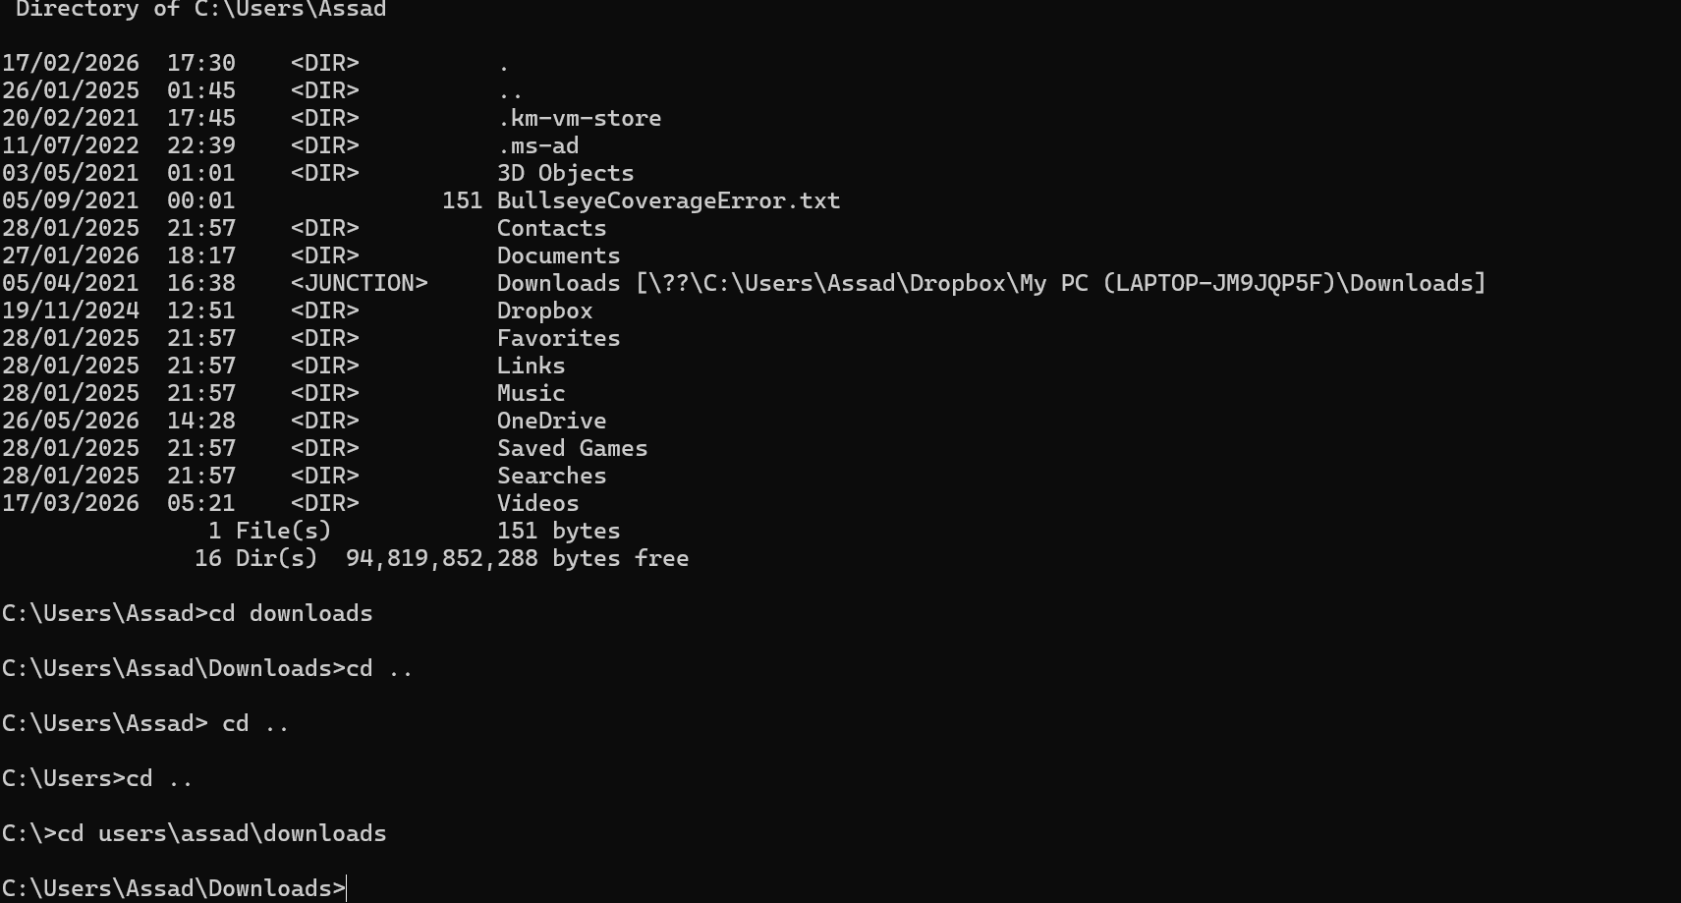
Figure 7: A screenshot showing the command cd

Example 3:
The command prompt mkdir is shown below and the output shows the user creating multiple folders
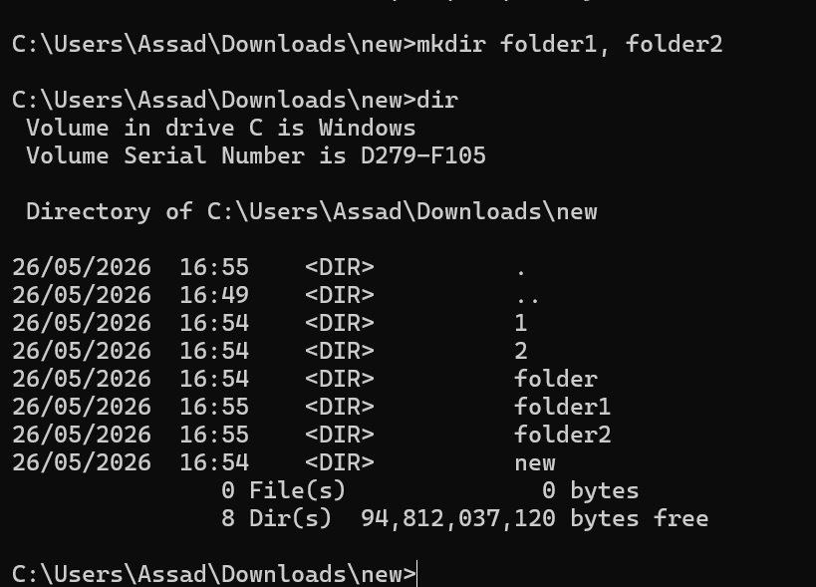
Figure 8: A snapshot of command mkdir

Example 4:
The command prompt rmdir is shown below and the output shows how to delete files.
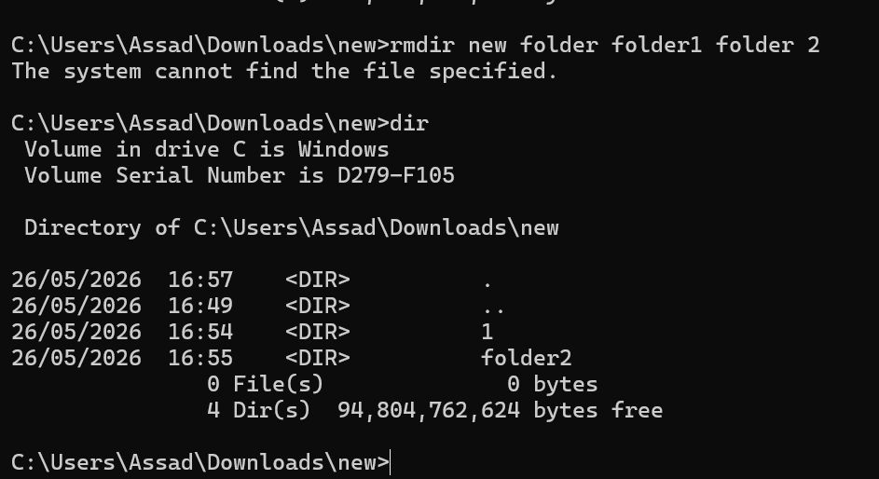
Figure 9: A snapshot showing command rmdir

Example 5:
The command prompt Echo is shown below, and the output shows custom text printed on the screen, it can also show the current status is switched on or off.

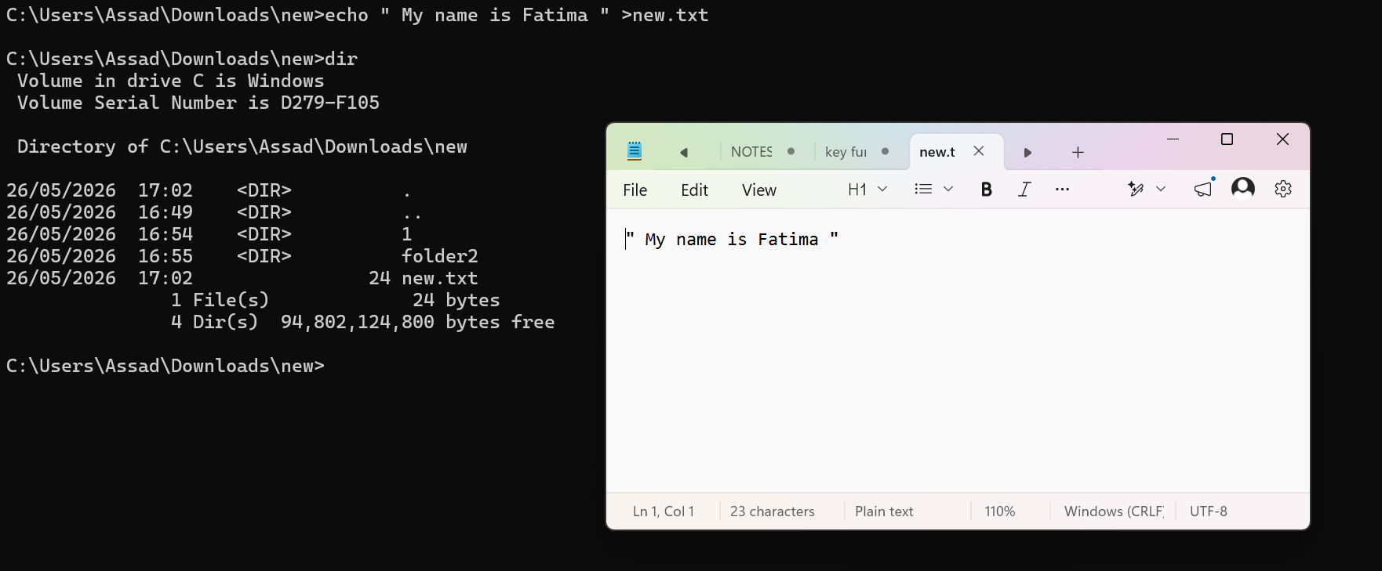
Figure 10: A snapshot showing the command prompt echo

Example 6:
The command prompt ipconfig shows below, shows the computers IP Address, it allows us to see our IT configuration. An IP address is needed for an internet connection. There are 2 types if IP address one is private one is public. 2 types of IP version 4 and IP version 6 like shown in image below
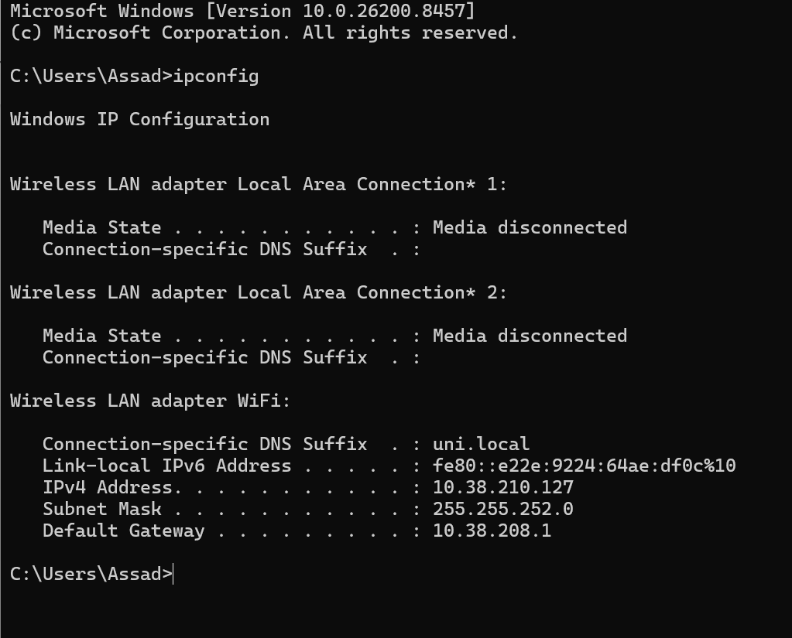
Figure 11: Snapshot showing ipconfig

Example 7: Explain the command and output.

The command prompt ping is shown below and the output shows if there is an internet connection the command is showing that google is sending 4 packets and getting 4 replies. If you get time outs that means, there isn’t an internet connection.
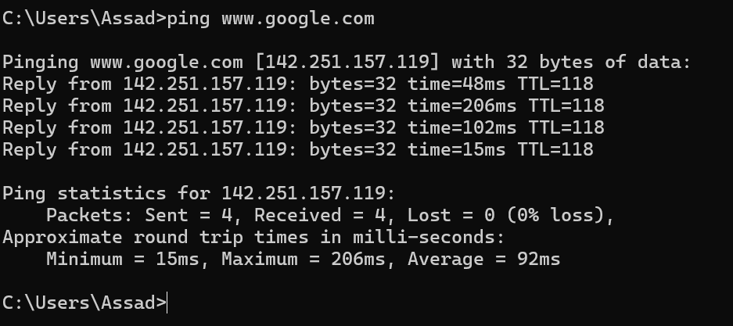
Figure 12: Image showing command prompt: Ping

Example 8: Explain the command and output.
The command prompt netstats (short form for network statistics). The output shows current active internet communications. This command can also show any cyber security breaches.
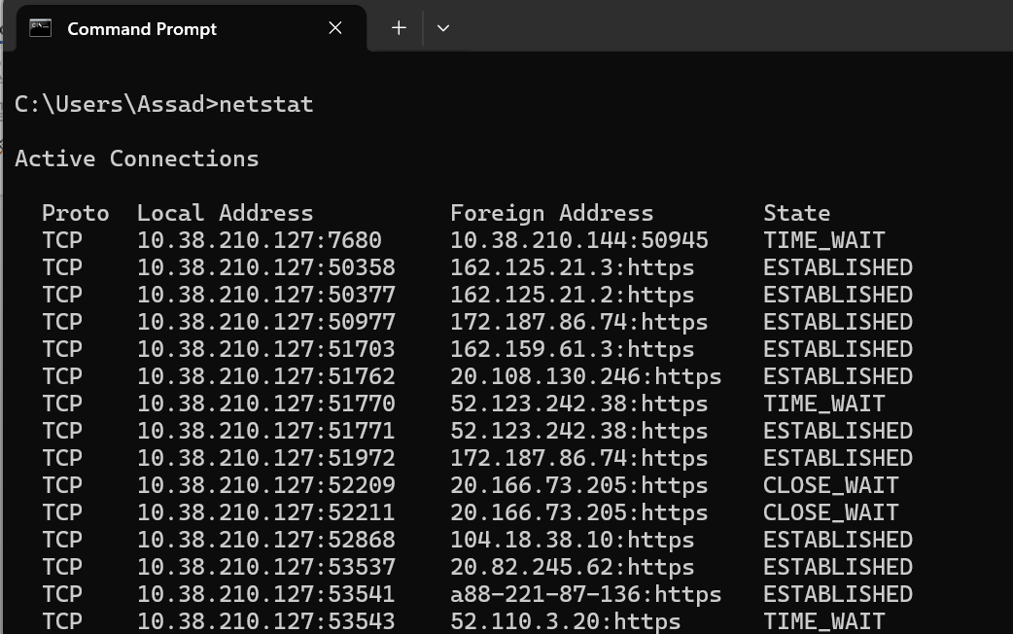
Figure 13: Image showing command prompt: netstats

Example 9:
the command prompt systeminfo is shown below and the output shows the software and hardware information all in one place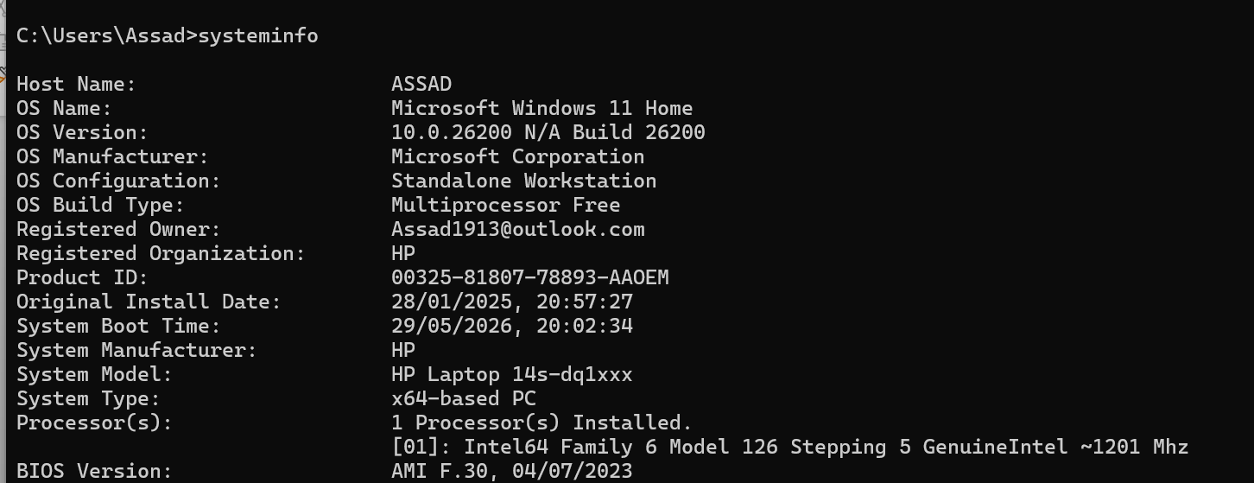
Figure 14: image showing command prompt: systeminfo

Example 10:
This command prompt tasklist is shown below and the output shows all the active tasks on the computer.
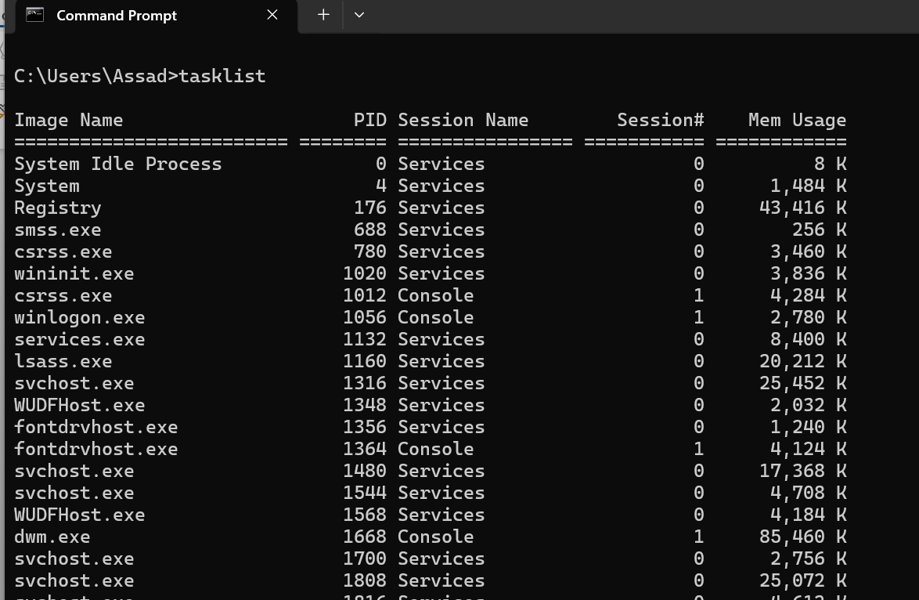
Figure 15: Image showing command prompt: task list

Use of Linux OS CLI commands
The use of Linux CLI (command Line Interface) is used to manage directories, files, users, permissions, software installations, and system configurations (4). The use of these makes Linux highly efficient in system administration, automation using scripts, troubleshooting and even remote administration form servers anywhere.

Example 1:
The command prompt pwd shown below shows the output of the full address and location, presents the working directory
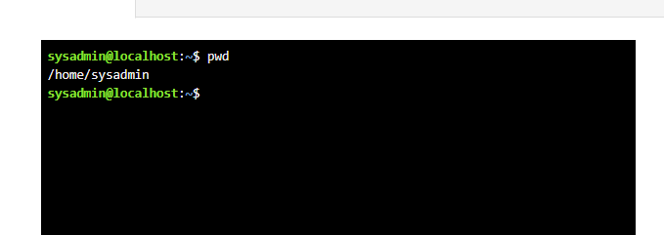
Figure 16: image above showing pwd command

Example 2:
This Command prompt su shown below shows the output of how can you log in to another user account or switch users. The output shows the different accounts.
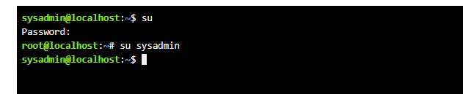
Figure 17: This image above shows the use of the command su

Example 3:
The command prompt ls shown below. This output shows the list of files and folders. Linux uses colour codes, for example for folders its is Blue, White for Files and Bright green for applications
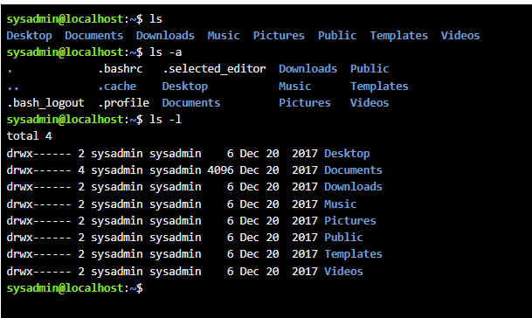
Figure 18: The image above shows the command ls ls -a (which means all) and ls -l (which means list)

Example 4:
The command prompt cd shown below shows the output of how to get into a folder
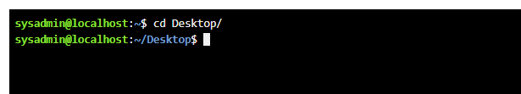
Figure 19: This image shows the command cd Desktop

Example 5:
The command prompt mkdir shown below, shows the output of how to create a new folder, it is the same command used in windows and ls is used to check the folder has been created
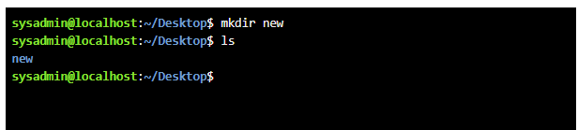
Figure 20: The image above shows the command mkdir

Example 6:
The command prompt rmdir shows below, shows the output on how to delete an empty folder, it is also the same command used to delete folders in windows, if the folder has any content, it won’t delete it.
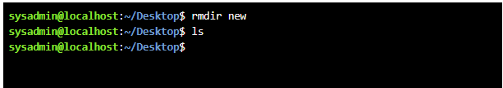
Figure 21: This image above is showing the use of the command rmdir and ls to check the folder has been deleted

Example 7:
The command prompt touch shown below is used to create a file; with Linux you must specify what file you want to create as shows below with text new.txt. This will create a text file, if you want an image file you should type the command as touch new.jpg
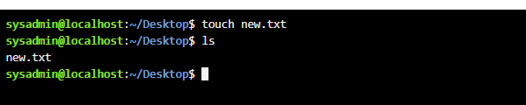
Figure 22: This image above is showing the use of the command touch new.txt to create a text file and ls to show the file exists.

Example 8:
There are two command prompts used in this example, the first one is echo which allows you to write in a new file and the second command which is cat allows you to read what is in the file
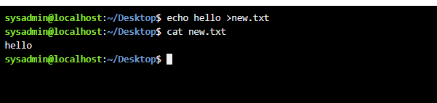
Figure 23: The image above shows the use of two commands echo and cat

Example 9:
The command prompt ifconfig shown below, shows the output of the internet configuration, in windows it is ipconfig
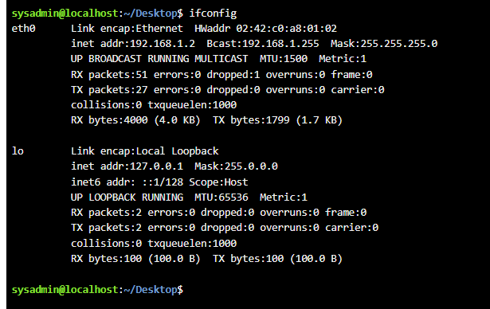
Figure 24: This image above shows the command ifconfig

Example 10:
There are two command prompts shown below the first one is whoami, it shows which user you are logged in as and the second prompt date, shows the date without leaving the screen.
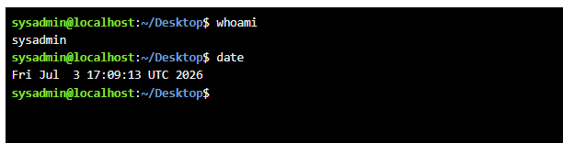
Figure 25: This image shows 2 commands in use, the first whoami and second the date.

Use of Windows OS scripts
Batch scripting for Windows OS is a text file that contains commands which will be run through the windows command interpreter (3). This type of script automates the tasks which may be done repeatedly, like managing files, installing software programs, making backups and other maintenance processes.

Example 1:
The example below shows the use of BATCH- the first thing you must do is save the file in a location on the computer, the file to be saved as a BATCH file as we are creating a script and then open application Notepad++. Write out the script as shown below we wrote a script to make a basic calculator to add numbers together.
First, every BATCH file starts with the 1st step which is @echo off for it to look neat if you don’t use this first step on command prompt it’ll show the code then output which looks messy therefore always start with this step.
The 2nd,3rd and 4th line you start with the grammar in this case its set, then you must set up the variable, the variable used is num1, num2 and num3. The /p shows the value comes from the user.
The 5th line the value is coming from the system not user therefore /a is used, to add all the numbers together.
The 6th line is a print command echo which shows the total value to the user of the sum they have requested
The 7th line the command pause allows the user to see the total otherwise the system will run the script and close the file, so the pause allows the user to view the answer. As a result of the pause, you see the sentence ‘press any key to continue’ in figure 27.
Once the script is done save the file. And then once saved go back to original file where file was saved and run program. This will bring you to the second image (Figure 27) below. once you click on file a blank page will show up with the first command e.g. Enter the first number etc. The output shows the code working asking the user to provide two numbers and providing the sum of both numbers at the end.
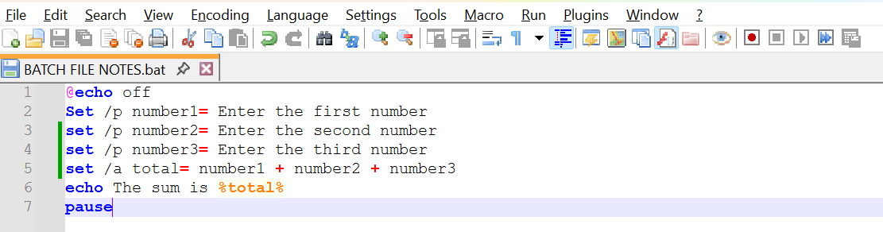
Figure 26: image shows BATCH code

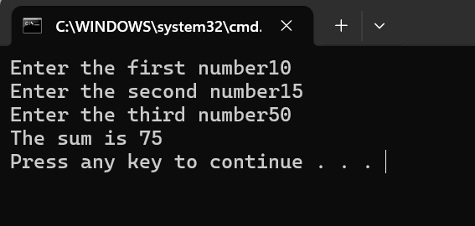
Figure 27: Image above shows code working on file

Example 2:
This is another concept called conditionals; first thing is to save the file again similar to example 1 making sure the type of file is saved as BATCH.
As shown in example 1 the first step is to set the command echo off for the code to look clean.
The 2nd line you start with the grammar in this case its set, then you must set up the variable, the variable used is number. The /p shows the value comes from the user. In this case it is asking for the user’s marks
The 3rd line is set as a conditional prompt; it can be true or false which is why prompt used is if. The command means if the marks are greater than 50
The 4th line will print the results based on the users input if the marks is over 50 it will print’ congratulations you’ve passed’
The 5th line the condition else will only work if the condition in line 3 is false, so if the user’s marks are below 50, they will get the message ‘better luck next time, you Failed’. The last line again is same as example 1 pause lets the user see the outcome of the result. These outputs are all shown in Figure 29.

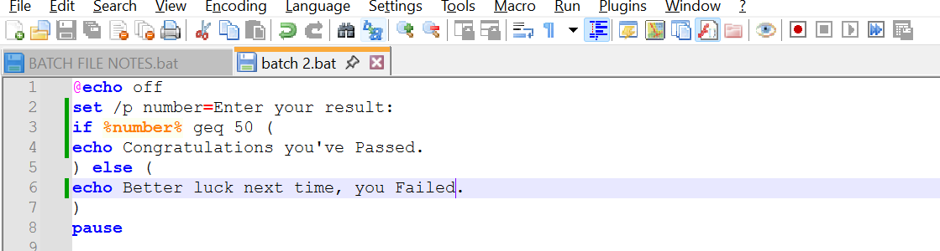
Figure 28: this image shows script on BATCH file

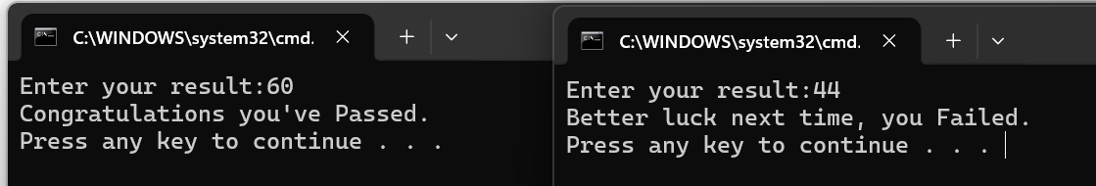
Figure 29: This image shows the code working on Command Prompt showing both exams.

Use of Linux OS scripts
BASH scripting refers to automation of tasks in Linux using BASH shell, Bash scripting helps users perform activities such as command running file management, backup scheduling and application configuration (4). BASH scripts increase efficiency, it minimises human errors, guarantee consistency in the performance of repetitive tasks, and make Linux system management easier.

Example 1:
The example below shows the addition of three numbers as a script. The first step in Linux is to create a file which is shown below in figure 31 called nano.script.sh. This will take you to the notepad Linux uses to write the script which is shown in figure 30.
In the first line like Windows Linux uses the prompt echo to type text so that the user knows what they need to do first in this example they need to enter the first number.
The second line the prompt is read which shows the user the n of the number they have typed on the screen. This step is repeated twice more in the example below.
The fourth prompt changes to total as now the system needs to know what to do next which is to add all the numbers together. Finally echo prompt is used again to show the sum of the total to the user. This file is then saved by clicking the ^X button and takes you back to the command prompt screen as shown in figure 31.
The first thing to do to test the prompt is to change the status of the file to a folder this is done first by the prompt ls to see if the file is present which it is in white. The white colour shows us that it’s still a file. The second prompt used is chmod +x and file name, this prompt is used to convert the file into a folder, and we can check that by using the prompt ls again. This time the name of the folder will show up in green which confirms it has been converted into a folder. Then using the prompt ./folder name we can test out the script. The output of the script is shown below on figure 31.
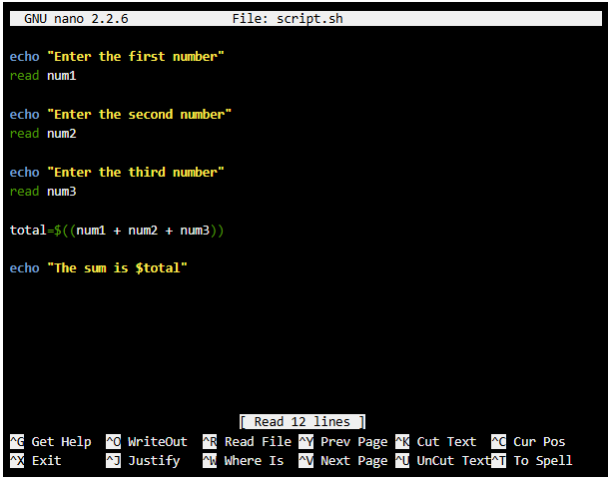
Figure 30: The image above shows the script

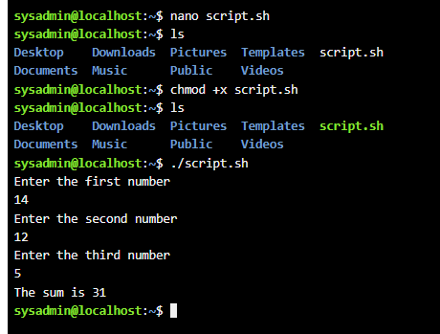
Figure 31: This image above shows the file changing into an application to run the script

Example 2:
This example is showing a loop, to do something multiple times. The script asks the user how many cricket score cards they would like, then we ask the script to count making the value into a variable. We are using the prompt ‘for’ as the loop and used a counter i. the counter is set at 1 as its condition. The semi column sets the start of the count, now we need to instruct where to stop. The stopping condition is to keep it running if the value is equal to or less than i (which is the value of i). the loop is between the word do and done. Echo is the value of i. i++ is the instruction to increase i by 1 each time.
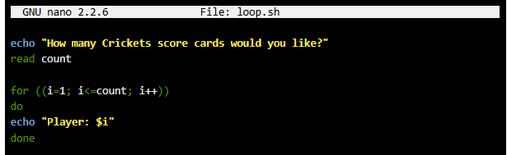
Figure 32: This image is of the script

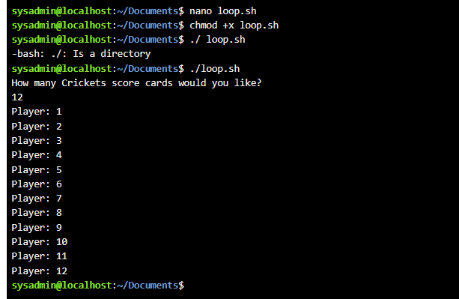
Figure 33: This image is of the output to run the script

Conclusion
This has been an interesting learning experience for me; I have learnt more about windows management systems and have also found learning about Command Line interface very intriguing as I haven’t come across it before. Learning about windows and Linux system has been enjoyable and very educational for me. It has shown how the user’s efficiency can be increased by using such tools with very small margins for errors. My interest in both these systems has peaked and I look forward to more independent learning and improving my skills on both systems. This course has also shown me a side to computing I have never considered before as a career option.

References
- B. Dauti, Windows Server 2022 administration fundamentals: a beginner’s guide to managing and administering Windows Server environments, Third edition. Birmingham: Packt Publishing, 2022.

- E. Bott and I. Pearson Education, Windows 11 inside out. Hoboken, New Jersey: Published with the authorization of Microsoft Corporation by Pearson Education, Inc., 2023

T. Dawson, “Introduction to the Windows Command Line with PowerShell,” The programming historian, no. 5, July 2016, doi: 10.46430/phen0054.

- G. McWilliams and linkedin.com, Carpenteria, CA. Linux System Engineer: Bash Shell Scripting for Automation., (2019). [Online Video]. Available at: https://www.linkedin.com/learning/linux-system-engineer-bash-shell-scripting-for-automation?u=77966930&auth=true

Appendices
Online Course name: Linux Unhatched

Figure 34: Certificate of completion

