Play

The Welsh Government Play Policy (2002) defines play as ‘children's behaviour which is freely chosen, personally directed and intrinsically motivated. It is performed for no external goal or reward and is a fundamental and integral part of healthy development - not only for individual children, but also for the society in which they live.’

Conway (2008) agrees, stating that self-directed play is as much as possible freely chosen, personally directed and intrinsically motivated

Housley-Juster (2015) includes in the idea of self-directed play, the necessity for children to make up their own rules, she goes to say how child directed play ‘fosters the development of the whole child’ enhancing the child’s ‘cognitive, social, emotional and physical skills’ and also feeds into academic achievements.
Housley Juster (2015) goes on to say that self-directed play can also help children’s problem solving skills, help them to asses ‘healthy risk’ appropriate to their development, find creative ways to understand how the world works in ways that interest them personally. She also says it helps children learn to effectively communicate their feelings and understanding that others have a different point of view. Child directed play also helps children enjoy self discovery, following their own creative ideas without ‘fear of failure that usually arises when there is one, predetermined way to be ‘right’ or ‘win’.

Houghton and Worroll (2016) state that in forest schools, free play allows independence and gives children space and freedom to use imagination and enhance social skills, while activities that are ‘guided by adults’ help children learn new physical skills, build new words and vocabulary, and actively improve the ability to manage risk. Adult guided activities can also help children create positive identities and lay foundations for learning throughout their life.

Siraj-Blatchford et al (2002) and Sylva et al (2004) (cited in House, 2011, p.205) also agree in both types having good aspects, they state that ‘during the last 20 years practitioners have been advised that there should be a balance of adult led and child led activities.’ They go on to say this balance is best achieved when the practitioner knows the child well and has a good communication with the child’s parents.

Long-Breipohl (2010) makes the point that self-directed play is unfortunately ‘disappearing fast from early childhood all over the world’. They say that children playing unsupervised outside is becoming increasingly dangerous, children are now often supervised by adults whilst doing adult-led activities.

Gill (2009) disagrees with this statement, he states that research shows that the crime rates have not increased significantly, but the media coverage has recently put all child related crime on the front page, which increases people’s fear, therefore leading to less outdoor play and less children walking to school (8 out of 10 eight year olds in 1971, to less that 1 out of 10 walking to school in 1990).

Crisis in the Kindergarten (2009) agrees that self-directed play is seen as less important than it should be. Their research found that studies of American kindergartens shows that self-initiated play is now a minor activity, given on average only thirty minutes a day, whereas tests and test preparation, especially for maths and literacy are taking between two and three hours a day. Likewise, Long Breipohl (2010) believe that play is not given enough importance in the curriculum, therefore not enough time in the day.

Sylva et al (2004) and Siraj-Blatchford et al (2002) (cited in House, 2011) say that to get a good balance of adult led and child led play, the practitioner needs to know the child well, and have good communication with the child and their parents. The practitioner should also possess the following qualities:
- The ability to observe and listen, to understand well from the child’s play and other communication whether the child is achieving things, or causing concern.
- They can sensitively intervene in play, with suggestions that the child is able to incorporate or not, such as ideas or props, making sure not to impose their views on the child
- The ability to join play without dominating, following the lead of the child
- Only intervening in play if they see something dangerous or harmful, and intervening in an empowering way, explaining carefully rather than crushing play with rules.
- The ability to reflect on their own adult influence on children’s play

Brown (2010) suggests that the concept of play might be difficult for adults to understand. Children are born knowing how to play intrinsically, which helps them learn about the world. As adults there is a stigma involved in play- ‘We learn to feel guilty for playing’ and deem it unproductive (Brown, 2010). The play that remains stigmatised in the lives of adults is ‘league sports, mostly very organised, rigid and competitive (Brown, 2010). ‘We strive to always be productive and if an activity doesn’t teach us a skill, make us money or get on the bosses good side, then we feel we should not be doing it’ (Brown, 2010). In this respect adults might find it hard to allow children to play as they want, and without the correct knowledge about the importance of play, may try and intervene to make it ‘educational’ thus ruining the benefits of self-directed play, replacing it with the rigidity of adult led play (Brown, 2010).
Knight (2011) has a different opinion on the role of the practitioner. She describes it as a unique role as they are able to ‘mediate pressures from family, culture and community’ allowing them to maximise their potential at a difficult time in a child’s life then they are developing self-awareness, self-esteem and self-confidence all at the same time.

Article 31 of the UNCRC gives the child a right to play (UNICEF). The EYFP states that ‘We aim to ensure that all children and young people: have access to play, leisure, sporting and cultural activities’ Welsh Government (2015). House (2011) Believes that ‘as long as the EYFS exists it involves government control in the background, which will inevitably corrupt everything by its inappropriate way of thinking’

House (2011) describes a spectrum of opinions on how adults can support play, ranging from the view that ‘children should be free to play without adult involvement or interference’ while others claim that it is important for adult observation of play to safeguard it, and extend play using skilful intervention, props and ideas, while allowing the children to remain in control (too much too soon). According to House (2011), others believe that teachers can ‘plan playful activities which they lead and direct’ is not child selected, directed or led, so no longer even counts as play no matter how skilful the practitioner is. Meanwhile, the lack of existing evidence that pretend play helps development should not be taken as an allowance for school programs to employ traditional teacher-centred instructional approaches that research has clearly shown are inferior for young children (Lillard et al., 2012). The hands-on, child-driven educational methods sometimes referred to as ‘playful learning’ (Hirsh-Pasek et al., 2009) are the most positive means yet known to help young children’s development.

One type of play- rough and tumble play- is defined by Frost (no date, cited in Long-Breipohl, 2010) as friendly or play fighting, and this definition may be extended to loosely include any active play that includes body contact amongst children. Long-Breipohl (2010) state that rough and tumble is mostly seen in children between the ages of 3 and 6 and that ‘Often there is not enough opportunity for positive and safe physical play experiences’. Furthermore, Almon (2013) talks about the lack of physical play today, children that used to play outside and maintain normal weight, now remain indoors, are barely ever seen riding their bikes through town, even in safe neighbourhoods, at the same time the obesity rate of children has dramatically increased.

According to Brown (2010) rough and tumble play is not just important for physical development, but that evidence shows it is beneficial for many aspects of the child’s development, including ‘maintenance of social awareness, cooperation, fairness and altruism.’ Long-Breipohl (2010) points out that fathers are usually good instigators of rough and tumble play at home, which is good as long as they make sure it is safe and non-competitive.

At schools and preschools, however, adults are usually unappreciative of rough and tumble play (Brown, 2010). Anxious parents and teachers see hitting and being rough not as play but ‘as a state of anarchy that must be controlled’ (Brown, 2010). Brown (2010) states that development benefits of rough play are shown clearly in research into play deprivation. The lack of this play in childhood, that helps with understanding of social mastery, can cause ‘adults to have poor control of violent impulses later in life’ (Brown, 2010). Studies of young murderers in Texas show the correlation between lack of rough and tumble play compared to non-murderers (Brown, 2010). The fact that ‘Many adults, including teachers are not able to distinguish between play fighting and real aggression, and prohibit any form of wrestling, shouting and make believe aggression’ suggests that in these cases the play would have been child-initiated as it was definitely not adult led (Brown, 2010). Donaldson has shown that the positive social effects of rough and tumble, which he identifies as ‘the most fundamental form of play’ as it helps form the beginnings of loving relationships, rough and tumble begins when children are still very young, in the form of playing with hands and feet and bodies, and forming loving bonds with parents through touch, care and love. Long-Breipohl (2010) agrees, stating that this play is essential for ‘building healthy self-confidence and loving relationships with others’ and not only helps develop movement and control over limbs, but also promotes feelings of wellbeing, and feeling at home in your body.

Another type of play is Imaginary play.
Fantasy and Imaginative Play: Children act out what is in their mind. These can be things children have experienced through the media, or something that they see in real life and imagine what it is like
(Hughes, 2006)

Smith, Cowie and Blades (2001) say that fantasy play can be seen from twelve months, Fenson and Schell (1986) wrote about the three trends they found in pretend play: Decentration- child and doll pretends to drink, from empty cups. Decontextualization- child pretends to drink from an imaginary cup, or uses another object to represent a cup. Integration- child pretends to feed dolls, then wash them and put them to bed. Smith, Cowie and Blades (2001) state that early pretend play relies heavily on objects, which adults can provide. Adults can also ‘help the process, by modelling or prompting the pretend use’ for example using something to represent something else (Smith, Cowie and Blades, 2001). Paley (2004) ‘there is no activity for which young children are better prepared than fantasy play. Nothing is more dependable and risk free, and the dangers are only pretend’. Brown (2010) highlights how imagination is a ‘powerful human ability’ and that children naturally engage in imaginative play and can freely flow between real-life and pretend. Furthermore, Brown (2010) suggests that children use their imaginations to help work through emotional and cognitive changes as they develop, and that it is also is critical for developing empathy, understanding, trust of others and the ability to cope.

Risk

According to Play Wales (2018), for children, seeking and experiencing risk is a natural part of being a child, it helps them to grow up, and learn how to ‘survive and find their way in the world’ they go on to say that if we don’t give children these risk experiences the lack of challenge may lead them to seek out risk on their own in ways that are less appropriate.

Tim Gill (2010) agrees, he gives us four reasons to support the role of risk in childhood. The first one is that it feeds children’s innate need for risk, meaning that it prevents them from sourcing their own greater unmanaged more dangerous risks for themselves. the second reason being risk helps children learn from a young age how to assess and manage risk. The third reason is health and developmental benefits, the fourth is that risk is character building, and enhances qualities such as resilience and self-reliance.

Knight (2011) agreed and thought that if children are trusted with reasonable risk, they will not need to find greater risks themselves. Therefor she recommends activities such as duke of Edinburgh award for older children, and for younger children a pile of logs is their mountain.

Haidt and Paresky (2019) point out that taking risks and learning to ‘master small dangers’ is vital for the development of their social and physical capability, and experiencing risk extends their coping ability. Brussoni et al (2015) state that risky play has diminished with the increase of worries regarding safety for children. Haidt and Paresky (2019) go on to say ‘ we may observe an increased neuroticism or psychopathology in society if children are hindered from partaking in age adequate risky play’

Almon ( 2013) also believes that children use risk to ‘extend their abilities through risky play, they learn to master challenging environments’ she suggests that they usually know how far to go without being dangerous or causing themselves harm.

Forest school usually acknowledge the importance of risk. Worroll and Houghton (2016) says they aim to ‘maximise social, emotional and developmental potential by allowing children to manage risk, have more independence in guiding their own learning, achieve goals, be active, play and learn through direct experience within nature.’

Risk-taking is considered to have further benefits, which contribute to the development of desirable personality traits, including creativity (Susa and Benedict in Ball, 2002).

Knight (2011) suggests that a positive outcome of risk opportunities are they engage children ‘at a sensory and intellectual level with their environment.’; the additional benefits are a chance to interact with their environment early on, mostly important because we live in ‘a world where climate change will be a real issue within their lifetime’

Risk is supported by policy in the following ways.

EYFS (2012) effective learning includes
- ‘ support for children to take risks and explore,
- encourage children to try new activities and to judge risks for themselves,
- always respect children’s efforts and ideas, so they feel safe to take a risk with a new idea

House (2011) suggests that risk aversion is not addressed in the EYFS and is accidentally encouraged by the policies emphasis on keeping children safe.

Lindon (2011) says that parents and practitioners are equally responsible for teaching children how to keep themselves safe step by step, and to give ‘well informed safety messages to children’ however she points out adults can be misled by the media about the rates of everyday risk.

Somerset County Council (no date) states that risk assessments are used to manage risk, but they suggest a new approach to doing risk assessments -reflect on ‘whether risks outweigh the benefits’ to come up with an idea of what is best for the children, rather than removing all risks. This risk benefit assessment examines benefits, risks, local factors and makes decisions such as: ‘do nothing, monitor the situation, mitigate or manage the risks, remove the risks’. Play wales( 2018) also advocate risk-benefit assessments.

Play wales says that ‘parental fear is often one of the largest barriers to children playing out with their friends.’ And House (2011) agrees, he states that caregivers and teachers are often ‘controlled by local authorities with a (sadly realistic) fear of being sued by the parents of any child who gets hurt’

Knight (2011) states that adults and practitioners can often get anxious about the increase of outdoor play, although Play Wales (2008) states that the likelihood of a capable practitioner being sued for negligence is very low because there should always safeguards in place to protect the children and adults.

Knight (2011) suggests that to help practitioners plan more adventurous play, first audit all the activities you currently do outside, identifying activities that allow experimentation and development of motor skills, looking at children’s developmental stages, and ‘which activities are in their zone of proximal development , and need an adult to scaffold success.’ She goes on to say that even settings with no outdoor area, can use outings to offer needed risk, or even for the right age group making a sandwich is a risk as they learn to use tools and look after themselves.

Dweck (2000) suggests that risk can have positive implications for children’s developmental needs. She has concluded that risk permits children to push themselves to the limits of their capacities and encourages them to progress. Drawing on her own and other people’s research, she suggests that rising to challenges, embracing risks and taking an ‘I can do it’ attitude, are important characteristics of effective learners.

Risk Assessment
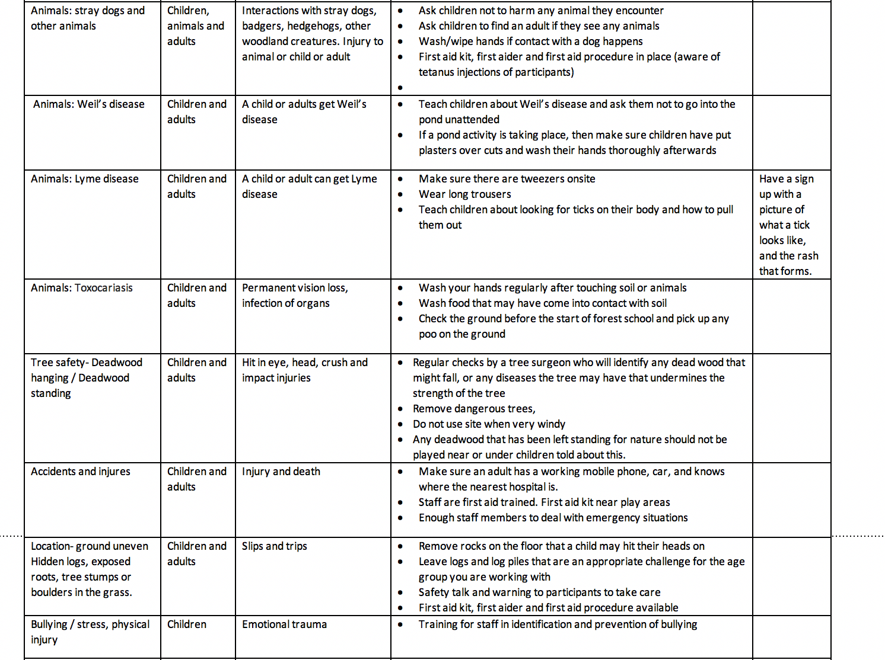
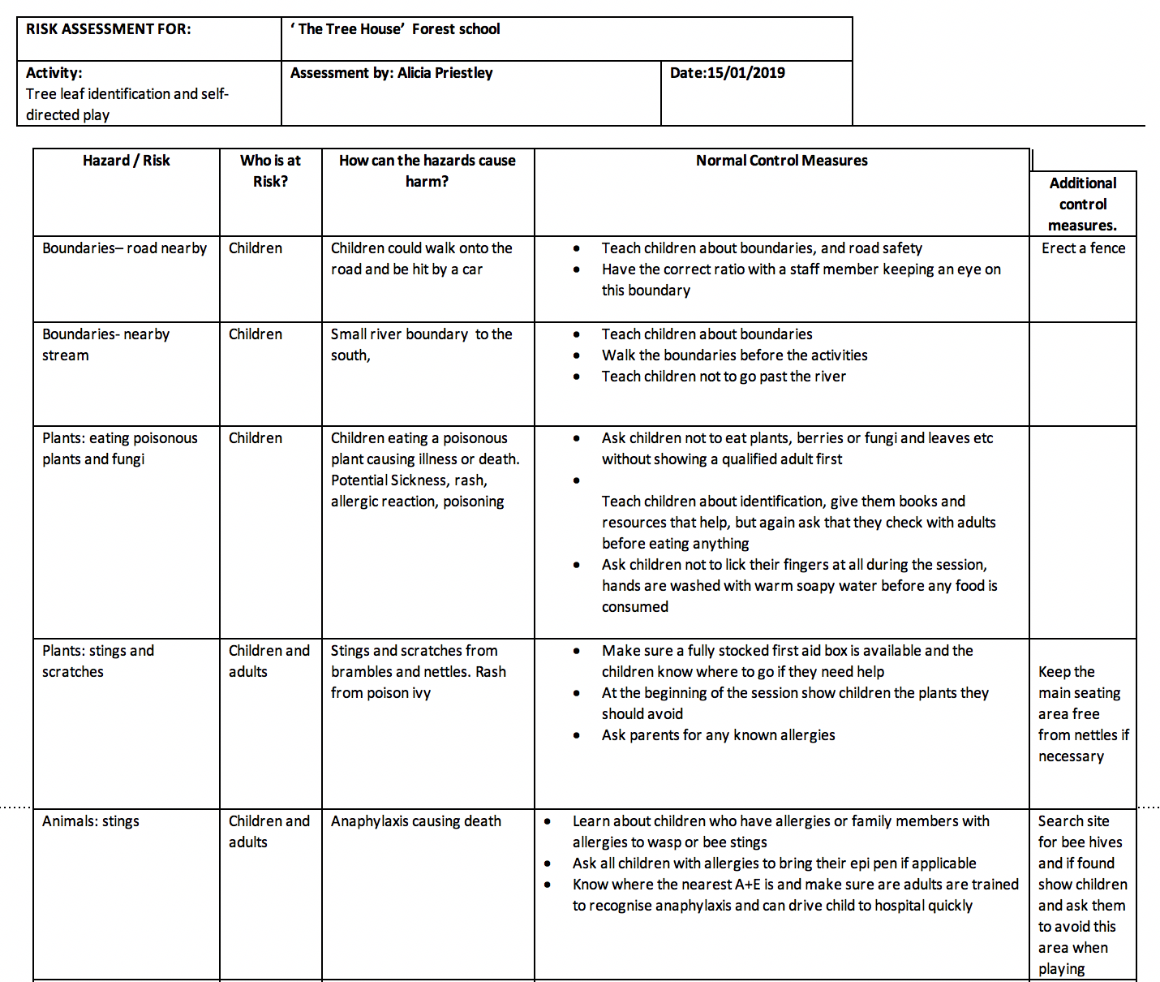
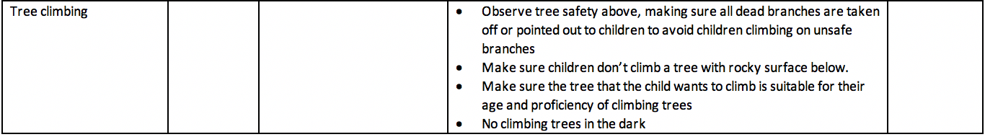
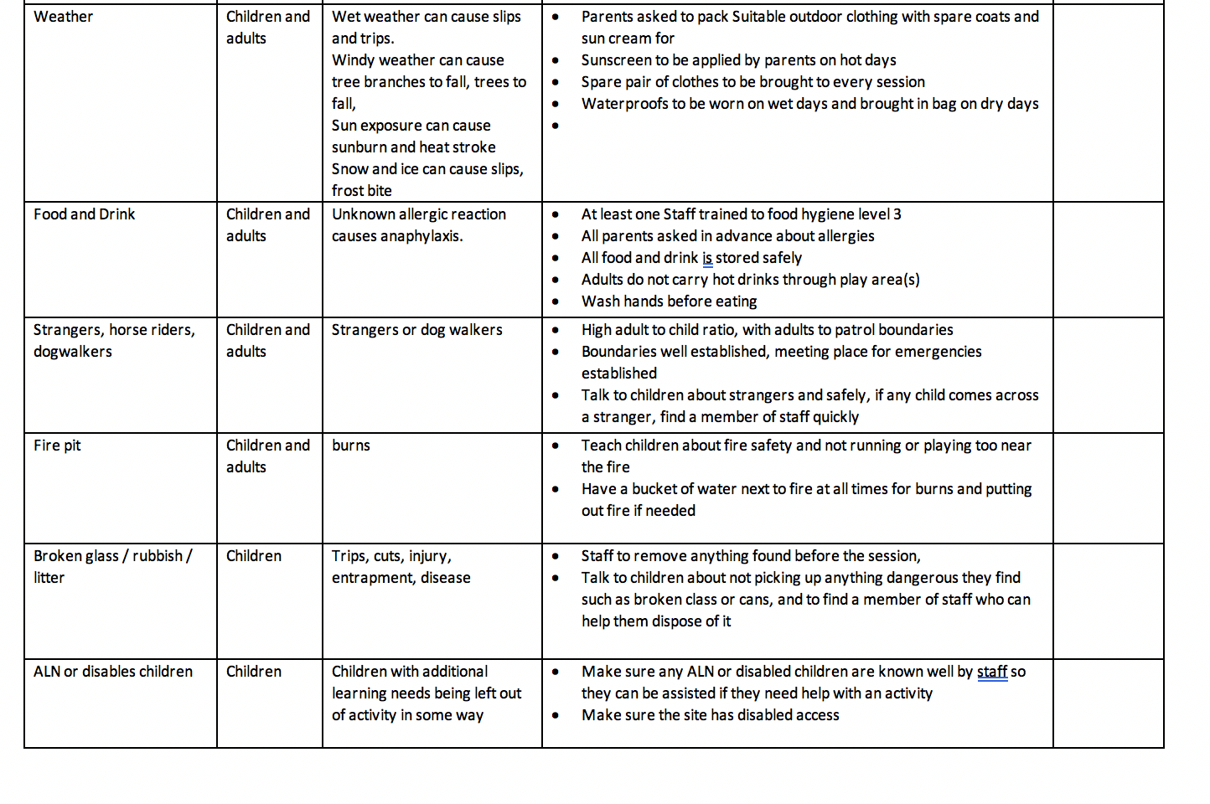

Reflection

When I started to think about writing a risk assessment for this activity, I first stood in the site of the activity and imagined the event from start to finish. I thought about the physical objects that we needed and that were in the way. I sat on the floor to gain perspective from the height of children. From this position I began to write down the risks I thought of in order of the activity. Starting with low risks that were likely, to the high risk unlikely risks. I wrote notes while onsite and took pictures so I could look back after a few days. When I had thought of everything, I asked a few people their opinion on the risks including a tree surgeon, who suggested several things related to tree safely that I would not have known. I then finally looked at a few forest school risk assessments online to check I hadn’t missed anything important.

I was looking forward to doing the risk assessment. As I was an event production manager for 5 years, I am used to writing long risk assessments for the council and funders to check the viability of an activity. I have never done a risk assessment for an early years activity before, so I was looking forward to applying my knowledge to a new activity. I knew that a risk assessment for this forest school activity was very important, as woodland locations can be very unpredictable and potentially dangerous

My first thought when I had read the finished risk assessment, was concern that I had written too much. The risk assessments I looked at afterwards online were short and missed several things out in my mind. My risk assessment was longer and more detailed. But on reflection I would rather know that I have everything covered, which gives me security as a practitioner that the activity that I am offering is safe. I whittled it down by cutting any repetition, without losing content, to make sure it’s not too long for someone to read. I think overall this is a good risk assessment, it includes several things that are unlikely to happen but have happened to me personally before, including surprise anaphylaxis from a wasp sting. This experience has given me insight that others may not have thought of. I think it was a good idea to ask others their advice about the risks they can see onsite, as they have input a lot of information from their experience that I may not have thought of. It was an especially good idea to ask a tree surgeons advise as he gave some great information about things that need to happen onsite to keep the trees a safe play space for children. The positive aspects of the risk assessment is that its in-depth and thorough. The negative aspect is that a risk assessment for the outdoors could be endless, and the space here is limited as I would want a risk assessment to be short enough for someone to want to read it. Over long documents often can be ignored.

Analysis

The play safety forum cited by Almon (2013) 'play provision aims to manage the level of risk so that children are not exposed to unacceptable risks of death or serious injury.’ This was my starting point to think about safeguarding while writing my risk assessment. First I identified the risks that could cause death and try to limit the danger while not limiting the activity.

Play Wales (2018) states that ‘ when completing a risk assessment for a play activity, reflect on whether the risks outweigh the benefits or vice versa to help you come to a conclusion that will be in the best interest of the children. This is known as a risk – benefit assessment.’ This risk benefit assessment examines benefits, risks, local factors and makes decisions such as: ‘do nothing, monitor the situation, mitigate or manage the risks, remove the risks’.

I used this risk benefit idea throughout my risk assessment. I noticed that some risk assessments for forest school online had cut activities such as making fires and climbing trees. I believe the benefits of these outweigh the potential risks. As my risk assessment points out, if a wasps nest were found, I would have to weigh up if it is better to remove it or leave it. I have chosen here to leave it but tell children where it is, and show them but ask that they leave it alone. I think it is more beneficial for children to know what a wasps nest looks like so they don’t get stung in the future when they are not in the presence of an adult who can watch out for any signs of anaphylaxis with the ability to drive them to hospital

Lindon (2011) says 'any adult involved with children should of course be concerned for their safety and well being... however a safe enough environment should not distort daily life for young children by removing a wide range of interesting experiences and resources'

Following this logic, we have removed the things we think are dangerous risks without compromising the child's ability to interact with the world and learn how to take care of themselves. For example, I noticed that in many of the forest school risk assessments I have read, they talk about removing stinging nettles and brambles totally to make sure children don’t sting themselves. This is taking away a range of 'interesting experiences and resources' as children will come into contact with stinging nettles regularly in the countryside. It is also putting the child at risk in future of being stung by a nettle as they don't know what it looks like. As a compromise, my risk assessment includes teaching children about stinging nettles and brambles, including what to do if you get stung, how to look for a dock leaf. To be balanced I would also do a session on the upsides of these plants, where we could pick and eat blackberries from the brambles, and make nettle tea.

Research indicates that a lack of supervision plays a key role in such child- hood injuries therefor a common control throughout my risk assessment is making sure there is a high enough staff ratio
‘Bad risks and hazards are those that are difficult or impossible for children to assess for themselves, and that have no obvious benefits. These might include sharp edges or points on equipment, weak structures that may collapse, and items that include traps for heads or fingers.’ (Play England 2007)
Almon (2013) agrees, she says ‘hazards as contrasted with a risk, has been defined as something that the child cannot be expected to see and therefor cannot avoid’

An example of my risk assessment removing a hazard, is that children are permitted to climb trees, but the dead branches will be removed, as children climbing will not expect a branch to snap under them, it will possibly therefor not teach them anything and this would be very dangerous. There is an example of a compromise between safeguarding and overprotecting.
Voce ( 2008) points out that ‘half of 7-12 year olds told us that they are not allowed to climb a tree without adult supervision or have been stopped from climbing trees because its considered too dangerous’
Wandsworth council recently banned climbing trees altogether, playing cricket and flying kites in their parks, in fact climbing up a tree without a ‘reasonable excuse’ could lead to a £500 fine in their 39 open spaces in London.

This overprotection is taking a normal part of childhood away from children, it is not allowing children to test their limits and develop greater motor skills, and they miss out on the ‘positive experiences’ the risk taking brings as well as the ‘sense of achievement, and self esteem.’ (Beate, Dandseter and Sando 2016)

In conclusion, I thought that the risk assessment and activity were a good choice, but I could perhaps introduce more risk into the activity, with added benefits. For example, we could show the children how to make a fire or use tools, as even though these are supervised, this could increase self-esteem and competence and risk. a self-directed play example of a more risky activity could be playing near dangerous elements, for example they could put wellies on and play near the small stream at the boundary, which would teach them about water safety and is a type of sensory play if they use mud and water.

References

Knight, S (2011) Risk and Adventure in Early Years Outdoor Play. London: Sage publications
Blundon, M (2018) ‘ London borough of Wandsworth plans fines of up to £500 for climbing treesm, flying kites or playing cricket in parks’ Evening Standard. Accessed 02/01/19 Available at : https://www.standard.co.uk/news/london/london-borough-of-wandsworth-to-issue-fines-of-up-to-500-for-climbing-trees-flying-kites-or-playing-a3768126.html
House, R (2011) Too Much Too Soon: early learning and the erosion of childhood. Glostershire: Hawthorn Press

Housley-Juster, A (2015) The amazing benefits of self directed play. Available at: http://www.beactivekids.org/assets/pdf/MorganLeichterSaxby.pdf (a

Long-Breipohl, R (2010) Supporting self-directed play in steiner Waldorf childhood education. New York: Waldorf early childhood association of north america

Lindon, J (2011) Too safe for their own good. London: NCB

Gill, T. (2009) No fear: Growing up in a risk averse society. London: Calouste Gulbenkian Foundation.
Lillard, A.S. et al. (2012) ‘The Impact of Pretend Play on Children’s Development: A Review of the Evidence’, Psychological Bulletin, Volume 139, Number 1, pp.1–34.

Hughes, B. (2006) Play: Types linked to the revised EYFS Areas of Learning. Leeds: Leeds Play Network.

S, Knight (2011) Risk and adventure in Early Years Outdoor Play: Learning from Forest School. London: Sage publications

Worroll, J and Houghton, P (2016) Play the Forest school way. London: Watkins publishers

Brown, S (2010) Play. New York: The Penguin Group

Miller E and Almon J (2009) Crisis in the Kindergarden why children need to play in school. Collage Park: Alliance for Childhood

Voce, A. (2008) ‘Risky play prepares kids for life’, The Guardian, 6 August.

Haidt, J and Pareksy, P (2016) ‘ By mollycoddling our children, we’re fueling mental illness in teenagers’ The Guardian, 10 Jan

Bazley, S ( 2018) A Playworkers guide to risk. Play wales
Brussoni, M et al (2015) ‘ What is the Relationship between Risky Outdoor Play and Health in Children? A Systematic Review’ international Journal of Environmental Research and Public Health, 12(6), pp.6423-6454. Accessed 10/01/19.
Available at : https://www.ncbi.nlm.nih.gov/pubmed/26062038

Smith, P, Cowie, H and Blades M (2001) Understanding children’s development. Oxford: Blackwell publishers.

Almon, J (2013) Adventure the value of risk in children’s play. Annapolis: Allicance for childhood

Somerset County Council. (No date) The Benefits of Risky Play. Accessed 20/01/19. Available at www.somerset.gov.uk/EasySiteWeb/GatewayLink.aspx?alId=43985

Gov.uk (2010) The United Nations Convention on the Rights of the Child Available at: https://www.gov.uk/government/publications/united-nations-convention-on-the-rights-of-the-child-uncrc-how-legislation-underpins-implementation-in-england [Accessed 19 jan. 2019].

Beate, E, Sandseter, H and Johan Sando, O (2016) ‘ We don’t allow children to climb trees’ American Journal of play, volume 8, number 2

