.

An Investigation into Enrolment Systems for A Levels
At NPTC Group of Colleges

Presented by
Oliver Smith (219240)

Supervisor: Jeanette Adams
Second Marker: John Williams

Project submitted as part of the requirements for the award of BSc (Hons) in Computing and Information Systems

2017/2018

Table of Contents
1. Abstract 4
2. Introduction 5
2.1. NPTC Group of Colleges 5
3. Research and Review of Literature 7
3.1. Introduction 7
3.2. Enrolment System Definition 7
3.3. Enrolment in Education 7
I. Who uses Enrolment Systems? 7
II. Importance of Enrolment 7
III. Proof and documentation required 8
3.4. A Level Qualifications 9
i. Introduction to A Levels 9
ii. Curriculum 9
iii. Studying A Levels 10
iv. A Level Grading 10
3.5. Current UK Legislation and Regulations 11
i. Education System 11
ii. Further and Higher Education Act 1992 14
iii. Data Protection Act 1998 15
iv. Computer Misuse Act 1990 17
v. Education and Inspections Act 2006 17
vi. Higher Education and Research Act 2017 18
vii. The Human Rights Act 1998 18
3.6. Enrolling on A Level Programmes 18
i. Combinations 18
ii. A Level Entry Rules 19
iii. A Level Pathways 20
iv. Linked Qualifications to A Levels 22
v. Available Methods and Tools 23
vi. Ethical Issues 30
vii. Critical Review 31
4. Research and Development Methodologies 34
4.1. Research Methodologies 34
i. Philosophy 34
ii. Approach 34
iii. Strategy 34
iv. Time Horizon 35
v. Data collection method 35
4.2. Development Methodologies 35
i. Timeboxing 35
4.3. Resources 36
i. People 36
ii. Application Packages 36
iii. Programming Languages 36
iv. Database Product 37
5. Design and Implementation 38
5.1. Project Requirements 38
5.2. Diagrams 39
i. Entity Relationship Diagram 39
ii. Data Flow Diagram 40
iii. Flow Chart 41
5.3. Interfaces 43
5.4. Code 46
i. Full screen 46
ii. SELECT 47
iii. WHERE 47
iv. INSERT 48
5.5. Testing 50
5.6. Timeboxing Iterative Methodology 60
6. Evaluation 63
7. Conclusions and Recommendations 65
7.1. Conclusion 65
7.2. Recommendations for Future Improvements 67
8. Reflection 68
Bibliography 69
Appendices 75
i. Appendix I – Declaration 75
ii. Appendix II – Form of Consent 75

Abstract

The aims of this report is to design, develop and implement software that would allow students at NPTC Group to self-enrol onto a course, determined by grades and subject chosen. The objectives include putting together a literature review to research and review:
- Definition of enrolment system – what is it and what does it do?
- How enrolment systems are used in education
- A Levels and Enrolling on A Levels
- UK Legislation
- Available tools, methods and packages available.

The deliverables of the project included:
- Project report
- Enrolment System Software
- Exhibition Board

The major findings of this report was how enrolment systems work in education and how much of an impact they have. A detailed research into A Levels in general has been written and how the current UK law links in with enrolment and education.

Introduction

NPTC Group of Colleges
NPTC Group of Colleges was formerly known as ‘Neath Port Talbot College’, but in 2013 they had a merger with Coleg Powys (1). Since their merger, they have now got a total of nine campuses and covers 30% of the country’s landmass (1). With the two colleges now being merged, they had two different systems. The college currently uses a system which is causing problems due to it repetitive nature and the lack of organisation. The process of becoming a student at NPTC Group include:

Pre-Enrolment
- Apply for a course
- Attend meeting with course leader – discuss the course, predicated grades etc.

Results
- Receive results to see if you met the entry requirements

Enrolment Day
- Collect a second application form
- Complete the application form, questionnaires provided
- Get exam results checked
- Get advice & guidance
- Go to the enrolment admin centre
- Get your details entered onto the system
- Pay for the course
- Get your picture taken and receive student ID card

There are many processes within this system. The student is made to fill out an application form, to show they are interested in studying at NPTC Group and to show the course they wish to apply for. On the day of enrolment, they have to complete that application form again. However, you have got your own application form, where some of your details are already printed onto the form, to save the student some time. Over the years, there has been many issues with staff not being able to find the students application form, so sometimes they will have to fill it out from scratch.

When you go to get your exams checked, there can be up to a 30-minute waiting time as there are many students enrolling at the same time. Another confusing thing about the enrolment at NPTC Group is the fact that during different years, the building you go to changes. For example, one year the entire enrolment took part in G block. In this block, you would do everything from collecting your application, checking your results and getting your student ID card. In recent years, students are made to collect their application forms from the Nidum Arts Centre, then get their results checked over in D block and then walk around to the library to get their information put onto the system, to pay for their course and then get their photo taken.

The aims of this report is to design, develop and implement software that would allow students at NPTC Group to self-enrol onto a course, determined by grades and subject chosen.

Research and Review of Literature

Introduction
A critical review of published work on enrolment provided an essential insight into the past and present techniques and methodologies employed by researchers and authors in academic areas of enrolment systems (2).

Enrolment System Definition
Enrolment is defined as “the act of putting yourself or someone else onto the official list of members of a group, course, or college” (3). This meaning, ‘signing up’ someone to an official course, college or group.
A system is then defined as “a set of connected things or devices that operate together” (4). When it comes to the systems, the “things” mentioned in the definition may include processes.
Therefore, putting them together, an enrolment system is a way of ‘signing’ yourself or someone to an official course, college or group, through a number of different processes.

Enrolment in Education

Who uses Enrolment Systems?
Enrolment systems are a very important within the education field, with lower level education. This can be as small as a tutor business. For example, ‘Tutor Club’ in Neath have got a mini enrolment system where students will enrol to their classes (5). Enrolment is also used in a higher level, such as colleges and universities.

Importance of Enrolment
University of Wales Trinity Saint David (UWTSD) has defined their enrolment as the process through which students will agree to attend the university, agree to follow all their rules and regulations, create student records onto the system (6). They then go on to state that if a student fails to enrol, they will not be entitled to participate in assessments, receive a student ID card or receive course timetables. Without any of these, this would result in the student unable to gain the qualification. There are numerous of other benefits that the student will not be entitled to if they do not enrol such as not receiving student discounts, receive student finance, live in the universities accommodations, access university grounds and they will not receive council tax exception certificate (where appropriate).

Especially with universities and colleges, failing to enrol will have an effect on their loans and grants from Student Finance. According the Student Finance Wales, if a student applies for a grant or loan, then that student must apply for the course and the university or college must confirm their attendance. When the university or college confirms their attendance, this is when records are added to their system and sent directly to the student finance company (7).

Proof and documentation required
Although all universities, colleges and schools may have slightly different ways of enrolling students, they all will follow a similar system. During enrolment, all students are required to bring evidence of nationality and immigration status, therefore if students are a UK national then they will bring their passport. If the student is an EU, EEA or Swiss national then they will need to bring their passport or national ID card. In a scenario where the student is a non-UK, EU, EEA or Swiss national then a passport and evidence of immigration status such as visa vignette in passport and/or biometric residence permit (8).

As part of the enrolment process, the student will need to being qualifications taken to date with proof of grades. Typically, this will be a certified certificate however during enrolment, students may bring their grade slips that are provided on results day. Students are required to provide their national insurance number, to help the prove their identity and to process any tuition fee loans (9). Depending on the course, students may be required to pay fees for the cost of course materials or a DBS check. If the student is aged between 16 and 18, they may need to complete a financial support application form and provide evidence, if they plan on applying for a bursary. Depending on the college/university the student will be able to apply online or face to face. If it gives the student an option to enrol online, then it will require them to scan their evidence onto a computer and upload onto the relevant form. If the enrolment is face to face, then photocopies of the certificates will be made, for the course leader(s) records (8).

A Level Qualifications

Introduction to A Levels
A Level, also known as Advanced Level, is a subject-based qualification awarded as part of the General Certificate of Education (GCE) as well as a school leaving qualification that is offered by educational bodies in the United Kingdom and the educational authorities of British Crown dependencies to students completing secondary or pre-university education (10). It is classed as “a main school leaving qualification” in England, Wales, Northern Ireland, the Channel Islands and the Isle of Man. Before, students who are studying A Levels would study over two years, where at the end of each year, they would sit examinations with each year weighing 50%. In 2015, a decision was made that students now sitting A levels will sit all their examinations on the second year, rather than spreading them out over the two years. This decision was made by Ofqual, who regulates qualifications, examinations and assessments in England (11).

Typically, students will choose three or four subjects, and take two years to study them between the ages 16 and 18 (10). In regards to grades, A* is the top grade and then grades A, B, C, D and E. Universities in the UK will often put grade requirements on their website so a course that requires AAA, for example, means that students will need to get at least three A grades at A-level to make a competitive application (10). A Levels are also available in different countries around the world, often schools and colleges in the UK. However, students may choose not to go down the A-Level path as universities accept any other equivalent academic qualifications which includes the International Baccalaureate and BTEC Extended diplomas (10)

Curriculum
Before Government alterations of the A Level systems, they were considered of two equally weighed parts which are AS, also known as Advanced Subsidiary, which is assessed during the first year and A2 level is then accessed during the second year of study (12). With the changes that are made with A Levels, it is still possible to take AS level as a stand-alone qualification however those exams will not count towards the full A level. A Level courses comprises four modules, or six modules for science and mathematics courses, where AS level will have two subjects, pushing to three for mathematics and science courses (13).

There are a wide range of subjects that are offered at A Level by five different exam boards. However, different exam boards will alter their curricula. The exam boards include AQA, OCR, Edexcel, WJEC and CCEA.

Studying A Levels
The number of exams that a typical A level student will take will vary on the subject. A typical route is to study four subjects at AS level and then drop down to three at A2 level, however some students continue with their fourth subject. In most cases, three is the minimum number of A levels required that universities require students to have. There is no limit set on the number of A levels that a student can study, meaning it is possible to take five and more (14).

A Level Grading
The pass grades for A Levels are, from highest to lowers, A*, A, B, C, D and E. A level grades are decided by the UMS, also known as the Uniform Mark Scheme. With this scheme, four module A levels have a maximum mark of 400 UMS, or 200 YNS each for AS and A2. Six module A levels have a maximum mark of 600, or 30 each for AS and A2. The maximum UMS within AS and A2 may be split unequally between each module, for example, a mathematic AS may have two exam modules worth 90 UMS and 150 UMS, and a coursework module worth 60 UMS. The raw marks such as the actual score the student received on each coursework may differ from UMS awarded. On each assignment, correspondence of raw marks to UMS will be decided by setting grade boundaries, which is a process involving the consultation by subject experts and the consideration of statistics, which aims on keeping standards for each grade the same each year (14).

The overall grade that a student will achieve depends on the percentage that they receive. They are as followed: less than 40% is a U which means ‘Unclassified’, meaning in order to pass students will need to gain higher than this grade. Passing grades start at 40% which us ab E grade, 50% a D, 60% a C, 70% a B and 80% is an A. A* grades were then introduced in 2010 which is awarded to students to average 80% UMS across all modules, with a score of over 90% UMS in all A2 modules (15). When it comes to Mathematics subjects, they include six 100 UMS modules, only the C3 and C4 modules count towards this requirement. With Additional and Further Mathematics, where more than three A2 modules can be taken, the best three scoring A2 modules will count, however at AS Level, it is not possible to achieve an A* grade.

Current UK Legislation and Regulations

Education System
The UNESCO Institute for statistics is the official trusted source of internationally-comparable data on education. They work to strengthen the ties between nations and societies and aims to ensure that each student has access to quality education (16).

School Leaving Age
In Wales, you can leave school on the last Friday in June, as long as you’ll be 16 by the end of that schools’ summer holidays. If you live in England, you must either stay in full-time education such as college, start an apprenticeship or traineeship or spend 20 hours or more a week working or volunteering, while in part time education or training (17).

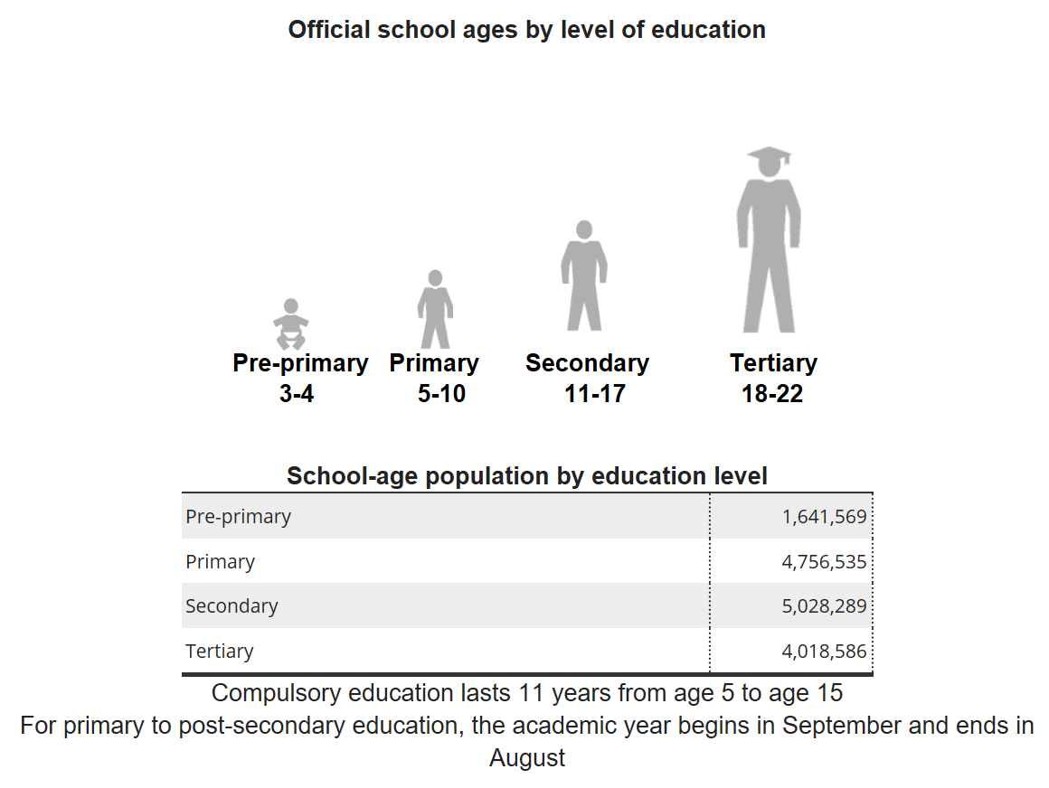
Figure 1 – Official school ages by level of education (18)
Pre-Education
Since September 2010, in England all three and four-year olds are entitled to 15 hours of free nursery education for 38 weeks of the year while in Wales, children are offered free part-time education during the term following their third birthday, right up until they enter statutory education. This means it can be in a non-maintained school such as a playgroup or a maintained school. The school-age population by education is 1,641,569, meaning that is the population of the children of the age group, that are able to enter this level of education in the year 2015 (18) (19).

Primary Education
Primary education is taught within three different age range: nursery for under 5-year olds and infants aged 5 to 8 which comes under the Key Stage 1 category. The third age range is junior for ages 11 and 12, which comes under the Key Stage 2 category. In Wales, there is a foundation phase, previously known as the early years, so rather than having Early years and Key Stage 1, all ages from 5 to 7 are taught from the same National Curriculum, known as the foundation phase (19). However, in England primary schools generally cater for 4-11-year olds.

Key Stages at primary education include: (20)
Age | Year | Key Stage | Assessment
3 to 4 | Nursery | Foundation Phase | -
4 to 5 | Reception | Foundation Phase | Assessments carried out by teacher.
5 to 6 | Year 1 | Foundation Phase | Phonics screening check
6 to 7 | Year 2 | Foundation Phase | National tests and teacher assessments in maths and science.
7 to 8 | Year 3 | Key Stage 2 | General Assessments
8 to 9 | Year 4 | Key Stage 2 | General Assessments
9 to 10 | Year 5 | Key Stage 2 | General Assessments
10 to 11 | Year 6 | Key Stage 2 | National tests and teacher assessments in English, maths and science.

The main aim during primary education is to achieve basic literacy and numeracy while establishing foundations in science, mathematics and other subjects. Students will then be assessed at the end of the foundation and key stage 2 phase (19).

Secondary Education
Secondary education is taught to students ages 11 to 16. This last for five to seven years, however the first give years is a legal requirement. The first five years is called “lower secondary” (21). During the years 7, 8 and 9 students will study a range of mandatory subjects such as English, Maths, Science, Design and Technology, Physical Education, Citizenship, Music, Art and Design, Modern Foreign Languages, Geography and History. In the final two years of the compulsory years to be taken at secondary education, students will be given the choice to drop certain subjects and to pick up new subjects to study further. Maths and Science are compulsory and are the ones that colleges, universities and employers think are important. In Wales, Welsh is also compulsory either as a first or second language GCSE. Religious Education can also be compulsory short course in different schools along with some form of physical education being compulsory (22). At the end of year 11, students will then sit their final GCSE exams and those exams determine what routes they can take if they decide to go onto further education.
Key Stages at secondary education include: (20)
Age | Year | Key Stage | Assessment
11 to 12 | Year 7 | Key Stage 3 | General teacher assessments
12 to 13 | Year 8 | Key Stage 3 | General teacher assessments
13 to 14 | Year 9 | Key Stage 3 | General teacher assessments
14 to 15 | Year 10 | Key Stage 4 | General teacher assessments  Some students will sit GCSE exams
15 to 16 | Year 11 | Key Stage 4 | GCSE exams

The main aim of secondary school is to prepare students for further education and to develop skills learnt during early stages of education, while developing new ones (19).

Further and Higher Education Act 1992
The Further and Higher Education Act is “An Act to make new provision about further and higher education” (23). It made changes in the administration and funding of further and higher education within England and Wales. The biggest result of this law was to allow thirty-five polytechnics to become universities while creating bodies to fund higher and further education. Previously in Wales and Scotland, universities were funded by one UK-wide Universities Funding Council. The Act has now created national unitary funding councils, removed colleges of further education from local government control and created quality assessment arrangements (23).

Data Protection Act 1998
This 1998 law is what controls how organisations use personal information. The law states that any organisations that is responsible for using data, has to follow strict rules called the ‘data protection principles’. According to its principles, all information that the organisations holds must be used fairly and lawfully. This means that the organisation has to tell people for which purpose the data is being collected, and if applicable, the data may be sent outside the European Economic Area. The most popular way of processing the data and the method that organisations use is by getting the individuals consent.

The law goes on to explain that the information must be used for limited, specifically stated purposes only. In order to conform to this the organisation will need to ensure data is collected for one purpose and is not then used for different purposes. The organisation would be able to cover this by including all likely purposes in the ‘data protection fair processing message’. The purpose for collecting the data must be reasonable. The organisation must be clear from the outset about why they are collecting personal data and what they intend to do with it.

The Data Protection Act imposes obligations on organisations to ensure the accuracy of the personal data that is being processed. This meaning that it must be kept up to date where necessary. The requirement is linked with the principle that “personal data is adequate” because ensuring the accuracy of personal data will assist the organisation in complying with that requirement as well. The act actually says “personal data shall be accurate and, where necessary, kept up to date”. Although this sounds straight forward, the law recognises that it may not be practical to double-check the accuracy of every item of personal data you receive. Because of this, the Act makes special provision about the accuracy of information that individuals provide about themselves, or that is obtained from third parties. To comply with this, organisations should take reasonable steps to ensure the accuracy of any personal data, ensure that the source of any personal data is clear and consider whether it is necessary to update the information.
The law then goes on to state that the information is to “be held no longer than is necessary for the registered purpose” meaning that the organisation will not to be able to hold information on its customers for longer than necessary (24) (25) (26).

Changes to the Data Protection Act
On May 25 2018, the Data Protection law will be changing to the General Data Protection Regulation (27). At the moment, the Information Commissioner’s Office can issue fines up to £500K to any UK organisation that seriously breaches to Data Protection Act. With the new General Data Protection Regulation can now be fined up to £20million or 4% of their annual global turnover – whichever is higher (28).

Accountability will underline the principles from the DPA however, it will be treated more importantly under the new GDPR. There will now be an accountability principle, which will require organisations to demonstrate compliance through a series of actions, which will include the implementation of apocopate technical and organisational measures. They will also be required to produce and maintain documents to demonstrate actions taken to achieve compliance such as easy to consume notices. There is also a new requirement called “breach notifications” which is designed to put pressure on organisations to reveal breaches at the earliest opportunity whereas the DPA did not require them to report any data breaches (28).

Another key difference to this law will include a “right to erasure” principle. The new principle builds on the original concept from the DPA to give data subjects direct control over their personal details. People will now have power to request the deletion or removal of personal data where businesses are to comply. Another concept is “the right to portability” which isn’t new however the new GDPR introduced it into EU law for the first time with a new right for data subjects. This means that people are able to obtain their personal data and reuse it if they wish. Organisations will need to comply with this, providing the information in question meets a specific set of criteria (28).

Computer Misuse Act 1990
The Computer Misuse Act was put in place to make provision for securing computer material against unauthorised access or modification (29). It is designed to protect computer users against wilful attacks and theft of information. Hacking, unauthorised access to computer systems and purposefully distributing damaging and malicious software such as viruses are all classed as offences to this act. It is also an offence to access or even attempt to access a computer system without authorisation. This meaning, if someone even tries to access a system but is unsuccessful, they can be prosecuted. This includes using software that can be used to break into a system or to discover ways to break into a system. If someone has authorised access to a system, however accesses part of the system that may not be allowed to access, this will count as a breach of the Computer Misuse Act. Attempts to modify computers such as altering software, interfering with the normal operation of the system and changing passwords and settings also break this law (30). It is the organisations responsibility to make sure that all their security systems are up to scratch and ensure there is access control in place. The main section of this law can be followed, just by following the Data Protection Act.

Education and Inspections Act 2006
This is “An Act to make provision about primary, secondary and further education and about training”. It is what gives local authorities a strategic role as champion of parents and children, where it sets up the national inspectorate in which it covers education, skills and children’s services (31). The Act is designed to give more freedom to schools and colleges, such as: employing their own staff, setting their own admissions arrangements and owning their own assets. The Act also gives schools and colleges the provision to give staff a clear statutory right to discipline students, to provide a behaviour policy to prevent bullying and misbehaviour. There are then provisions in place in regards to nutritional standards of food supplied (31).

Higher Education and Research Act 2017
This is a recent law, only being brought into place by the Houses of Parliament in 2017. This is now the replacement of the Further and Higher Education Act 1992 and it creates a new regulatory framework for higher education, increase competition and student choice to make sure the student receives the value of their money (32).

The Human Rights Act 1998
The Human Rights Act is what gives an individual legal protection of their human rights, such as their right to life, or their right to a fair trial (33). According to Article 2 of Protocol 1, everyone has the right to education (34). This will include, that an individual living in the UK has the right to:
- Attend school, college or university
- Get official recognition when studies have been completed, for example, the qualification earned (34).
This Act also protects your rights to a private and family life. This meaning, the college must:
- Respect your sexuality
- The right to be able to make choices yourself
- Respect for private and confidential information, particularly when storing and sharing of information. This gets linked in with the Data Protection Act.
- The right to have confidential and unlimited communication with others
- The right to control how information about your private life is shared, such as photographs.

Enrolling on A Level Programmes

Combinations
Choosing an A Level course is a difficult decision for students and as there is a range of A Level courses to choose from, that means there are many different combination possibilities. By the time students go to enrol, they will have some idea of what courses they wish to undertake. Some subjects cover common ground such as geography, environmental studies or media studies. When selecting A levels, students will need to check that they are not too similar as some colleges and universities may not accept the combinations when applying for higher education. According to Oxford Learning College, good A level combinations tend to fall into the categories, however there will be many crossovers:
- Arts and Humanities (such as. English Literature, History)
- Business and Management (such as Business Studies, Accounting, Politics)
- Environmental Studies (such as Environmental Science, Geography)
- Health and social Care (such as Childcare and Health and Social care
- Languages (such as Spanish, French, German)
- Law
- Maths (such as Statistics and Economics)
- Science (such as Biology, Chemistry, Physics)
- Social Science (such as Philosophy, Sociology etc)

From the above example, it shows that subjects can span within more than one category. Therefore, if students want to go within a specific course entry such as medicine, then students can visit UCAS website to see what the combinations of A levels are that they need. For example, it might not be the three core science subjects such as Biology, Chemistry and Physics but it may be something such as Biology, Chemistry and an optional subject from a range of choices such as Psychology and Maths (35). Some subject combinations are complimentary and will fit well together, such as doing physics as well as Maths or another science module. This could help students with their studies and will enable them to meet entry requirements for higher education. Some schools and colleges may have restrictions on subject combinations so students will need to check their options. When applying for University, students will need to check as they may require you to sit specific A Level module and to achieve specific grades (35) (36).

A Level Entry Rules
According to the City and Islington College, the minimum entry requirements to study three A Level courses, you need have achieved at least five GCSEs at grade 9-4/A*-C, including grade 4/C in GCSE English Language and Mathematics. However, although these are the minimum requirements to sit A Level courses, each course will have specific entry requirements, so the student will need to check with the school or college that they are studying at. It is a government requirement that any student who has not achieved at least a grade 4 in English Language or Mathematics will need to resist the subject alongside their study programme (37).

GCSE Grading System
New GCSEs will now be grade 9 to 1 rather than the traditional A* to G. With the new grading system, grade 9 is the highest, which will be equivalent to the old A* mark. The purpose of the new grading system is to help provide more differentiation, especially among higher achieving students (38). With the new grading system, a 9 is considered a A*, grade 4 and 5 are considered as a grade C, with 5 being a higher C grade and 1 is now classed as grade G.

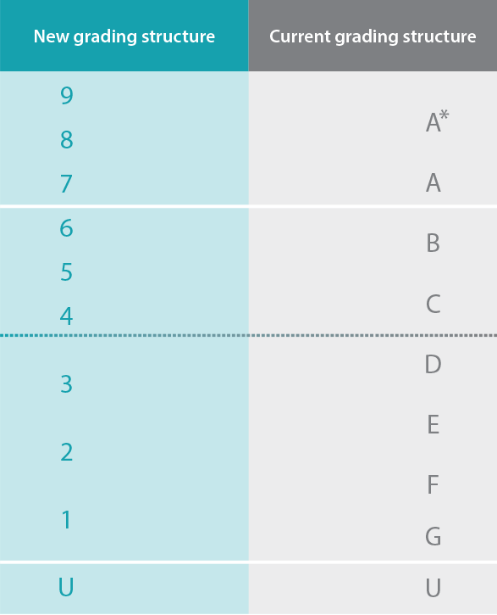
Figure 2 – GCSE 9 to 1 grades (39)

A Level Pathways
A Level is a level 3 qualification, where the stage states “Qualified/skilled worker entry to higher education after second year” (40). All level 3 courses that are equivalent to A Level courses include: NVQ Level 3, Vocational Qualifications Level 3 and Advanced Diplomas. After achieving grades at the level 3 standard, if students decide to remain in education, they then can step up to level 4. Level 4 subjects can include: Level 4 certificate, leaving certificate and Higher National Certificates, however these courses are normally on a part time basis.

For a lot of students, the first year of university starts at level 5 and 6. The courses that fall under the level 5 category are Foundation Degrees, Diplomas of Higher Education (DipHE), Higher National Diploma (HND). The courses at level 6 then include Bachelor’s Degree with Honours, Bachelor’s Degree, Professional Graduate Certificate in Education (PGCE), Graduate Diplomas and Graduate Certificates (40).

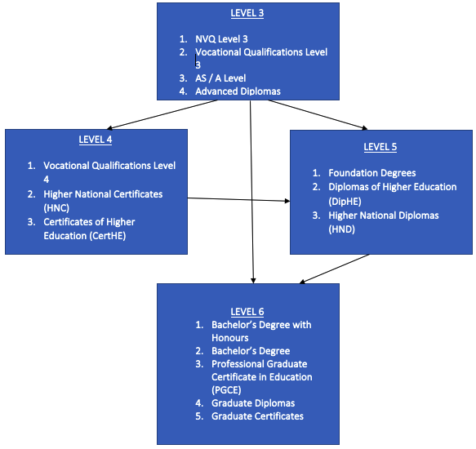
Figure 3 – Pathways from Level 3 Qualifications (40)

Another pathway that students may go is by doing an apprenticeship. An apprenticeship combines work and learning, so students will be studying for a qualification while developing real-world experience and earning a wage. Apprenticeship are available from the age at 16, however those who have completed their A levels will find even more opportunities. It is also possible to apply for Higher Apprenticeship, which will offer students the same work at a higher level. This will be more advanced such as Foundation Degrees, Higher National Certificates and Diplomas. Because these Higher Apprenticeships are more advanced, the pay will be a lot higher (41).

Students may also decide to go straight into work. A Levels are very useful to show employers skills and abilities. Sometimes, students may find it best to get some work experience before finding work as a lot of employers now expect work experience along with qualifications (41).

Linked Qualifications to A Levels
The Welsh Baccalaureate
This is commonly known as ‘Welsh Bacc’ and it is an award made up of a combination of qualifications, which include:
- The Skills Challenge Certificate which is a new and advanced skill-based qualification that allows learners to develop skills for life, employment and education.
- GCSE in English or Welsh Language and Maths.
- A choice of supporting qualifications of a specified size and level (42).

The Welsh Baccalaureate is then awarded at three levels, these include:
- Level 1 (Foundation Welsh Baccalaureate) which is awarded at key stage 4 or before age 16.
- Level 2 (National Welsh Baccalaureate) which is awarded at key stage 4 or before the age 16.
- Level 3 (Advanced Welsh Baccalaureate) which is awarded at post-16 only.

This is a programme of activities that students need to complete alongside their A Levels to get the qualifications and is worth 120 UCAS points, equivalent to an A grade at A Level. The downside to this is that not all universities include Welsh Baccalaureate in their entry requirement. It does not count as a subject-specific entry requirement either. This meaning, if a student gets two grade A’s in geography and English and a B in another subject then students will not be able to offer their welsh Baccalaureate as one of their A’s. One concern about Welsh Baccalaureate is the fact it can be a distraction. If a student is taking Welsh Baccalaureate as an extra subject such as along with their three A Level subjects, that could result in them being under a lot of pressure.

Although there are some downfalls to the subject, it does give students a good opportunity to develop skills typically looked upon by universities as a good preparation for higher education. Some of the skills include critical thinking, research and analytical skills, presentation skills, problem solving and citizenship. Although some universities will not accept Welsh Baccalaureate, there are a lot of Welsh universities that will (43).

Essential Skills
The Essential Skills qualifications are designed to access the skills that learners will need for learning, employment and life. This qualification provides a single ladder of progression from level 1 to 3 in Essential Digital Literally Skills, Essential Application of Number Skills, Essential Communication Skills and Essential Employability Skills.

Available Methods and Tools
Methods
Data Entry Collection
Data entry is “the work or process of putting information into a computer database” (44). Tasks include filing, data entry, and special projects in administrative departments (44). However, it computer terms it includes keyboard entry, scanning and voice recognition (45). There are many types of data entry, however, there are two main types that are still used in today’s industries, data entry from hand-written application forms and data entry from online application forms.
Printed Pre-Formatted Forms
This is when someone will fill out an application form by paper (45). One of the main disadvantages of this is the fact that there is no validation. There is nothing that makes the applicant fill something in. Even if the field says, it must be filled in, they can still skip it. When an application form needs to be entered onto the system, just like NPTC Groups current enrolment system, there is the risk of poor handwriting. Poor handwriting can have serious effects on the data being held, which could lead to the data being incorrect, making it ‘dirty data’ (46). For example, if a student enters their emergency phone number but their ‘6’ looks like a ‘8’ then that could have a serious effect on the student in the future if something was to go wrong (46).

Online Pre-Formatted Forms
This is when someone will fill out an application form through an online application form, normally through a website (46). One of the main disadvantages of this is that the student will need to have an Internet connection. Unlike a paper application form, the college is able to collect data with minimum error. For example, the application form may require the student to enter fields and if the student fails to do this, they will not be able to proceed. It is simpler to analyse the answers given as charts, graphs and reports are able to be produced. It is easier to read the answers overall as there is no concern over whether you can read the answers properly because they will be all typed (46).

Tools
EBS by Tribal
EBS stands for Education Business System and this is the system that NPTC Group currently uses for their registers. According to an advertising brochure that Tribal hand out to their clients, EBS is there to “manage the entire admissions process” (47). This package offers students to schedule their own interviews and will be reminded when they need to complete something, such as uploading evidence. A benefits for using ebs by Tribal would include the fact that Tribal offers support services between 9am to 5pm Monday – Friday. Training courses are always available and are delivered either on-site or via webinar, which will provide support to the college. The package is clean and it has been designed by professional
- It is a clean package.
- The system is secured by Tribal, so anything that is to go wrong with the package, they will examine it.
- Smart tools such as postcode recognition, third-party payment methods etc.
The limitations include:
- It is an expensive package.
- It is not beneficial to the students as they have to go through repetitive stages.
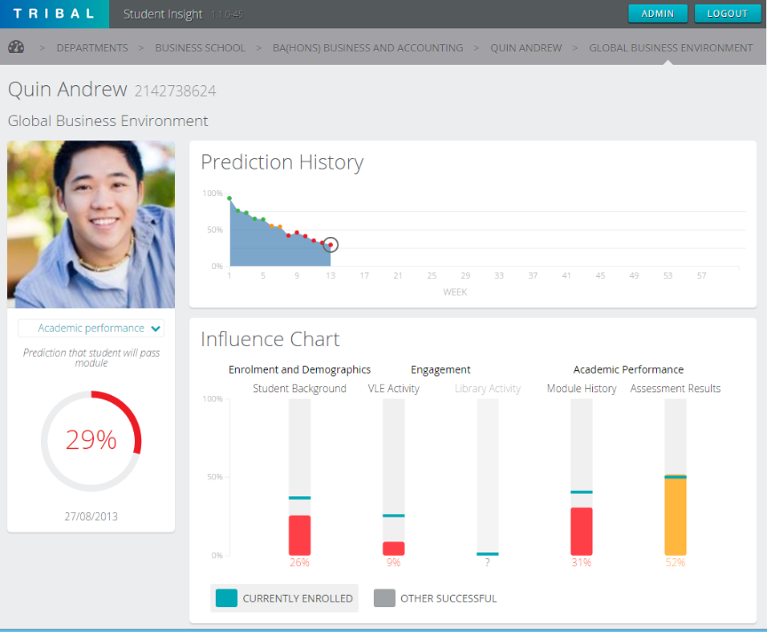
Figure 2 – Screenshot of EBS by Tribal (48)

UNIT-3
UNIT-e is a student management information system, which puts the power of MIS into the hands of the institution, students, staff, parents and other stakeholders (49). This system offers a range of features, from full validation to enabling students to pay online at the point of enrolment. As it is self-serviced for students, it minimises the time of staff to spend on the application process which speeds up the process (49).
Some of the benefits include
- It is a self-enrolment system for students and staff.
- It is a professional software, designed by experts.
- The creators, Capita, have got a helpline.
Some of the limitations include
- It is not just designed for education, so some features may not be relevant to the college.
- It is an expensive package.

Student Management by Unit 4
Unit 4 now says that they “work with your skilled staff so they can focus on education and research instead of administrations” (50). The systems allow its users to add, create, update and delete student instantly, meaning there will be no more waiting. It allows managements to produce reports that show information such as the growth of students from year to year.
Some of the benefits to this software would be
- The college has already had a close relationship with Unit 4
- A very professional interface and back end.
- It is currently being used by large universities such as University of Essex, Cranfield University, University of Bristol, University of Southampton and University of Cambridge.
- Cloud services are available
Some of the limitations of this software includes
- It is an expensive software to run.
- Need to follow Unit 4s regulations.

Web Based Enrolment System
As mentioned, there are many organisations that have their enrolment system online. Although this has many benefits such as, the student does not even have to leave home to enrol, it does have some disadvantages. University of Wales Trinity Saint David (UWTSD) uses this type of enrolment system, as it is on their website (6). When you go click on ‘enrolment’, it asks to user to enter their username and password. For a first time student, this can be confusing as it may not give the student a clear indication on how to actually apply to the University. Some students might find ‘enrolment’ is the same thing as ‘apply’ which will cause confusion.
In order to access this enrolment system, the student will need to have access to the Internet. This may also cause issues if their website goes down, for maintenance or unplanned issues.

IDE’s
.NET
.NET is a Microsoft web service which connects information, people, systems and devices through a software making it easier for users to share and use their information between multiple programs and computers. It is a programming model that allows developers the ability to do rapid application development. .NET is free of charge and is a cross-platform, open source developer platform for building applications. It offers many different languages such as C#, F# and Visual Basic. When it comes to cross platforms, regardless of the language being used, the code will run natively on any compatible operating system. There are different .NET implementations such as:
- .NET Core which is a cross-platform .NET implementation for websites, servers and console apps on macOS, Windows and Linux.
- .NET Framework supports websites, services and desktop apps on Windows operating systems.
- Xamarin/Mono is a .NET implementation for running apps on all major mobile operating systems.

.NET offers one consistent API called .NET Standard is common to all .NET implementations. Each implementation can expose additional APIs that are specific to the operating system, for example, ,NET Framework is a Windows-only ..NET implementation which includes API for accessing the Windows Registry.

An advantage of using .NET is the fact is allows you to use multiple programming language, meaning more applications can be run by it. Also it gives the developer a bit more freedom on the language they prefer to use. The tools and IDEs are very well presented and easy to use, everything will be everywhere you expect it to be. Also the tools will be pre-tested, so all tools are functioning well.

A disadvantage of .NET will be the fact you cannot use it across other platforms, it is built mainly for Microsoft. The fact that it is not compatible across other platforms is such a downfall as developers are keen to be able to run their applications across all platforms as more platforms means more people are using it. Another disadvantage of this is the fact that if a developer decides to migrate their application it could be expensive (51) (52) (53).

NetBeans
NetBeans is a free Java IDE that provides support for different programming languages such as PHP, Java, JavaScript and C/C++. It is an open-source project dedicated to providing software development products that users require. Many businesses uses NetBeans as a basis for their products, particularly to ensure them to develop these products, as quick and efficiently as possible at industry standards.

In June 2000, NetBeans was made an open source IDE, where Sun Microsystems remained sponsors, until it became a subsidiary of Oracle. The two products, NetBeans IDE and NetBeans Platform are free for commercial and non-commercial use. The source code for both of these are available to anyone to reuse within the terms of use (54).

NetBeans offers first-class tools for java web, enterprise, desktop and mobile application development. It is the first IDE to support latest version of the Java FK, Java EE and JDK. It also provides users with smart overviews to help them understand and manage their applications (55). A benefit of using NetBeans is that it works “Out of the Box” by just downloading the NetBeans IDE, once it is installed it is all ready to use. Once it has been installed, all the tools and features are integrated with the IDE, meaning users will not have to install plugins. The fact that it is a free open source IDE, so downloading and installing is free and there is a community with thousands of users offering help, advice and solutions for developers. It has a powerful GUI builder that supports different frameworks, such as Beans Binding. The range of languages that can be used is beneficial, so the developer is able to use a language of their choice (56).

Languages
Visual Basic
Visual Basic is “an approachable language with simple syntax for building type-safe, object-oriented apps” (57). It slows developers to target Windows, Web and mobile devices. Programs that are written in Visual Basic benefit from the security offered by Microsoft. It is known as the fast and easy way to create .NET Framework-based applications (57).

A beneficial point with Visual Basic is the structure is a basic programming language. Visual Basic is not just a language but it is largely an intergraded, interactive development environment (58). You can find many tools with Visual Basic such as Sharewares and Freeware on the Internet that will free up some time for the programmer (59).

However, there are some limitations with Visual basic such as name lengths. There is a maximum number of characters for the name of every object, which could cause problems when programs start getting complex and names start getting longer. The maximum line length is 65535 characters. It is an exclusive language, meaning it cannot be easily transferred and ran on another operating system (60).

C#
This is another programming language that is offered in the .NET IDE. C# is pronounced “C sharp" and it is an object-oriented and type safe programming language. It has roots with the C family of languages which makes all the languages very familiar. The languages that are very familiar to C# include C, C++, Java and JavaScript (61).

An advantage of C# is the fact it is an object-oriented language, so it will allow developers to create flexible maintainable applications and reusable codes. Another benefit with using C# is that it is easy to develop because of the rich class libraries. Applications written in .NET have better integration and interpretability with other .NET technologies (61).

Java
Java is a high-level programming language developed by Sun Microsystems. It was originally designed for developing programs for set-top boxes and handheld devices, but later became a popular choice for creating web applications.

The Java syntax is similar to C++, but is strictly an object-oriented programming language. For example, most Java programs contain classes, which are used to define objects, and methods, which are assigned to individual classes. Java is also known for being more strict than C++, meaning variables and functions must be explicitly defined. This means Java source code may produce errors or "exceptions" more easily than other languages, but it also limits other types of errors that may be caused by undefined variables or unassigned types.

Ethical Issues
Ethical considerations for data collection and research tools
When data is being collected, high ethical standards must be upheld (62). During the project, interviews will need to take place, in order to gain information. When it comes to interviews, the main ethical issues that will need to be put into consideration are:
- Confidentiality – interviews are personal interaction and everything that is recoded will need to remain confidential to protect the participant.
- Consideration on who is reading the data, will they need to sign a confidentiality agreement?
- Could things being said and recorded during the interview be misinterpreted? It is important to take clear and detailed notes (62).
The same things apply to observations. Ethical considerations that will need to be considered are:
- It needs to be considered that the presence of an observer may be threatening and may exert an influence on behaviour.
With regards to data collection and research tools, there are several actions to be taken.
- Anyone who is to be interviews will have clear understanding what the information being given will be used for. They will be informed that they will be used as a reference, of the project.
- Dummy data will be used, so no real student data will be stored, so this will mean for the project no consent forms will need to be signed.

Critical Review
After reviewing literature on enrolment systems, it has been discovered that self-enrolment is becoming popular in the education industry. After an investigation the meaning of enrolment systems has been defined has adding someone into an official course, college or group. Enrolment systems are used in education for small businesses such as tutors to large businesses such as colleges. When a student officially enrols, they will receive their student ID card and other benefits that students receive.

NPTC Group of Colleges have got an inefficient enrolment system due to its repetitive nature. Students have to complete forms with similar questions multiple times, which is not productive. Part of the system is still paper-based, where students have to fill in forms on paper. After the research, it shows that paper-based systems cause issues because of there have been multiple incidents where staff cannot find students pre-printed forms on enrolment day and when it comes to data entry, handwriting can cause problems.
When it comes to education and handling data, there are legislations in place in which the college needs to follow. When there is any sort of data involved, the Data Protection Act is something that has to be followed. The DPA is all about keeping the data secure and only using it for specific purposes and making sure everyone is aware on what data is being held against them and why. The computer misuse act ties in with this, because the college will need to make sure that material is secured against unauthorised access or modification. After further investigations into the law, it was found that the college has to keep up to the standards of teaching under the “education and inspections act 2006”. A recent law “Higher Education and Research Act 2017” is something the college needs to focus on, to make sure that their courses are up to the standards, to what the student pays in tuition fees. A common law is the human’s right act, which states that the college must respect students and lectures personal lives such as beliefs, religion and sexual orientation. These are some of the laws that have been identified from the research that has been undertaken.

After doing research on the current methods, tools and software that are being used, it has been noticed there is a pattern and a lot of Universities and Colleges have gone down the web based route for self-enrolment. An example enrolment system that is being reviewed at is UWTSD enrolment system, where they have to enter their username and college ID to enrol. This can cause confusion at first, as on the website students may get the words “enrolment” and “apply” mixed up, thinking they mean the same thing. So when that student goes to click on enrol, it will ask them for a username and password, which they may not have which will cause confusion. With the system that is to be developd, the student has to come into college to actually enrol and once they have been given their student ID and password, they can then access the kiosk to start the enrolment. As this is a software application, it does not depend on the Internet to run, so regardless if the Internet is working or not, the student will still be able to enrol. By making the student come into college, it also gives them the chance to view college grounds and seek help and advice in person.
The literature has produced evidence that automated self-service enrolment system is the way forward. It is highly important to get the enrolment stage correct, as this is the official way for a student to participate in a course. All education institutions need to use enrolment systems, to get students onto the courses. As mentioned, the college has issues with its enrolment system, due to the repetitive nature of the system. The system that is being planned to be developed will only mean that the student will have to enter their data once and everything will be done automatically such as bringing up recommended courses.

Research and Development Methodologies

Research Methodologies

Philosophy
According to the City University of Seattle, a research philosophy is a “belief about the way in which data about a phenomenon should be gathered, analysed and used” (63). Within the research onion on the philosophy layer, after researching ‘Positivism’ was the philosophy that was selected. Auguste Comte, the father of positive philosophy says that “the only valid knowledge is knowledge gained through the scientific method” (64). The basis of his philosophy is knowing or stating facts through the scientific methods e.g. observations and experiments. As part of the research, it will be proven that the current enrolment system can be improved.

Approach
Inductive research usually aims to explore a new phenomenon, or to look at a previous researched phenomenon from a different prospective (65). Mainly, this focuses on creating new knowledge and the researcher will create research problem and then starts creating research questions and will then find data through observations. This approach is use to identify patterns and create a conceptual framework. By using this approach, a theory will be built upon, which is that the enrolment system can be improved.

Strategy
Action research “is a disciplined process of inquiry conducted by and for those taking the action” where the main aim is to “assist the actor in improving or refining their actions” (66). It can be research to solve an immediate problem or a reflective process of progressive problem solving. Weaver (2004) described it as a way where a researcher aims to add to the body of knowledge in an area by applying theory to a problem and then evaluating the results. One of the main reasons why it has been decided to go with action research is because it allows the researcher to be both, participant and researcher. Action research also allows me to make some changes and work practices to improve the present situation.

Time Horizon
The next layer within the ‘research onion’ is time horizon, which “highlights the time horizon over which the researcher undertakes the research” (67). Longitudinal will be used, as this is used when answering questions or addressing problem requires data to be collected for a certain amount of time (67).

Data collection method
Quantitative methods are beneficial to the researcher when meaningful data is being drawn from a large body of qualitative data (68). Quantitative data is measured by numeric terms and can measure things such as percentages and rating scales. For this particular project it will be measured by time ranking scales, prioritising different tasks by a rank number.

Observations are an “exempt observation” or an “observation” that requires consent (69). This is where the researcher will watch interactions of people in a public space. Notes from observations will not include the names of the participants, so it is all anonymous. Observations allow the researcher to watch how the current problem is accruing, which is the reason why this has been opted for.

The main purpose of an interview is to find out what is on someone’s mind that may not be written down (70). These are good for collecting detailed information which allows the researcher to follow up. They are prepared in advance, so the researcher knows what they need to find out and what questions they actually need to ask. The reason why Interviews is a good option is because the researcher will need to interview the users of the enrolment system, to get their take on the current enrolment system and what could be done to make their jobs easier.

Development Methodologies

Timeboxing
In timeboxing model, development is done interactively as in the interactive enhancement model. But, in time boxing model, each iteration is done in a timebox of fixed duration. The functionality to be developed is adjusted to fit the duration of the timebox. Each timebox is divided into a sequence of fixed stages where each stage performs clearly defined task that can be done independently. It also requires that the time duration of each stage is approximately equal so that pipelining concept is employed to have the reduction in development time and product releases (71). What makes timeboxing different is that it encourages you to concentrate on time, rather than the actual task. Meaning, if you say you have a task and you say you are going to have it done by a time, then you will have to move on, on the date regardless.
Some of the main reasons why timeboxing has been selected includes:
- It speeds up the development methods as you have time allocated for each task, and that time only.
- It is suited to develop projects with a number of features, in a short amount of time
- It is a simple methodology to use.

Resources

People
- MIS staff – TBA – To gain more knowledge on the current enrolment system
- Users – TBA – To give feedback on the system
- Project Supervisor – Jeanette Adams – This person will provide help and advice throughout the project.

Application Packages
- Microsoft Word – This will be used to create all of my documentations for the project. Documentations include literature review and user documentation.
- Microsoft Project – This will be used to plan out the project such as all the different tasks the project requires.
- yED – This will be used for diagrams that will need to be created.

Programming Languages
The package that will be used for the development of the system is Microsoft Visual studio. Everything that will be needed for the system will be found within the Visual Studio environment, which includes the actual database. For maintenance purposes, Visual Studio will need to be downloaded onto the computer from the 2010 version or newer versions. Visual Studio is a complete set of development tools for C#, Visual C++ and Visual Basic. The programming language that will be used for this specific system will be Visual Basic (VB).

Database Product
Microsoft SQL Server is a relational database management system that will be used for the system. It supports a wide variety of transaction processing, business intelligence and analytics application in corporate IT environments.

Design and Implementation

Project Requirements
The project requirements is to improve the existing enrolment system that NPTC Group of Colleges have in place. As the current enrolment system only allows for students to attend face-to-face enrolment, it has been decided that making a self-enrolling system for students will make it more efficient. While using the enrolment system, students will be able to view important information about their course and decide whether they want to enrol on it. The requirements that will need to be considered within the project include the following:
- Student Login – to ensure not just anyone can walk in and enrol, they will need to be given a username and password. Prior to enrolment, the student would have attended an interview with a lecturer, where they would provide these details for them. Only lecturers will be able to create accounts on the enrolment system.
- Course Information – the system will need to provide information on courses, so the student can make any final decisions.
- Details – When the student logs in, fields should already be filled in from when they attended an interview with the lecturer and they manually typed in this data. It must give the student an option to update any details.
- Qualifications – The new system will need to allow the student to enter their qualifications. If the student has not got a grade C (or a grade 4) in GCSE English Language and Mathematics, then the system will provide re-sit options. If the student received a grade D, they will need to re-sit a GCSE class, if they received a grade E then they will need to sit a pre-GCSE class. If the student received a grade C/4 then it should give them the option to re-sit to get a higher grade.
- Select course – The student needs to be able to select a course. If their grades match the entry requirements, then the students will be able to proceed. If not, a meeting will need to be arranged with the lecturer to discuss further.
- Lecturers will need to be able to update entry requirements, course information and add / delete students from the system.

Diagrams

Entity Relationship Diagram

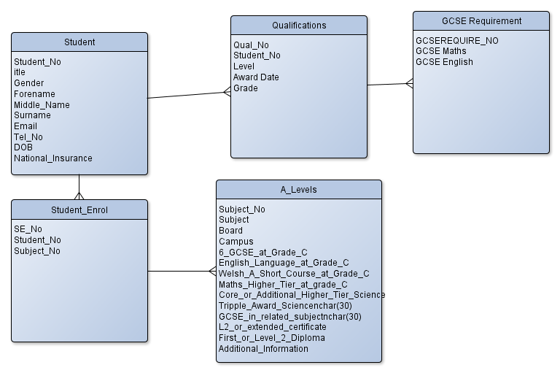
A entity relationship has been created, showing the relationships between the tables for the enrolment system.
- A student can enrol onto multiple A Level courses, while A level courses can have multiple students enrolling on it.
- A student can have more than one qualification, but a qualification can only be for one student.
- Qualifications can have more than one GCSE requirements, but GCSEs can only be assigned to one student.

Data Flow Diagram

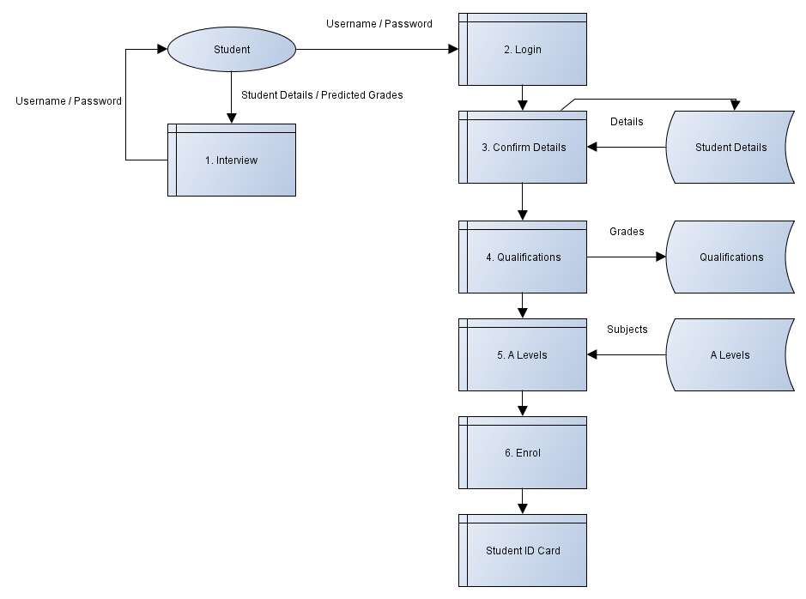
A data flow diagram has been created, to show the flow of data throughout the system.
- A student attends a interview with the lecturer. The lecturer creates an account and gives the student the ID number and password.
- Once the student has received their grades, they will come in to enrol. They will first login to the system.
- Information will then appear, they will need to confirm this. If there is anything need updating, then they will need to update it. The data will come from the student table, and if the student decides to update the details, it will update in this table.
- The student will then need to enter their qualifications, this will be added to the qualifications table. This will then be added to the qualifications table.
- A level subjects will appear from the A Levels table. The student will be able to select up to three subjects. It will then check to see I the student has enough qualifications to enrol.
- Once the student has enrolled, they will then make payments and receive their ID card.

Flow Chart
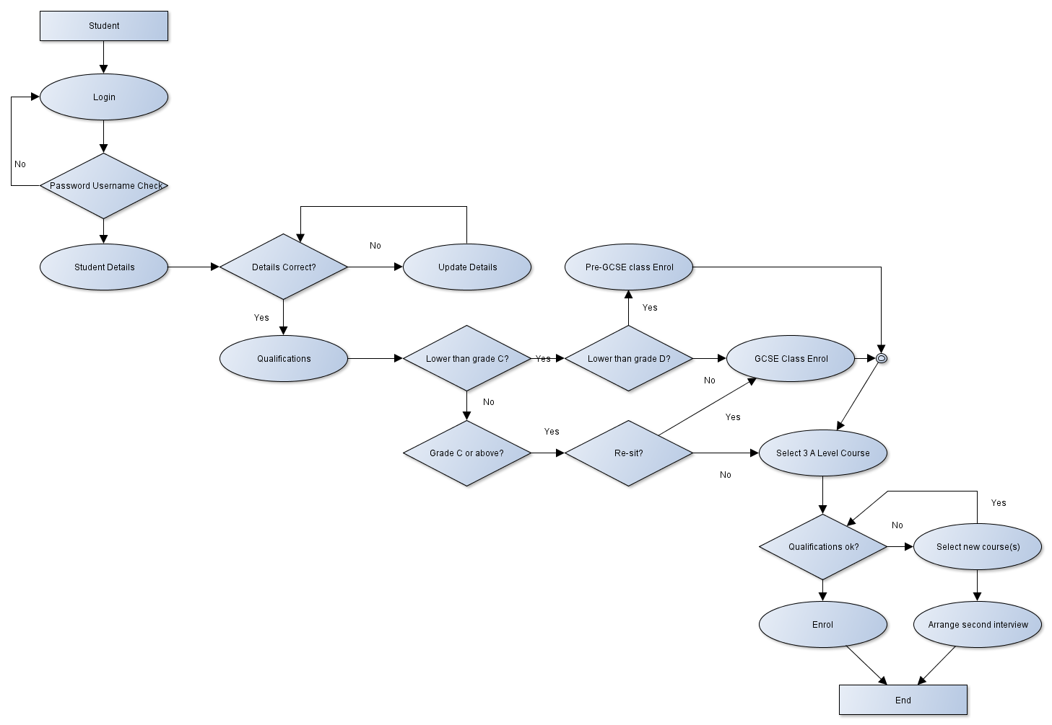

A flowchart has been created, to show the possibilities of all scenarios on the system.
- A student logins. If username and password is correct it will log them in, if not it will fail.
- Student details will then appear. If they are correct they will move onto qualifications. If they are not correct, they will need to update. They will then need to check their qualifications again, once they are finally correct, they will move onto qualifications.
- If a student got lower than grade C in GCSE Mathematics or English, then they will need to re-sit. If the grade is lower than a D, they will need to attend pre-GCSE classes. If the grade is a D, then they will need to re-sit the GCSE. If the student has C or higher, they will be given the option if they want to enrol for higher marks.
- Once the GCSEs have been sorted, they will then select three A levels. If they have not achieved the correct grades, they will need to select a new subject. If a student does not want to do this, they can then arrange a meeting with the lecturer to discuss further.
- Once the grades are correct, the student can then enrol on the course and pay.
- A student card is then given to the student and details on when to attend will be discussed with lecturer via email at a later date.

Interfaces
In all the following designs, the theme colours have been followed from NPTC Group of Colleges website, to match their design to make it consistent.
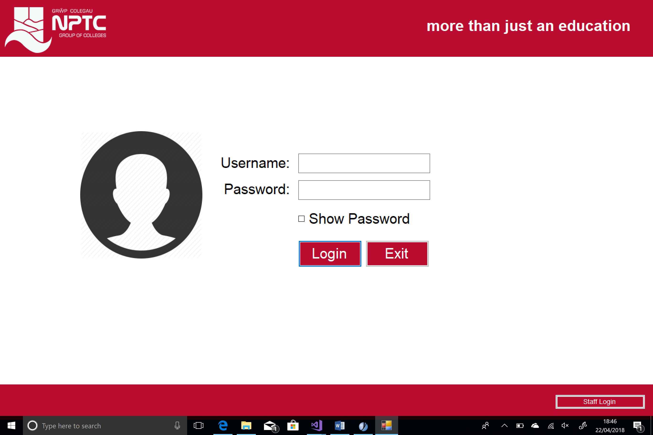
This is the first screen that the user will see is the login screen. The student will need to use their login details provided. If a member of staff wants to login, they will need to click on the staff login button, bottom right of the page.

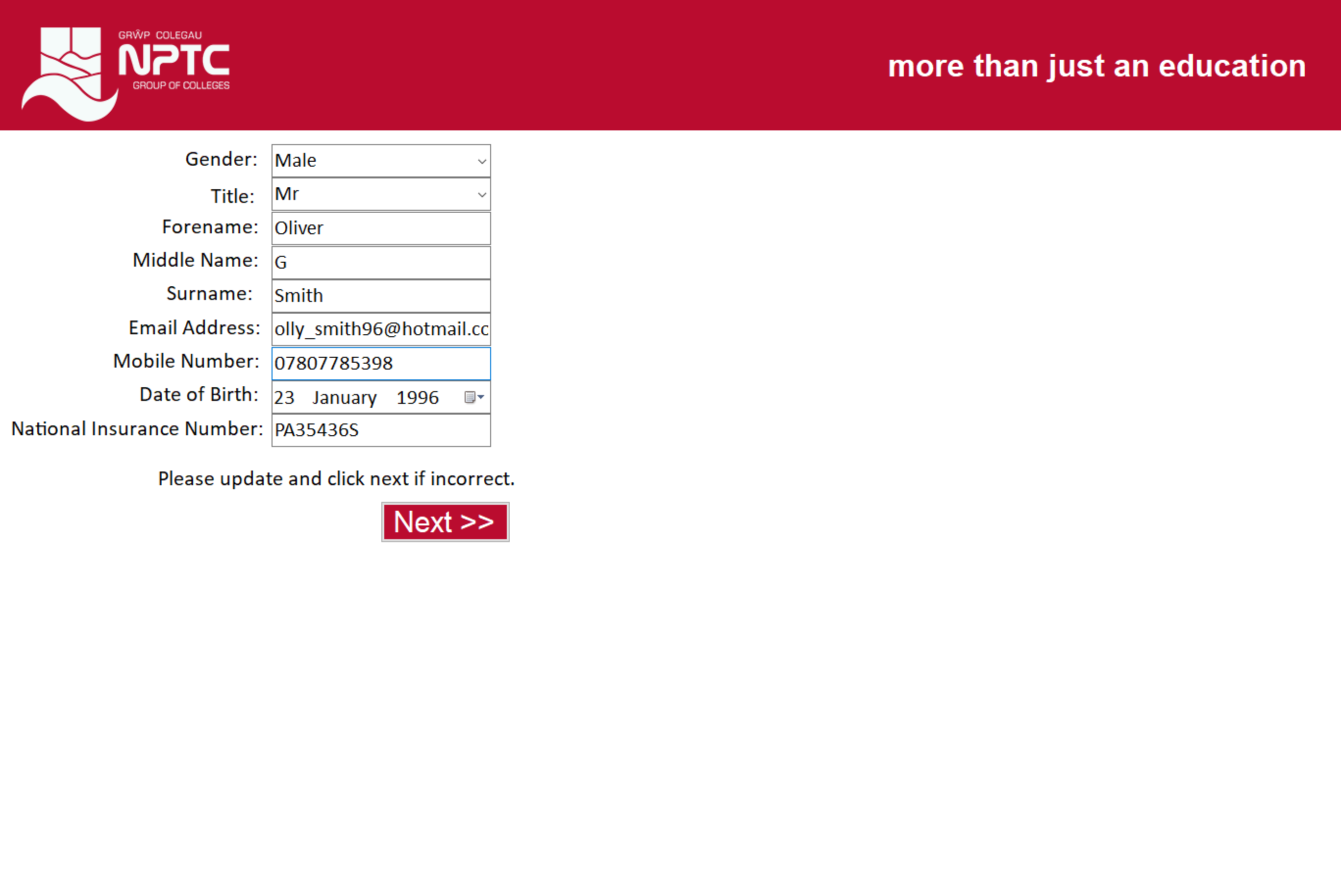
The student will then check their details. If they are incorrect, they will need to type-over the current data and click next. If it is correct, they will just click next without updating.
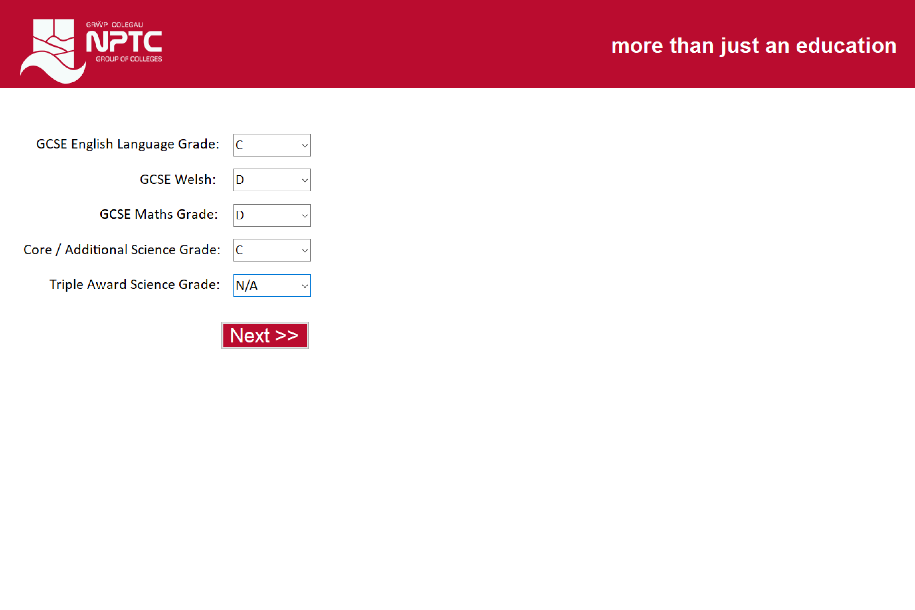
The student will then need to enter core qualifications. These are the main qualifications that are asked for on A Level courses.

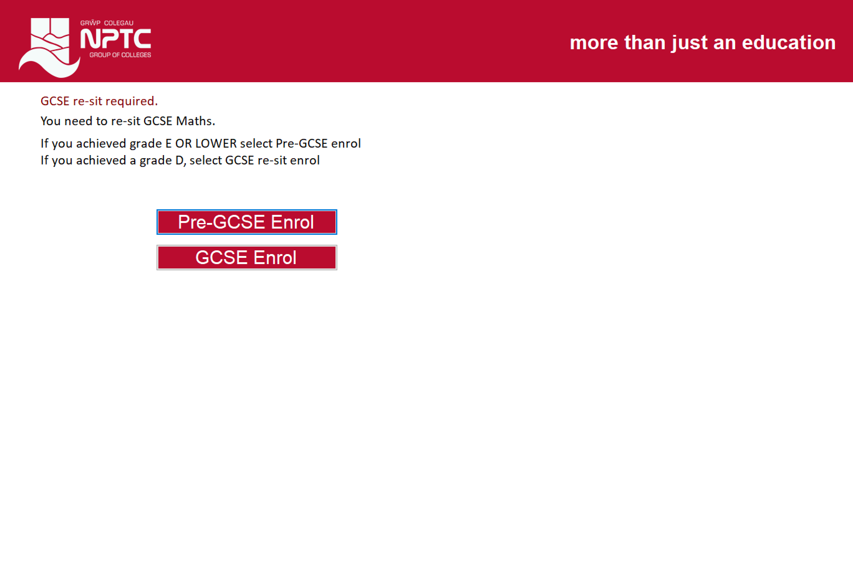
The system then picks up if the student has passed GCSE Maths and English. If not, this screen will appear, requiring them to enrol.

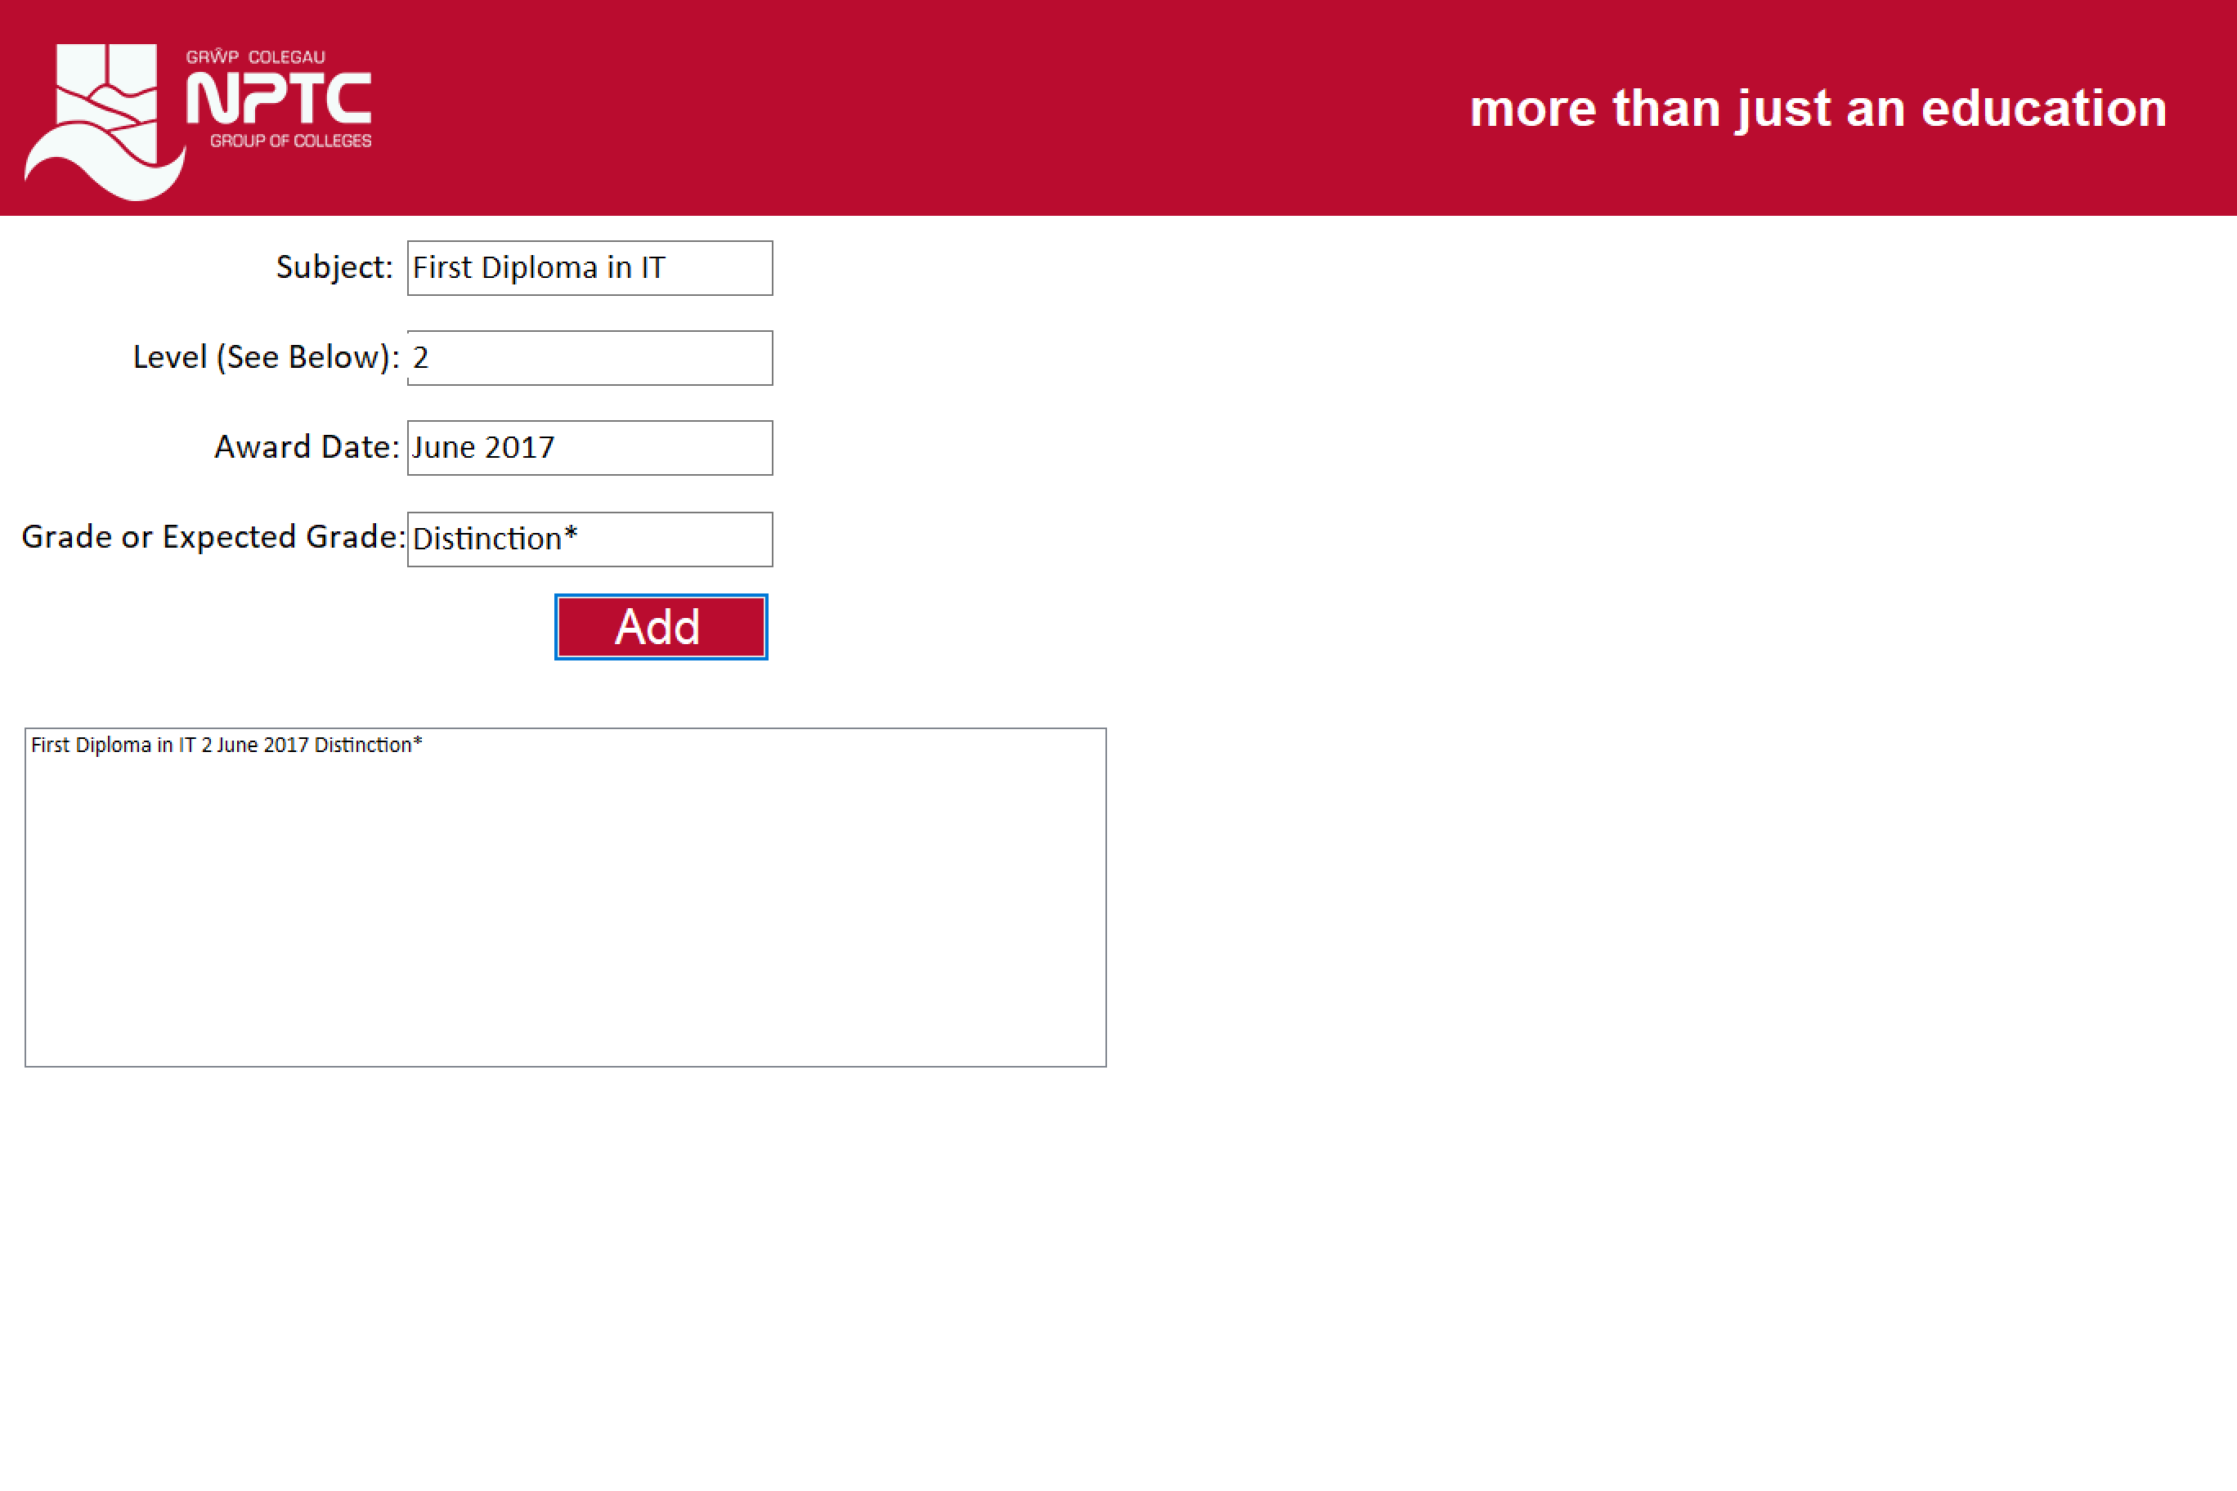
The student will then need to enter any other qualifications that they have achieved.

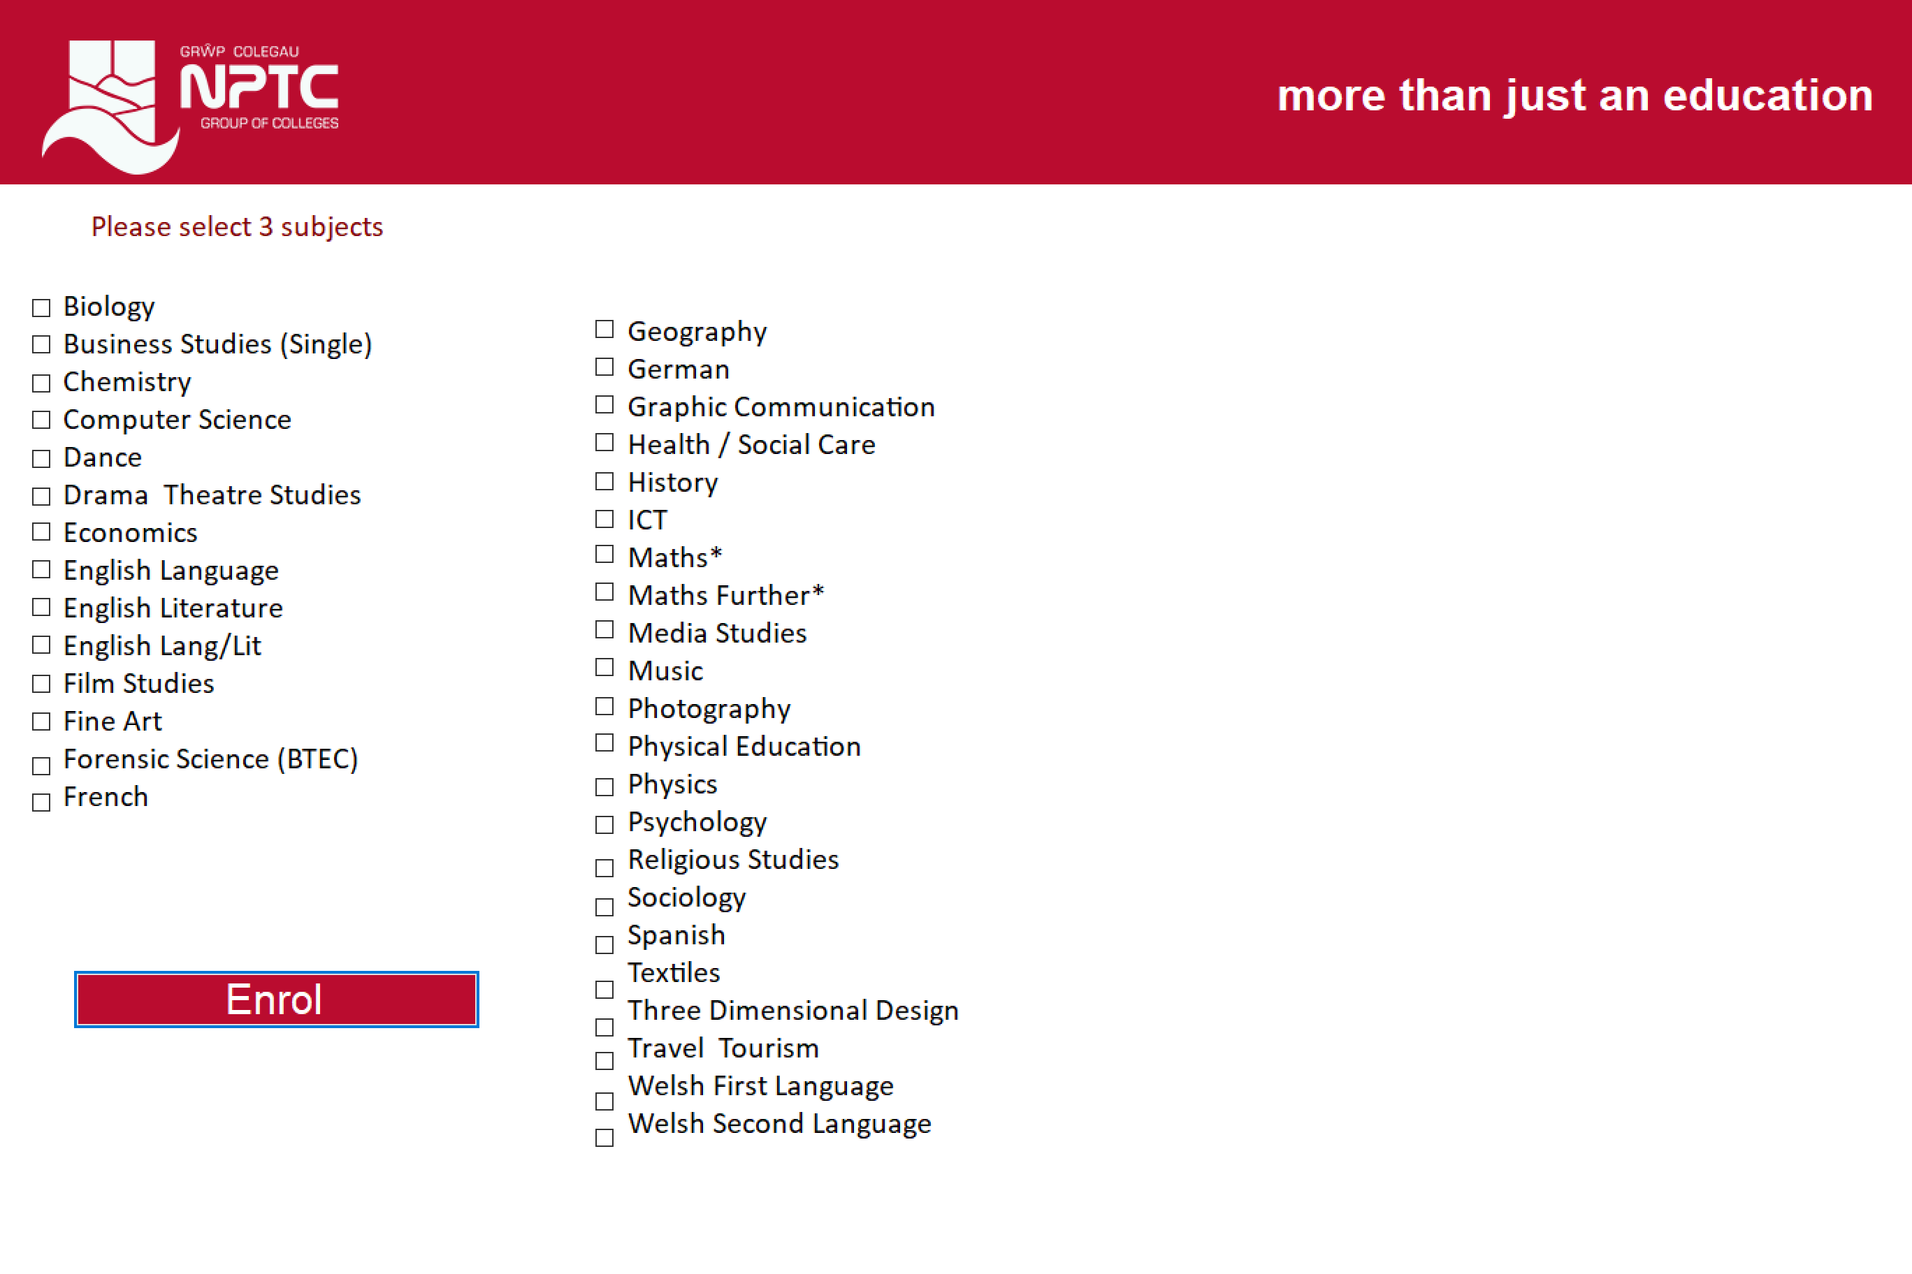
At this stage of the process, the student will need to select three subjects that they would wish to study.

Code

Full screen
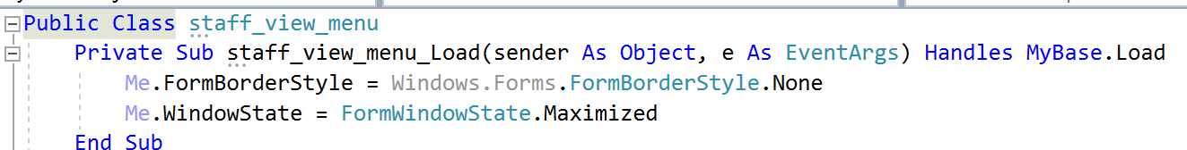
This is the code that was used, to make the form full screen.

SELECT
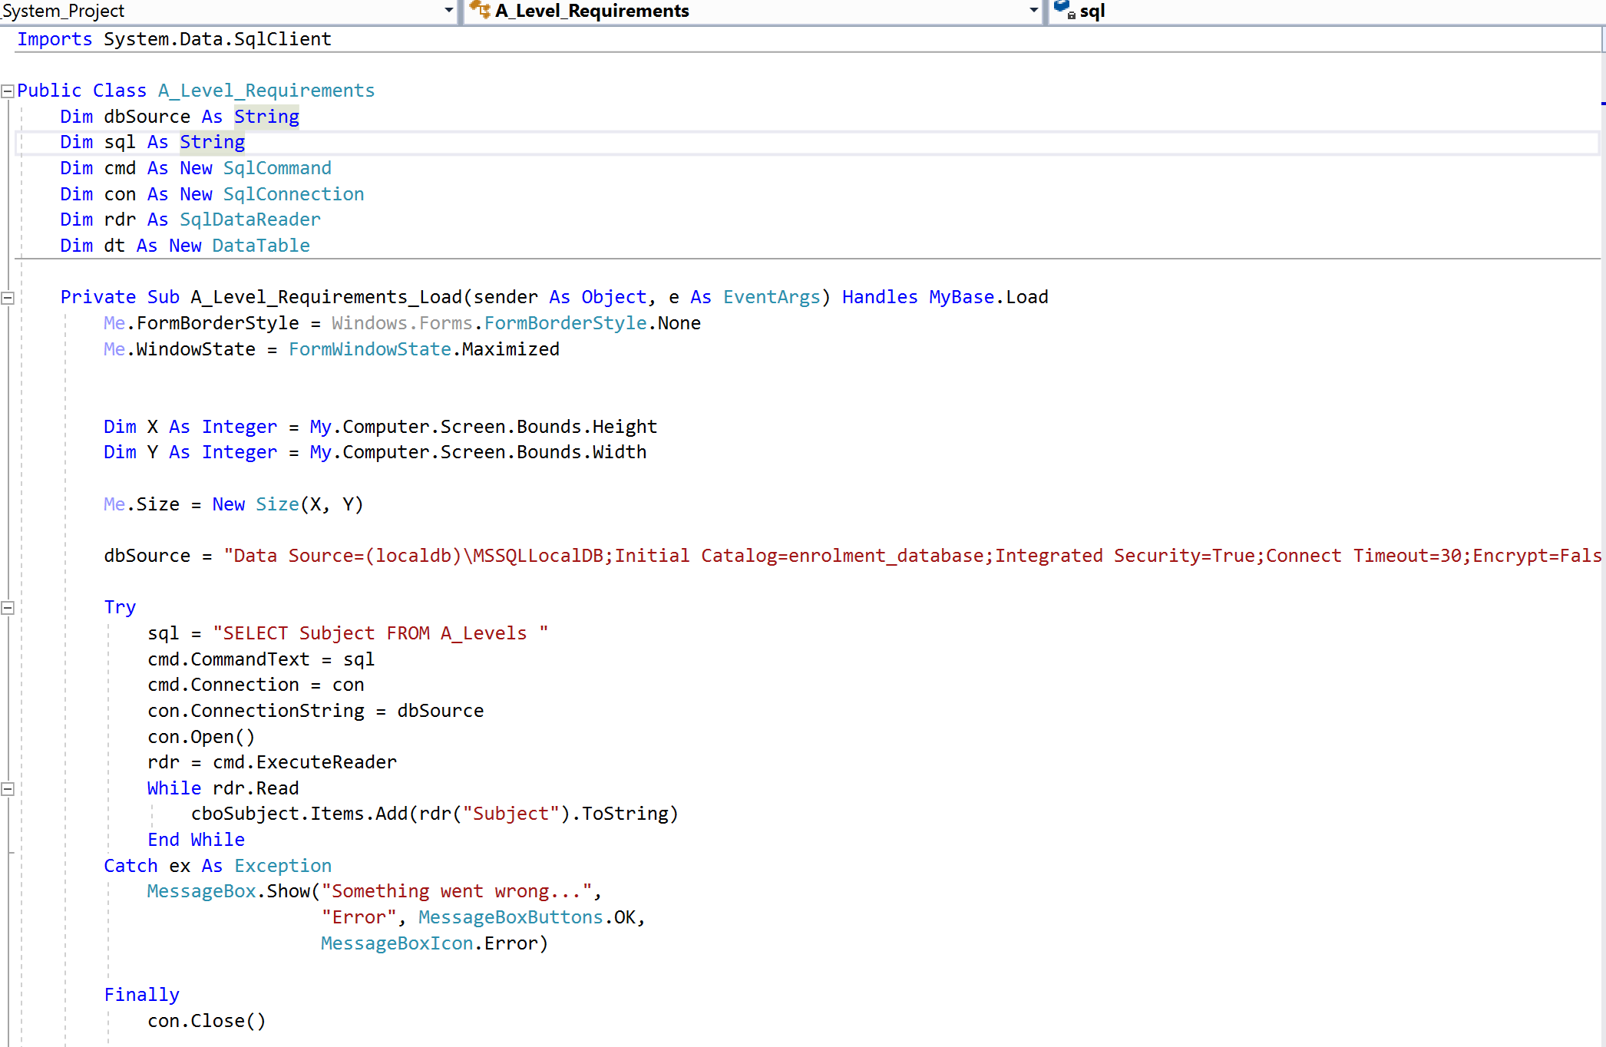
The SELECT statement is used to ‘select’ data from a database. The results are then stored in a result table, known as the result-set. This statement is one of the most used statements in SQL. When you use the SELECT statement, it does not matter what order the column names are. You are able to use this SQL statement to select different fields from a table.

WHERE
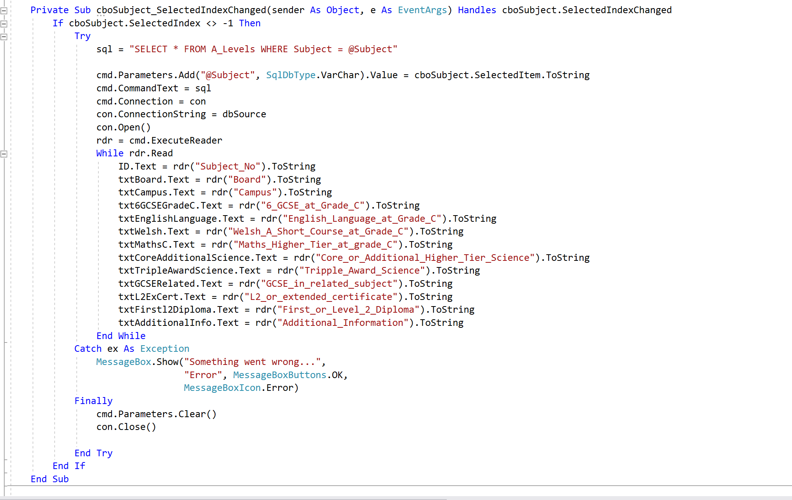
The WHERE statement is used to extract those records that fulfil a specified criterion. This statement can be used with the SELECT statement, but by using WHERE, you can get exactly what you want.

Data can be extracted from the student table, where a students age is less or over a certain age.
This will allow you to bring up more meaningful data. You can also use the WHERE statement in many different statements such as SELECT and UPDATE.

One of the other benefits of using the WHERE statement is that you can extract more specific data from a table, as explained above. This will then become more useful when it comes to producing reports.

INSERT
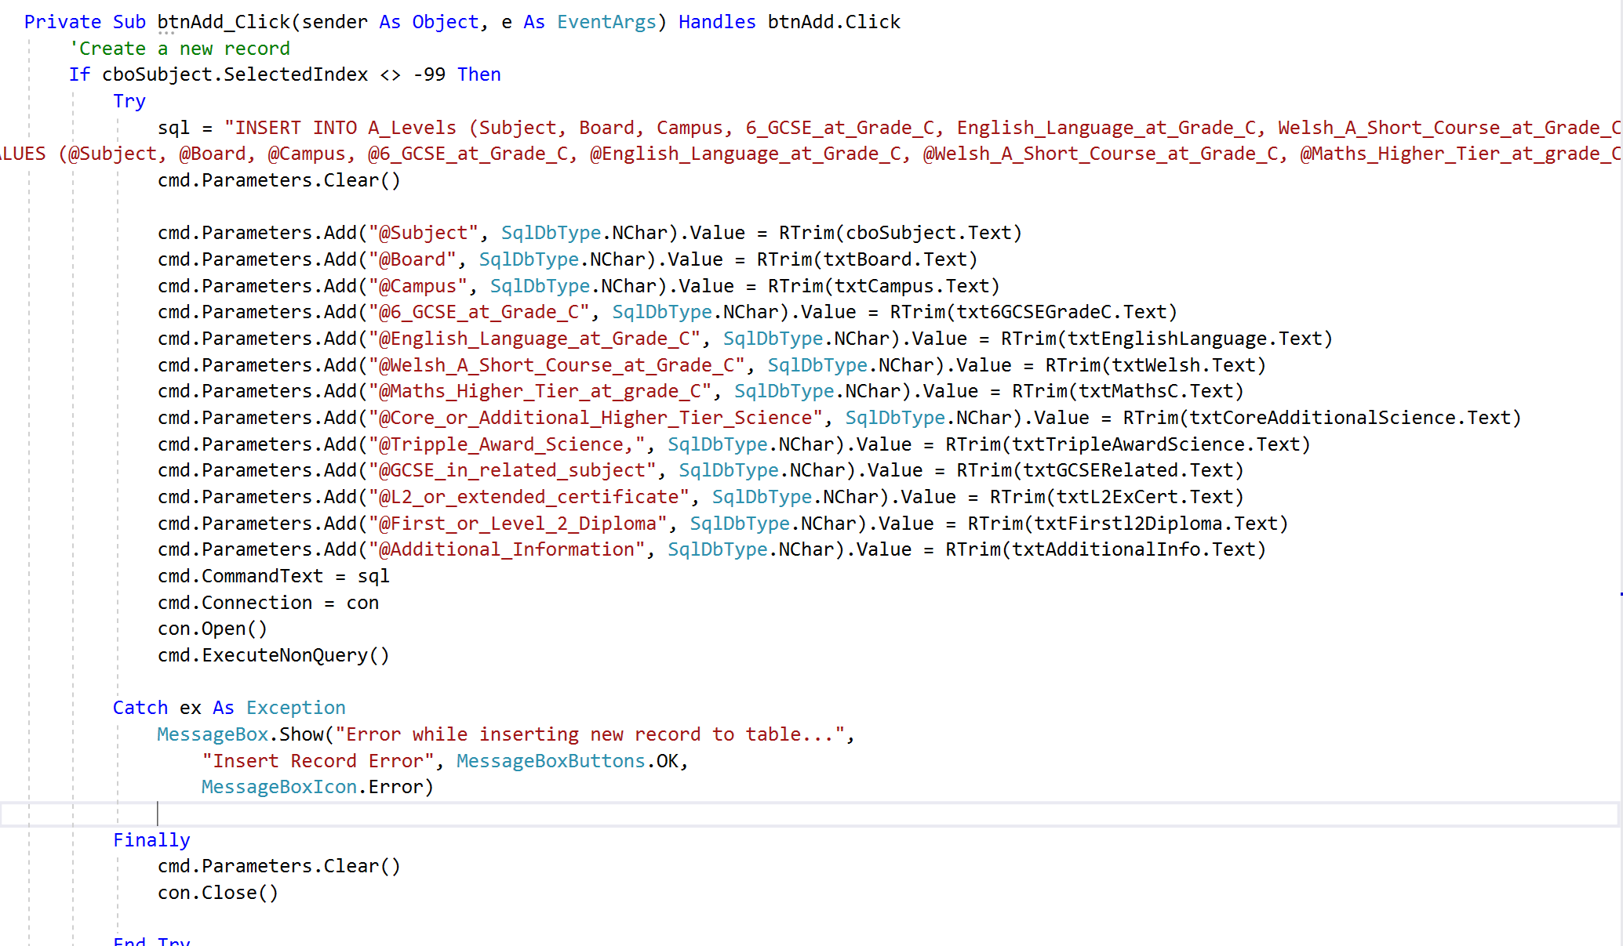
The INSERT INTO statement is to simply insert new records in a table. You are able to write this statement in two ways:
- INSERT INTO [table name]
VALUES (value1, value2,….)

- INSERT INTO [table name] (column1, column2,…)
VALUES (value1,2,….)

One of the benefits of using this statement is that you can extract more specific data from the table.

Another benefit of using this is the fact that you are able to take the users input and put it into an actual database table to store. This is an important query to use, as without this, you will not be able to add data to the database easily, instead you would actually need to go to the database table. The INSERT INTO statement works well when you have created a form, so everything entered in the input fields are added to the table (72).

Testing
Test Number | Test Method | Expected Results | Actual Results | Further Action | Unit Testing
- Login
1.1. | Try logging in as student. Type wrong password. Then type correct password. | When incorrect password is entered, it will not allow me onto the system.  When correct password is typed in, it allows me on the system. | As expected | No
1.2 | Try logging in as staff member. Type wrong password. Then type correct password. | When incorrect password is entered, it will not allow me onto the system.  When correct password is typed in, it allows me on the system. | As expected | No
- Staff View
2.1 | View A level courses | When A level course selected, all data will appear in textbox. | As expected | No
2.2 | Add, edit, delete A Level courses | Add A level course to system by clicking add.  Edit A Level course by clicking update  Delete A level course by clicking delete | As expected | No
2.3 | View applications | Click on view applications to see if students appear. | Test failed – error message appears. | Error in code is going to need to be looked at.
- Enrol
3.1 | Enrol onto course  Go through all steps and see if it allows student to enrol. | Enrol on a course without any errors. | As expected | No
3.2 | GCSE – Enter student GCSE English grade E and see if the system makes them enrol on a course. | System should tell student to enrol on GCSE course. | As expected | No
3.3 | GCSE – Enter student GCSE Maths grade C and see if the system offers the student a chance to improve grade. | System should give student option to improve their grade. | As expected | No
3.4 | As most A Levels require 6 GCSEs, try typing 1 GCSE in. | It should say I have not got enough qualifications. | As expected | No
3.5 | Try select more than 3 A Level courses | Message box should display saying to select 3 only. | As expected | No

  - Try logging in as student. Type wrong password. Then type correct password.
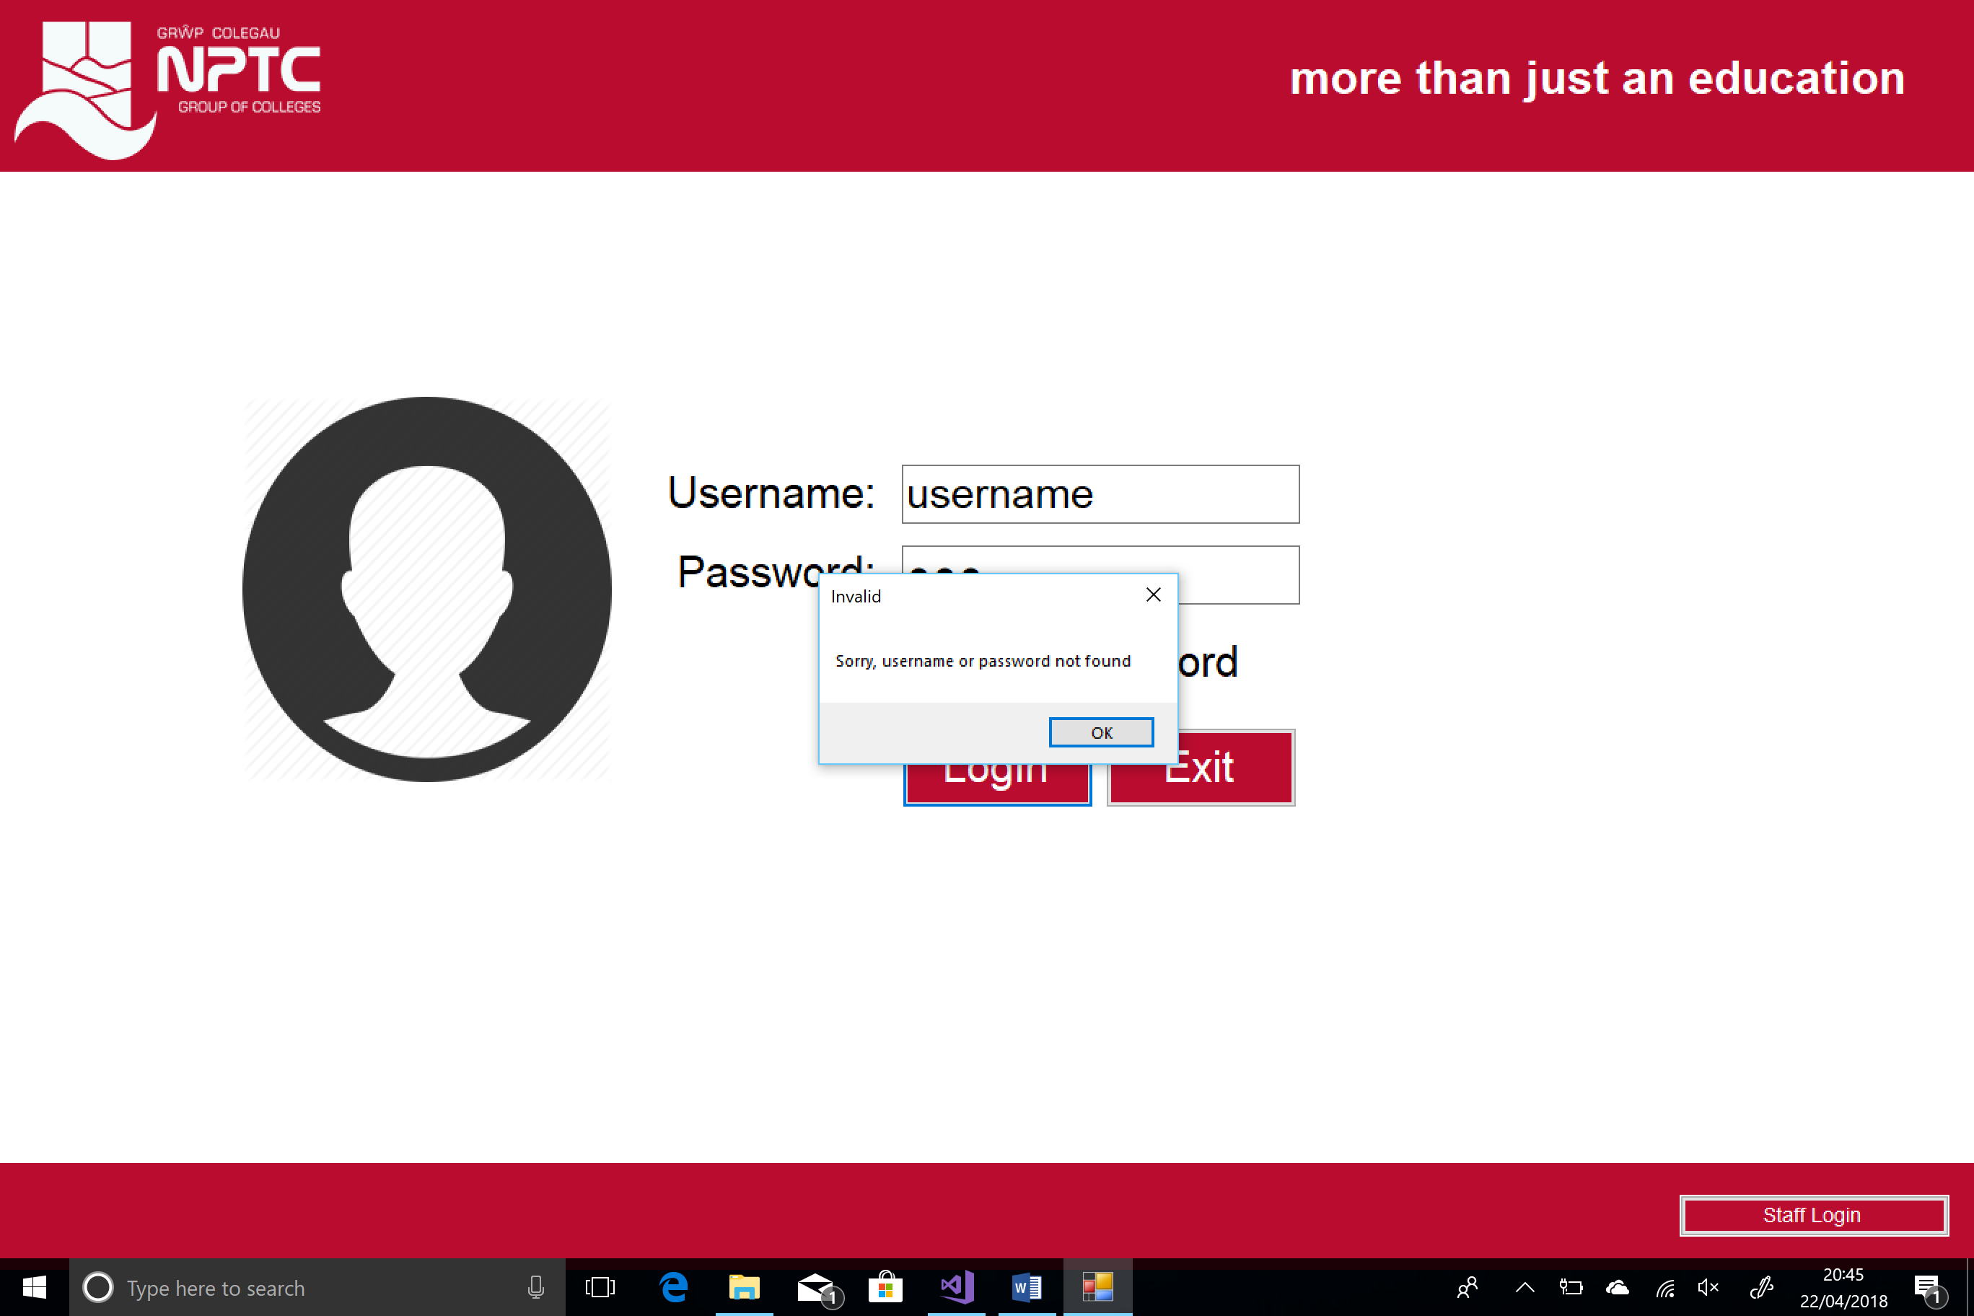

  - Try logging in as staff member. Type wrong password. Then type correct password.
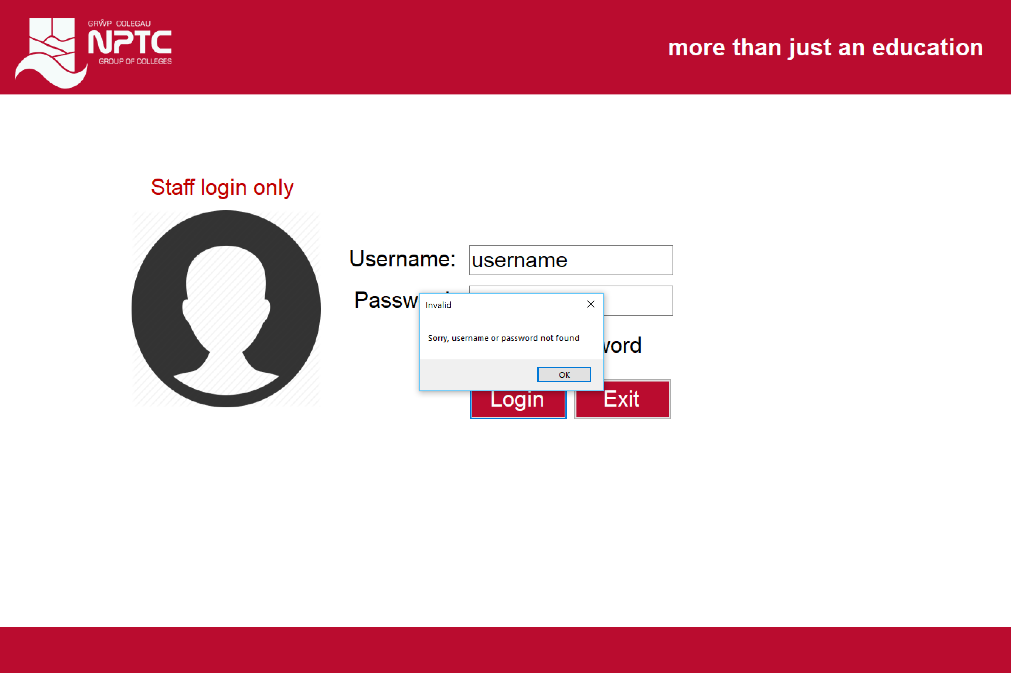

  - View A Level Courses
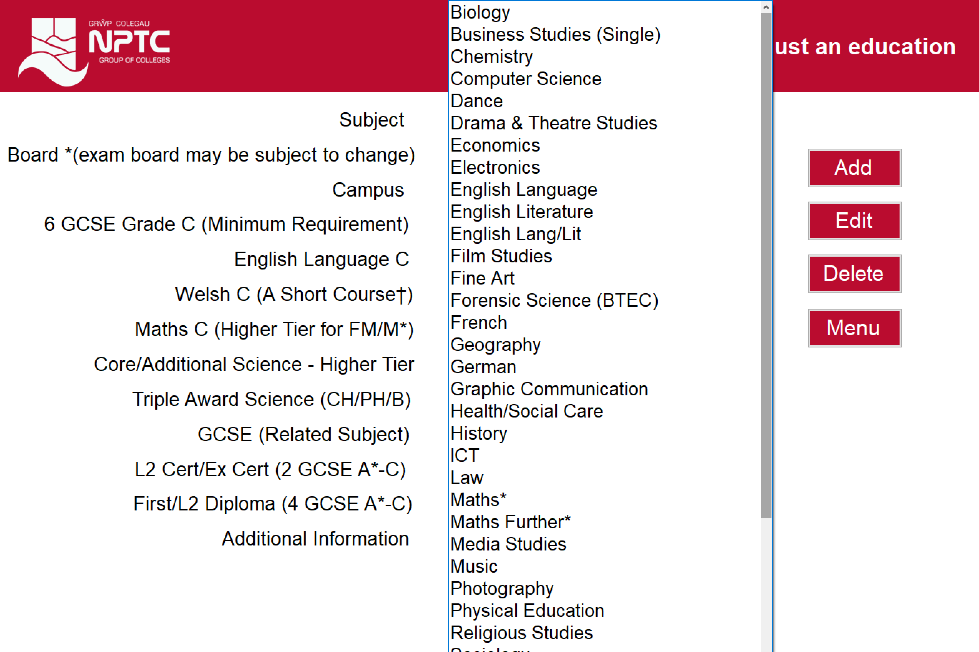
  - Add, edit, delete A Level courses

Add
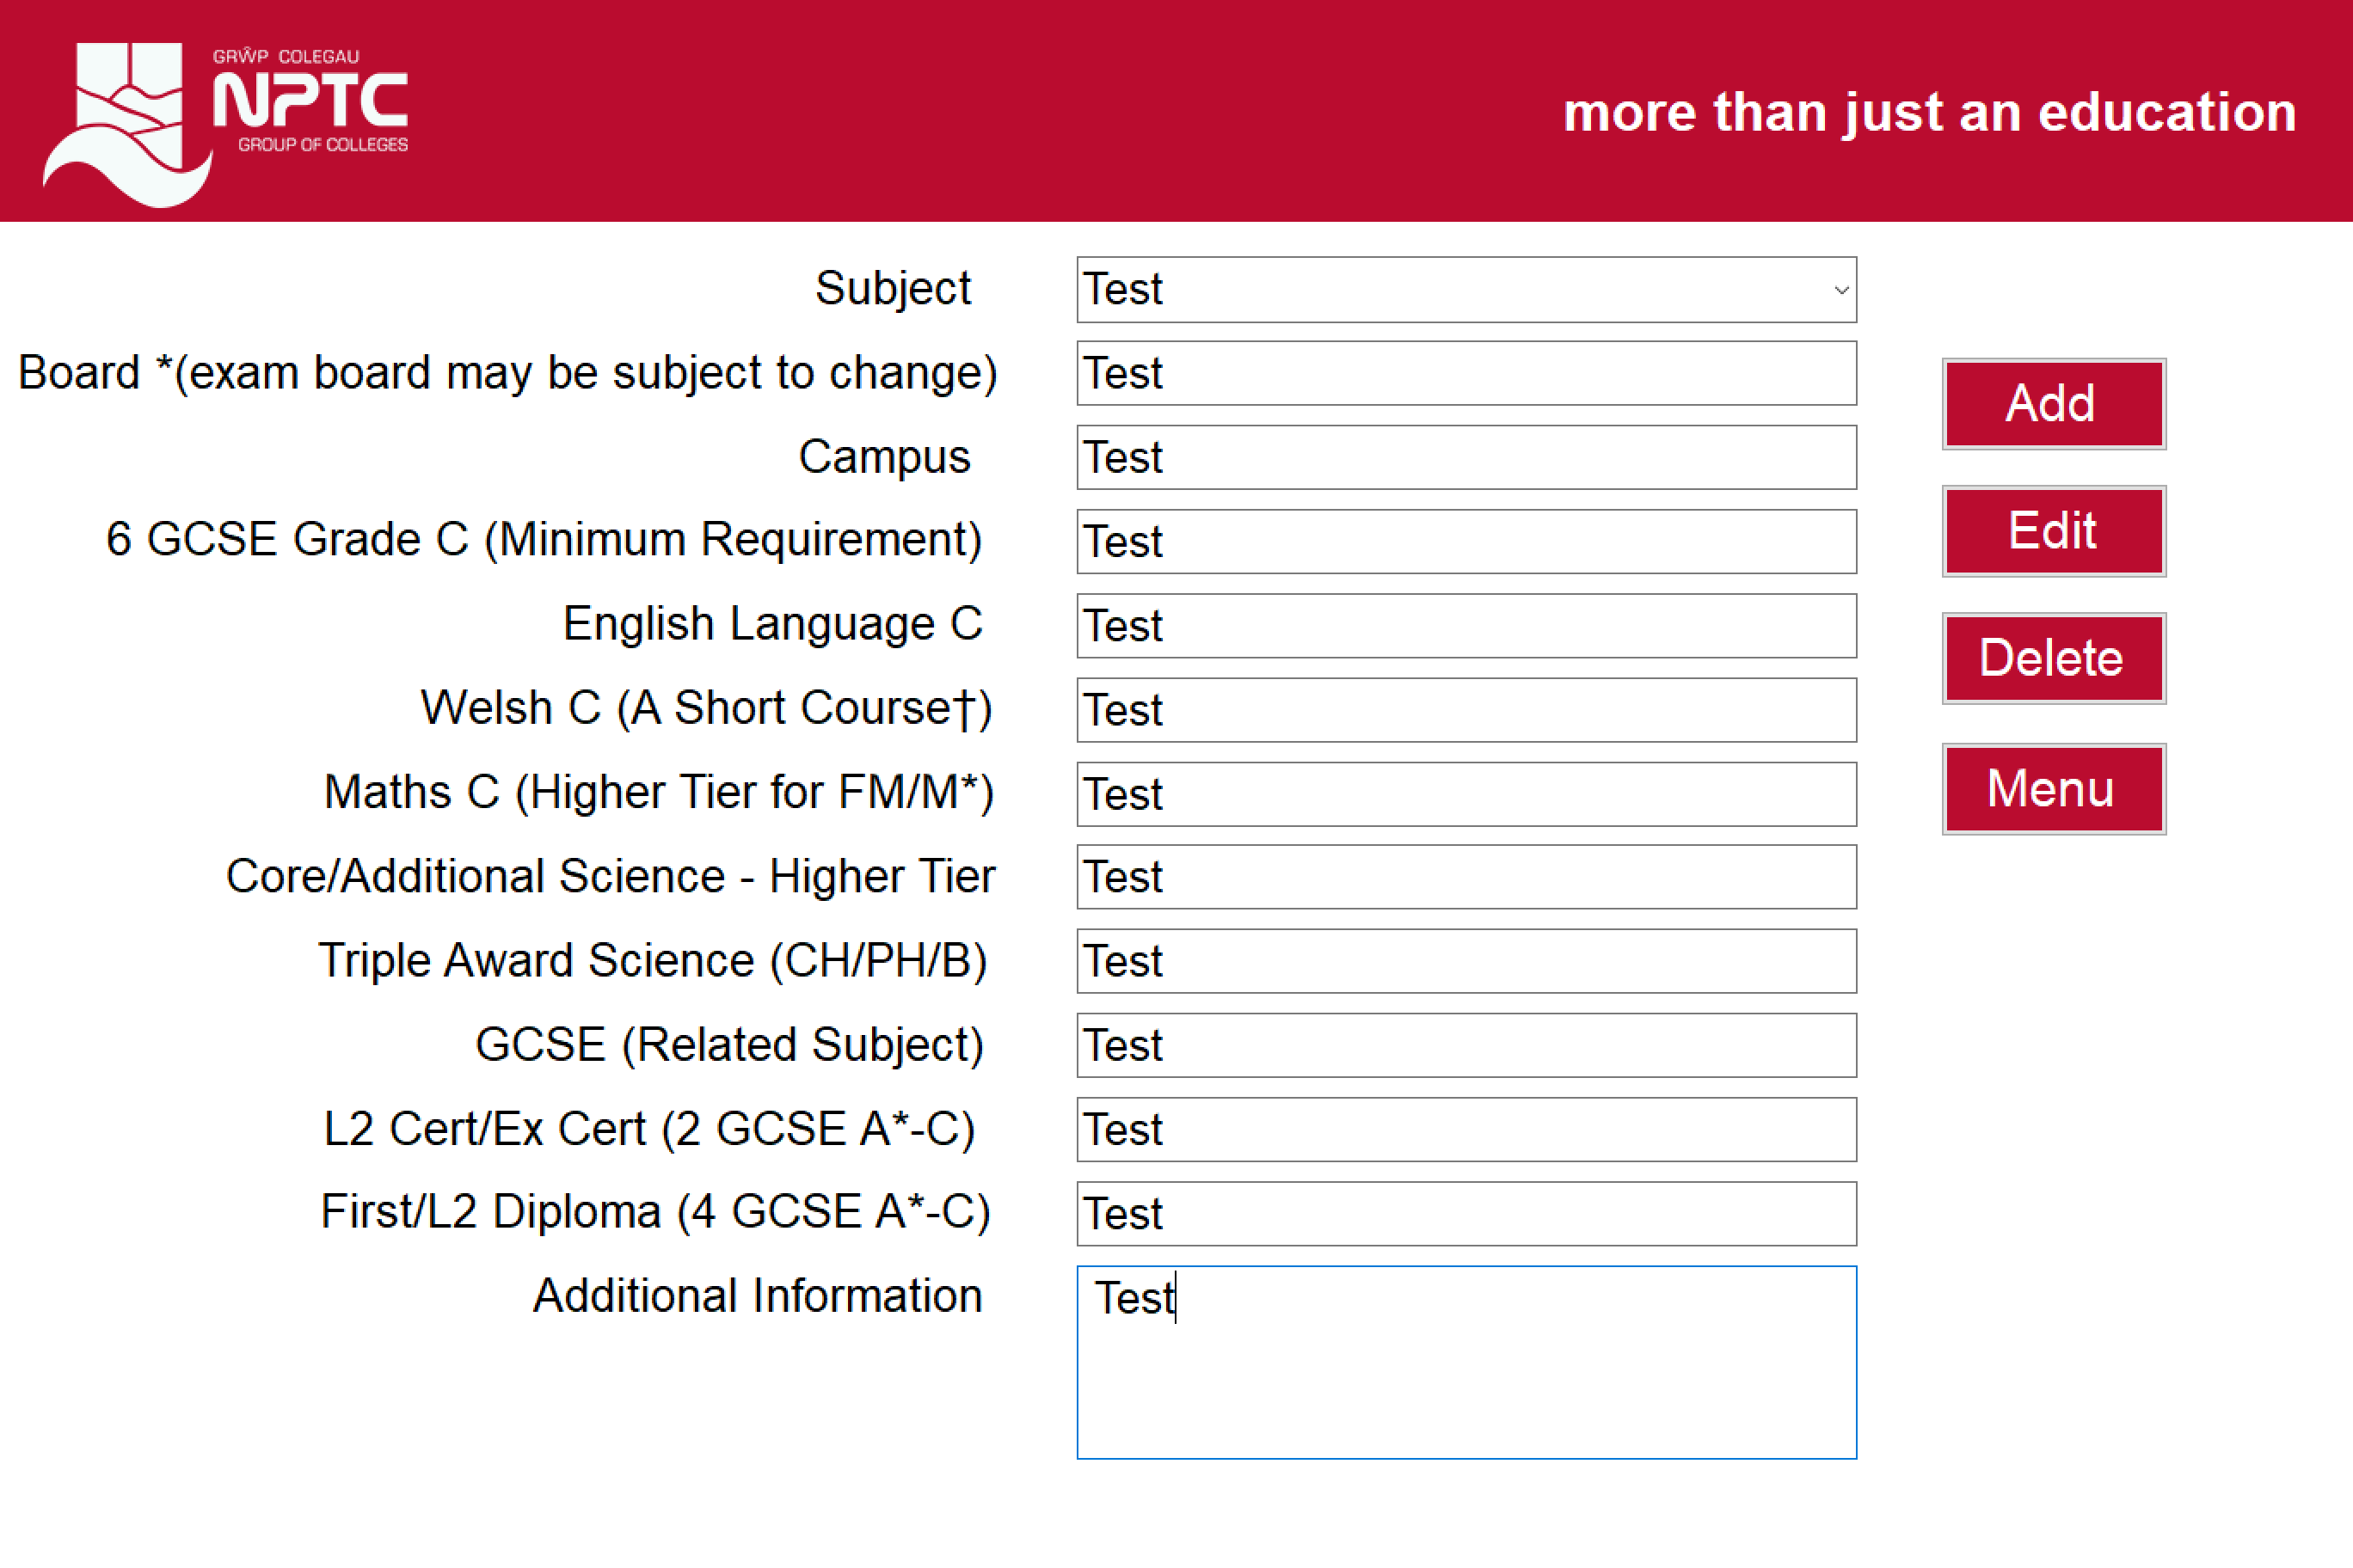
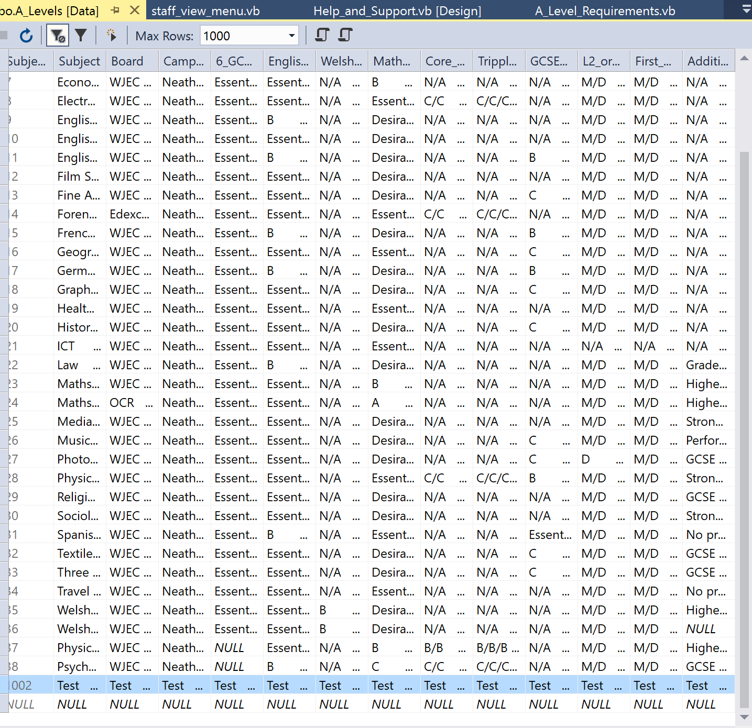
Edit
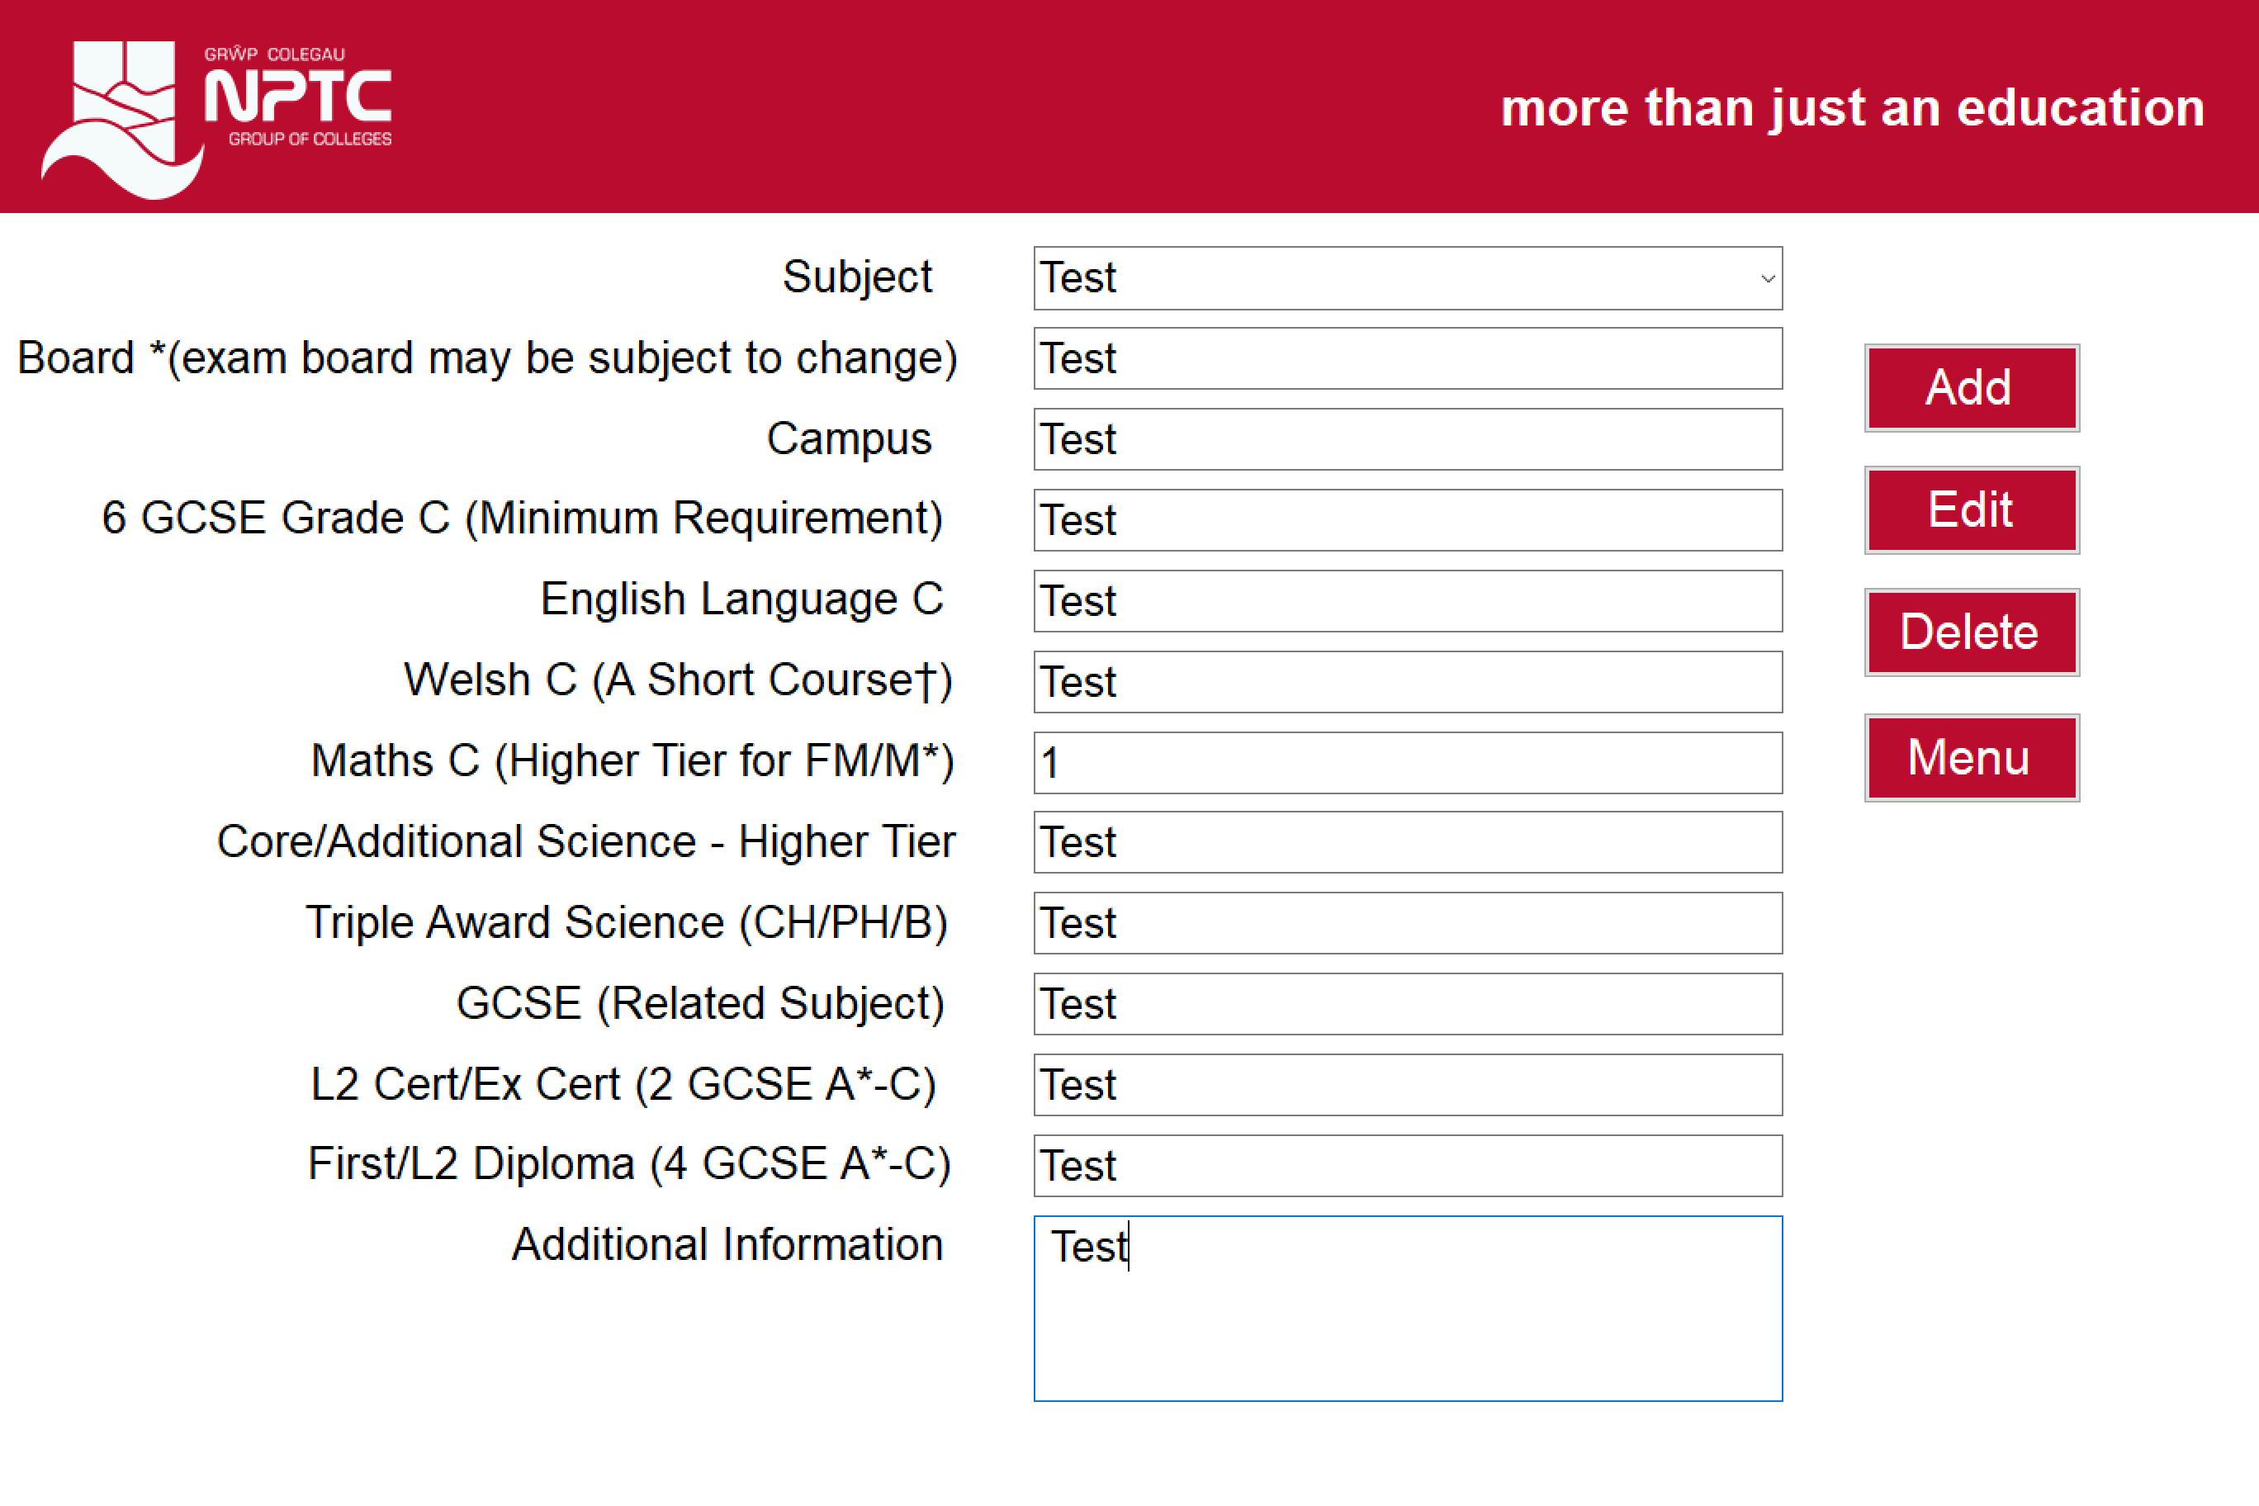
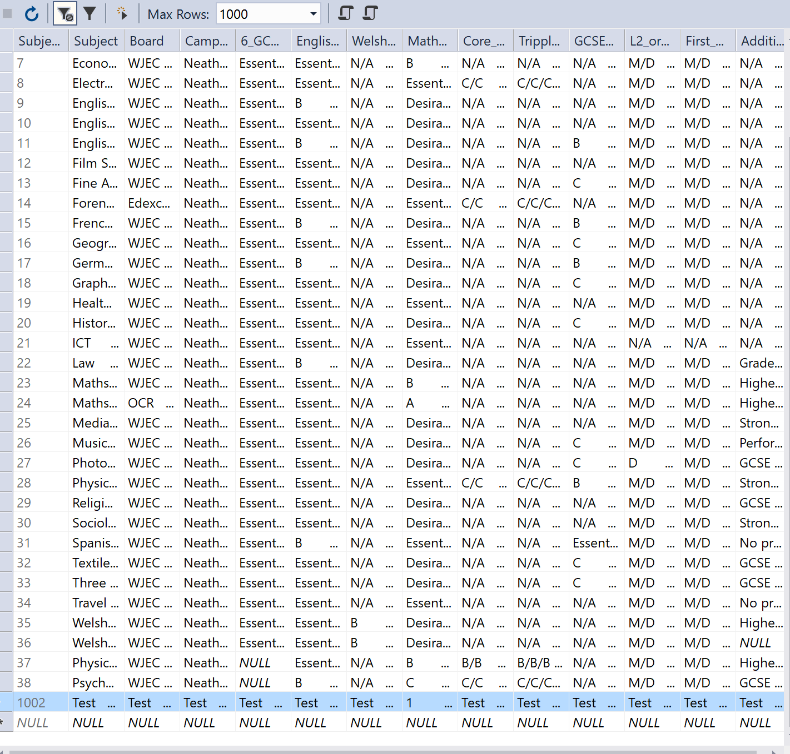

Delete
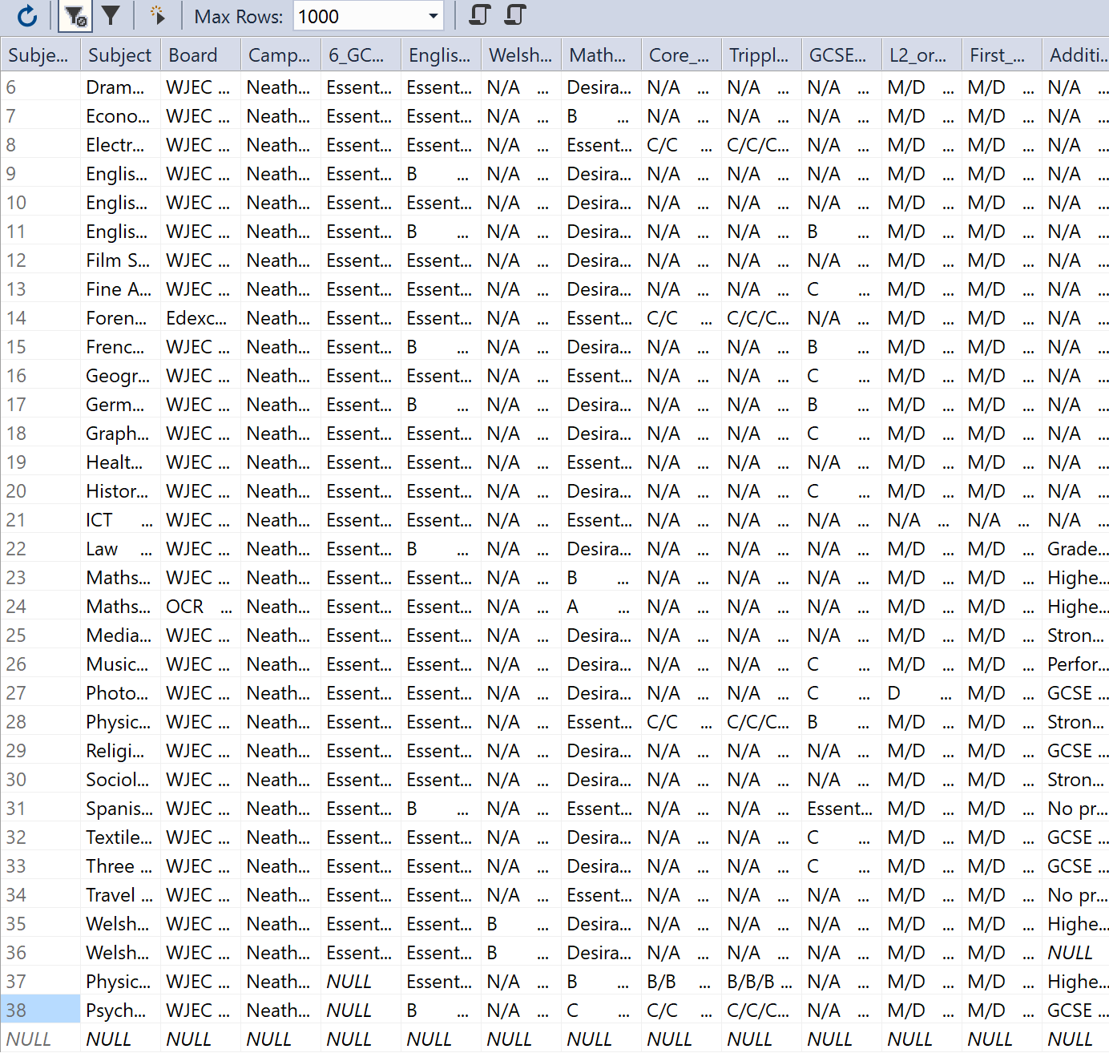
  - View Applications
Error message displayed

  - Enrol onto course

  - Enter student GCSE grade E and see if it makes them enrol on GCSE course

  - Enter student GCSE grade C and see if it offers them a chance to improve their grade

  - Type only one GCSE in and see if it allows me to enrol
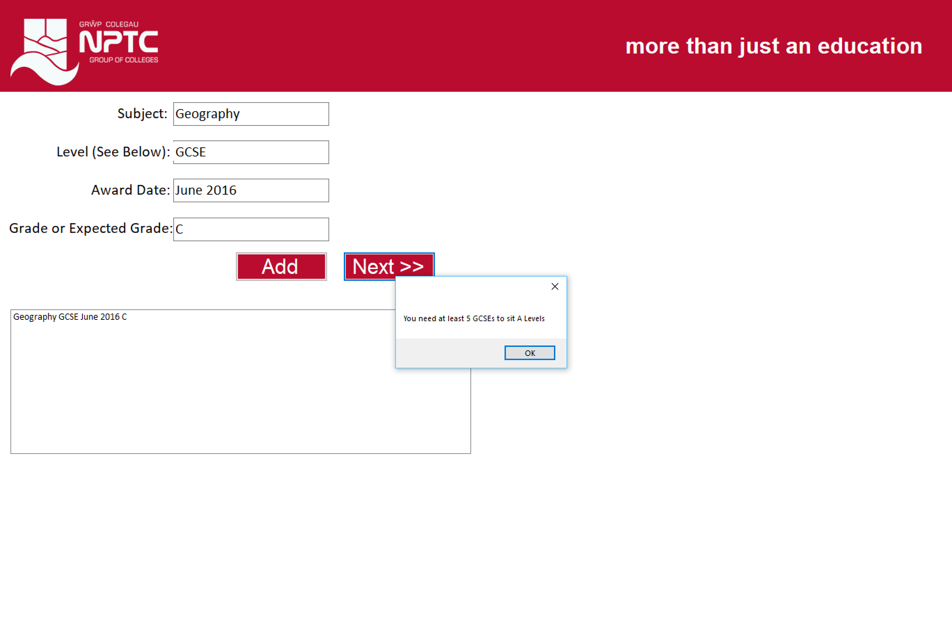

  - Try selecting more than 3 A Levels
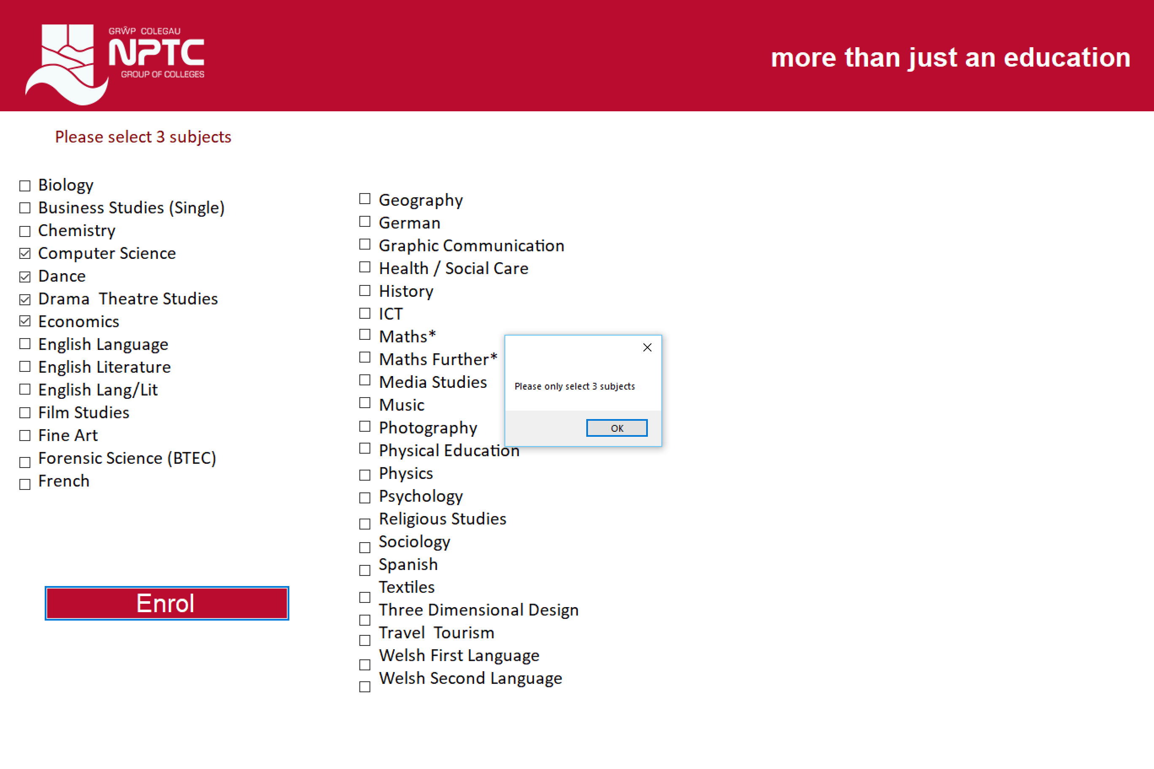

Timeboxing Iterative Methodology
In the chapter “Research and Development Methodologies” it was stated that Timeboxing would be used. Each stage of the development had its own timebox.
Timebox | Method | Date to be completed | Was it completed on time?
Overall | To design and implement a self enrolment system for NPTC Group | Sunday April 22 2018 | Yes
- Design, implement database | Design the database, create primary and foreign keys. Create all tables. | Tuesday December 05 2017 | Yes
- Design and implement A Level requirement form | Design A level requirement view from staff member view. Be able to add, edit, delete subjects. | Tuesday January 09 2018 | Yes
- Design and implement Staff login | Create a login screen for staff member and set up username and password | Tuesday January 30 2018 | Yes
- Design and implement student details form |  | Tuesday February 13 2018 | Yes
- Design and implement student login | Create a login screen for students and set up username and password | Tuesday February 27 2018 | Yes
- Design and implement GCSE validation forms | Design forms for student re-sitting GCSEs | Tuesday March 06 2018 | Yes
- Design and implement qualification forms | Design qualification form | Tuesday March 13 2018 | Yes
- Design and implement A Level selection form | Design form for students to select A levels | Tuesday March 20 2018 | Yes
- Design and implement final message form | A thank you for enrolling form. | Tuesday April 03 2018 | Yes
- Design and implement student view for staff members | A form to allow staff members to view students who have enrolled. | Tuesday April 10 2018 | No

Evaluation
Within this chapter, a full evaluation will be produced on the system developed for NPTC Group of Colleges. The aim that was originally set out was “to design, develop and implement software that would allow students at NPTC Group of Colleges to self-enrol onto a course, determined by grades and subjects chosen”.

This system does meet most of the requirements listed in the previous chapters. A student is able to use the system from start to finish and enrol themselves onto a course. The student is almost able to go through the entire enrolment process through the system, which was an objective I set out. Most things, the student is able to do such as enter personal details, select a course and enter examination results. Stated in the original objectives, it stated that students will be able to self enrol on a subject determined by their grades, however, when this was first set out the original goal was for the user to enter their qualifications and recommended A Level courses would appear. Moving forward, it was decided that the student would be able to select three subjects of their choice and if they had the appropriate grades, it would allow them to enrol. If the student does not meet the entry requirements, then the system would offer them the option to pick another subject or to arrange an interview with the course leader to discuss options. If it’s GCSE Mathematics or English Language that the student is missing, the system will make them enrol onto the course to proceed. Summing up the above statement, the system does meet the requirements.

In the first chapter of this report, a literature review was completed and it looked at all subject areas around A Level enrolment. In the findings in the literature review, it was discovered that there were different proof of identification that is required to enrol, such as National Insurance number, passport and examination results. The enrolment system that has been designed does not ask for any of these. The main idea behind it is this system will run alongside the current system and students will be required to provide evidence of qualifications during their induction week. As this would be a desktop application, it would require all machines having scanners, which would cause delays and slow running systems. If there was one main scanner, students would end up having to wait, which would defeat the objective of this new system, which is to speed up the process.

It was discovered that students are able to take up three A Level subjects, so the new system allows that. After further research was done on entry requirements, it was found that GCSEs had new grading systems, so the new system needed to support the new subjects. Even though it currently does not, it is something that would be implemented in the near future.

The different IDE’s and languages were researched in detail and Visual Basic was the right language to use. The language was simple to understand and the .NET IDE was very organised as everything was done in that, including the database design. There was a lot of support available from multiple sources online, to help with the more complex code in the design.

If this program was to be completed again, I would dedicate more time on the build of the project rather than the planning. A lot of time was spent planning on what was going to be done, rather than actually doing it. I would also change the technology from a desktop application, to a web application. I have decided this as after testing the software, it has become more clear that even though the system works really well, it would be more of an advantage if the student was able to enrol at home over the Internet. However, weighing up the advantage of this, it encourages the student to actually visit the college, meaning they can seek advice and get a taste for the college.

Conclusions and Recommendations
This chapter will summarise everything that has been done so far, discussing whether there are any suggestions for future development.

Conclusion
After reviewing the current enrolment system at NPTC Group of Colleges, I offered my assistance to help come up with a more relevant way of enrolling students onto courses. A literature review was carried out, where a lot of information was found and a lot of personal knowledge was gained from this. It looked into enrolment systems in general as in what they are, how they are used and who uses them. As the system was designed for enrolling students onto A Level courses only, it was important that the literature review covered great detail about A Levels. This included looking into the curriculum, how students study A Levels, how the grading works, and the current statistics.

It was important that the current UK laws and regulations were investigated, to ensure knowledge on making the system legal. As part of this, it needed to be discovered what age students attended college and how old typical A Level students are. A look into the UK education system was important, to show how far up the curriculum A levels actually was, compared to other subjects offered in schools. The Data Protection Act needed to be accessed as enrolment systems would handle sensitive data, meaning it is important that it is looked after and safe. As the Data Protection Act was being researched, it was then discovered that the law was changing, and even though all the regulations remain the same, it just gets tougher on organisations.

After the legislation was researched, more information on A levels needed to be researched. Within this section of the first chapter, different A Level combinations were looked at, along with the A Level entry rules, the new GCSE grading system, the pathways leading to and from A Levels, and the link qualifications that are offered.

The different methods was then looked at, where different data collection methods were discussed. Face-to-face, printed pre-formatted forms, online pre-printed forms were all looked at along with the benefits and limitations of each. Different tools that are already out in industry was also researched, to see what other companies are offering and how this system could be different and relevant. Different technologies such as application software, desktop app and web applications were looked at, to sum up what was the best way of approaching this. Different IDEs and languages were discovered, to weigh up which one was best to use, while keeping options open. To finish off the literature review, the different ethical issues was researched in more detail.

The project required the implementation of a research methodology, along with a development methodology. For research methodologies, ‘Positivism’, as it was going to be proven that the current enrolment system can be improved. The approach that was used was inductive research because it was a theory that was going to be built upon, which is in fact the college system being improved. Action research was chosen for strategy, because it allows the researcher to be both the participant and the researcher, which is what happened in this project. In regards to time horizon, Longitudinal was used as it is used when answering questions or addressing problem requires data to be collected for a certain amount of time. Quantitative data collection methods is used, as success can be measured by numeric terms, making it more simple to weigh up how successful the project was. Observation was another one, as observation could be done while people are using the old system and when they use the new system. Interviews was carried out to gather feedback, to discuss what is needed from the system and to gather more notes.

For the development methodology, timeboxing was used because it gave each task a certain amount of time to complete and when the time was over, it is time to move onto the next task regardless.

Diagrams were produced to help with the design and development of the system. Firstly, a Entity Relationship Diagram was produced as this would help see the relationship between the tables. The data flow diagram was then designed to help show the flow of data throughout the system. The final flow diagram was designed to help show the logic, which the system use.

Testing was used to test parts of the system such as the individual code, alongside testing the entire system. This was used to ensure the entire system was working to meet the final objectives. As a conclusion, all sections of the final report helped a significant amount in creating the end product for the user.

Recommendations for Future Improvements
For future development, I would recommend developing this as a website. This is what most universities do such as University of South Wales and USWTSD. For future development, I would create user accounts for different staff members, rather than them all having to use the same account. This could be an issue regarding security and could breach the Data Protection Act.

In the requirements, I set out to allow the students to research A level options before enrolling, however this is something that was never implemented. Another improvement would be for the student to double check their information before actually enrolling, so it will be the last form with all the information that they have entered, along with a progress bar to show how far they gotten through the process.

Reflection
After going through this process, I have learnt how useful it is to do your research before development as you start to gain more ideas on how to approach things, after reading other peoples approaches. I learnt that even though something seems like the right way, there is always going to be another way to do things as I have discovered. Right from the start, I said I wanted to develop an enrolment system using a desktop application, however, now I am at the end I wish I took a different approach.

I realised how important it was to follow the plan that I had created previous to this report, as it would have set out more realistic milestones for me.

Bibliography
1. NPTC Group. About Us. [Online] [Cited: 21 November 2017.] https://www.nptcgroup.ac.uk/about-us/.
2. Oliver Smith. Research Development Assignment 1. [Online]
3. Camebridge Dictonary. Enrolment. [Online] [Cited: 8 November 2017.] https://dictionary.cambridge.org/dictionary/english/enrolment.
4. Cambridge Dictonary. System. [Online] [Cited: 08 November 2017.] https://dictionary.cambridge.org/dictionary/english/system.
5. Tutor Club. Tutor Club Neath. [Online] [Cited: 21 November 2017.] www.tuitionneath.co.uk/.
6. University of Wales Trinity Saint David. Enrolment. [Online] [Cited: 21 November 2017.] http://www.uwtsd.ac.uk/registry/enrolment/.
7. Student Finance Wales. How much can you get? [Online] [Cited: 21 November 2017.] http://www.studentfinancewales.co.uk/undergraduate-students/part-time-students/continuing-students/course-grant.aspx#.WhQLNrKLRph.
8. City and Islington College. How to enrol. [Online] [Cited: 2 April 2018.] http://www.candi.ac.uk/apply-enrol/how-enrol#What%20to%20bring%20to%20Enrolment.
9. GOV.UK. National Insurance. [Online] [Cited: 2018 April 1.] https://www.gov.uk/national-insurance/your-national-insurance-number.
10. University of Oxford. What are A-levels? [Online] [Cited: 1 April 2018.] https://uni-of-oxford.custhelp.com/app/answers/detail/a_id/1325/~/what-are-a-levels%3F.
11. GOV.UK. Ofqual. [Online] [Cited: April 2 2018.] https://www.gov.uk/government/organisations/ofqual/about.
12. UCAS. A Levels. [Online] [Cited: 6 March 2018.] https://www.ucas.com/ucas/16-18-choices/search-and-apply/qualifications-you-can-take/levels.
13. GOV.UK. GCE AS and A level languages with smaller cohorts. [Online] [Cited: 2 April 2018.] https://assets.publishing.service.gov.uk/government/uploads/system/uploads/attachment_data/file/596067/MFL_smaller_cohorts_AS_Alevel.pdf.
14. Research and Evaluation Division. The Changing Pattern of A-level/AS uptake in England. [Online] [Cited: 2 April 2018.] http://cambridgeassessment.org.uk/Images/109710-the-changing-pattern-of-a-level-as-uptake-in-england.pdf.
15. BBC. A-level results 2010: A* grade boosts new exams record. [Online] 19 August 2010. [Cited: 2 April 2018.] http://www.bbc.co.uk/news/education-11012369.
16. United Kingdom National Commission for UNESCO. [Online] [Cited: 19 March 2018.] https://www.unesco.org.uk/about-us/.
17. GOV.UK. School leaving age. [Online] [Cited: 06 March 2018.] https://www.gov.uk/know-when-you-can-leave-school.
18. UIS UNESCO. United Kingdom of Great Britain and Northern Ireland. [Online] [Cited: 19 March 2018.] http://uis.unesco.org/en/country/gb.
19. GOV.UK. Education System in the UK. [Online] [Cited: 19 March 2018.] https://www.gov.uk/government/uploads/system/uploads/attachment_data/file/219167/v01-2012ukes.pdf.
20. —. The national curriculum. [Online] [Cited: 3 April 2018.] https://www.gov.uk/national-curriculum.
21. InterNations. Secondary Education in the UK. [Online] [Cited: 3 April 2018.] https://www.internations.org/great-britain-expats/guide/29461-family-children-education/schools-in-the-uk-16116/secondary-education-in-the-uk-2.
22. Careers Wales. Can I choose all of my subjects or are some compulsory? [Online] [Cited: 4 April 2018.] https://www.careerswales.com/en/your-career/features-1/option-choices-in-year-9/faqs-gcse-options/.
23. GOV.UK. Further and Higher Education Act 1992. [Online] 6 March 1992. [Cited: 4 April 2018.] https://www.legislation.gov.uk/ukpga/1992/13/introduction.
24. —. Data Protection. [Online] [Cited: 21 November 2017.] https://www.gov.uk/data-protection.
25. Information Commissioner's Office. Data protection principles. [Online] [Cited: 15 February 2018.] https://ico.org.uk/for-organisations/guide-to-data-protection/data-protection-principles/.
26. parliment.uk. Data Protection. [Online] [Cited: 06 March 2018.] https://www.parliament.uk/site-information/data-protection/.
27. ICO. Getting ready for the GDPR. [Online] [Cited: 5 April 2018.] https://ico.org.uk/for-organisations/business/.
28. Trust Hub. GDPR vs. UK DPA - THE KEY DIFFERENCES. [Online] [Cited: 5 May 2018.] https://cdn2.hubspot.net/hubfs/2380850/Assets/GDPR%20vs%20DPA%202017.pdf.
29. Legislation.gov.uk. Computer Misuse Act 1990. [Online] [Cited: 21 November 2017.] https://www.legislation.gov.uk/ukpga/1990/18/contents. https://www.legislation.gov.uk/ukpga/1990/18/introduction.
30. SQA. What is Computer Misuse? [Online] [Cited: 5 April 2018.] https://www.sqa.org.uk/e-learning/ITLaw01CD/page_03.htm.
31. Legislation.gov.uk. Education and Inspections Act 2006. [Online] [Cited: 28 November 2017.] https://www.legislation.gov.uk/ukpga/2006/40/introduction.
32. Legisilation.gov.uk. Higher Education and Research Act 2017. [Online] [Cited: 28 November 2017.] http://www.legislation.gov.uk/ukpga/2017/29/introduction.
33. Legislation.co.uk. Human Rights Act 1998. [Online] [Cited: 2017 November 2017.] https://www.legislation.gov.uk/ukpga/1998/42/contents.
34. Mind.org.uk. Human Rights Act 1998. Mind for better mental health. [Online] [Cited: 28 November 2017.] https://www.mind.org.uk/media/1823083/human-rights-act.pdf.
35. Oxford Learning College. Which 3 A Level Combinations Work Best Together? [Online] 27 July 2011. [Cited: 5 April 2018.] https://www.oxfordcollege.ac/news/which-3-a-level-combinations-work-best-together/.
36. UCAS. TIPS ON CHOOSING A LEVEL SUBJECTS. [Online] [Cited: 5 April 2018.] https://www.ucas.com/file/13666/download?token=3fXOA_Nd.
37. City And Islington College. A Level entry requirements. [Online] [Cited: 6 April 2018.] http://www.candi.ac.uk/apply-enrol/level-entry-requirements.
38. AQA. 9 to 1 grading. [Online] [Cited: 5 April 2018.] http://www.aqa.org.uk/about-us/what-we-do/policy/gcse-and-a-level-changes/9-to-1.
39. GOV.UK. GCSE 9 to 1 grades: a brief guide for parents. [Online] 2 March 2018. [Cited: 2018 April 5.] https://ofqual.blog.gov.uk/2018/03/02/gcse-9-to-1-grades-a-brief-guide-for-parents/.
40. eal. UK Qualification Comparison Chart. [Online] [Cited: 5 April 2018.] http://eal.org.uk/support/document-library/7-uk-qualifications-comparison-table/file.
41. Bright Knowledge from Brightside. What's next after A-Levels? [Online] [Cited: 5 April 2018.] https://www.brightknowledge.org/education/what-s-next-after-a-levels.
42. Qualifications Wales. The Welsh Baccalaureate. [Online] [Cited: 6 April 2018.] http://www.qualificationswales.org/english/qualifications/welsh-baccalaureate/.
43. Which? How do universities view the Welsh Baccalaureate? [Online] [Cited: 6 April 2018.] https://university.which.co.uk/advice/ucas-application/how-do-universities-view-the-welsh-baccalaureate.
44. Cambridge Dictionary. Data Entry. [Online] [Cited: 14 November 2017.] https://dictionary.cambridge.org/dictionary/english/data-entry?q=Data+Entry.
45. Your Dictonary. Data Entry. [Online] [Cited: 14 November 2017.] http://www.yourdictionary.org/data-entry.
46. Vanderbilt University. The advantages and disadvantages of data entry methofs. Department of Biostatistics. [Online] [Cited: 14 November 2017.] http://biostat.mc.vanderbilt.edu/TPT/SOURCE/Extras/DataManagement/Data%20entry%20methods.pdf.
47. TribalGroup. ebs Empoweing FE and vocational providers to deliver successful outcomes. [Online] [Cited: 28 November 2017.] http://www.tribalgroup.com/media/1221/bro_ebs_v4.pdf.
48. Scatler, Niall. Effective Learning Analysis. Jisc. [Online] 27 October 2014. [Cited: 19 March 2018.] https://analytics.jiscinvolve.org/wp/2014/10/27/tribal-student-insight-an-interview-with-chris-ballard/.
49. CAPITA. UNIT-e student management information system. [Online] [Cited: 28 November 2017.] http://www.capita-fhe.co.uk/unit-e.
50. Unit 4. Student Management System. [Online] [Cited: 3 December 2017.] http://www.unit4.com/uki/sectors/education.
51. Invensis. Advantages and Disadvantages of .NET and Java. [Online] 18 March 2015. [Cited: 6 April 2018.] https://www.invensis.net/blog/it/advantages-and-disadvantages-of-dotnet-and-java/.
52. Smith, Oliver. Concepts of Web Applications Development. 2016.
53. Microsoft. What is .NET? [Online] [Cited: 6 April 2018.] https://www.microsoft.com/net/learn/what-is-dotnet.
54. NetBeans. Welcome to the NetBeans Community. [Online] [Cited: 6 April 2018.] https://netbeans.org/about/index.html.
55. Oracle. NetBeans & Oracle. [Online] [Cited: 6 April 2018.] http://www.oracle.com/technetwork/developer-tools/netbeans/netbeans-oracle/index.html.
56. NetBeans. Top Reasons to Switch to the NetBeans IDE. [Online] [Cited: 6 April 2018.] https://netbeans.org/switch/why.html.
57. Microsoft. Visual Basic. [Online] [Cited: 4 April 2018.] https://www.microsoft.com/net/learn/languages.
58. SourceForge. Advantages of Visual Basic. [Online] [Cited: 6 April 2018.] http://lavape.sourceforge.net/doc/html/AdvantVB.htm.
59. Bilkent University. CTP108 - Programming for Business. [Online] [Cited: 6 April 2018.] http://www.ctp.bilkent.edu.tr/~ctp108/ctp108_ln_w1.pdf.
60. Microsoft. Visual Basic Limitations. [Online] [Cited: 6 April 2018.] https://docs.microsoft.com/en-us/dotnet/visual-basic/programming-guide/program-structure/limitations.
61. —. C# Guide. [Online] [Cited: 6 April 2018.] https://docs.microsoft.com/en-gb/dotnet/csharp/.
62. Danvers, Emily and Desai, Riti. Ethical consideration for data collection and research tools. Cardiff Metropolitan University. [Online] 2008. [Cited: 4 December 2017.] https://study.cardiffmet.ac.uk/AcSkills/Documents/Research/Research_Ethics_elesson/page_22.htm.
63. City University of Seattle. Chapter Three: Research Methodology. [Online] [Cited: 28 November 2017.] http://www.is.cityu.edu.hk/staff/isrobert/phd/ch3.pdf.
64. Comte, Auguste. Positive Philosophy. [Online] [Cited: 3 December 2017.] http://philosophy.lander.edu/intro/articles/comte-a.pdf.
65. Spiral. Video lesson plan for: Difference Between Inductive and Deductive Research . [Online] [Cited: 4 December 2017.] https://www.spiral.ac/sharing/w41qw6v/difference-between-inductive-and-deductive-research.
66. ASCD. Guiding School Improvement with Action Research. [Online] [Cited: 4 December 2017.] http://www.ascd.org/publications/books/100047/chapters/What-Is-Action-Research%C2%A2.aspx.
67. Saunders, Mark and Tosey, Paul. The Layers of Research Design. Academia. [Online] [Cited: 5 December 2017.] http://www.academia.edu/4107831/The_Layers_of_Research_Design.
68. Building, Harry Pitt. QUANTITATIVE ANALYSIS APPROACHES TO QUALITATIVE DATA. CuteSeerX. [Online] [Cited: 5 December 2017.] http://citeseerx.ist.psu.edu/viewdoc/download;jsessionid=56A9791D73D3A511040688EE8F87898D?doi=10.1.1.189.3862&rep=rep1&type=pdf.
69. Institutional Review Board for Social & Behavioral Sciences. Observations. [Online] [Cited: 5 December 2017.] http://www.virginia.edu/vpr/irb/sbs/resources_guide_data_method_observe.html.
70. University of Missouri St. Louis. Data Collection Methods. [Online] [Cited: 5 December 2017.] http://www.umsl.edu/~sauterv/analysis/488_f02_papers/data_collexn_files/thePaper.htm.
71. MindTools. Timeboxing. [Online] [Cited: 5 December 2017.] https://www.mindtools.com/pages/article/timeboxing.htm.
72. Smith, Oliver. Assignment 2 - Manipulation & Querying Tools. [Online] 17 March 2017. [Cited: 2018 April 15.] Available on NPTC Moodle, HND Computing, Unit 33, Assignment 2.
73. Joint Council for Qualifications. A-Levels. [Online] [Cited: 3 April 2018.] https://www.jcq.org.uk/examination-results/a-levels.

Appendices

Appendix I – Declaration

I, Oliver Smith declare that I am the sole author of this Project; that all references cited have been consulted; that I have conducted all work of which this is a record, and that the finished work lies within the prescribed word limits.

This work has not previously been accepted as part of any other degree submission.

Signed: O Smith
Date: January 09 2017

--------------------------------------------------------------------------------------------------------------------------

Appendix II – Form of Consent

I, Oliver Smith hereby consent that my Project, submitted in candidature for the BSc (Hons) in Computing & Information Systems degree, if successful, may be made available for inter-library loan or photocopying (subject to the law of copyright), and that the title and abstract may be made available to outside organisations.

Signed: O Smith
Date: January 09 2017

