

Management Economics

Borislava Borisova
Student ID: 2114506
Lecture: Taya Osadiya

Table of Contents
1. Introduction 3
Company Overview 3
2. Demand and Market Equilibrium 3
3. Indicate whether demand is more elastic or more inelastic 5
Conclusion 9
Reference 10

1. Introduction

Company Overview
IKEA is one of the leading Swedish multinational conglomerates depending on Nederland. The company design as well as sells ready-to-assemble furniture decoration, kitchen appliances, and home accessories as well as several other home services and other goods. The company was established by Ingvar Kamprad in 1943. The organization has been the biggest furniture company since 2008. This brand was utilized by many people. They operate more than 445 numbers of locations and services in many areas including Oceania, South America, Europe, India, North America, East Asia, North Africa and the Middle East. They offer products like homeware, ready-to-assemble, food products and furniture. They have generated revenue of 41.9 billion Euros in 2021 and a net income of 710,000,001 Euros in 2022. They employ about 231,000 employees in 2022. The vision of the company is to create a good everyday life for several individuals. Their business idea is a wider range of well-designed and functional home furnishing products at lower prices so many individuals will be capable to afford them (Bühren and Pleßner, 2023).
IKEA specializes within low-priced products, sold whenever possible within compact flat pack form for in-home assembly by the consumer. The home furnishing is beautiful as it is well functional, well designed, sustainable, quality and affordable (Ichev and Marinč, 2018). Their stores utilize their product range to develop solutions that are applicable to consumers. The organization work hard for attaining quality at affordable prices for their consumers by optimising their whole value chain, building a long-term relationship with suppliers, investing within highly automated products as well as producing large volume. The key financial principle of the company is to develop by utilizing their available sources (Ichev and Marinč, 2018). The products offered by the company are affordable as well as good quality which is the reason behind their success.

2. Demand and Market Equilibrium
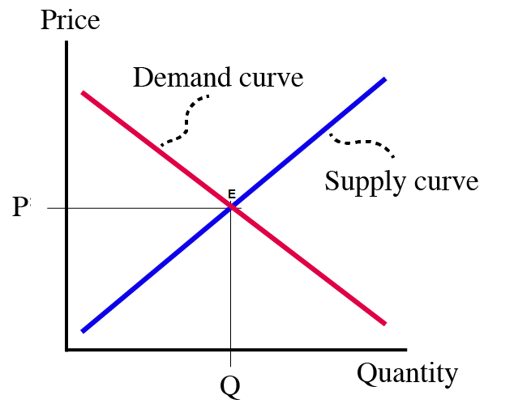
Figure 1: Demand and market equilibrium
In the above diagram, it has been illustrated that demand and market equilibrium are intertwined and when the quantity of goods sought and supplied are in balance, there are an equal number of buyers and sellers in the market. P and Q stand for price and quantity in the above figure, whereas point E denotes the market equilibrium. Consumer preferences are represented by the demand curve, which affects market equilibrium by affecting quantity and price. It demonstrates that the amount related to the equilibrium is referred to as the equilibrium quantity and the price associated with the equilibrium is defined as the equilibrium price.
Demand is defined as the desire of the customer to buy a specific service and goods. Market demand is the demand for specific products in the market. It is a consumer desire along with a willingness to purchase goods at a given price (Ichev and Marinč, 2018). A market has attained an equilibrium price when the supply of products matches demand. Market equilibrium describes 3 characteristics which are –the behaviour of agents inconsistent, A dynamic procedure governs equilibrium results and there are no incentives for agents to change in behaviour
There are many factors that affect demand for products such as the price of complements, consumer income, demographics, consumer expectations of price and consumer preferences and tastes (Keele and Titiunik, 2015). Each of these factors is discussed below-
Price of substitutes
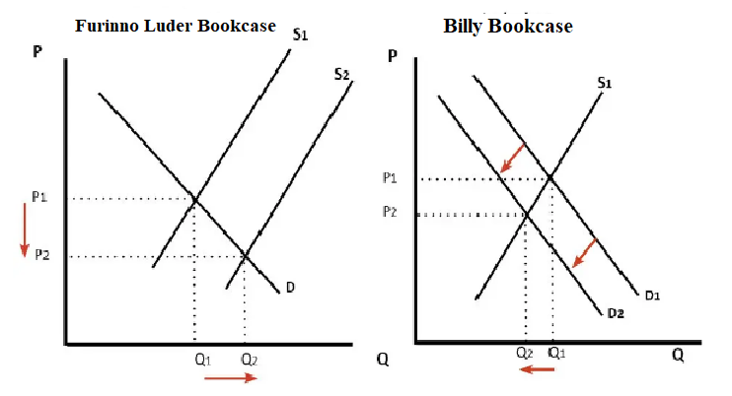
Demand for products is significantly influenced by the cost of alternatives. Consumers are more inclined to switch to the less expensive option when the price of a substitute product rises, which lowers demand for the original offering. On the other hand, if a substitute's price drops, customers can choose the now-cheaper alternative instead of the original product, which would reduce demand for the original offering (Ichev and Marinč, 2018). In conclusion, demand for the original good increases when alternatives are more expensive, but desire declines when substitutes are less expensive.
As an example: Billy Bookcase is one of the best and most popular products of IKEA (Ahmed et al., 2016). This product has cemented itself firmly as one of the most famous products in the company. It is predicted that every 5 seconds, one Billy Bookcase is sold somewhere around the globe (Keele and Titiunik, 2015). Amazon offers Furinno Luder Bookcase which is a substitute for the Billy Bookcase offered by IKEA. If the price of Furinno Luder Bookcase declines, the demand for Billy Bookcase will decline and vice-versa. So demand for Billy Bookcase is directly influenced by a change in the price of Furinno Luder Bookcase.
Price of complements
If two commodities are complements, it means that a rise in the price of one good will encourage a downshift in demand for the other goods (Holt and Shobe, 2016). The price of complementary commodities also shifts the demand curve. When the price of a commodity that complements good declines then the quantity demanded of one raises as well as the demand for the other raises (Klenert et al., 2018). In other words, when the price of a complementary commodity decreases, the quantity demand for the other product increases (Keele and Titiunik, 2015). For example, when the prices of petrol decline there is an increment in the quantity demanded of cars.
Consumer Income
The change in demand of consumers for services and goods depends on their income. When the income of individuals increases, they will demand more services and goods (Klenert et al., 2018). For example, when the income of consumers increases, it will increase demand for Billy Bookcase and if their income decreases, the demand for Billy Bookcase wills decreases. There are direct relations between the income of consumers and the demand for commodities (Holt and Shobe, 2016).
Consumer tastes & preferences
Demand for products is affected by the preferences and tests of the consumers positively (Holt and Shobe, 2016). If the preferences and tests are positive then demand will be raised and if preferences and tests are negative, the demand will be declined. There are adverse relationships between demand and consumer tastes & preferences (Den Boer, 2015). The demand for Billy Bookcase will rise if the preferences and tests of consumers are changed in favour of this product (Klenert et al., 2018). Any kind of unfavourable change in the preferences and tests will decline the demand for Billy Bookcase.
Consumer expectations of price
If consumers of Billy Bookcase expect the prices to go up, they are more likely to purchase the product now and shift the demand curve to the right side (Li et al., 2016). If they expect the prices of Billy Bookcase to go down, they will stop purchasing Billy Bookcase and shift the demand curve to the left.
Demographics - Number of Consumers (Buyers)
Demand for products and services is determined by how many consumers are purchasing specific goods. A higher number of buyers of commodities increase the demand for that product. In the case of Billy Bookcase, a higher number of customers will increase its demand Ellerman, Valero and Zaklan, 2015). The lower number of buyers will negatively affect demand for Billy Bookcase. There is a direct relationship between the number of purchasers and the demand for products (Den Boer, 2015).

3. Indicate whether demand is more elastic or more inelastic
The price elasticity of demand is explained as the percentage change within the quality demanded of services and goods divided by the percentage change within the price (Li et al., 2016). Price elasticity defines as the extent to which changes in the prices of goods influence the demand for services and products.
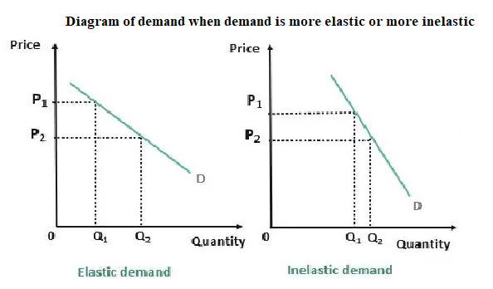
Substitution Effects
The demand for a product is likely to be more elastic if there are close replacements available. Customers may readily move to replacements when the price of the product rises, which significantly reduces the amount requested.
The substitution impact is the decline in sales for a service and merchandise that might be attributed to customers switching to cheaper alternatives when their price amplifies (Ellerman, Valero and Zaklan, 2015). A product can lose their market share for several reasons however; the substitution effect is purely a reflection of frugality. In the case of IKEA, prices of Billy Bookcases increased and customers respond by buying more Furinno Luder Bookcases. Any kind of increment in the prices of Billy Bookcase will increase demand of Furinno Luder Bookcase.
In economics, a luxury commodity is a good for which demand enhances more than what is proportional as income increases so that expenses on the goods become a huge proportion of overall expenditure (Li et al., 2016). Luxury commodities are the opposite of necessity commodities, where demand raises proportionally less in comparison of income (Li, Chen and Dahleh, 2015). Apart from this, luxury commodities are totally the opposite of necessity goods which are goods that individuals purchase regardless of their wealth or income level (Ellerman, Valero and Zaklan, 2015). Water, utilities and food utilized to live in an apartment or house would likely be considered necessity commodities for most of the population.
Billy Bookcase is luxury not necessity as investing in good quality furniture is necessary but investing in branded furniture is luxury. So it can be said that Billy Bookcase is a luxury product rather than a necessity (Li, Chen and Dahleh, 2015). If the goods are something the consumer requires, the price elasticity of demand is lower. The price elasticity of demand tends to be high if it is a luxury commodity (Li, Chen and Dahleh, 2015). Medical treatment and necessities commodity tend to be inelastic whereas luxury commodity tends to be most elastic (Ahmed et al., 2016). Luxury commodities are said to have a higher income elasticity of demand (Munoz et al., 2018). In simple words, as the public becomes wealthier, they will purchase more and more of luxury commodities( Ellerman, Valero and Zaklan, 2015).
Income effect
The income impacts explain how an increment can change the quantity of commodities (Curto et al., 2021). The income statement in economics is a part of customer selection theory, which links preferences to customer expenses as well as goods and services (Den Boer, 2015). The income influence expresses the effect of changes in buying power of consumers. Any kind of change in real income can outcome from normal income transformation. When nominal income rises without any kind of change in prices, it means customers can buy more services and products at similar projects (Munoz et al., 2018). An increment of the income of people will increase the demand of Billy Bookcase.
Elastic demand is demonstrated by the fact that for common items, a rise in income increases demand. In contrast, for subpar products, a rise in income results in a fall in demand, demonstrating inelastic demand.
Income percentage is one of the Percentages of Profit and loss that is deriving from any source of company. It is a fact that purchases of services or goods show a small or larger portion of the income of consumers (Nagle and Muller, 2018). If consumers purchase more and luxury products and services, it means their earning is high and when consumer purchase less and necessities services and products at a lower price, it means their earning is less. There is a direct relationship between the income of consumers and the purchase of goods (Munoz et al., 2018). Higher-income motivates for more purchases while lower-income motivates for saving and less expenditure.
The income elasticity of demand explains the sensitivity to transform in customer income relative to the amount of a product that customer demand (Prabavathi and Gnanadass, 2015). Goods with high elastics will observe their quantity demanded transformation contently with the income transformation. Whereas inelastic goods will see a similar quantity demanded even as income changes.
Pricing policy
A pricing policy is an approach of a company to determining the price at which provides a service. These policies assist the firm make sure they remain profitable as well as provide them with the flexibility to price different products distinctly (Prabavathi and Gnanadass, 2015). There are distinct types of pricing policies including competitive bidding in competitive markets and geographical pricing, price discounts an allowances' and geographic pricing. Organizations can use any one of them for products (Nagle and Muller, 2018).
Competitive bidding in the competitive market
The competitive bid is linked with the proposal in addition to price submitted by the vendor or service provider to a soliciting company for the venture opportunity, including products or services (Pereira and Costa, 2015). It might potentially be related to any kind of venture opportunities in which the organization represents the proposal including venture deals. Competitive bidding comprises of the proposal by an organization looking for offering services or bid for a venture with another firm (Prabavathi and Gnanadass, 2015).
Geographical pricing: geographical pricing is the practice of adjusting the product’s sale price grounded on the location of the customer. Many times the diversification in the sale price is grounded on the cost to ship the item to that location. However, the disparity can even be grounded on what amount the individual in that location wants to pay (Curto et al., 2021). It is practiced by firms for reflect the diverse shipping costs accrued when transporting products to diverse markets (Pereira and Costa, 2015). Prices could be lower if the products compete within the crowded market where the customer has a number of other quality options.
Price discounts and allowances'
The main goals of giving allowance or discounts are to deal with rivals. But, discounts could be dangerous if not controlled appropriately. Discount is like the price differential that quotes the price so that the buyer pays much less than the quoted price (Curto et al., 2021). Discounts might be delegated into the following 4 types, as if, quantity, trade, seasonal and cash. In addition to , the discount might be numerous types and they are –quantity discounts, trade discounts, seasonal discounts and cash discounts as well as regarding the factors that influence pricing (Caraballo, Wang and Xu, 2014).
Geographic pricing
IKEA should adopt geographical pricing strategy because adopting this strategy may offer them ample benefits. With this strategy, ventures may decline their shipping, freight as well as alternative transportation expense (Pereira and Costa, 2015). Moreover, by using this strategy, they may make it more financially viable for ventures to expand into new geographic markets. Localizing their prices will support to boost consumer satisfaction and trust within their venture. When clients in many geographic regions see the organization's name as credible, they might be more probably to become loyal clients or recommend that firm to others in their realm (Nagle and Muller, 2018). Through forming diverse pricing within geographical locations, ventures can create maximum profit in every region. This may support amplifying the organization's entire revenue and enable it to expand or further develop their venture (Caraballo, Wang and Xu, 2014).

Conclusion
This report has mentioned that A market has attained an equilibrium price when the supply of products matches demand. This product has cemented itself firmly as one of the most famous products in the company. It is predicted that every 5 seconds, one Billy Bookcase is sold somewhere around the globe. Substitute goods are defined as goods that can be utilized in place of one another to meet the desire of an individual such as coffee and tea. When the income of consumers increases, it will increase demand for Billy Bookcase and if their income decreases, the demand for Billy Bookcase wills decreases. Any kind of unfavourable change in the preferences and tests will decline the demand for Billy Bookcase. If they expect the prices of Billy Bookcase to go down, they will stop purchasing Billy Bookcase and shift the demand curve to the left. There is a direct relationship between the number of purchasers and the demand for products. Price elasticity defines as the extent to which changes in the prices of goods influence the demand for services and products. By using this strategy, they may make it more financially viable for ventures to expand into new geographic markets. Localizing their prices will support to boost consumer satisfaction and trust within their venture. When clients in many geographic regions see the organization's name as credible, they might be more probably to become loyal clients or recommend that firm to others in their realm.

Reference
Ahmed, M.O., El-Adaway, I.H., Coatney, K.T. and Eid, M.S., 2016. Construction bidding and the winner’s curse: Game theory approach. Journal of Construction engineering and Management, 142(2), p.04015076.
Caraballo, R.S., Wang, X. and Xu, X., 2014. Can you refuse these discounts? An evaluation of the use and price discount impact of price-related promotions among US adult smokers by cigarette manufacturers. BMJ open, 4(6), p.e004685.
Curto, V., Einav, L., Levin, J. and Bhattacharya, J., 2021. Can health insurance competition work? evidence from medicare advantage. Journal of Political Economy, 129(2), pp.570-606.
Den Boer, A.V., 2015. Dynamic pricing and learning: historical origins, current research, and new directions. Surveys in operations research and management science, 20(1), pp.1-18.
Ellerman, A.D., Valero, V. and Zaklan, A., 2015. An analysis of allowance banking in the EU ETS. Robert Schuman Centre for Advanced Studies Research Paper No. RSCAS, 29.
Holt, C.A. and Shobe, W.M., 2016. Reprint of: Price and quantity collars for stabilizing emission allowance prices: Laboratory experiments on the EU ETS market stability reserve. Journal of Environmental Economics and Management, 80, pp.69-86.
Ichev, R. and Marinč, M., 2018. Stock prices and geographic proximity of information: Evidence from the Ebola outbreak. International Review of Financial Analysis, 56, pp.153-166.
Keele, L.J. and Titiunik, R., 2015. Geographic boundaries as regression discontinuities. Political Analysis, 23(1), pp.127-155.
Klenert, D., Mattauch, L., Combet, E., Edenhofer, O., Hepburn, C., Rafaty, R. and Stern, N., 2018. Making carbon pricing work for citizens. Nature Climate Change, 8(8), pp.669-677.
Li, B., Zhu, M., Jiang, Y. and Li, Z., 2016. Pricing policies of a competitive dual-channel green supply chain. Journal of Cleaner Production, 112, pp.2029-2042.
Li, N., Chen, L. and Dahleh, M.A., 2015. Demand response using linear supply function bidding. IEEE Transactions on Smart Grid, 6(4), pp.1827-1838.
Munoz, F.D., Wogrin, S., Oren, S.S. and Hobbs, B.F., 2018. Economic inefficiencies of cost-based electricity market designs. The Energy Journal, 39(3).
Nagle, T.T. and Muller, G., 2018. The strategy and tactics of pricing. Routledge.
Pereira, V. and Costa, H.G., 2015. A literature review on lot size with quantity discounts: 1995-2013. Journal of Modelling in Management, 10(3), pp.341-359.
Prabavathi, M. and Gnanadass, R., 2015. Energy bidding strategies for restructured electricity market. International Journal of Electrical Power & Energy Systems, 64, pp.956-966.
Bühren, C. and Pleßner, M., 2023. IKEA vs Trophy effect–an experimental comparison. Journal of Consumer Marketing, 40(4), pp.493-505.

