Nathan Morgan 1801338 Software Engineering

accA4018
Assignment 1

Abstract
A report on the website created for my assignment, detailing the content and the methodology in creating the website, the accessibility and an evaluation on the web page and the future improvements I can make. In the evaluation I cover the accessibility, the future improvements and the search engine optimisation implemented and a test log of the navigation.

Contents
Abstract 1
Requirements 1
Implementation 2
Test log 2
Web pages and validation screenshots 4
Evaluation 4
Evaluation of completed website 5

Requirements
The requirements for this assignment were straight forward, I made it for a fictious company called not a flag mining Corp, inspired by the elite dangerous game. In the website I detailed the information about the company in a way that is appealing to the reader targeting an audience that is enthusiastic about space exploration. The Company specialises in mapping and mining the unknown universe and returning to earth with the harvested resources and the data captured this fictious company is a pioneer in the field. This format allowed me to use different media types to display my knowledge of html, including use of a cascading style sheet, and boot strap and a little bit of JavaScript I was able to put my website together.

Implementation

Test log
Test number | Test description | Expected result | Actual result
1 | Upon clicking Not a flag, Mining corp logo | Go to home page | Go to home page
2 | When clicking the navigation drop down menu | Open the drop-down menu and display a selection of web pages to navigate too. | Open the drop-down menu and display a selection of web pages to navigate too.
3 | Upon selecting the home web page from the navigation menu while on the index web page | Go to home page | Go to home page
4 | Upon selecting the Locations web page from the navigation menu while on the index web page | Go to locations web page | Go to locations home page
5 | Upon selecting the Hardware web page from the navigation menu while on the index web page | Go to hardware page | Go to hardware page
6 | Upon selecting the Materials page from the navigation menu while on the index web page | Go to materials page | Go to materials page
7 | Upon selecting the contact, us web page from the navigation menu while on the index web page | Go to contact us page | Go to contact us page
8 | Upon selecting the home web page from the navigation menu while on the location’s web page | Go to home page | Go to home page
9 | Upon selecting the Locations web page from the navigation menu while on the location’s web page | Go to locations web page | Go to locations home page
10 | Upon selecting the Hardware web page from the navigation menu while on the location’s web page | Go to hardware page | Go to hardware page
11 | Upon selecting the Materials page from the navigation menu while on the location’s web page | Go to materials page | Go to materials page
12 | Upon selecting the contact, us web page from the navigation menu while on the location’s web page | Go to contact us page | Go to contact us page
13 | Upon selecting the home web page from the navigation menu while on the Hardware web page | Go to home page | Go to home page
14 | Upon selecting the Locations web page from the navigation menu while on the Hardware web page | Go to locations web page | Go to locations home page
15 | Upon selecting the Hardware web page from the navigation menu while on the Hardware web page | Go to hardware page | Go to hardware page
16 | Upon selecting the Materials page from the navigation menu while on the Hardware web page | Go to materials page | Go to materials page
17 | Upon selecting the contact, us web page from the navigation menu while on the Hardware web page | Go to contact us page | Go to contact us page
18 | Upon selecting the home web page from the navigation menu while on the Materials web page | Go to home page | Go to home page
19 | Upon selecting the Locations web page from the navigation menu while on the Materials web page | Go to locations web page | Go to locations home page
20 | Upon selecting the Hardware web page from the navigation menu while on the Materials web page | Go to hardware page | Go to hardware page
21 | Upon selecting the Materials page from the navigation menu while on the Materials web page | Go to materials page | Go to materials page
22 | Upon selecting the contact, us web page from the navigation menu while on the Materials web page | Go to contact us page | Go to contact us page
23 | Upon selecting the home web page from the navigation menu while on the Contact Us web page | Go to home page | Go to home page
24 | Upon selecting the Locations web page from the navigation menu while on the Contact Us web page | Go to locations web page | Go to locations home page
25 | Upon selecting the Hardware web page from the navigation menu while on the Contact Us web page | Go to hardware page | Go to hardware page
26 | Upon selecting the Materials page from the navigation menu while on the Contact Us web page | Go to materials page | Go to materials page
27 | Upon selecting the contact, us web page from the navigation menu while on the Contact Us web page | Go to contact us page | Go to contact us page

Web pages and validation screenshots
The home page with validation
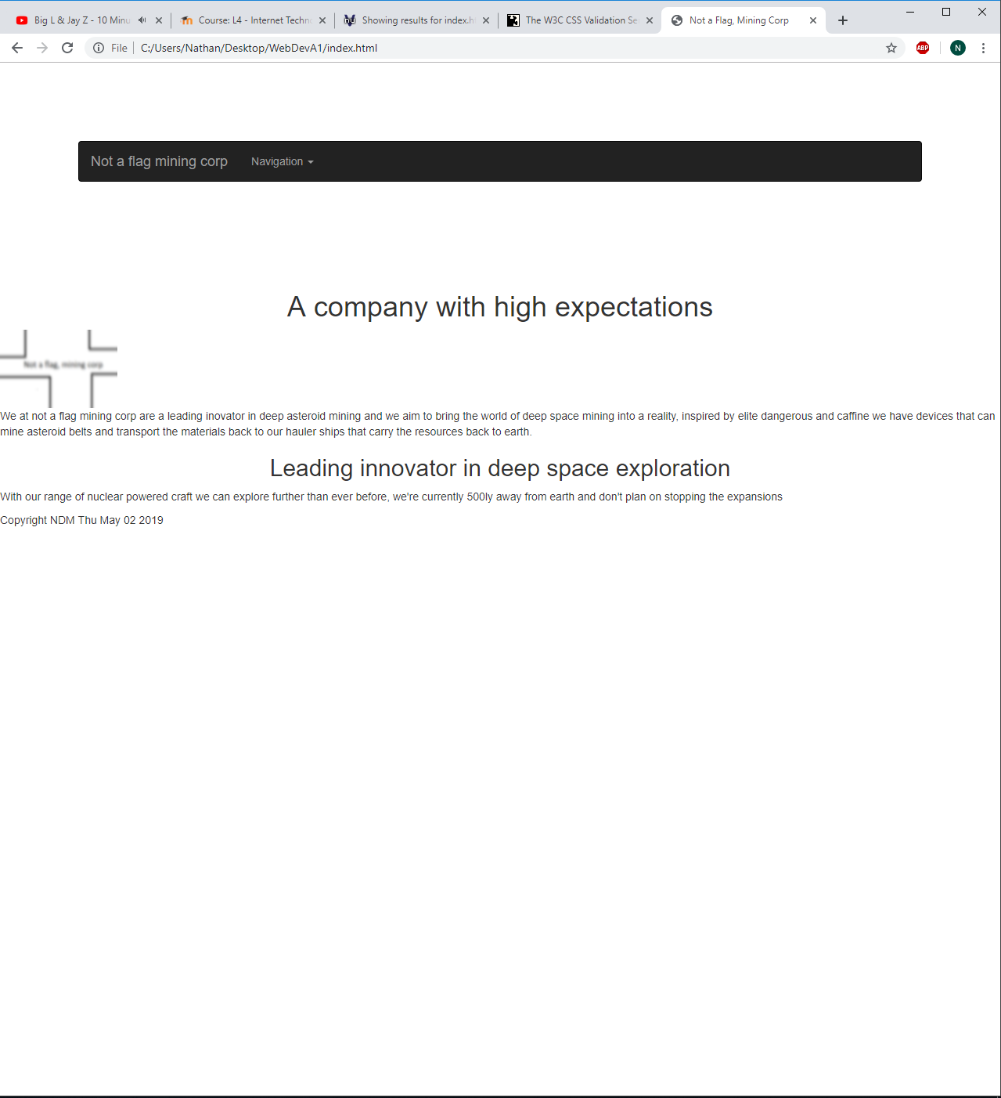
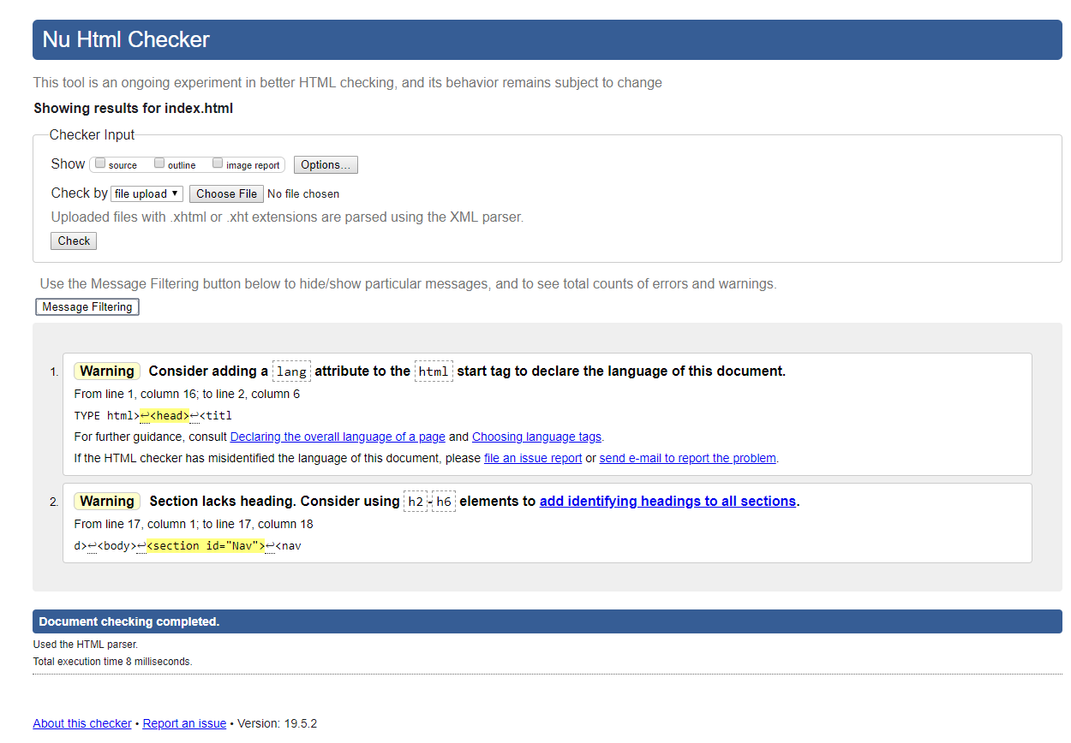

Locations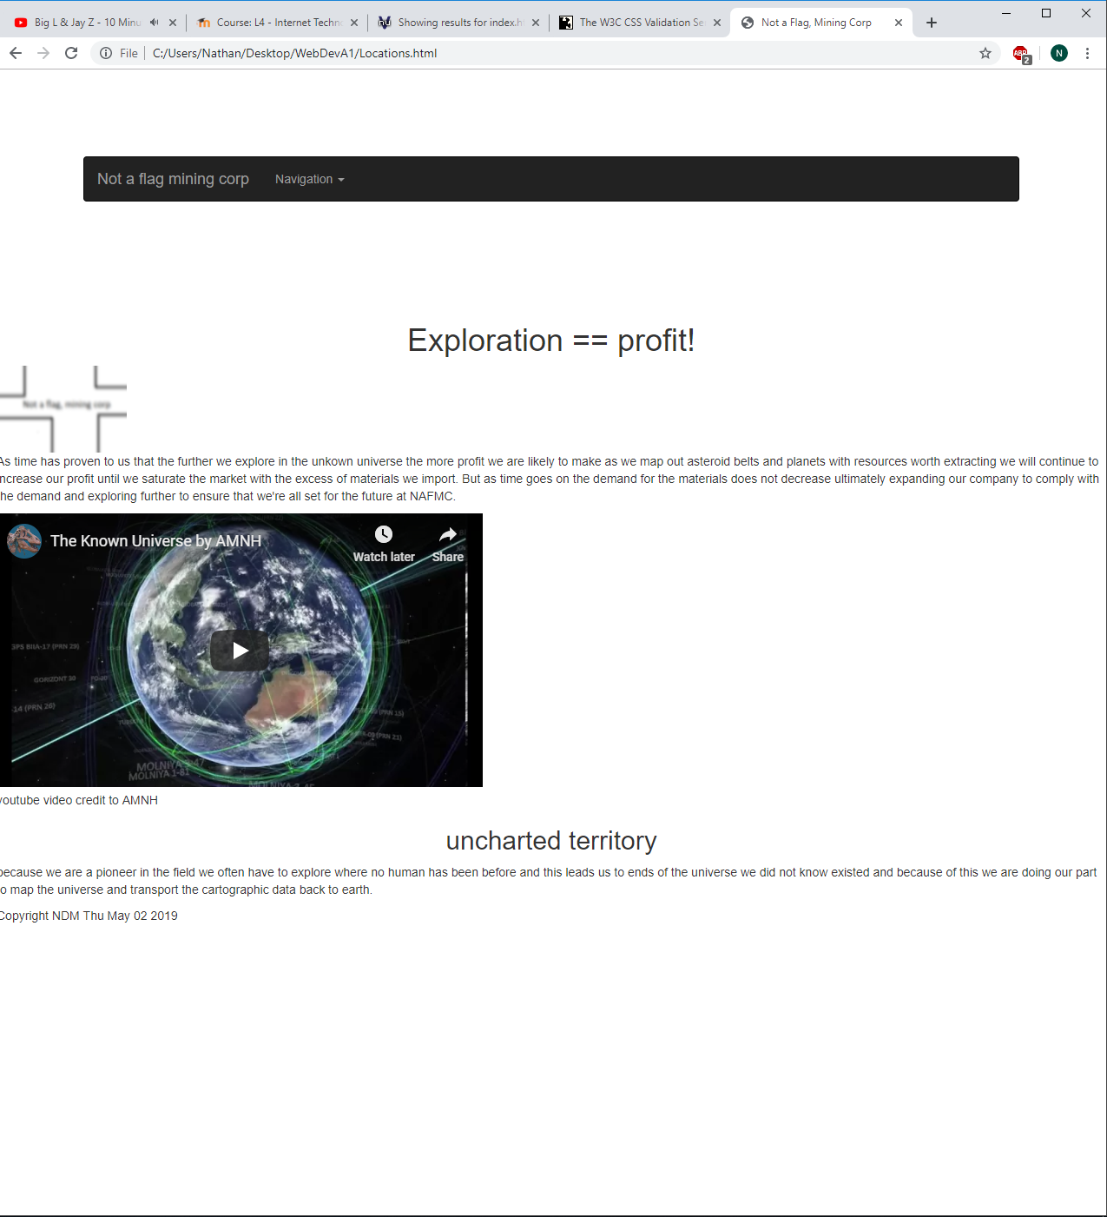
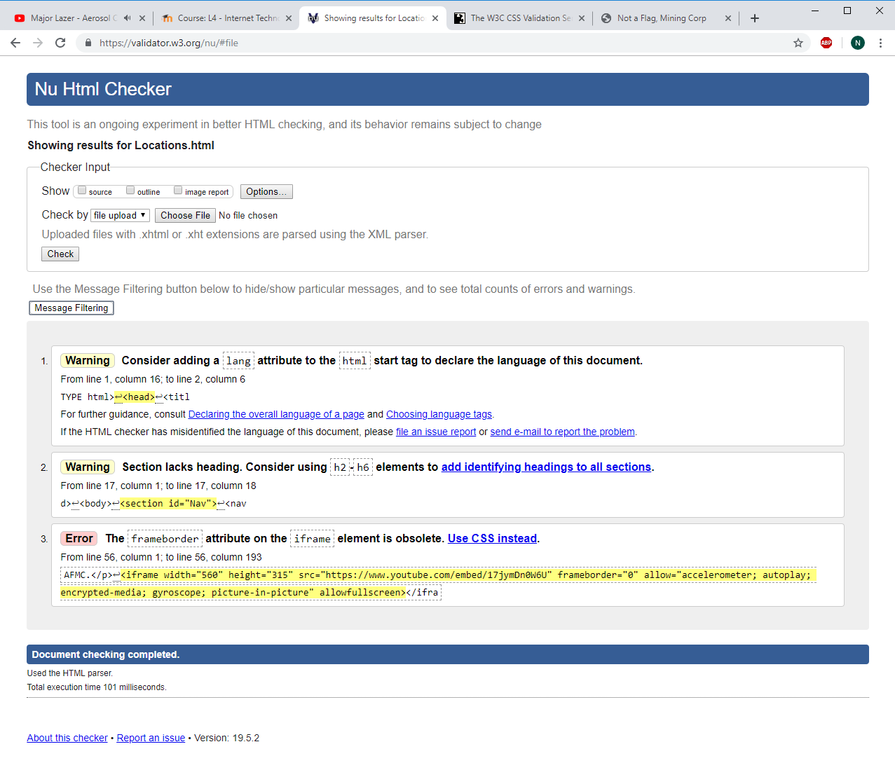
Hardware
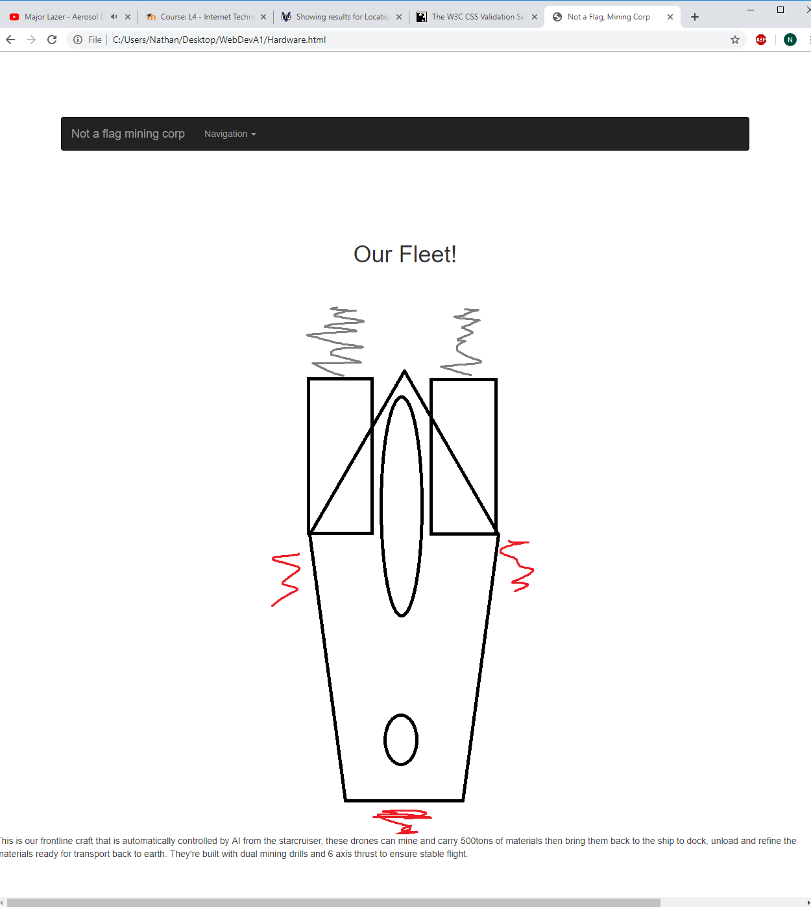
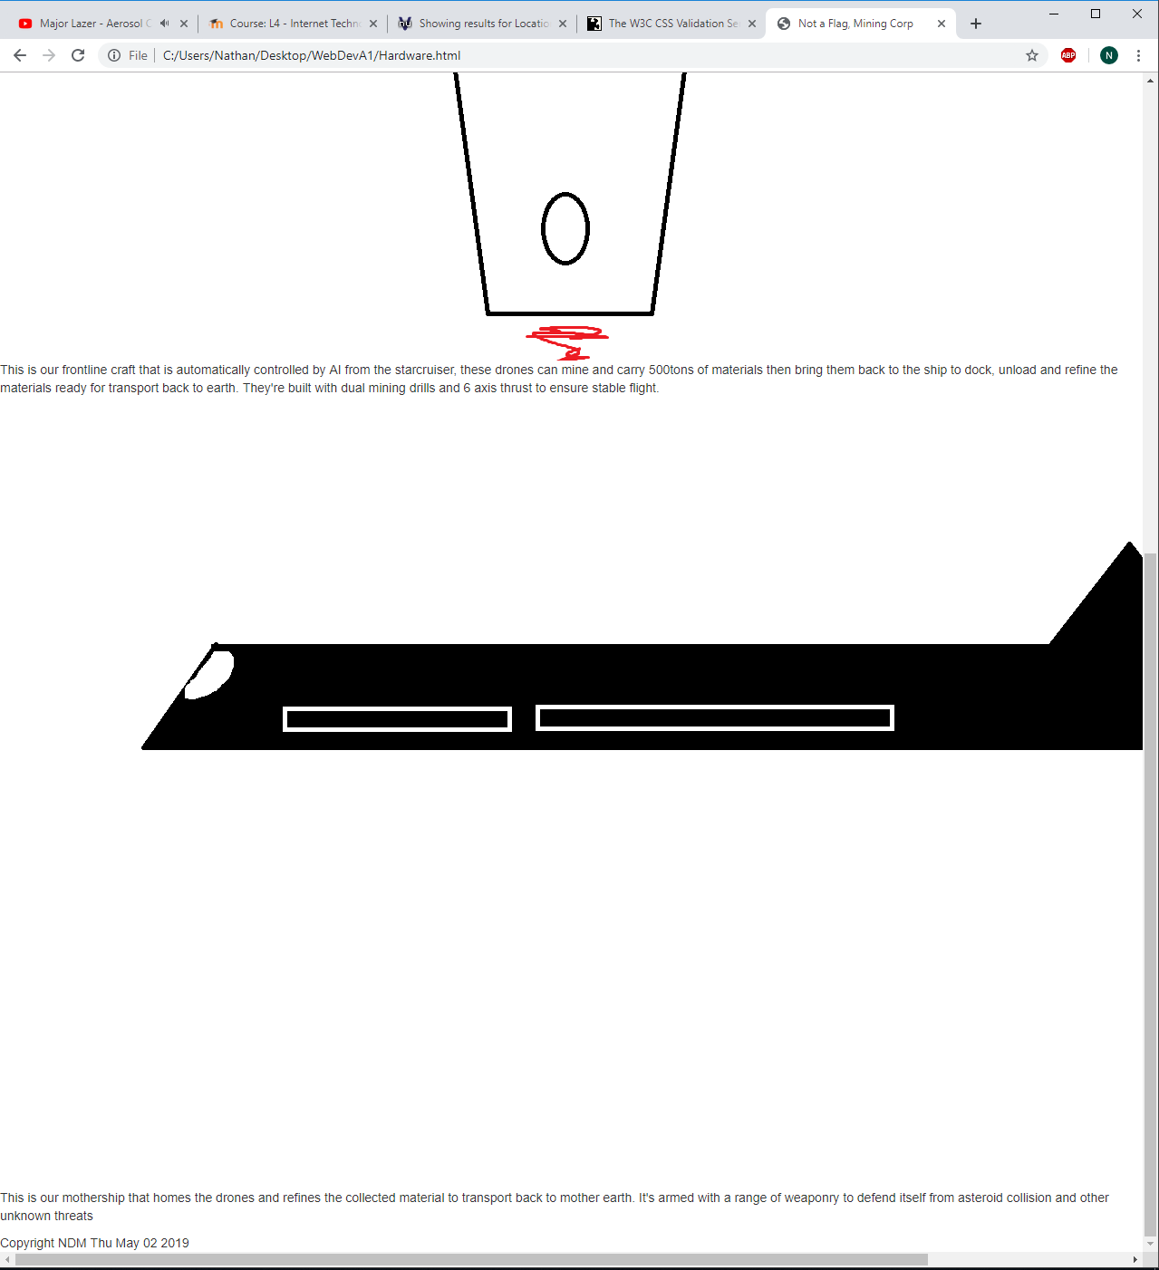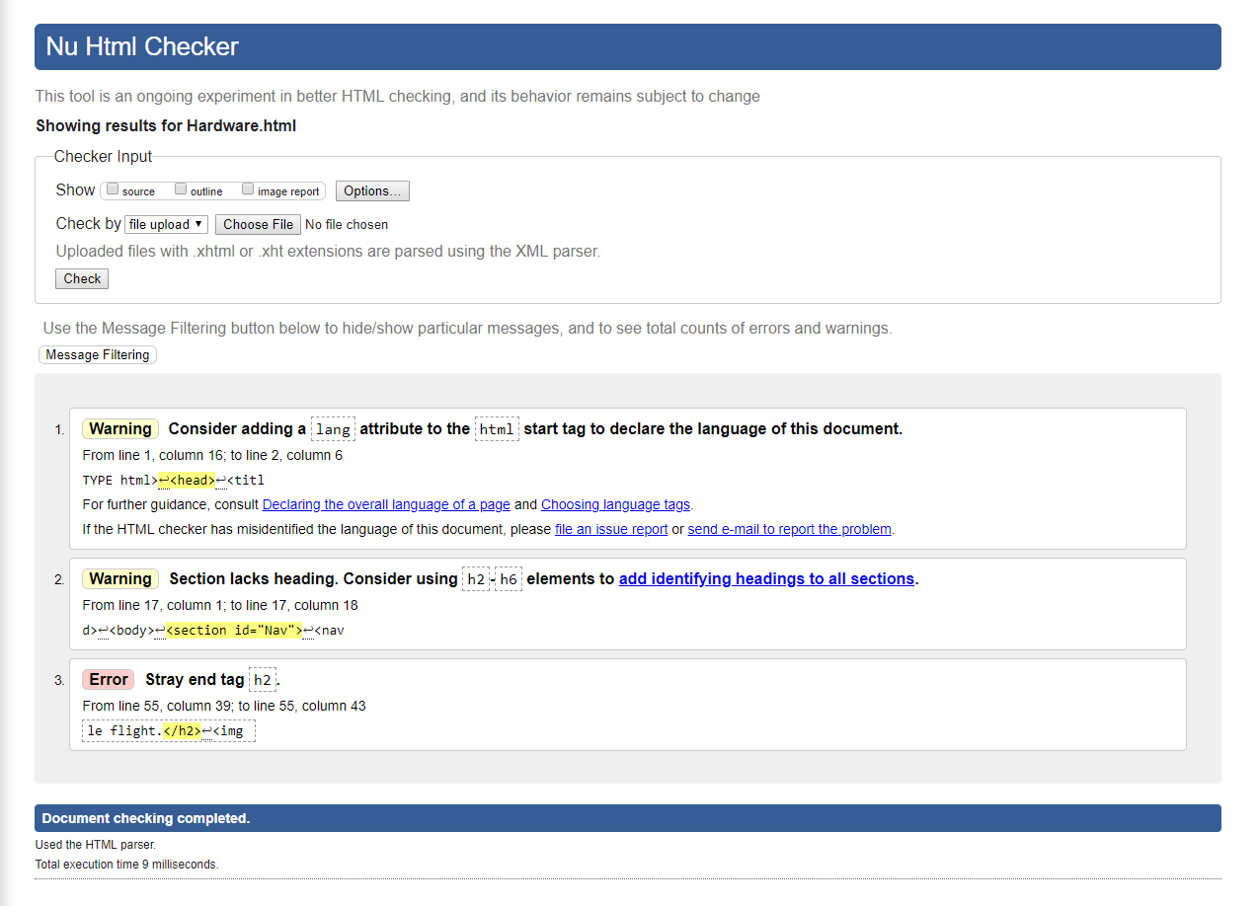
Here you can see my first error, that is that I’ve got a random ending h2 tag, I resolved this by deleting it.
Materials page
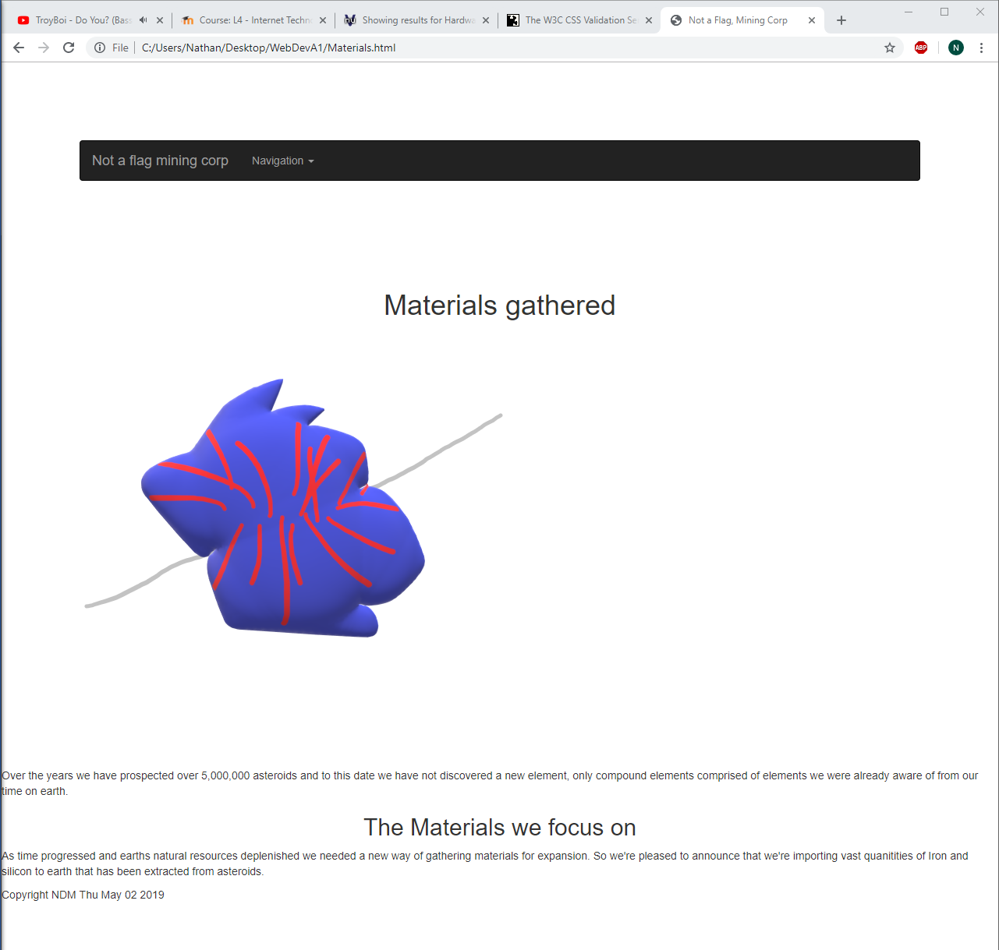
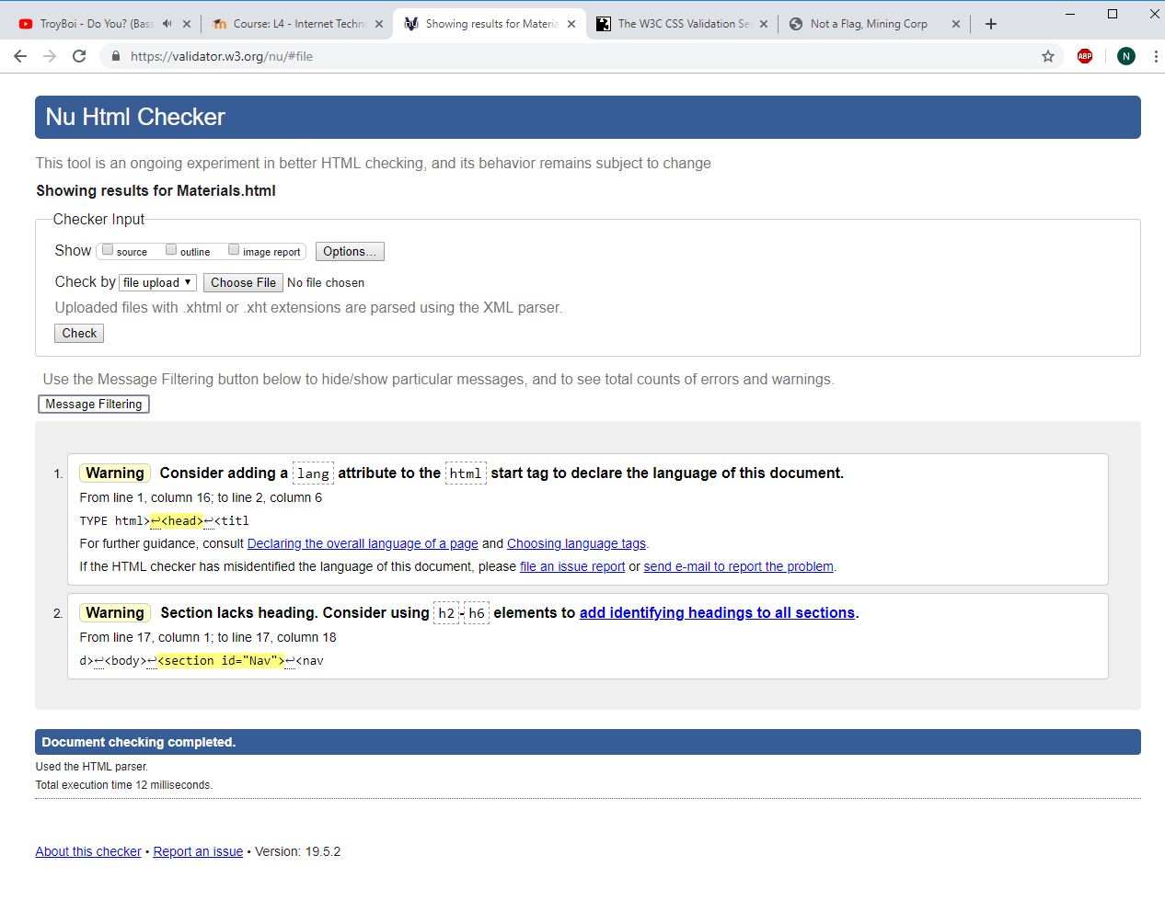
Contact us
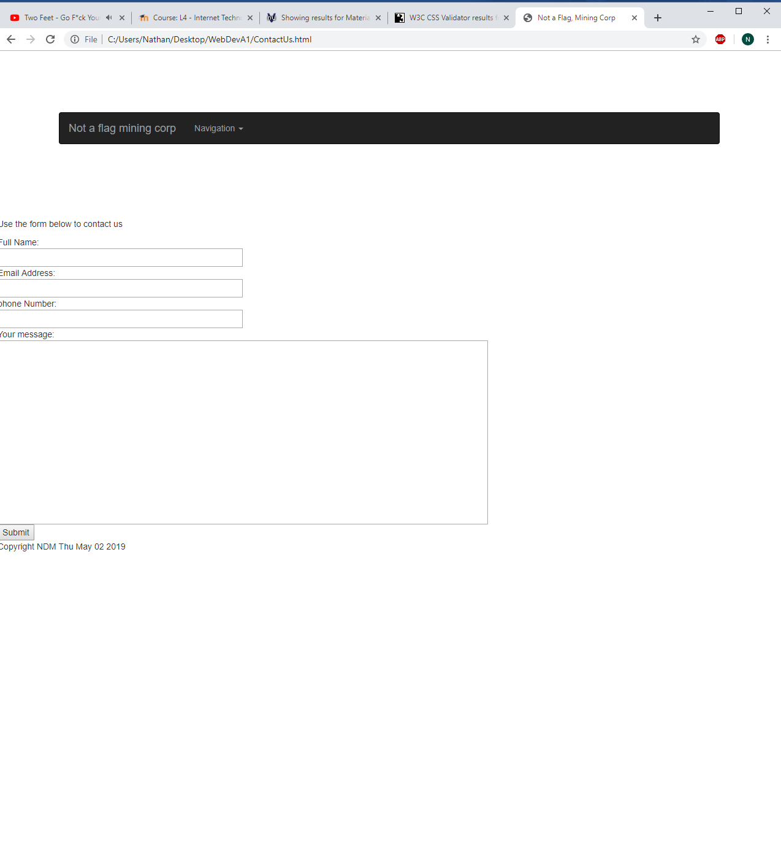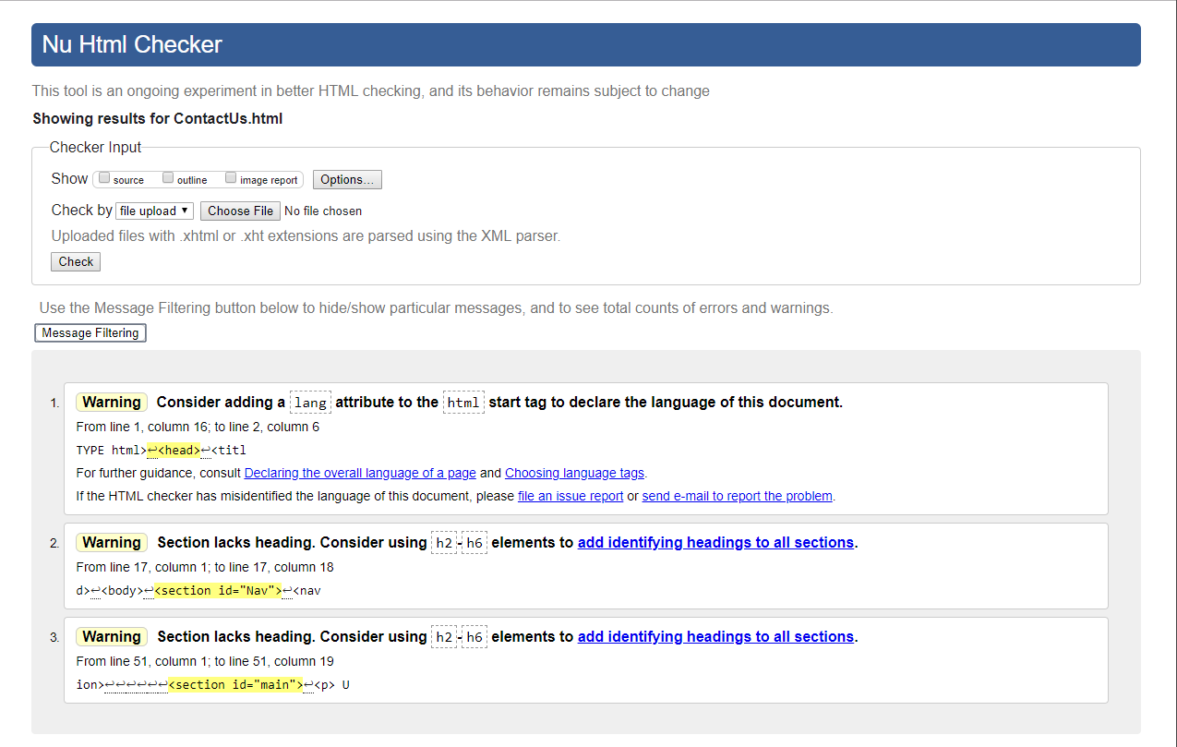

CSS
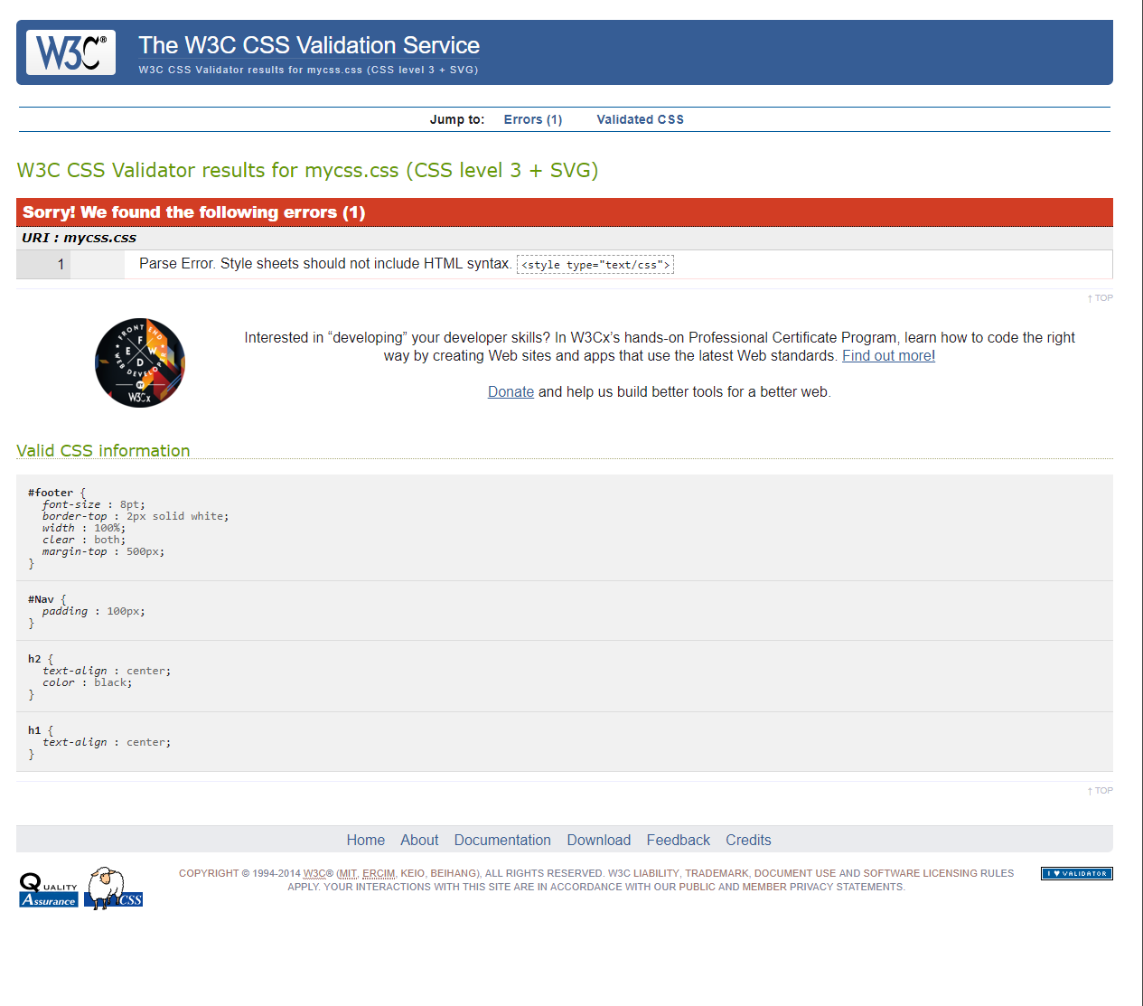
Corrected the error by removing the irrelevant syntax.

Evaluation
Accessible evaluation curtesy of juicy Studio
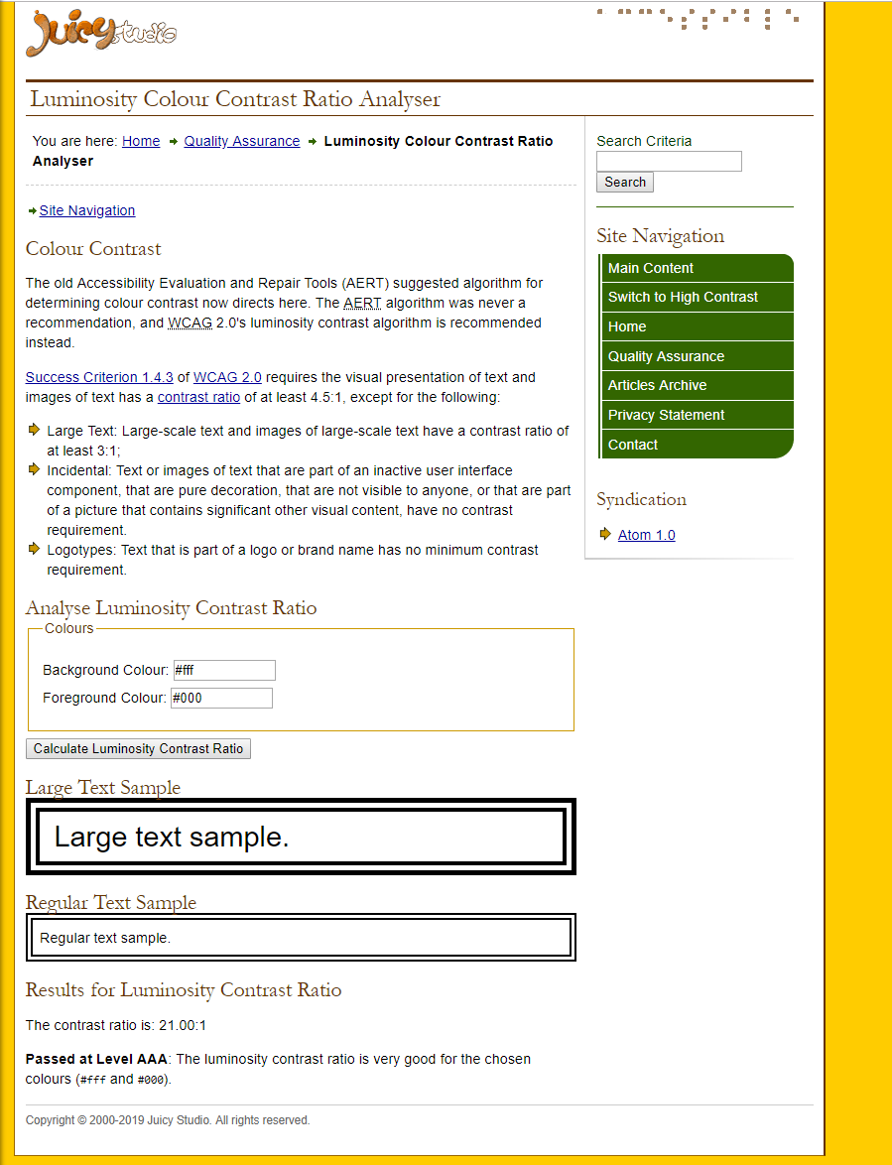

Evaluation of completed website
Pros
Easy to use, Navigation is intuitive with common features such as an easy to use on mobile drop down menu, that reduces the amount of space used on screen.
Simple colour scheme so it’s not too over bearing on the eyes and sharp for night time users.
A selection of different media, such as images and videos that display as needed.
Cons
Styling needs improvement.
Text should centre, this is easily manageable with a simple line in the CSS, given that all the text is contained in the section labelled Main.
Media should be centre of the screen. this is easily manageable with a simple line in the CSS, given that all the text is contained in the section labelled Main.
More written content to fill out the space on the screen
Lack of jumbotron, this would have made dynamically changing the screen more appeasing
In the nav menu home is not capitalized and this is an easy fix.
Future improvements
First thing on my list would be to improve the general format, possibly implement a jumbotron.
Second would be to add an image logo into the navigation bar.
Third I would implement a search bar for easy navigation
Fourth I would implement a live chat service for immediate communication with customer services
Further descriptions of the assets mentioned, and better artwork would be more eye appealing for the customers.
Implementing a live map to display the captured data and allow the website users to navigate our explored systems.
Automatic browser detection to detect what browser the user is using to display a web page that is more suited to that page as some html syntax is different on a per browser basis.
More accessibility options to change font size and background colour could be implemented to ensure the website is accessible for the visually impaired and smaller screen sizes. This could be a nice addition that will suit the wider audience.
Form validation would be a good implementation, this would automatically detect if the user has entered the relevant details into the fields on the contact us page and would help prevent user error. This would also allow us to implement automatic spam detection and further increase the usefulness of the contact us page.
The contact us page could also implement the option to send pictures so the user can share data with us too.
A better description of what the company does would also improve the websites flow a bit, and I feel that there is too much empty space on the website.
A nice feature that could be implemented is live tracking of where the vessels are and allow for tracking of cargo, perhaps for verified users only.
User accounts to allow users to sign in to access the previously mentioned tracking ability, to eliminate the fictious space pirates.
Decompress the logo a considerable amount so it is easier to see. But it was compressed to save data for mobile users that go to the home page.

Search engine optimisation
I’ve made use of a description and meta tags in my website, but this could be further improved by giving more relevant tags per page rather than a general set for all pages.
Further describing of the website would also be useful as the more buzzwords the better, improving the relevance and making it more optimised.
With more meta tags we may get picked up by more search engine searches and this would ultimately drive more traffic to the website.

