

The Contemporary Significance of My Research and Practice in Spatial Design
Shiyu Zhang （Sapphire Zhang）
2221696@uwtsd.students.ac.uk
University of Wales Trinity St Davids, Swansea

Mental Health and Spatial Design in China
In today's dynamic world, there's a noticeable rise in mental health challenges. While the West has actively addressed these concerns, China is gradually recognizing the intricate relationship between space and psychological well-being. This presents a potential research gap in spatial design. My research, intertwining design with multidisciplinary psychological theories, aims to delve into this area. Historically, Chinese spatial design has been predominantly function-centric, occasionally sidelining the emotional and psychological needs of its inhabitants. With the growing global emphasis on mental health, there's a budding opportunity to weave psychological elements into spatial design. My approach seeks to navigate this perspective, especially within the Chinese context.

Collage Art: A Fresh Perspective
Collage art, in its 2D form, provides a fresh avenue to capture multidimensional psychological experiences. This art form, while challenging, offers a tangible medium to suspend linear thinking, fostering new insights (Zaltman & Coulter, 1995; Butler-Kisber & Poldma, 2010). Through collage, I endeavor to present a non-verbal communication tool, shedding a new light on spatial psychology.

3D Exhibition Space: Beyond Display
The 3D exhibition space I envision serves more than just an artistic display; it's a platform for real-time physiological data collection from visitors. This continuous data collection ensures my work remains adaptive and relevant. In our rapidly evolving society, up-to-date data is invaluable. My approach is geared towards ensuring that my research and practice stay attuned to contemporary spatial design nuances.

References:
Zaltman, G. & Coulter, R.H., 1995. Seeing the voice of the customer: Metaphor-based advertising research. Journal of Advertising Research, 35(4), pp.35-51.
Butler-Kisber, L. & Poldma, T., 2010. The power of visual approaches in qualitative inquiry: The use of collage making and concept mapping in experiential research. Journal of Research Practice, 6(2), pp.1-17.

Relevant work and artist:

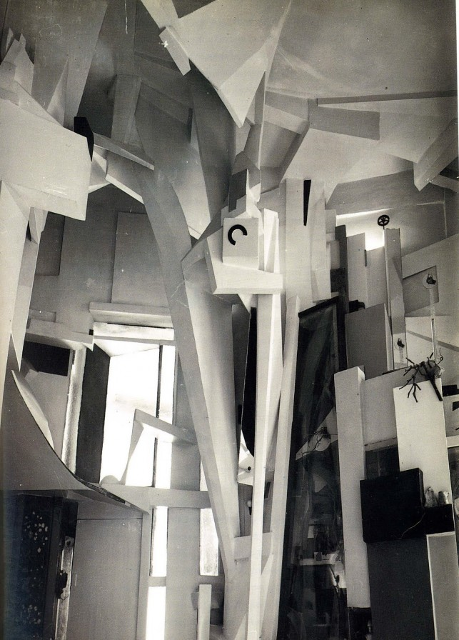
The Hannover Merzbau by Kurt Schwitters. Photo by Wilhelm Redemann, 1933.
Useful link: https://www.moma.org/explore/inside_out/2012/07/09/in-search-of-lost-art-kurt-schwitterss-merzbau/

Merzbau is an interdisciplinary work that blends architecture, sculpture, and collage art, resonating with my approach of intertwining spatial design with psychological theories. Schwitters highlighted the relationship between space and emotions and psychology, which is pertinent to my exploration of mental health in spatial design. Additionally, his 3D collage technique inspires my collage art in capturing multidimensional psychological experiences.

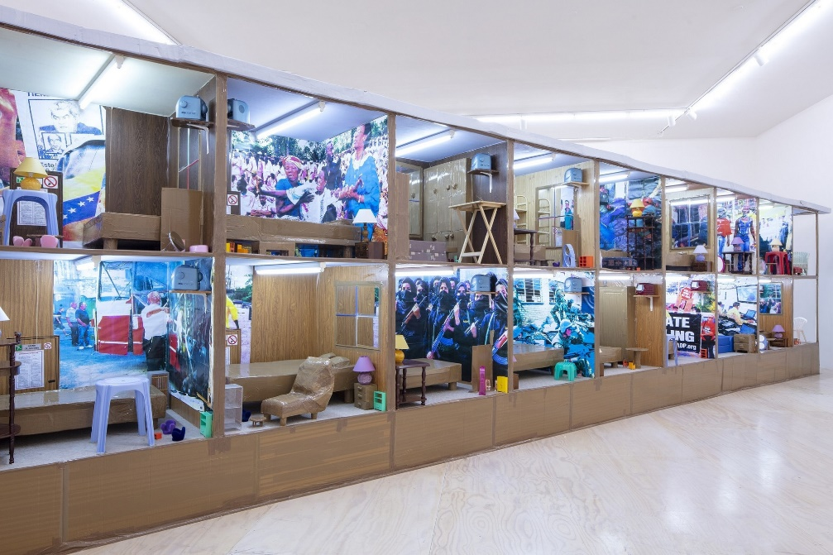
Installation view of Thomas Hirschhorn, Hotel Democracy (2003) on view in
the exhibition Theater of Operations: The Gulf Wars 1991–2011 at MoMA PS1,
New York from November 3 to March 1, 2020. Photo by Matthew Septimus.
Useful link: https://www.tate.org.uk/art/artists/thomas-hirschhorn-6254/studio-thomas-hirschhorn

Thomas Hirschhorn's 'Hotel Democracy' is a thought-provoking installation that delves into socio-political themes using an immersive spatial design. Its interdisciplinary approach, blending art with socio-political commentary, resonates with my endeavor to intertwine spatial design with psychological theories. The way Hirschhorn uses space to evoke emotions and provoke thought mirrors my exploration of the relationship between space and mental health. His work serves as an inspiration, reminding me of the power of spatial design to communicate complex ideas and emotions.

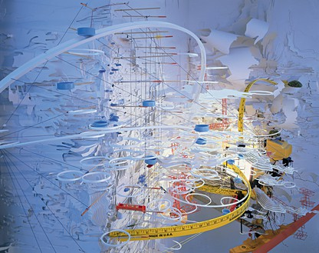
Sarah Sze’s work
Useful link: https://gagosian.com/artists/sarah-sze/

Sarah Sze gleans objects and images from worlds both physical and digital, assembling them into complex multimedia works that shift scale between microscopic observation and macroscopic perspective on the infinite. A peerless bricoleur, Sze moves with a light touch across proliferating media. Her dynamic, generative body of work spans sculpture, painting, drawing, printmaking, video, and installation while always addressing the precarious nature of materiality and grappling with matters of entropy and temporality

