(CERTHE) Skills development in the workplace

ACMA4013

Student Number: 2026224

Mohammed Miah

Task 3: Select any topic covered under Unit 3 and reflect on your own (workplace/own life/educational institute). (20 Marks)
The resources in Unit Three of this module will help you to complete this task.

Unit 3 – Topic 4
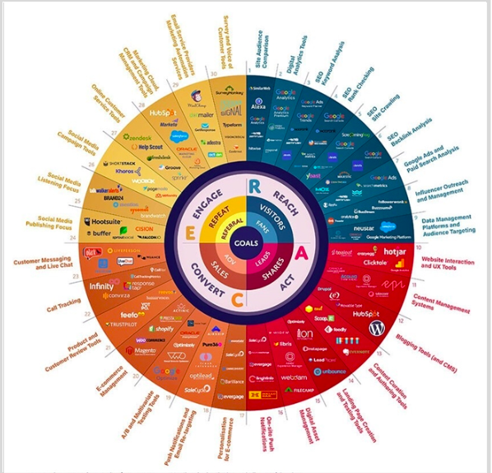
This infographic just shows you visually how vast the digital media world is. With so many available to us we can use these as digital marketing tools and use them for our benefits.

The social medias I use are:
- Facebook
- Whatsapp
I use both of these every day and use them for seeing friends and families’ daily activities and keep in touch with them and how they are doing.

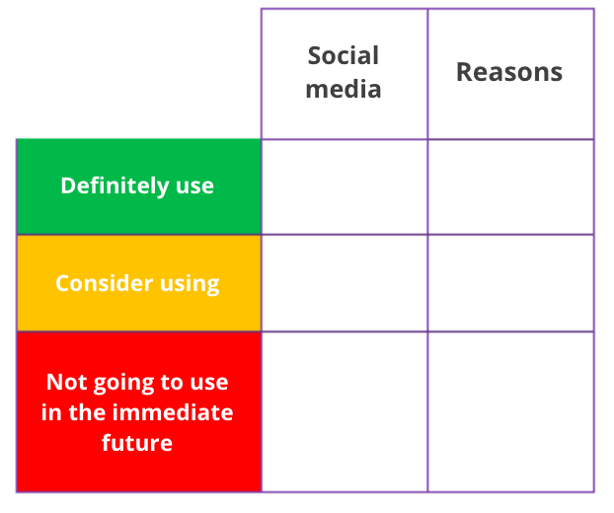
Only photo use and lasts only for 24 hours
More professional
I’m familiar with the social media
Snapchat
Facebook
Linkedin

There is a fine line between personal and professional lives. Some people struggle to separate these two things and may look less professional.
So, people would tackle this and create a professional persona.
- Make a good first impression.
- Keep everything up to date.
- Start conversations.
- Create a simple portfolio or blog.

My brand:
This is how I would like others to view me and my brand.
- Authentic
- Strong
- Unique
- Passionate
- Determined

Task 4: Select any topic covered under Unit 4 and reflect on your own (workplace/own life/educational institute). (20 Marks)
The resources in Unit Four of this module will help you to complete this task.

Unit 4 – Topic 1

Who do I consider a successful individual.


Elon Musk:
Founder and CEO of Spacex and Tesla.

Net worth of $200 billion. Became one of the richest people on the planet.

However, success does not mean fame. Most successful people become famous. However, there are a lot of not so famous people who are still successful in this world.
Success is something the individual must define for themselves. The definition of success is different to everyone and that makes everyone unique.

Success could mean:
- A sense of giving back to the world and making a difference.
- A sense of accomplishment and career progression.
- Being able to do things you love and enjoy.

The Pygmalion Effect:

The Pygmalion effect is a psychological phenomenon in which high expectations lead to improved performance in each area and low expectations lead to worse.

I’ve had high expectations within my workplace, and this has helped me become better and more importantly helped me keep consistency with my quality of work.

This can be dangerous as if someone misinterprets an individuals’ potential it could lead to unrealistic expectations and therefore, demotivates that individual to lead to bad performances.

Well – Being map

These are the 5 key elements of well-being.
- Community
- Career
- Social
- Physical
- Financial
Working with colleagues that have same interests of me

Help others around me within my area

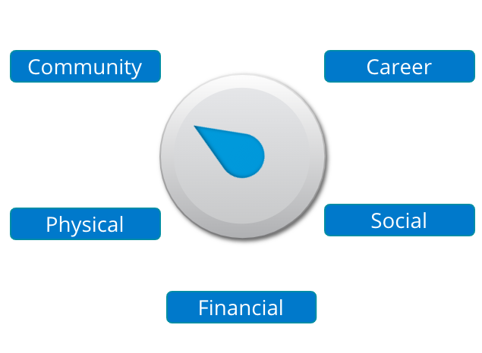
Got two jobs that I enjoy and I am good at
Playing games with my friends/colleagues after work
Need to improve diet

