Human Resource Management
  - A Case of Dyson UK


Student name | Patrisiya Todorova Gospodinova
Student ID no. | 1602994
Lecturer | Gladius David Kulothungan
Course Name and Code | Human Resource Management LCMB7000

Table of Contents
Introduction 3
Company Overview 4
Human Resource Management Strategies 4
Change Management 5
Staffing: Retention 8
Staffing: Recruitment and availability of skilled local labour 11
Conclusion 13
References 14

Introduction
Managing the people working at the workplace and achieving the common goals and objectives with the collective efforts of the employees at the workplace is known as human resource management. For human managers in the contemporary environment, it has become really important to apply effective strategies of human resource management at the workplace to achieve enhanced employee productivity, a peaceful work environment and efficient management at the organisation (Cooke et al., 2020).

Company Overview
One of the fastest-growing international technology brands is Dyson that is a UK based and private limited company. The company was founded in the technical industry of the UK on the 8th of July, 1991 that was about 30 years ago from now. The founder of Dyson is James Dyson that provide a range of product including desk fans, vacuum cleaners, purifiers, hairdryers, hand dryers etc. the company earns $8.2 billion in revenues every year at the global level. The employment rate of Dyson is 43.67% that is the highest in comparison to its other competitors. The evidence to the above-mentioned fact about Dyson employment is that at present more than 13, 000 people are working with Dyson (Dyson, 2020).

Human Resource Management Strategies
The success of an organisation is in the hands of the employees or the people that are working for the organisation. This is because a single person or the owner of the organisation alone cannot achieve the milestone of success in such a challenging business environment of the contemporary era. Therefore it can be said that the human resource of an organisation is an asset to the company because they are the key to success (Michael, 2019). To maintain and regulate the smooth functioning at the workplace strategic human resource is important that means the HR manager at the workplace have to prepare some effective strategies to improve the productivity of employees and have a peaceful working environment at the workplace. to deploy and develop an effective human resource strategy is essential for modern HR managers because it helps the HR manager to make the employee understand its value to the organisation. Also, it develops or appreciates the sense of belongingness within an employee towards the organisation (Boon et al., 2019). The aspects for which strategic human resource management is being addressed further in the report are changes management, staffing retention and recruitment of skills and local labour. The models and theories that are applied to support the discussion are Kotter’s change management theory, ERC retention model of HRM and contingency HRM model.

Change Management
HRM Strategy for Change Management
Change is one of the constant and the common part of the business environment that keeps on affecting the working of the organisations and the managers have to apply several strategies to adopt the changes and meet the changing requirements and demands of the customers as well. Many of the time it becomes really difficult for the manager to deal with the changes in the market as well as the changes in the demand and requirement of the customers (Ahammad et al., 2020). Therefore two of the strategies will be best suitable for the change management and its effective acceptance for the Dyson that are planning carefully and being transparent. The recent change that took place in Dyson is the termination of its contract with Malaysian supplier ATA because of conflicts over labour. As a result, the loss suffered by Dyson is estimated to be 3.4 billion dollars. These changes affect the entire human resource of the organisation and to be safe from its negative implication on the organisation the strategy of careful planning and transparency will be the best suitable strategy for the same (Hee et al., 2019). The careful planning strategy states that the managers and leaders at Dyson should plan effectively before adopting any kind of change and also review its negative as well as the positive implication. The other strategy is transparency which means at the workplace there should be a high level of transparency between the employees and senior staff to gain the trust of employees and deploy the feeling of employee retention (Alfes et al., 2019).
Contribution of Strategy to the Team Members
The strategy of careful planning and transparency contributes a lot to the value increment of the team member and provides a sense of belongingness to the employees. For example, the transparency strategy will be exchanging all the organizational related information with all levels of employees and this is going to make realize employees that they are important or valued to the organisation. Moreover, the strategy of clear planning is going to contribute to the improved sense of understanding and management within the team members at the workplace like Dyson (Ahammad et al., 2020).
Kotter’s Change Management model
The leaders and managers of large business organisations like Dyson need to implement an effective change management model to apply all the strategies to change management that are addressed above. Here is the application of Kotter’s change management model in the context of the Dyson organisation changes.
- Creating urgency is the first step of the model where the change manager at Dyson will create the urgency and address to the entire team members about the changes that are going to take place in the future (Laig et al., 2021).
- Powerful coalition formation will be the next step of the model in which according to Kotter’s it is the responsibility of the manager at Dyson to inform the key people of the company like stakeholders, board of directors, senior staff etc about the change and convince them to change their working style according to the change because change is an essential and constant part of the business environment (Lazuardi et al., 2021).
- Afterwards creating a vision for change will be the next step in which the change manager and leader at Dyson are going to prepare effective strategies according to the vision decided by the organisation (Laig et al., 2021).
- Communicating the vision is the next step and equally important for the management at Dyson so that the employees that will contribute to achieving the changed vision will prepare themselves accordingly (Lazuardi et al., 2021).
- Before implementing the change by using the critical analysis techniques Dyson can identify the obstacles in the change and will implement the next step of the model that is removing obstacles by planning effective strategies for the same (Laig et al., 2021).
- After the removal of obstacles and challenges, the change planning needs to be done in the sixth stage of Kotter's model by creating the small wins for the change adaptability (Lazuardi et al., 2021).
- The second last stage of the model is building on the change that means the change manager at Dyson will be using the change management strategies that are addressed above of careful planning and being transparent to build effective change management at the workplace (Laig et al., 2021).
- Last and the final stage of the model is to anchor the final changes and incorporate the changes in the work culture. Like training and developing employees according to the changes in the business environment or as per the changing dynamics of the market (Lazuardi et al., 2021).
Advantages
The model is beneficial for modern entrepreneurs as well as the business managers running the organisations like Dyson because it majorly focuses on the reasons to adopt the changes and provides a clear description to employees regarding the methods or approaches used by the company to adopt the change. This makes it easier for the employees to accept the change and incorporate it into the workplace (Boon et al., 2019).
Disadvantages
The negative implication of the model on Dyson will be the non-reliability of the model if even the stage of the model is being skipped by the managers. Moreover, the model is time-consuming and dissatisfactory for the employees of the present era. In the present time where time is not their the employees are not going to listen to the entire process or implement it (Cooke et al., 2020).
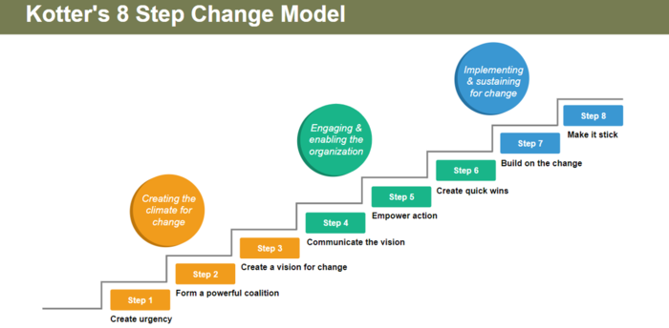
Figure 1:Kotter's Change Model
Source: (Alfes et al., 2019)

Staffing: Retention
HRM Strategy for Employee Retention
The strategies and actions performed by the manager at the workplace to improve the stability of employees in the organisation for a longer duration and benefit the company for a longer period are known as employee retention or staffing strategies. It is really important as well as the duty of the HR manager to implement effective strategies for deploying the employee retention of the organisation (Trullen et al., 2020). Employee retention matters a lot to the HR manager of the organisation because it provides several benefits to the organisation as well as to the HR manager like cost reduction to manage people at the workplace, enhanced employee satisfaction level, developed employee engagement, improved work culture and most importantly increased productivity. The strategies that are implemented for employee retention are also used for staffing strategies at the organisation. The nest effective strategies for an HR manager to improve organisations staffing or develop employee retention are providing monetary benefits like incentives and bonuses to maintain competition at the workplace and make all possible efforts to reduce employee stress or pain and increase the employee satisfaction level at the company (Michael, 2019).
Contribution of Strategy to the Team Members
The strategy that is addressed above will be beneficial for an organisation like Dyson because it contributes to increased employee productivity and increased employee motivation at a large scale. For example, in return for performance appraisal, Dyson has given its employee a major monetary benefit that means an increment in salary of 10%. As a result, the employee gets motivated and worked with double energy and enthusiasm. This is because the monetary benefit strategy has encouraged the employee and developed an interest in work. Another strategy of reducing employee stress contributes to thriving employee productivity and a peaceful working environment for the employees (Khalid et al., 2018).

ERC Retention Model
According to Fenech et al (2019), there are several tools and techniques used by the managers at the workplace to boost up employee retention but the most suitable technique is the ERC employee retention model. There are three major drivers of employee retention that are simulating work, leadership and recognition & reward. When all the three drives are fulfilled of an employee then it will be easier for the HR manager to retain employees and make them work in the company for a longer duration. The three parameters of the model are discussed below.
- Variability of the work will contribute to achieving the work simulation parameter of the model because it will maintain the interest of the employee in performing different types of work and employees will not get bored soon (Kaur, 2017).
- Leadership works as a motivation to the employees therefore according to the model leaders should always be the title holder for change and always be unfurled for the new and unique ideas. The unique and critical thinking qualities in a person makes the person capable to fulfill the parameter of leadership in the model and developing employee retention (Hussainy, 2020).
- The last element is recognition and rewards that mean if hardworking and smart employees are recognized at the workplace then they should be recognized in front of the entire office and given a performance appraisal in monetary terms or in kind to motivate them towards work (Kaur, 2017).
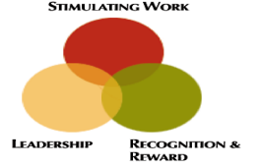
Figure 2: ERC Employee Retention Model
Source: (Kaur, 2017)
Advantages
The benefit of implementing the ERC model is at an organisation like Dyson is increased employee productivity and employee retention that will benefit Dyson to save the cost of frequent recruitments and maintain a peaceful work environment at the workplace (Fenech et al., 2019).
Disadvantages
The drawback of the ERC retention model to Dyson will be the wastage of precious time and ignorance of the training and development of employees to improve the weak areas of the personality and adapt to the challenges of the professional world (Hussainy, 2020).

Staffing: Recruitment and availability of skilled local labour
HRM Strategy for Recruitment
Recruitment refers to the use of techniques for hiring the best out of several applicants that the HR manager faces regularly. The strategy that will be benefiting the company like Dyson to improve the recruitment style and hire more local labourers are effective marketing strategies for hiring and recruitments and also to develop an effective interview process to attract the applicant and hire the best out of all. The benefit of using all of these strategies to Dyson will be that the company will be able to hire more local staff and the best out of all the applicants (He et al., 2020).
Contribution of Strategies to Team Members
These strategies that are mentioned above help to improve employee productivity and achieve the desired targets with the equal contribution of employees at the workplace. for example, the strategy of improving the interview process is going to benefit Dyson in selecting and hiring the best of local staff that will be giving its services to the staff for a longer duration. By implementing these strategies for hiring the employee retention of Dyson increased or developed by 23.15% (Hussainy, 2020).

Contingency Hiring Model
According to the contingency hiring model, there is a contingency recruiter that plays the role of the mediator between the applicant and the employer. In this, the recruiter will contact the employer and will collect all the information about the available job posts to the organisation. On the other hand, the applicant will also apply for the respective job role on several job applications or job portals. This is how the employer and the applicant will connect through each other by contingency model of recruitment and it will be helpful to the company to hire more local employees (Fenech et al., 2019).
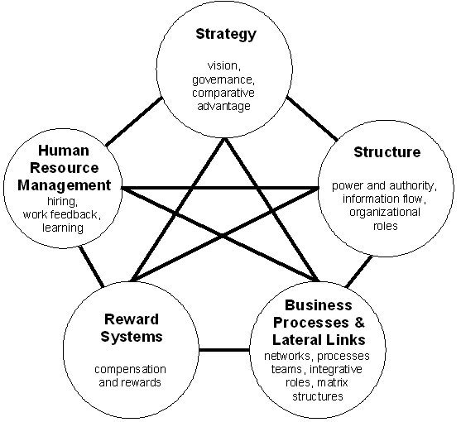
Figure 3: Contingency Model of Hiring
Source: (Spychala et al., 2019)
Advantages
The benefit of implementing the model is that there is no need for wasting time in finding a job rather than the applicant can make direct contact with the recruiter and look for the desired job role (Spychala et al., 2019).
Disadvantage
There is a certain drawback to the model like maintaining a lot of records about the applicants and employees to make its utilization in the future as well. Another important thing is that there needs to be proper safety and security of the personal information provided to the recruiter (Spychala et al., 2019).

Conclusion
The report has delivered the arguments about appropriate Human Resource Strategies that will deploy the change management, staffing human resource and recruitment of local labour aspects of human resource management at the Dyson UK. The relatable theories and models are also applied in the report in the context of the Dyson UK.

References
Ahammad, M. F., Glaister, K. W., and Gomes, E. (2020). Strategic agility and human resource management. Human Resource Management Review, 30(1), 100700.
Alfes, K., Shantz, A. D., Bailey, C., Conway, E., Monks, K., and Fu, N. (2019). Perceived human resource system strength and employee reactions toward change: Revisiting human resource's remit as a change agent. Human Resource Management, 58(3), 239-252.
Boon, C., Den Hartog, D. N., and Lepak, D. P. (2019). A systematic review of human resource management systems and their measurement. Journal of Management, 45(6), 2498-2537.
Cooke, F. L., Schuler, R., and Varma, A. (2020). Human resource management research and practice in Asia: Past, present and future. Human Resource Management Review, 30(4), 100778.
Dyson. (2020). Retrieved 8 December 2021, from https://www.dyson-group.com/investor-relations.html
Fenech, R., Baguant, P., and Ivanov, D. (2019). The changing role of human resource management in an era of digital transformation. Journal of Management Information and Decision Sciences, 22(2), 1-10.
Hee, O. C., and Shanmugam, N. (2019). A Review of Human Resource Change Management Strategies in the Digital Era. International Journal of Academic Research in Business and Social Sciences, 9(3), 521-531.
Hussainy, S. S. (2020). Review on Motivational Theories and Models: Its application for Employees' Retention and Recruitment in Organizations.
Kaur, R. (2017). Employee retention models and factors affecting employees retention in IT companies. International Journal of Business Administration and Management, 7(1), 161-174.
Khalid, K., and Nawab, S. (2018). Employee participation and employee retention are given compensation. SAGE Open, 8(4), 2158244018810067.
Laig, R. B. D., and Abocejo, F. T. (2021). Change Management Process in a Mining Company: Kotter’s 8-Step Change Model. Organization, 5(3), 31-50.
Lazuardi, M. L., and Muhyi, H. A. (2021). Change model combination: A comprehensive way for successfully change. Journal of Public Value and Administrative Insight, 4(1), 1-10.
Michael, A. (2019). A handbook of human resource management practice.
Spychała, M., Goliński, M., Szafrański, M., and Graczyk-Kucharska, M. (2019, May). Competency models as modern tools in the recruitment process of employees. In European Conference on Intangibles and Intellectual Capital (pp. 282-XIV). Academic Conferences International Limited.
Trullen, J., Bos‐Nehles, A., and Valverde, M. (2020). From intended to actual and beyond: A cross‐disciplinary view of (human resource management) implementation. International journal of management reviews, 22(2), 150-176.

