Evidence of Learning

(E-Portfolio)

Student name: David Cosmin Lungu

Student number: 2314067

Module code: BMSW4008

Lecturer name: Philippa Fitzgerald

Contents Page
- Introduction
Overview of the project and brand introduction – GreenHarvest Farms
- Task 1 – Market Research Analysis: Consumer Preferences for Fresh Fruit
  - Summary of questionnaire findings
  - Consumer behaviour insights
  - Pricing preferences
  - Subscription box interest
  - Sustainability and ethical concerns
  - Business opportunities and recommendations
- Task 2 – How Questionnaire Data Informed Website and Marketing Material Design
  - Using data to shape website content and structure
  - Data-driven marketing strategies
  - Audience segmentation and targeting
  - SEO and online visibility strategies
  - Conclusion
- Task 3– The Importance of Microsoft Excel in the Digital Era
  - Excel as a financial planning tool
  - Data analysis and decision-making
  - Automation and efficiency benefits
  - Data visualisation and reporting
  - Excel’s role in future digital business
- Task 4– Video Advertisement: GreenHarvest Farms
  - Video script (3-minute promotional video)
  - Storytelling techniques explained (200-word reflection)
- Conclusion
Summary of project outcomes and key learning points
- References
Harvard-style references for all tasks

Task 1
Market Research Analysis: Consumer Preferences for Fresh Fruit
Understanding consumer preferences is essential for shaping a successful fruit farm business. Through a market research questionnaire distributed to potential customers, I gathered valuable insights into their purchasing behavior, preferences, and expectations. The responses were analyzed, and four key questions provided significant findings that can guide business decisions. These include preferred fruit purchasing locations, willingness to pay for farm-fresh fruit, interest in a subscription box, and the importance of sustainability.
Where participants usually buy fresh fruit was one of the most revealing questions. Their responses strongly favored farmers’ markets and direct farm sales over grocery stores and online providers. It is, therefore, possible to conclude that the consumers view local sources as higher quality and fresher, thus offering an opportunity to the farms to focus on direct-to-consumer sales channels. To help meet this demand, one would have to establish a farm store or improve farmers’ market presence. Moreover, the results suggested the necessity to work out promotional activities, which will appeal to the consumers who usually purchase their food from grocery stores (Caspi et al., 2017).
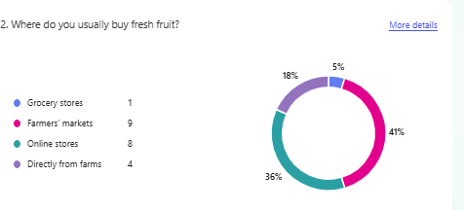
Another crucial query focused on to what extent consumers are ready to pay for farm fresh fruits rather than the grocery store. Over a third of the respondents claimed they are willing to pay about the same price, while others would prefer paying grocery store levels. This supports the notion that customers are willing to pay a premium price for freshness and quality. But farming can’t be too expensive to produce — and be profitable. Different pricing tiers, for example, bulk discounts or loyalty programs, may promote repeat purchases at fair prices (Nagle, 2023).
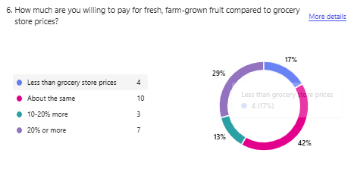The second question looked at consumer interest in a fruit subscription box to offer a stable revenue source for a fruit farm. The responses showed that the majority of the participants were interested or at least open to the idea; €20 – €40 and €60 - €80 were the favourite price ranges. That means that the subscription model can be created in a way that would be economically viable. Subscription could be offered at various tiers by a farm suitable to tastes of those with different budgets and consumption levels. Moreover, seasonal fruit variety as well as customised options aspect of the product may attract more customers (Arora, 2008).
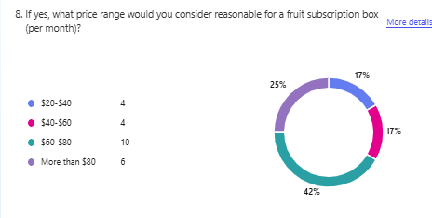In addition, consumer purchasing decisions are strongly influenced by sustainability (Maniatis, 2016). Many respondents also rated sustainability as extremely important or somewhat important. This fits with the increasingly eco conscious path our customers are walking down, showing a desire for products to be organic, locally sourced, and presented little at all to them in terms of packaging. This insight can be leveraged by the farms in implementing and advertising sustainable farming practices like reducing plastic waste, using eco-friendly packaging materials, and highlighting ethical sourcing. The initiatives of these farms directly target environmentally responsible customer but help them to differentiate themselves from their competitors (Popović et al., 2019).
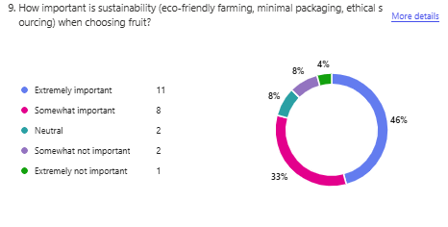
Based on the survey results, there are actionable insights that could be used to improve the business plans of a fruit farm. The desire to purchase farm products directly further implies the need to open direct sales outlets in the form of farm stores and farmers’ markets. An opportunity to charge a premium and offer for free value-added services (loyalty programs) exist if consumers are willing to pay more for farm-fresh fruit. There's a good suggestion for a recurring revenue model here, plus a strong focus on sustainability points towards doing it the 'right way'. These key factors can be implemented by a fruit farm to build a more customer-centric and competitive business.

Task 2
How Questionnaire Data Informed Website and Marketing Material Design
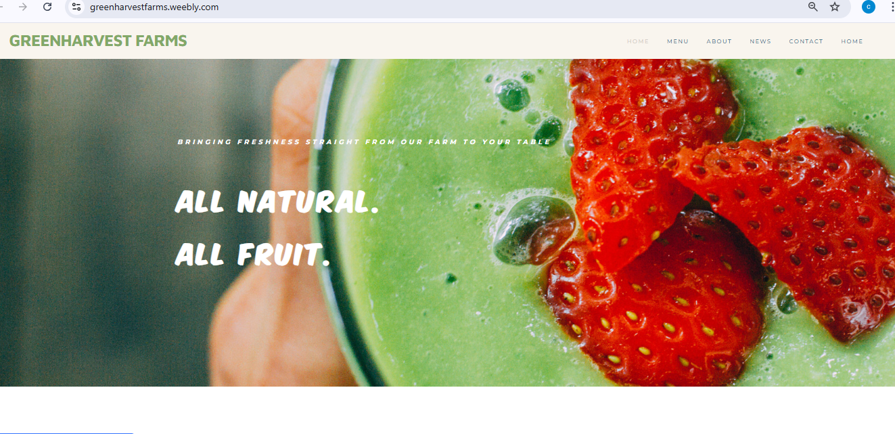
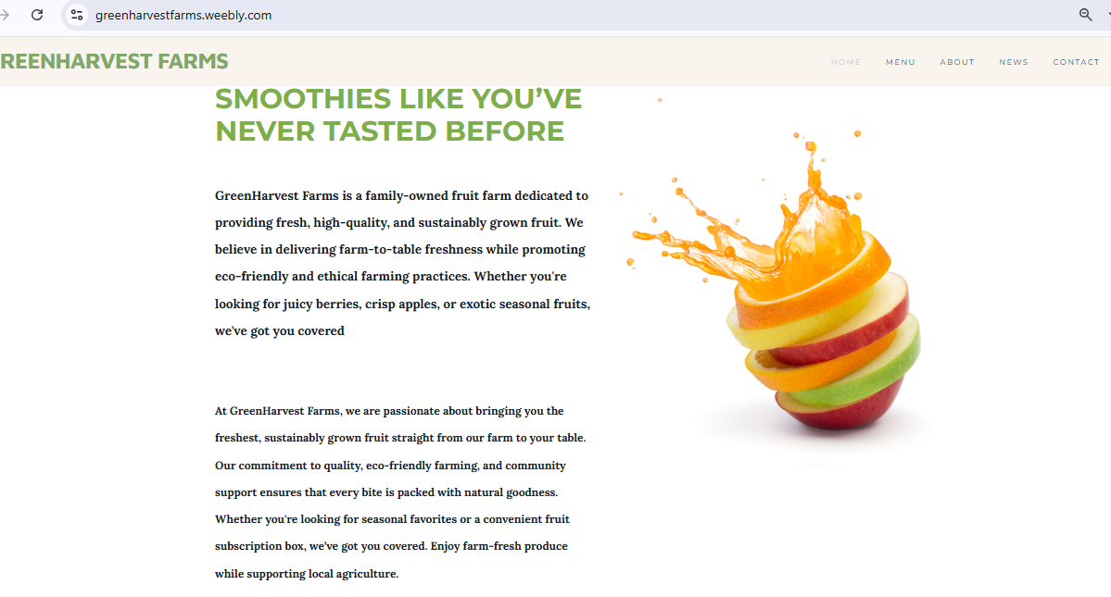
Introduction
An in-depth market research questionnaire was the process used to build a strong brand and online presence for GreenHarvest Farms. We collected responses from potential customers, and through these, we learnt a lot about what they liked and didn’t like, their preferences, their shopping behaviour, and the reasons that existed for them concerning fresh fruit purchases. The findings from the questionnaire showed that there is a preference for organic and sustainably sourced produce, as well an interest in a fruit plan and the need for an easy ordering and delivery process. They influenced the design and the overall content of the two-page website as well as the marketing materials to ensure that we attracted our target audience. In the following analysis, we defined how the questionnaire data used as part of customer base segmentation informed the basic choices of our website and made it possible to optimize our marketing materials from a search engine optimization (SEO) point of view to increase online visibility.
Using Data to Shape Website Design
Based on the questionnaire result, one of the major findings is that most of the respondents considered sustainability as important in decision making on the purchasing. More than half of the respondents indicated their interest in familiarizing themselves with the farm’s sustainability efforts, while over 80% of the participants said that they would prefer to purchase from the farms that use eco-friendly practices. Based on this insight, the structure of the website was directly influenced (Aerts et al., 2017). A notable section on the homepage is our welcoming commitment to sustainable farming, and that is based on organic cultivation methods, eco-friendly packaging, and ethical labour. Right out of the gate, the tagline 'Farm-Fresh Fruit, Delivered to Your Door – Sustainably Grown, Naturally Delicious' clearly communicates what we are all about and nails on the head our business model.
Another key takeaway was that convenience played a major role in consumer decision-making, with 65% of respondents showing interest in a subscription-based fruit delivery service. For this demand, there is a "Subscription Box" page on the website that details information on different fruit box options, associated prices, and flexible delivery plans. The navigation in this section is simple, and calls to action are clear and invite visitors to subscribe. Furthermore, the FAQ section includes questions and answers based on the results of the questionnaire among common customer concerns on the subscription service, shipping methods, and refund policies (Bradburn et al., 2004).
Data-Driven Marketing Strategies
The insights discovered as a part of the questionnaire were not only beneficial to GreenHarvest Farms website design but also for the creation of marketing materials. Since most of our targeted audience wants organic and chemical-free produce, the major focus of the marketing content is all about the health benefits & purity of the produce directly from our farm. Nature-inspired colours and fresh, amazing images of fruit have been used as branding and visual elements, designed with Canva, to reinforce the image of the organic and eco-friendly business.
Meanwhile, social media marketing strategies were created in line with the interests of the customers. It was found from the questionnaire data that younger consumers are more likely to interact with farm brands on Instagram and Facebook, whereas older users Favor email newsletters (Grandh et al., 2021). With this information in mind, our digital marketing plan consists of using social media content that engages, like behind-the-scenes videos of farm operations, customer testimonials, and special promotions. The newsletter for email marketing was a monthly offering of seasonal fruit availability, sustainability updates, and exclusive discounts (Hartemo, 2016). By being so targeted, our messaging hits all the right notes across the different segments of our audience, thereby ensuring customer engagement and brand loyalty.
Audience Segmentation and Targeting
Our responses to the questionnaire enabled us to differentiate four main customer segments with different needs and expectations. The first segment is eco-conscious consumers who prefer to buy sustainability. In the content of the site and sales materials, we focused on how GreenHarvest Farms’ practices were good for the environment (for this group). The second segment is busy professionals and families in search of convenience. The marketing flyers and advertisements for ease and reliability of farm fresh fruit deliveries were the reason for this group to be drawn to the subscription box service.
Health-conscious people with organic preferences and willingness to pay a premium for good quality are also another key customer segment. In an attempt to appeal to them, we have a blog content on the website that discusses the nutritional benefits of fresh fruits and recipes for healthy living. Finally, we found that there is a local customer base that likes to visit local farms directly in making purchases. Because this is the target group, we tried to optimize our website regarding local SEO using keywords including 'organic fruit farm near me,' listing our business on Google My Business, and increasing visibility in location-based searches (Smith, 2017).
Search Engine Optimization (SEO) Strategies
Optimizing the website for search engines was crucial for attracting organic traffic and increasing brand awareness. The results of the questionnaire made possible the identification of the most used search terms about the delivery of fresh fruit, organic farming, and sustainability. To do this, we inserted both keywords all over the website into the homepage text, product descriptions, and blog articles. For instance, organic fruit subscription boxes and farm fresh fruit delivery were used in the meta descriptions and headers of the web pages to boost search rankings.
Local SEO was also a huge focus, as many of the respondents showed interest in buying from farms close by. We made our location, contact information as well and business hours listing clearly on the website to further strengthen GreenHavest Farms’ online presence in local search results (Alfiana et al., 2023). We also encouraged our happy customers to leave reviews on Google, which aids in proving credibility and visibility on the search page. One way of leveraging our website is to exploit general and location-specific SEO techniques so that we maximise reach and our potential customers can easily find and engage with our brand (Iskandar, 2018).
Conclusion
In creating GreenHarvest Farms’ website and marketing materials, the process was data-driven to ensure that all design and messaging properly fit within the expectations of the customer base. What the questionnaire offered are insights that have shaped our business strategy up to this day, ranging from audience segmentation and content creation to marketing outreach and SEO optimization. We tackled the concerns of the consumer by making a website that speaks to what the consumer wants: sustainability, convenience, and health benefits.
In addition, we based our targeted marketing strategy on the audience’s preferred items so that our promotional materials resonated with potential customers, further enhancing our engagement and conversion rates. In addition to SEO techniques used, it increased GreenHarvest Farm’s online presence, which allowed customers to easily find and relate to our brand. From here on out, we will expand to further monitor customer feedback and search trends so that our digital presence can be refined as we move in response to market needs. GreenHarvest Farms will then be able to grow and become established as a competent provider of high-quality, sustainably grown fruit, while making the customer as their focus.

Task 3
The Importance of Microsoft Excel in the Digital Era
Introduction
Today, data is a very important part of decision-making in various industries in today’s digital world. That is, one can see that whatever from business, education, healthcare and finance, professionals use tools capable of managing, analysing and presenting data. Microsoft Excel is one of the most widely used tools for these purposes. Since its introduction, Excel has continued to grow into quite a versatile software that can organize one’s financial records, keeping track of his/her expenses, generating reports as well and its capacity to make data easily readable.
Excel as a Financial Planning Tool for Businesses
In the world of business, one thing is especially essential for small businesses it is financial planning. Companies must check income, keep track of expenses, and see whether they’re profitable to make the best decisions. This process is simplified by Microsoft Excel, where users can create financial projections, budgets, and profit and loss statements. Financial records are presented in a structured manner using Excel spreadsheets, which explains how data is well-organised and easy to locate (Fairhurst, 2019). Therefore, businesses can utilize columns for their income, expenses, and profits for different months to be able to track their income, expenses, and profits over time. Enables one to apply basic formulas like SUM (), AVERAGE (), and IF() to automate calculations, eliminate errors, and enhance efficiency (Akpan, 2024). Small business owner doesn’t have advanced accounting knowledge but need to know if their business is gaining or not on their money.
Data Analysis and Decision Making
Excel’s capability to analyse huge datasets efficiently is one of the primary reasons Excel still counts in the digital era. A typical case is that businesses produce a mammoth amount of sales, customer behaviours, inventory, and operational cost data. Using Excel’s features like PivotTables, data sorting, and filtering, users can easily identify trends and patterns (Akpan, 2024). For instance, a company could use PivotTables to tabulate financial data to calculate the monthly revenues. When a company discerns a drop in sales during an eligible period, they can understand the reason for this trend and make some adjustments, like carrying out a marketing campaign or giving discounts if it stands reasonable. Also, Excel has conditional formatting that, with support from the user, highlights important financial data (Lohani 2023). For example, if a business wants to see expenses that exceed a pretty high limit, conditional formatting can be used to highlight those values. Having such representation of data helps businesses to take corrective actions before financial problems get blown out of proportion.
Automation and Efficiency
The digital age has necessitated that businesses find means to be more efficient as they reduce manual workload. Various automation tools in Microsoft Excel, like macros and advanced formulas, reduce the tedious repeatability of tasks (Jelen, 2022). A small business keeping track of monthly revenue and expenses, for instance, can create a macro that generates profit and loss statements on its own. Instead, the macro can be configured to pull information from various sheets and update financial summaries in real time instead of entering data manually and manually recalculating totals every month. Nevertheless, this avoids human errors and saves a lot of time. In addition, Excel can be connected with other business software like QuickBooks, Google Sheets, and Power BI (Igulu et al., 2023). As a result, this enables businesses to import or export data smoothly while improving productivity. Excel is a very useful tool for businesses based on the automation capabilities within Excel itself.
Data Visualization and Reporting
Excel is another major strength of the digital age when it comes to data visualization. Any business often requires an easy-to-understand and precise financial report that can be passed over to the stakeholders, investors, or employees. Various charting tools, such as bar charts, pie charts, and line graphs, are provided by Excel to visualize financial data more effectively (Mahajan, 2021). For instance, a bar chart that compares income and expenses across three months is made with ease. If the business expenditure increases at a higher rate than his or her income, the organizational expenditure may be cut. This helps decision makers easier to interpret complex financial information at a glance. Additionally, Excel’s dashboard function permits the business to create interactive reports where users can filter and provide reports and analysis of different aspects of financial data on the go (Akpan, 2024). This is very useful for small businesses that want to professionally and persuasively.
Excel’s Role in the Future of Digital Business
However, with the march of digital transformation, there’s no doubt that Excel remains integral to financial management, data analysis, business intelligence, and all business activities. As an increasing number of cloud-based platforms, such as Microsoft 365, use Excel, it is possible to edit it no matter where you are, and in collaboration or from a remote area. One more element that has grown due to the integration of artificial intelligence (AI) and machine learning in Excel is the availability of its extended capabilities (Raschka et al., 2020). There are features such as Excel Ideas that provide users with automated data insights and suggestions, enabling more people to do financial analysis. If businesses are generating more data, then Excel will need to process that data efficiently to make the right data-driven decisions.

Task 4 Storytelling Techniques Used in the Video

The video advertisement for GreenHarvest Farms utilises storytelling techniques to create a captivating and engaging brand narrative. The film commences with a personal introduction, showcasing my visage to cultivate trust and forge a relationship with the audience. I adhered to a structured framework based on the “hero’s journey,” identifying a problem (the scarcity of fresh, sustainable fruit options) and proposing GreenHarvest Farms as the solution.

The video employs emotional appeal to emphasise values such as health, convenience, sustainability, and community. Visual storytelling enhances the message by depicting innovative products, sustainable packaging, and satisfied customers. The images augment brand identification and assist the viewer in conceptualising the customer experience.

I employed direct and friendly language, along with a warm tone, to convey the approachable nature of the business. The concluding call to action prompts viewers to access the website and engage with the brand on social media, thereby fostering ongoing interaction.

The video employs techniques such as character connection, emotional resonance, clear structure, and visual cues to construct a compelling narrative that establishes GreenHarvest Farms as a reliable, values-oriented brand.
There is the link for the video on YouTube: https://youtu.be/5ebohaR7LEg?si=OseJiGDqz74yQ-W5

References
Aerts, G., Smits, T., & Verlegh, P. W. (2017). The platform shapes the message: How website design affects abstraction and valence of online consumer reviews. Decision Support Systems, 104, 104-112.
Akpan, D. M. (2024). Excel: VLOOKUP, pivot tables and SQL. In Future-Proof Accounting: Data and Technology Strategies (pp. 95-127). Emerald Publishing Limited.
Alfiana, F., Khofifah, N., Ramadhan, T., Septiani, N., Wahyuningsih, W., Azizah, N.N. and Ramadhona, N., 2023. Apply the search engine optimization (seo) method to determine website ranking on search engines. International Journal of Cyber and IT Service Management, 3(1), pp.65-73.
Arora, N., Dreze, X., Ghose, A., Hess, J.D., Iyengar, R., Jing, B., Joshi, Y., Kumar, V., Lurie, N., Neslin, S. and Sajeesh, S., 2008. Putting one-to-one marketing to work: Personalization, customization, and choice. Marketing Letters, 19, pp.305-321.
Bradburn, N.M., Sudman, S. and Wansink, B., 2004. Asking questions: the definitive guide to questionnaire design--for market research, political polls, and social and health questionnaires. John Wiley & Sons.
Caspi, C.E., Lenk, K., Pelletier, J.E., Barnes, T.L., Harnack, L., Erickson, D.J. and Laska, M.N., 2017. Association between store food environment and customer purchases in small grocery stores, gas-marts, pharmacies and dollar stores. International Journal of Behavioral Nutrition and Physical Activity, 14, pp.1-11.
Fairhurst, D. S. (2019). Using Excel for business and Financial Modelling: A practical guide. John Wiley & Sons.
Grandhi, B., Patwa, N. and Saleem, K., 2021. Data-driven marketing for growth and profitability. EuroMed Journal of Business, 16(4), pp.381-398.
Hartemo, M., 2016. Email marketing in the era of the empowered consumer. Journal of Research in Interactive Marketing, 10(3), pp.212-230.
Iskandar, M.S. and Komara, D., 2018, August. Application marketing strategy search engine optimization (SEO). In IOP Conference Series: Materials Science and Engineering (Vol. 407, No. 1, p. 012011). IOP Publishing.
Jelen, B., & Syrstad, T. (2022). Microsoft Excel VBA and Macros (Office 2021 and Microsoft 365). Microsoft Press.
Lohani, S.K., 2023. Excel for Finance and Accounting: Learn how to optimize Excel formulas and functions for financial analysis (English Edition). BPB Publications.
Mahajan, K. N., & Gokhale, L. A. (2019). Advanced charting techniques of Microsoft excel 2016 aiming visualization. International Journal of Computer Sciences and Engineering (IJCSE), 7(1).
Maniatis, P., 2016. Investigating factors influencing consumer decision-making while choosing green products. Journal of Cleaner Production, 132, pp.215-228.
Nagle, T.T., Müller, G. and Gruyaert, E., 2023. The strategy and tactics of pricing: A guide to growing more profitably. Routledge.
Popovic, I., Bossink, B.A. and van Der Sijde, P.C., 2019. Factors influencing consumers’ decision to purchase food in environmentally friendly packaging: what do we know and where do we go from here?. Sustainability, 11(24), p.7197.
Raschka, S., Patterson, J., & Nolet, C. (2020). Machine learning in python: Main developments and technology trends in data science, machine learning, and artificial intelligence. Information, 11(4), 193.
Smith, R.A., 2017. Audience segmentation techniques. In Oxford Research Encyclopedia of Communication.
Denning, S. (2011) The leader's guide to storytelling: mastering the art and discipline of business narrative. 2nd edn. San Francisco: Jossey-Bass.
Fog, K., Budtz, C., Munch, P. and Blanchette, S. (2010) Storytelling: branding in practice. 2nd edn. Berlin: Springer.
McKee, R. and Fryer, B. (2003) ‘Storytelling that moves people’, Harvard Business Review, 81(6), pp. 51–55. Available at: https://hbr.org/2003/06/storytelling-that-moves-people (Accessed: 28 March 2025).
Simmons, A. (2006) The story factor: inspiration, influence, and persuasion through the art of storytelling. 2nd edn. New York: Basic Books.
Pulizzi, J. (2012) ‘The rise of storytelling as the new marketing’, Publishing Research Quarterly, 28(2), pp. 116–123. Available at: https://doi.org/10.1007/s12109-012-9264-5 (Accessed: 28 March 2025).

Appendix
Microsoft Form Link
https://forms.office.com/Pages/AnalysisPage.aspx?AnalyzerToken=4JveXmEJ3kjn0ESLWtSRGYuDh4y0pUQT&id=9WGLRnUYcEyMC1fTv96REeI6b-UaUd9JiyBnPXBlS_JURVJCOEpUUzlPNE1NWEFaQzAwUFRIMElEUy4u

Excel Sheet
Month | Total Income (EUR) | Total Expenses (USD) | Profit/Loss (EUR)
January | 5000 | 3000 | 2000
February | 5200 | 3100 | 2100
March | 5300 | 3200 | 2100
April | 5500 | 3300 | 2200
May | 5800 | 3400 | 2400
June | 6000 | 3500 | 2500
July | 6200 | 3600 | 2600
August | 6300 | 3700 | 2600
September | 6500 | 3800 | 2700
October | 6700 | 3900 | 2800
November | 6900 | 4000 | 2900
December | 7000 | 4100 | 2900
Totals | 72400 | 42600

