DRS1

Student Name: Massangbe Saran SY SAVANE
Student ID: 1807717
Module Name: Digital Skills and Research Method

Introduction

We are living in a new era, that of the technological revolution, to the point that we can not imagine our life without this revolution technologic. So, technology has transformed our world and also our life, in a positive way on several levels such as medical, Business, Education, production and communication among others. In addition, our moment of pleasure, well-being, leisure and socialization have a special touch thanks to technology.
Technology has reduced distances, reduced time, brought people together and alleviated suffering. For instance, on the Business level thanks to technology, distance is no longer a major obstacle to achieving objectives.

In this study, it will be a question of assessing the efficiency of the use of modern technology, and explore social media as a tool for marketing and information collecting and within the workplace.

Is it possible today to advance your project without resorting to technology?
What are the different types of technology, from smartphones to web conferencing, to social media? As I am to going to compare two smartphones (iPhone 11 Pro and Huawei P40 Pro) and also two web conferencing (GoToMeeting and Adobe Connect).

Technology1: Smartphones

A smartphone means a multifunctional mobile phone which has the capacity to peruse the internet, read music and films, equipped with a GPS chip, a touch screen which can change over time using updates, and which has the capacity to download and install new applications.
We owe everything to applications because they are the ones that value smartphones such as:

- Communicate (Skype, Facebook, WhatsApp, Gmail…)
- Edit photos, publish them (Instagram, Flickr, Retrica…)
- Find your way (Maps, walking itineraries…)
- Consult public transport timetables (City mapper…)
- Consult the cooking recipes (Marmiton Ptichef…)
- Produce, take notes (Google Drive, Microsoft Office, OneDrive…)
- Consult information and weather
- Games (Angry Birds, Pac Man, Candy Crush…)

iPhone 11 pro Versus Huawei P40 Pro

 | iPhone 11 Pro | Huawei P40 Pro
Performance | Apple A13 Bionic | HiSilicon Kirin
Storage | 64 GB | 256 GB
Camera | 12 MP +12 MP | 50MP+40MP+12MP
Battery | 3110 mAh | 4200 mAh
Display | 6.1 (15.49 cm) | 6.58 (16.71 cm)
Ram | 4 GB | 8 GB
Width | 75.7 mm | 8.9 mm
Weight | 194 grams | 209 grams
Height | 150.9 mm | 158.2 mm

Web Conferencing

Web conferencing is accessible facility that allows you to organize live meetings, conferences, presentations, and training via the Internet, in particular on TCP/IP networks. You can also join to the session by phone or by using your computer’s speakers and microphone via a VoIP connection.
Web conferencing generally allows real time end-to-end communications, as well as the possibility of communicating from an organizer to numerous receivers in separate locations. Depending on the service, either an application (additional software) is downloaded and installed, or a web based application is launched from the participant’s browser.
Thus, the new open source technology for web conferencing is Google’s WebRTC.

Adobe Connect Versus GoToMeeting

Adobe Connect (Adobe) | GoToMeeting (LogMeln)
No Electronic Hand Raising | With Electronic Hand Raising
No HD Audio | With HD Audio
No Mobile Access | With Mobile Access
On Demand Webcasting | On Demand Webcasting
Presentation Streaming | Presentation Streaming
Presentation Tools | Presentation Tools
No Private Chat | With Private Chat
Real time chat | Real time chat
Record and Playback Ability | Record and Playback Ability
Screen sharing | Screen sharing
Two way Audio and Video | Two way Audio and Video
Video Conferencing | Video Conferencing

Adobe Connect is more expensive monthly than GoToMeeting. But it is best for any company to share presentations or media securely over the internet. In opposition, GoToMeeting is best for for businesses of all sizes with web meeting needs.
Exploring Social Media

Social media

Social media has become essential to advertising strategy. Yet, to use them efficiently, it is central to totally apprehend their nature and their efficacy. Social media are all online communication channels for contributions, interactions, content sharing and collaboration within the community.

Though, using social media for Marketing can help firms expand their reach to more customers. They relate with brands via social networks, therefore, with a good stratagem on social networks and a good presence on the web is the key to attracting their interest. If implemented properly, social media marketing can bring remarkable success to your business.

Social media represent three major interests:

- Social media allow to launch a chat with one’s community, and therefore a real affiliation.
- Social media allow to develop interactions (‘like’, ‘retweet’, ‘sharing’…) revealing a commitment on the part of a community and leading to vivacity.
- Social media allow you to communicate with your community at any time, even when you are on the move. In the age of smartphones and tablets, your target is perpetually connected and therefore, always likely to obtain information.

Six reasons why you should integrate Social media in your communication Strategy:

- Social media can increase your visibility and your notoriety.

- Social media can rally your SEO; the more links a site has to its pages the better it will be referenced. Social networks therefore symbolise the prospect to distribute and allocate links to pages of your website and thus adjust their placing of search.

- Social media helps find new consumers and followers.

- Social media allows you to manage customer relationship in real time.

- Social media can help you manage your e-reputation.

- Social media allow you to keep a constant watch on your market in real time.

Nevertheless, companies must work upstream before embarking on digital marketing.
- You have to know your target
- You have to work on a documented strategy
- Use good social media
- You have to work an editorial calendar
In other words, marketing must constantly adapt to new technologies. And although social media is already well established in the landscape. Many companies have not yet gotten into the habit of using them or are not yet considering the issue. A question arises.

Should you be doing social media marketing?

As I said before, social media marketing has become a must for all kinds of businesses and organisations. Social media gives you access to a huge audience, through free or paid advertising, an audience that you can shape or develop yourself.

Social media marketing does not work for everybody, and it would be a mistake to see it as an easy and inexpensive way to make money. So, the most prosperous strategies take into account the planning of the company and become part of its global strategy. Different enterprises different approaches.
The bottom line is that social media offers great opportunities for most businesses, even if it is not just about posting messages to increase trades.

What benefits can I get from social media marketing?

There are many approaches and the results vary on which ones you adopt. Here is an overview of the main benefits of social media marketing:
- It provides the company with rapid customer service for users located around the world.
- It creates new opportunities to sell and promote your products.
- It promotes your brands and keeps your customers loyal
- It allows you to promote your own content in ways to reach new users, without breaking the bank.
- It interconnects your corporate culture and facilitates recruitment procedures.

However, even if these strategies help your business become more profitable, sales will not increase overnight. So, you should rather see social media as a solid base on which your business can count at all times.
According to Gary Vaynerchuck, expert in social media summed up in these terms: ‘think of the best known social media, the Internet. I find it hard to imagine someone not betting on the Internet’.

Notwithstanding the hype proximate social media, the time has come to start using them on different levels, but with good aptitude.

Some others advantages of Social Media for firms

Social media offers different values to firms:
- Improved brand popularity
- Simplifying word of mouth communication
- Increasing sales
- Sharing information in business context
- Generating social support for consumers

Benefits of social media for consumers
- Keep consumer’s current
- Offer convenience and quick service
- Help build a better relationship
- Provide 24/7 access
- Create a personalized experience
- Provide your audience with options
- Allow for comparison shopping
- Obtain quality content
- It helps you reach a global audience
- It provides clear product information

Safety and security measures on social media

How to surf on the Internet and social networks safely?

Instant communications, exchange of films, images, texts, online shopping and formalities; multiplication of contacts with family, friends and people sharing the same interests: Internet and information technology are changing our daily lives. Practical, fun or social, these new tools and services accessible on computer, smartphone or tablet are not without risk.

What are the risks?

At home, in the office or on the move, we are more and more connected on a daily basis and exchange on the telecommunication networks a growing number of personal data: from a simple message to your bank details, through private photos or administrative information. If they make our lives easier, these services also arouse the interest of malicious people, who use their digital skills to commit thefts, attack privacy or divert our services and equipment from their normal use. Fortunately, there are ways to protect ourselves!

Anti pirate displays

- Protect your equipment

Computer, phone or tablet; your equipment can be the target of pirates and thieves. Always remember to install antivirus software on your devices or to subscribe to a remote protection service offered by your operator. And because there are not virtual threats, in case of loss or theft, do not forget to lock the access to your equipment with a password.

- Keep an eye on your messages
Emails is one of the main ways hackers use it to gain access to your personal information. In addition to the use of an antivirus, antispam, you must be vigilant. Never open messages and attachments from unknown senders, beware of messages with overly enticing headings, and watch out for usurpers; a bank or a merchant will never ask you by e-mail to communicate your passwords or bank details…

- Navigate safely
When you surf on Internet, be careful of the pages you visit from link to link. Again, some sites may be malicious; make purchases only the pages of traders whose identity you have verified and remember to configure the security/privacy settings in the options or settings menu of your browser.

- Data protection
Most online services require a username and password. This is information to protect as a priority to avoid any theft or intrusion. What to do:

- Avoid obvious passwords (name and first name, date of birth…)
- Avoid overly simple passwords: choose at least six characters, mixing numbers and letters, capital letters and small letters.
- Use a different username and password for each service.
- Regularly change passwords
- Never communicate your password to a third party.
Likewise, in order not to juggle too many passwords, you can also use the services offered by certain Internet access providers or security software publishers, which automatically generate secure identifiers or allow you to identify yourself from verified main account.

My presence on social media: Facebook profile
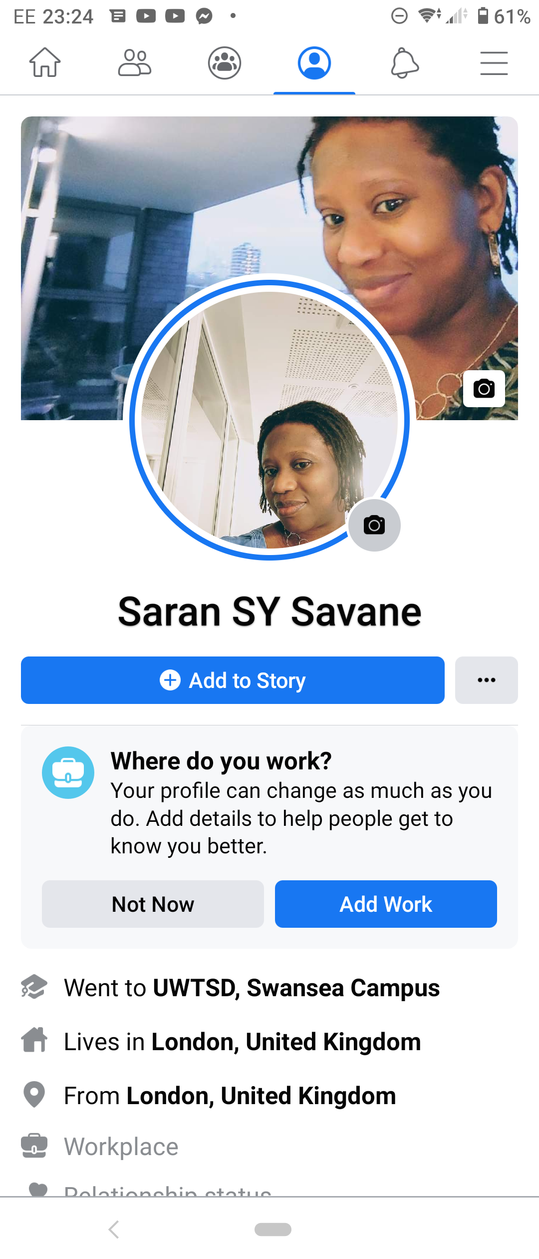

Conclusion

No one can deny the impact of new technologies in our life. How much they have revolutionized our daily lives. As well as, the usefulness of social media for advancement in the field of business is no longer to be demonstrated. So, it is obvious that with a good communication strategy by responding to the needs of our customers, so that we can achieve our goals.
However, the adventure is not without risk, certain parameters must be taken into account, some security and safety measures are inevitable to be avoided in order to success or not to fall into the captors’ trap. Thus, it is also proven that a company that does not use social media is called to lag, remains in the shadows and even disappears over time.

References:

Hajli. N, (2013), A study of the impact of social media on consumers. International Journal of Market Research Vol. 56 Issue 3. Birkbeck University of London.

Hilde. A, and al, (2018), Engagement with Social Media and Social Media Advertising. Available online on https://www.tandfonline.com/doi/full/ p 38-54

Maund. A, and al. (2017), Technology and Media, in Certificate in Higher Education: Skills for the Workplace Student Yearbook, SAGE London, p105-127

Paquette. H. (2013), Social Media as a Marketing Tool: A Literature Review. University of Rhode Island DigitalCommons@URI, available online digitalcommons.uri.edu/cgi/viewcontent.cgi

