UNIVERSITY OF WALES TRINITY SAINT DAVID



ACADEMIC REPORT WRITING

TOPICS COVERED TIME MANAGEMENT, REFLECTION,
REFERENCING, ANALYTICAL & CRITICAL THINKING


This Photo by Unknown Author is licensed under CC BY-SA

DECEMBER 24, 2020 ERKAN PACA 2010132, ACADEMIC & EMPLOYABILTY SKILLS LECTURER BARBARA CHINYANI, SUBMISSION DEADLINE 04/01/2021.

ACADEMIC & EMPLOYABILITY SKILLS

INTRODUCTION

TOPICS COVERED
- TIME MANAGEMENT
- REFLECTION
- REFERENCING
- ANALYTICAL & CRITICAL THINKING

- TIME MANAGEMENT

“HOW EFFECTIVE ARE YOU”
According to Chaneski, W (2017) finding a time to play golf did not actually hold him to do another task that is organizing the D.DAY invasion, whilst others would struggle to do both task at the same time in everyday life. Most important facts about the Eisenhower method is, how you organize your time in an effective and efficient manner.
It is essential to work in a smart way because more hours of concentrating do not actually mean, it is beneficial for us in fact this can be achievable by being effective and efficient with your time that is consuming less time to deal with it. Urgent activities usually the ones that comes with great pressure of concentration related with other people tasks we found ourselves working for, whereas important activities are based on result orientated for personal achievements.
The definition of Eisenhower method is how one prioritize their tasks in the following order:
- Important and Urgent: Two main points for it is to be described as, one it is left to be done at a later stage, as called, ‘procrastination, ‘secondly as unpredictable ones that is hard to be predicted. You can minimize your unexpected ones by organize and plan your tasks ahead.
- Important, but not Urgent: Allow plenty of time for yourself to complete these tasks to finish because in contrast it may cause a great deal of problem delaying your tasks at hand, and may lose the essence of importance.
- Not Important and but Urgent: Main sources of these activities are the ones that given to us by others to deal with, but simply say no and delegate it appropriately when needed.
- Not Important and Not Urgent: It is an activity that can divert your attention by not completing the important tasks at hand, and which you should concentrate on. The cause of that is other people, who can pass these tasks to you to complete, by simply refusing them with reason in a polite way makes you unapproachable.
It has been a great learning experience during my study to know how to reflect these methods of time management with my target to be a social worker in relation to my career path, moreover, time management is a crucial skill in social care. I also have learned that with homework given to us during the class activity which we were taught to prioritize more important tasks in our general life and study in health and social care career.
I now manage my time more effectively and efficiently whereas before I left things to be dealt at a later stage which made it very difficult for me to handle and stressed me out to finish the tasks at hand. As a matter of fact, it is been a very useful method of learning for me because I knew nothing about managing my time or how to make a plan to organize my time. It was great experience to achieve such an important method of learning where I try to use this in everyday life situation.

- REFLECTION

GIBBS REFLECTIVE STYLE (1988)
B, DEVET (2015)” THE STEPS OF THE CYCLE BREAKDOWN” 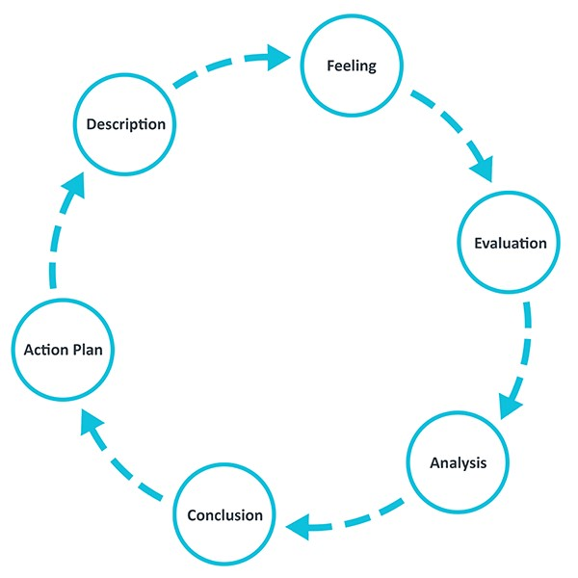

“GIBBS RELECTIVE CYCLE” GIBBS,GRAHAM (2015) their view on clearly inform that in a six steps format, by questioning the matter as, by describing it insightful manner exploring what has actually happened with your own experiences on that, following by your sense of feeling and what crosses in your mind when heard. The actual experiences you have felt for evaluating what was good or bad about by solving the matter after. Putting yourself in the same situation that, why this have happened indeed similar personal experiences you had encounter, and what could have been done to help prevent happening. At your own reflection on how It can be avoidable as a negative impact during the procedure, by creating a plan to avoid the same thing happening again when it occurs.
The main advantages that Gibbs cycle has, by letting your own thoughts and feelings during the procedure in a step by step approach by gathering information which help to solve the matter insightfully. Also using Gibbs reflection style “enhances their learning skills among group teaching and teachers” (Hall 112-13).
Disadvantages of Gibbs cycle is, ideal consultancy may not reach when seeking to find a perfect remedy for it, therefore they criticize themselves for not meeting the perfectional solution that could lose the breadth of the concept (Mattison 43)
On my learning experience within the classroom activities are;
- There are different types of reflection for example:
- Superficial (descriptive reflection) very basic does not specify any information.
- Medium (dialogic reflection) step back approach thoughts, feelings explored during the consultation and prepare for an action plan for future.
DESCRIPTION
WHAT
(
HAPPENED?)
FEELINGS (WHAT
WERE YOU
THINKING AND
FEELING?)
EVALUATION
GOOD AND BAD
(
EXPERIENCE THAT
YOU FELT?)
ANALYSIS (WHAT
SENSE CAN YOU
MAKE OF THE
SITUATION?)
CONCLUSION &
ACTION PLAN
(
WHAT ELSE
COULD YOU HAVE
DONE AND IF IT
AROSE AGAIN
WHAT WOULD YOU
DO?)

Deep (critical reflection) it is like a critical thinking process in depth approach, with empathy to evaluate the whole experience and reflect his or her learning experience for the service users to have the maximum benefit. Other reflective cycles are;
- Kolb reflective style is good for basic starters no critical thinking is quite superficial.
- Driscoll model is good for organizational model questioned asked what, why etc., but no deeper reflection or empathy.
Above the reflection models that I learned within my class activity, has helped me to be a social worker. I need to apply these effective models of reflection in my career path.
It is an essential skill to have as a social worker, where this skill of reflection be used in all aspect of social care so that service users can benefit the most of it in accordance with social guidelines.
I try to use this method of learning in all aspect of my life because it contains critical thinking with analysing your own experiences to be reflected on.

- REFERENCING
Richard & Shield (2010) identified the referencing is an idea of your own opinion when you read other people’s articles or information based on your contribution at your own research which can be done verbally or in writing to be shared with essay, report, seminar paper, dissertation projects or resources. It is a detailed gathered information which should be included as cited and concluded in the end as a references list in alphabetical order, so that your view on that, can be accessible for the readers to control and check the location of the information according to academic protocol. It makes readers to find the relevant information easily within the citation order first and referenced to be, in the end as a reference list.
It can also give you a wider view on your read about relevant topics or researches at your own argument and contribution that makes your own writing to be marked or grade in better result.
In addition to that you are able to show your own contribution and read to the topic. It shows that you have actually spend time and add your own analyses argument into your research.
There are different numbers of referencing style used which can actually cause a confusion for many students. Two distinctive referencing styles are, the one is Auto date referencing styles these are called Harvard and APA. The other one is numeric style that are MHRA AND OSCALA in text citation with full bibliographic details in footnotes. Although many referencing styles used in education main perspective is how readers can easily identify your sourced information by remaining the same style.
Referencing is an important skill that must be applied during our study doing our essay, report, dissertation etc. so that information sought for our research can be done in accordance with academic protocol. This will be carried out to our career path enabling us to do proper investigational research for our clients to obtain the best and right service when needed.

- ANALYTICAL & CRITICAL THINKING SKILLS
The peak performance centre (2020)” Analytical thinking is the mental process of breaking down complex information or comprehensive data info fundamental parts or basic principle”
Analytical thinking is a method that can be solved and identify problems into small parts, so that the conclusion can be made accordingly. Analytical thinking is a gathered information that is based on relevant topics to be explored into smaller parts where converted in sub-parts that is evaluated and being put your own understanding it’s components.
Looking into different perspectives with your own objectivity to, and how you connect relevant information to other formation. Integrate all the pieces with your own research of different views of topics is essential. Finally compiling all pieces at your own contribution reaching to appropriate conclusions.
“Analytical Thinking Includes;”
- Gathering relevant information
- Focusing on fact and evidence
- Examining chunks of data or information
- Identifying key issues
- Using logic and reasoning to process information
- Separating more complex information into simpler parts
- Sub-dividing information into manageable sizes
- Finding patterns and recognizing trends
- Identify cause and effect”
- Understanding connections and relationships
- Eliminating extraneous information
- Organizing information
- Drawing appropriate conclusions”
- Critical thinking involves your own insights of explaining all angles be put into right perspectives and conclusions in the end to make appropriate judgements. Relevant information explored with part by part approach into combined information with your own experiences to be added for a right assessment, reflecting your own sound judgement with right sources researched by you to apply on your conclusion. Relevant information which is gathered to get the best possibility of explanation and, then converted into right formula of reflection used and forwarded with your evaluation that is based on your ideas. All possibilities need to be considered so that well reasoning on conclusion can be apply via evidential support of judgement.
“Critical Thinking Involves”;
- Gathering relevant information
- Evaluating information
- Asking questions
- Assessing bias and unsubstantiated assumptions
- Making inferences from the information and filling the gaps
- Using abstract ideas to interpret information
- Formulating ideas
- Weighing opinions
- Reaching well-reasoned conclusions
- Considering alternative possibilities
- Testing conclusions
- Verifying if evidence/arguments support the conclusions”

Analytical thinking is a taught process of critical thinking when the problem occurs. Ideal to use analytical thinking before critical thinking. Analytical thinking needs a formulative solution of judgement based on other information, in contrast the critical thinking evaluating different sources of information which is based on your own experiences and knowledge to be reflected on your conclusion.
When it comes to my learning experience throughout my class activity that is recognizing the underlying issues or problems and organizing the related information to integrate all the pieces as breakdown of problems in points, then putting your proper conclusion. Analytical skills make you a better problem solver.
Critical thinking is about questioning and learning with an open mind. Also dig deeper, evaluate, pros and cons with your own personal experiences to be reflected on the problems at hand.
As a social worker both analytical and critical thinking are essential skills to have in social care because in every aspect of it, as a social worker, we are going to use these skills adding with our own experiences on, so that service users can benefit it accordingly within the guidelines. Great skills to have, in order to give the best service to clients I must apply these skills of reflection appropriately. In addition to that my personal experiences in similar settings given me a great deal of courage.
I appreciate the skill learned during my study and placed in my everyday life and willing to use this important skill once I become a social worker.

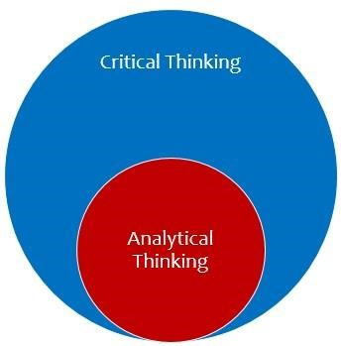

- CONCLUSION

It is important to have a reflection in health & social care using many methods of reflections in this academic report I write certain reflection models like time management, reflection, referencing, analytical & critical thinking and how important to have these skills in my career path to become a social worker each model in a way linked each other in health & social care to solve issues and problems for service users who sought help. I will use all models of reflection to achieve my goal to have become a social worker in future with my background experiences and being in the similar settings and working as a Turkish interpreter would give me an advantage to reach my target.

- REFERENCE LIST

Chaneski, Wayne S. (OCT2017)” time management- how effective are you”,
Gardner Publication (modern machine shop); Cincinnati, vol.90, iss.5 p (36,38)
Devet, Bonnie. (2015)” Gibbs Reflective Style” (1988) “the writing centre and transfer: a primer for directors” the writing centre journal”, vol.35, no.1,2015, pp
(119-51)
Gibbs, Graham. Learning by doing: a guide to teaching and learning methods. Oxford, Brookes, U, 2013, thoughtsmostlyaboutlearning.files.wordpress/2015/12learning-by-doing-grahamgibbs.pdf.
Hall. R, Mark. (2017) “around the texts of writing centre work”: an inquiry-based approach to tutor education. Utah State UP, 2017.
Mattison, Mike (2007) “someone to watch over me: reflection and authority in the writing centre.” the writing centre journal, vol 27, no.1, 2007, pp (29-51) https://thepeakperformancecenter.com/educational-learning/thinking/criticalthinking/analytical-thinking-critical-thinking/access date:(29/12/2020)

