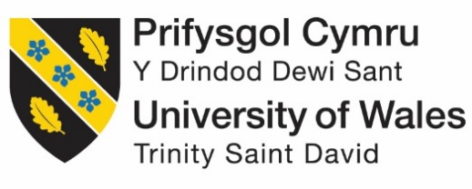

Strategic Management (LCMB7003)

Strategic Analysis of Coca-Cola

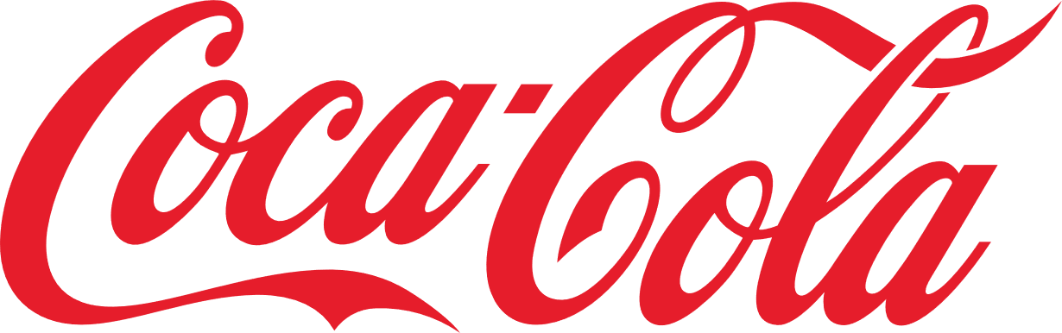

Student name: Ronak Rameshbhai Sojitra
Student Number: 2519657
Lecturer: Hoang Nguyen
Word count: 5028
Submission Date: 12th August 2026

Table of Contents
Section 1 3
1. Organisational Context and Overview 3
1.1 Company Overview 3
1.2 Industry Overview, Competitors and Market Position 5
2. External and Internal Analysis 6
2.1 Analysis of External Factors using PESTEL Analysis 6
2.2 Key Opportunities and Threats 13
2.3 Internal Environment Analysis Using the VRIO Framework 15
2.4 SWOT Analysis of Coca-Cola Zero Sugar (UK) 19
3. Comprehensive and Holistic View of the Organisation 23
3.1 Implementing Balance Score Card 23
4. Strategic Choices and Implementation 29
4.1 Business-Level Strategic Choices 29
4.2 The Appropriate Strategy for the Organisation 30
4.3 Recommended Business Strategy 35
4.4 Implementation Challenges and Mitigation Strategies 37
Section 2 40
1. Reflective Account Using Gibbs' Reflective Cycle 40
Reference list 43

Section 1

1. Organisational Context and Overview

1.1 Company Overview
The Coca-Cola Company, established in Atlanta, Georgia in 1886, has developed into one of the largest beverage companies globally, operating in over 200 countries and territories (Coca-Cola Company, 2026). Coca-Cola products are manufactured, marketed, and distributed across the United Kingdom by Coca-Cola Europacific Partners (CCEP) (Cocacolaep, 2026).
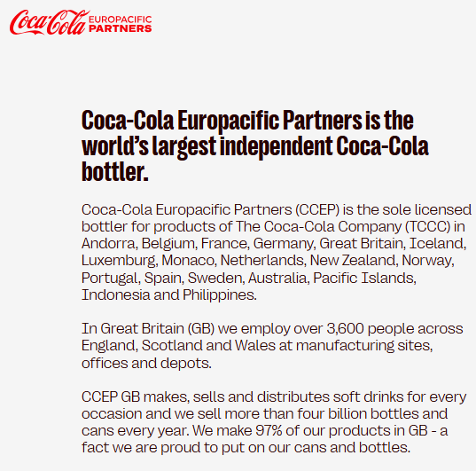
Figure 1: Coca-Cola Europacific Partners
(Source: Cocacolaep, 2026)
The focus of this report will be on Coca-Cola Zero Sugar within the UK, as the UK features one of Coca-Cola’s most developed and strategically crucial markets in Europe. The rise of health consciousness among consumers has increased demand for health drinks in the UK because of government regulations such as the Soft Drinks Industry Levy (Sugar Tax) (Scarborough et al., 2020) and increased health awareness among consumers. The Coca-Cola Zero Sugar beverage has grown rapidly since its launch and has now become one of the main drivers of the company's sustainable growth. In FY2025, Coca-Cola Zero Sugar recorded a volume growth of 5.3% in CCEP markets (Cocacolaep, 2026), with the strong growth continuing in Great Britain until 2026.
The mission of the Coca-Cola Company “refresh the world and make a difference”, whereas its vision revolves around creating brands that people will love, developing a sustainable business model and securing sustainable value for its shareholders (The Coca-Cola Company, 2026).
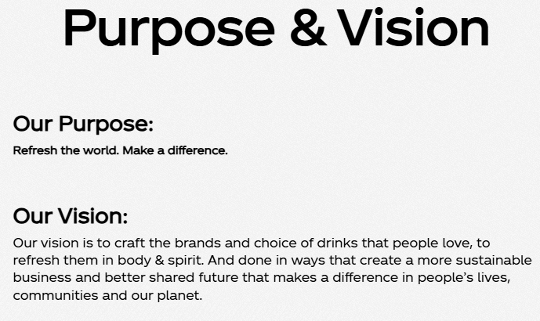
Figure 2: Purpose and Vision of Coca-Cola
(Source: The Coca-Cola Company, 2026)
The Coca-Cola Company’s business model relies on the global franchise model (The Coca-Cola Company, 2026), whereby it owns the trademarks and concentrates while bottling partners such as CCEP produce, distribute and sell the finished beverage locally. The asset-light approach allows Coca-Cola to maintain brand consistency worldwide while being able to adapt to local preferences of consumers and maintain an effective supply chain.

1.2 Industry Overview, Competitors and Market Position
Coca-Cola Zero Sugar belongs to the UK soft drinks sector, in particular the expanding low- and no-sugar soft drinks segment. Consumers are increasingly changing their preferences for healthier drinks, pushing producers to spend heavily on sugar-free product developments. According to Coca-Cola, two-thirds of the drinks sold in Great Britain are low or no-calorie drinks, since the company removed over 52,000 tons of sugar from its product line (Coca-Cola, 2026).
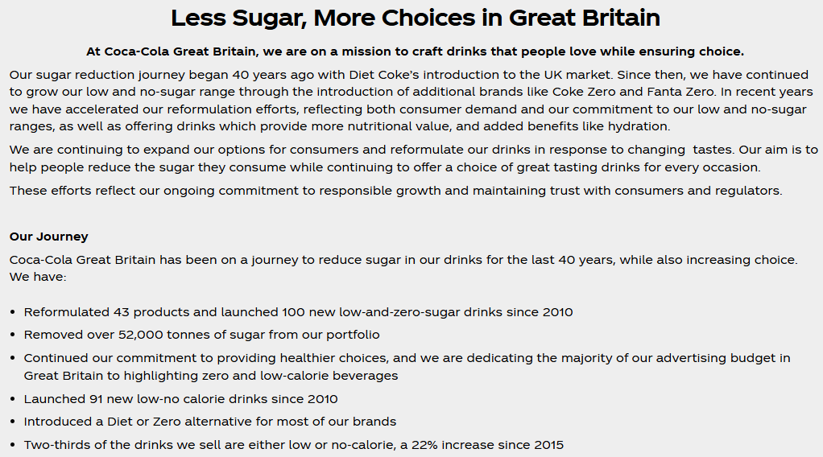
Figure 3: Less Sugar, More Choices in Great Britain
(Source: Coca-Cola, 2026)
The main competitors of Coca-Cola Zero Sugar in the UK include PepsiCo, Britvic and some supermarket private-label cola brands. Despite the high competition, Coca-Cola remains a market leader due to its great brand equity, good product availability, strong innovative ability, and high marketing expenses.

2. External and Internal Analysis

2.1 Analysis of External Factors using PESTEL Analysis
Political Factors
The UK government implementing restrictions on promotion and placement of foods and beverages with high in fat, salt, and sugar (HFSS) (GOV.UK, 2023). It created favourable environment for Coca-Cola Zero Sugar with no sugar content. The Soft Drink Industry Levy (SDIL) introduced in 2018 (GOV.UK, 2026), is encouraging for low-sugar content. It reduced 46% sugar content in soft drinks for tax implemented (Gov.uk, 2025), increasing demand for zero sugar alternatives.
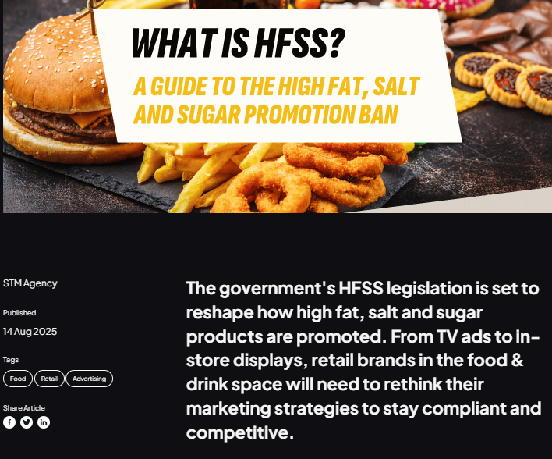
Figure 4: About HFSS
(Source: STM Agency, 2025)
UK government policies have created market opportunities for Coca-Cola Zero Sugar in retail positioning but may increase operating cost.

Economic Factors
Inflation in UK eased in 2025-2026 (BBC, 2026), but customers are highly price cautious prioritising products by value and health benefits. Consumer price has increased by 30.70% from January 2021 (Harari, 2026), leading to high cost-of-living.
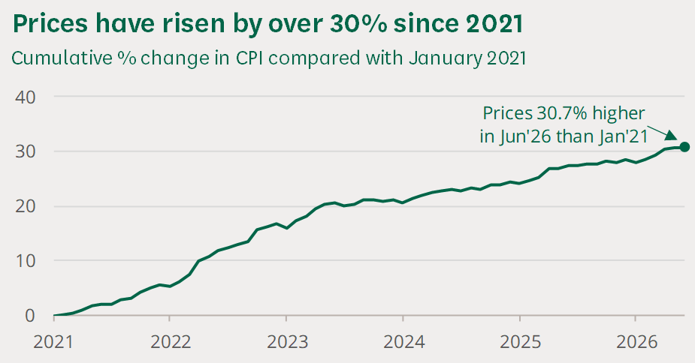
Figure 5: CPI index in the UK
(Source: Harari, 2026)
UK inflation stabilised in 2.60% in July 2026 but household expenditure feeling pressure (BBC, 2026).
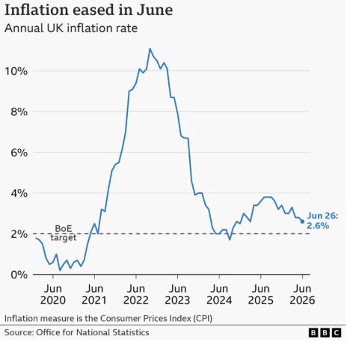
Figure 6: Inflation in the UK
(Source: BBC, 2026)
UK soft drink market valued £26.3 billion in 2025 (Britishsoftdrinks, 2025), with fast growing low/no-sugar category. Coca-Cola Zero Sugar can benefit from customer’s preference for premium healthier alternatives. High energy prices, transportation expenses, and packaging can increase production cost.
Social Factors
The UK Customers are deeply prioritising social trends for health consciousness increasing demand for Coca-Cola Zero Sugar. As per NHS England (2026), 66% UK adults are obese which increased public demand for low-sugar beverages.
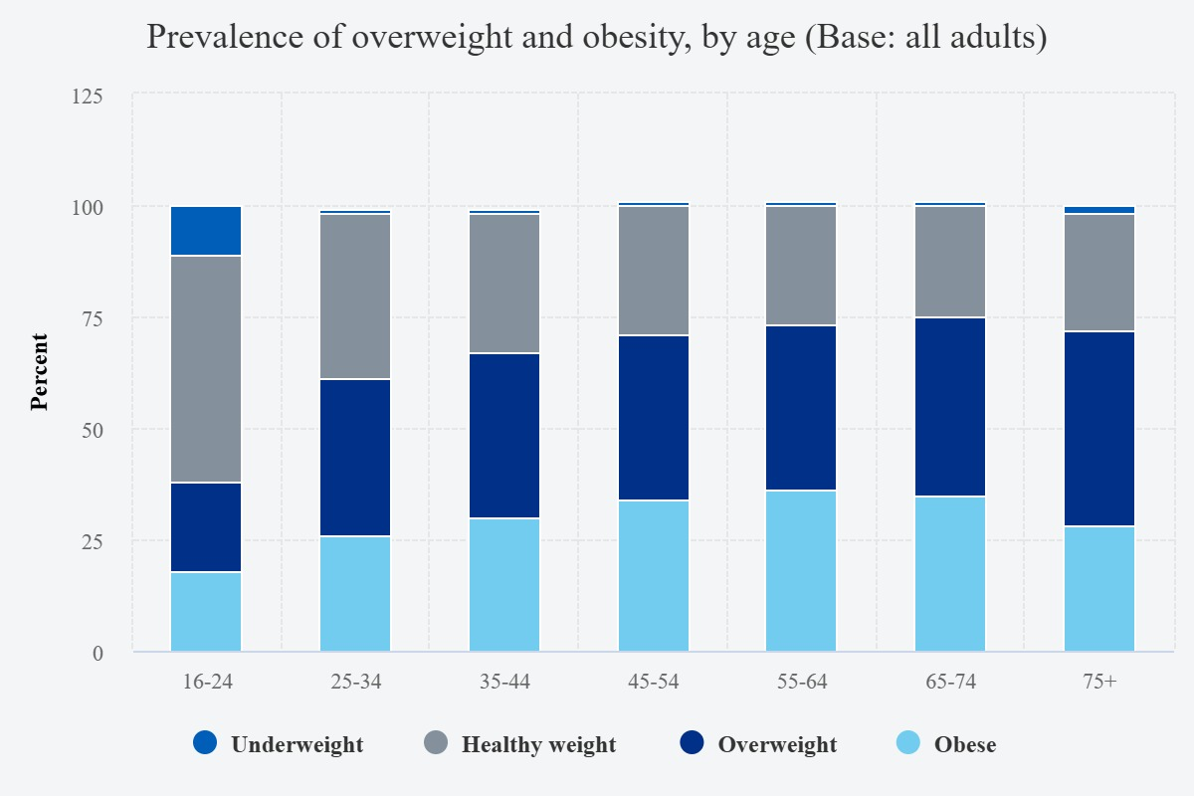
Figure 7: Prevalence of overweight and obesity by age
(Source: NHS England, 2026)
Customers are shifting from calorie reduction to healthy lifestyle. Social media, fitness culture, and nutritional education have increased awareness for wellness (Experian, 2025), strengthening demand for Coca-Cola Zero Sugar. Market alternatives like functional drinks, flavoured water, and natural beverages are threat. Customer demand for additional health benefits may force Coca-Cola to innovate beverage portfolio.
Technological Factors
Coca-Cola Zero Sugar can utilise technological innovation as Coca-Cola Euro-Pacific partners invested €1 billion for logistical upgrades, packaging innovation, digital transformation and sustainability (Cocacolaep, 2025).
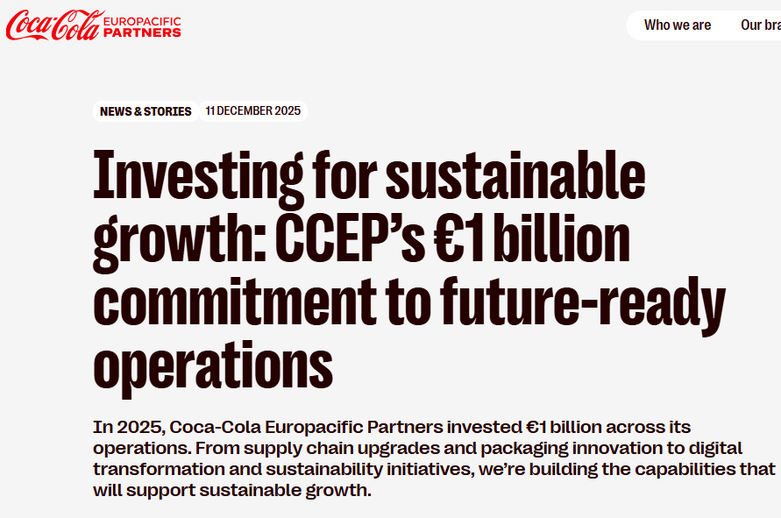
Figure 8: Investment for future ready operations
(Source: Cocacolaep, 2025)
95% of the UK adults have used Internet in last three months (Department for Science, Innovation and Technology, 2026). Hence, digital marketing can enable Coca-Cola for targeted digital campaigns, loyalty programmes, and e-commerce platforms.
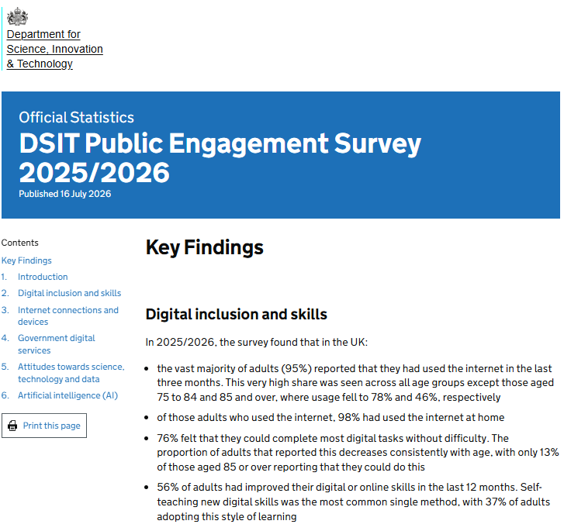
Figure 9: Internet usage in the UK
(Source: Department for Science, Innovation and Technology, 2026)
Coca-Cola can integrate AI-ML and predictive analytics for accurate inventory management and feedback analysis but cyber-security risks need relentless investments in digital infrastructure.
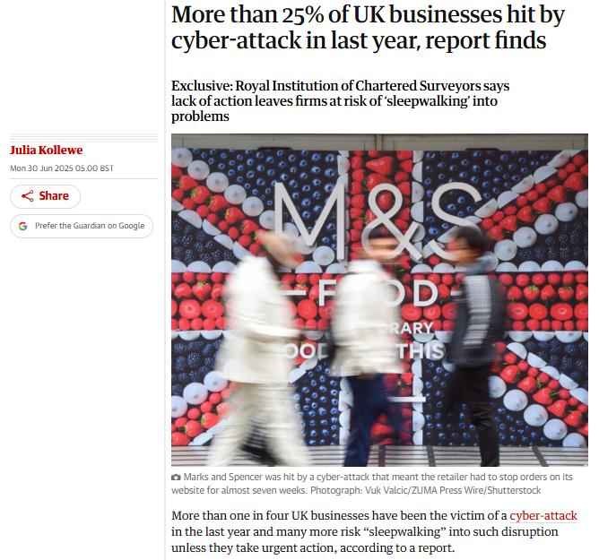
Figure 10: Cyber-attack in the UK
(Source: Kollewe, 2025)
Environmental Factors
UK customers prefer environmentally responsible brands as UK government implement strict environmental compliance policies. Coca-Cola has committed to achieve 25% reusable packaging by FY2030 through its World Without Waste strategy (Coca-Cola Company, 2022). In UK, Coca-Cola Euro-Pacific partners manufacturer 97% of products locally (Coca-Cola, 2026), reducing transportation-related carbon emissions supporting domestic businesses.
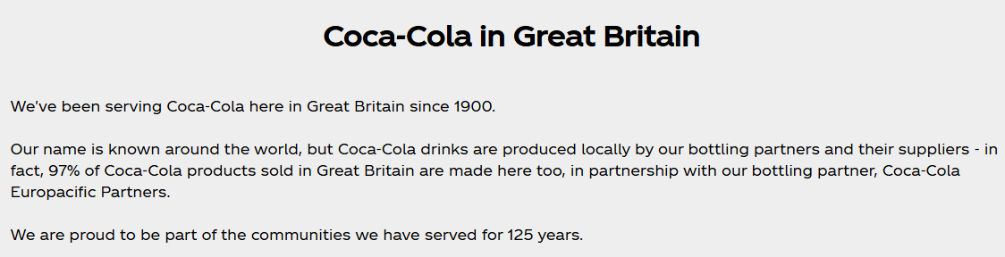
Figure 11: Local production by Coca-Cola
(Source: Coca-Cola, 2026)
The Deposit Return Schemes in UK need operational adjustments for rising expectations for carbon neutrality, water stewardship, and circular packaging increasing operational costs. Environmental challenges consist plastic packaging which attracts public scrutiny.
Legal Factors
The UK laws continuously focus on food safety, product labelling, environmental reporting, and customer protection. UK policies restrict unhealthy HFSS products which creates opportunity for Coca-Cola Zero sugar because of its alignment with government health objectives. The strict legislation focuses on recycling obligations, producer responsibility, and environmental disclosures which increase compliance cost. Coca-Cola can expand digital marketing and customer engagement initiatives by complying with the UK General Data Protection Regulation (UK Government, 2025).

2.2 Key Opportunities and Threats
Opportunities
The external environment present huge opportunities for Coca-Cola Zero sugar due to the UK government's growing focus on health awareness and policies to encourage low-sugar alternatives. In 2025, the British Soft Drinks Association reported that the economic value of the UK soft drinks sector was £26.3 billion, indicating popularity of low and no-sugar drinks (Britishsoftdrinks, 2025). Nowadays, two-thirds of the drinks Coca-Cola sells are low- or zero-calorie products, which is 22% more than in 2015. Technological advances advancements and increased customer demand for low-calorie beverages also provides strong growth.
Threats
Global economic uncertainty, rising production costs, environmental regulations, evolving customer preferences for functional beverages, and competition from Pepsi Max and private-brands pose significant threats for Coca-Cola Zero Sugar.
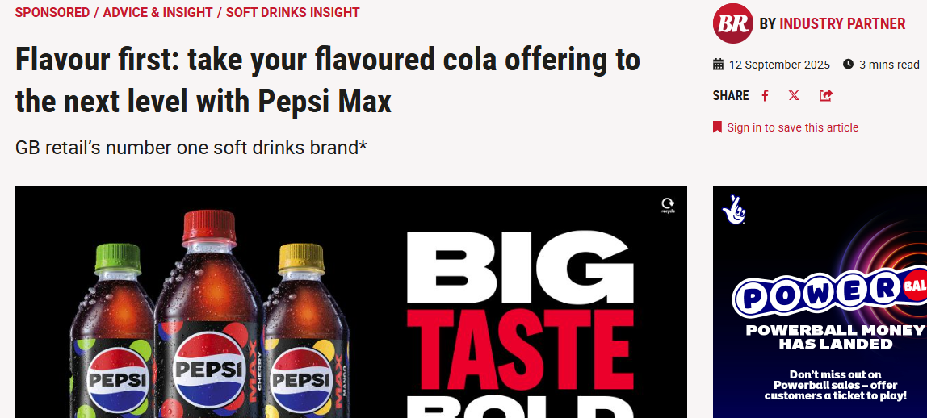
Figure 12: Popularity of Pepsi Max
(Source: Betterretailing, 2025)
In addition to this, increasing customer preferences for functional beverages, sparkling water, and energy drinks may cause less demand for carbonated soft drinks. Therefore, Coca-Cola Zero Sugar should invest in product innovation, sustainability initiatives, digital infrastructure, and customer engagement complying with UK’s regulatory environment in order to gain competitive advantages.

2.3 Internal Environment Analysis Using the VRIO Framework
1) Brand Equity and Marketing Capability (Strength)
Coca-Cola is global consistently high ranking valuable brands with market value of $60.10 Billion in 2025 (Interbrand, 2025), being its strategic asset.
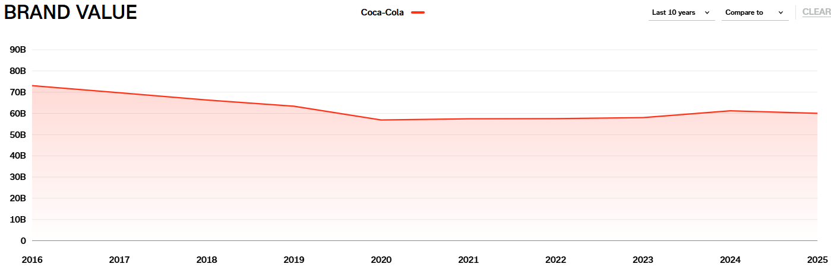
Figure 13: Brand value of Coca-Cola
(Source: Interbrand, 2026)
Coca-Cola Zero Sugar benefits from brand value, customer trust, and positions as a healthy alternative to traditional drinks. Coca-Cola is investing heavily in integrated marketing campaigns (The Coca-Cola Company, 2026), digital advertising, and sports sponsorship for strong customer engagement in multiple channels. Coca-Cola’s brand is valuable, rare, difficult to imitate, and effectively organised which gives the company a sustainable competitive advantage under VRIO framework. Strong brand equity allows Coca-Cola Zero sugar to maintain premium pricing under intense competition.
2) Distribution Network and Franchise System (Strength)
Coca cola’s extensive distribution network ensures excellent product availability in supermarkets, convenience stores, restaurants command online retailers. The Coca-Cola Euro-Pacific partners (CCEP) manufacturers its products locally selling 22 billion litres per year (Cocacolaep, 2026).
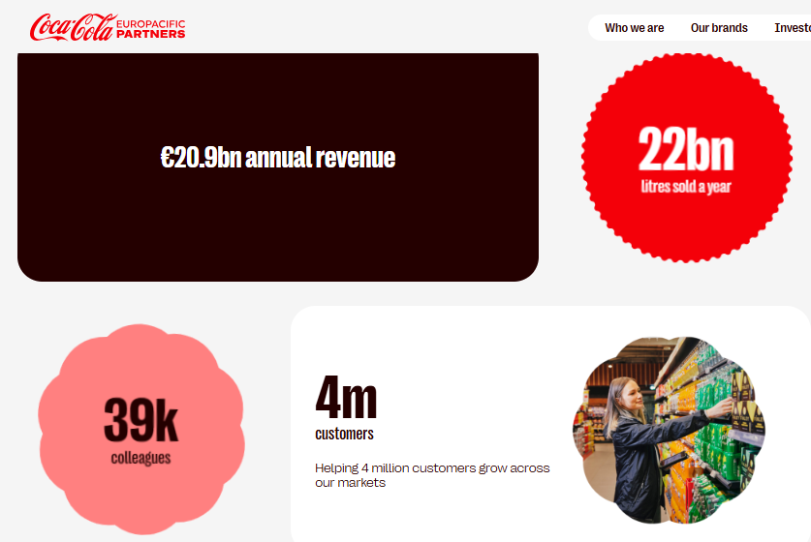
Figure 14: Performance of Coca-Cola Europacific Partners
(Source: Cocacolaep, 2026)
The extensive logistical network strengthens Coca-Cola Zero Sugar’s market penetration and customer accessibility in the UK. The franchise business model enables Coca-Cola to focus on brand management as CCEP provides efficient manufacturing and logistics. This distribution capability satisfies all VRIO criteria for its valuable, difficult to replicate by the contenders, and supported by highly coordinated organisational process.
3) Innovation and Product Development (Strength)
With the help of its continuous innovation strategy, Coca-Cola responded to the rapidly evolving customer preferences. Coca-Cola has offered more than 100 low- and no-sugar beverages since 2010 in Great Britain. The company also eliminated over 52,000 tonnes of sugar from its portfolio (Coca-Cola, 2026). In addition to this, in FY2025 Coca-Cola Zero Sugar has gained 5.3% volume growth in its CCEP market (Cocacolaep, 2026). This reflects successful product reformation of the company and strategy to ensure customer acceptance.
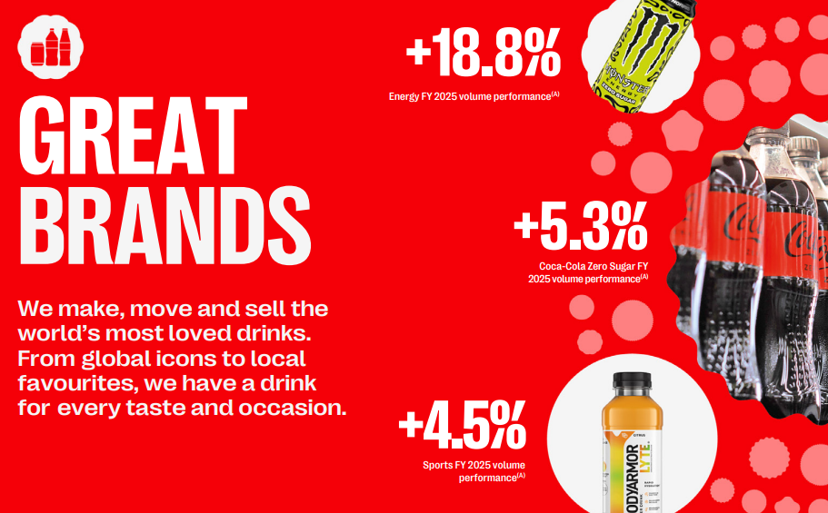
Figure 15: Coca-Cola Zero Sugar FY2025 volume performance
(Source: Cocacolaep, 2026)
The company invested in R&D, digital marketing, AI, and customer insights substantially, offering valuable and comparatively difficult-to-imitate capabilities which provides sustainable competitive advantage
4. High Marketing and Sustainability Investment Requirements (Weakness)
To maintain market leadership, Coca-Cola needs to invest substantially in advertising, sustainability initiatives, and product innovation. According to the report of Investopedia (2026), Coca-Cola spends more than $4 billion on advertising in a year. The company also focus on investing heavily in advanced digital technologies, recyclable packaging, and carbon reduction initiatives.
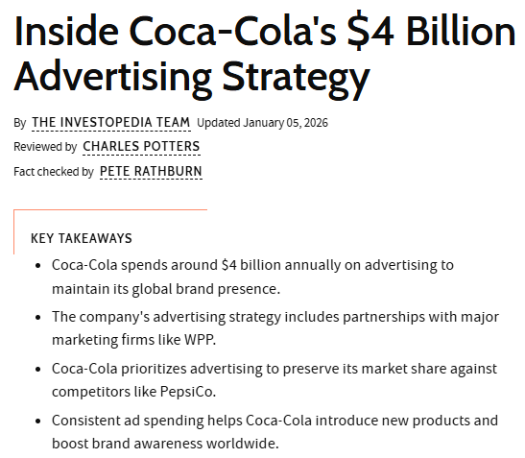
Figure 16: Advertising strategy of Coca-Cola
(Source: Investopedia, 2026)
Despite the fact that these investments help the company gain competitive advantages but these are also increasing operating costs as well as expenses of production. Therefore, relatively smaller companies may implement lower cost structures and compete on price in several market segments.
Overall VRIO Assessment
Resource/Capability | Valuable (V) | Rare (R) | Inimitable (I) | Organised (O) | Competitive Advantages
Brand equity and marketing capability | Yes | Yes | Yes | Yes | Sustained Competitive Advantage
Distribution network and franchise system | Yes | Yes | Yes | Yes | Sustained Competitive Advantage
Innovation and Product Development | Yes | No | No | Yes | Temporary Competitive Advantage
High Marketing and Sustainability Investment Requirements | No | No | No | Yes | Competitive Weakness
Table 1: VRIO analysis
(Source: self-made)

2.4 SWOT Analysis of Coca-Cola Zero Sugar (UK)
Strengths
Coca cola has several advantages over other competitive brands. United Kingdom Low/Zero Sugar Beverages Market size, valued at USD 0.17 Billion in 2025, is expected to expand to USD 0.57 Billion by 2034(Bennett, 2026).
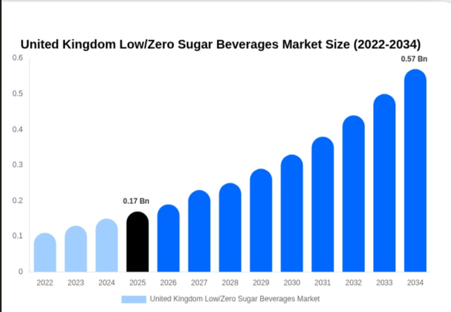
Figure 17: Market size of low/ zero sugar beverages in UK
(Source: Bennett, 2026)
Coca cola is a well-known brand and it provides high consumer trust and strong brand loyalty. The company also has an extensive distribution network. Coca-Cola Euro pacific Partners (CCEP) sells approximately 22 billion litres of beverages yearly across the UK (Cocacolaep, 2026). This makes sure that the product is always available and market coverage. Additionally constant innovation has enhanced the market position of the brand. The company reformulated 43 products since 2010. It also removed more than 52,000 tonnes of sugar from its portfolio and launched low and zero sugar drinks (Coca cola, 2026)

Weaknesses
In spite of several strength Coca cola zero sugar, limited sugar free products of is one of its major weaknesses. Now, consumer gives preference to functional beverages, flavoured water and natural health drinks. Beside this, to maintain the market leadership company needs to invest a significant amount in advertising, sustainability initiatives and digital transformation.
Coca-Cola spends over $4 billion annually on advertising (Investopedia, 2026). This increases the cost of operation. It also creates pressure on profitability during periods of inflation and raises expenses of production.
Opportunities
Increasing health awareness offers significant opportunities for Coca-Cola Zero Sugar. According to a survey two thirds of adults in UK were either overweight or obese. Among children leaving primary school, 22.2% were obese, rising to 29.3% in the most deprived areas more than double the 13.5% in the least deprived (Tandukar, 2026). Because of this problem demand for healthier beverage alternative increased.
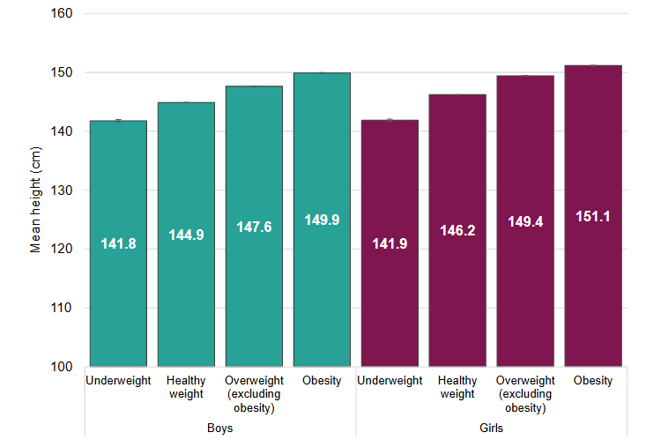
Figure 18: Average (mean) height in centimetres at age 11 by BMI category in England
(Source: Gov.UK, 2026)
Various government initiatives like the Soft Drinks Industry Levy (SDIL) (Scarborough et al., 2020) regulations continue to encourage consumers to choose sugar-free products. Also, development in artificial intelligence, digital marketing and sustainable packaging provide opportunities to enhance customer engagement, efficiency of operation and environmental performance.
Threats
The company faces several competitions from Pepsi Max, Britvic (Britvic, 2023) and supermarket private-label brands. This creates extra pricing pressure within the market of UK soft drinks. The margins of profit are also impacted by increasing energy, transportation and packaging costs. Beside this, stricter environmental regulations and increasing demand of the consumer for functional and plant-based beverages could decrease demand for traditional carbonated drinks. Coca-Cola can resolve this by diversifying its product portfolio. Overall, Coca-Cola Zero Sugar remains well positioned for future growth if it continues investing in innovation, sustainability and healthier beverage offerings.

3. Comprehensive and Holistic View of the Organisation

3.1 Implementing Balance Score Card
Introduced by Kaplan and Norton, the Balanced Scorecard determined an organisation's strategy into a quantifiable balance between economic and non-economic measures. In the United Kingdom, Coca-Cola Zero Sugar was able to adopt this to assess strategic performance. Four perspectives correlated with the benefits of better decision-making, operations, growth and competitiveness in the long-term.
i) Financial Perspectives
Coca-Cola Europacific Partners (CCEP) presented its financial results for 2025, where total sales amounted to €20.9 billion, an increase of 2.3% on a comparable basis (Fatima, 2026). The growth meant that the Coca-Cola Europacific Partners company enhanced its financial performance and continued to sustain stable business growth in 2025. The company also recorded operating profit of €2.8 billion, an indicator of effective cost management and profitable business operations all over the world (Coca-Cola EP, 2026a). The operating profit was a good sign of the company's financial performance, cost management, and business operations in the international markets. For the quarter, Coca‑Cola Zero Sugar increased by 13%, and for the full year it grew by 14%, with all of these gains coming from each of the company's geographic operating segments (Coca-Cola Company, 2026). This outcome revealed that demand was high and would continue to create financially healthy growth for the company from the growth in sales of Coca-Cola Zero Sugar globally.
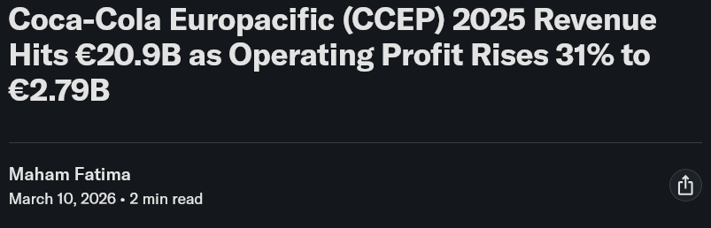

Figure 19: Coca-Cola Europacific (CCEP) 2025 Revenue
(Source: Fatima, 2026)
Objectives
- Gain revenue from the sale of more Coca-Cola Zero Sugar in the UK.
- Improve operating profit by maintaining effective cost management and operational efficiency.
Measures / KPIs
- Total revenue growth.
- Gross profit margin.
- Coca-Cola Zero Sugar sales volume.
- Return on investment.
Targets
- Expand Coca-Cola Zero Sugar distribution in the U.K. to drive sales.
- Ensure sustainable growth of revenues and operating profits in future financial periods.
Initiatives
- Increase distribution of Coca-Cola Zero Sugar in supermarkets, convenience stores and foodservice.
- Improve digital marketing and promotional strategies for health-conscious buyers.
ii) Customer Perspectives
Coca-Cola Zero Sugar will help deliver value to customers by offering beverage options that are healthier without sacrificing the original Coca-Cola flavour. The company also phased out more than 52,000 tonnes of sugar and increased the availability of healthier drinks throughout Britain consistently (Coca-Cola, 2026a). The accomplishment is an expression of the firm's dedication to initiating consumer changes and building trust with healthier product choices across the country. Consumers were shifting to healthier beverage alternatives for the evening in the country, and Coca-Cola Zero Caffeine Zero Sugar was relaunched to address this preference in 2026 (Coca-Cola EP, 2026b). Refreshment will come in a new design, using a format upgrade for existing packs, as a premium black and gold pack.
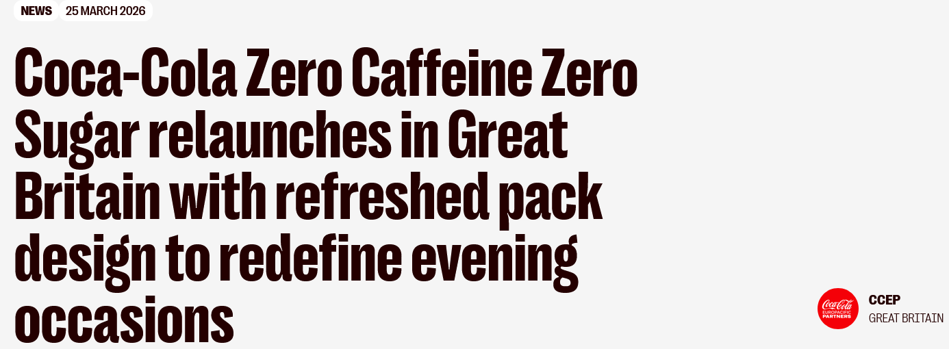

Figure 20: Coca-Cola Zero Caffeine Zero Sugar re-launches in Great Britain s
(Source: Coca-Cola EP, 2026b)
Objectives
- Enhance customer satisfaction and customer loyalty.
- Encourage buyers of Coca-Cola Zero Sugar.
- Continue the growth in UK market share
Measures / KPIs
Customer satisfaction score. Brand awareness. Customer retention rate. Repeat purchase rate. Market share.
Targets
- Encourage customer loyalty with improved beverage options.
- Increase the repurchase rate for health-conscious customers.
- Increase brand preference in the UK soft drinks market.
Initiatives
- Introduce new product varieties with Zero Sugar.
- Increase digital and social media marketing programs.
- Facilitate responsible marketing and health messages.
- Increase retail partnerships for greater product availability.
iii) Internal Business Processes
The internal business process perspective was used for the internal efficiency of the business processes to generate value, measured consistently through quality, innovation and productivity improvements. To boost manufacturing efficiency, Coca-Cola Europacific Partners implemented Spot, an artificial intelligence (AI) based robotic inspection solution in all production sites in the United Kingdom. Advanced sensors and real-time operation enabled the continuous monitoring of nearly 600 inspection points on seven production lines (Coca-Cola EP, 2026c). These enhancements resulted in proactive maintenance, decreased equipment downtime, increased production dependability, and increased energy efficiency during the manufacturing process. Coca-Cola already has “Cane Sugar” Coke in other markets, such as Mexico, and some U.S. grocery stores stock glass bottles of Mexican” Coke (Tabassum, 2025). The conversion to cane sugar will also have cost implications, such as major supply chain changes, industry analysts said. Expensive products may also put pressure on consumers' budgets.
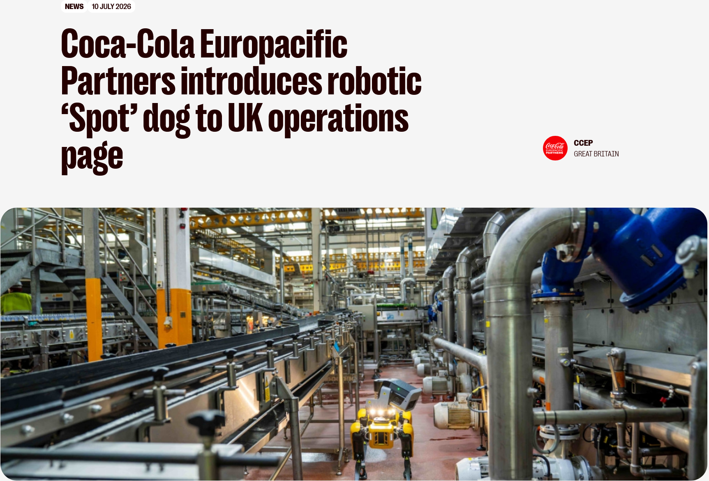

Figure 21: Coca-Cola Europacific Partners introduces robotic ‘Spot’ dog
(Source: Coca-Cola EP, 2026c)
Objectives
- Enhance production efficiency and effectiveness.
- Decrease package waste and improve sustainable manufacturing.
Measures / KPIs
- Recycled packaging content.
- Production efficiency.
- Recycling rate.
- Manufacturing quality.
- Packaging waste reduction.
Targets
- Continue recycling of eligible bottles at 100% (recycled plastic content).
- Improve the recycling performance throughout manufacturing processes.
Initiatives
- Promote the development of innovative packaging solutions that are sustainable.
- Increase recycling facilities and collections.
- Use lightweight packages.
iv) Learning and Growth
The focus of the reforms to the apprenticeship system is expected to deliver a benefit of 1000 youth, over the next three years, through the £725 million package of reforms, addressing issues of youth employment and boosting economic growth (GOV.UK, 2025). These changes to the apprenticeship meant that it eliminated barriers to learning and promoted more involvement in work. In Great Britain Coca Cola proud to employ 22,000 people and contribute to a further 43,800 jobs across the wider supply chain (Coca-Cola, 2026b).
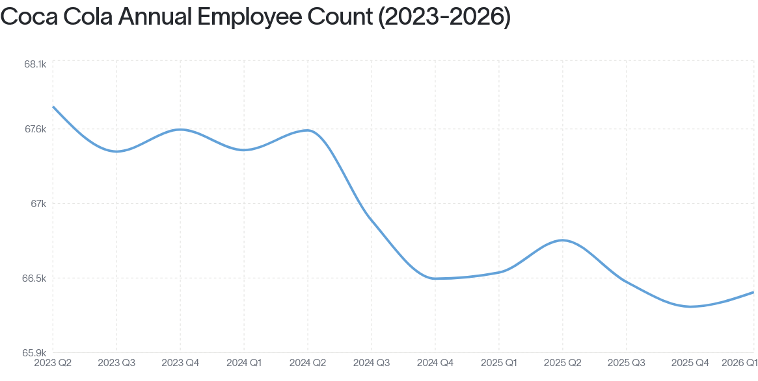

Figure 22: Coca-Cola Annual Employee Count (2023-2026)
(Source: Revelio Labs, 2026)
Objectives
- Improve employees' skills and leadership development.
- Improve innovation and organisational learning.
Measures / KPIs
- Employee training completion.
- Apprenticeship participation.
- Leadership development.
- Workforce productivity.
Targets
- Develop and enhance the skills of the workforce by further training.
- Develop the skills and capacity of employees
- Develop future leaders.
Initiatives
- Expand apprenticeship programmes.
- Improve technical and computer skills.
- Facilitate Career Development special programs and leadership programs.

4. Strategic Choices and Implementation

4.1 Business-Level Strategic Choices
Cost Leadership Strategy
The commitment to cost leadership aimed at reducing costs to make the beverage industry competitive in the UK. A 7% rise in revenue to $13.4 billion in the quarter, as reported by Barron's, the company also became more profitable, with a focus on pricing and operating savings (Neves, 2026). This outcome showed improved financial growth and competitiveness, supported by cost management.
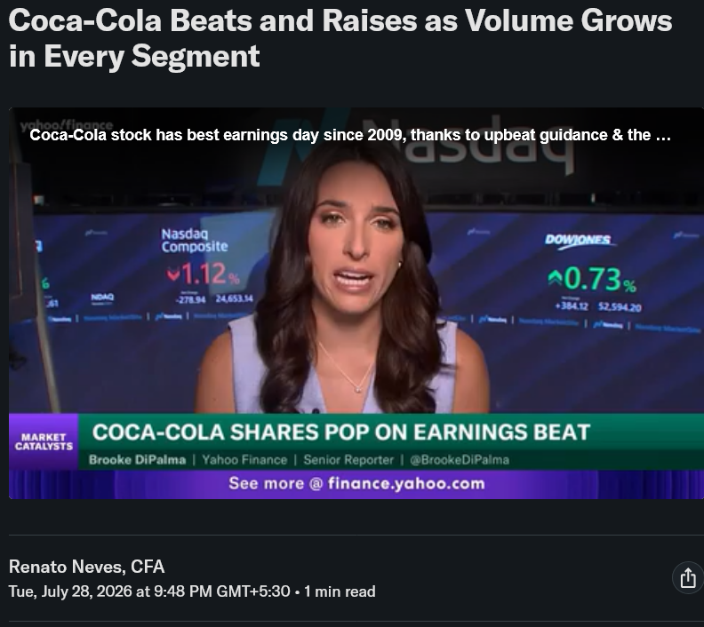

Figure 23: Coca-Cola Beats and Raises as Volume Grows in Every Segment
(Source: Neves, 2026)
Differentiation Strategy
The Coca-Cola Company KO is betting on premiumization to fuel its expansion in its overseas markets (The Globe and Mail, 2026). The company's business model is focused on creating a variety of innovative brands and price points, from low-cost, local offerings to high-quality and high-end beverages.
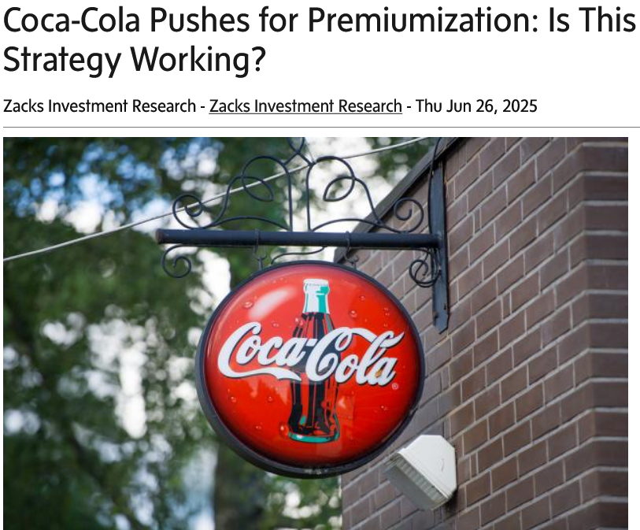

Figure 24: Coca-Cola Pushes for Premiumization
(Source: The Globe and Mail, 2026)

4.2 The Appropriate Strategy for the Organisation
Porter's Five Forces
- Competitive Rivalry - High
Coconut water, also known as the clear liquid from young green coconuts, can be extracted from the young green shells. Coconut water is naturally cooling and loaded with important nutrients as opposed to sugared soft drinks (JKFods, 2026). The coconut water is a huge business opportunity for retailers and wholesalers.
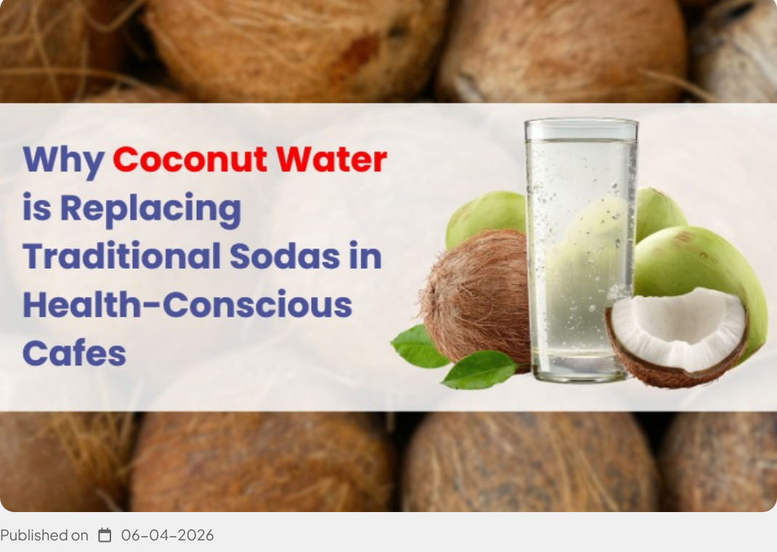

Figure 25: Coconut Water is Replacing Traditional Sodas
(Source: JKFods, 2026)
- Threat of New Entrants
Entry barriers are low due to the positioning of established brands, widespread distribution and high marketing efforts, and that is why the threat of new entrants is low. The Coca-Cola Company is back in the Premier League with its new three-year deal, indicating the return of the soft drinks giant to the world's most-watched football league (Premier League, 2025)..
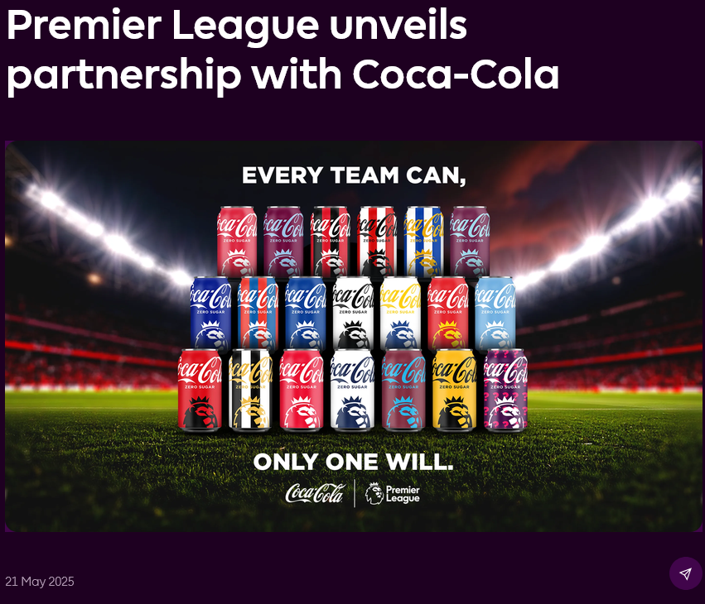

Figure 26: Premier League unveils partnership with Coca-Cola
(Source: Premier League, 2025)
- Bargaining Power of Buyers
UK supermarkets provided a wide choice of competitor drinks, and private label options were available, which meant that buyers' power was high. Consumers are on a sugar fast, and 62% of them have cut back on sugar consumption, and 74% of UK adults lessen their alcohol intake, fueling sales of alternative products (Grocery Trader, 2026).
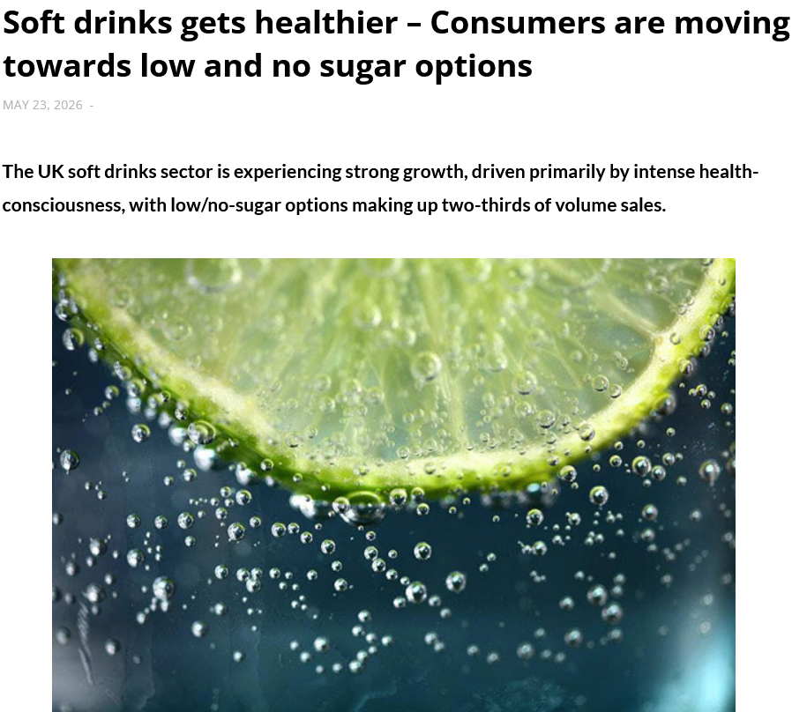

Figure 27: Soft drinks get healthier
(Source: Grocery Trader, 2026)
- Bargaining Power of Suppliers
British food and drink exports, which are declining for a 10th consecutive quarter, contracted by 8.9% in volume compared with the same quarter last year to reach their lowest level in a decade (Reuters, 2026).
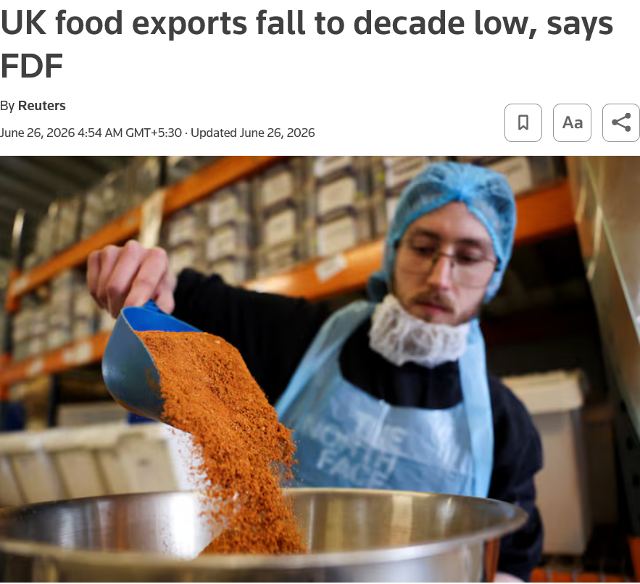

Figure 28: UK food exports fall to decade low, says FDF
(Source: Reuters, 2026)
- Threat of Substitutes
The risk of substitutes remained high as consumers became increasingly desirous of bottled water, functional drinks, energy and natural refreshments. Functional drinks use ingredients like ginger and turmeric to harness a health trend that is growing in significance to consumers across the UK, increasing by a compound annual growth rate (CAGR) of 47% in the last three years, and this market was essentially non-existent 10 years ago (West, 2026).
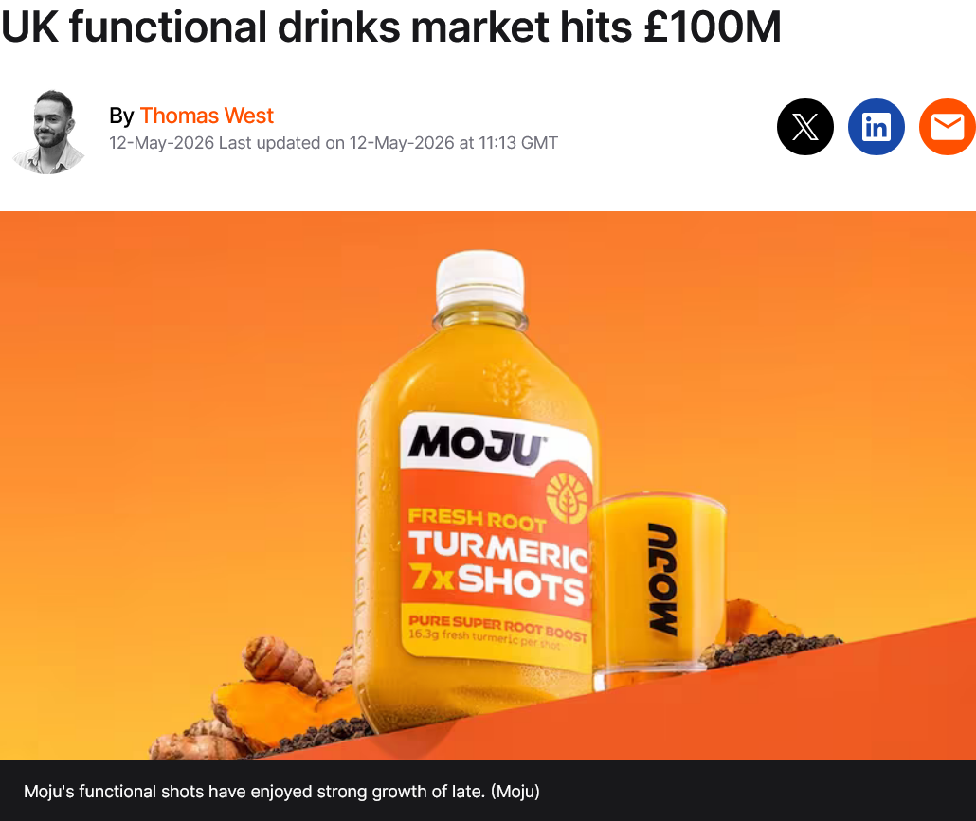

Figure 29: UK functional drinks market hits £100M
(Source: West, 2026)

4.3 Recommended Business Strategy
By understanding the actions of competitors, Game Theory allowed Coca-Cola Zero Sugar to establish its differentiation strategy effectively. The first principle was player identification, when PepsiCo and Britvic were identified as key players in the UK beverage market. The second principle was analysing strengths and weaknesses, and in this case, Coca-Cola had strong brand equity while the competitor had a keen expansion of the healthier beverage portfolio. Pepsi MAX introduced Pepsi MAX Tropical in 2026 to add to its £218 million flavours portfolio with fresh products and packaging (Carlsberg Britvic, 2026). The third rule, which is to identify shift, proposed that Coca-Cola should launch new Zero Sugar varieties before the market had an opportunity to get covered by rival products. The fourth principle, analysing payoffs, suggested that creating a differentiation was a better way to gain customer loyalty and premium value than competing on price.
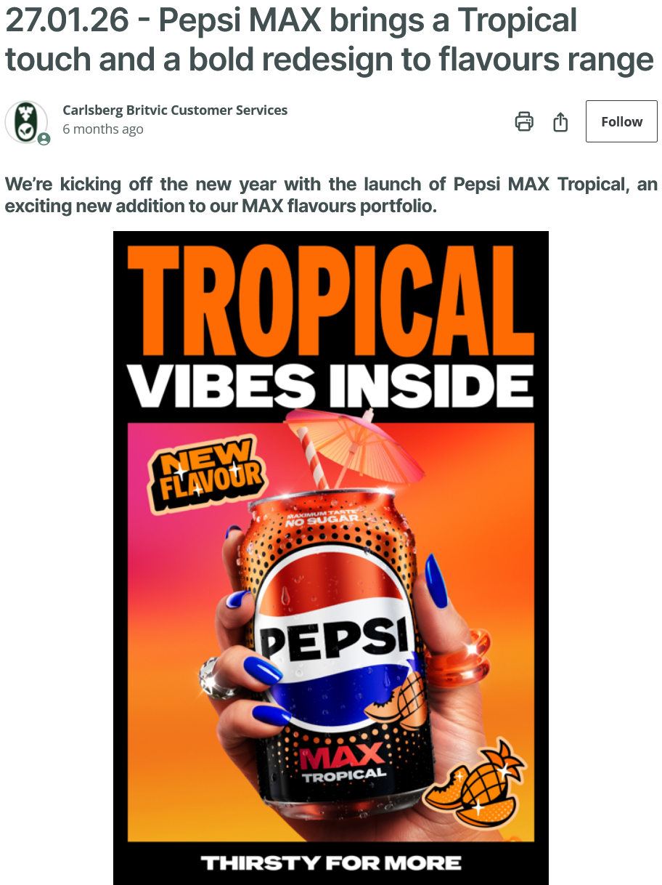

Figure 30: Pepsi MAX brings a Tropical touch and a bold redesign to flavours range
(Source: Carlsberg Britvic, 2026)
PepsiCo bought out Poppi for $1.95 billion with an additional $300 million in tax benefits projected for 2026, when it will introduce five low-sugar options to retail outlets in the United Kingdom (PepsiCo, 2025). Under Game Theory, continuous differentiation would produce mutually beneficial results for Coca-Cola, while reducing destructive competition between the major beverage companies.
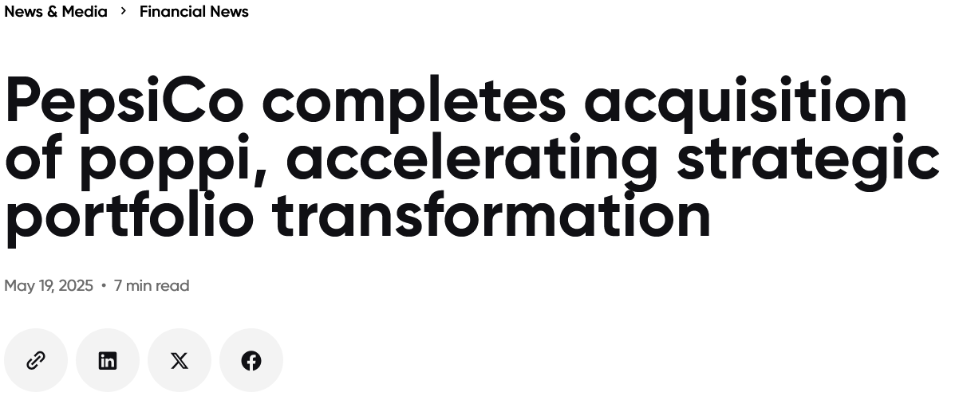

Figure 31: PepsiCo completes acquisition of Poppi
(Source: PepsiCo, 2025)

4.4 Implementation Challenges and Mitigation Strategies
- Challenge 1: Increasing Regulatory Pressure
The UK has an estimated 2/3rd of the population with overweight or obesity, and child obesity is one of the highest rates in Europe. The cost of these issues to the NHS in the UK is currently £6.5bn per year, and by 2050 it is projected to be £9.7bn per year (Walker, 2026). The Health and Care Act 2022 will have much more stringent regulations for HFSS products from 2026.
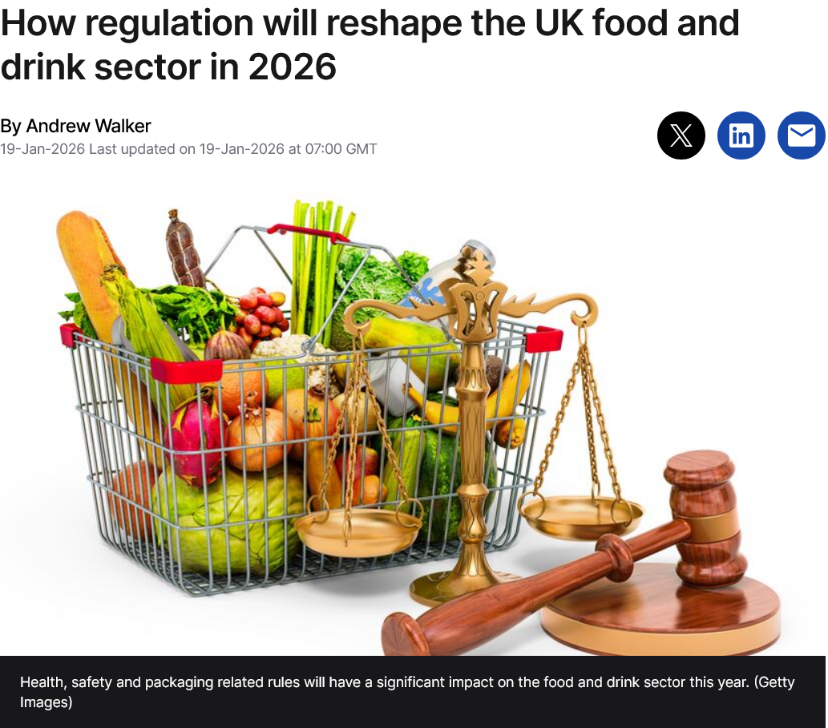

Figure 32: How regulation will reshape the UK food and drink sector in 2026
(Source: Walker, 2026)
- Mitigation Strategy
The Coca-Cola Company ought to boost Zero Sugar innovation, proactively repackage their products, and improve marketing in digital channels rather than in targeted ones. Increased regulatory monitoring, fresher product manufacturing and collaboration with retailers would help with compliance, mitigate potential implementation risks and ensure retention of competitive positioning in the food and beverages sector (Ojukwu et al., 2026).
- Challenge 2 – Rising Reformulation and Market Pressure
The policy will be implemented in Scotland from 1 October 2026, reducing high-fat, high sugar, high salt product promotions or larger shelf displays found in greater retail outlets (Hyslop, 2026).
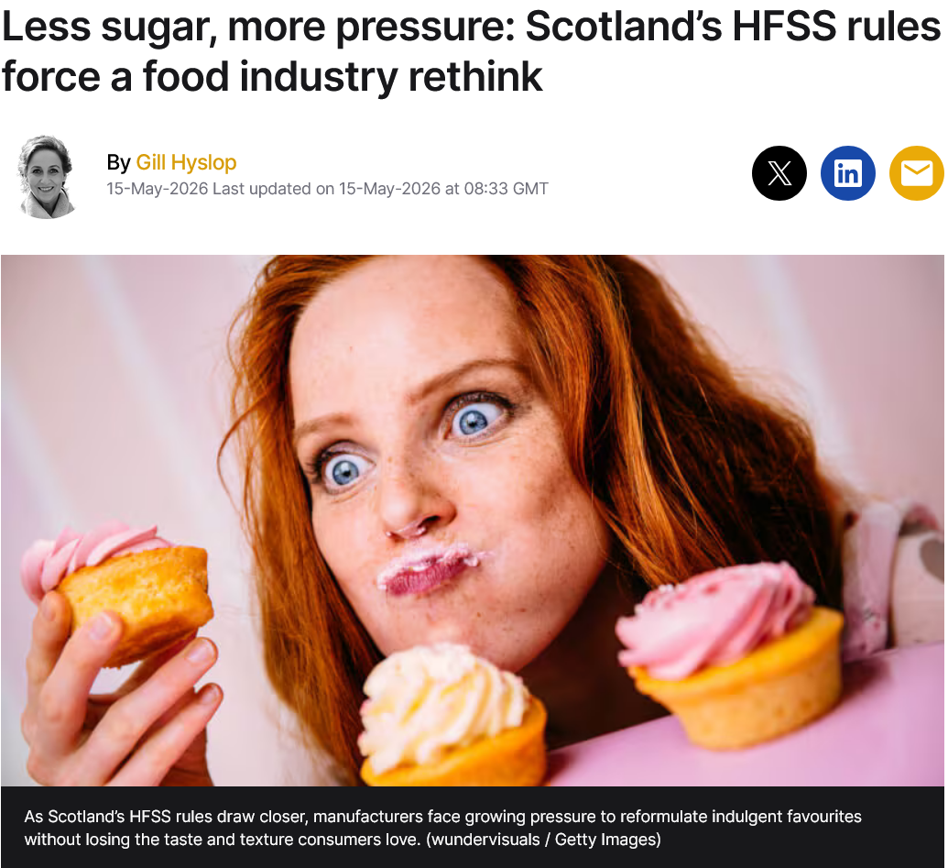

Figure 33: Scotland’s HFSS rules force a food industry rethink
(Source: Hyslop, 2026)
- Mitigation Strategy
Coca-Cola should invest more in research, taste products regularly and make some minor tweaks to recipes before rolling them across the nation. The cross-functional interactions between R&D and marketing teams and production teams would ensure the quality of the product, enhance consumer acceptance, and create a sustainable competitive advantage through the development of continuous innovations (Boudjenoun et al., 2025).

Section 2

1. Reflective Account Using Gibbs' Reflective Cycle
Description
In this assessment a strategic analysis of Coca-Cola Zero Sugar case was discussed with the help of strategic management frameworks such as PESTEL analysis, VRIO analysis, SWOT analysis, Balanced Scorecard, Porter's Five Forces, and Game Theory. The purposes included evaluations of the company's internal competences and external surroundings, identification of strategic problems, development of recommendations based on evidence and suggesting relevant implementation plans. In order to complete the report I studied articles, reports from various industries, publications from government, and company report. I used only latest evidence thus the analysis is based on up-to-date process in business. To make recommendations more reliable quantitative data including revenues, inflation rate, obesity statistics and consumers' wishes in relation to sugar-free drinks were also added.
Feelings
I felt confident at the initial stage of the assessment because I had primary knowledge about strategic management and related frameworks. However, I started feeling anxious after knowing that applying the strategic management frameworks to a multinational company needed an in depth level of research as well as critical analysis. I face difficulties at first in collecting recent UK specific information related to Coca Cola zero sugar because most of the literatures are based on the global Coca Cola business. Throughout the assessment I understood that it is important to evaluate the reliability of different industry reports. I also came to know that it is important to have careful judgement capabilities in order to distinguish between company wide and brand specific information. Gradually I became familiar with the company reports, academic sources, and government databases. This significantly enhanced my confidence end improve my analytics skills. I also successfully linked theoretical concepts with real organizational evidence. This provides me with greater confidence in my ability to conduct a strategic analysis individually. This assessment also strengthened my knowledge about how business theories can be applied real practice.
Evaluation
This assessment is overall positive experience for me because it significantly helped me to develop a comprehensive strategic evaluation with the help of recent incredible evidence. By applying several frameworks like VRIO, SWOT, the balanced scorecard, PESTEL, and quarters 5 forces I had analysed Coca Cola from several strategic perspectives. This approach helped me to develop evidence based recommendations. As I used recent statistics, this also strengthened my argument and my capability to apply strategic management theories in practical.
However, I also faced some challenges during this assessment. I struggled to obtain consistent as well as up to date UK market data per Coca Cola zero sugar because most of sources focused on overall performance of Coca Cola. Additionally, I also faced difficulties in balancing academic literature with industry evidence which is needed to ensure that every argument remind objective and relevant.
Analysis
This evaluation highlighted that theoretical models must be complemented by practical business information. PESTEL analysis enabled me to see the impact of different forces on strategic decision-making, such as government regulations, the economy, and technological developments. The VRIO analysis has shown how resources like the reputation of the brand, the capacity for innovation, and the distribution system bring about sustainable competitive advantage. At the same time, the SWOT analysis allowed me to identify strengths and weaknesses of the organization in combination with opportunities and threats present in the environment.
The Balanced Scorecard (Hayes, 2025) helps me to go beyond the financial perspective when assessing an organisation’s success. Furthermore, Porter’s Five Forces and the Game Theory showed that the level of competition and the behaviour of players in the market affect long-term strategies of companies operating in the UK soft drink industry, enhancing my critical thinking skills.
Conclusion
I understand that successful strategic analysis needs thorough research, critical evaluation, and the combination of various sources of evidence upon reflection in this assessment. Despite the difficulty and time required to collect information that is up to date and related to the company in concern, my experience improved my skills in researching, analysed thinking and making decisions. I better realised how companies adjust their strategies due to customers' needs, state regulation, technological progress and competition. In general, this assessment developed my skills in the application of strategic management frameworks and recommendation formation based on the evidence.
Action Plan
Development Area | Action Plan | Timeline | Expected Outcome
Research Skills | Use a wider range of academic journals, company reports and government publications to improve the quality and reliability of evidence. | Next 3 months | Produce more credible and evidence-based strategic analyses.
Critical Evaluation | Compare multiple sources before drawing conclusions and evaluate the reliability of information. | On-going | Strengthen analytical and decision-making skills.
Application of Frameworks | Practise integrating strategic frameworks into a coherent analysis. | Next semester | Improve the quality and logical flow of strategic recommendations.
Data Analysis and Report Writing | Regularly practise interpreting business statistics and presenting findings in a clear, concise and professional manner. | On-going | Enhance report-writing skills and prepare stronger consultancy reports for future academic and professional work.
Table 2: Action Plan
(Source: self-made)

Reference list
BBC (2026). UK Inflation Rate: How Quickly Are Prices Rising? BBC. [online] Available at: https://www.bbc.com/news/articles/c17rgd8e9gjo.
Bennett, N. (2026). United Kingdom Low/Zero Sugar Beverages Market Size & Share Report by 2034. [online] Deep_M_Insights. Available at: https://deepmarketinsights.com/vista/insights/lowzero-sugar-beverages-market/united-kingdom.
Betterretailing (2025). Flavour first: take your flavoured cola offering to the next level with Pepsi Max. [online] Betterretailing. Available at: https://www.betterretailing.com/br/insights/pepsi-max-free-stock-boost-sales/.
Boudjenoun, C., Saib, M., Zemmouchi-Ghomari, L., and Rezgui, W. (2025) ‘Leveraging intelligent manufacturing execution systems for digital transformation in the food and beverage industry', Journal of Intelligent Manufacturing and Special Equipment, 6(2), 155-180. https://doi.org/10.1108/JIMSE-05-2025-0006
Britishsoftdrinks (2026). Every major soft drinks category grows as UK market reaches record £26.3 billion. [online] Britishsoftdrinks.com. Available at: https://www.britishsoftdrinks.com/articles/every-major-soft-drinks-category-grows-as-uk-market-reaches-record-263-billion.
Britvic (2023). Home. [online] Britvic.com. Available at: https://www.britvic.com/.
Carlsberg Britvic (2026) Pepsi MAX brings a Tropical touch and a bold redesign to flavours range. Available at: https://help.carlsbergbritvic.co.uk/hc/en-gb/articles/33531784758685-27-01-26-Pepsi-MAX-brings-a-Tropical-touch-and-a-bold-redesign-to-flavours-range
Coca cola (2026). Less sugar, more choices in Great Britain. [online] www.coca-cola.com. Available at: https://www.coca-cola.com/gb/en/social/less-sugar-more-choice-great-britain.
Coca-Cola (2026a). Coca-Cola in Great Britain. [online] Coca-cola.com. Available at: https://www.coca-cola.com/gb/en/social/coca-cola-in-great-britain.
Coca-Cola (2026b). Our company. [online] The Coca-Cola Company. www.coca-colacompany.com. Available at: https://www.coca-colacompany.com/about-us.
Coca-Cola Company (2022). The Coca-Cola Company announces industry-leading target for reusable packaging – News & Articles. [online] www.coca-colacompany.com. Available at: https://www.coca-colacompany.com/media-center/coca-cola-announces-industry-leading-target-for-reusable-packaging.
Coca-Cola Company (2026) Coca‑Cola Reports Fourth Quarter and Full Year 2025 Results. Available at: https://www.coca-colacompany.com/media-center/coca-cola-reports-fourth-quarter-and-full-year-2025-results
Coca-Cola EP (2026a) WELCOME TO OUR 2025 ANNUAL REPORT HUB. Available at: https://www.cocacolaep.com/investors/financial-reports-and-results/latest-annual-report/
Coca-Cola EP (2026) Coca-Cola Zero Caffeine Zero Sugar relaunches in Great Britain with refreshed pack design to redefine evening occasions. Available at: https://www.cocacolaep.com/gb/news-and-stories/coca-cola-zero-caffeine-zero-sugar-relaunches-in-great-britain-with-refreshed-pack-design-to-redefine-evening-occasions/
Coca-Cola EP (2026) Coca-Cola Europacific Partners introduces robotic ‘Spot’ dog to UK operations page. Available at: https://www.cocacolaep.com/gb/news-and-stories/new-newscoca-cola-europacific-partners-introduces-robotic-spot-dog-to-uk-operations-page
Cocacolaep (2025). Coca-Cola Europacific Partners. [online] Coca-Cola Europacific Partners. Available at: https://www.cocacolaep.com/news-and-stories/investing-for-sustainable-growth-cceps-1-billion-commitment-to-future-ready-operations/.
Cocacolaep (2026). Coca Cola European Partners. [online] Coca-Cola European Partners. Available at: https://www.cocacolaep.com/.
Cocacolaep (2026). Great Britain. [online] Great Britain. Available at: https://www.cocacolaep.com/gb/.
Cocacolaep (2026a). ANNUAL REPORT AND FORM 20-F 2025. [online] Cocacolaep. Available at: https://www.cocacolaep.com/assets/Global/Investors/2025-Annual-Report/CCEP-Annual-Report-and-Form-20-F-2025.pdf.
Cocacolaep (2026b). Coca Cola European Partners. [online] Coca-Cola European Partners. Available at: https://www.cocacolaep.com/.
Department for Science, Innovation and Technology (2026). DSIT Public Engagement Survey 2025/2026. [online] GOV.UK. Available at: https://www.gov.uk/government/statistics/dsit-public-engagement-survey-20252026/dsit-public-engagement-survey-20252026.
Experian (2025). Health-conscious Britain: The UK’s Health & Wellness boom revealed. [online] Experianplc.com. Available at: https://www.experianplc.com/newsroom/press-releases/2025/health-conscious-britain--the-uk-s-health---wellness-boom-reveal.
Fatima, M (2026) Coca-Cola Europacific (CCEP) 2025 Revenue Hits €20.9B as Operating Profit Rises 31% to €2.79B. Available at: https://finance.yahoo.com/news/coca-cola-europacific-ccep-2025-001443002.html
GOV.UK (2023). Restricting Promotions of Products High in fat, Sugar or Salt by Location and by Volume price: Implementation Guidance. [online] GOV.UK. Available at: https://www.gov.uk/government/publications/restricting-promotions-of-products-high-in-fat-sugar-or-salt-by-location-and-by-volume-price/restricting-promotions-of-products-high-in-fat-sugar-or-salt-by-location-and-by-volume-price-implementation-guidance.
GOV.UK (2025). 50,000 more young people to benefit from apprenticeships as Government unveils new skills reforms to get Britain working. Available at: https://www.gov.uk/government/news/50000-more-young-people-to-benefit-from-apprenticeships-as-government-unveils-new-skills-reforms-to-get-britain-working
Gov.UK (2025). Obesity Profile: Statistical Commentary on Patterns and Trends in Child Height, February 2025. [online] GOV.UK. Available at: https://www.gov.uk/government/statistics/obesity-profile-february-2025-update/obesity-profile-statistical-commentary-on-patterns-and-trends-in-child-height-february-2025.
Gov.uk (2025). Strengthening the Soft Drinks Industry Levy consultation. [online] GOV.UK. Available at: https://www.gov.uk/government/consultations/strengthening-the-soft-drinks-industry-levy/strengthening-the-soft-drinks-industry-levy-consultation.
GOV.UK (2026). Soft Drinks Industry Levy Statistics background and references. [online] GOV.UK. Available at: https://www.gov.uk/government/statistics/soft-drinks-industry-levy-statistics/soft-drinks-industry-levy-statistics-background-and-references.
Grocery Trader (2026) Soft drinks gets healthier – Consumers are moving towards low and no sugar options. Available at: https://grocerytrader.co.uk/soft-drinks-gets-healthier-consumers-are-moving-towards-low-and-no-sugar-options/
Harari, D. (2026). Economic Update: The New Prime Minister, Inflation and the Cost of Living - House of Commons Library. [online] House of Commons Library. Available at: https://commonslibrary.parliament.uk/research-briefings/cbp-10975/.
Hayes, A. (2025). What Is a Balanced Scorecard (BSC)? Examples and Uses. [online] Investopedia. Available at: https://www.investopedia.com/terms/b/balancedscorecard.asp.
Hyslop, G (2026) Less sugar, more pressure: Scotland’s HFSS rules force a food industry rethink. Available at: https://www.bakeryandsnacks.com/Article/2026/05/15/scotlands-hfss-rules-pile-reformulation-pressure-on-food-manufacturers/
Interbrand (2026). Coca-Cola - Interbrand. [online] Interbrand. Available at: http://interbrand.com/best-global-brands/global/coca-cola/.
Investopedia (2026). How Much Coca-Cola Spends on Advertising. [online] Investopedia. Available at: https://www.investopedia.com/articles/markets/081315/look-cocacolas-advertising-expenses.asp.
JKFods (2026) Why Coconut Water is Replacing Traditional Sodas in Health Conscious Cafés. Available at: https://jkfoods.co.uk/blog/why-coconut-water-is-replacing-traditional-sodas-in-health-conscious-caf%C3%A9s?srsltid=AfmBOoqCltswqHTjdG2Gmew5oG9zxWmgxnqishxO9YRdlUerKCsAff9r
Kollewe, J. (2025). More than 25% of UK businesses hit by cyber-attack in last year, report finds. [online] the Guardian. The Guardian. Available at: https://www.theguardian.com/business/2025/jun/30/uk-businesses-hit-by-cyber-attack-last-year-report.
Neves, R (2026) Coca-Cola Beats and Raises as Volume Grows in Every Segment. Available at: https://finance.yahoo.com/markets/stocks/articles/coca-cola-beats-raises-volume-161852561.html
NHS England (2026). Welcome to Zscaler Directory Authentication. [online] Digital.nhs.uk. Available at: https://digital.nhs.uk/data-and-information/publications/statistical/health-survey-for-england/2024/adults-overweight-and-obesity.
Ojukwu, H.S., Nkechi, N.C. and Kingsley, I.C. (2026) ‘Process innovation and operational efficiency of food and beverage firms in Anambra State, Nigeria’, International Journal of Business and Management Research, 7(1), pp.367-401. https://www.researchgate.net/profile/Henry-Ojukwu-2/publication/403521396_PROCESS_INNOVATION_AND_OPERATIONAL_EFFICIENCY_OF_FOOD_AND_BEVERAGE_FIRMS_IN_ANAMBRA_STATE_NIGERIA/links/69d282663c6189430673ee02/PROCESS-INNOVATION-AND-OPERATIONAL-EFFICIENCY-OF-FOOD-AND-BEVERAGE-FIRMS-IN-ANAMBRA-STATE-NIGERIA.pdf
PepsiCo (2025) PepsiCo completes acquisition of poppi, accelerating strategic portfolio transformation. Available at: https://www.pepsico.com/newsroom/press-releases/2025/pepsico-completes-acquisition-of-poppi-accelerating-strategic-portfolio-transformation
Premier League (2025) Premier League unveils partnership with Coca-Cola. Available at: https://www.premierleague.com/en/news/4314789
Reuters (2026) UK food exports fall to decade low, says FDF. Available at: https://www.reuters.com/world/uk/uk-food-exports-fall-decade-low-says-fdf-2026-06-25/
Revelio Labs (2026) How many employees work at Coca-Cola? Available at: https://www.reveliolabs.com/companies/coca-cola/employees
Scarborough, P., Adhikari, V., Harrington, R.A., Elhussein, A., Briggs, A., Rayner, M., Adams, J., Cummins, S., Penney, T. and White, M. (2020). Impact of the Announcement and Implementation of the UK Soft Drinks Industry Levy on Sugar content, price, Product Size and Number of Available Soft Drinks in the UK, 2015-19: A controlled Interrupted Time Series Analysis. PLOS Medicine, [online] 17(2), p.e1003025. doi:10.1371/journal.pmed.1003025.
STM Agency (2025). What is HFSS Legislation? A Guide to the HFSS Promotion Ban. [online] Stmagency.co.uk. Shoot the Moon Group Limited. Available at: https://www.stmagency.co.uk/thought-leadership/what-is-hfss-legislation-a-guide-to-the-hfss-advertising-ban.
Tabassum, J (2025) Coca-Cola plans cane-sugar Coke as higher prices boost profits. Available at: https://www.reuters.com/business/coca-cola-plans-cane-sugar-coke-higher-prices-boost-profits-2025-07-22
Tandukar, A. (2026). Obesity in the UK 2026: 50+ statistics on prevalence, demographics, health costs, and where the UK ranks globally. [online] heySlim. Available at: https://www.heyslim.co.uk/blog/uk-obesity-statistics-2026.
The Coca-Cola Company (2026). The Coca-Cola Company. [online] The Coca-Cola Company. Available at: https://investors.coca-colacompany.com/about/growth-strategy.
The Coca-Cola Company (2026a). Purpose & Company Vision. [online] The Coca-Cola Company. Available at: https://www.coca-colacompany.com/about-us/purpose-and-vision.
The Globe and Mail (2026) Coca-Cola Pushes for Premiumization: Is This Strategy Working? Available at: https://www.theglobeandmail.com/investing/markets/stocks/KO/pressreleases/33074844/coca-cola-pushes-for-premiumization-is-this-strategy-working/
UK Government (2025). Data Protection Act. [online] Gov.uk. www.gov.uk. Available at: https://www.gov.uk/data-protection.
Walker, A (2026) How regulation will reshape the UK food and drink sector in 2026. Available at: https://www.foodnavigator.com/Article/2026/01/19/how-regulation-will-reshape-the-uk-food-and-drink-sector-in-2026/
West, T (2026) Healthy beverage market in UK: UK functional drinks market hits £100M. Available at: https://www.foodmanufacture.co.uk/Article/2026/05/12/uk-functional-drinks-markets-hits-100m-in-value-sales-as-health-consciousness-grows/

