

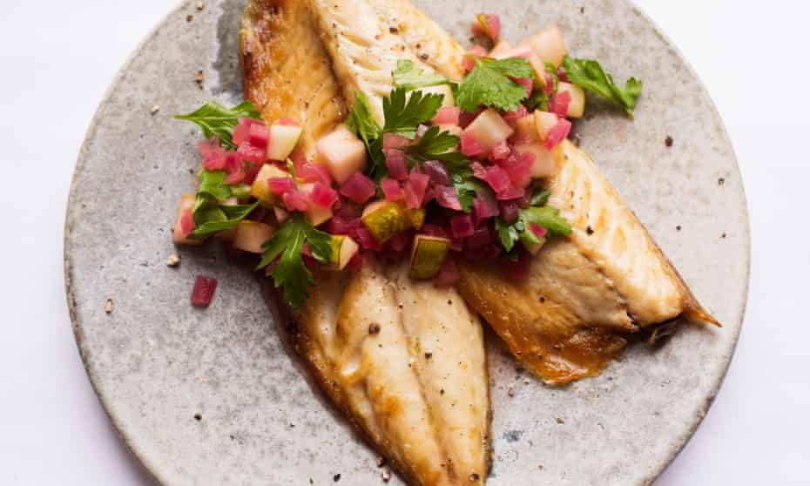

Description of Hotel Trinity:
HOTELHO

HOTEL
TRINITY
Starters
- Roasted Salmon Fish with Garlic Ketchup; seasoned fish with assorted herbs, fried with sautéed onion ketchup, and served with peppery and chef's custom tartar ketchup; allergens include salmon fish, Red wine and Riesling £12
- Asparagus Casserole with Granary bread; cooked little crusted pastry base with green scallions, clove caramelized cruciferous vegetables, season, salt, as well as additional crème soft cheese. It's paired with Potted shrimps to balance out Merlot wine and Malbec wine; protein and carbohydrate are both allergies £11
- Beetroot croissants with tangy vinegar; crunchy french fries starch in a grasp form; mashed flour with butter, cream, and chopped garlic. It arrives with a vinaigrette salt mixed chocolate pouring sauce, as well as a restricted list of allergies such milk, egg, and starch £9.50
Entrée menu
Garlic and rosemary lamb chops; marinated meat with clove, chilli, salt, oregano, and lime zest Garlic, red wine, and lamb protein are allergens; served with butter sautéed vegetables £31.95
Roasted button mushrooms with Sauvignon Grigio wine; paired with chef's unique sauteed honey, Pinot Noir and Sauvignon Grigio wine; allergens include mushroom and alcohol £21.59
Scrape and Zinfandel wine would cause allergic reaction. Vegetable burger with Zinfandel; it comprises cream cheese stirred seasonal veggies in buttered multi grain buns and topped with Zinfandel wine as well as zesty mayonnaise sauce £18.99

Sauteed full mackerel with salt, chilli, lime juice, sunflower oil, bay leaves, garlic, and oregano; entire mackerel baked in the oven with Champagne. It appears in a platter, with the mackerel covered in foil to keep the embedded flavor intact. Champagne is also served with this dish £27.99
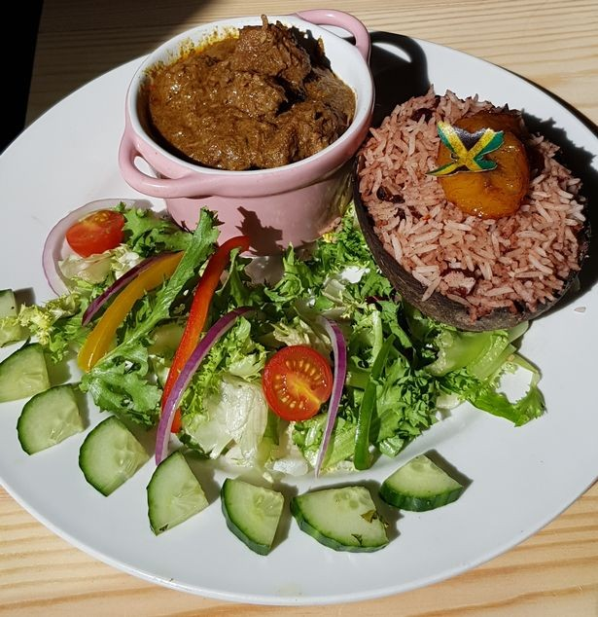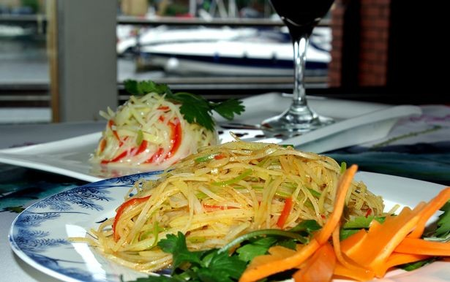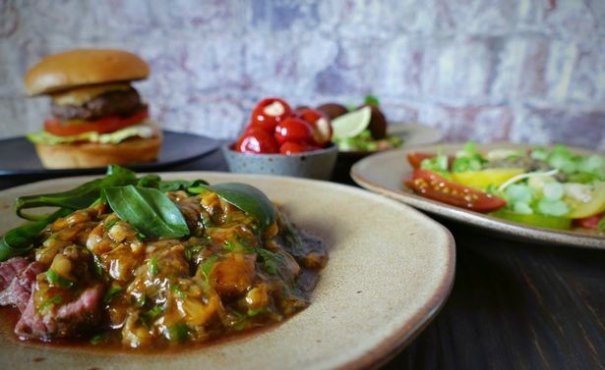

Hotel Trinity is a 4-star independent hotel on Swansea's shoreline in South Wales. The hotel caters to the general public, delivering food to customers throughout Swansea City. The hotel serves both main courses and wine pairings. According to the standards of South Wales as well as the United Kingdom, the hotel provides a restricted selection of servings at a reasonable price.
Vegan Statement:
Allergens may be present in certain of our foods, which our consumers should be aware of. Milk, fish, eggs, peanuts, and almonds have been designated as allergies by the law. Because some of our dishes use this ingredient, check to see if you are allergic to it before placing an order.
Hygiene Statement:
Vegetarians are taken into account in the Hotel Trinity's menu. Customers who order only pure vegetables have their orders taken into account as well. Customers should declare and be explicit about their requests as well as the type of dish that they require.
Calories per dish:
To avoid food illness, the hotel pays close attention to hygiene. It guarantees that its restaurant is clean, that the cooks are clean, and that the meals are prepared in a clean manner. Water is plentiful and has been treated before being consumed. This is done in accordance with UK and South Wales hotel hygiene regulations.
Hotel Trinity makes an effort to keep the calorie count in its dishes to a minimum. It encourages clients to order a substantial and regulated amount of food in order to keep their calorie consumption under control. Every dish has some fruits and vegetables, which help to reduce calorie intake.

Desserts
Chocolate Brownie Red Wine Truffles; the wine-grazed cream filled with cocoa morsels cheese as well as ice cream of your preference as a seasoning; allergens comprehend milk, chocolate, and Red wine.
Molasses with stewed pear dough; the menu includes three entire pear poached inside gingerbread dough incorporated with wine as well as served with ceylon tea; allergens include herb strawberry, chocolate, pear, roots, and wine.
Blackberry Sauvignon Cheesecake; spongy pastries with blackberry impregnated flavors and a blackberry on top; other covering options include plums, blueberries, and raspberries; red wine, berries, and milk are allergens.
The Sugar Mill's Broiled Black Chili Watermelon with Cocktails Cranberry Frozen Yogurt with peanuts and milk & Tia María Chocolate Syrup; allergens include milk, peanuts.
Caramel desserts are made by layering an uncooked cream on top of an unprocessed or lightly seared shell and baking them together. Eggplant dish, squash and chestnut, and sweet potato are among of the most popular options; allergens include egg, nuts.

D
Others Information
Availability of time: From Sunday through Saturday, Hotel Trinity is active and ready for takeout every day of the week. From 6 a.m. to 11 a.m., the hotel is open. Orders are taken from 6 a.m. to 8 p.m. This is the best time to place your requests, and they will be transported right away.
Information about how to contact us: Orders can be placed over the phone, via text messaging, or on the hotel's website. Orders should be placed by calling 0173215576. You can also go to our webpage www.hoteltrinity.uk.com. Orders placed over the phone or online are handled promptly, and we meet the needs of our customers.
Order fulfillment and payment methods: The hotel's employees take the meals to the customer's door. According to the Coronavirus concerns, this is attempted to avoid congestion and social distance monitoring. We deliver to areas in and around Swansea City, as well as the rest of South Wales. Items are distributed for free in areas near Swansea city. However, deliveries in remote areas of South Wales are made for a nominal price. Cash transactions are not required according to Covid 19 guidelines. The orders are paid for using the Shop's Digital wallet.
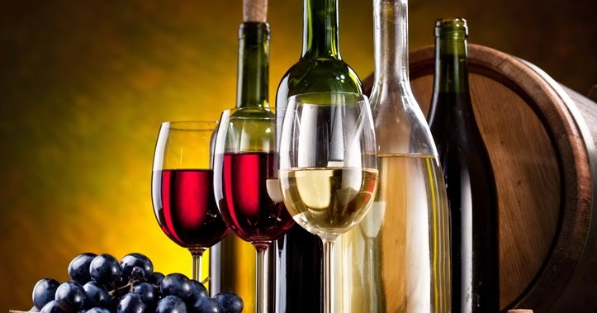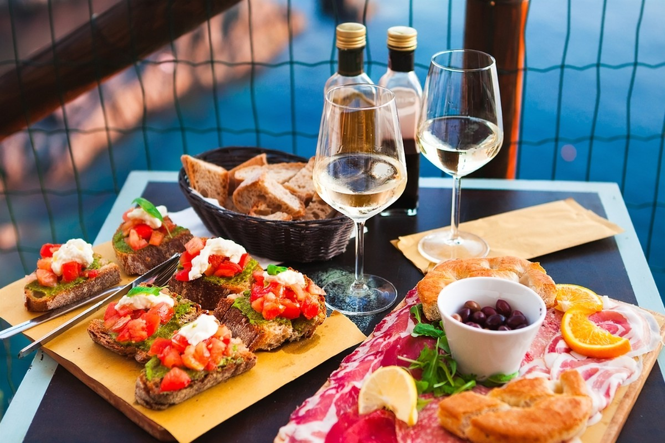
Beverage Menu
Beverages
Wine
Glaring Wine
Champagne £2.95
Cava £2.79
Prosecco £2.89
Medium red wine
Merlot £7.05
Grenache £6.99
Zinfandel £6.95
Sweet white wine
Malyasia £4.95
Moscato £4.95
Riesling £5.95
Drinks
Coca cola (diet/sober) 200 ml £1.95
Black Tea 200 ml £2
Orangina 350 ml £3
Tea
Lemon tea £1.85
Matcha £1.00
Coffee
Espresso con panna £3.95
Cafe au lait £2.95
Scorched arabic macchiato £2.99
Latte espresso with vanilla ice cream £3
Roasted arabica cappucino £3.95
Iced coffee £1.95

References
Almanza, B & Ghiselli, R (2016) Food safety. Apple Academic Press, Oakville, Ontario.
Antona, M & Stephanidis, C (2020) Handbook of research on entrepreneurship, innovation, sustainability, and ICTs in the post-COVID-19 era. 5th edn. Springer International Publishing, Cham.
Drysdale, J (2019) Restaurant food service equipment. Prentice Hall, Upper Saddle River, N.J.
Etcheverria, O (2020) The Restaurant, a Geographical Approach. John Wiley & Sons, Incorporated, Newark.
Meredith, M (2017) Menu making. IPC Magazines, London.
Secker, J, Boden, D & Price, G (2018) Restaurant starter menu. 2nd edn. Chandos, Oxford.
Smith, D (2015) Online Food Ordering System. Blackwell Science, London.

