Assignment 2: Professional Development Plan (PDP)
Digital Learning
Dan Field
2430604
Table of Contents
Assignment 2: Professional Development Plan (PDP) 1
Task 1 – Self-evaluation. 1
Personality Test 2 2
Personality Test 3 2
Personality Test 4 2
Task 2 – PDP. 2
Task 3 – Unit 4 topic summary. 3
Task 4 – Video presentation. 4

Task 1 – Self-evaluation.
Personality Test 1
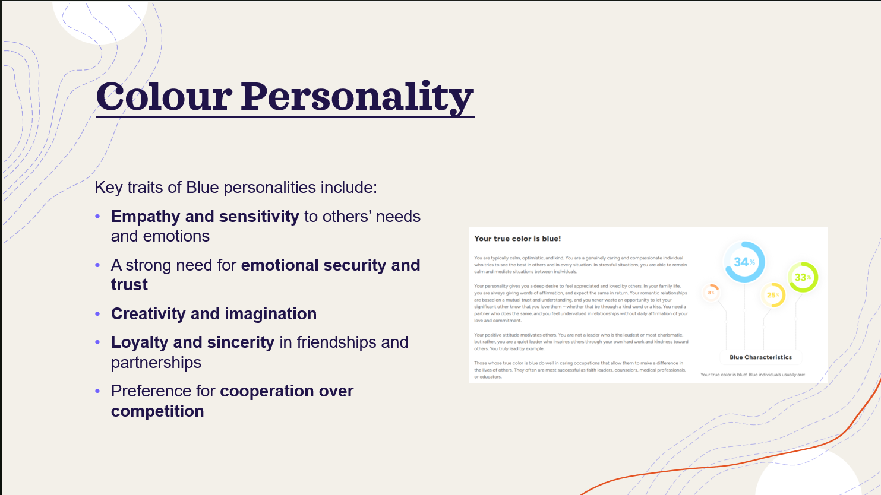
Personality Test 2
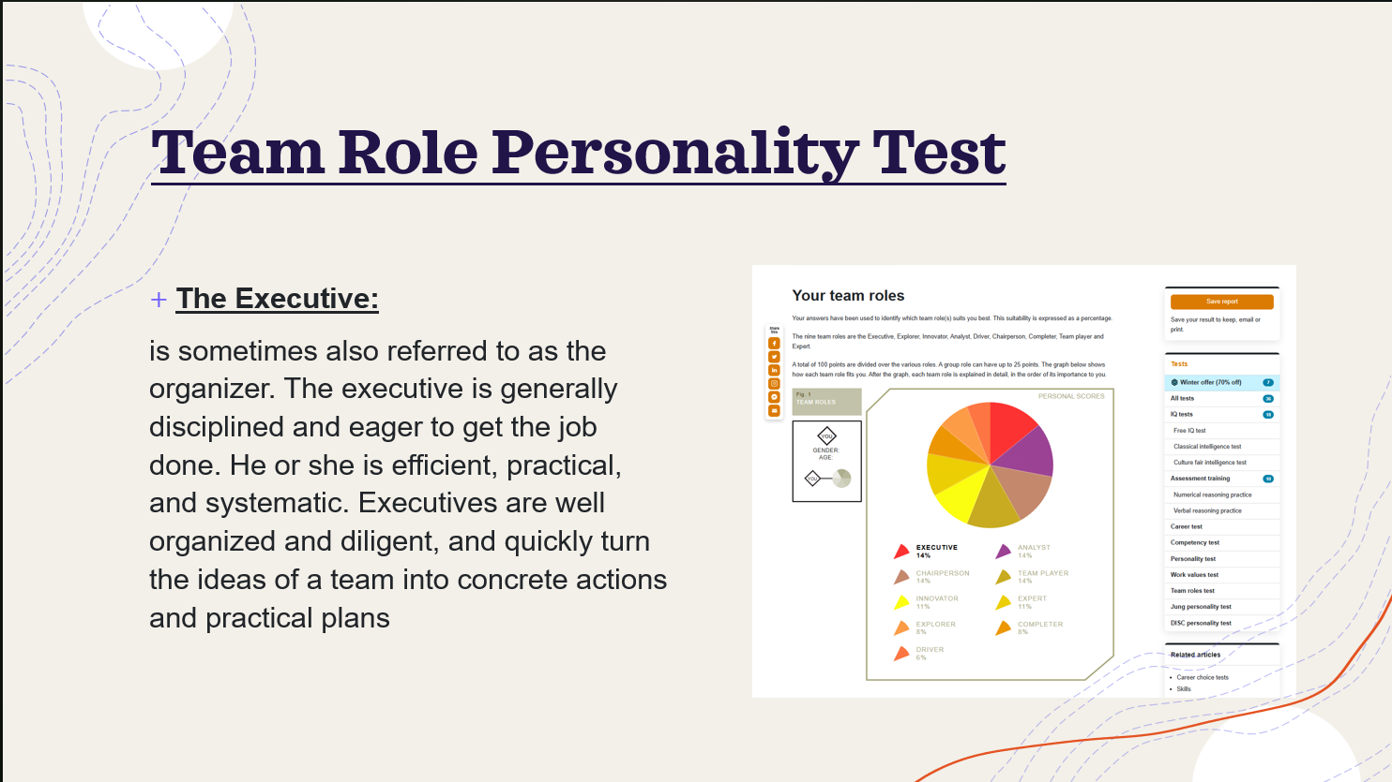
Personality Test 3
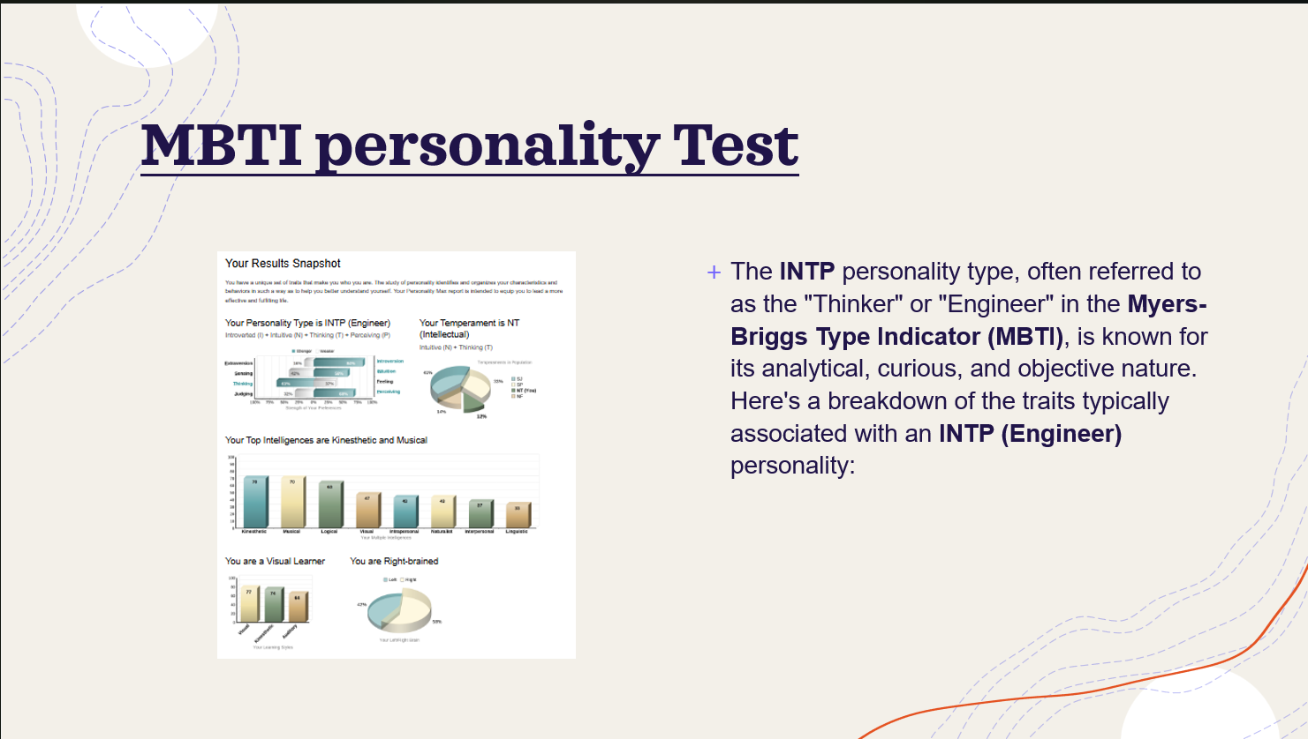
Personality Test 4
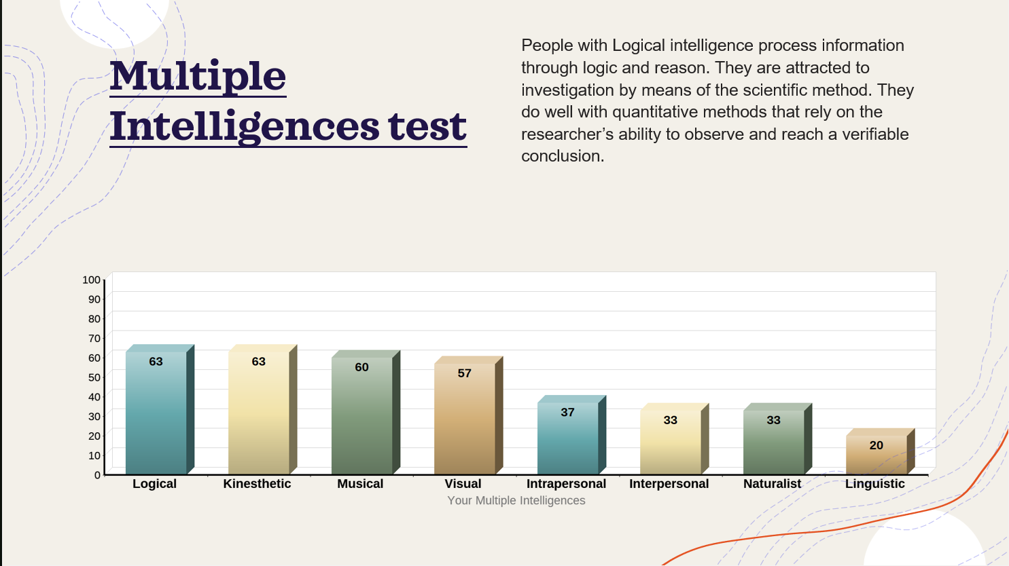
Task 2 – PDP.
1. A link to view/download the PDP from it’s cloud storage (e.g. OneDrive, google drive).
PDP.docx
2. A screenshot of the task answer from e.g. the PowerPoint or video presentation.
Task 3 – Unit 4 topic summary.
* A screenshot of the task answer from e.g. the PowerPoint or video presentation.

Task 4 – Video presentation.
- A link to the Video in its cloud platform (e.g. YouTube).
Video link = https://youtu.be/dFW9te4_PsE
- A single screenshot of the Video in its cloud platform (e.g. YouTube).
- A link to view/download the Presentation (e.g. PowerPoint file) from its cloud storage (e.g. OneDrive, google drive).
Assignment 2 Presentation.pptx

