Week 4 Assignment- Archaeology and Burial Practices
Burial sites can provide an archaeologist or historian with vital information about the society that commissioned it or the norms of that period. No matter where you look, from the pyramids of Giza to our own local cemeteries, the dead have been marked and memorialised throughout history; understanding how a society chose to celebrate their dead gives us an insight into the culture itself, their values and traditions. Sometimes what can be even more crucial in understanding the past are the graves that don’t fit the expectation or pattern. These burial sites can often provide information about those who stood out in this culture, either as a symbol of status above others, or as a sign of their criminal or unconventional life. In short, a grave can tell us not just about the person buried or marked there, but also about the society from which they came, and sometimes their rank within it.
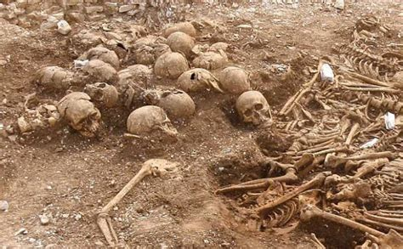
When looking at these sites, an archaeologist has to interpret what they see, to understand how it related to the past and what it can tell us; uniformitarianism is a way of doing this, by using the present to explain the past. Through mechanical processes that leave residue, an archaeologist can look for similar processes in the present, and use this contemporary evidence to explain the past. For example, we can identify a medieval grave through it’s similarities to our present ones, or recognise that the charred remains of bodies might be an early form of cremation. In more specific cases, we can compare the practices of neolithic settlers with those of current tribal communities that retain some similarities.
This grave site, found in Weymouth, UK, is a key example of an unconventional grave that provides an insight into the past. An archaeologist, even before the remains have been fully analysed, can make presumptions about this burial site, based on it’s location and knowledge of Christian practice: the united kingdom has, since the 7th century, been heavily Christian, and a typical Christian burial is orderly, marked with gravestones, and doesn’t include any ‘desecration’ of the bodies. We know the bodies were all decapitated and the skulls were “tightly packed in a variety of positions and orientations”. From this, an understanding can be gained that these individuals were not from Britain, and their burial in this way was meant to be a disrespect, leading to the assumption that they were invaders. Isotope analysis revealed them to be most likely Scandinavian, and so it was confirmed they were Vikings. This example of a Viking grave in a Christian country can tell us a lot about how the invaders were treated, and how even in death they were not treated with respect but thrown into a pit haphazardly. This kind of grave can also deepen our understanding of Viking culture, as a sample can be taken – being that 51 is a huge sample to use – and similarities between the bodies can help to extrapolate information about the society. For example, it was found that many of the skulls had teeth with filed marks from modification, suggesting that the action had a symbolic meaning to them, or was a sign of status or fashion. To better understand the meaning of this action, more samples from other sites would be needed.
Figure 1- Viking Burial Site, Weymouth
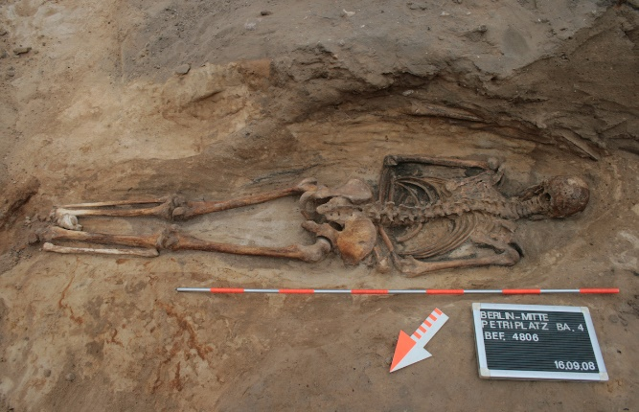
Christian burials tend to reveal a lot about the society, as often those deemed not a suitable part of the community received a different burial than others, making them stand out. For example, Andrew Reynolds found that in the Early Medieval period, criminals were often “located on administrative boundaries and buried in unusual positions, often prone”, revealing a lot about medieval society and it’s classification of criminals or ‘other’s as not part of their society in a way that deserved the same burial and respect. In some cases, archaeologists theorise that these graves are a result of superstition; it’s harder for a body to rise from the grave facing down: as bodies decay, muscles can sometimes move, when trapped air escapes it can be heard, making it seem as if the corpse is becoming reanimated. “In addition, prone position was believed to ward off epidemic diseases which would otherwise spread from the deceased to the living.”
Figure 2- Prone skeleton found in Sicily
To sum up, we can use a number of different techniques to interpret burial evidence, using contemporary societies as a reference for understanding past processes; the static records, such as the bodies and grave markers, can provide an archaeologist with invaluable insights into a society’s treatment of the dead and of the living. The aim of these individuals is using this static evidence to gain an understanding of the dynamics of the past – the how and why behind an action. Burial evidence is key to understanding any society, as it gives us a clear idea of what was important to that society, such as a Christian grave’s orientation towards the east; which, they believe, faces toward the direction of the prophesised second coming of Christ (has stirred up one from the east).

The Haskins Society Journal 25: 2013. Studies in Medieval History, Laura L. Gathagan and William North
Deviant Burial in the Archaeological Record, Eileen M. Murphy
Between belief and fear - Reinterpreting prone burials during the Middle Ages and early modern period in German-speaking Europe, Amelie Alterauge, Thomas Meier, Bettina Jungklaus, Marco Milella, Sandra L$\ddot{o}$sch
Bible Verse, Isaiah 42: 2

