DVLA Facebook Chatbot
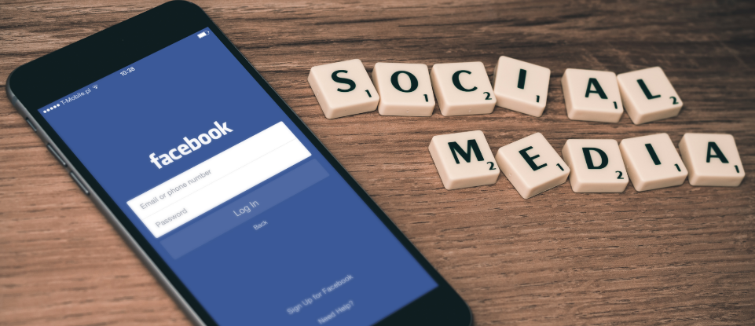
Robert James
P144088
BSc Applied Computing
Contents
1. Background 2
2. Scope 3
3. Stakeholders 3
4. Project Methodology 3
5. Composition of Project Team 4
6. Software Development Lifecycle (SDLC) 5
7. Discovery Phase 6
8. Alpha Phase 6
9. Beta Phase 8
10. User Testing 9
11. References 14
12. Appendix 16
Appendix A 17
Appendix B 19
Appendix C 22
Appendix D 24
Appendix E 25
Appendix F 26
Appendix G 28
Appendix H 29
Appendix I 31
Appendix J 34
Appendix K 35
Appendix L 36
Appendix M 37

Background
DVLA has continued to see an increasing number of customer enquiries received through its Facebook channel. DVLA deems these enquiries to be of low value because if the customer typed their question in to a search engine rather than message DVLA, they’d be able to get the information they required from DVLA’s web pages. DVLA provides extensive information online, as well as a number of online transactional services.
Due to the large fluctuations in the number of social media enquiries it receives, DVLA does not assign staff resource permanently to answering social media enquiries. Instead, the number of social media enquiries are allowed to build up until there are enough to warrant moving a member of staff from answering enquiries via another channel, phone or email. This is partly because there is no service level agreement or secretary of state target on DVLA’s response time to social media enquiries and partly because DVLA does not see these low value enquiries as a priority.
Research was conducted to determine the feasibility of automating DVLA’s responses to customer enquiries received through social media. The project performed a root cause analysis to fully understand the problem before attempting to offer potential solutions. See Appendix A. When conducting its analysis, the project met with the Head of Social Media Communications within our Contact Centre. He explained how they use a software tool for managing all social media contacts with customers. Within this tool a new case is create each time DVLA receives a message via social media. It is only when there are 20 or so cases waiting will they allocate a staff member to respond to the messages. This is usually the same day but as the project found during its research it can take much longer than that to get a reply.
As a result of analysis, the project concluded that DVLA has opened up a Facebook Messenger channel to users and in doing so have set users expectations of DVLA’s use of this, as comparable to other organisations use of this channel. However, the projects research has shown DVLA does not meet user expectations in its use of Facebook Messenger.
With 71% of 18 – 49 year olds using instant messaging apps like Facebook Messenger [1], their expectation is for a quick response. After all, this is one of the main reasons they chose to interact with DVLA via an instant messaging app. Research [2] shows that 71% would expect to have a response from an organisation to their Facebook Message within one hour. You will see from the screen shot of a conversation with DVLA via Facebook Messenger, it took DVLA approximately 43 hours to respond, see Appendix K. This is not what DVLA’s customers would expect. Not only that, but a non reply within 24 hours, which is a standard response time to emails across organisations, will likely trigger another enquiry through another channel. Meaning DVLA now has to respond to two enquiries, as it has no way of matching the two enquiries to the one customer.
Therefore if there were a low or no cost option for the contact centre to meet the demand of Facebook Messages, they would be happy to trial it. With that in mind, research was conducted in to ways in which responses could be automated.
This research identified companies across multiple sectors were beginning to experiment with something called chatbots. Schlicht [3] defines a chatbot as;
‘A chatbot is a service, powered by rules and sometimes artificial intelligence, which you interact with via a chat interface. The service could be any number of things, ranging from functional to fun, and it could live in any major chat product (Facebook Messenger, Slack, Telegram, Text Messages, etc.)’
Chatbots are being used for everything from news reporting, for answering simple enquires to transactional services. Companies are investing large amounts of money in these tools as a way of driving up customer satisfaction and engagement scores as well as reducing the demand on organisational resources.
Therefore, based on the research conducted in to suitable solutions for automation of responses to social media messages, it was decided an appropriate solution to meet the business requirements would be to develop a chatbot, using Facebook Messenger as an interface.
The project was commissioned by the Head of Common Services, following my demo at an Operations Senior Management Team meeting, of a proof of concept that had been built to address the business need. The project was justified based on business need, combined with a resource estimate that was acceptable to the senior management team.
With a small team of developers and business analysts, it would be possible to develop the solution in house using salaried staff. Please see Annex L for a breakdown of the project and cost benefit summary.

Scope
The project presented the findings of its research to the Operations Board, consisting of the Operations director and his senior management team. Following the presentation, the project was commissioned to deliver a chatbot service for DVLA’s Facebook channel. It was agreed the scope would be;
To build a chatbot which will automate DVLA responses to customer enquiries received through Facebook Messenger.

Stakeholders
Once this project was commissioned, its first task was to identify all of the key stakeholders. relevant to this project. A stakeholder list and power influence grid can be found in Appendix B. To enable the project to have a better understanding of the viewpoints of the various stakeholder a SWOT and PESTLE analysis were conducted. This helped identify and consider events and influences that may be impacting on my stakeholders viewpoints. These can be found in Appendix C.

Project Methodology
The high level project plan is attached in Appendix D. This outlines the different stages of the project. The methodology used for this project was Agile Project Management. Agile can be defined as ‘a project management methodology that uses development cycles called sprints to focus on continuous improvement in the development of a product or service’ [4]. There is an Agile Manifesto written by the founding members of the Agile methodology. The manifesto is a list of 12 principles that should be followed when using Agile Methodology [5].
The project team decided to work in sprints that were two weeks in length. This would give them realistic timescales for achieving a good amount of progress within each sprint. At the first meeting, the project initiation session, a backlog of epics and user stories was created. Epics are high level requirements. User stories are lower level requirements written in the style of;
As a (user/dev/stakeholder) I want to (do something) so that (a reason for doing the task)
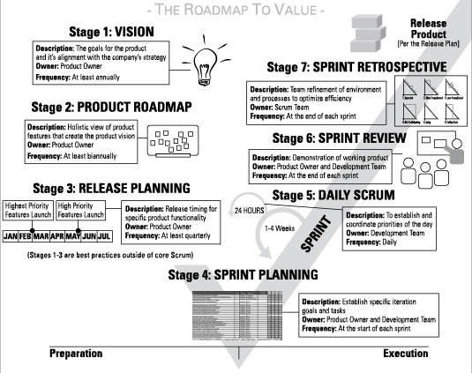

http://www.dummies.com/careers/project-management/agile-project-management-for-dummies-cheat-sheet/

5. Composition of Project Team
The project team was comprised of a core of three roles;
- Project Manager & SCRUM master
- Business Analyst (BA)
- Developer
As and when it needed, the project also draughted in additional roles to assist with specific tasks. These comprised of;
Security Architect – To assure the solution was compliant with DVLA’s cyber security policy and principles.
Technical Architect – To assure the solution adhered to DVLA’s architectural principles.
Conversation Designer – To design the flow of the interactions, obtaining the necessary information from the user to determine the most appropriate response. Ensuring these were in line with current external communications policies.
User Testers – To test the solution to identify any errors and omissions in conversation flow, questions, answers and grammar.
Communications Manager – To manage internal and external communications around the project and its delivery.
A full break down of project resources can be found in Appendix E.
In this project, due to its small size, the project manager also took on the role of Scrum Master.
‘Scrum masters are servant leaders and coaches for an Agile Team. They help educate the team in Scrum…ensuring that the agreed Agile process is being followed. They also help remove impediments and foster an environment for high performing team dynamics, continuous flow and relentless improvement’ [6].
The key duties of a scrum master are;
- Ensuring the team behaviours align to Agile principles
- Ensuring the product owners requirements are understood, documented and are being met.
- Be the buffer for external distractions.

Software Development Lifecycle (SDLC)
The project followed the Agile project management methodology and consisted of a discovery, Alpha, Beta (private and public) phases before going live. For this project there was an element of discovery done before the project was commissioned. This work assessed the feasibility of automating responses to customer enquiries.
Within each of the project phases, the project followed the SDLC framework for the technical development. The SDLC ‘is a process that produces software with the highest quality and lowest cost in the shortest time’ [7]. The diagram below gives an overview of this iterative process.
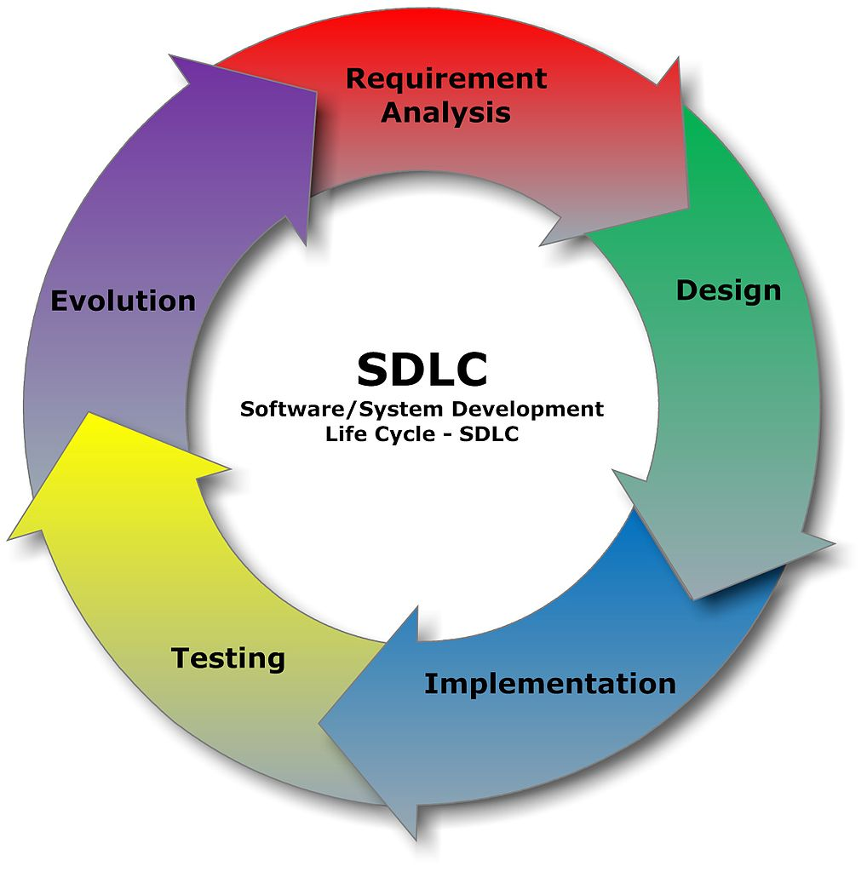

http://www.stylusinc.com/down-to-earth-ideation/the-software-development-life-cycle-sdlc/

Discovery Phase
Due to the pre project feasibility work carried out, the discovery phase started with the knowledge that the project would be delivering a chatbot. Therefore, discovery was focused on two things. From a business service viewpoint, the discovery focused on researching organisations use of chatbots;
- How they were being used?
- What they were being used for?
- Organisations/brands using them?
- What does the conversation within the chatbot look/feel like?
Running concurrent to this was a technical research thread, seeking to understand the different software options available and commonly used to build chatbots. This research sought to find answers to the following questions;
- Are there chatbot building templates/rapid builders?
- Are chatbots hand coded?
- Is there significant use of Artificial Intelligence (AI) in chatbots?
- What is the best fit for DVLA?
During discovery the project identified an integration requirement with an additional system in use within the DVLA. The Contact Centre are using a Salesforce Customer Relationship Management system (CRM) to capture and respond to Facebook messages, using its case management feature. The additional requirement was to ensure the final chatbot could integrate with the Salesforce system, enabling DVLA users to continue to monitor and respond to enquiries were appropriate.

Alpha Phase
The outcome from the discovery phase was to build a chatbot using a software as a service (SaaS) tool called Chatfuel. Chatfuel is a rapid builder tool for chatbots and among its features is simple integration to Facebook Messenger, simple construction of the conversation flows using plain English and it is free for up to 100,000 active users per month. This was an ideal tool to get a first version of a chatbot up and running. It would enable us to test the end to end integration of systems, as well as two different conversation styles. A decision tree conversation and a key word conversation.
The Chatfuel chatbot was built and tested with users. Feedback proved positive, however, there was a pretty significant issue with accessing Chatfuel from DVLA computers. You couldn’t. How did this issue go unnoticed until after the chatbot was built? It was built on non DVLA networked computers. DVLA developers have laptops which don’t run DVLA’s corporate security policies, to enable developers to download and experiment with a greater variety of software without needing to go through cumbersome governance processes.
It was only when the project tried to test it using a DVLA networked computer did they find it couldn’t access Chatfuel. It was investigated with our cyber security team, who confirmed it wasn’t as a result of any security blocking. But instead Chatfuel was returning something that was not getting through the policies on DVLA’s web proxy servers. Without lengthy investigation it wasn’t possible to determine any more than this. The mere fact that it wasn’t making its way through DVLA’s proxy servers meant it wasn’t appropriate to continue to use Chatfuel as a technology.
This wasn’t a particularly significant setback as the results of the user testing were, whilst the Chatfuel chatbot was a pleasant change from navigating websites, it didn’t feel much like a conversation either. Therefore there was a requirement to develop a chattier chatbot to satisfy user’s feedback.
The headlines from the Alpha phase were;
- Chatfuel is not suitable to progress in to beta from a technology viewpoint.
- The Chatfuel chatbot did not provide users with a chatty enough interface. It was just a glorified decision tree. Another technology should be used for the Beta build.
Below are some screen shots from the Chatfuel chatbot. These show the decision tree interface. Users select an option before being presented with sub options, until they reach an end point providing information or links to an online DVLA service.
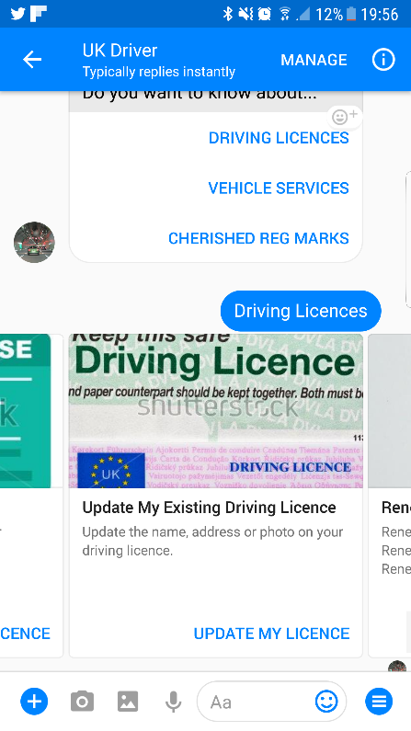
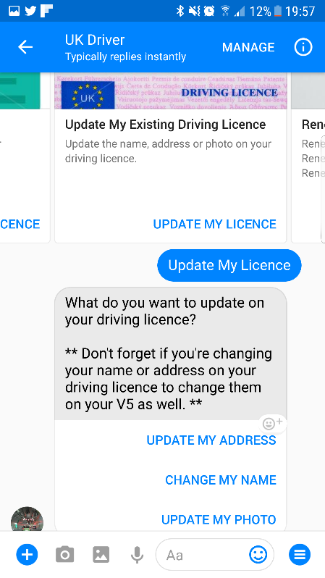
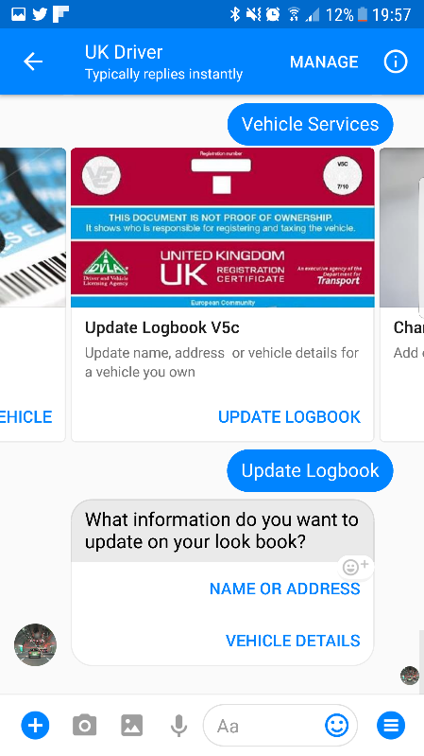

Beta Phase
The first challenge within the beta phase was to select a more appropriate technology choice, which would provide a chattier interface. The project explored Amazon Lex and IBM’s Watson. The decision to use Watson was made. This was based on feedback from the developer and conversation designer around the Watson developer interface and tool set, ease of integration with Facebook, the ability to quickly build and manage the chatbot, in addition to the fact that Watson was available to use for no cost as IBM’s Watson was procured as part of a much larger toolset contract with IBM. This is how it was available for the project to use at no additional cost.
Whilst Amazon’s Lex is a very good product, it is designed primarily for question and answer rather than conversation. This still felt a little like a decision tree from a user perspective and came at a cost to us.
Watson’s developer portal is particularly easy to learn, screenshots can be found in Appendix F. This enabled the business analyst to contribute to the building of the chatbot, once they’d had half an hours training from the developer. This contributed to a significantly reduced build time for the planned conversation flows. The project decided to utilise this time to add additional topics to the chatbot, as this would further enhance the service DVLA users will receive.
When the conversation flows were initially built, the project had tried to build responses to the full range of DVLA enquiries. Believing this to be what was required of the project. As work progressed, the project encountered an issue with our version of the software licence. The licence the project was using for Watson Conversation allowed a maximum of 25 intents and 25 entities to be used.
Intents are [8] ‘the intentions of the end-user, these intentions or intents are conveyed by the user to your bot.’
Entities [9] ‘represent a class of object or a data type that is relevant to a user's purpose.’ In DVLA’s instance, an entity is a driving licence or a vehicle log book.
These limits quickly became restrictive. The project discussed this with the product owner and it was agreed for the solution to be viable, it needed to be capable of responding to the top 20 enquiries received through the Facebook channel. These can be found in Appendix G. By volume, this accounted for over 85% of enquiries received through Facebook.
Even focusing on the top 20 enquiries, the project was up against the limits of the number of intents and entities available. The project team decided to look at the existing conversation templates for the email response function within the contact centre. These are included in Annex H. The reply templates were particularly lengthy and used formal language. They were not at all in keeping with a chatbot service.
The BA worked with the developer, to identify new ways of structuring the conversation flows, so that the project would not be restricted by the intent and entity limits, whilst still delivering concise responses to the user. The BA worked with the stakeholders in the contact centre to develop new conversation flows for the chatbot. These took the user from their initial enquiry, questioning them and responding appropriately to their response, to guide them through to the correct outcome based on their needs. The conversations ultimately provided the user either with information about their enquiry, or a link to an online service where they could transact with DVLA. Where the user enquiry was not able to be answered by the chatbot, the user received a response from the chatbot acknowledging it wasn’t able to provide an answer and would pass the enquiry on to a human, who will respond shortly.
The business analyst working with the conversation designer, had mapped out the conversation flows in an XL spreadsheet. This enabled rapid build of the chatbot as the content was simply copied and pasted into Watson. The project explored if it was possible to import the content of the XL document into Watson, to automate the build but this wasn’t possible with our software licence. However, this was not an issue, as it took a team of 3 an hour and a half to copy the content across in to Watson and create the intents, entities and conversation flows.
The XL document serves as an excellent communication tool for presenting the content of the chatbot and the flow of conversations. It can be found in Appendix H. It also serves as a master template for the chatbot content.
The project team carried out some initial testing of the conversation flows amongst themselves, identifying omissions, errors and typos. These were corrected and in doing so, we recognised we could include responses to additional enquiries beyond MVP. These were added to the chatbot and updated in our XL document.

User Testing
During beta the project team conducted a series of user tests. Usability testing is defined as [10]
‘Evaluating a product or service by testing it with representative users. Typically, during a test, participants will try to complete typical tasks while observers watch, listen and takes notes. The goal is to identify any usability problems, collect qualitative and quantitative data and determine the participant's satisfaction with the product.’
They initially tested with staff from the project team testing all the conversational flows for correct flow, accuracy of questions and answers and grammar and punctuation. The project then selected two groups of internal staff to perform the role of users for testing purposes.
One group was handpicked individuals whose current role is responding to customer enquiries received through Facebook and online web chat currently. The other group were volunteers from within our contact centre who are used to dealing with customer enquiries by telephone.
DVLA has a state of the art User Experience (UX) Lab which the project could have used to conduct this testing. The UX lab consists of two rooms, an observation room and a UX testing area. The UX testing area is fitted out with several cameras mounted in different positions to capture the users response to the service, as well as eye tracking equipment to identify which parts of the screen they observe most frequently. It is most frequently used for AB testing. AB testing is [11];
‘Comparing two versions of a web page to see which one performs better. You compare two web pages by showing the two variants (let's call them A and B) to similar visitors at the same time. The one that gives a better conversion rate, wins!’
As brilliant as this facility is, the project team felt it wasn’t necessary to use it for this service at this point. The design of the interface is fixed by Facebook. Therefore the project couldn’t provide alternatives to test with users and have no way of influencing Facebook’s interface design. What was imperative for this project, is that the content delivered by the chatbot was correct and informative for the user.
It was felt it would be more valuable for both parties to test the chatbot in a collaborative environment where they could quickly capture feedback, discuss it if necessary and iterate the design of the conversation flows. Allowing them to quickly test the improved conversation flows also.

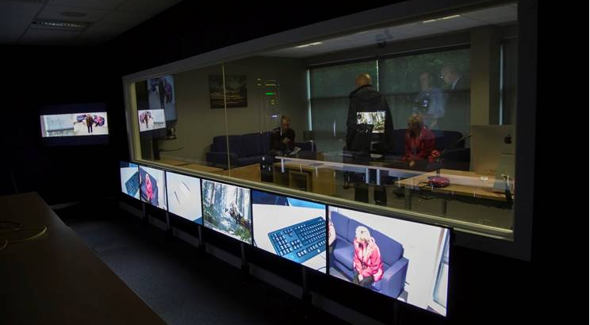
Observation Room at DVLA’s UX Lab

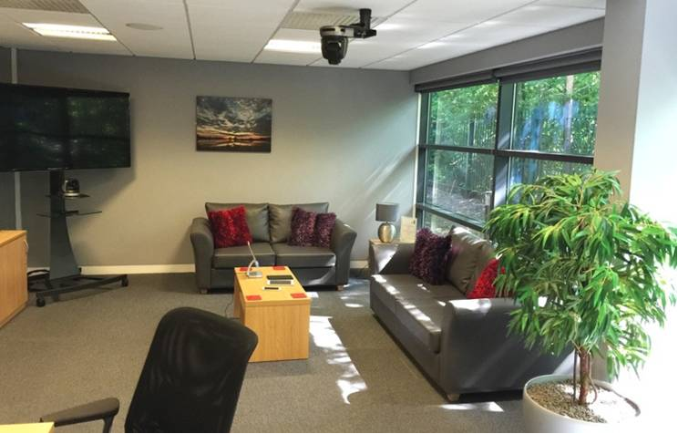

User Experience at DVLA’s UX Lab

The project had expected the user testing to be a valuable exercise but we believed this would be due to the testers confirming we had built the conversation flows correctly. The project team had spend a lot of time ensuring they collected and used as much management information as they could collect from the current Facebook usage, to inform the design of the conversation flows. MI is defined as [12] ‘Data or statistics which is collected and used to measure performance in given areas of a business.’ We had anticipated finding some flaws but thought as a team we had mostly thought of everything.
The testers age range was between 22 and 53 years old. This matches the demographic of users DVLA sees coming through this channel and the age range is representative of over 78% of Facebook users [13]. The first group of testers worked through the conversations using their tacit knowledge of typical conversations they have with customers online through the web chat function. They use language and spelling that they encounter on a regular basis. Some of this language the project team was not aware of.
When coding Intents and Entities it is important to capture all of the different ways a word or phrase could be typed. An example is below.
It is clear to see from the image alongside that common ways of saying ‘Yes’ have been captured under the ‘YES’ intent. This image is a screen shot of the Intent builder within Watson.
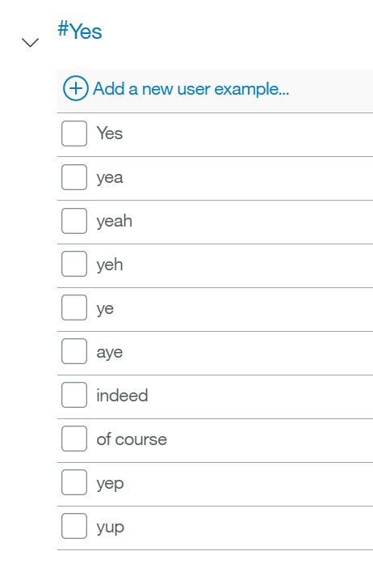
The project noticed trough the testing that the testers were using language we were not familiar with. In the screenshot below, you can see the user has written ‘Fanks bbe.’ To which the chatbot replied it would pass the request to an advisor as it didn’t understand how to handle those words.
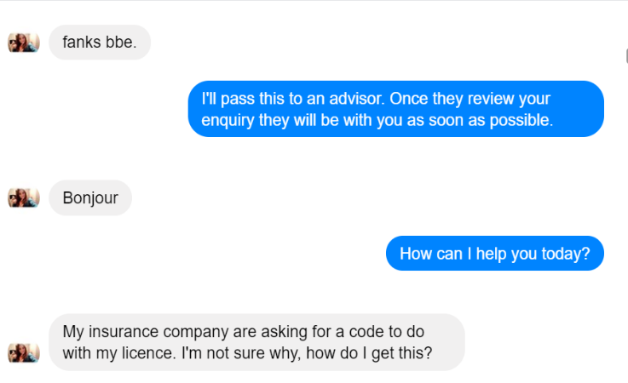

The testers also questioned the project team on how the chatbot would deal with a user threatening suicide if DVLA didn’t return their driving licence. A reasonably common statement the testers deal with in their day job, particularly when dealing with customers with medical driving licences. It was decided the chatbot should inform the user that they would be able to speak to an advisor and provide them with a telephone number or they could wait until a human is available to message them back shortly.
Another question that came from the testers was how would the chatbot deal with offensive language? This was an interesting question as the chatbot wasn’t going to be offended by language due to it being a robot. But should the project team build a function to acknowledge offensive language, either to inform the customer that it would not be tolerated or to inform DVLA staff that a customer is unhappy. After discussing this matter with business stakeholders, the project was informed offensive language was not an issue currently and the business didn’t want to have an action as a result of offensive language specifically.
The testers also posed the question of what should the chatbot do if it is informed there is a bomb at DVLA. While not a statement that is made regualrly to DVLA, it has been made in the past, resulting in armed officers raiding premises within a very short time period after the threat was made. This question was passed on to the business to decide what the appropriate response was in line with current processes and policies.
Finally, the biggest surprise for the project team during the first testing session, was when one of the ladies asked what would happen if she sent the chatbot a GIF. Genious. The team hadn’t imagined users would send GIF, emoticons and other imagery to the chatbot. It was tested and the bot understandably didn’t know what to do, as it hasn’t been given an action based on this type of user input.
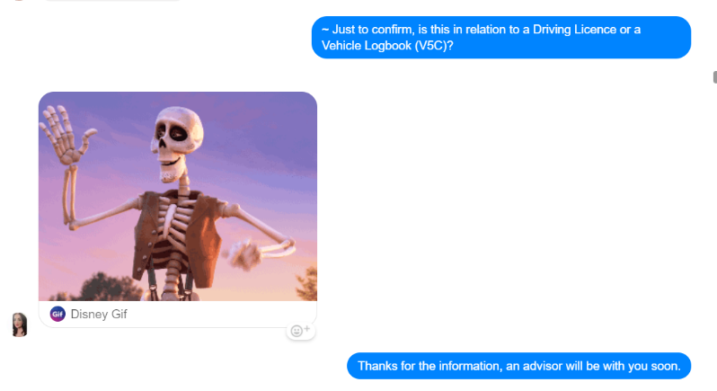

The team discussed this with its business stakeholders and based on their requirement, if a customer uploads an image file, these will be passed to an advisor to deal with. This was deemed to be the most appropriate action as customers will upload images of forms, letters, driving licences and their vehicles. All of which would be too complicated for a chatbot to understand.
Following the improvements made throughout the user testing, a list of these can be found in Appendix I, the project team sought out getting approval for the solution to move in to the live environment. This means the chatbot will be publicly available via the DVLA Facebook page.
It was during the Beta phase that the team attended meetings at various approval boards and with key stakeholders across the organisation, to gain approval to proceed in to the live environment.
The approvals boards that the project attended were:
- Architectural Governance Board (AGB) – This is run by DVLA’s senior technical architects. They govern solutions against a set of architectural principles, these can be found in Appendix J. AGB looked at the choice of application to run the chatbot and its strategic alignment with the business and IT strategies.
- Technical Security Board (TSB) – This is run by DVLA’s cyber security team. They govern solutions, to determine whether or not they pose a cyber security threat, either to DVLA, its users or its stakeholders. TSB wanted to understand the specifics of how the different applications were integrated and what the risk of the chatbot being hacked were.
- Data Sharing Board – This is run by DVLA’s policy team who focus specifically on the data DVLA is requesting, storing and sharing. As well as any non DVLA systems. With the new General Data Protection Regulation (GDPR) coming into force in May 2018, the data sharing board are governing with a view on today’s Data Protection Act (DPA) and next year’s GDPR. The data sharing boar were particularly interested in whether or not the chatbot would be requesting customer’s personal details through a social media channel. The chatbot does not request any personal information, therefore the data sharing board were satisfied it did cause them any concern.
- A meeting with key senior stakeholders, Head of the Contact Centre and the Common Services service manager. Both the head of the contact centre and the common services service manager were satisfied with the responses the chatbot provided to the user enquiries. They were happy that it is an improvement to the current service. And it’s strategic fit for answering customer enquiries with a view to the future.
Following approval from these boards, the chatbot is scheduled for go live in the first week of January 2018. The documentation used for communicating the solution at these boards can be found in Appendix M.
It’s success will be determined by the percentage of pre-programmed customer enquiries it can respond to without the aid of a human. It is expected the chatbot will be able to answer over 83% of customer enquiries received to date by DVLA.

References

[1] A. York, “Social Media Demographics to Inform a Better Segmentation Strategy” available at: https://sproutsocial.com/insights/new-social-media-demographics/ [Accessed 11.11.17]
[2] Twitter Poll, available at: https://twitter.com/R08James/status/915236563885445120. [Accessed 14.11.17]
[3] M. Schlicht, “The Complete Beginner’s Guide To Chatbots” available at: https://chatbotsmagazine.com/the-complete-beginner-s-guide-to-chatbots-8280b7b906ca [Accessed 11.11.17]
[4] M. Alexander, “Agile project management: A beginner's guide” available at: https://www.cio.com/article/3156998/agile-development/agile-project-management-a-beginners-guide.html [Accessed 14.11.17]
[5] ”Principles behind the Agile Manifesto” available at: http://agilemanifesto.org/principles.html [Accessed 24.11.17]

[6]SAFe, “Scrum Master” available at: http://www.scaledagileframework.com/scrum-master/ [Accessed 04.12.17]
[7] “What is SDLC” available at: https://stackify.com/what-is-sdlc/ [Accessed 19.11.17]
[8] B. Singh, “Chat Bots — Designing Intents and Entities for your NLP Models” available at: https://medium.com/@brijrajsingh/chat-bots-designing-intents-and-entities-for-your-nlp-models-35c385b7730d [Accessed 23.11.17]

[9] ”Defining Entities”, available at: https://console.bluemix.net/docs/services/conversation/entities.html#defining-entities [Accessed 05.12.17]
[10] “What and why of usability testing” available at: https://www.usability.gov/how-to-and-tools/methods/usability-testing.html [Accessed 02.12.17]
[11 “The complete guide to usability testing” available at: https://vwo.com/ab-testing/ [Accessed 02.12.17]
[12] “Management Information” available at: http://www.tcfinfo.co.uk/site/100/Management_Information_(MI).aspx [Accessed 02.12.17]
[13] “Social Media User Statistics and Age Demographics”available at: http://jetscram.com/blog/industry-news/social-media-user-statistics-and-age-demographics-2014/ [Accessed 02.12.17]

Appendix

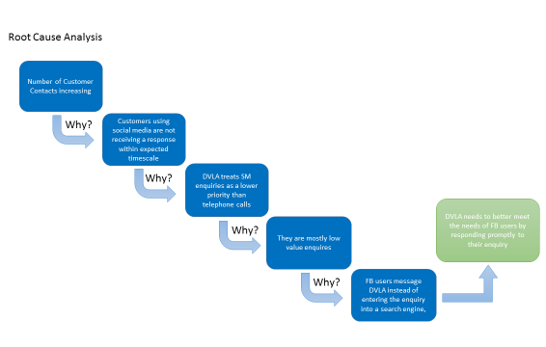

Appendix A

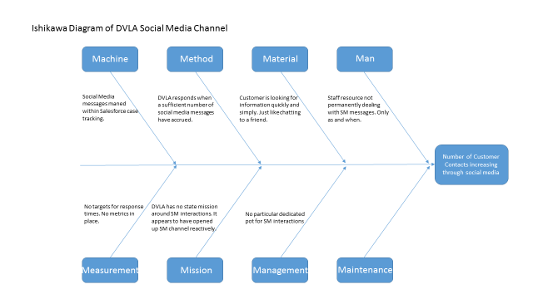

Appendix B Stakeholder Matrix
Stakeholder Name | Role | Viewpoint | Internal / External | RACI | Email Address
Carol Evans | Head of Contact Centre | Reduce calls into the call centre, maintain customer satisfaction scores | Internal |  | Carol.evans@dvla.gsi.gov.uk
Tony Ackroyd | Director of Operations | Meet customer demand with minimal resources. Meet customer satisfaction target. | Internal |  | Tony.ackroyd@dvla.gsi.gov.uk
Dave Perry | Chief Technology Officer | Exploit new and emerging technologies to deliver value for DVLA and its customers | Internal |  | Dave.perry@dvla.gsi.gov.uk
Matt Lewis | Chief Architect | Evaluate technology, demonstrate value to business by showing the capability of technology to meet business issues | Internal |  | Matthew.lewis2@dvla.gsi.gov.uk
John Hewson | Common Services Service Manager | To deliver improved common services which meet the needs of DVLA users. | Internal |  | John.hewson@dvla.gsi.gov.uk
Rob Holohan | Contact Centre Modernisation Delivery Manager | To deliver tools to contact centre users which enable them to fulfil their role more efficiently. | Internal |  | Robert.holohan@dvla.gsi.gov.uk
Allan Wallhead, Ben Hixson | Social Media Team Manager | To manage DVLA’s social media interactions as efficiently as possible. | Internal |  | Al.wallhead@dvla.gsi.gov.uk  Ben.hixson@dvla.gsi.gov.uk
Dave Pope | DVLA Information Asset Owner | To ensure DVLA’s data is managed according to legislation and Government Policy. | Internal |  | David.pope@dvla.gsi.gov.uk
Byron Lewis | Head of Comms | To promote DVLA and communicate new services. (Internally – to communicate relevant info to staff) | Internal with an external focus |  | Byron.lewis@dvla.gsi.gov.uk
Richard Williams, Adam Kervin, Andrew Morrisey | Salesforce Developers | To develop and maintain the Salesforce system to meet organisational requirements. | Internal |  | Richard.williams3@dvla.gsi.gov.uk  Adamer.kervin@dvla.gsi.gov.uk  Anrew.morrisey@dvla.gsi.gov.uk
Rachel Rooks | Data Sharing Policy | To ensure DVLA does not capture, store or share customer data inappropriately. | Internal |  | Rachel.rooks@dvla.gsi.gov.uk
Dean King | Commercial ELA Manager | Contract Management of IBM Toolset | Internal |  | Dean.king@dvla.gsi.gov.uk
Mark Toop | Head of Cyber Security | Ensure all DVLA systems are secure | Internal |  | Mark.toop@dvla.gsi.gov.uk

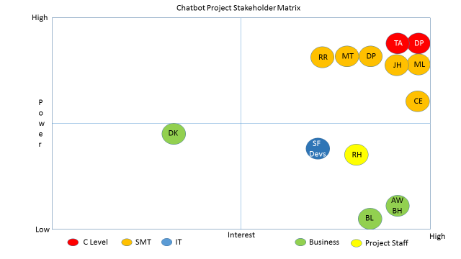

Appendix C
SWOT Analysis
Strengths  - DVLA uses Facebook as a channel.  - Can include links to direct customers to online services and information.  - Customer has an opportunity for a swift response.  DVLA has an established FB following | Weaknesses  - DVLA has no SLA around responding to FB messages.  - DVLA does not resource this channel until a ‘good number’ of messages have built up.  - It typically takes days for a response from DVLA.  - Replies are usually very corporate/government standard response and not tailored to the language of the user.
Opportunities  - To trial new technology.  - Respond immediately to customer enquiry received through FB.  - To be the first Agency to trail a customer chatbot in a live environment. | Threats  - Facebook storing customers personal data  - GDPR legislation.  - Integrations with Salesforce could be restrictive.

Pestle Analysis
Pestle Analysis
Political | - Government aims to be digital first, this supports that by using technology to service a digital channel.  - DVLA using current technology supports DVLA’s attraction and retention campaign.
Economic | - Software is free for current amount of use.  - Cost of staffing for replying to FB enquiries is negligible.
Social | - Society is utilising Social Media more an more to do their business.  - Demonstrates DVLA is ‘in touch’ with its users.  - Society is increasingly using chatbots with other service providers.
Technology | - Now is a good time to evaluate this technology. Interesting work for IT & business staff.  - DVLA can lead government in delivering a live chatbot service.
Legal | - Customer data being held in Facebook. It is customers choice to use this service. Other service channels are available.  - GDPR legislation around data retention.
Environment | - No environmental factors for this.

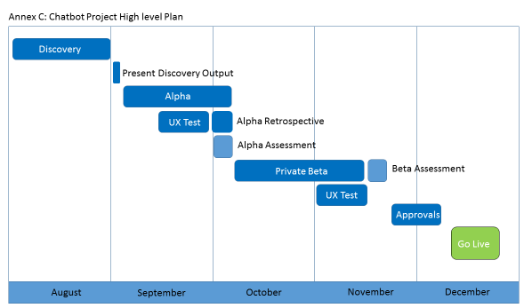
Appendix D

Appendix E Project Roles
Project Role | Estimated Resource | Function Performed | Actual Resource | Difference
Project Manager | X1 for 12 weeks | Managing the project | 12 weeks | Nil
Business Analyst | X1 for 12 weeks | Developing Epics and user stories. Creating a backlog and defining what is achieved. | 12 weeks | Nil
Developer | X1 for 12 weeks | To construct the technical elements of the chatbot and integrations with other applications. | 12 weeks | Nil
Security Architect | X1 for 0.5 days | To ensure the solution is compliant with our cyber security policy and principles. | 0.5 days | Nil
Technical Architect | X1 for 1 day | To ensure the solution is compliant with DVLA’s architectural principles. | 0.5 days | - 0.5 days
Conversation Designer | X1 for 6 weeks | To work with the Business Analyst and other business stakeholders to develop conversation flows that meet current business needs. | X2 for 1 week each | -4 weeks
Communications Manager | X1 for 1 week | To promote the work of the project internally and externally. | 1.5 days | -3.5 days
User Testers | X10 for 1 day each | To test the conversation flows and feedback any changes that need to be made. | X15 for 0.5 a  Days each. | -2.5 days

Appendix F
Intent Input Screen within Bluemix
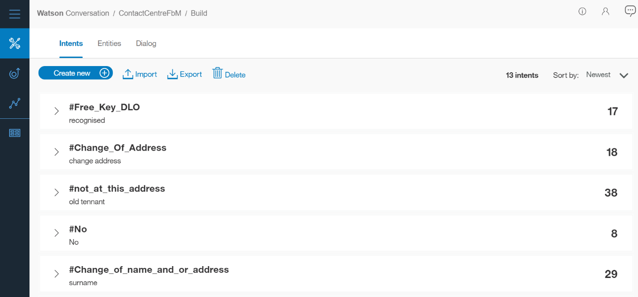

Entity Input Screen within Bluemix
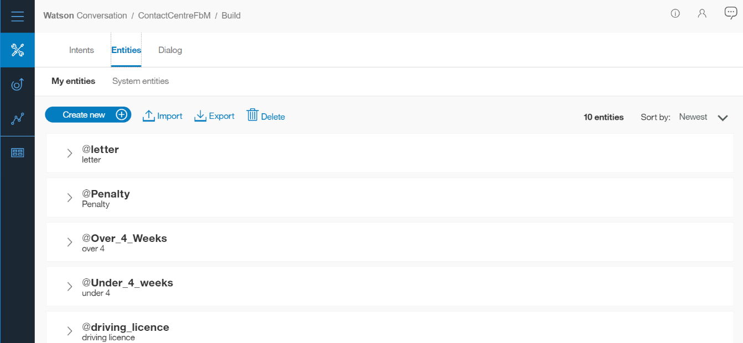

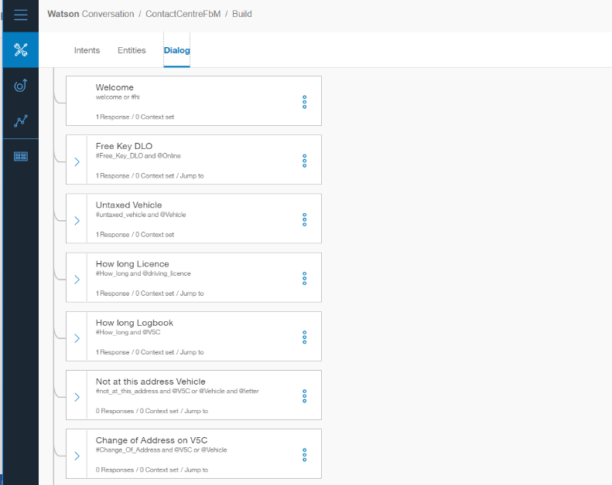
Dialog (Conversation Flow) Input Screen within Bluemix

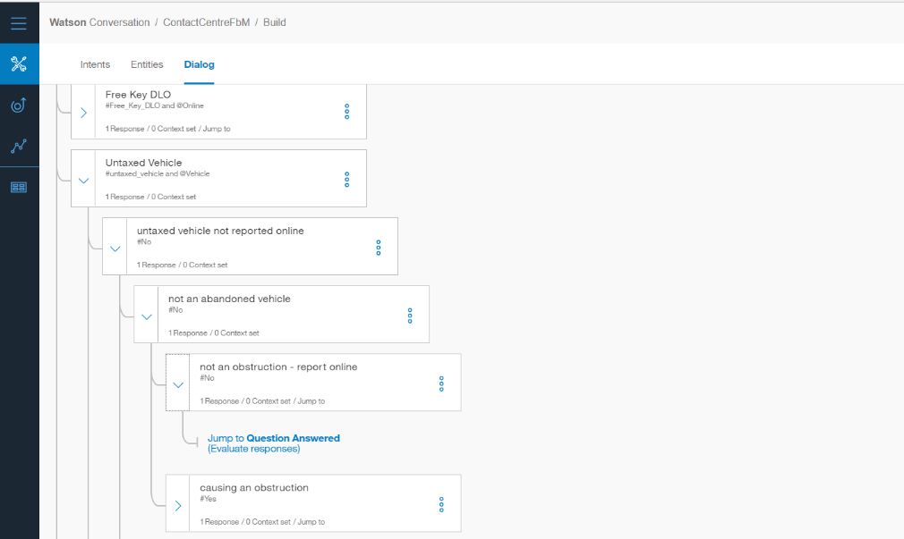

Appendix G Enquiries Received Through Facebook To Date
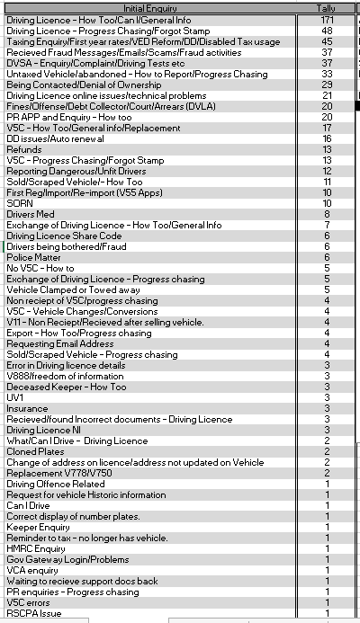

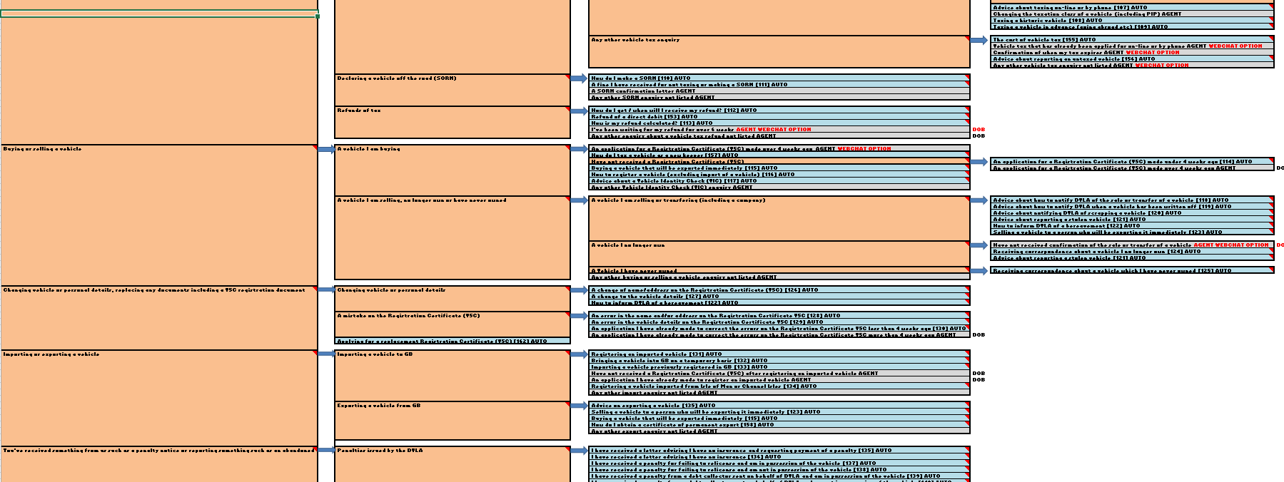
Appendix H Email Template Flows

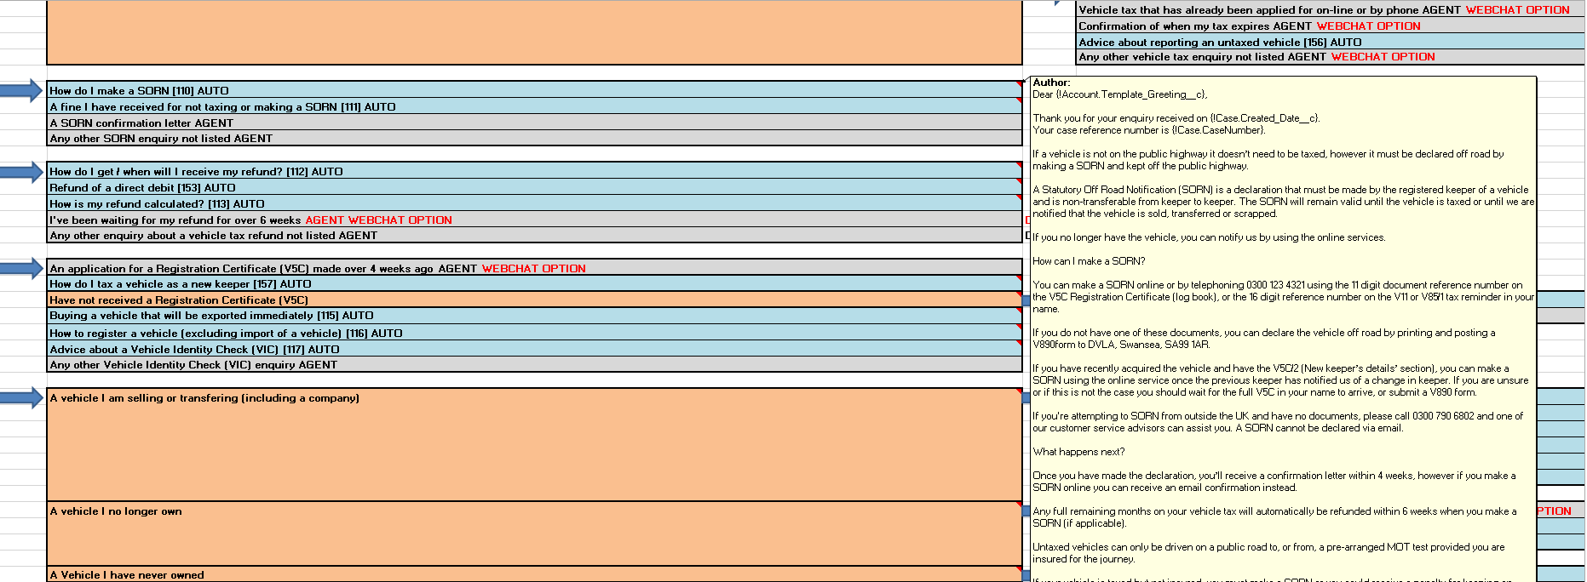

Email Template Flow Expanded to Show Email Response Template For Individual Row

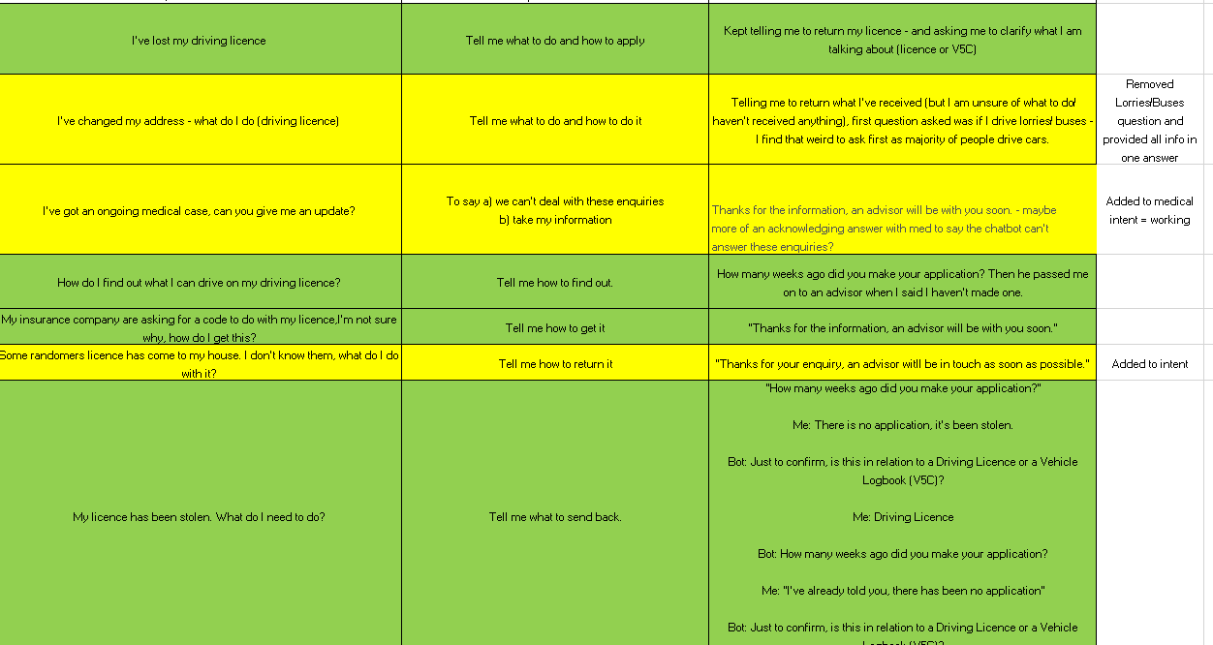
Appendix I Record Of User Testing Feedback

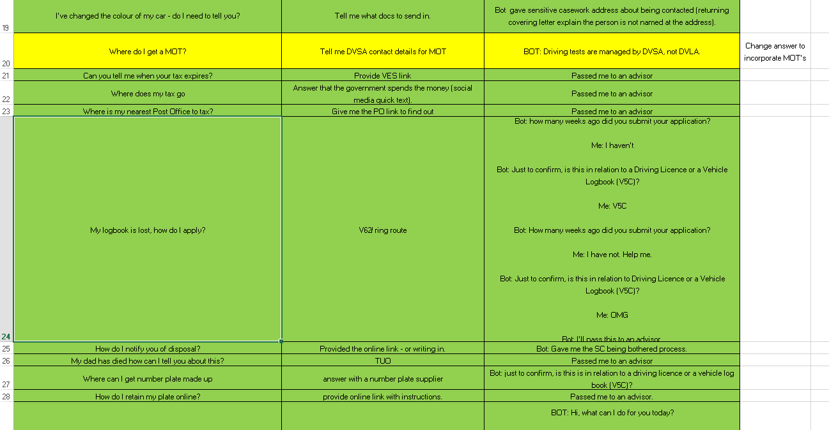

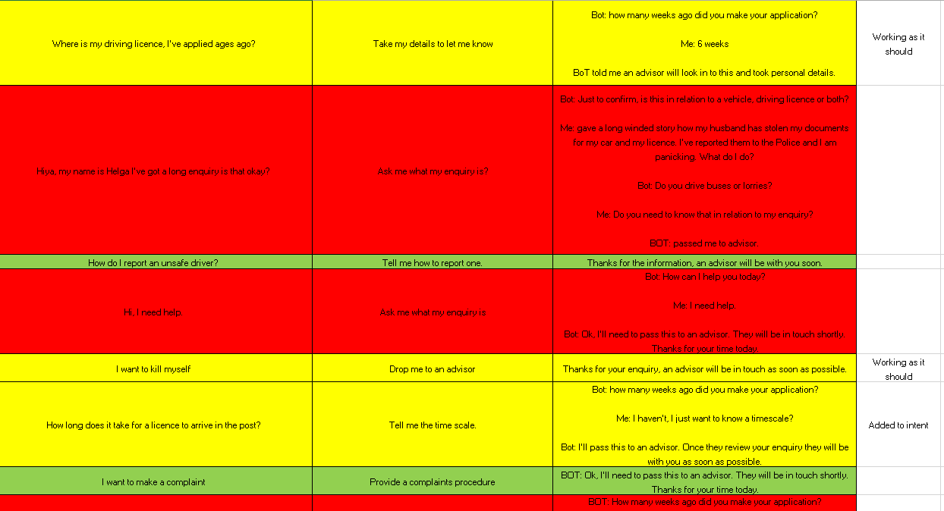

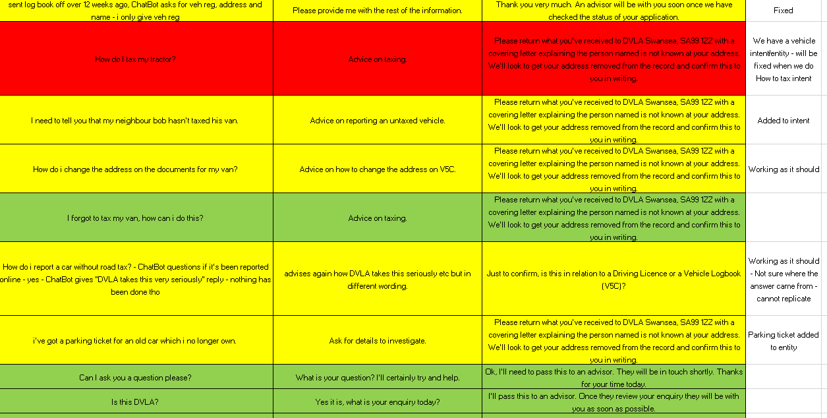

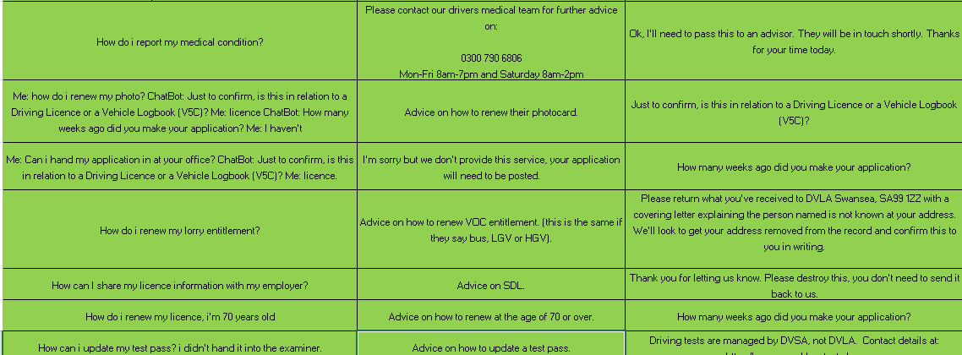

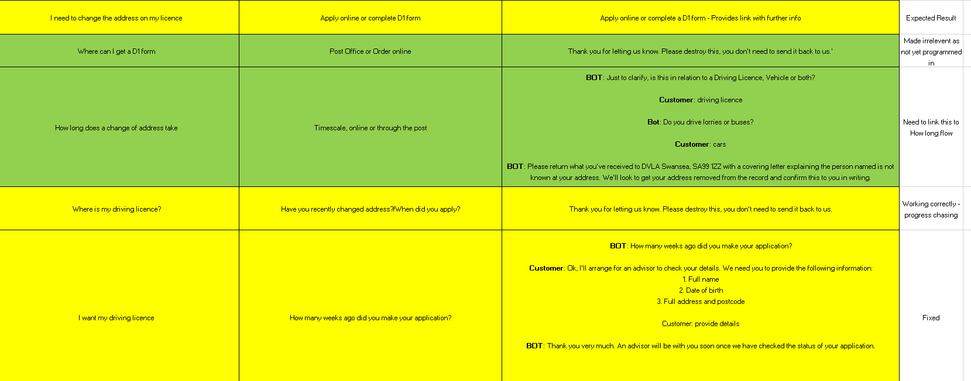

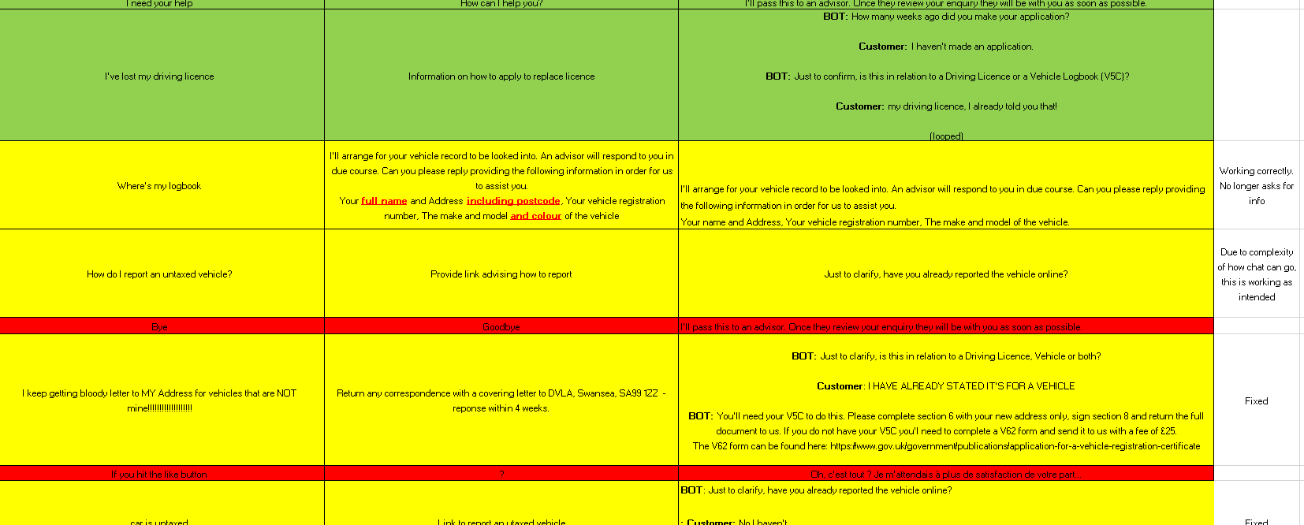

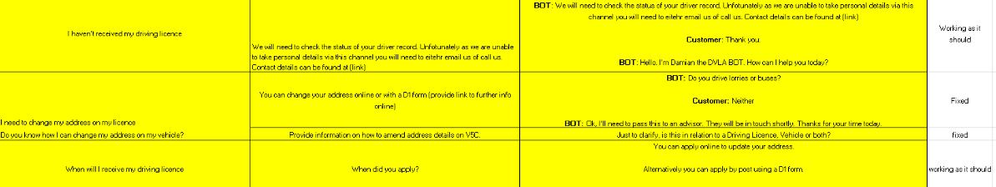

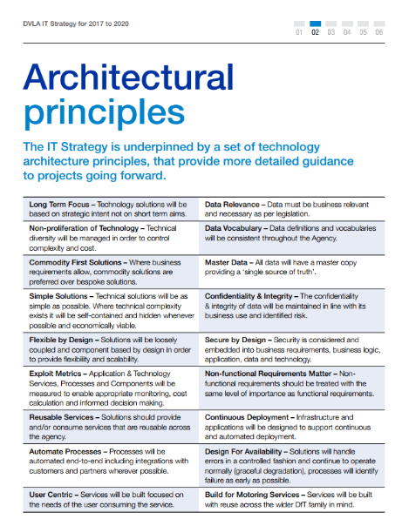
Appendix J

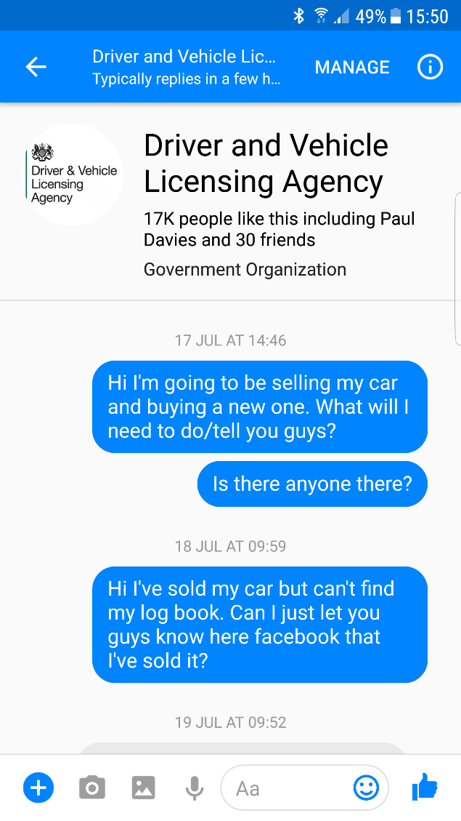
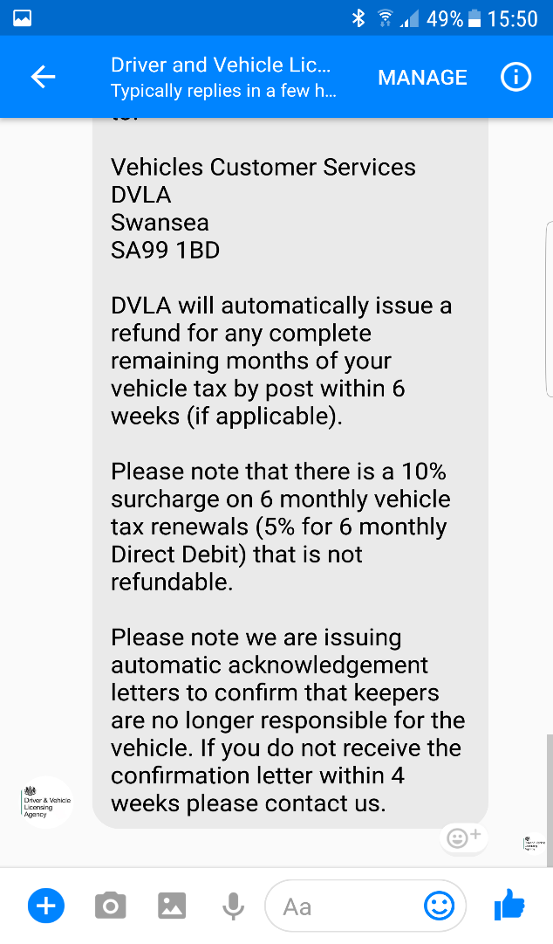
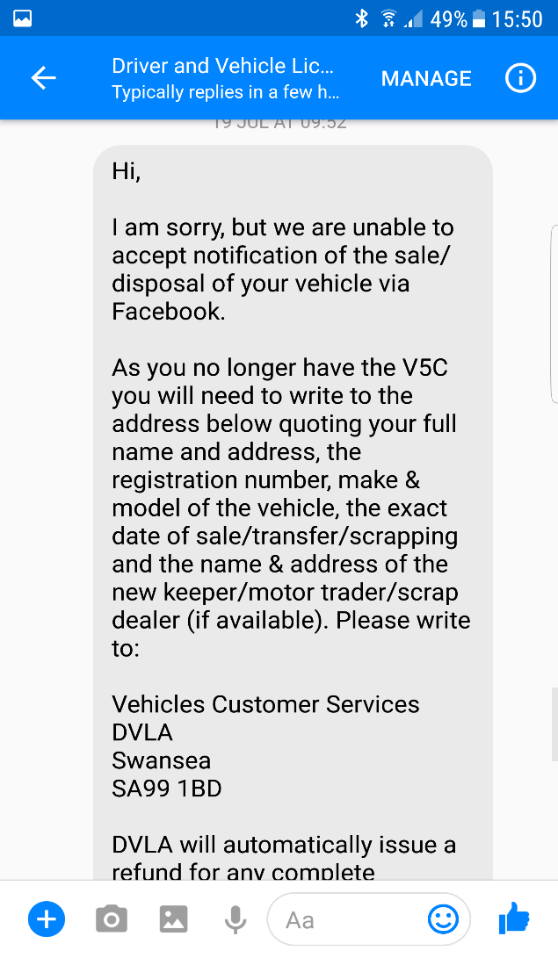

Appendix K
DVLA Facebook Message Response

My enquiry to DVLA on 17th July @ 14:46

My second enquiry to DVLA on 18th July @ 09:59

DVLA’s reply to me on the 19th July @ 09:52

Emerging Technology Tracker
Appendix L Emerging Technology Tracker
Business Area | Contact Centre / External Communications
Problem Statement | To automate DVLA’s response to low value, repetitive enquiries received through Facebook Messenger to the DVLA.  To do this using chatbot technology, in order to explore how DVLA could make use of this type of service.
Technology To Be Explored | Chatbots integrated with Facebook Messenger
Solutions considered | Chatfuel  + Online builder with simple GUI  + Easy integration with Facebook  + Really simple to build rapidly  (-) Not chatty. Glorified decision tree  (-) Can’t access from DVLA network. Blocked  IBM Watson  + Online builder with straightforward builder GUI.  + Conversational  + Fuzzy matching  + Intents an entities  (-) More complex to integrate with FBM  (-) Restricted to only 25 intents & 25 entities  Amazon Lex  + Amazon’s Lex is what powers Alexa. Highly developed, market leading text to speech  + Amazon tools are strategic choice  (-) The most complex to integrate  (-) Difficult to understand conversation builder GUI
Solution to be investigated | Chatfuel – due to rapid build and opportunity for learning.
Costs | Free for up to 100,00 active users per month (DVLA received approx. 40 FBM messages p/m)
DVLA Systems Impacted | Salesforce – DVLA has integrated its FB page into the Salesforce system. So when DVLA staff respond to FBM messages, they do so through the Salesforce system.
Roles Required | Non-technical developer, Contact Centre Social Media Team input, Salesforce Dev’s for testing.
Benefits | Automation of common low value enquiries.  Significantly improved response times for customers – preventing additional enquiries through other channels.  DVLA delivers innovative service, first in government.

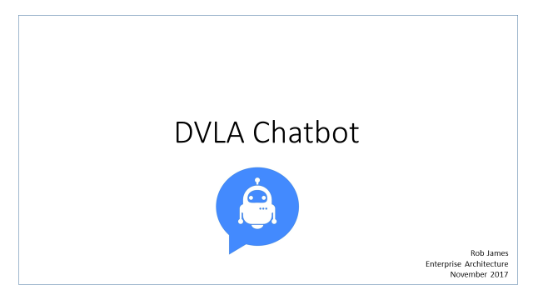

Appendix M



