Abstract
The experiment concluded that Herodotus’ writing on the use of Natron was successful, looking at wider reading on other mummification experiments and the other aspects of mummification which was not used during the experiment to compare and understand what could be different. The use of a tangerine and a frankfurter was used in the experiment, concluding that the frankfurter had been successful and the tangerine not due to limitations in the experiment, since it was a 3-week period.
Key Words: Frankfurter, Herodotus, Tangerine, Salt, Mummification.
1 | Introduction
For the experiment to be understood, there must be an understanding on what mummification is, and any instances in which supports the experiment in the salts that were used, and how successful the salts were in the dehydration process. Additionally, what other experiments support or devalue the experiment that was undertaken. In the report there will be examples of experiments such as MUMAB, Alan Billis and the experiment of the Canopic Jar Project to better understand the results that were gathered throughout the 3 weeks in the experiment. Unfortunately, due to the use of a frankfurter and tangerine in the experiment carried out over the last 3 weeks, there were limitations to the process of the experiment that did not resemble the same complexity as the ancient Egyptians; particularly the embalming stage of ancient Egyptian mummification. For most examples of mummified persons in ancient Egypt, once the organs were removed from the deceased, they often filled the cavities of the ears, eyes and nasal with molten resinous materials which were regarded as preservative materials. In regards to what mummification itself is, it was performed for over 2000 years, the process evolved over centuries becoming more sophisticated over time, whilst also mummifying animals alongside humans. Mummification was also one of the most integral aspects of ancient Egyptian culture throughout all the dynasties of Egypt, and the primary goal for the mummification is the long-term preservation of the deceased. The experiment on the hotdog and the tangerine will confirm whether the salt mixture that was used can successful dehydrate an organic object, using the experimental half of both the tangerine and hotdog and the control of the two to view the changes over the 3 week experiment. Additionally, using Herodotus and other experiments, the experiment is to mummify a hotdog and a tangerine using a dry salt mixture.
2 | Methodology
For the experiment the choice in organic objects were a frankfurter and a tangerine. The frankfurter’s ingredients consisted of pork meat (71%), water, pork protein, salt, modified starch, glucose stabilisers: E450, flavourings, flavour enhancer, E621, antioxidant: E301, preservatives: E250. Lastly, the Frankfurter may contain soya, milk (including lactose), celery and mustard with the use by date on the 12/03/2026. The tangerine did not contain any additional information and was a sweet easy peeler.
Callipers were used for the experiment, in order to measure the height, length, and width of the controls and the experimental tangerine and frankfurter. Additionally, a weighing scale was used to weigh how many grams the objects had. PMS was also used in order to follow the change of colour on the frankfurter and the tangerine. The salt mixture that was used in the experiment consisted of: 20% Sodium Bicarbonate, 70% Table salt (Sodium Chloride) and 10% Epsom salt. As to why this mixture was used, was to ensure as close as the experiment could get to Natron, which is made up of a mixture of Sodium Carbonate, Sodium Bicarbonate, Sodium Chloride, and Sodium Sulphate.
During the first week which began on the 5th of March, the group had measured the weight, height, length and width of both the frankfurter and the tangerine. Once the objects were weighed and measured, the salt mixture was added to 2 zip lock bags and another 2 of the zip lock bags were left alone, without the salt mixture for the control, to view the change in the frankfurter and the tangerine throughout the experiment, unimpeded by the dehydration process of the salt mixture used. As to why this was used in the experiment was to ensure that the experimental halves of the organic objects were successful in their dehydration using a dry salt mixture. One the preparation on the mummification experiment had begun, the experiment required for the group to measure the objects on a weekly basis until the end of week 3. Additionally, since checking the objects on week 2 and week 3 the salt had to be removed once the objects were taken out of the bag to ensure the object was measured and observed without impediment.
3 | Results
The second week of the experiment the experimental tangerine had become softer, whereas the control of the tangerine had not changed as much. Secondly, the experimental frankfurter had become harder, and both the experimental tangerine and frankfurter had become lesser in weight and size (see weight graph and volume line graph). As seen on the table for week 1, 2 and 3. The sizes of the samples were measured using millimetres and grams for the weight. Week 1’s sample colours were unchanged because dehydration had not taken place, the colour for both the experimental and control tangerine was 2575c for the peel, 2023c for the flesh, and 4201TCX for the pith. The frankfurter’s colour was 472c on the outside and the inside was 698c (see fig 1). Commencing Week 2’s samples the colours for had changed drastically, the frankfurter control which also developed a white substance (4201TCX) but had retained the other colours from Week 1 (see fig 3). In regards to the experimental frankfurter in Week 2 its colour became 4261c for the outside and 435c for the inside (see fig 2). The tangerine had changed in Week 2 to having the peel colour of 6018c, flesh 1485c, and pith 134c for the control, the colour of the experimental was 1575c for the peel, 2013c for the flesh and the pith had not changed and retained its original colour (see fig 2). The third Weeks results for the frankfurter had not changed, however, the sample had developed mould, which was coloured to 18-5993TCX (see fig 4).
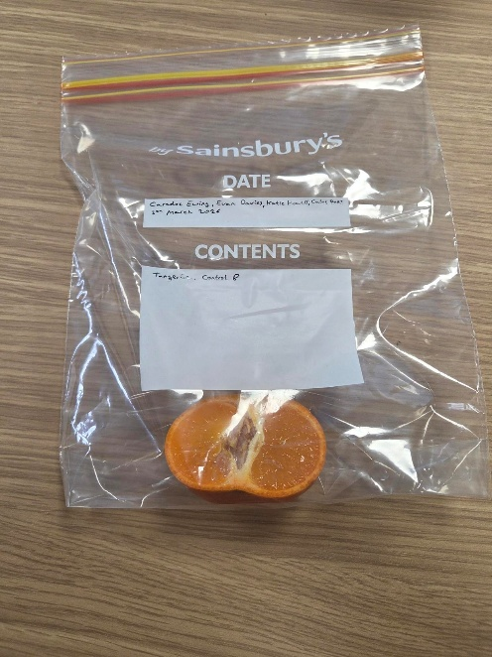
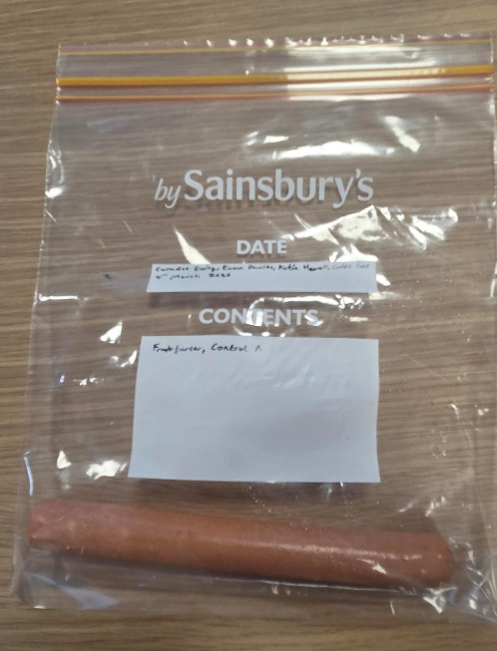
Figure 1, Week 1 images of samples (Davies, 2026)
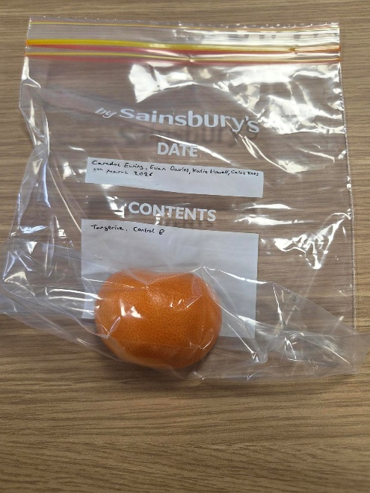
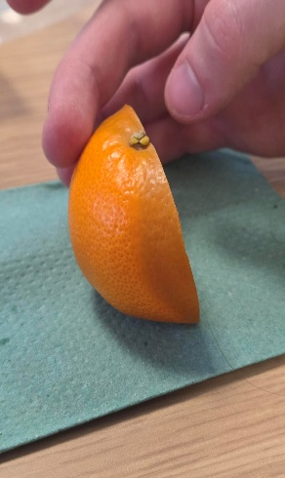
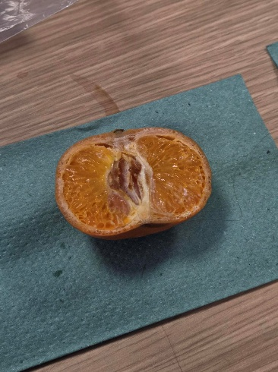
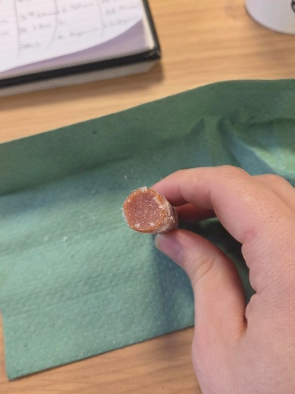
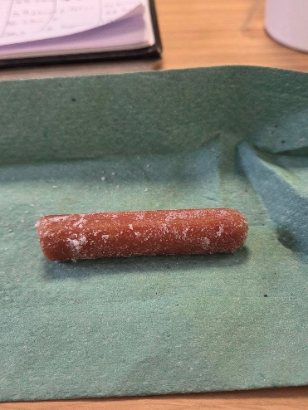
Figure 2, Week 2 images of samples (Davies, 2026)
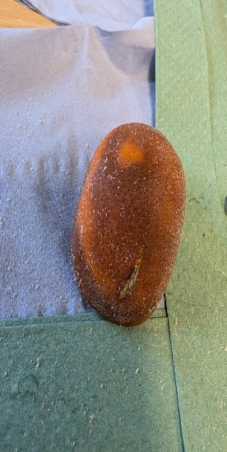
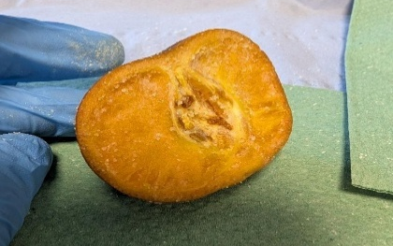
Figure 4, Week 3 images of control frankfurter
(Ewing, 2026)
Figure 3, Week 2 images of control frankfurter (Davies, 2026)
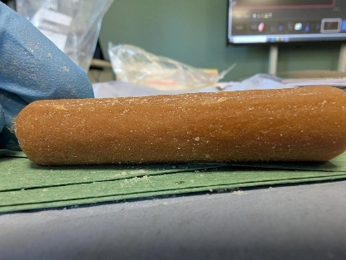
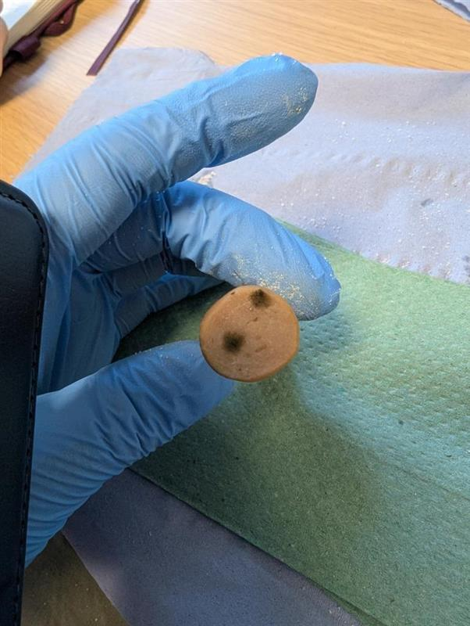
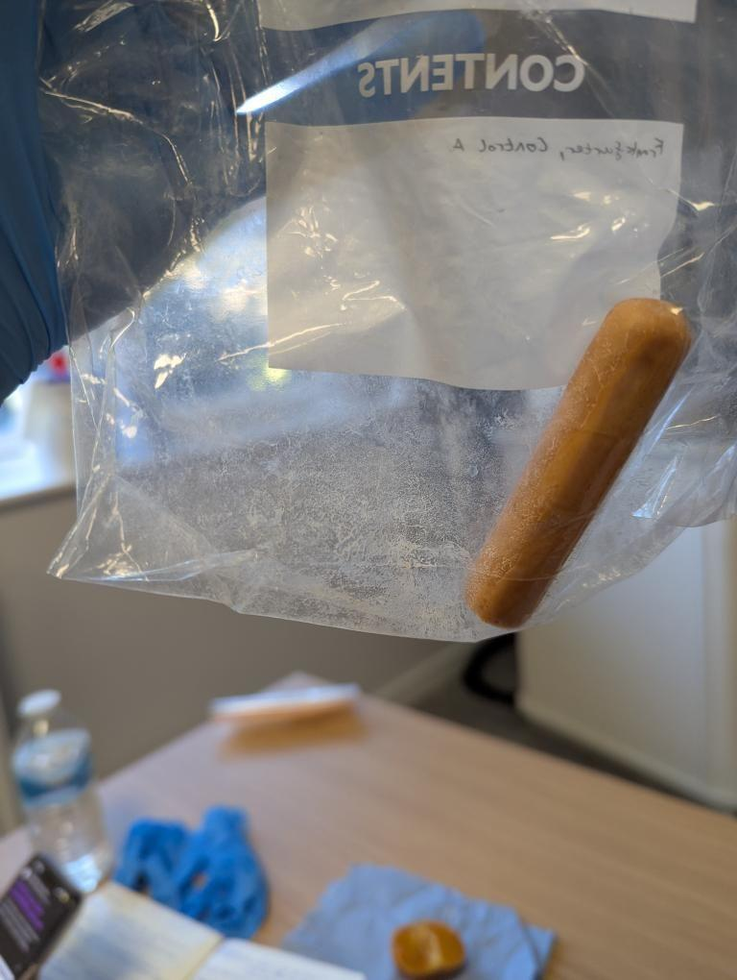

The textures in week 1 were soft and moist with a spongy inside for the frankfurter, and for the tangerine the texture was soft with give, and a damp interior. During week 2 the controls had changed alongside the experimental samples. The control frankfurter had becoming increasingly slimy due to the development of a white substance (see fig 3), the experimental frankfurter had become hard and try, with a much stronger smell, with noticeable shrinkage (see weight graph and volume line graph), and the sample had become darker in colouration as stated above. In regards to the tangerine during week 2, the controls flesh had become sticky and had developed damp edges (see fig 2). Additionally, the flesh began pulling away from the pith due to the flesh shrinking with darker spots appearing at the cut with a fermenting aroma. The experimental tangerine had become much softer than the control, and the salt had become full of moisture and begun clumping in areas, with flesh in much better condition (see fig 2). The frankfurter control in week 3 had become sticky and slimy, with soft skin, and the cut in the frankfurter had shrunk in on itself slightly (see fig 4). The experimental frankfurter had not changed drastically, the skin had become leathery and harder (see fi g 4), and the salt had become increasingly clumpier in the zip lock bag. The control tangerine in week 3 had become moist on its skin which had grown considerably since week 2, and was not moist but sticky in the inside, and kept the characteristic from week 2. The experimental tangerine had gotten even softer skin, more of the flesh and shrunk, and the salt was saturated more than week 2 in the salt mixture (see fig 4).

Week 1 | Control Tangerine | Experimental Tangerine | Control Frankfurter | Experimental Frankfurter
Weight | 40.7g | 46.1g | 19.3g | 18.2g
Height | 42.81mm | 43.22mm | 16.64mm | 16.74mm
Length | 59.49mm | 59.45mm | 76.12mm | 73.65mm
Width | 29.16mm | 29.74mm | 17.35mm | 17.46mm

Week 2 | Control Tangerine | Experimental Tangerine | Control Frankfurter | Experimental Frankfurter
Weight | 40g | 38g | 18.8g | 10.6g
Height | 42.18mm | 39.23mm | 16.54mm | 13.71mm
Length | 60.05mm | 56.28mm | 75.6mm | 66.9mm
Width | 28.53mm | 27.03mm | 17.2mm | 14.14mm

Week 3 | Control Tangerine | Experimental Tangerine | Control Frankfurter | Experimental Frankfurter
Weight | 39.3g | 32.1g | 18.0g | 10.6g
Height | 39.71mm | 37.37mm | 15.68mm | 13.78mm
Length | 58.46mm | 57.08mm | 74.73mm | 67.16mm
Width | 27.18mm | 25.60mm | 17.02mm | 14.44mm

4 | Discussion
These results show that the experiment on the tangerine and the frankfurter were successful in mummifying them with the tools available at the time. Similarly, the organic objects that were put into the salt mixture, did show signs similar to the Canopic Jar Projects results, being that they lost a considerable amount of volume in comparison to the controls. Similar to the great decrease in weight and volume that the aforementioned experiment had, the objects that were chosen had also remained partially stagnant to a degree, similar to the experimental tangerine and frankfurter (see volume line graph and weight graph). Although, despite the mummification experiment of the tangerine and the frankfurter, the Canopic Jar Project did have more resources and time to complete and monitor the experiment far more. Additionally, other experiments such as that of Alan Billis’ mummification and that of MUMAB can loosely be compared to the tangerine and frankfurter experiment. However, not as effectively as the Canopic Jar Project, since the those experiments had access to far more resources than the frankfurter and tangerine experiment, for example, the project of MUMAB and Alan Billis included resinous materials to be inserted into the cavities, which were used as preservative materials during mummification – since this experiment could not include this aspect of mummification, it hinder the understanding on it, despite this further research on how Alan Billis and MUMABs experiment was allows further understanding on mummification and what it is the experiment can provide. Although the experiment did not include this, or the embalming undertaken by MUMAB and the Alan Billis experiment, the dehydration process is something that can be compared to. Since the experiment did have access to a control, it was apparent throughout the experiment how microorganism affected the control samples in comparison to the experimental, since the presence of salt, causes the dehydration and causes enzyme inactivation through heating or cooling tissue, invading the microorganisms either completely, or substantially. Additionally, the ancient Egyptian did not leave writing records on the process of mummification, however, there are records written by Herodotus and Diodorus on the process of mummification. Herodotus writes on the removal of the brain using a crooked piece of iron and clearing the rest with drugs and records the use of resins from a cedar tree. Herodotus also mentions the use of Natrum which can suggests that it is Natron, and to cover the deceased entirely for 70 days in the Natrum. Using Herodotus’s account on mummification this is what the experiment attempted, although with little time, however, was successful in doing so, considering the samples were considerably smaller than what was used. However, the tangerine had not preserved itself as well as the frankfurter and this can be seen evidently when looking at the charts and graphs. However, if given more time and availability to change the salt mixture since it had become awfully saturated up to week 3.
5 | Conclusion
The experiment was successful, the dehydration of the frankfurter had successfully reached a form of mummification resembling that of the ancient Egyptians to a degree, through using Herodotus’ writing on the process, furthermore, the tangerine had not been able to successfully mummify as intended due to the duration of the experiment and lack of equipment, the control allows a wider understanding on the process without the salt mixture, proving the salt mixture chosen for the experiment and how it was applied to be successful in accordance to Herodotus. Additionally, due to the supporting experiments used in the report, it had allowed a greater discussion on how mummification works, and how successful the experiment undertaken by the group in the 3 weeks was. To conclude, the experiment was successful but there were limitations which dampened the results.

References
- Abdel-Maksoud, G., El-Shemy, H.A. and Abdel-Hamied, M. (2025) “A comprehensive overview of the evolution of resin materials in mummification: A review,” Journal of cultural heritage, 74, pp. 52–65. Available at: https://doi.org/10.1016/j.culher.2025.05.005.

- Barnes, K.M., Whiffin, A.L. and Bulling, M.T. (2019) “A preliminary study on the antibacterial activity and insect repellent properties of embalming fluids from the 18th Dynasty (1550–1292 BCE) in ancient Egypt,” Journal of archaeological science, reports, 25, pp. 600–609. Available at: https://doi.org/10.1016/j.jasrep.2019.05.032.

- Byard, R.W. (2025) “Mummification – An historical and cultural overview,” Journal of forensic and legal medicine, 112. Available at: https://doi.org/10.1016/j.jflm.2025.102863.

- Ewing. C. (2026) Figure, 4, Week 3 Images of Control Frankfurter.

- Davies, E. (2026) Figure 1, Week 1 images of samples.

- Davies, E. (2026) Figure 2, Week 2 images of samples.

- Davies, E. (2026) Figure 3, Week 2 images of control frankfurter.

- Herodotus. 2017. ‘Mummification - Livius’, Livius.org https://www.livius.org/sources/content/herodotus/mummification/.

- Mummifying Alan: Egypt’s Last Secret (Mummifying Alan: Egypt’s Last Secret, 22:10 30/03/2013, More4, 100 mins. https://learningonscreen.ac.uk/ondemand/index.php/prog/0211F9B7?bcast=95124075 (Accessed 19 Mar 2026).

- Öhrström, L., Tekin, A., Biedermann, P., Morozova, I., Habicht, M., Gascho, D., Bode‐Lesniewska, B., Imhof, A., Rühli, F., & Eppenberger, P. (2020). Experimental mummification—In the tracks of the ancient Egyptians. Clinical Anatomy, 33(6), 860–871. https://doi.org/10.1002/ca.23568.

- Wade, Andrew D., Ronald G. Beckett, Gerald J. Conlogue, Ramon Gonzalez, Ronn Wade, and others. 2015. ‘MUMAB: A Conversation with the Past’, The Anatomical Record, 298.6: 954–73 https://doi.org/10.1002/ar.23152.

Öhrström, L., Tekin, A., Biedermann, P., Morozova, I., Habicht, M., Gascho, D., Bode‐Lesniewska, B., Imhof, A., Rühli, F., & Eppenberger, P. (2020). Experimental mummification—In the tracks of the ancient Egyptians. Clinical Anatomy, 33(6), 860–871. https://doi.org/10.1002/ca.23568.
Barnes, K.M., Whiffin, A.L. and Bulling, M.T. (2019) “A preliminary study on the antibacterial activity and insect repellent properties of embalming fluids from the 18th Dynasty (1550–1292 BCE) in ancient Egypt,” Journal of archaeological science, reports, 25, pp. 600–609. Available at: https://doi.org/10.1016/j.jasrep.2019.05.032. p. 603.
Abdel-Maksoud, G., El-Shemy, H.A. and Abdel-Hamied, M. (2025) “A comprehensive overview of the evolution of resin materials in mummification: A review,” Journal of cultural heritage, 74, pp. 52–65. Available at: https://doi.org/10.1016/j.culher.2025.05.005. p. 53.
Byard, R.W. (2025) “Mummification – An historical and cultural overview,” Journal of forensic and legal medicine, 112. Available at: https://doi.org/10.1016/j.jflm.2025.102863. p. 1
Abdel-Maksoud, G., El-Shemy, H.A. and Abdel-Hamied, M. (2025) “A comprehensive overview of the evolution of resin materials in mummification: A review,” Journal of cultural heritage, 74, pp. 52–65. Available at: https://doi.org/10.1016/j.culher.2025.05.005. p. 52
Öhrström, L., Tekin, A., Biedermann, P., Morozova, I., Habicht, M., Gascho, D., Bode‐Lesniewska, B., Imhof, A., Rühli, F., & Eppenberger, P. (2020). Experimental mummification—In the tracks of the ancient Egyptians. Clinical Anatomy, 33(6), 860–871. https://doi.org/10.1002/ca.23568. p. 862
Wade, Andrew D., Ronald G. Beckett, Gerald J. Conlogue, Ramon Gonzalez, Ronn Wade, and others. 2015. ‘MUMAB: A Conversation with the Past’, The Anatomical Record, 298.6: 954–73 <https://doi.org/10.1002/ar.23152> . p. 962
Öhrström, L., Tekin, A., Biedermann, P., Morozova, I., Habicht, M., Gascho, D., Bode‐Lesniewska, B., Imhof, A., Rühli, F., & Eppenberger, P. (2020). Experimental mummification—In the tracks of the ancient Egyptians. Clinical Anatomy, 33(6), 860–871. https://doi.org/10.1002/ca.23568. p. 865.
Ibid, p. 865.
Ibid.
Wade, Andrew D., Ronald G. Beckett, Gerald J. Conlogue, Ramon Gonzalez, Ronn Wade, and others. 2015. ‘MUMAB: A Conversation with the Past’, The Anatomical Record, 298.6: 954–73 https://doi.org/10.1002/ar.23152. p. 954.
Abdel-Maksoud, G., El-Shemy, H.A. and Abdel-Hamied, M. (2025) “A comprehensive overview of the evolution of resin materials in mummification: A review,” Journal of cultural heritage, 74, pp. 52–65. Available at: https://doi.org/10.1016/j.culher.2025.05.005. p. 52
Mummifying Alan: Egypt’s Last Secret (Mummifying Alan: Egypt’s Last Secret, 22:10 30/03/2013, More4, 100 mins. https://learningonscreen.ac.uk/ondemand/index.php/prog/0211F9B7?bcast=95124075 (Accessed 19 Mar 2026).
Barnes, K.M., Whiffin, A.L. and Bulling, M.T. (2019) “A preliminary study on the antibacterial activity and insect repellent properties of embalming fluids from the 18th Dynasty (1550–1292 BCE) in ancient Egypt,” Journal of archaeological science, reports, 25, pp. 600–609. Available at: https://doi.org/10.1016/j.jasrep.2019.05.032. p. 600
Herodotus. 2017. ‘Mummification - Livius’, Livius.org https://www.livius.org/sources/content/herodotus/mummification/.
Ibid.
Ibid.

