Module: Teaching in Higher Education 2 (UNHE7006)

Portfolio

Julie Thomas
Student Number: 0252294

Submitted in partial fulfilment for the award of the Postgraduate Certificate in Teaching for Higher Education (PGCert tHE)

University of Wales Trinity Saint David
2019-2020

DECLARATION

This work has not previously been accepted in substance for any qualification and is not being concurrently submitted in candidature for any qualification.
Signed ...................................................................... (candidate)

Date ..........28th April 2020..............................................................

STATEMENT

This work is the result of my own investigations, except where otherwise stated.

Other sources are acknowledged by in-text citations and reference lists.
Signed ..................................................................... (candidate)

Date ............28th April 2020............................................................

Contents

Title | Page Number
Reflective Report of Teaching Intervention Cycle Two | 4
Poster of a Teaching Intervention Cycle | 16
Report of Teaching Observation 1 | 17
Report of Teaching Observation 2 | 19
Report of Teaching Observation 3 | 21
Reflective Evaluation of CPD Event 1 | 23
Reflective Evaluation of CPD Event 2 | 26
Reflective Evaluation of CPD Event 3 | 28
Assessment of Professional Development throughout the programme plus analysis of future development needs | 31
Evidence of 100 Hours of Teaching | 34

Reflective Report of Teaching Intervention Cycle Two (Approximately 4000 words)
In order to provide a reflection of a teaching intervention cycle in Module 1, I used the framework for action learning devised by Norton (2001), as cited by Norton and Campbell (2007). This framework centres around the acronym ‘ITDEM’:
Identifying a problem/paradox/issue/difficulty
Thinking of ways to tackle the problem
Doing it
Evaluating it
Modifying future teaching

As this framework enabled me to effectively describe and evaluate my first teaching cycle, this is the framework I will use to evaluate this cycle.

Identifying a problem/paradox/issue/difficulty:
In the Summer term of 2019 I was asked to deliver the level 7 module called ‘Human Resource Management in Context’, which forms part of the Postgraduate Diploma and MA in Human Resource Management. At the same time I was asked to become Programme Manager for the whole programme. Student feedback had been received which indicated that block teaching (only teaching one module at a time) was effective in reducing student workload and pressure points and therefore needed to be considered for all programmes. The previous programme manager created a timetable whereby I would deliver the module from 1st October 2019 to 12th November, every Tuesday from 1pm-7:30pm. Another module would then begin on 19th November, though the exam for HRM in Context would still need to take place during the exam period (14th January 2020). My task was to devise content that would be effective using the ‘block’ format as well as appropriate assessments (A1).

Thinking of Ways to Tackle the Problem:
As the module had been delivered before, learning outcomes had been prepared. These are listed below:
Upon the successful completion of this module, the student will be able to understand, analyse and critically evaluate:
- Contemporary organisations and their principal environments.
- The managerial and business environment within which HR professionals work.
- How organisational and HR strategies are shaped by and developed in response to internal and external environmental factors.
- The market and competitive environments of organisations and how organisational leaders and the HR function respond to them.
- Globalisation and international forces and how they shape and impact on organisational and HR strategies and HR practices.
- Demographic, social and technological trends and how they shape and impact on organisational and HR strategies and HR practices.
- Government policy and legal regulation and how these shape and impact on organisational and HR strategies and HR practices.

In order to deliver the module, I had to devise the following (A1, A2):
- Formative assessments.
- Summative assessments, including the assignment and exam.
- Content for 8 sessions (7 x 6.5 hours each, 1 x 4 hours).
- Supporting resources for the Moodle (Virtual Learning Environment) page.

Formative assessments (A1)
For many of the students, who were professionals occupying part or full-time HR roles and all well over 18 in most cases, this module was their first taste of academic life in a very long time. As a result I decided to give them as many feedback opportunities as possible (K2, K3, V1, V2). This was incorporated into the initial 7 weeks through the use of presentations (whereby immediate feedback was given regarding academic writing and context) and submission of three blogs which could then be used as part of their final assignment (A3). The aim was to boost their skills and so their confidence, which would help with attainment as well as retention of the students themselves (Busher & James, 2019).

Summative assessments (A1)
There was a requirement that the assignment and exam comply with guidelines described in the current Module Descriptor. These guidelines were used to create an assignment that assessed elements of the learning outcomes. To create both, I researched current trends using the CIPD website, LinkedIn and consultancy websites such as McKinsey and Price Waterhouse Coopers (K1, A5, V3). The following key concepts emerged:
The impact of Brexit – for example, talent shortages, uncertainty (CIPD, 2018)
The impact of current trends such as the ageing workforce, a more diverse workforce (Deloitte, 2018)
The impact of increased awareness of mental health issues and climate change (CIPD, 2018)
The impact of technology and AI on the future of work (UKES, 2014)
Using previous assignments and exams, I created both documents and sent them to the external examiner (Peter Evans, University of Edinburgh) for feedback. His comments were as follows:

This looks to be an effective component of assessment for this module. My concerns here are:

- By copying in the blog posts, the students may have trouble in keeping to the 2000 word limit. Should the students be asked to summarise the three posts rather than copying them.
- The Introduction to specify a critical examination of the PESTLE tool rather than only justifying it. The critical approach is clear in the assessment criteria but could helpfully be included in the task description itself.

The adjustments were duly incorporated into the final version. Level 7 students in particular should demonstrate a high degree of critical thinking and with such skills becoming ever more important in the workplace, it was prudent to include the above adjustment (Charlton, 2019).
No comments for improvement were made regarding the exam, which I was particularly pleased with.

Session content
All content was designed in order to achieve the learning outcomes, in accordance with the principles of constructive alignment (Biggs & Tang, 2011). To enable students to get the most out of each session I devised a learning plan with recommended reading for each week. As there was a comprehensive core text-book – ‘Human Resource Management in Context’ by David Farnham (2015), I recommended that students read the relevant chapter for each session, plus a small number of other sources. As most had families and other commitments, I did not want to overwhelm them, but at the same time it was important for them to prepare for sessions so that they engaged as active learners (Biggs & Tang, 2011). In my experience, students also want to know what they will be covering and what’s expected of them so issuing a learning plan with this information, served to reassure them so that they could focus on their learning, rather than worrying about it. Mature learners need a greater degree of reassurance in this respect as some have had negative experiences of education in the past or lack confidence because they have been out of education for a long period of time (Busher & James, 2019) (V1, V2).
Each session was planned, using a lesson plan, incorporating appropriate timings and resources. An example lesson plan for week 6 is below:
Week 6
- Learning Outcome 6 - Demographic, social and technological trends and how they shape and impact on organisational and HR strategies and HR practices.

Time | Topic/Activity | Resources Needed
1pm | Explanation of LO6  Slides - Demographic Trends | PC, projector
1:25pm | Activity - Statistics | Laptops/phones
2pm | Slides - Social Trends | PC, projector
2:30pm | Student Peer Learning Activity | PC, projector
3pm | Break
3:30pm | Activity – Diversity and Inclusion | Laptops/phones
4pm | Activity – Ageing Workforce | Laptops/phones
4:45pm | Video – Weforum.org | PC, projector
5pm | Break
5:30 | Slides – Technological Trends | PC, projector
5:45 | Video – Deloitte | PC, projector
6pm | Activity – Will robots take my job? | Laptops/phones
6:15 | Activity – Technological trends | Laptops/phone
7:15 | Questions
7:30 | Close

Sessions were planned so that they complied with the following best practice:
- Clear indication of the learning outcome at the start (Race, 2015).
- Alignment of learning activities with the learning outcome (Biggs & Tang, 2011).
- The use of high level activities where the learner was active, to encourage deep learning (Biggs & Tang, 2011).
- Sufficient time to allow students to fully immerse themselves in the activities and achieve the deep learning.
- Sign-posting to materials to read to encourage independent learning (Fry, et al., 2015).

Doing it:
As students progress through the levels, the amount of critical analysis becomes increasingly important. For this module (level 7), I ensured that I incorporated activities that involved students using their analytical skills. For the above session on learning outcome 6, I started with a relatively easy exercise to encourage students to use evaluate and use statistics to underpin their work:
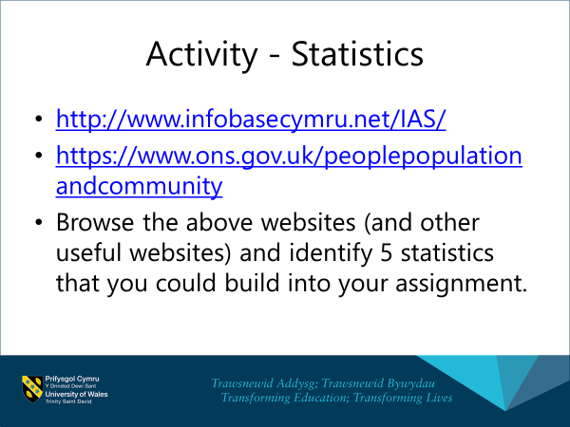
Starting with an easy exercise served to help build their confidence and feelings of self-efficacy (Gibbs, 2015).
I then moved on to a more demanding exercise, involving the use of their analytical skills:

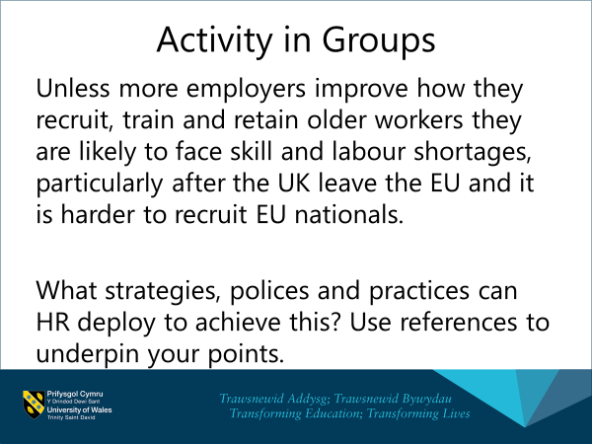

As most students did not do the required reading in preparation for each session, it was challenging to devise high level activities, which students would be capable of undertaking during their time in class. I therefore allowed them sufficient time to read parts of websites and do a certain amount of research in class, before they attempted the tasks. I also showed students short videos which are effective in making essential points and stimulating discussion (K2).

Classroom management
All of the students in the class were working professionals who were generally self-motivated - a trait common to adult learners (Jarvis, 2010), and engaged. However, during the initial sessions there were times when students were more interested in their phones than participating in class. As students were taking time out from work to attend class and also have families, I allowed students to keep their phones on their desks. However, this led to students reacting to every ‘ping’ of their phones and not fully engaging with the material. I therefore had to remind students that they should only keep their phones in view if absolutely necessary. This temporarily affected the atmosphere in the room, but I quickly rectified this by involving students in an activity. As well as a tactic to regain an atmosphere conducive to learning, sustained engagement – i.e. keeping students busy is a good tactic to prevent undesirable behaviour from students in the first place (Nagro & Hooks, 2019). (A4)

Promoting Further Learning and Engagement with Materials
In order to encourage engagement with relevant materials I set up a Facebook page for HR Students, called HR Students at UWTSD (K4, V4). Within a few days over 70 students, from this programme, plus the other programme that I oversee (CIPD Diploma in Applied HR) had joined the group. Immediately students started posting relevant material (useful articles that they had found), which was very encouraging. My aim was to create an excitement about learning and find alternative ways for students to learn that has meaning for them, as championed by Shackleton-Jones (2019), which appeared to work.



Evaluating it (K5):
In order to make improvements and to further develop your skills as a teacher, it is important to evaluate the course at the end of each programme delivery (Gravells, 2016). Fortunately this process is built into the University’s quality assurance procedures with lecturers required to complete a module review for each module they deliver. There is a standard template for this. The findings of the module review are discussed below:
Analysis of Grades
28 students were initially registered on this module. 5 students withdrew very early on in the programme, 1 did not start and 2 withdrew before assignment submission. This left 20 students.
Following first sittings, 11 out of 20 students passed overall. The breakdown is below:
Pass – 5
Merit – 4
Distinction - 2
Part One – Assignment:
All 20 students submitted their assignment. Their result were as follows:
Average | 56
Max | 75
Min | 42
Standard deviation | 8.7
Fail | 7
Pass | 5
Merit | 6
Distinction | 2

13 out of 20 (65%) passed first time round. This compares to 82% passing in 2018. As the assignment was very similar to last time, this may indicate that the cohort as a whole was less capable than the last one.
Similar to last time (53 in 2018), the average mark (56) was quite low. As this was the first assignment of the course, low average marks were to be expected. Nevertheless, as the average mark was slightly higher than 2018 (3 marks) – this may indicate that completion of the blogs helped raise levels of competence to a certain extent. The fact that 4 out of the 7 who did not pass, had not submitted all 3 blogs seems to indicate that when students complete blogs and therefore receive feedback, they are more likely to pass.
Part Two – Exam:
17 out of the 20 sat the exam. 11 out of the 17 passed (65%). This is the same pass rate as the assignment. The average mark was 55%, which is less than last year (63%). Again, together with the fact that all students passed first time in 2018, this may indicate that the calibre of students was not as strong as the last cohort. It is not felt that the exam was any more difficult this time round – the exam was written and externally verified by the same individuals, using the same format as last time.
Students commented that the mock exam, held the week before, provided useful feedback.

Summary of Student Feedback
During the Staff Student Committee Meeting in December 2019, the student representative gave the following feedback:
‘Students could see the benefit of completing blogs in that they contributed to the assignment and served as preparation for the module ‘Developing Skills for Business Leadership’.’
The representative mentioned that the word count for the assignment was challenging but understood the need to practise being concise. 15 out of 20 students completed a Module Review form at the end of the module. Students were asked to complete the form after completion of teaching and before the exam. Overall the feedback was very positive. Students thought the content and teaching was very good and enjoyed the group work. The main suggestion for improvement concerned scheduling the module at the beginning of the course (this is normally the case, but due to numbers, this module fell in the second year of some students’ course). Some students thought 6.5 hours on one module was too long and some did not like participating in peer learning (presentations). Comments are listed below:
Good aspects of module (aligned with the UKPSF, demonstrating my competence in these areas):
Comprehensive and thorough direction from tutor (A2). Returning to learning as a student felt out of depth but Student Services and Library support has been very helpful.
Active learning sessions in groups really useful (K2, K3). Great course with some really powerful information (K1). Relevant to my work and business (V4). Have really enjoyed.
Very informative, good course content, sharing information with peers (K1).
The relevance of each topic to our own organisations and learning about all the other organisations (A1) .The whole module is thought-provoking and I’ve been able to utilise theories and ideas in my job (A2).
Content is interesting, resources good, continuity of lecturer and set up of course, simple instructions, Julie was extremely helpful. Provided overall information on HR, understanding the basics, mixed teaching styles (A1, A2, K1, K2, K3).
The module creates a really good basis for the rest of the course, teaching has been interactive. The layout of the programme; mixed teaching styles – Powerpoint, peer learning. (K4)
Provided a valuable understanding of how wider issues impact organisations and that HR can take forward. Very good module. (V4)
The different aspects of organisational strategy and the impact on HR and the company as a whole, learning about other organisations and how other organisations manage issues. (K1)
It has been really helpful and informative. Has been a good introduction back into education. Tutor has been very supportive. (A2)
Content on Moodle, a lot of information on this module. This module has been a good open[er] to the MA course. (K1, K4)
The wide range of topics discussed in HRM in Context really helped to broaden my knowledge; very informative. (K1)
Nothing [to improve] – it has been very informative, and engaging with group work classroom discussion and background reading of case studies etc. (K1, K3)

The above comments confirm my competence in many areas of the UKPSF. A common theme is that students felt that the sessions were informative, which indicates that they felt that they had increased their knowledge and therefore learnt something, which I was particularly pleased with. According to Ashwin (2015), effective teaching and learning should equip learners for life in its broadest sense. This is certainly the philosophy underpinning courses at the Business school, which emphasise ‘employability’. All of the students on this course are already employed, but the above comments demonstrate that the course has enabled students to do their jobs better. This is from a knowledge point of view, which has many benefits including giving students credibility amongst their peers and service users in the workplace, allowing students to answer queries and solve problems more effectively and quickly, as well as boosting their self-esteem. The course has also encouraged them to have a more critical approach to their work, which will help them challenge decisions appropriately and create better business cases.
Possible Improvements:
Referencing session earlier on in the programme to cater for those who have been out of education for a while – 20 years.
More wider group discussions rather than small groups.
More variety rather than just exercises in groups/pairs.
Presentation was not assessed so seemed to not add value to course.
Personally, I would prefer to start the teaching session earlier in the day as I am using my day off so I would still have some time afterwards in daylight.
Too many breaks; change to start of programme; clarity of exam and assignment at the beginning of the programme to allow us to prepare better. Information on this course would have been more useful at the start of this programme rather than the second year. Possibly at a disadvantage with regards to other students because of when the course was delivered.
6 and a half hours on one module is very long; maybe having a split of 2 modules would be beneficial. This module would have been beneficial at the beginning of year one as we are in year 2.
Putting it as module 1 of the course or at least in year 1.
6.5 hours on one module is long – concentration goes.
This should be the first module for the course or in year 1.
Upload contents of Powerpoint slides before the session so can make notes on those.
Peer presentations on Moodle.
More activities so that the information sinks in; Not presentations; Peer presentations not being required – more time going through theories and models.

The above comments will be discussed further in the ‘modifying future teaching’ section below.

Student Engagement
The use of a Facebook page, as a way of encouraging engagement with materials and provide meaning for students, was partially successful. According to Facebook statistics (K5) accessed on 28th February 2020, over the previous 28 days there had been 65 active members, 45 posts, 12 comments and 29 reactions. The most popular days were Monday and Tuesday, with the most popular time being 6:30pm. This information will be used going forwards, in that I will endeavour to post material on a Monday and Tuesday, to have the biggest impact.
Initially several students posted very relevant content. However, several lecturers began to post regularly and enthusiastically, which led to less student posts, some possibly believing that the forum was top-down and one-way. However, many students continue to view posts as demonstrated by the statistics, and I have recently asked student representatives to make additional posts, to try to encourage more participation from students themselves.

Marking of Assignment (A3)
My marking was internally verified by a colleague, whose only comment related to the mark that I had given the distinction candidate. She felt it was too low. On reflection, I agreed and so adjusted the mark from 70 to 75. The IV helped me to reflect on the mark by suggesting that I consider whether the piece of work deserved to lose 30 marks or not. Looking at the assignment this way, rather than focussing on where the overall mark had come from, made me realise that I should have given the candidate a higher mark initially.
The external examiner was content with the IV process and made the following specific comments:
Does feedback identify opportunities for improved performance? – Very Clearly
Is there mention of improvement to referencing and consideration of unfair practice, where relevant? – Yes, although the poor academic practice shown by P151416 including the possibility of self-plagiarism could be more clearly emphasised.
As a result of these comments I will ensure that my feedback is more comprehensive in relation to poor academic practice.
Following the release of assignment results, two students informally complained about their grade (being too low), but upon initial investigation it was discovered that they had not attended lectures regularly and had not participated in the blogs. When this was put to them, no further action was taken by the students. I discussed this with the Internal Verifier, particularly as she had made comments about the Distinction candidates’ mark being too low, but she reassured me that my marking had been appropriate for these two candidates.

Modifying Future Teaching:
Students comments reveal that this module is most beneficial in the first year of the course as it provides a good basis for the other modules. This will be planned for, where student numbers allow. This year both the first and second years were combined, due to low numbers. Therefore, some students studied this module in their second year. I will also ensure that referencing and basic academic writing sessions are held early on.
As some students did not appear to value the peer presentations that they were asked to do, in future I will include a participation score for the presentation and incorporate it into the end of course assignment. Although not ideal in terms of motivating students, this is likely to be effective (Shackleton-Jones, 2019). I will also strictly limit the times of student presentations in future and will place slides on Moodle before sessions.
Having marked both the assignment and exam, I would suggest changing the requirement to submit blogs from three to one, to reduce the marking burden on lecturers. Also, I would change the requirement to discuss three issues in the assignment to two, to allow students to explore issues in more depth which is required for Master’s level (University of Wales Trinity Saint David, 2018).
Although the pass mark was lower than last time, I do not feel that the exam requires amendment in terms of its format, due to the high pass mark the previous time.
I will also spend more time at the beginning of the module, showing students examples of good and poor work so that they can pitch their answers more accurately. I did some of this last time, but maybe not enough. According to Bloxham (2015), this kind of peer assessment is important if students are to improve their own work.

Conclusion
Reflecting on our teaching is necessary if we are to improve our future teaching practices and continually develop as professionals (Ashwin, 2015). This teaching intervention has confirmed that I am competent in many areas of the UKPSF including activity areas A1-4 and core knowledge areas K1-6. It also confirms my adherence to the professional values in terms of respecting individual learners and acknowledging the wider context in which higher education operates, as demonstrated by my students’ comments. A review of the module has highlighted several areas to improve as described above, which not only will help improve learners’ experiences, but will help improve the effectiveness of my teaching going forwards.

References
Ashwin, P. (2015). Reflective Teaching in Higher Education. 1st ed. London: Bloomsbury Academic.
Biggs, J. & Tang, C. (2011). Teaching for Quality Learning at University. 4th ed. Maidenhead: Open University Press.
Bloxham, S. (2015). Assessing Assessment. In: H. Fry, S. Ketteridge & S. Marshall, eds. A Handbook for Teaching and Learning in Higher Education. Abingdon: Routledge, pp. 107-122.
Busher, H. & James, N. (2019). Struggling to become successful learners: Mature students’ early experiences of access to higher education courses. Studies in the Education of Adults, 51(1), pp. 74-88.
Charlton, E. (2019). This soft skill will boost your employability. Available at: https://www.weforum.org (Accessed: 23 April 2020).
CIPD (2018). Preparing for Brexit Through Workforce Planning. Available at: https://www.cipd.co.uk (Accessed 23 April 2020)
CIPD (2018). Supporting Mental Health at Work. Available at: https://www.cipd.co.uk (Accessed 23 April 2020)
Deloitte (2018). The Rise of the Social Enterprise: 2018 Deloitte Global Human Capital Trends. Available at: https://www2.deloitte.com/us/en/insights/focus/human-capital-trends/2018.html (Accessed 23 April 2020).
Fry, H., Ketteridge, S. & Marshall, S. (2015). A Handbook for Teaching and Learning in Higher Education: Enhancing Academic Practice. 4th ed. Abingdon: Routledge.
Gibbs, G. (2015). Maximising student learning gain. In: H. Fry, S. Ketteridge & S. Marshall, eds. A Handbook for Teaching and Learning in Higher Education. Abingdon: Routledge, pp. 193-208.
Gravells, A. (2016). Principles and Practices of Assessment: A Guide for Assessors in the FE and Skills Sector. 3rd ed. London: Learning Matters.
Nagro, S. A. F. D. W. & Hooks, S. A. (2019). Lesson Planning With Engagement in Mind: Proactive Classroom Management Strategies for Curriculum Instruction.. Intervention in School and Clinic, Volume 54.3, pp. 131-140.
Race, P. (2015). The Lecturer's Toolkit. 4th ed. Abingdon: Routledge.
Shackleton-Jones, N. (2019). How People Learn. London: Kogan Page Limited.
UKES (2014). The Future of Work: Jobs and Skills in 2030. Available at: https://www.gov.uk/government/publications/jobs-and-skills-in-2030. (Accessed 23 April 2020).
University of Wales Trinity Saint David (2018). GA36d Level 7 Assessment Specification Template. [Online]
Available at: https://www.uwtsd.ac.uk/academic-office/appendices-and-forms/
[Accessed 30 March 2019].

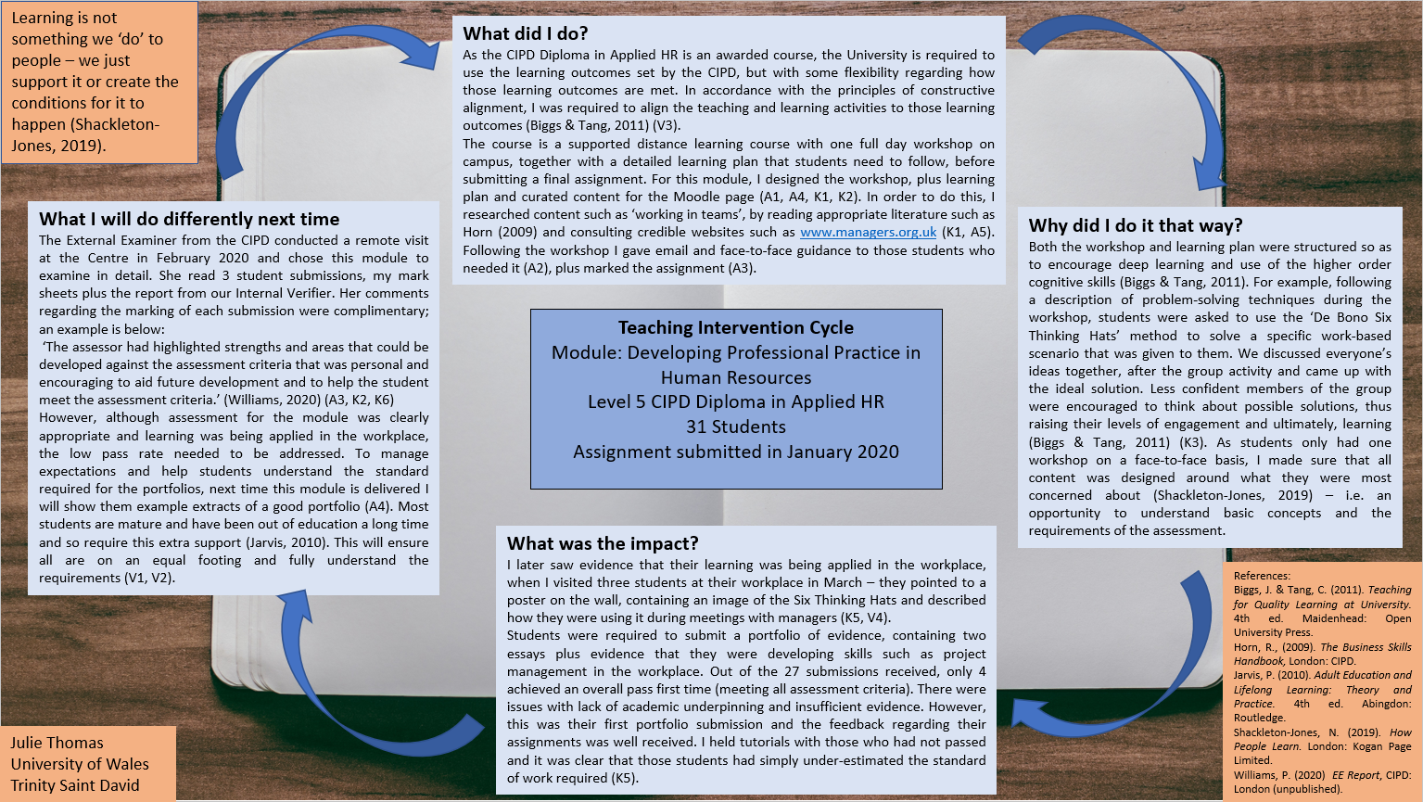
Peer Observation One – Aligned to the UKPSF
A comparison between an early and recent peer observation.
The Institute of Management and Health (where I work) is committed to continuous professional development and quality assurance and as a result requires its staff to take part in peer observations every year (K6). As I have been employed as a lecturer for three years now, this reflection will consider my progress throughout that time by comparing a peer observation undertaken in November 2017 to one undertaken in November 2019.
The first observation was completed by a fellow lecturer during a session (lecture/tutorial) that I was delivering on the level 5 undergraduate BA module ‘Managing People’. This module had been delivered previously by other lecturers and I used their slides as a basis for the lecture, but added additional slides, plus supporting material and activities. The observer’s comments confirmed that I was performing reasonably well – I was using learning objectives and activities that aligned with them, therefore adhering to the principles of constructive alignment. The use of technology (Powerpoint) was good (K4) and I used questioning techniques in an attempt to encourage a deep approach to learning (V3).
According to Jarvis (2010), students benefit from a number of different approaches to teaching, and this point was made by the observer, who suggested that I use more variety in my sessions. Rather than being purely didactic, I was deploying methods such as socratic teaching, to help with student engagement (Jarvis, 2010), however, clearly, it would have been beneficial to use more (such as facilitative or experiential methods). In 2017, my teaching was, as Biggs and Tang (2011) describe, more level 1 (didactic), than the level 3 I should have been aiming for.
The observer commented on lack of student engagement, but since then I have noticed that undergraduates on the BA programme tend to be generally less engaged and participative. This may be because they are more acutely aware of social rejection than other students, due to their age (Shackleton-Jones, 2019). I will therefore use alternative ways of encouraging participation in the future that do not involve students potentially feeling uncomfortable; one technique is to allow students to make points or ask questions anonymously, by using post-it notes in break-out sessions (V1).
The second observation was completed by a fellow lecturer during a workshop that I was delivering on the level 5 CIPD Diploma in Applied Human Resources module called ‘Developing Professional Practice’. By comparison to the first observation, there were no suggested areas for development. This teaching session included far more variety in terms of teaching methods and the observer noted the use of didactic, socratic, facilitative and experiential teaching (Jarvis, 2010). There was a high level of engagement, which was not easy to achieve as the group was so big (31 participants) and many of the students were mature and lacking in self-confidence as they had been out of education a long time. Participation was high, perhaps because they felt it was a safe environment and were encouraged by my positive comments; this was a deliberate strategy to boost their confidence, a necessary condition for successful adult learning (Race, 2015) (V1, V2, V3).
Alignment to UKPSF
Both observations confirmed my ability to design and plan learning activities (A1), teach and support learning (A2), give feedback to learners (A3) and develop effective learning environments (A4). Both supported my good level of subject knowledge and the second more than the first, confirmed my knowledge in other areas such as appropriate methods for teaching (K2), an awareness of how people learn (K3), the use of appropriate learning technologies (K4). In terms of values, my acknowledgement of different learners needs (young undergraduates/mature students) confirms my respect of individual learners (V1) and equality of opportunity (V2). My use of evidence-informed approaches such as frequent praise, confirms my commitment to underpinning my teaching with good practice (V3).

References:
Biggs, J. & Tang, C. (2011). Teaching for Quality Learning at University. 4th ed. Maidenhead: Open University Press.
Jarvis, P. (2010). Adult Education and Lifelong Learning: Theory and Practice. 4th ed. Abingdon: Routledge.
Race, P. (2015). The Lecturer's Toolkit. 4th ed. Abingdon: Routledge.
Shackleton-Jones, N. (2019). How People Learn. London: Kogan Page Limited.

Peer Observation Two – Aligned to the UKPSF
I am Programme Manager for the level 5 CIPD Diploma in Applied HR. This is an externally awarded course, that I deliver on behalf of the CIPD and forms part of the Higher Apprenticeship in HRM, which Coleg Sir Gar oversees. Every year, the CIPD External Examiner visits the University (a CIPD Awarded and CIPD Approved Centre), as part of its quality assurance (K6). On 18th February 2020, I was responsible for overseeing the visit and provided all requested documents and other information. Although I employ several lecturers to deliver the workshops, by coincidence the External Examiner chose two modules that I deliver, to examine in depth. The full report (contained in the appendix) therefore was a reflection of my work, from a teacher and programme manager point of view.
In summary, the report highlighted the following examples of good practice at the Centre:
- The use of constructive personal feedback that gave students ‘a clear understanding of strengths and areas that could be developed to aid future development’ (Williams, 2020, p.5). (A3)
- Clear standardisation and internal verification procedures (Williams, 2020, p.5). (K6)
- Good consideration of student feedback and views (Williams, 2020, p.4). (A4, K5)

During the visit the External Examiner spoke to the current student representative who mentioned that she thought the tutor (me) was ‘good and supportive’ (A2, A4). She said that lessons were structured well and that the pace of the programme was good (A1, K2). She also said that she was enjoying the course and was learning transferable skills (Williams, 2020, p.10) (V4).
At the end of the visit the External Examiner gave the Centre a ‘1’ rating, which indicated ‘high confidence’ (CIPD is very confident there is little or no risk to the integrity of CIPD qualification or brand). This is significant as it confirms that the Centre is continuing to provide high quality teaching and learning and is important in terms of current and future students’ confidence in the Centre (K6).
Alignment to UKPSF
The report confirms that I am able to design and plan effective programmes of study (A1), as well as teach and support learning (A2). Out of 16 modules on the CIPD Diploma in Applied HR, I created the slides, on-line content and activities for 9, two of which were examined as part of the above visit. The report also confirms that my assessment and feedback to learners is accurate and in accordance with the assessment criteria (A3). The student’s comments confirm that the environment that I have created is supportive (A4). The following can also be assumed, as no negative comments were made in the report – that my subject knowledge was accurate (K1), appropriate teaching methods were used (K2). The report also confirmed that effective methods for evaluating teaching were being used (K5).
The report confirmed that I am currently following best practice (A5, V3) and creating learning environments that are student centred (Jarvis, 2010) and conducive to effective learning. The student’s comments reveal that students feel safe (Shackleton-Jones, 2019) and value their learning (Knowles, 1984, cited in Aubrey and Riley, 2016) (V1).

References
Aubrey, K. & Riley, A., 2016. Understanding and Using Educational Theories. London: Sage.
Jarvis, P., 2010. Adult Education and Lifelong Learning: Theory and Practice. 4th ed. Abingdon: Routledge.
Shackleton-Jones, N., 2019. How People Learn. London: Kogan Page Limited.
Williams, P. (2020). External Quality Assurance Report. Internal CIPD report. Unpublished.

Peer Observation Three – Aligned to the UKPSF
As part of the University’s quality assurance, there is a system of internal verification for each module. In February 2020, four assignments that I had assessed for the level 5 module ‘Contributing to the Management of Change’ (part of the CIPD Diploma in Applied HR) were internally verified by the lecturer, Deborah Rees (A1, A3, K6). As part of her assessment, she identified the following areas of good practice:
- The assessment processes met CIPD requirements and were effectively planned (A1).
As the University delivers this programme on behalf of the CIPD, I used assessments from the CIPD’s assessment bank, to ensure that the assessment processes met their requirements. Regarding planning, I produce a timetable containing workshop and assignment submission date, in advance of every cohort starting. I ensure that assignments are appropriately spaced, to avoid assignment overload and potential student burnout. For this particular module I ensured that students had an appropriate amount of time to complete their port-folios.
- Assessment methods are valid, reliable, fair and safe (K2, A1).
The assessments are designed by the CIPD with constructive alignment in mind - assessment criteria relate directly to the learning outcomes of the module.
- Assessment decisions are based on evidence that is valid, authentic and sufficient (A3).
I made sure that students declared their work as their own. I also checked similarity scores with other work (via Turnitin) and considered word count requirements, as well as ensuring the work was in line with the assessment guidance for the module.
- Feedback is constructive, linked to relevant criteria and identified opportunities for improved performance or remedial action (K2).
Again, in the spirit of constructive alignment (Bloxham, 2015) I ensured that my feedback was linked to the criteria and sufficiently detailed, to aid learning.
- Assessment decisions are accurate and consistent (K1, K2).
Consistency was important, to ensure fairness.

Deborah concluded that my feedback was comprehensive and specific and related to the assessment criteria (K2). She said that I had a very encouraging style and included ample praise throughout my feedback. This is vital for self-efficacy, a vital component of learning (Gibbs, 2015).

In terms of improvements, she felt that I had missed some opportunities for more detailed constructive feedback in some cases and could have pointed out that students should be using the most up to date sources. As stated on the internal verification form (see appendix), the CIPD recommend that students use sources no more than three years old, so I agree that this should be emphasised. Deborah’s comments regarding students use of the CIPD factsheet, however, may have been slightly unfair, since the factsheet was updated in November 2019, the month when their first piece of work was due. If students had submitted early, they would not have been aware of this update. Perceived fairness is an important consideration to keep students motivated (Race, 2015) (V1, V2).

On reflection, I consciously ensure that my feedback is balanced – there needs to be a balance between developmental feedback and praise, but when a student’s work is clearly a pass overall, I spend less time on developmental feedback. I can see the benefits, however, of encouraging students to do even better, particularly if they are thinking of progressing to the next level. Pointing out good aspects of a student’s work encourages them to do more of the same next time, reassures them but also keeps them motivated (Race, 2015; Jarvis, 2010).

Despite studies showing that many students do not read feedback on their assignments (Bowness, 2019), I have found that as their marks are integrated with their feedback, the majority of my students do read it, which makes it even more important to get it right.

References
Bloxham, S. (2015). Assessing Assessment. In: H. Fry, S. Ketteridge & S. Marshall, eds. A Handbook for Teaching and Learning in Higher Education. Abingdon: Routledge, pp. 107-122.
Bowness, S. (2019) ‘Giving Feedback’. University Affairs, 60(8). Available at https://www.universityaffairs.ca/features/feature-article/how-to-bring-students-into-the-feedback-loop/ (Accessed: 23rd April 2020).
Gibbs, G. (2015). Maximising student learning gain. In: H. Fry, S. Ketteridge & S. Marshall, eds. A Handbook for Teaching and Learning in Higher Education. Abingdon: Routledge, pp. 193-208.
Jarvis, P. (2010). Adult Education and Lifelong Learning: Theory and Practice. 4th ed. Abingdon: Routledge.
Race, P. (2015). The Lecturer's Toolkit. 4th ed. Abingdon: Routledge.

Reflective Evaluation of CPD Event One – 13th June 2019
In June 2019 I attended the CIPD Festival of Work (conference) in London, as part of my Continuing Professional Development for my subject area (K1, K4). I attended a series of talks and workshops over the two days on topics such as performance management, flexible working, building trust, engagement, employer branding, change management, technology in recruitment, well-being, assessment, game-based learning, leadership and the candidate experience (recruitment). Below is a reflection of one session, however, that had particular relevance to teaching.
On the second day I attended a session by the company ‘Brightest Bulb’. This company provides training on creating high quality employee generated video content, using just a smart phone. I attended the session in order to enhance my own ability to create engaging content for my students, using technology (K4, A1, K2). In terms of the credibility of the content of the session, I was reassured to discover that all of the company’s courses are CPD accredited.
Video is highly effective in engaging audiences of all generations (Dixon, 2019) and Brightest Bulb advocates its use to communicate with employees, customers and the general public. This means that it potentially would be effective with students too. According to the company, people retain 50% of video content, compared to 10% of what they have read (Dixon, 2019). I also quickly realised during the session that I could also ask students to produce their own videos as part of an assessment process, a modern task that may motivate students to engage with the content and take a deep approach to learning (Biggs & Tang, 2011) (A1).
John Dixon, one of the directors from Brightest Bulb, shared his top tips with the audience. The ones I made particular note of are listed below:
- You can buy a gimbal mount/stabiliser and additional lenses to enhance the quality of your video. I have since researched these on Amazon – most seem to be around £89.
- You need to be aware of framing, focus and exposure, for the best quality video.
- Don’t make a script – instead edit out any content that you are not happy with. Make some bullet points and then talk freely – this is more likely to keep the audience’s attention.
- Consider - who is your audience, location, how do you keep them wanting more?
It took me a while to translate my learning into practice (mainly because of time), but in March 2020, I felt video would be the best medium to connect with my students, following the outbreak of the Coronavirus pandemic. On 22nd March 2020 I formulated a few points that I wanted to make in my video, found a suitable background at home and shot the video using my phone. The purpose was to connect with students and motivate them to continue engaging with their studies, during a very stressful time for all. I posted the video initially on Facebook - 31 of my students ‘liked’ the video and six made comments. I also shared it on LinkedIn – my post had 36 likes, 3 comments and 2 shares (as of 30th March 2020). When you consider that I usually get 2-3 likes and 1 comment on my written posts, this video can be deemed to have been very successful. It was quite a revelation to me and reinforced the importance of embracing technology to enhance teaching and learning (Race, 2015).
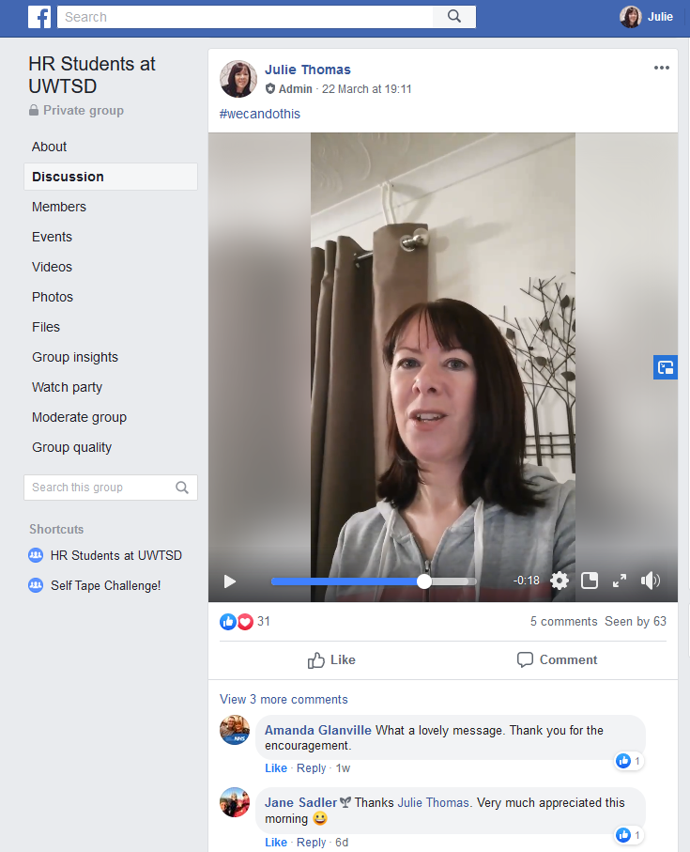
Figure 1: Screenshot of Facebook Page – HR Students at UWTSD (Thomas, 2020).

References
Biggs, J. & Tang, C. (2011). Teaching for Quality Learning at University. 4th ed. Maidenhead: Open University Press.
Dixon, J. (2019). Lights, smartphone, action! [Conference presentation]. CIPD Festival of Work. 13th June.
Race, P. (2015). The Lecturer's Toolkit. 4th ed. Abingdon: Routledge.
Thomas, J. (2020). HR Students at UWTSD [Facebook] 30th March. Available at: https://www.facebook.com (Accessed: 30th March 2020).

Reflective Evaluation of CPD Event Two – 12th October 2019
On 12th October 2019 I attended the CIPD Regional Midlands Annual Event in Birmingham, to increase my subject area knowledge (A5) and generally keep up to date with HR trends (V4). The conference was entitled ‘Enabling Well-being, Furthering Inclusion, Creating Flexibility’.
The one day conference included presentations from a variety of speakers, from CIPD representatives to motivational speakers. On the way back on the train I reflected on the whole conference and made the following observations:
- We don’t know what the future will hold but we can influence it. We (as HR professionals) can make work, work for people and make a genuine difference to people’s lives (D’Souza, 2019).
- Businesses need to focus on well-being and ignore it at their peril. If you need a business case to do this, then avoiding tribunal claims and large fines is a reason, but there are many other incentives for businesses including increased loyalty, engagement and retention of staff (Harries, 2019).
- Businesses should do the right thing by their staff and focus on wellbeing, as well as increasing diversity and inclusion, because of their moral obligation, not just because there is a business case (Briner, 2019).
- HR need to ensure that there is value in what we are doing and focus on the impact of our actions. Spend time on defining the problem (causes) and consider evidence to make decisions (Briner, 2019).
- In a world where women’s issues are increasingly being highlighted, don’t forget men. Focus on inclusion, as well as particular issues regarding equality and diversity (Jungle HR, 2019).
- Kindness is key – be a compassionate manager. Employees want to be part of a company that does good and CEO’s ignore this at their peril (Vickers-Byrne, 2019).
- Businesses need to look after their people and in a way, HR is going back to its welfare roots (Vickers-Byrne, 2019).

In terms of key themes, these seemed to be wellbeing, inclusion, kindness and HR’s responsibility to shape the future in terms of good people management. In an increasingly uncertain world, emphasised by the recent Coronavirus outbreak, being guided by these principles (as opposed to any strict rules) seems a good way to tackle the inevitable challenges to come. Overriding principles for making key decisions have been built into the new CIPD Profession Map (CIPD, 2018), which is a tool to guide professional development for HR. The three core principles are ‘Work matters, People matter and professionalism matter’, which appeared to underpin the key themes of the conference. In terms of relating this to teaching, you could equally say ‘Learning matters, Students matter and Practice matters’. As teachers we need to make sure that students learn, we need to support students pastorally and ensure our delivery and assessment is effective (Jarvis, 2010, Shackleton-Jones, 2019, Biggs &Tang, 2011). These principles could be seen as a summary of the ten principles initially created by the UK’s Teaching and Learning Research Programme (Ashwin, 2015). If we use these principles to underpin our work as teachers, this should mean that students leave our programmes with more knowledge, competence and experience than they started with.

References
Ashwin, P. (2015). Reflective Teaching in Higher Education. 1st ed. London: Bloomsbury Academic.
Biggs, J. & Tang, C. (2011). Teaching for Quality Learning at University. 4th ed. Maidenhead: Open University Press.
Boughey, T. (2019). Case study – creating a diverse and inclusive culture in your organisation. [Conference presentation], CIPD Midlands Annual Event. 12th October.
Briner, R. (2019). Taking an evidence-based approach to diversity and inclusion. [Conference presentation], CIPD Midlands Annual Event. 12th October.
D’Souza, D. (2019). Opening keynote – raising the voice of the people profession. CIPD. [Conference presentation], CIPD Midlands Annual Event. 12th October.
Harries, T. (2019). Wellbeing and sickness absence: how do you solve a problem like Maria being off sick with anxiety? [Conference presentation], CIPD Midlands Annual Event. 12th October.
Jarvis, P. (2010). Adult Education and Lifelong Learning: Theory and Practice. 4th ed. Abingdon: Routledge.
Race, P. (2015). The Lecturer's Toolkit. 4th ed. Abingdon: Routledge.
Shackleton-Jones, N. (2019). How People Learn. London: Kogan Page Limited.
Vickers-Byrne, T. (2019). Interactive session – furthering diversity and flexibility in the workplace. [Conference presentation], CIPD Midlands Annual Event. 12th October.

Reflective Evaluation of CPD Event Three – 13th March 2020
Training to Deliver all Courses On-line (A1, A2, A4, A5, K2, K4)
In March 2020, the University took the decision to cease all on-campus delivery, following the outbreak of the COVID-19 Coronavirus. This meant that with effect from 23rd March, all campus delivery would be moved on-line, which was a fundamental shift for lecturers and students alike. On 13th March I attended training on the software, VideoScribe and on Tuesday 17th March (just before all campuses closed), I attended specific training on the software, Panopto. This was followed by an interactive session at home, on ‘Microsoft Teams’, following campus closure.
VideoScribe is a piece of software that enables users to create moving ‘whiteboard’ graphics to be used alongside audio commentary. A screenshot example is below:

Figure 1: VideoScribe (2020)

Panopto is a piece of software that enables users to create videos, which can be used to aid learning. I attended the training with the objective of learning how to add voice-overs to Powerpoint slides. Microsoft Teams can be used to communicate and share resources with fellow colleagues and students.
At the start of the VideoScribe session, my manager explained that the software licences had been purchased following the successful use of the software by Academic Director, Gareth Hughes. He had used it to create a video as a revision resource for students, which had been the only video accessed twice by students and used by the vast majority of them. This gave a strong indication that it had been of value to learners, which is important to get students to engage (Biggs & Tang, 2011).
As well as learning how to use the software (K4), I derived a number of other learning points from the training:
- To make presentations more visually appealing, free images can be obtained from the websites Pixabay and Pexels. As well as using this myself, I could inform my students of this, so that they could use them to enhance their own presentations.
- Current students like the conversational style of YouTube videos – therefore a loosely scripted, more natural style is preferred. This creates social presence and aids the projection of the lecturer as a real person, thus helping keep students engaged (Ní Shé et al, 2019) (K3).
- Lecturers should only talk for 20 – 25 minutes, before asking students to complete an activity or having another type of interaction, in order to maintain engagement. This, however, is similar to the student-centred approach taken in face to face teaching (Shackleton-Jones, 2019) (K2).
- To monitor engagement and help evaluate its success lecturers can view statistics regarding their video (K5).

Unlike face-to-face teaching, for on-line learning, nearly all materials need to be prepared beforehand (Trammell and LaForge, 2017, as cited in Ní Shé et al, 2019), which is going to be a challenge for lecturers who are used to a more flexible approach. They will also have to adopt a number of new roles, or enhance the extent they undertake these roles at the moment. Of the roles mentioned by Ní Shé et al (2019), shown in figure 2 below, the technical (IT) and social (providing a friendly environment, mentoring and supporting) roles appear to present the biggest challenge for me. Hopefully these additional training sessions will sufficiently upskill me in this respect.

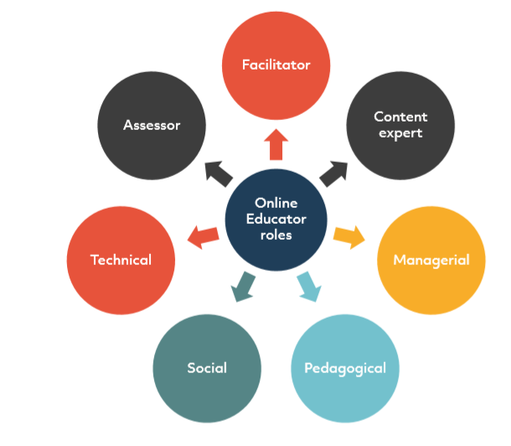
Figure 2: #Openteach model of on-line educator roles (Ní Shé, 2019).

References
Biggs, J. & Tang, C.(2011). Teaching for Quality Learning at University. 4th ed. Maidenhead: Open University Press.
Ní Shé et al (2019). Teaching online is different: Critical Perspectives from the Literature. [Online]
Available at: https://openteach.ie/wp-content/uploads/2019/11/Teaching-online-is-different.pdf
[Accessed 24 March 2020].
Shackleton-Jones, N. (2019). How People Learn. London: Kogan Page Limited.
Trammell, B. A. & LaForge, C. (2017). Common challenges for instructors in large online courses: Strategies to mitigate student and instructor frustration. Journal of Educators Online, Vol. 14, No. 1, p. 11.

Assessment of My Professional Development throughout the Programme, plus Analysis of Future Development Needs
Several authors (Matheson, 2015; Shackleton-Jones, 2019; Biggs and Tang, 2011) make the point that effective teaching is not about knowledge-transfer – rather it is about engaging students in active learning so that they build upon their existing knowledge and understanding. This is something that I clearly did not appreciate when I first started teaching. I thought I was employed to impart my knowledge to students and that most of my time should be spent ‘lecturing’ (i.e. giving a lecture). I am therefore indebted to this programme for giving me insight into what effective teaching entails.
According to Shackleton-Jones (2019), in theory you can learn from a lecture if it contains story-telling, conversations and activities, but you will achieve more learning if it means something to the learner. This emphasises the importance of putting the learner at the heart of your teaching and designing your content to meet their needs. Most of my students have been out of education a long time and also work, so my initial sessions now focus on guidance and activities regarding academic writing (A4, V1, V2). I also regularly reiterate the relevance of what is being covered to real-life situations and tell as many stories as I can (important in adult learning and learning in general, according to Shackleton-Jones, 2019). One way of doing this is by bringing up recent news stories on screen and discussing the link between the theory we have covered and what is going on now in the world.
My confidence has grown over the two years on the programme and I feel comfortable not using notes or a script and having more of a conversation with students, rather than lecturing them. According to Knowles (1984), as cited in Aubrey and Riley (2016), in order to help students go from dependent to independent learner, the teacher needs to act as a facilitator, which is certainly the role I aim to adopt in most of my sessions.
I try to build enthusiasm and passion into my workshops (advocated by many authors including Shackleton-Jones, 2019 and Knowles, 1984, cited in Aubrey and Riley, 2016) and sometimes this makes me feel like I am putting on a performance, but when I can see that I have their full attention, it is worth the effort.
In summary, although I started my career as a level 1 teacher (Biggs and Tang, 2011), I aim focussing now on whether learning outcomes have been achieved (level 3). I have a deeper understanding of how people learn and more of an appreciation that the learner experience is key. I am still making mistakes – like when I had to cover a colleague for the last three weeks of term and decided to hold a quiz to test students’ level of knowledge and understanding, to see where to pitch my teaching, which ended up in zero scores and a very uncomfortable atmosphere in the class – but in the true spirit of reflection, will approach a similar situation differently next time. Now more than ever, I appreciate the value of reflection.
In terms of future development needs, there are subject areas that I need to focus on (such as Emotional Intelligence) (K1), but, mainly due to the developing Coronavirus situation and need for online learning, I need to continue to upskill myself in terms of the use of technology (K4). In addition to this I would benefit from enhancing my knowledge of the wider context in which we operate, specifically in relation to the work of the International Institute for Creative Entrepreneurial Development, which is also incorporated into my Personal Development Plan, below (V4).

References:

Aubrey, K. & Riley, A. (2016). Understanding and Using Educational Theories. London: Sage.
Biggs, J. & Tang, C. (2011). Teaching for Quality Learning at University. 4th ed. Maidenhead: Open University Press.
Mathieson, S. (2015). Student Learning. In: H. Fry, S. Ketteridge & S. Marshall, eds. A Handbook for Teaching and Learning in Higher Education: Enhancing Academic Practice. Abingdon: Routledge, pp. 63-79.
Shackleton-Jones, N. (2019). How People Learn. London: Kogan Page Limited.

Development plan

NAME: | Julie Thomas
COVERING THE PERIOD FROM: | April 2020 | TO: | December 2020

Planned outcome

Where do I want to be by the end of this period? What do I want to be doing? (This may be evolutionary or “more of the same”.)

What do I want/need to learn? | What will I do to achieve this? | What resources or support will I need? | What will my success criteria be? | Target dates for review and completion
More features of particular software – e.g Badges function and ability to track student engagement with materials on Moodle. | Watch the webinar on the TEL section of the UWTSD website. | Access to computer, time. | Tracking reports produced for the two courses being delivered in term 3 (April-June 2020). | 20th July 2020.
Subject knowledge to support delivery of module ‘Developing Emotional Intelligence’. | Read articles from credible sources such as the World Economic Forum, read articles by Daniel Goleman. | Access to computer, time. | Creation of engaging content for the module.  Positive feedback from students. | First session has to be ready by 4th May 2020. Final session – 8th July.
Keep up to date with trends in HR. | Attend CIPD Festival of Work in June 2020 or if this is cancelled due to the Coronavirus, attend CIPD Midlands Annual Event in October. | Train ticket, hotel booking, time (approved January 2020). | Attendance at a variety of talks and workshops which I later refer to in sessions with students. | June 2020/October 2020.
Increase knowledge of Entrepreneurial learning, which was highlighted in a conference I attended in 2019. | Read articles on the Entrecomp website and blogs written by fellow lecturer who has an interest in the area. | Access to computer, time. | Ability to build in more activities into sessions with students which help develop entrepreneurial skills. | December 2020.

Evidence of 100 Hours of Teaching
I joined the University of Wales Trinity Saint David in February 2017, as a lecturer, following over 20 years’ experience in HR roles in the private and public sector. I currently work full-time, delivering traditional and supported distance learning courses. Since February 2018 I have been Programme Manager for the CIPD Diploma in Applied Human Resources (which I developed and launched myself) and since August 2019, I have been Programme Manager for all CIPD Programmes at the University including the PGDip and MA in Human Resource Management. In 2018 I won the Roffey Park National Research Competition – my report was published by Roffey Park and an article of mine, based on the report, appeared in the February 2019 issue of HR Magazine.
This academic year I have completed over 100 hours of teaching, as confirmed by Dr Margaret Inman, in an email to Mark Flagg on 25th February 2020:

From: Margaret Inman <margaret.inman@uwtsd.ac.uk>
Sent: 25 February 2020 16:26
To: Julie Thomas <julie.thomas@uwtsd.ac.uk>
Subject: RE: Evidence of 100 hours of Teaching for PG Cert tHE

Hi Julie
Yes I can confirm that you have completed this teaching.
Thanks
Maggie

From: Julie Thomas <julie.thomas@uwtsd.ac.uk>
Sent: 25 February 2020 15:34
To: Margaret Inman <margaret.inman@uwtsd.ac.uk>
Subject: Evidence of 100 hours of Teaching for PG Cert tHE

Hi Maggie

As part of my port-folio submission for module 2 of the above qualification, I am required to provide evidence of 100 hours teaching. Please could you reply to this email to confirm that this academic year I have so far delivered the following modules?

Inductions for level 5 and 7 - 20 hours
Level 7 HRM in Context - 50 hours
Level 5 Skills for the Workplace - Workplace Culture and its impact on Organisational Efficiency - 40 hours
Level 5 BA - Developing Professional Practice - 12 hours
CIPD Level 5 - Understanding the Management of Change - 20 hours
CIPD Level 5 - Contributing to the Management of Change - 40 hours
CIPD Level 5 - Using a Research Approach in HR - 20 hours
CIPD Level 5 - Developing Professional Practice in HR - 40 hours
Dissertation supervision - 5 x MA, 6 x BA

The above excludes modules to be delivered in term 3 (Skills for the Workplace and Level 5 CIPD modules).

Thanks.

Julie

Appendices (see documents sent separately)
External Quality Assurance Report dated 18th February 2020
Internal Verification Report dated February 2020
Peer Observation dated 1st November 2017
Peer Observation dated 20th November 2019

