

Task 1 – Reading Task Template
Upload your photo of your A3 in-class notes here:
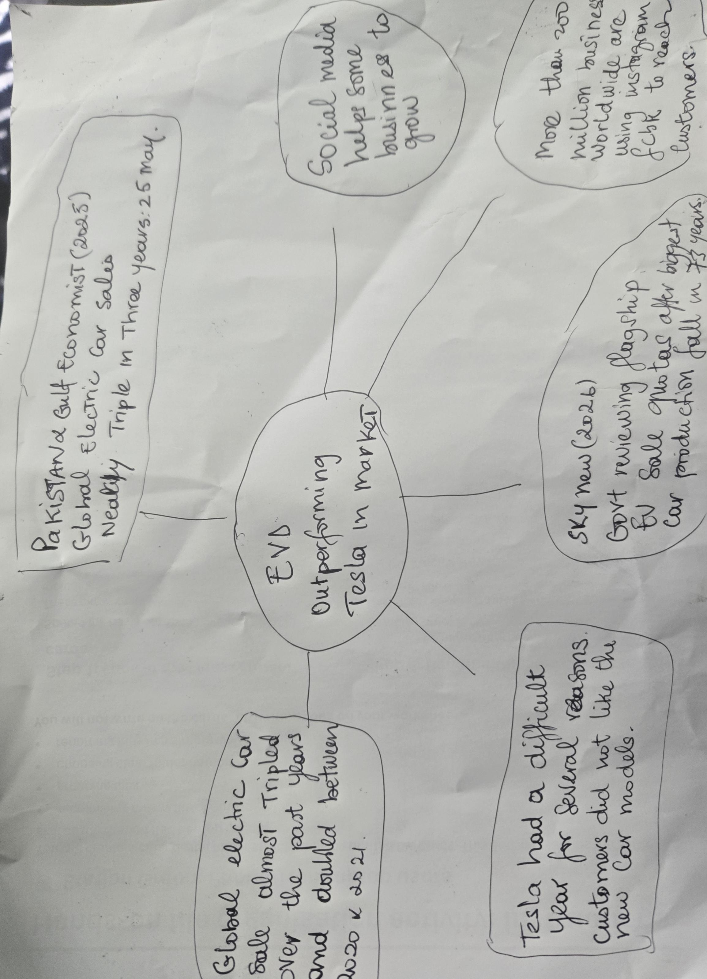

1. Answer these questions using the sentence starters below
a. What is the main idea of the text?
The main idea is that China BYD as beaten Tesla to become world’s, top EV seller in the world.
b. What are two key points?
One key point is he has sold more cars than the American company Tesla.
Another key point is Tesla had a difficult year for many reasons, political, and some customer don’t like the new EV cars.
c. What part of the text did you find most important? Why?
The most important part is global electric car sales almost tripled over the past year and the had previously doubled between 2020 and 2021.
d. Was anything unclear or difficult to understand?,
I was not sure about why uk government is reviewing it’s electric car sale quotas. One of its flagship green policies.
e. How did your group help you understand the text better?
My group helped me by understanding the context of the message we tried to find the correct answer an make sure the answer will help everyone .
3. One sentence reflection
Question: What did you find challenging about this task?
The hardest part was Information in clear way, use AI to summarise and check.

